Supplemental materials
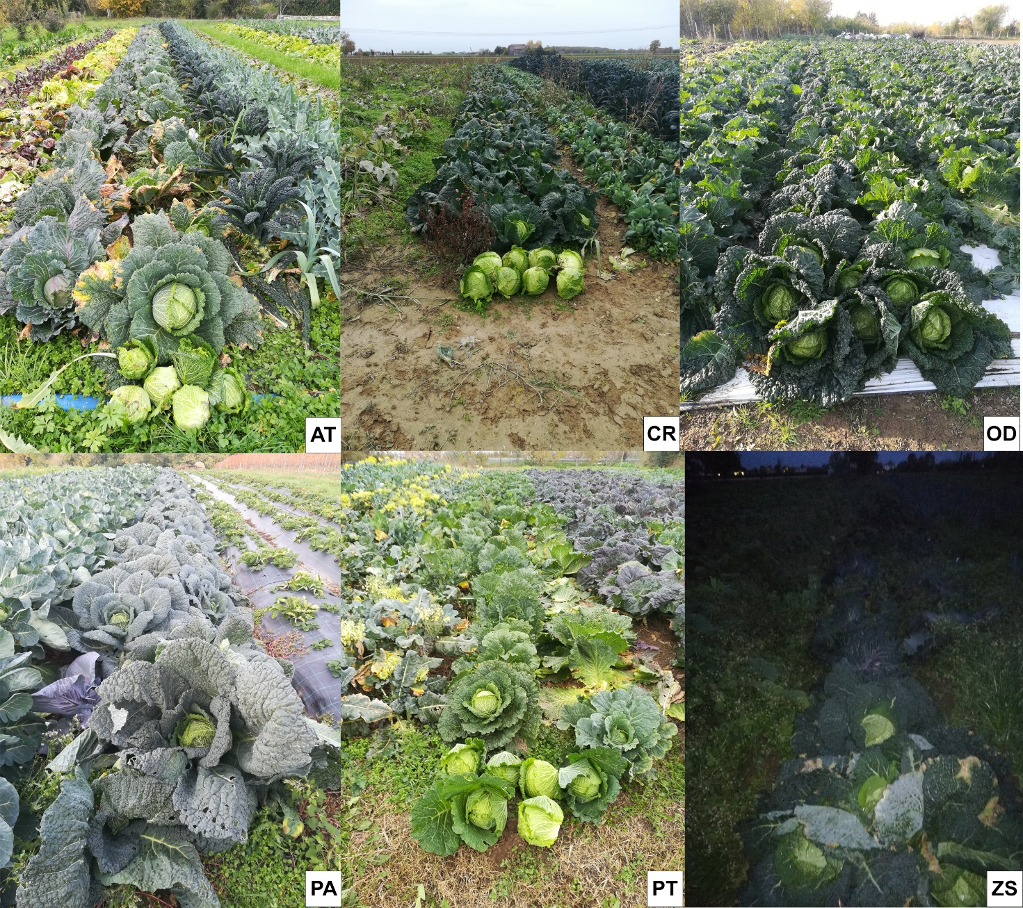
Figure S1. Cabbage crop in conv: AT, CR and OD, and in mgm: PA, PT and ZS farms.
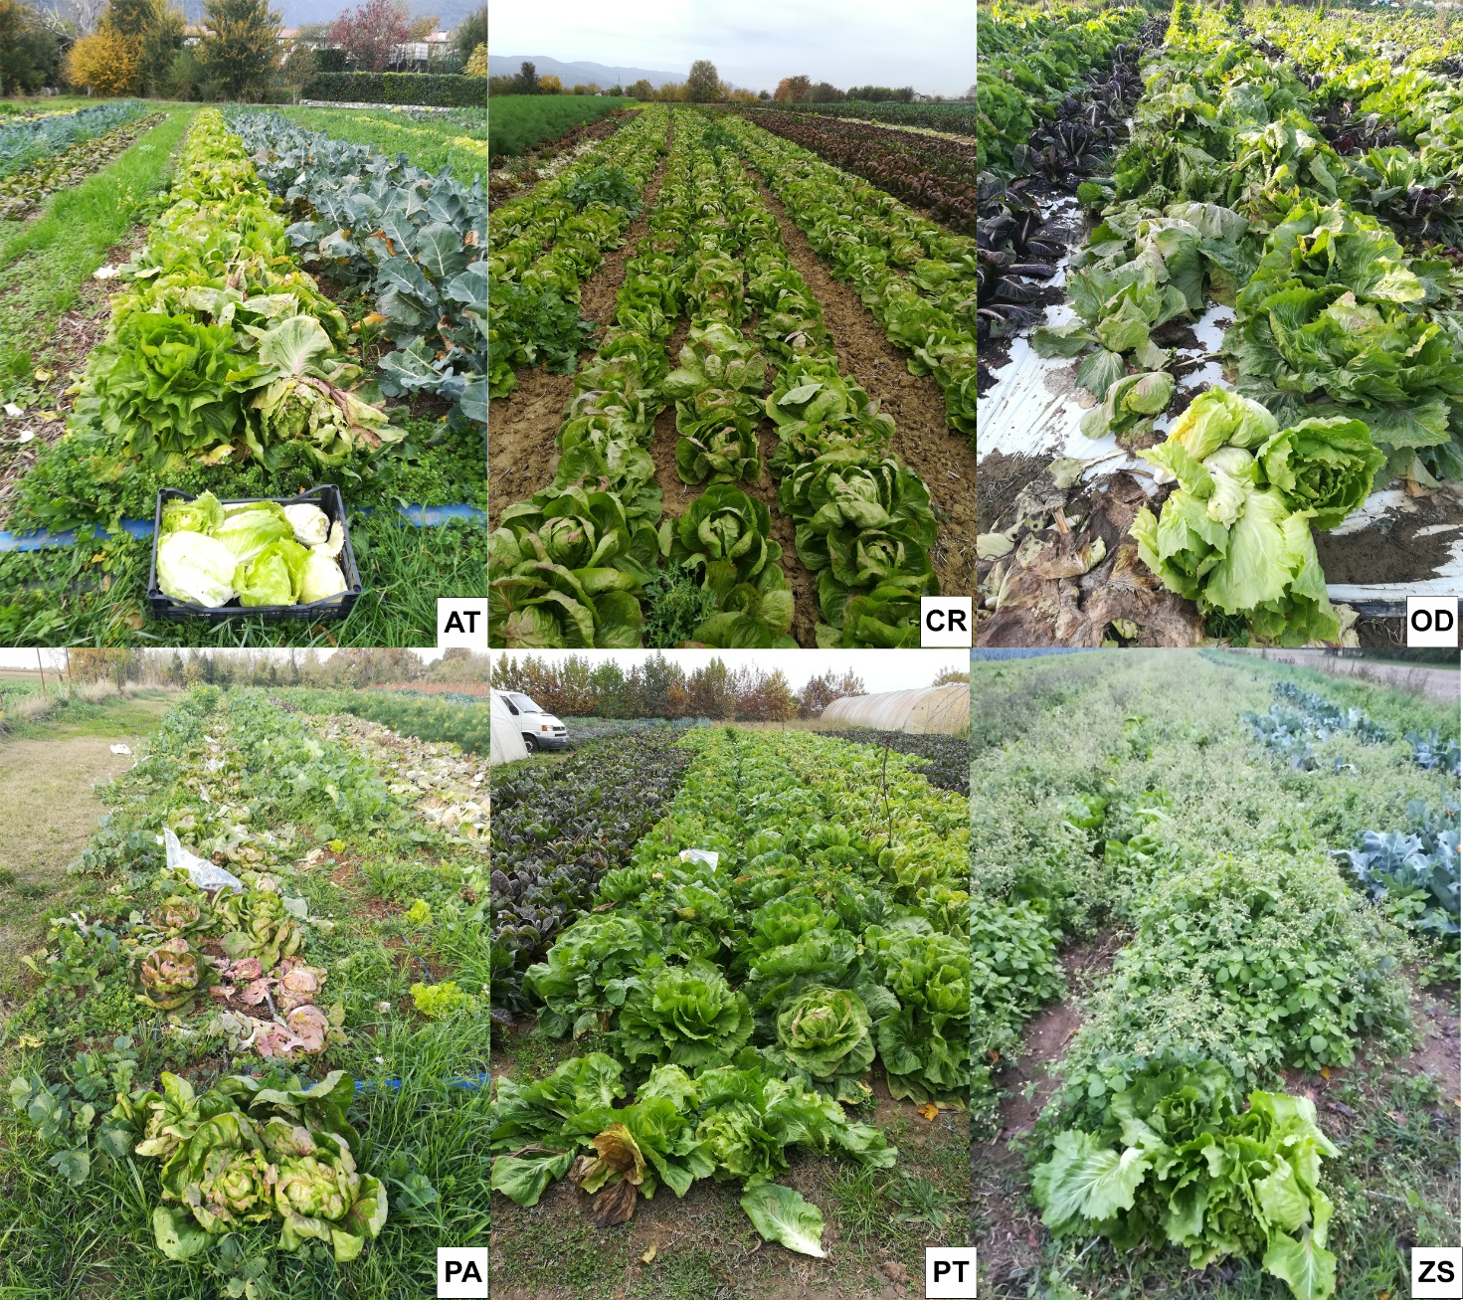
Figure S2. Radicchio crop in conv: AT, CR and OD, and in mgm: PA, PT and ZS farms.
S3) 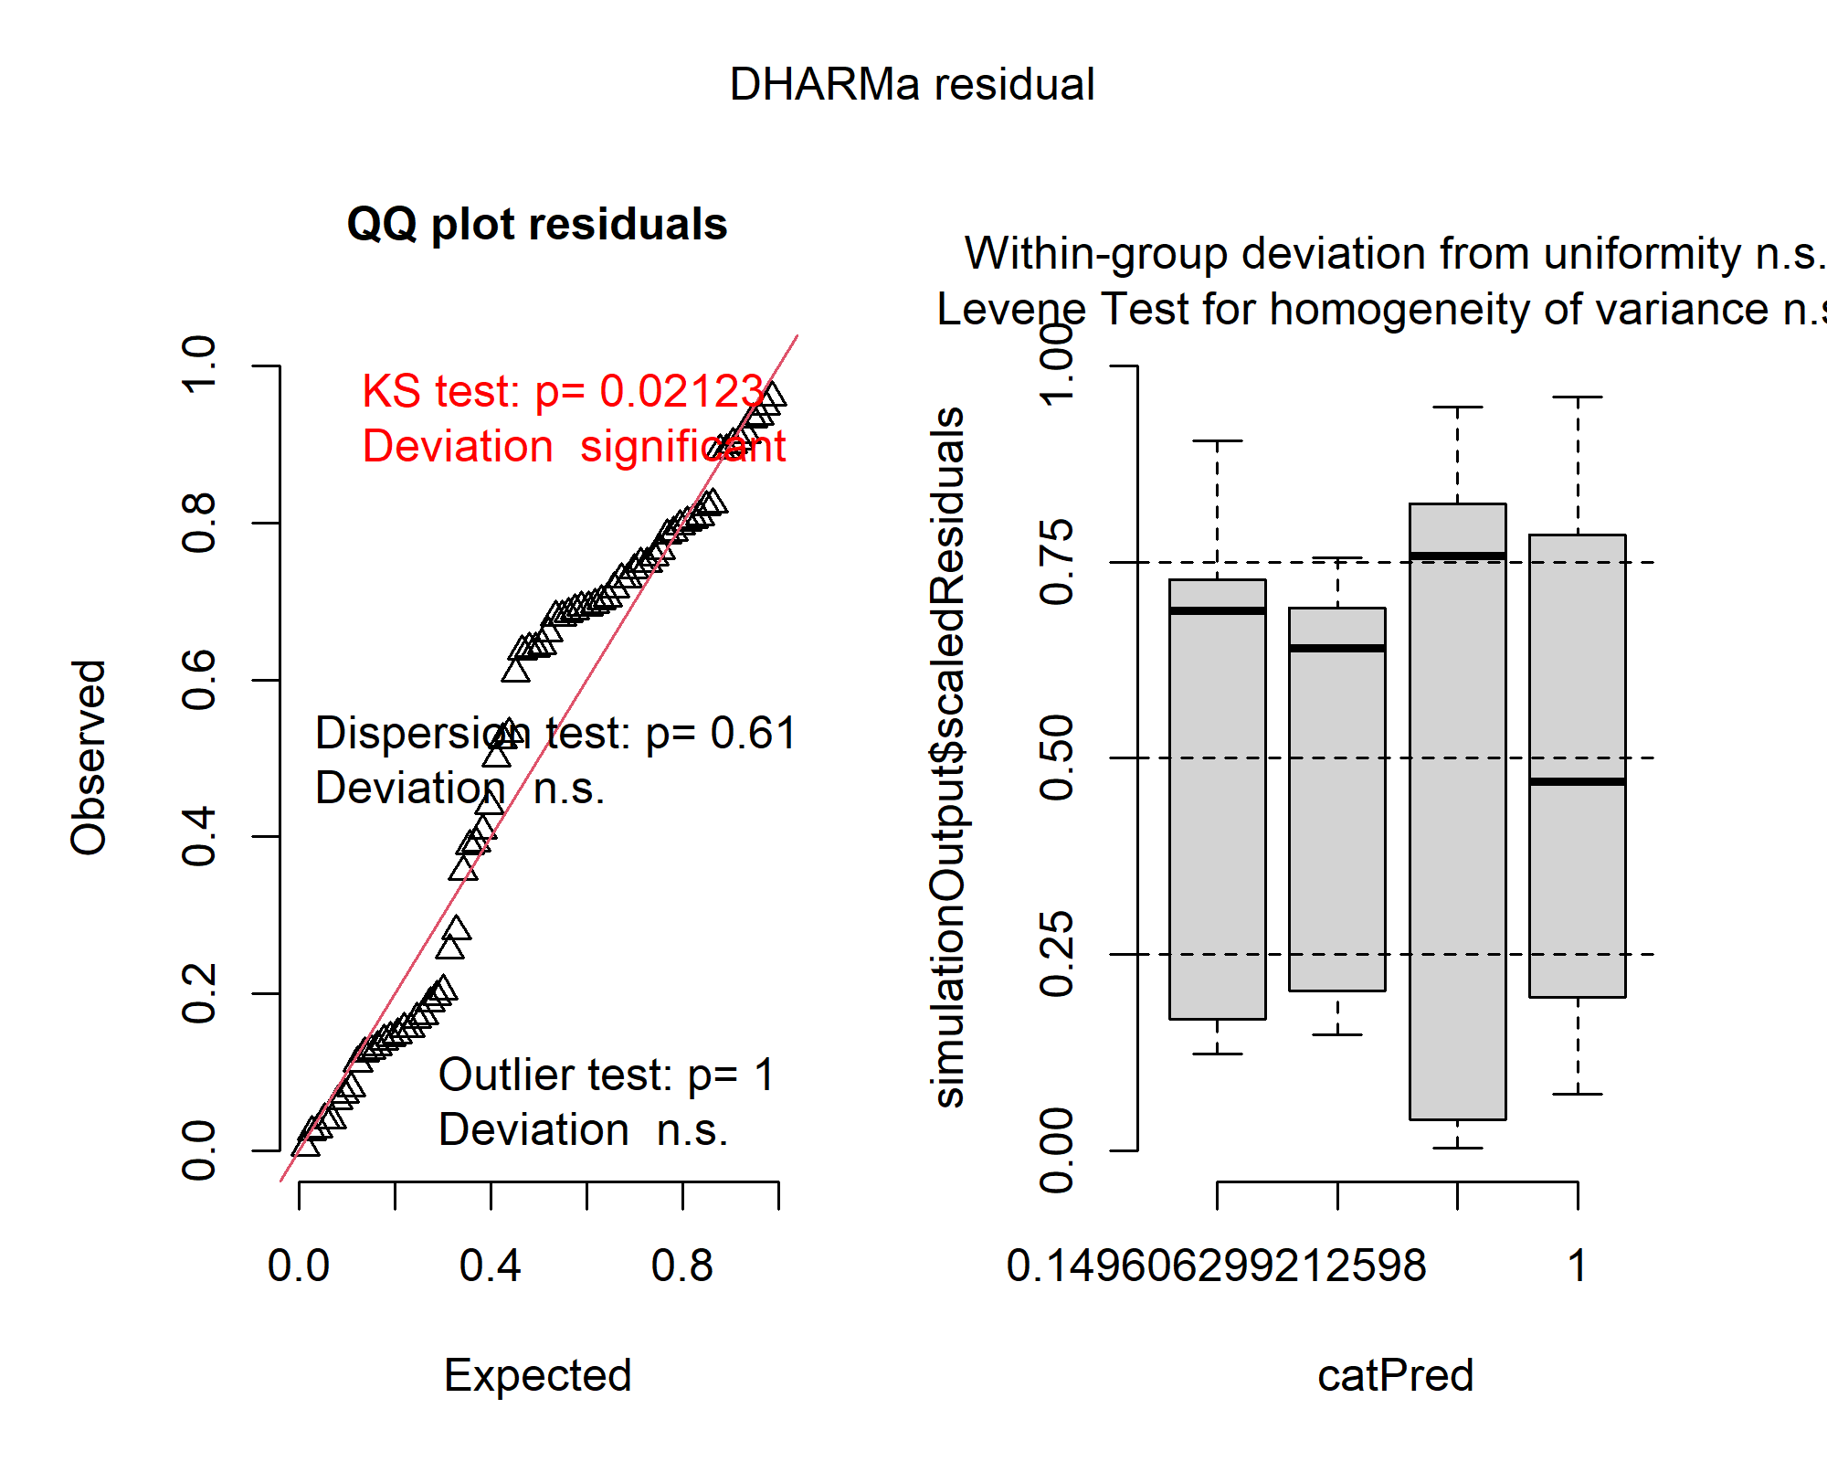
S4) 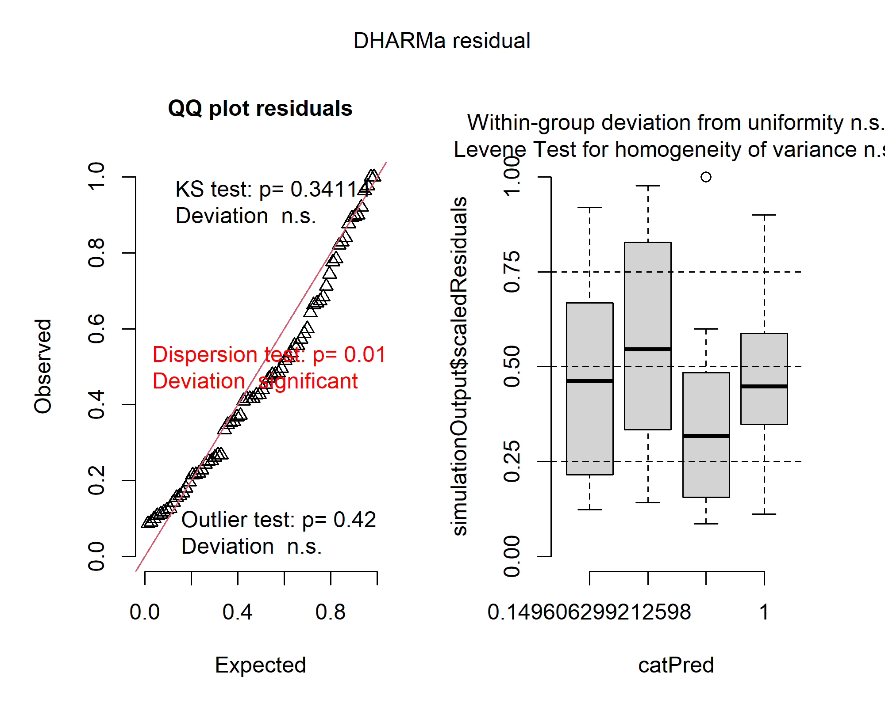
S5) 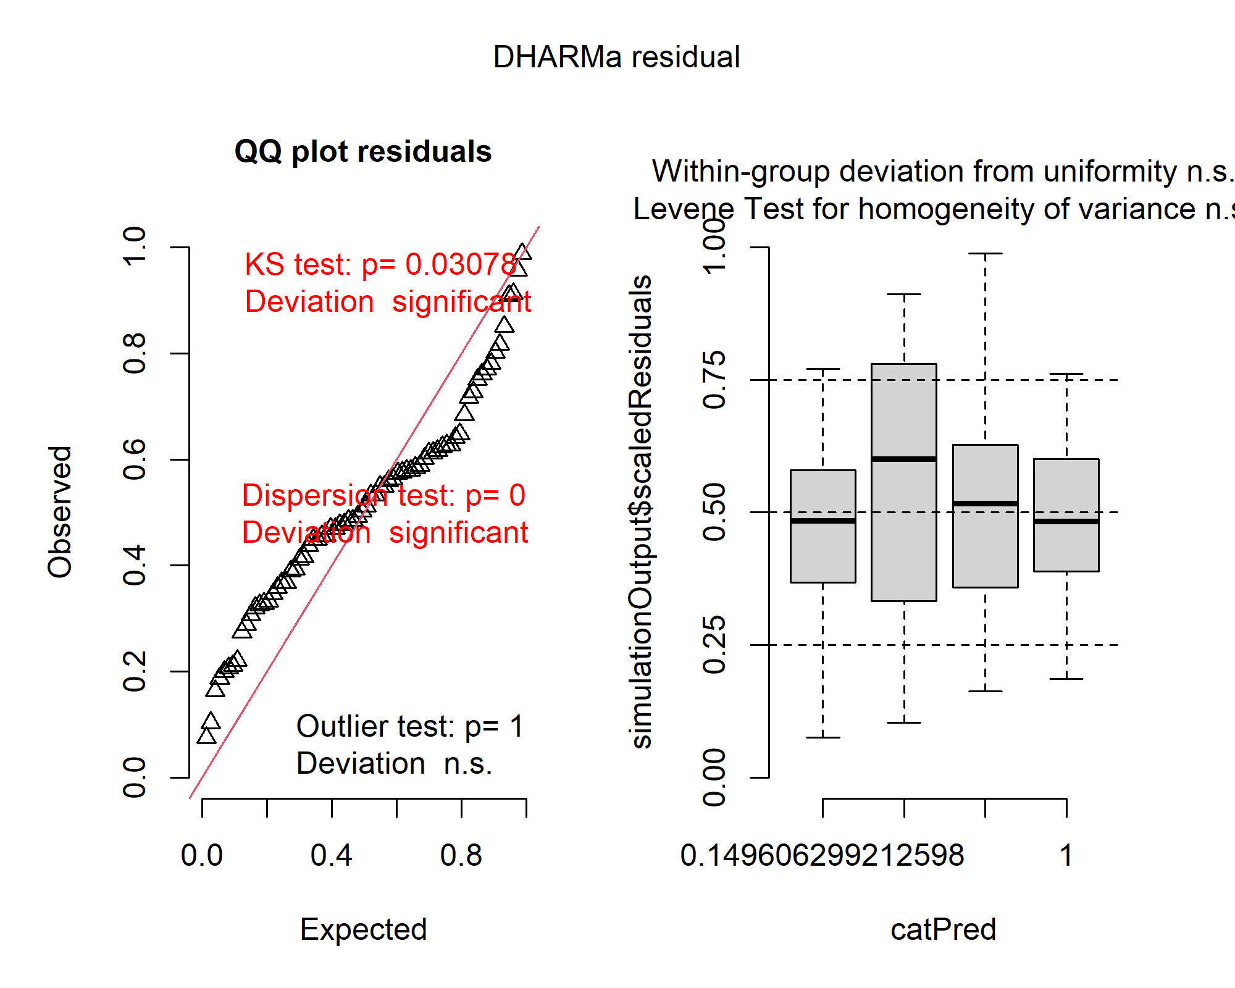
S6) 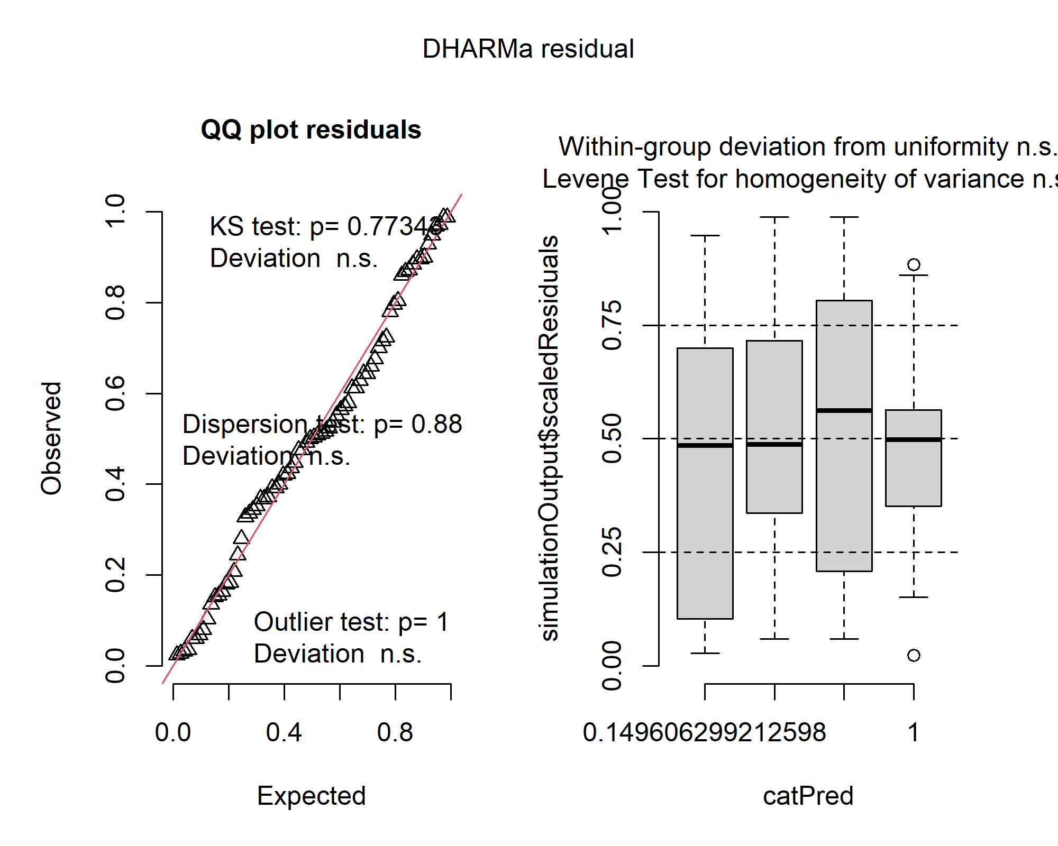
S7) 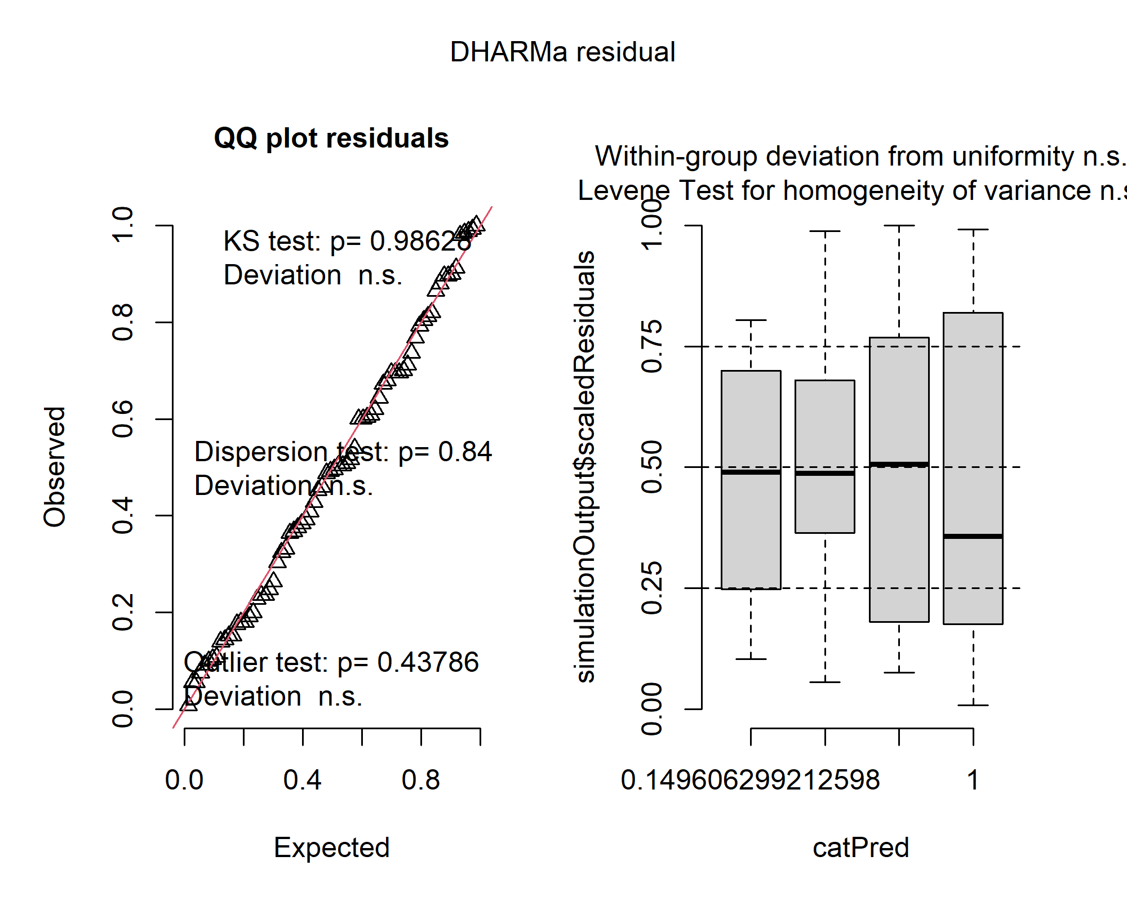
S8) 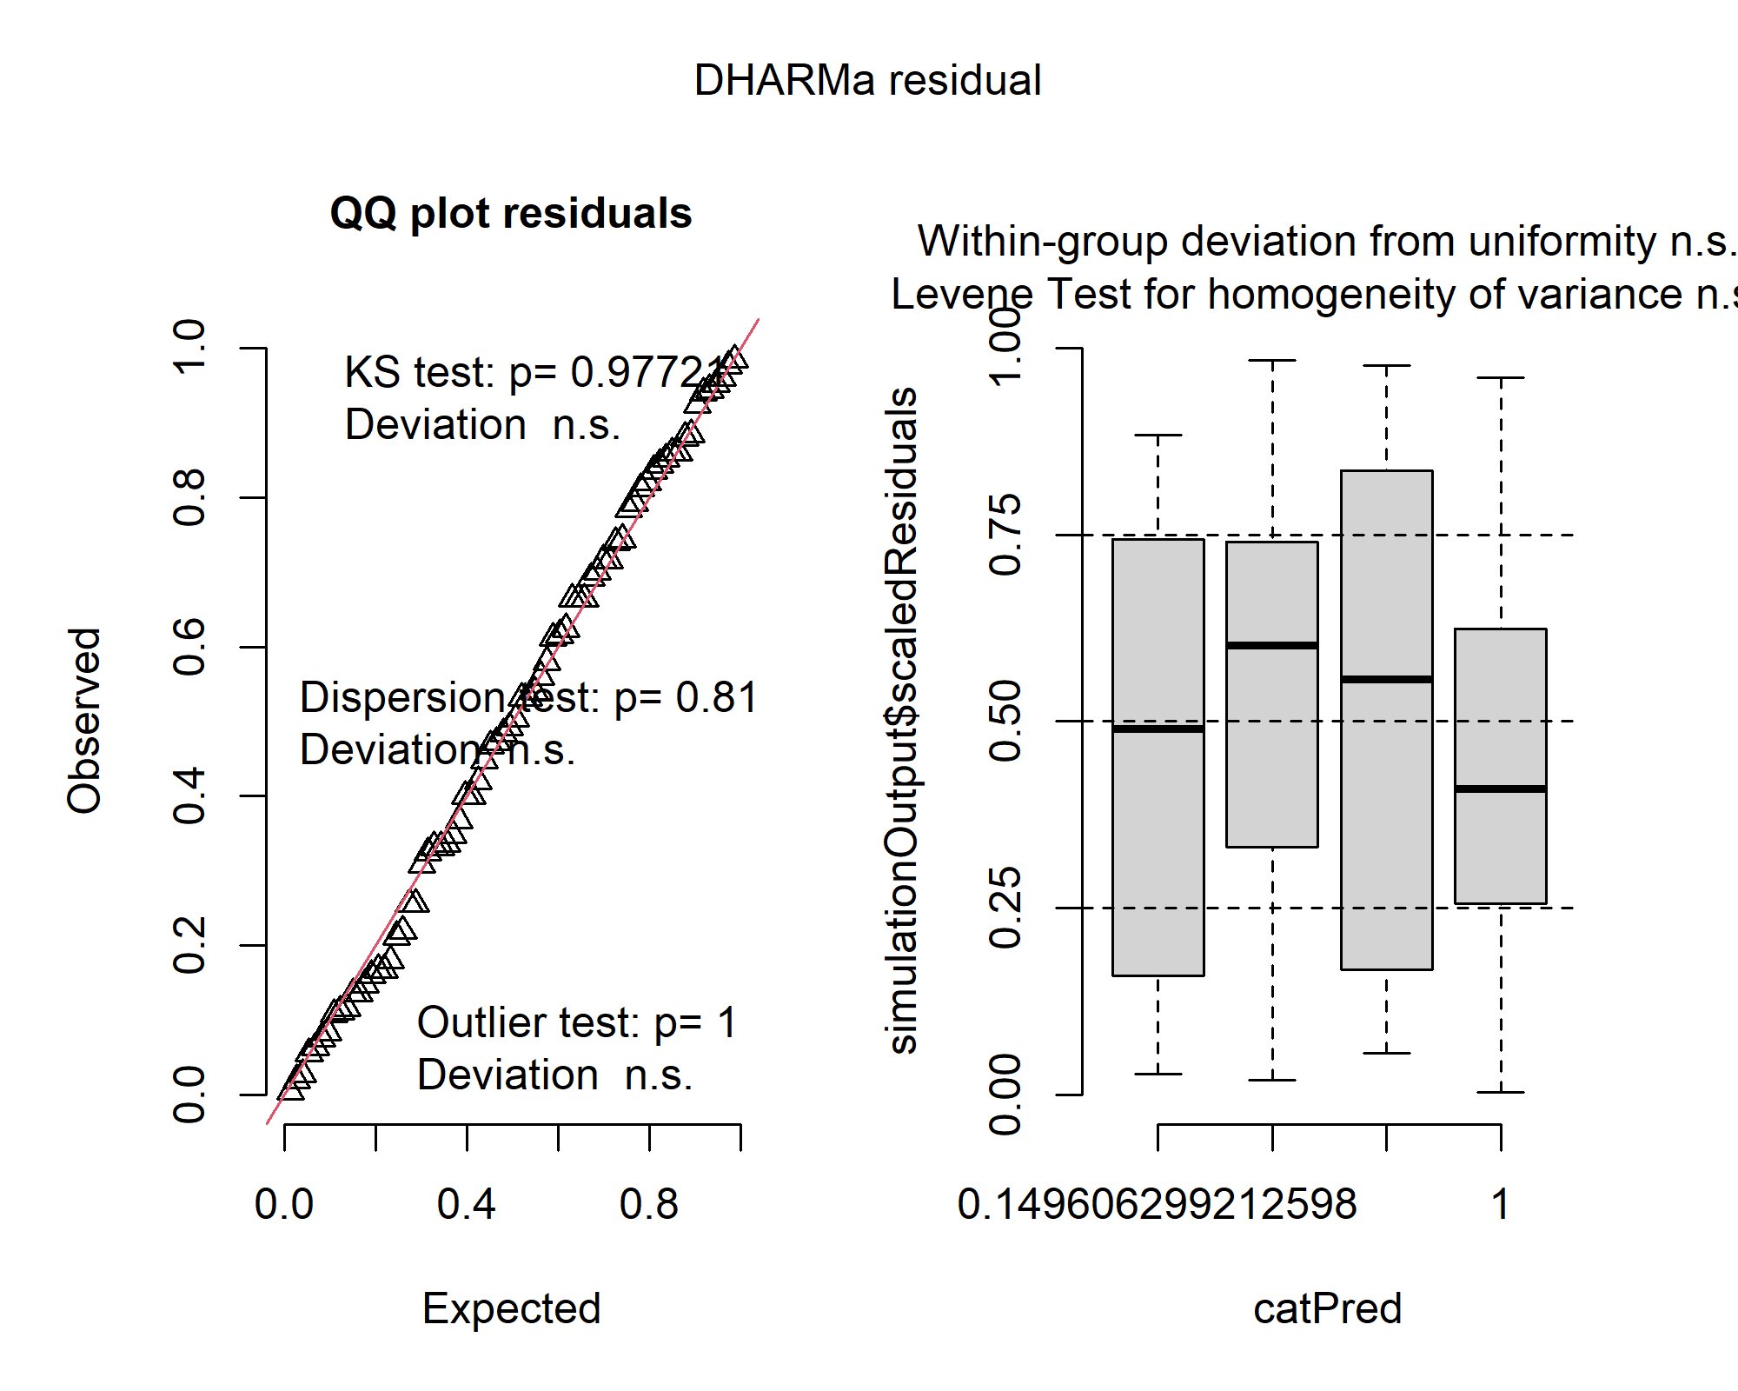
S9) 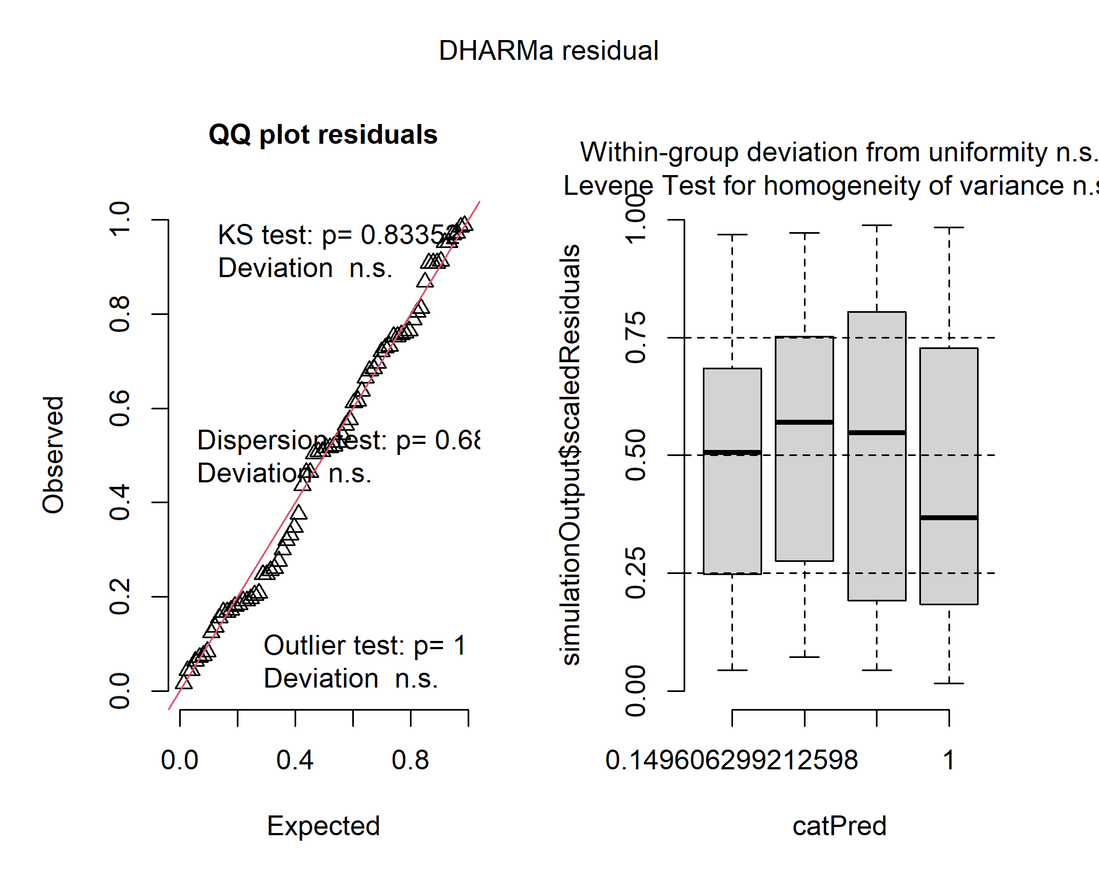
S10) 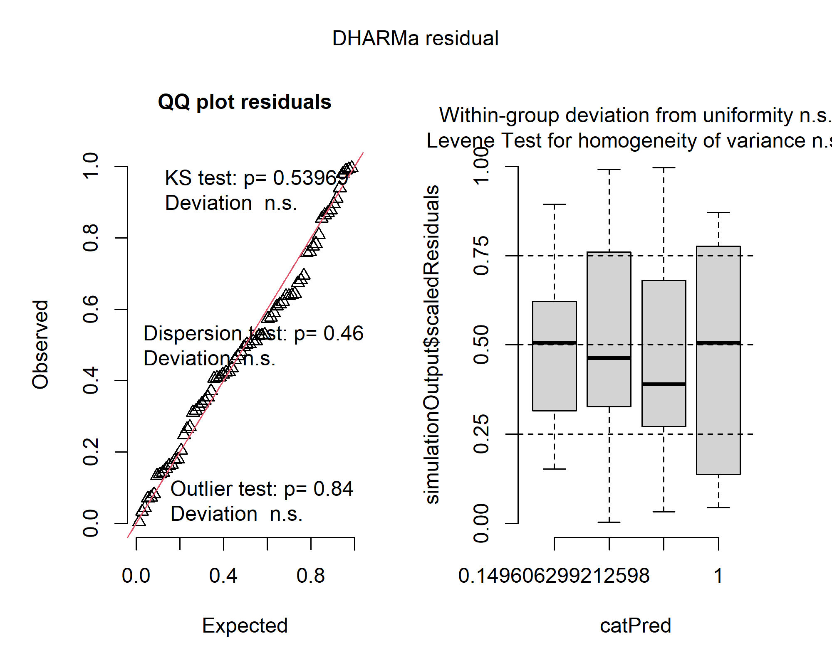
Figure S3-S10. DHARMa residual diagnostics for mixed-effects models.
Simulated residual diagnostics (DHARMa package) for (S3) SOM (log-Gaussian), (S4) Abundance (negative binomial), (S5) Number of groups (Poisson), (S6) Acarina/Collembola ratio (log-Gaussian), (S7) Shannon diversity (Gaussian), (S8) Simpson index (Beta regression), (S9) Pielou’s evenness (Beta regression), and (S10) QBS-ar (negative binomial).
Plots display quantile–quantile residual distributions, residuals vs. predicted values, and simulation-based dispersion tests. No major deviations from model assumptions were detected, except for moderate overdispersion in the abundance model and slight underdispersion in the number-of-groups model (see Table S2).

