Tristearin and C12-18 saturated fatty acids blends: interplay between eutectic phase behaviour and polymorphic transition
Serena Bertoni^{a*}, Elena Simone^{b}, Beatrice Albertiniª, Nadia Passeriniª
ªDepartment of Pharmacy and Biotechnology, University of Bologna, Via S. Donato 19/2, 40127 Bologna, Italy
^{b}Department of Applied Science and Technology, Politecnico di Torino, Torino, 10129, Italy
*Corresponding author (serena.bertoni4@unibo.it)

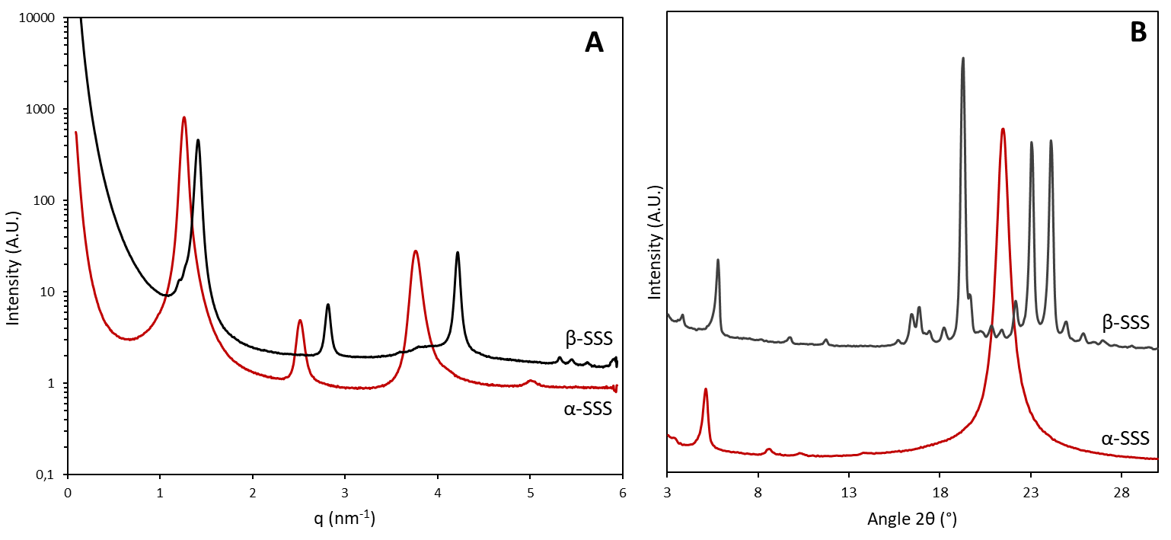
Fig. 1 SI. A) SAXS and B) PXRD patter of α-SSS and β-SSS

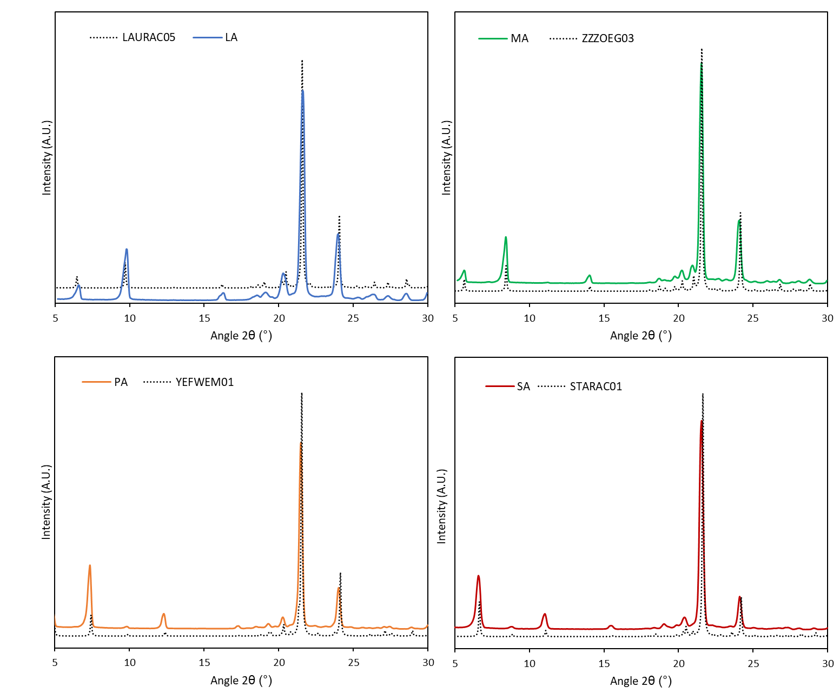
Fig. 2SI PXRD pattern of pure FAs compared with powder diffraction patterns calculated from single-crystal structures available on Cambridge Structural Database.
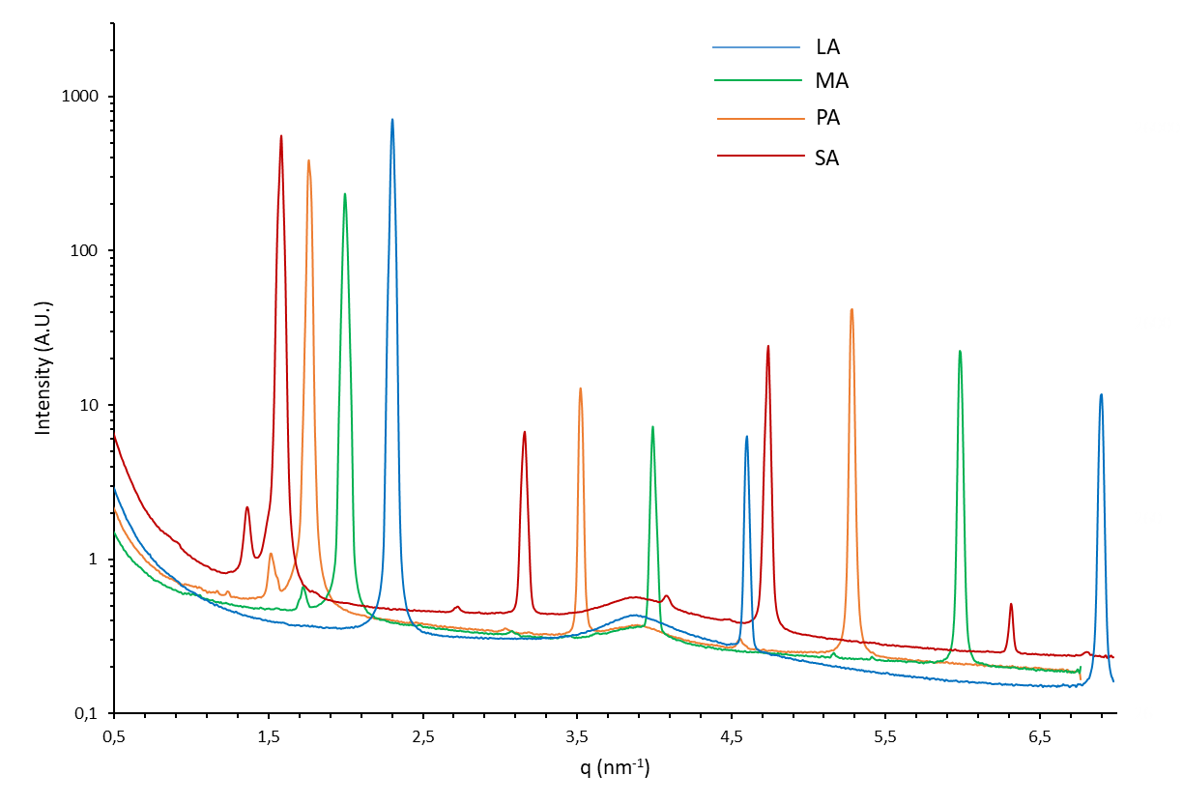
Fig. 3SI SAXS pattern of pure FAs recorded at 25°C
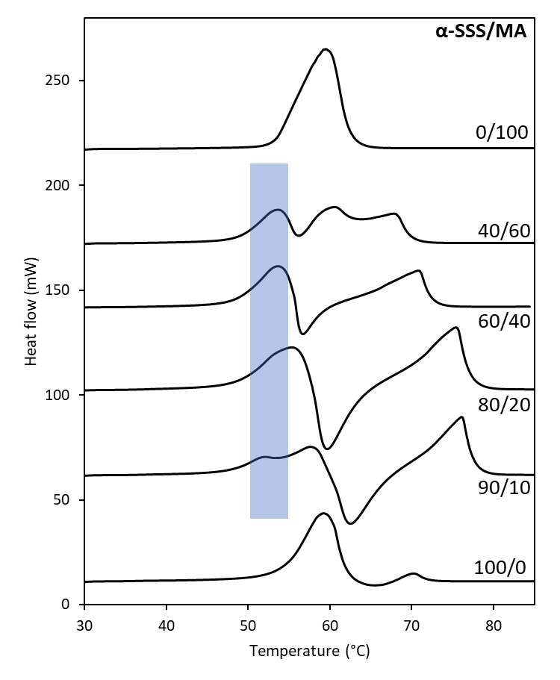
Fig. 4SI DSC melting curves of α-SSS/MA binary mixtures at the different mass proportion.

