Supporting Information to the paper

Pafumi, E. et al. Using spectral diversity and heterogeneity measures to map habitat mosaics: an example from the Classical Karst

Appendix S1. Study area and habitat classes

Supplementary methods

Vegetation height maps
To improve the accuracy of manual mapping, we used vegetation height maps derived from LiDAR data. LiDAR RAFVG survey has been conducted in Friuli Venezia Giulia region in the years 2017-2020 by aerial means. LiDAR point clouds, that have an average density of 16 points/m², were downloaded from Eagle FVG portal (https://eaglefvg.regione.fvg.it). Each point includes a classification field (1 – unclassified, 2 – ground, 3 – low vegetation, 4 – medium vegetation, 5 – high vegetation): points belonging to “Ground” class were extracted and interpolated to create a plan, then the distance of the vegetation points from the plan was computed and maps of vegetation height were produced. Elaboration was performed in CloudCompare 2.11.1 (Cloud Compare, 2021).

Table S1. Intervention areas of "Ecomosaico del Carso" project.
N° area | Locality | Municipality | Owner / farmer | Area (m²)
1 | Grotta Noè | Duino-Aurisina | Jus Comunella "La comune di S. Croce" | 21391.24
2 | Grotta Noè | Duino-Aurisina | Jus Comunella "La comune di S. Croce" | 2369.85
3 | Grotta Noè | Duino-Aurisina | Jus Comunella "Nabresina Gemeinde" | 13272.72
5 | Case Coisce | Duino-Aurisina | Società agricola Kohisce srl | 104217.75
6 | Monfalcone | Monfalcone | Comune di Monfalcone – Az. Agr. Ferfoglia Andrej | 80946.40
7 | Monfalcone | Monfalcone | Comune di Monfalcone – Az. Agr. Ferfoglia Andrej | 38665.51
8 | Monfalcone | Monfalcone | Comune di Monfalcone – Az. Agr. e agrit. Kovac | 146533.78
11 | San Lorenzo | Trieste | Srenja Borst "La Comune di Borst" | 37532.92
13 | San Giuseppe | Trieste | Comune di San Giuseppe della Chiusa – Jus Comunella Trebiciano "La Comune di Trebich" | 16739.84
15 | San Giuseppe | Trieste | Comune di San Giuseppe della Chiusa – Jus Comunella Trebiciano "La Comune di Trebich" | 1024.94
16 | San Giuseppe | Trieste | Comune di San Giuseppe della Chiusa – Jus Comunella Trebiciano "La Comune di Trebich" | 15545.11
20 | Opicina | Trieste | La Comune di Optschina – Società agricola Kmetija D.F. | 76890.18

Table S2. List of habitat classes found in intervention areas during field surveys. A finer classification mainly based on the phytosociological types described for the Italian part of the Classical Karst by Poldini (1989; 2009) includes a total of 26 habitat classes (first column), which are aggregated in the second classification into 11 coarser classes on the basis of structural-physiognomic and ecological characteristics (second column). Annex I habitat type codes (Council Directive 92/43/EEC) corresponding to the main vegetation types are reported between brackets and in italics.

Fine classes | Coarse classes (acronym)
Mesophilous calcareous grassland (Carici humilis-Centaureetum rupestris) (62A0)  - Typical grassland with no encroachment (E0)  - Mosaic grassland/Sesleria autumnalis-dominated patches at second encroachment stage (E2) | Grassland E0 (Gr_E0)  Grassland E1 (Gr_E1)  Grassland E2 (Gr_E2)
Thermophilous calcareous grassland (Centaureo cristatae-
Chrysopogonetum gryllii) (62A0)
- Typical grassland with no encroachment (E0)
- Grassland + Sesleria autumnalis-dominated patches at first
encroachment stage (E1)
- Mosaic grassland/Sesleria autumnalis-dominated patches
at first encroachment stage (E1)
- Mosaic grassland/Sesleria autumnalis-dominated patches
at second encroachment stage (E2)
- Sesleria autumnalis-dominated grassland at first
encroachment stage (E1)
- Sesleria autumnalis-dominated grassland at second encroachment stage (E2)
Thermophilous grassland on flysch (Centaureo cristatae-Chrysopogonetum gryllii onobrichydetosum tommasinii) (62A0)
- Typical grassland with no encroachment (E0)
- Mosaic grassland/Sesleria autumnalis-dominated patches at first encroachment stage (E1)
- Mosaic grassland/Sesleria autumnalis-dominated patches at second encroachment stage (E2)
- Sesleria autumnalis-dominated grassland at second
encroachment stage (E2)
Pasture-grassland (Danthonio-Scorzoneretum villosae) (62A0) | Pasture-grassland (PG)
Hay meadow (Anthoxantho-Brometum erecti) (6510) | Hay meadow (HM)
Grassland-woodland mosaic (-) | Grassland-woodland  mosaic (GWM)
Pioneer shrubland on screes with Ostrya carpinifolia (-) | Shrubland (Shr)
Pioneer thermophilous shrubland on screes (Frangulo-Prunetum  mahaleb) (-) | Shrubland (Shr)
Shrubland with Cotinus coggygria (-) | Shrubland (Shr)
Shrubland with Fraxinus ornus (-) | Shrubland (Shr)
Thermophilous Karst shrubland (Pruno-Paliuretum spina-christi)  (-) | Shrubland (Shr)
Downy oak woodland (Ostryo-Quercetum pubescentis) (-) | Downy oak  woodland (DOW)
Young downy oak woodland (Ostryo-Quercetum pubescentis) (-) | Downy oak  woodland (DOW)
Sessile oak woodland (Seslerio-Quercetum petraeae) (-) | Sessile oak  woodland (SOW)
Black pine plantation (-) | Black pine  plantation (BPP)
Grove with Ailanthus altissima (-) | Invasive alien species  grove (IAS)
Grove with Robinia pseudoacacia (-) | Invasive alien species  grove (IAS)

Appendix S2. Vegetation and spectral heterogeneity indices

Supplementary methods

Vegetation indices
Vegetation indices were preferred over the original Sentinel-2 spectral bands as inputs for the classifications because they allow to reduce the dimensionality of the dataset while being more strongly related to the temporal variation of vegetation (Coppin et al., 2004).
NDVI (Rouse et al., 1975) includes the red and NIR bands, respectively sensitive to chlorophyll content and leaf structure. It has been proven to be correlated to biomass, leaf area index (LAI) and photosynthetic activity (Gamon et al., 1995). GNDVI is an alternative to NDVI, with the green band instead of the red band, that has been proposed to avoid saturation in case of high chlorophyll content (Gitelson et al., 1996). NDWI, including the NIR and SWIR bands, is sensitive to water content and can be useful in assessing vegetation water status (Chen et al., 2005). Finally, IRECI uses Sentinel-2 red and red-edge bands and is very sensitive to LAI parameter and canopy chlorophyll content (Frampton et al., 2013).

Metrics of spectral heterogeneity and diversity
Rao’s quadratic entropy (Rao’s Q; Rao, 1982) is a diversity index that considers both relative abundances of pixel values ($p_{i}$, $p_{j}$) and spectral distances among them ($d_{ij}$):
$$Q=\sum_{i=1}^{N}{\sum_{j=1}^{N}{d_{ij}×p_{i}×p_{j}}}$$
In this study, spectral Rao’s Q layers were separately obtained from each vegetation index raster through package rasterdiv (Rocchini et al., 2021c; Thouverai et al., 2021) in R software (R Core Team, 2022). Following the function specifications, each input raster layer was first rescaled in 8-bit and the moving window was set to 3.
To calculate Rao’s Q in the temporal dimension, a “multidimension” method was set. In this case, the distances among pixel values are calculated considering more than one layer. For each vegetation index, two layers of temporal Rao’s Q were produced per year, one from the stack of 12 monthly images and the other from the stack of 4 seasonal composites.
Spectral 𝛼- and 𝛽-diversity metrics were calculated following the spectral species concept proposed by Féret and Asner (2014), using the R package biodivMapR (Féret and Boissieu, 2020). The used algorithm includes several steps: first, the multi-spectral Sentinel-2 images are filtered to remove irrelevant pixels (non-vegetated, shady, or cloudy). Then, a principal component analysis (PCA) is performed, and the relevant principal components (PCs) are manually selected based on visual analysis. Spectral species mapping is based on k-means clustering. A subset of pixels is randomly extracted from the image and used to define k clusters (i.e., “spectral species”). The number of clusters was set to 20 in this study as it was suggested as the optimal for moderately diverse temperate sites (Féret and Boissieu, 2020). Then, clustering is applied to the whole image, so that each pixel is assigned to a cluster. Finally, 𝛼- and 𝛽-diversity maps are produced, basing on the distribution of spectral species in the window size, that was set to 3x3 pixels in this case, since habitat patches were small. Shannon index was chosen as indicator of 𝛼-diversity, while 𝛽-diversity was derived from a pairwise Bray-Curtis (BC; Bray and Curtis, 1957) dissimilarity matrix obtained from the spectral species map. The BC matrix was then subjected to an ordination (Principal Coordinate Analysis, PCoA) to project it into a 3-dimensional space and obtain a visual representation of the results (larger BC dissimilarity between pixels corresponds to larger color differences in the RGB space).
To apply this procedure on a temporal level, stacks of vegetation indices covering a whole year were used as input. For each vegetation index, temporal 𝛼- and 𝛽-diversity maps were obtained first from a stack of 12 layers (each corresponding to a month) and then from a stack of 4 layers (each corresponding to a season). Thus, yearly values of 𝛼- and 𝛽-diversity computed over months and over seasons were obtained for each vegetation index.

Supplementary results

Vegetation indices
A monthly and a seasonal time series were produced for each of the four vegetation indices selected, namely NDVI, GNDVI, NDWI, and IRECI. The trend of vegetation indices over time differs according to the habitat class, as represented in Fig. S1. For most of the habitats, vegetation indices increase in late spring and decrease in late autumn-winter, and the largest differences between habitats are found in summer. For example, summer values of IRECI are represented in Fig. S5: the highest values of IRECI in summer are found for downy oak and sessile oak woodlands (mean values of 1.18 and 0.99, respectively), while the lowest values are found for grassland at encroachment stage 1 and pasture-grassland (mean values of 0.26 and 0.35).

Metrics of spectral heterogeneity and diversity
Rao’s Q layers were obtained from all vegetation indices, on monthly, seasonal, and yearly scales, for a total of 72 layers. Maps of Rao’s Q computed on NDVI seasonal composites are reported in Fig. S6 as an example. As expected, higher spectral heterogeneity is mainly located at the edges between different habitat types. This is especially clear in the summer and autumn maps, while the winter and spring ones are noisier. Rao’s Q index is highly variable over the year, with differences according to habitat: it varies largely in habitats like downy oak woodlands and black pine plantations, while it is relatively stable in others, like grasslands and meadows. Summer is the season with the largest differences among habitat types (Fig. S7). In this season, the highest mean values of Rao’s Q computed on NDVI are found for pasture-grasslands (20.27) and pure grasslands (18.19), while downy oak woodlands and black pine plantations have the lowest values (respectively 3.21 and 3.77). A similar pattern can be observed in autumn, while in spring and winter the highest Rao’s Q values are reached by invasive alien species groves (15.51 in spring and 16.65 in winter).
A total of 32 𝛼-diversity and 72 𝛽-diversity layers were obtained from Sentinel-2 images and from yearly vegetation indices stacks. Seasonal 𝛼-diversity maps are represented in Fig. S8 for an example. Generally, areas with high spectral 𝛼-diversity are areas with a high presence of mixed pixels, like invasive alien species groves (mean spring value = 1.34), shrublands (mean spring value = 1.33) and grassland-woodland mosaics (mean spring value = 1.12), or areas with low vegetation heights, as meadows (mean spring value = 1.15) and grasslands (mean spring value = 1.10). The lowest values of 𝛼-diversity are found in black pine plantations (mean spring value = 0.66), as shown in Fig. S9.
In the case of 𝛽-diversity, the BC matrix of spectral dissimilarity between habitats was subjected to PCoA so that it could be represented in the 3-dimensional space and expressed through differences in RGB colors (Fig. S10). As an example, the PCoA of the 𝛽-diversity computed on the autumn composite is shown in Fig. S11c. The first PCoA axis (explaining 16.94% of the variance) separates woodlands on the left from grasslands and black pine plantations on the right. The second PCoA axis (explaining 12.96% of the variance) represents a gradient from grasslands to black pine plantations, passing through woodlands and shrublands. Thus, three main groups of habitats are distinguished through 𝛽-diversity: woodlands, grasslands and black pine plantations.

Figure S1. Monthly time series of vegetation indices, namely NDVI (a), GNDVI (b), NDWI (c), and IRECI (d), averaged across all training areas. Habitat acronyms are reported in Table S2.

Figure S2. Boxplots of NDVI computed from the spring (a), summer (b), autumn (c) and winter (d) seasonal composites, averaged across all training areas. Habitat acronyms are reported in Table S2.

Figure S3. Boxplots of GNDVI computed from the spring (a), summer (b), autumn (c) and winter (d) seasonal composites, averaged across all training areas. Habitat acronyms are reported in Table S2.

Figure S4. Boxplots of NDWI computed from the spring (a), summer (b), autumn (c) and winter (d) seasonal composites, averaged across all training areas. Habitat acronyms are reported in Table S2.

Figure S5. Boxplots of IRECI computed from the spring (a), summer (b), autumn (c) and winter (d) seasonal composites, averaged across all training areas. Habitat acronyms are reported in Table S2.

Figure S6. Maps of Rao's Q index computed on spring (a), summer (b), autumn (c) and winter (d) NDVI composites, and NDVI yearly stack based on seasonal values (e). The intervention area of Case Coisce (n. 5) is presented as an example.
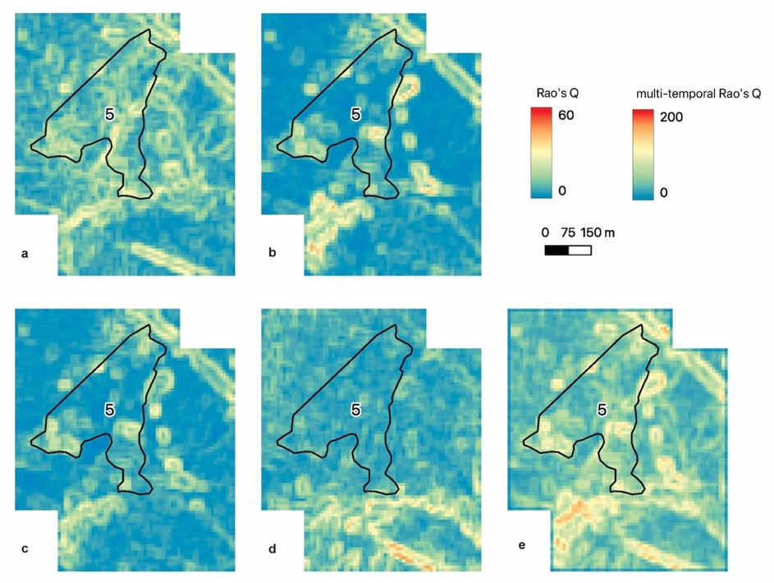

Figure S7. Boxplots of Rao's Q index computed from the spring (a), summer (b), autumn (c) and winter (d) NDVI composites, averaged across all training areas. Habitat acronyms are reported in Table S2.

Figure S8. Maps of 𝛼-diversity computed on spring (a), summer (b), autumn (c) and winter (d) Sentinel-2 composites, and on NDVI yearly stack based on seasonal values (e). The intervention area of Case Coisce (n. 5) is presented as an example.
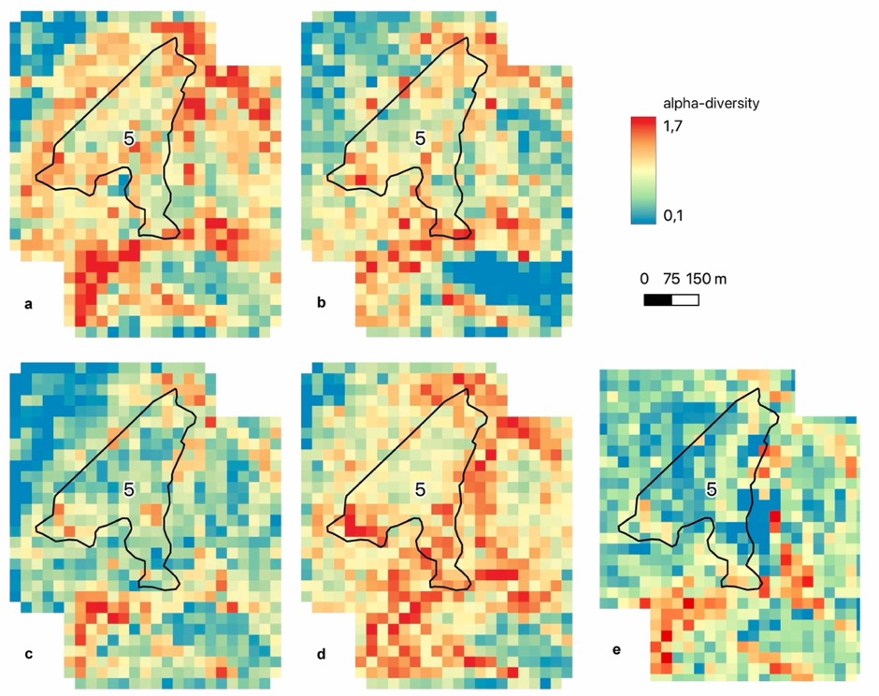

Figure S9. Boxplots of spectral 𝛼-diversity computed from the spring (a), summer (b), autumn (c) and winter (d) seasonal composites, averaged across all training areas. Habitat acronyms are reported in Table S2.

Figure S10. Maps of spectral 𝛽-diversity computed on spring (a), summer (b), autumn (c) and winter (d) Sentinel-2 composites, and on NDVI yearly stack based on seasonal values (e). The spectral 𝛽-diversity was derived from a pairwise Bray-Curtis dissimilarity matrix subjected to Principal Coordinate Analysis (PCoA) to obtain a visual representation of the results: larger color differences in the RGB space correspond to larger dissimilarity between pixels. The intervention area of Case Coisce (n. 5) is presented as an example.
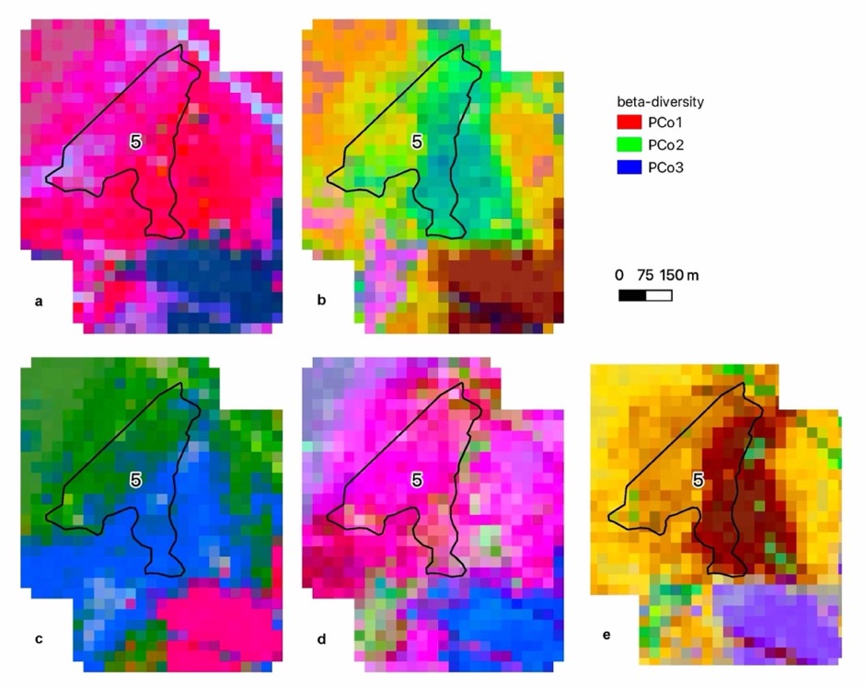

Figure S11. Principal Coordinate Analysis (PCoA) of 𝛽-diversity computed on the spring (a), summer (b), autumn (c) and winter (d) seasonal composites. The variance explained by the first two PCoA axes is reported in the images. Habitat acronyms are reported in Table S2.
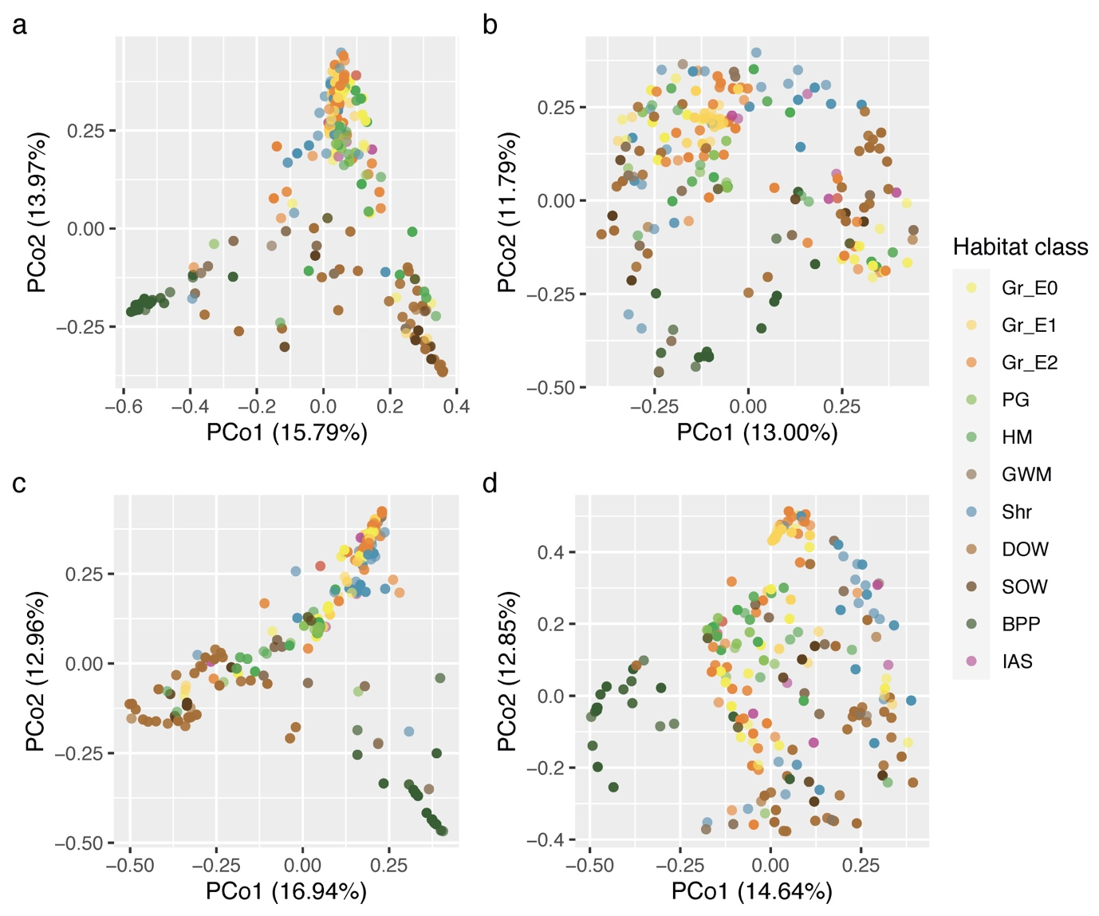

Appendix S3. Satellite image classifications

Supplementary methods

Classification algorithm
Random Forest (Breiman, 2001) is an ensemble machine-learning classifier that builds a large number of decision trees (DTs), each based on a random subset of the training data and of the predictor variables. The training data not used to build the model (i.e., the out-of-bag data, OOB) are used to evaluate the model performance. The results of the different DT models are then averaged to assign each pixel to a class. In this way, the overall result is more reliable than the one obtained from an individual DT and is less affected by correlation among predictors (Maxwell et al., 2018). The relative importance of the predictor variables is computed using the OOB data, by systematically comparing the performance of the DTs that include specific variables and of those that do not: variables with high importance have a positive effect on the prediction accuracy (Breiman, 2001).
For each combination of input variables, two alternative pathways were followed. In one case, the whole set of variables was used as input for the classification. In the other case, a subset of variables was extracted through Recursive Feature Elimination (RFE; Guyon et al., 2002). RFE is a common feature selection algorithm based on backward elimination that uses a RF classifier to determine variables permutation importance and remove the less important variables. The importance measures are updated after each deletion, making the method suitable also to highly correlated variables (Gregorutti et al., 2017).
In this study, RF classification was performed using the caret R package (Kuhn, 2021). Training data were randomly partitioned into a training and a testing set, with respectively 80% and 20% of the data. The mtry parameter (the number of randomly selected predictors used at each node) was optimized through a 5-fold cross-validation, while the relative importance of variables was calculated with varImp function.

Accuracy metrics
The overall accuracy (OA) is the proportion of correctly classified pixels, derived from the confusion matrix. OA is preferable to other common metrics such as the Kappa coefficient because it is easier to understand and more suited for comparisons (Foody, 2004).
The Kappa coefficient is a multivariate measure of the overall statistical agreement of an error matrix computed by applying the following equation:
$$k=\frac{n\sum_{i=1}^{r}{x_{ii}}-\sum_{i=1}^{r}{{(x}_{i.}*x_{.i}})}{n-\sum_{i=1}^{r}{{(x}_{i.}*x_{.i}})}$$
where $x_{.i}$ is the total observations in i-th row, $x_{i.}$ is the total observations in i-th column, $x_{ii}$
is the number of major diagonal observations in i-th row and i-th column, r is the number of
rows in the error matrix, and n is the total number of observations (Borra et al., 2019).
Performances for individual classes are assessed by considering User's accuracy (UA) and Producer’s accuracy (PA). For a given class i, UA is the proportion of pixels classified as i that have reference class i, while PA is the proportion of pixels of reference class i that are classified as i (Borra et al., 2019). Both metrics vary between 0 and 1.

Supplementary results

Class-specific accuracy assessment for the best 11-class classification
Black pine plantation was the class for which the best results were achieved considering both Producer’s accuracy (PA = 0.88) and User’s accuracy (UA = 0.92), followed by downy oak woodland (PA = 0.74, UA = 0.86). Pure grassland (UA = 0.80, PA = 0.71) and grassland E1 (UA = 0.78, PA = 0.68) were mainly confused with grassland E2 and downy oak woodland, while grassland E2 (PA = 0.64, UA = 0.69) was partially misclassified as grassland-woodland mosaic and confused with grassland-1 and downy oak woodland. Many pixels classified as shrublands (PA = 0.57, UA = 0.21) belonged to grassland E2 and downy oak woodland. Hay meadow (PA = 0.71, UA = 0.59) was mainly confused with grassland E2, pasture-grassland (UA = 1.00, PA = 0.13) with hay meadow, while grassland-woodland mosaic (UA = 0.28, PA = 0.72) with grasslands and downy oak woodlands. The lowest values of accuracy were obtained for sessile oak woodlands (UA = 0.36, PA = 0.27), that were mainly confused with downy oak woodlands, and for invasive alien species groves, for which all validation pixels were misclassified as shrublands, downy oak woodlands or grassland E1 (UA = 0.00, PA = 0.00).

Class-specific accuracy assessment for the best 26-class classification
The highest values of UA and PA were found for black pine plantation (UA = 0.91, PA = 0.89) and downy oak woodland (UA = 0.89, PA = 0.76). For grassland classes, the different types (mesophilous calcareous, thermophilous calcareous and thermophilous on flysch) were well differentiated, and most errors occurred within the same type, between different levels of encroachment and presence of Sesleria autumnalis. For example, thermophilous grassland with no encroachment (E0) had a high accuracy (PA = 0.75, UA = 0.75), while the class with encroachment E1 and a mosaic of S. autumnalis (second degradation stage) was confused with both the first and the third degradation stages (PA = 0.14). All classes of grasslands at encroachment stage E2 were partially confused with shrublands, and thermophilous grasslands in particular was confused with thermophilous Karst shrubland. Pasture-grassland was mainly misclassified as hay meadow (PA = 0.13), while grassland-woodland mosaic (UA = 0.25) was confused with young downy oak woodland and grassland. Sessile oak woodland was mainly confused with downy oak woodland (UA = 0.40, PA = 0.67), while the lowest values of accuracy were reached for both the classes of invasive alien species (PA = 0.00, UA = 0.00), that were mainly misclassified as shrublands and downy oak woodland.

Table S3. Confusion matrix for the seasonal classification performed with 26 classes. The rows represent the results obtained from the classification, while the columns represent the reference data. The values on the matrix diagonal are the correctly classified pixels. Habitats are abbreviated as follows: Mesophilous calcareous grassland (MG), Thermophilous calcareous grassland (GT), Thermophilous grassland on flysch (GF) – each at different encroachment stages (E0, E1, E2) and degradation stages (d1, d2, d3), Pasture-grassland (PG), Hay meadow (HM), Grassland-woodland mosaic (GWM), Pioneer shrubland with Ostrya carpinifolia (Shr_Oc), Pioneer thermophilous shrubland Frangulo-Prunetum mahaleb (Shr_FP), Shrubland with Cotinus coggygria (Shr_Cc), Shrubland with Fraxinus ornus (Shr_Fo), Thermophilous shrubland Pruno-Paliuretum spina-christi (Shr_PP), Downy oak woodland (DOW), Young downy oak woodland (DOW_y), Sessile oak woodland (SOW), Black pine plantation (BPP), Grove with Ailanthus altissima (IAS_Aa), Grove with Robinia pseudoacacia (IAS_Rp).

 | GM_  E0 | GM_  d2E2 | GT_  E0 | GT_  d1E1 | GT_  d1E2 | GT_  d2E1 | GT_  d2E2 | GT_  d3E1 | GT_  d3E2 | GF_  E0 | GF_  d2E2 | GF_  d3E2 | PG | HM | GW  M | Shr_  Oc | Shr_  FP | Shr_  Cc | Shr_  Fo | Shr_  PP | DO  W | DO  W_y | SO  W | BP  P | IAS  _Aa | IAS  _Rp
GM_  E0 | 1 | . | . | . | . | . | . | . | . | . | . | . | . | . | . | . | . | . | . | . | . | . | . | . | . | .
GM_  d2E2 | . | 2 | . | . | . | . | . | 1 | . | . | . | . | . | . | . | . | . | . | . | 1 | . | . | . | . | . | .
GT_  E0 | . | . | 9 | . | . | . | . | . | . | . | . | . | . | . | 2 | . | . | . | . | . | . | 1 | . | . | . | .
GT_  d1E1 | . | . | 1 | 11 | 1 | 1 | . | 3 | 3 | . | . | . | . | . | . | . | . | . | . | . | . | . | . | . | . | .
GT_  d1E2 | . | . | . | 1 | 1 | . | . | . | . | . | . | . | . | . | . | . | . | . | . | . | . | . | . | . | . | .
GT_  d2E1 | . | . | . | . | . | 1 | . | . | . | . | . | . | . | . | . | . | . | . | . | . | . | . | . | . | . | .
GT_  d2E2 | 1 | . | 1 | . | . | 1 | . | . | 2 | . | . | . | . | . | . | . | . | . | . | . | . | . | . | . | . | .
GT_  d3E1 | . | . | . | . | 1 | 1 | . | 4 | . | . | . | . | . | . | . | . | . | . | . | 1 | . | . | . | . | . | .
GT_  d3E2 | . | . | . | 3 | 2 | 1 | 13 | . | 14 | . | . | . | . | . | . | . | . | . | 1 | . | . | . | . | . | . | .
GF_  E0 | . | . | . | . | . | . | . | . | . | 1 | . | . | . | . | . | . | . | . | . | . | 5 | . | . | . | . | 1
GF_  d2E2 | . | 2 | . | . | . | . | . | . | . | . | 5 | . | . | . | . | . | . | . | . | . | 2 | . | . | . | . | .
GF_  d3E2 | . | . | . | . | . | . | . | . | . | . | 1 | 1 | . | . | . | . | . | . | . | . | . | . | . | . | . | .
PG | 1 | . | . | . | . | . | . | . | . | . | . | . | 1 | . | . | . | . | . | . | . | . | . | . | . | . | .
HM | . | . | . | . | . | . | . | . | 1 | . | . | . | 6 | 11 | . | . | . | . | . | . | 1 | . | 1 | . | . | .
GWM | 1 | 1 | 1 | . | 1 | 2 | 1 | . | 2 | . | . | . | 1 | 2 | 14 | . | . | 1 | . | . | 1 | 24 | . | 4 | . | .
Shr_  Oc | . | . | . | . | . | . | . | . | . | . | . | . | . | . | . | 3 | . | . | . | . | 1 | . | . | . | . | .
Shr_  FP | . | . | . | . | . | . | 2 | . | . | . | . | . | . | . | . | . | . | . | . | . | . | . | . | . | . | .
Shr_  Cc | . | . | . | . | . | . | . | . | . | . | . | . | . | . | . | . | . | . | . | . | . | . | . | . | . | .
Shr_  Fo | . | 2 | . | . | 1 | . | 2 | . | 2 | . | . | . | . | . | . | . | . | . | 2 | 2 | 4 | . | . | 1 | . | 1
Shr_  PP | . | . | . | 1 | 1 | . | 1 | . | 14 | . | . | . | . | . | . | . | . | . | . | . | . | . | . | . | . | 1
DOW | . | . | . | . | . | . | . | . | . | . | 1 | . | . | . | . | . | . | . | . | . | 132 | 4 | 4 | 7 | . | .
DOW  _y | . | . | . | . | . | . | . | . | . | . | . | . | . | . | 1 | . | 1 | . | 1 | . | 6 | 5 | . | 1 | 1 | .
SOW | . | . | . | . | . | . | . | . | . | . | . | . | . | 1 | . | . | . | . | . | . | 12 | 1 | 10 | 1 | . | .
BPP | . | . | . | . | . | . | . | . | . | . | . | . | . | . | 1 | . | . | . | . | 1 | 7 | 2 | . | 108 | . | .
IAS_  Aa | . | . | . | . | . | . | . | . | . | . | . | . | . | . | . | . | . | . | . | . | 1 | . | . | . | . | .
IAS_  Rp | . | . | . | . | . | . | . | . | . | . | . | . | . | . | . | . | . | . | . | . | 1 | . | . | . | . | .

Table S4. Class-specific accuracy parameters (UA: user’s accuracy, PA: producer’s accuracy) obtained for the seasonal classification performed with 26 classes. Accuracy was assessed using independent validation data.
Class | UA | PA
Mesophilous grassland E0 | 1.00 | 0.25
Mesophilous grassland degr2 E2 | 0.50 | 0.29
Thermophilous calcareous grassland E0 | 0.75 | 0.75
Thermophilous calcareous grassland degr1 E1 | 0.55 | 0.69
Thermophilous calcareous grassland degr1 E2 | 0.50 | 0.13
Thermophilous calcareous grassland degr2 E1 | 1.00 | 0.14
Thermophilous calcareous grassland degr2 E2 | 0.00 | 0.00
Thermophilous calcareous grassland degr3 E1 | 0.57 | 0.50
Thermophilous calcareous grassland degr3 E2 | 0.41 | 0.37
Thermophilous grassland on flysch E0 | 0.14 | 1.00
Thermophilous grassland on flysch degr2 E2 | 0.56 | 0.71
Thermophilous grassland on flysch degr3 E2 | 0.50 | 1.00
Pasture-grassland | 0.50 | 0.13
Hay meadow | 0.55 | 0.79
Grassland-woodland mosaic | 0.25 | 0.78
Pioneer shrubland with Cotinus coggygria | NA | 0.00
Pioneer thermophilous shrubland (Frangulo-Prunetum mahaleb) | 0.00 | 0.00
Shrubland with Fraxinus ornus | 0.12 | 0.50
Shrubland with Ostrya carpinifolia | 0.75 | 1.00
Thermophilous Karst shrubland (Pruno-Paliuretum spina-christi) | 0.00 | 0.00
Downy oak woodland | 0.89 | 0.76
Downy oak woodland (young) | 0.31 | 0.14
Sessile oak woodland | 0.40 | 0.67
Black pine plantation | 0.91 | 0.89
Grove with Ailanthus altissima | 0.00 | 0.00
Grove with Robinia pseudoacacia | 0.00 | 0.00

Figure S12. Habitat map resulting from the RF classification based on seasonal layers of vegetation and spectral heterogeneity indices. A total of 26 habitat classes were considered. The areas are located in Monfalcone (a), Case Coisce (b), Opicina (c), Aurisina (d), San Lorenzo (e) and San Giuseppe (f).

Figure S13. Habitat map resulting from the RF classification based on seasonal layers of vegetation indices (spectral heterogeneity indices were excluded from the analysis). A total of 11 habitat classes were considered. The areas are located in Monfalcone (a), Case Coisce (b), Opicina (c), Aurisina (d), San Lorenzo (e) and San Giuseppe (f).

Figure S14. Habitat map resulting from the RF classification based on yearly layers of spectral heterogeneity indices computed over seasons. A total of 11 habitat classes were considered. The areas are located in Monfalcone (a), Case Coisce (b), Opicina (c), Aurisina (d), San Lorenzo (e) and San Giuseppe (f).

Figure S15. Relative importance of the variables used as input for the monthly classifications. For the first two classifications (a, b) a total of 26 habitat classes was considered, while for the other classifications (c, d) the habitat classes were aggregated into 11 coarser classes. Classifications were performed with the whole set of input variables (a, c) and with a subset obtained by RFE (b, d). Only the first 20 variables are shown.

Figure S16. Relative importance of the variables used as input for the seasonal classifications with 26 classes. Classifications were performed with the whole set of input variables (a) and with a subset obtained by RFE (b). Only the first 20 variables are shown.

Figure S17. Relative importance of the variables used as input for the yearly classifications based on monthly values. For the first two classifications (a, b) a total of 26 habitat classes was considered, while for the other classifications (c, d) the habitat classes were aggregated into 11 coarser classes. Classifications were performed with the whole set of input variables (a, c) and with a subset obtained by RFE (b, d). Only the first 10 variables are shown.

Figure S18. Relative importance of the variables used as input for the yearly classifications based on seasonal values. For the first two classifications (a, b) a total of 26 habitat classes was considered, while for the other classifications (c, d) the habitat classes were aggregated into 11 coarser classes. Classifications were performed with the whole set of input variables (a, c) and with a subset obtained by RFE (b, d). Only the first 10 variables are shown.

References
Borra, S., Thanki, R. & Dey, N. (2019) Satellite Image Analysis: Clustering and Classification. SpringerBriefs in Applied Sciences and Technology. Springer Singapore, Singapore. https://doi.org/10.1007/978-981-13-6424-2
Bray, J.R. & Curtis, J.T. (1957) An Ordination of the Upland Forest Communities of Southern Wisconsin. Ecological Monographs, 27, 325–349. https://doi.org/10.2307/1942268
Breiman, L. (2001) Random Forests. Machine Learning, 45, 5–32. https://doi.org/10.1023/A:1010933404324
Cloud Compare (2021) Cloud Compare (version 2.11.1). URL http://www.cloudcompare.org/.
Coppin, P., Jonckheere, I., Nackaerts, K., Muys, B. & Lambin, E. (2004) Digital change detection methods in ecosystem monitoring: a review. International Journal of Remote Sensing, 25, 1565–1596. https://doi.org/10.1080/0143116031000101675
Foody, G.M. (2004) Thematic Map Comparison: Evaluating the statistical significance of differences in classification accuracy. Photogrammetric Engineering & Remote Sensing, 70, 627–633. https://doi.org/10.14358/PERS.70.5.627
Gamon, J.A., Field, C.B., Goulden, M.L., Griffin, K.L., Hartley, A.E., Joel, G., Penuelas, J. & Valentini, R. (1995) Relationships Between NDVI, Canopy Structure, and Photosynthesis in Three Californian Vegetation Types. Ecological Applications, 5, 28–41. https://doi.org/10.2307/1942049
Gregorutti, B., Michel, B. & Saint-Pierre, P. (2017) Correlation and variable importance in random forests. Statistics and Computing, 27, 659–678. https://doi.org/10.1007/s11222-016-9646-1
Guyon, I., Weston, J., Barnhill, S. & Vapnik, V. (2002) Gene selection for cancer classification using support vector machines. Machine Learning, 46, 389–422. https://doi.org/10.1023/A:1012487302797
Kuhn, M. (2021) caret: Classification and Regression Training.
Maxwell, A.E., Warner, T.A., & Fang, F. (2018) Implementation of machine-learning classification in remote sensing: an applied review. International Journal of Remote Sensing, 39, 2784–2817. https://doi.org/10.1080/01431161.2018.1433343
Rao, C.R. (1982) Diversity and dissimilarity coefficients: A unified approach. Theoretical Population Biology, 21, 24–43. https://doi.org/10.1016/0040-5809(82)90004-1
Shannon, C.E. (1948) A Mathematical Theory of Communication. Bell System Technical Journal, 27, 379–423. https://doi.org/10.1002/j.1538-7305.1948.tb01338.x

