Quantifying Species and Age-Dependent Fibroblast Morphologies on Biomaterial Surfaces via Optical Diffraction Tomography
Francesco Formaggio^{1*}, Pooja Anantha^{2*}, Federica Trebbi³, Vincenzo Palermo^{4,5}, Tamara Posati⁴, Marianna Barbalinardo⁶, Gioacchino Calandra Sebastianella⁴, Simone Bonetti⁶, Marco Caprini¹, Jessica Chen⁷, Giovanna Sotgiu⁴, Maira Bacchiega⁸, Roberto Zamboni⁴, Annalisa Convertino^{9#}, Ishan Barman^{2,10,11#}, Emanuela Saracino^{4#}.

1. Department of Pharmacy and Biotechnology, University of Bologna, via S. Donato 19/2, 40127 Bologna, Italy.
2. Department of Mechanical Engineering, Johns Hopkins University, Baltimore, MD 21218, USA.
3. Department of Biomedical and Neuromotor Sciences, University of Bologna, Piazza di Porta S. Donato 2, 40126 Bologna, Italy.
4. Institute for Organic Synthesis and Photoreactivity, National Research Council, Via Gobetti 101, 40129 Bologna, Italy.
5. Department of Industrial and Materials Science, Chalmers University of Technology, Gothenburg, Sweden.
6. Institute for the Study of Nanostructured Materials, National Research Council, Via Gobetti 101, 40129 Bologna, Italy Italy.
7. Department of Biology, Johns Hopkins University, Baltimore, MD 21218, USA.
8. Schaefer SEE Srl, Via Luigi Einaudi 23, 45100 Rovigo, Italy.
9. Institute for Microelectronics and Microsystems, National Research Council, via Fosso del Cavaliere 100, Rome, 00133 Italy.
10. Department of Oncology, Johns Hopkins University, Baltimore, MD 21287, USA.
11. The Russell H. Morgan Department of Radiology and Radiological Science, Division of Cancer Imaging Research, Johns Hopkins University School of Medicine, Baltimore, MD 21205, USA.

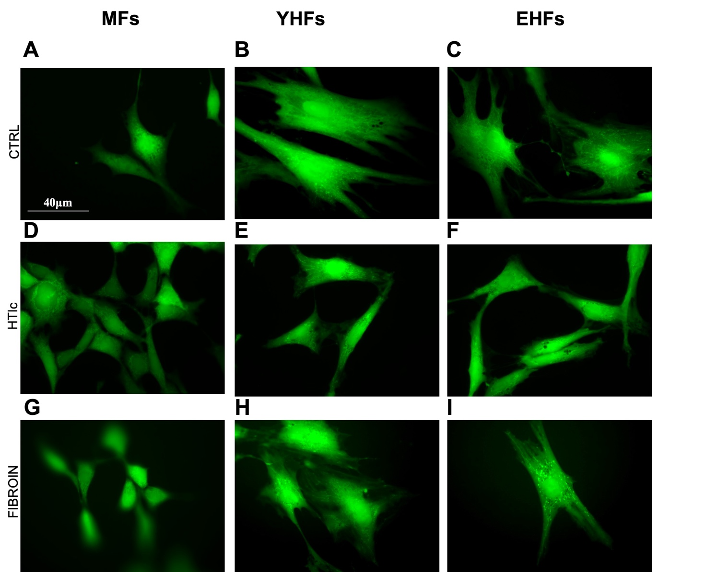

Figure S1: Fluorescent images of low density seeded MFs (A, D, G), YHFs (B,E,H) and EHFs (C, F, I) stained with fluorescein diacetate (FDA) for CTRL (A-C), HTlc (D-F) and SF (G-I). Scale bars, 40 μm.

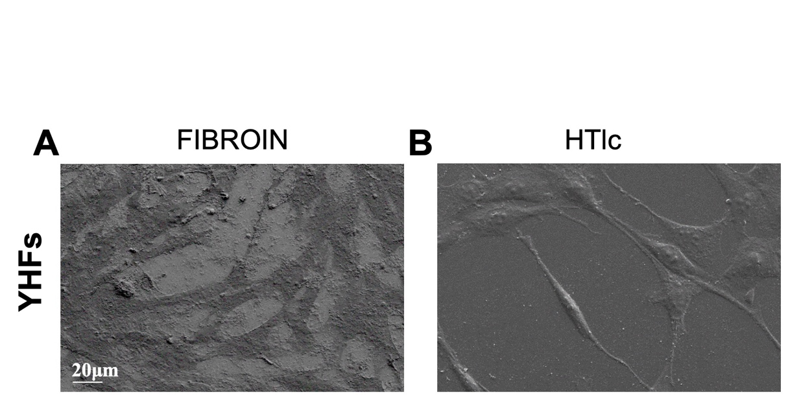

Figure S2: SEM imaging of YHFs grown on SF (A) and HTlc (B). Note the presence of elongated morphology of human fibroblasts on both substrates. However, on HTlc cell bodies appear more elongated and differentiated in terms of long branches departing from cell body compared to SF (A). All samples have been fixed with 2.5% glutaraldehyde and 1% Osmium Tetra-Oxide (OsO4) at RT. Data suggest the impact of both the different nanostructures on the cell body differentiation of young human fibroblasts.

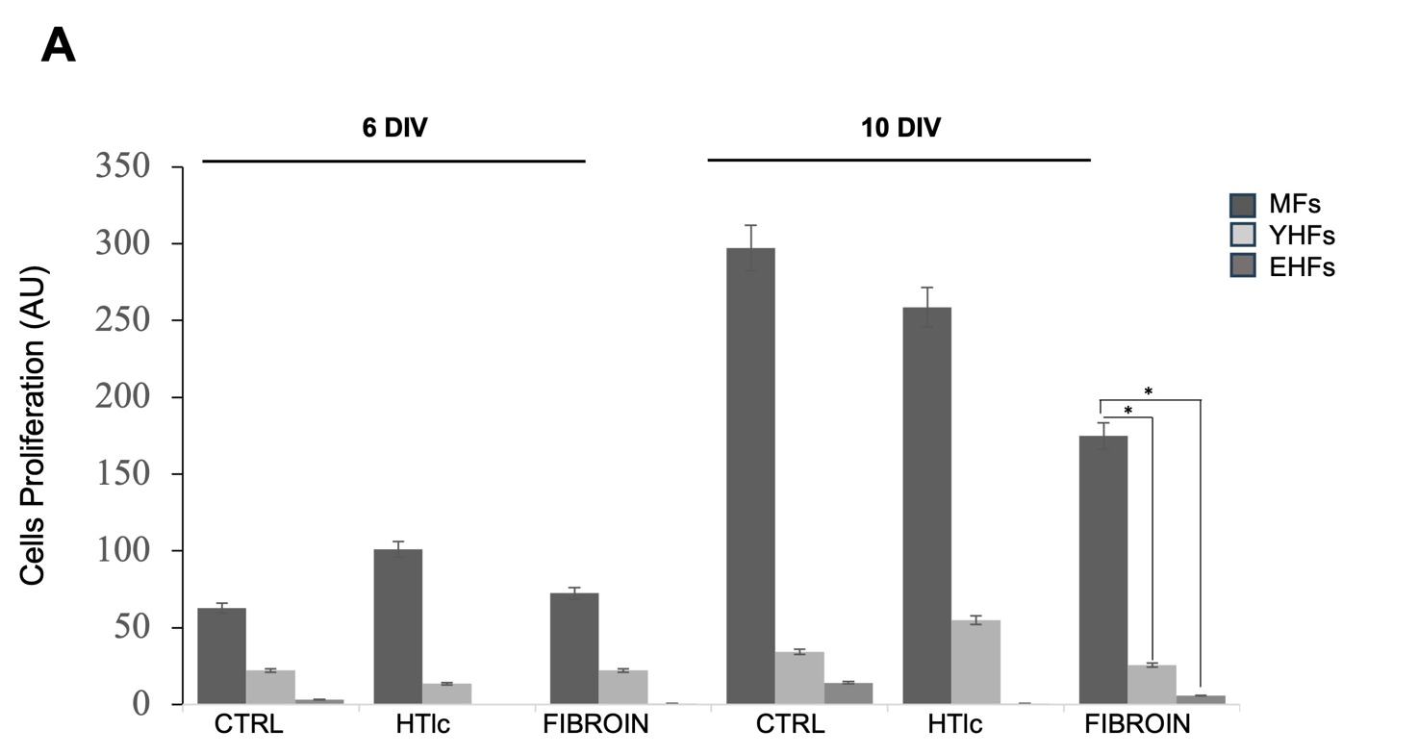

Figure S3: Alamar Blue assay was performed at 6 and 10 days in vitro (DIV) to evaluate metabolic activity in MFs, YHFs, EHFs cultured on CTRL, HTlc, and Fibroin substrates. All substrates supported cell survival throughout the experimental period. MFs exhibited significantly higher proliferative activity than HFs, particularly at 10 DIV, whereas EHFs showed generally, the lowest metabolic activity. Fibroin generally resulted in reduced cell proliferation compared with Control and HTlc conditions while maintaining cell viability especially for EHFs. Data are presented as mean and error bars. Statistical significance is indicated (*p < 0.05).

