Supplementary Information
Polymer Derived Tribofilm on Silicon Doped Diamond Like Carbon Coatings
Takeru Omiya^{1, 2, 3*}, Alexander Welle⁴, Manuel Evaristo¹, Pooja Sharma¹, Albano Cavaleiro^{1, 3}, Arménio C. Serra², Jorge F. J. Coelho^{2,3}, Fabio Ferreira^{1, 3}
¹University of Coimbra, CEMMPRE, ARISE, Department of Mechanical Engineering, Rua Luís Reis Santos, 3030-788 Coimbra, Portugal;
²University of Coimbra, CEMMPRE, ARISE, Department of Chemical Engineering, Rua Silvio Lima, 3030-790 Coimbra, Portugal;
³Laboratory for Wear, Testing & Materials, Instituto Pedro Nunes, Rua Pedro Nunes, 3030-199 Coimbra, Portugal;
⁴Karlsruhe Nano Micro Facility, and Institute of Functional Interfaces (IFG), Karlsruhe Institute of Technology (KIT), 76344 Eggenstein-Leopoldshafen, Germany.
*Corresponding author: takeru.omiya@student.dem.uc.pt

Figure S1 presents the time-dependent evolution of the friction coefficient (CoF) over a 40-minute sliding test for different lubricant–coating combinations. Among all tested conditions, PLMA-b-PDMAEMA on Si-DLC exhibits the lowest and most stable CoF throughout the entire test duration. This indicates that the strong interactions between the amine-functionalized polymer segments and the silicon-doped DLC surface contribute to the formation of a robust tribofilm, effectively reducing friction and ensuring stable lubrication performance. In contrast, other conditions, such as PLMA on Si-DLC or PLMA-b-PDMAEMA on Pure DLC, exhibit higher CoF values and greater fluctuations over time, suggesting weaker adsorption or less effective film formation.

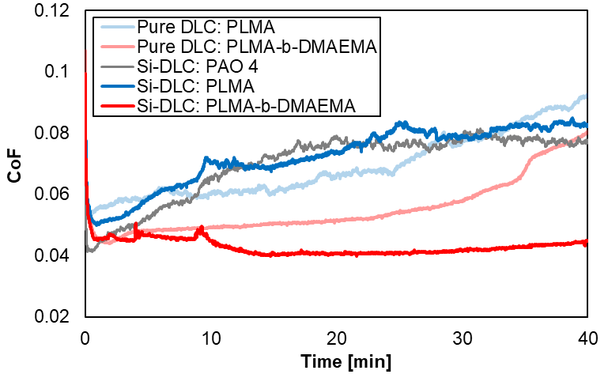
Figure S1. Evolution of the friction coefficient (CoF) over a 40-minute sliding test for each of the investigated lubricant–coating combinations

Figure S2 shows the negative ion intensity of three characteristic fragments, C₃H₃O⁻, C₄H₅O⁻, and C₁₂H₂₃O⁻, collected from the wear scars under various lubrication conditions. In all cases, the use of PLMA-b-PDMAEMA led to a higher signal intensity compared to PLMA alone, both on Pure DLC and Si-DLC surfaces. Notably, the difference is particularly pronounced for the C₁₂H₂₃O⁻ peak, which corresponds to the long alkyl chain segment of PLMA. The near absence of this peak in the presence of non-functionalized PLMA further underscores the importance of the amine groups in promoting stronger surface interactions. These results align well with the positive ion spectra observations discussed in the main text, providing additional evidence that the amine-functionalized segments of PLMA-b-PDMAEMA play a crucial role in tribofilm formation on Si-DLC coatings.

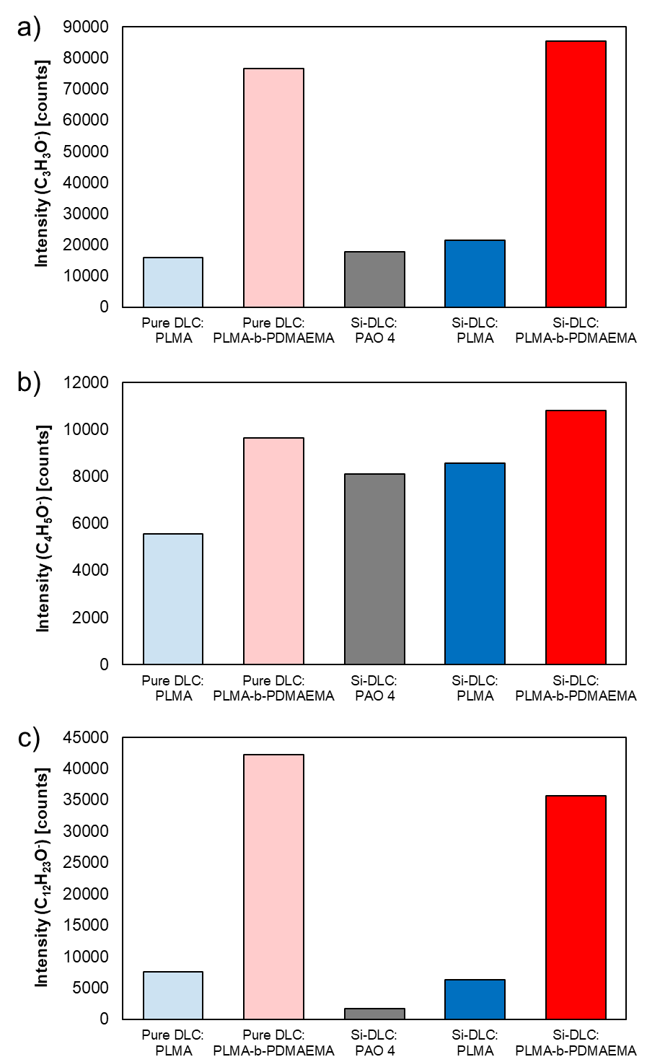
Figure S2. Satic ToF-SIMS: Comparison of (a) C₃H₃O⁻ (m/z = 55), (b) C₄H₅O₂⁻ (m/z = 85) and (c) C₁₂H₂₃O⁻ (m/z = 183) peak intensity in wear scars for PLMA and PLMA-b-PDMAEMA on Pure DLC and Si-DLC surface, with PAO 4 on Si-DLC serving as the benchmark.
Synchrotron-based XPS
All XPS spectra were fitted using CasaXPS software. A Shirley or U 3 Tougaard background was applied depending on the peak nature, and the peaks were fitted using LA(1,643) line shapes as appropriate.
Figure S3 compares the XPS Si 2p region at photon energies of 550 eV and 730 eV, illustrating how an increase in photon energy enables deeper probing of the sample. Two distinct bonding states can be observed, Si-C (peak at 100.8 ± 0.2 eV) and Si-O-C (peak at 102.6 ± 0.2 eV) [1]. Although each Si 2p component consists of a spin-orbit doublet (2p₃⁄₂ and 2p₁⁄₂), the splitting (~0.6 eV) is too small to be clearly resolved under the current measurement conditions, and therefore the peaks were treated as single components in the fitting. The full width at half maximum (FWHM) for Si–C and Si–O–C components was constrained to 1.6 ± 0.2 eV. As the photon energy increases, the intensity of the Si-C peak decreases relative to Si-O-C, indicating a depth-dependent distribution of silicon bonding states within the tribofilm. This observation supports the idea that an oxide-rich layer is more pronounced at greater depths, while the carbided silicon component dominates nearer the surface.
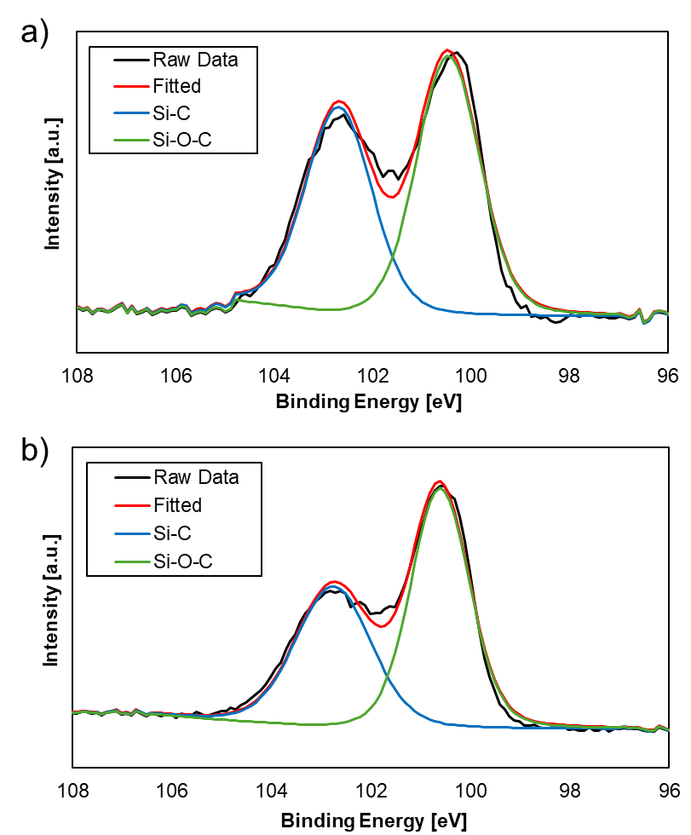
Figure S3. XPS spectra of silicon peaks at (a) 550 eV and (b) 730 eV.
Figure S4 presents the XPS N 1s region at photon energies of 550 eV and 730 eV, highlighting how an increase in photon energy enables detection of signals from deeper regions of the sample. Two distinct bonding states are visible, N-Si (peak at 398.8 ± 0.2 eV) and N-C (peak at 399.8 ± 0.2 eV) [2, 3]. The FWHM was constrained to 1.4 ± 0.2 eV for the N–Si component and 1.8 ± 0.2 eV for the N–C component. As the photon energy increases, the relative intensity of N-Si rises with respect to N-C, indicating a depth-dependent distribution of nitrogen bonding states. This finding supports the notion that nitrogen is more strongly bonded to silicon at greater depths, while nitrogen bonded to carbon dominates nearer the surface.
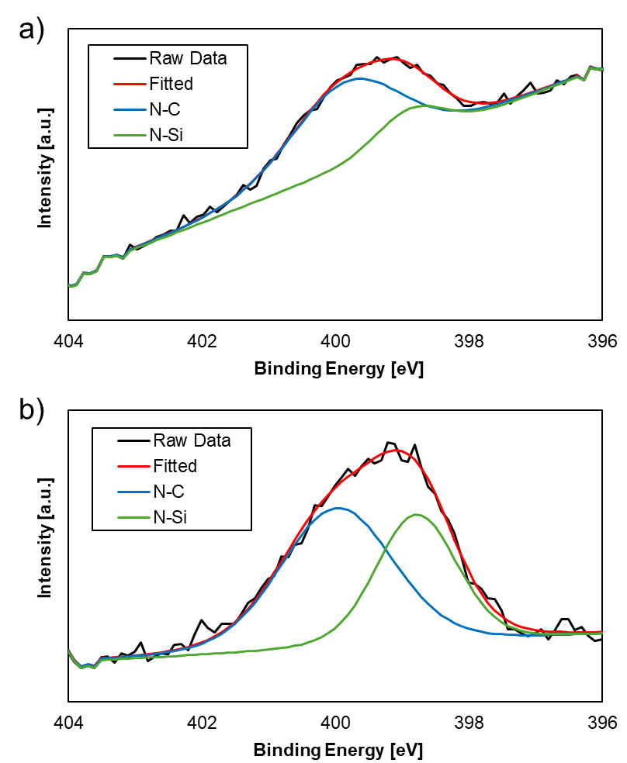
Figure S4. XPS spectra of nitrogen peaks at (a) 550 eV and (b) 730 eV.

Figure S5 shows the C 1s spectrum at a photon energy of 550 eV, revealing six distinct bonding states. These include C-Si (283.5 ± 0.2 eV), C-C sp² (284.6 ± 0.2 eV), C-C sp³ (285.3 ± 0.2 eV), C-O (286.6 ± 0.2 eV), C=O (288.0 ± 0.2 eV), and O-C=O (288.8 ± 0.2 eV) [4-10]. The FWHM was constrained to 1.2 ± 0.2 eV for the C–Si, C–C sp² components, to 1.6 ± 0.2 eV for the C–C sp³, C–O and C=O components, and to 2.3 ± 0.2 eV for the O-C=O. The distribution and intensity of these peaks provide insights into the carbon bonding environment and the structural composition within the tribofilm.
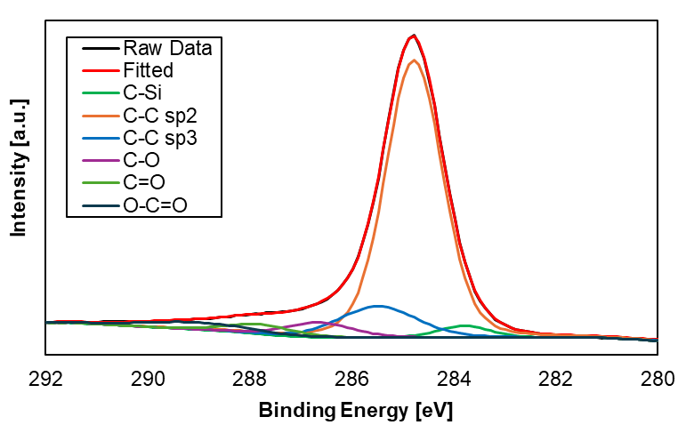
Figure S5. XPS spectra of carbon peaks at 550 eV.

Figure S6 presents the depth profiles of the C–C and oxygen-containing carbon bonds (C–O and C=O) within the tribofilm on Si-DLC. The relative intensities were extracted from the fitted C 1s spectra at different photon energies. A slight decrease in the C–C bonds and a corresponding increase in C–O and C=O bonds were observed with increasing analysis depth. However, the total variation remained within approximately 4 percent, which may fall within the range of fitting uncertainty. These trends suggest a moderate increase in polymer backbone contribution with depth, although the differences are less significant compared to the changes observed in nitrogen and silicon signals.
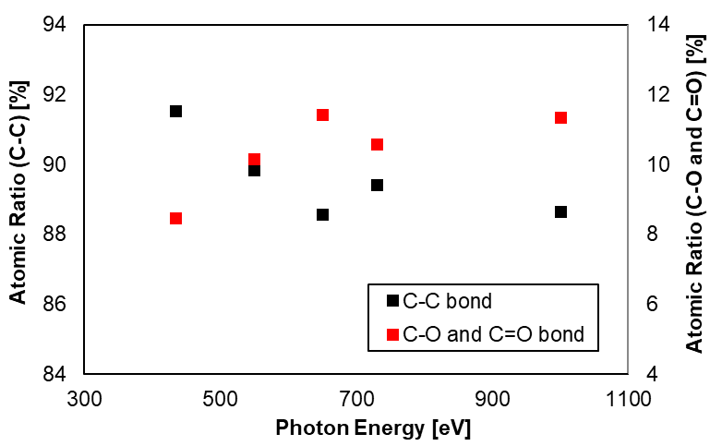
Figure S6. Depth profiles of C–C and oxygen-containing carbon bond ratios at different photon energies on Si-DLC wear scars in the presence of PLMA-b-PDMAEMA.

References
[1] M. Evaristo, R. Azevedo, C. Palacio, A. Cavaleiro, Influence of the silicon and oxygen content on the properties of non-hydrogenated amorphous carbon coatings, Diamond and Related Materials 70 (2016) 201-210.
[2] G.-R. Yang, Y.-P. Zhao, Y. Hu, T.P. Chow, R.J. Gutmann, XPS and AFM study of chemical mechanical polishing of silicon nitride, Thin Solid Films 333(1-2) (1998) 219-223.
[3] Z.-W. Deng, R. Souda, XPS studies on silicon carbonitride films prepared by sequential implantation of nitrogen and carbon into silicon, Diamond and related materials 11(9) (2002) 1676-1682.
[4] G.D. Sorarù, G. D'Andrea, A. Glisenti, XPS characterization of gel-derived silicon oxycarbide glasses, Materials Letters 27(1-2) (1996) 1-5.
[5] Y. Hijikata, H. Yaguchi, M. Yoshikawa, S. Yoshida, Composition analysis of SiO2/SiC interfaces by electron spectroscopic measurements using slope-shaped oxide films, Applied Surface Science 184(1-4) (2001) 161-166.
[6] X. Yan, T. Xu, S. Yang, H. Liu, Q. Xue, Characterization of hydrogenated diamond-like carbon films electrochemically deposited on a silicon substrate, Journal of Physics D: Applied Physics 37(17) (2004) 2416.
[7] G. Wan, P. Yang, R.K. Fu, Y. Mei, T. Qiu, S. Kwok, J.P. Ho, N. Huang, X. Wu, P.K. Chu, Characteristics and surface energy of silicon-doped diamond-like carbon films fabricated by plasma immersion ion implantation and deposition, Diamond and related materials 15(9) (2006) 1276-1281.
[8] A. Bendavid, P. Martin, C. Comte, E. Preston, A. Haq, F.M. Ismail, R. Singh, The mechanical and biocompatibility properties of DLC-Si films prepared by pulsed DC plasma activated chemical vapor deposition, Diamond and Related Materials 16(8) (2007) 1616-1622.
[9] M.H. Ahmed, J.A. Byrne, J. McLaughlin, W. Ahmed, Study of human serum albumin adsorption and conformational change on DLC and silicon doped DLC using XPS and FTIR spectroscopy, (2013).
[10] Y.L. Khung, S.H. Ngalim, A. Scaccabarozzi, D. Narducci, Formation of stable Si–O–C submonolayers on hydrogen-terminated silicon (111) under low-temperature conditions, Beilstein journal of nanotechnology 6(1) (2015) 19-26.

