SUPPLEMENTARY MATERIALS:
Smartphone and Web Apps for Pest and Disease Management in Viticulture: A Mapping of Functionality, AI Integration, and Accessibility
Agata Morelli^{1*}, Antonio Masetti¹
¹Department of Agricultural and Food Sciences, University of Bologna, Italy
* Corresponding author: agata.morelli2@unibo.it

Table S1. Keyword categories and search-string structure used in the rotating search strategy. As app store platforms do not support structured Boolean search syntax, keyword combinations were entered as plain, space-separated search strings rather than formal Boolean queries. For each row, three search strings were run: the full three-term string (vineyard-related + pest/disease + digital/commercial term, e.g. 'vineyard crop protection app'), and two two-term strings pairing the vineyard-related term with each of the other categories individually (e.g. 'vineyard crop protection'; 'vineyard app'). This structure was applied systematically across all rows in the table. Unlike bibliographic database searches, which support structured Boolean queries against a stable, retrievable index, app store platforms return results governed by undisclosed, platform-specific ranking logic; a substantially larger number of search strings was therefore required to achieve comparable retrieval coverage. Full search execution is described in Section 2.1.
Vineyard-related keywords | Pest and Disease keywords | Digital and Commercial keywords
viticulture | crop protection | app
vineyard | pest management | mobile app
grapevine | disease management | platform
grape | IPM | DSS
vine | monitoring | decision support system
wine grape | forecasting | digital tool
precision viticulture | scouting | web app
vineyard management | early detection | software
grape production | insect monitoring | AI
Vitis vinifera | pathogen detection | commercial

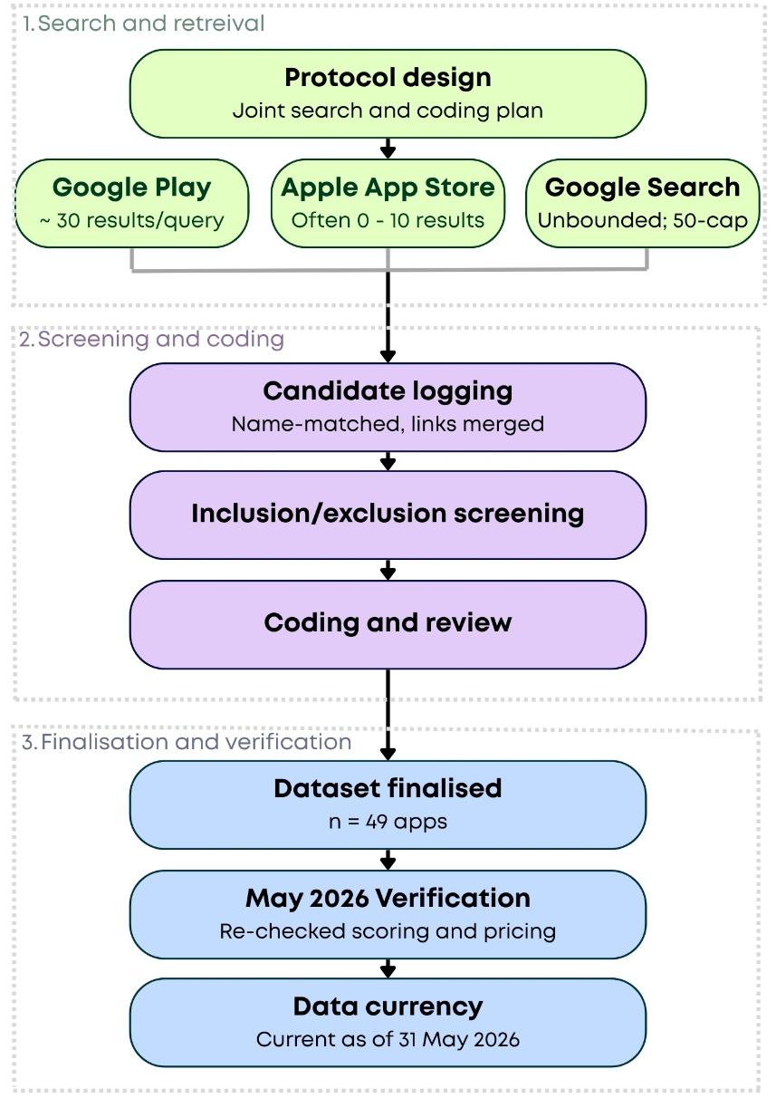
Figure S1. Overview of the search, screening, and coding workflow used to identify and finalise the dataset of viticulture pest and disease management apps. Phase 1 (Search and retrieval): a joint search protocol was applied across three platforms with differing output behaviour. Google Play (approximately 30 results per query), Apple App Store (< 10 results per query, frequently returning none), and Google Search (effectively unbounded, with a 50-result screening cap applied as a practical stopping rule). Phase 2 (Screening and coding): candidate apps were logged by name and source link, with duplicate entries merged; apps were then assessed against the inclusion and exclusion criteria (Section 2.2) and coded (Section 2.3). Phase 3 (Finalisation and verification): the dataset was finalised at n = 49 apps, with a supplementary verification pass conducted in May 2026 to re-check categorisation, scoring, and pricing information; the final dataset reflects application information current as of 31 May 2026.

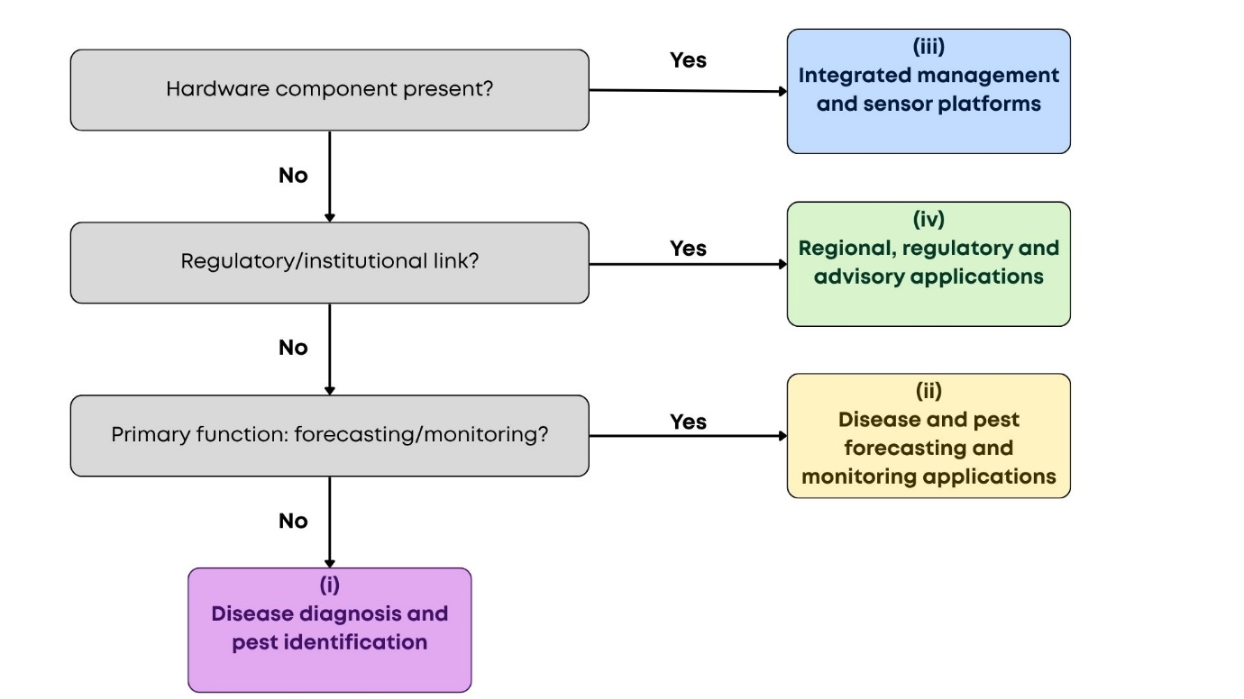
Figure S2. Decision tree summarising the hierarchical rule used to assign apps to one of four functional categories (Section 2.3). Apps were evaluated sequentially: those incorporating a dependent hardware component were classified under category (iii); among the remainder, those with an explicit regulatory or institutional affiliation were classified under category (iv); among the remainder, apps with a primary forecasting or monitoring function were classified under category (ii); all other apps were classified under category (i). This adjudication process is not mutually exclusive at the level of individual features, only at the level of dominant function and delivery mechanism (Section 2.3).

Table S2. Overview of the 49 publicly and commercially available smartphone and web-based apps identified through the systematic search, including developer information and access links. Where no company website was available, app store links are provided. All references were last checked on 31 May 2026.
App Name | Developer | Link
4Grapes® | Perleuve Srl | https://www.academy.4grapes.it/
Aerobotics | Aerobotics (Pty) Ltd | https://aerobotics.com/
Agrigenius® Vite | BASF Agricultural Solutions; partnership with Horta | https://www.agro.basf.it/it/Soluzioni-digitali/Agrigenius/Agrigenius-Vite.html
Agrio | Saillog Ltd. | https://agrio.app/
Agrometeo | Agroscope | https://agrometeo.ch/it
Climate Analogues - Vines | University of Geneva (UNIGE); Agroscope collaboration | https://play.google.com/store/apps/details?id=ch.unige.twinsvignes
Corteva™ FarmFundi | Corteva Agriscience with Plantix collaboration | https://www.corteva.com/za/the-farmfundi-app.html
DeciTrait ® | Institut Français de la Vigne & du Vin (IFV) | https://www.vignevin.com/article/decitrait-un-nouvel-oad-dedie-a-la-protection-de-la-vigne/
Di@gnoPlant Vigne | INRAE | https://ephytia.inrae.fr/fr/CMS/74/Diagnoplant
DigiAgriApp | Digital Agriculture Unit of the Edmund Mach Foundation (FEM) | https://digiagriapp.gitlab.io/digiagriapp-website/
eVineyard | Elmibit d.o.o. | https://www.evineyardapp.com/index.php
Farmable | Farmable AS | https://farmable.tech/farm-management-app/
FieldClimate | Pessl Instruments GmbH; creators of the METOS® brand | https://metos.global/en/fieldclimate/
Fitodetective | StudioCM; Servizio Fitosanitario della Regione Lombardia (Regional Phytosanitary Service of Lombardy) and managed alongside ERSAF (Regional Entity for Agricultural and Forestry Services) | https://www.fitosanitario.regione.lombardia.it/wps/portal/site/sfr/sorveglianza/fitodetective
Grape Assess | University of Adelaide | https://apps.apple.com/au/app/grape-assess/id1342167843
Grape DSS | Agricolus | https://www.agricolus.com/en/solutions/crops-protection/grapedss/
GrapeVision | Bayer Crop Science | https://agrocloud.bayer.com/fr/en/grapevision.html
iAgro | Agrobit S.r.l. | https://www.agrobit.ag/soluzioni/iagro
iScout | Pessl Instruments GmbH; creators of the METOS® brand | https://metos.global/en/iscout/
MAIWY | INFOrmAtIc Teens | https://www.maiwy.com/english
Mapp.it | Spin. Works S.A. | https://mapp.it/
MyIPM | Clemson University; University of Georgia Centre for Invasive Species and Ecosystem Health | https://myipm.app/
MyPestGuide Grapes | DIPLR | https://www.dpird.wa.gov.au/online-tools/mypestguide/mypestguide-grapes/
NEWA | Cornell Integrated Pest Management, the Northeast Regional Climate Centre, and Cornell University | https://newa.cornell.edu/crop-and-pest-management/
Onside | Onside Limited. | https://www.getonside.com/use-cases/farm-operations
Plantix | PEAT GmbH (Progressive Environmental & Agricultural Technologies) | https://plantix.net/en/
PlantVoice | PlantVoice (born collaborative prototype with EURAC) | https://plantvoice.farm/
Rimpro | Albatros Group and RIMpro b.v. | https://rimpro.cloud/
Scout | AgScout.ai | https://agscout.ai/
ScoutLabs | Scoutlabs | https://scoutlabs.ag/
Semios | Semios; Almanac | https://semios.com/
Sentinel Vine Manager | Sentinel Tech | https://sentineltech.eu/
Tornatura | Led by institutions including the IFAB International Foundation and the University of Bologna (Alma Mater Studiorum - DISTAL) | https://www.tornatura.it/
Trapview | EFOS d.o.o. | https://trapview.com/crop-solutions/grapes/
TTU The Vineyard Advisor | TTU | https://apps.apple.com/us/app/ttu-vineyard-advisor/id1435822922
Vigneto Sicuro | Trace Technologies S.r.l. | https://vignetosicuro.it/il-metodo-per-combattere-le-malattie-del-vigneto/
VineForecast | VineForecast GmbH | https://www.vineforecast.com/en/
VineSignal | Deep Planet; Oxford University spin-off | https://www.deepplanet.ai/precision-agriculture
VineView | VineView; SkySquirrel Technologies, Inc. | https://vineview.com/
Vineyard Cloud (VY-C) | Vineyard Cloud GmbH / VYC | https://www.vy-c.com/en/ueber-uns
Vineyard: from A to Z | Agroinform.TJ | https://play.google.com/store/apps/details?id=tj.agroinform.vineyard&hl=en
Vintel ® | ITK (Intelligence Technology Knowledge) | https://vintel-itk.com/en/
Vite.net | Horta S.r.l | https://www.horta-srl.it/en/vite-net/
VitiCanopy | University of Adelaide; University of Melbourne | https://viticanopy.com.au/
Vitimeteo | Staatliches Weinbauinstitut Freiburg (State Wine Institute Freiburg, Germany) and Agroscope (Switzerland) | https://wiki.vitimeteo.info/bin/view/Die%20VitiMeteo%20Website/
VURE | Integrape | https://www.vurehub.com/
wAIneApp | Wondersys S.r.l.; University of Pisa | https://play.google.com/store/apps/details?id=com.wondersys.waine
xarvio Field Manager | BASF Digital Farming GmbH | https://www.xarvio.com/us/en.html
xFarm | xFarm Technologies | https://www.xfarm.ag/en

Table S3. Annual and cumulative counts of identified apps, overall and AI-enabled, underlying Figure 1. The 2026 count reflects a partial year (through 31 May 2026).
Year | All apps (n) | All apps (cumulative) | AI-enabled (n) | AI-enabled (cumulative)
2000 | 1 | 1 | – | –
2002 | 1 | 2 | – | –
2005 | 1 | 3 | – | –
2007 | 1 | 4 | – | –
2010 | 1 | 5 | – | –
2012 | 3 | 8 | – | –
2013 | 2 | 10 | – | –
2014 | 2 | 12 | – | –
2015 | 5 | 17 | 1 | 1
2016 | 2 | 19 | 2 | 3
2017 | 4 | 23 | 3 | 6
2018 | 6 | 29 | 4 | 10
2019 | 2 | 31 | 1 | 11
2020 | 3 | 34 | – | –
2021 | 2 | 36 | 4 | 15
2022 | 4 | 40 | 2 | 17
2023 | 3 | 43 | 3 | 20
2024 | – | – | 1 | 21
2025 | 5 | 48 | 5 | 26
2026 | 1 | 49 | 2 | 28

Sensitivity analysis for Spearman correlation between organism coverage and IPM score
A sensitivity analysis was conducted to evaluate the influence of a potential outlier app, which covered 200 pest organisms, on the Spearman correlation between pest coverage and the IPM Score. When the potential outlier was included, the analysis revealed a weak, non-significant negative correlation (r_{s} = −0.28, p = 0.08; 95% CI: −0.58 to 0.08). Excluding the outlier yielded a similar result (r_{s} = −0.25, p = 0.12; 95% CI: −0.56 to 0.10). Bootstrap 95% CIs, based on 5,000 resamples, were also comparable between the two analyses and included zero in both cases, indicating that the observed association was not statistically significant regardless of the outlier's inclusion. As the exclusion of the potential outlier did not meaningfully alter the magnitude, direction, or statistical significance of the correlation, it was retained in the final analysis.

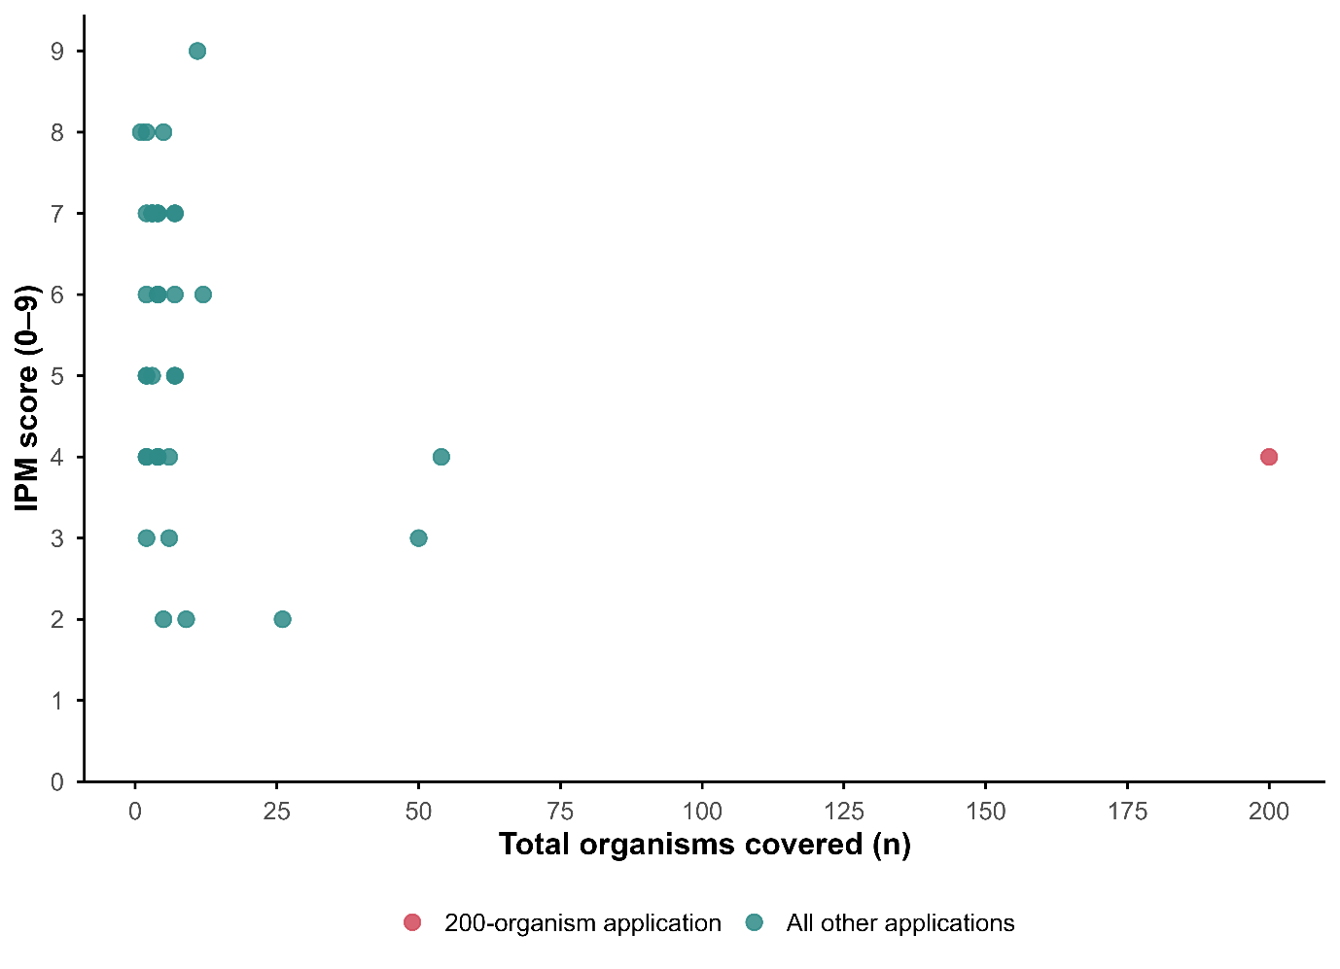
Figure S3. Correlation analysis between total pest organisms covered and IPM score across the 39 apps disclosing an overall organism count. The app disclosing 200 organisms (red) is the potential outlier, tested by the sensitivity analysis.

Table S4. Contingency table of pricing model by AI integration status (N = 49).

AI status | Free | Subscription | Total
Non-AI | 12 | 9 | 21
AI-enabled | 5 | 23 | 28
Total | 17 | 32 | 49

