Supplementary Material

Supplementary Data
We analyzed SARS-CoV-2-specific CD8+ in COVID-19 patients (n=51) with CoVITEST; 100% of COVID-19 patients had CD4 T cell responses while 41% developed CD8+ responses.

Supplementary Figure
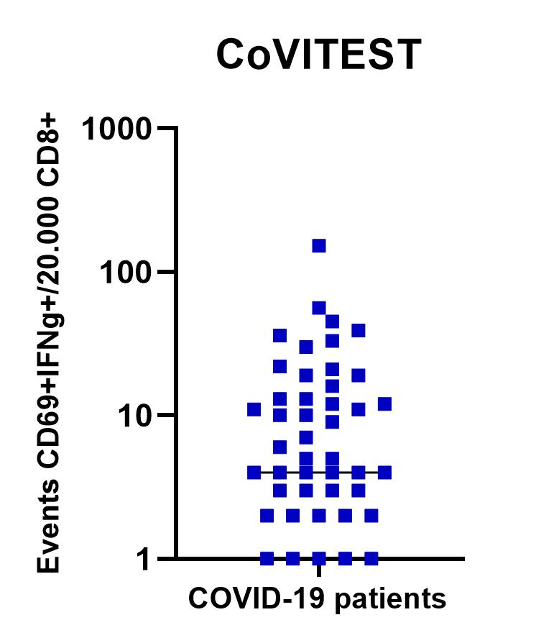

Supplementary Figure 1. Whole blood (CoVITEST) quantifies SARS-CoV-2-specific CD8+ in COVID-19 patients. SARS-CoV-2 specific T cells (CD8+ IFN-γ+ CD69+) after stimulation with spike and nucleocapsid SARS-CoV-2 peptide pools between two weeks and 6 months after the first positive RT-PCR test (n=51). A sample was considered to have reactive T cells when eight or more events were detected in 20,000 CD8+ T cells in the test tube.

