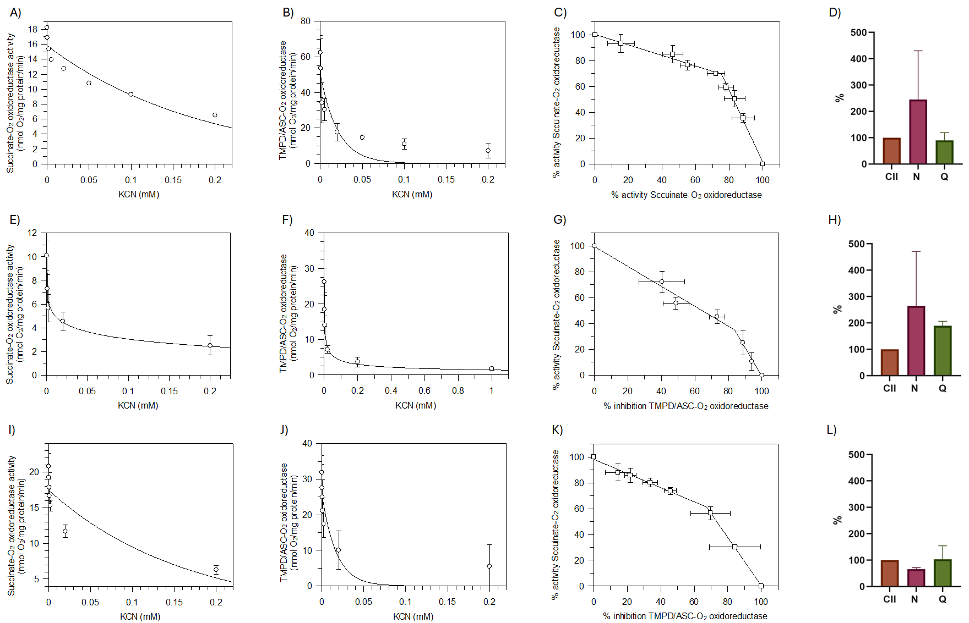
Figure S1. Mitochondrial brain respiration in SHR-SR. Inhibitory KCN titrations analysis of the respiratory activities in SHR-SR ND (A-C), JD 4 wk (E-G), and JD 10 wk (I-K). Profile of global flux with the stepwise inhibition of succinate-O₂ oxidoreductase activity (A,E,I) and individual flux with the stepwise inhibition of TMPD/ASC-O₂ oxidoreductase activity (B,F,J). Threshold plots of succinate oxidase activity (C,G,K) where each point represents the % activity of aerobic succinate oxidation with CII as a function of % inhibition of CIV for the same KCN concentration. The respiratory substrates sustaining the mitochondrial respiration were 10 mM succinate, 0.5 mM TMPD/2 mM ASC. Quantification of the presence of N-respirasome (N) and Q-respirasome (Q) in brain mitochondria of SHR-SR ND (D), JD 4 wk (H), and JD 10 wk (L). All points represent the mean±SD (vertical bars in A,B,D,E,F,H,I,J,L) and (vertical and horizontal bars in C,G,K) from three independent experiments carried out on different mitochondrial preparations.

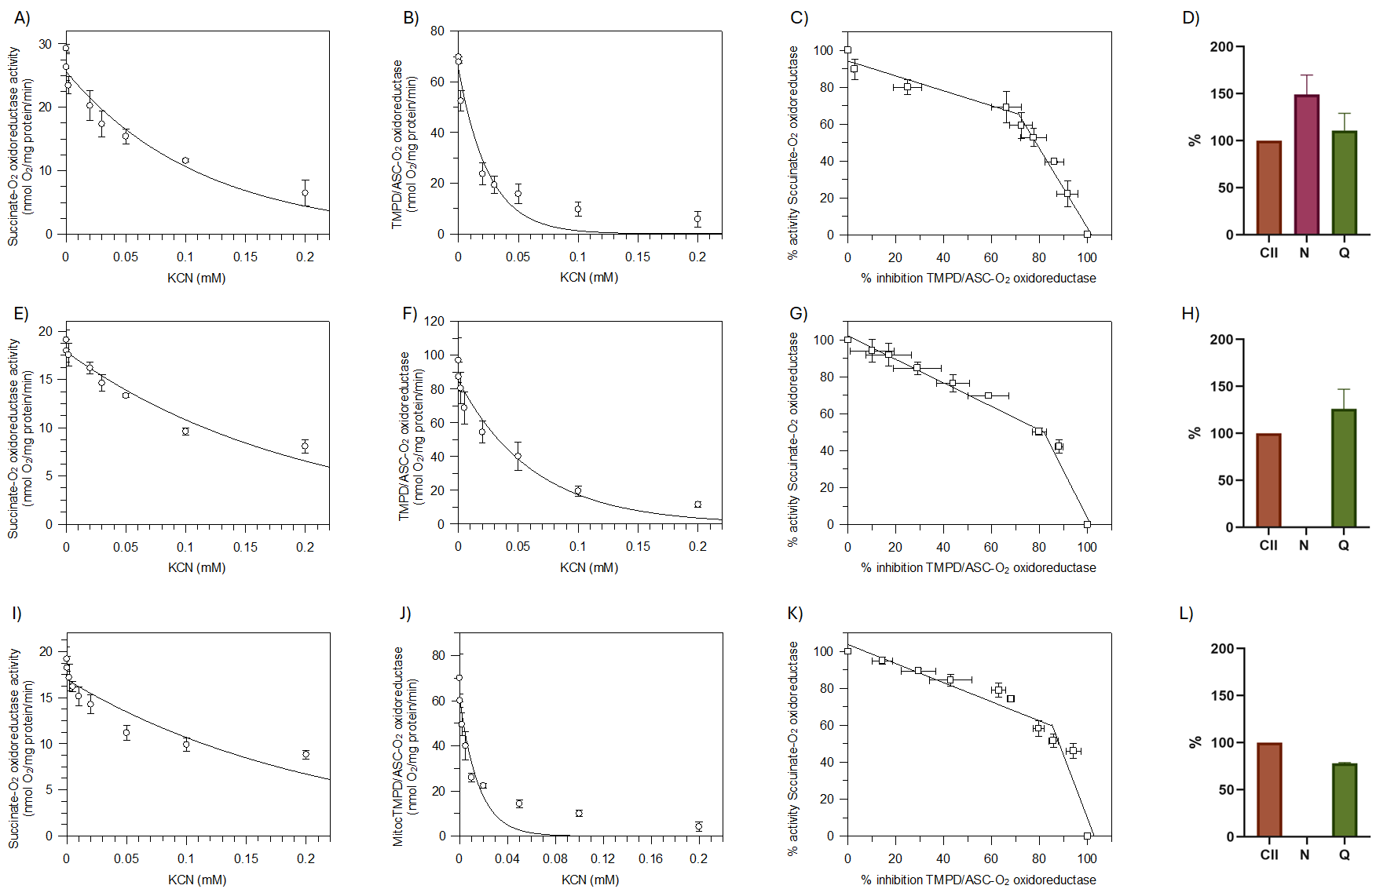
Figure S2. Mitochondrial brain respiration in SHR-SP. Inhibitory KCN titrations analysis of the respiratory activities in SHR-SP ND (A-C), JD 4 wk (E-G), and JD 6-8 wk (I-K). Profile of global flux with the stepwise inhibition of succinate-O₂ oxidoreductase activity (A,E,I) and individual flux with the stepwise inhibition of TMPD/ASC-O₂ oxidoreductase activity (B,F,J). Threshold plots of succinate oxidase activity (C,G,K) where each point represents the % activity of aerobic succinate oxidation with CII as a function of % inhibition of CIV for the same KCN concentration. The respiratory substrates sustaining the mitochondrial respiration were 10 mM succinate, 0.5 mM TMPD/2 mM ASC. Quantification of the presence of N-respirasome (N) and Q-respirasome (Q) in brain mitochondria of SHR-SP ND (D), JD 4 wk (H), and JD 10 wk (L). All points represent the mean±SD (vertical bars in A,B,D,E,F,H,I,J,L) and (vertical and horizontal bars in C,G,K) from three independent experiments carried out on different mitochondrial preparations.

