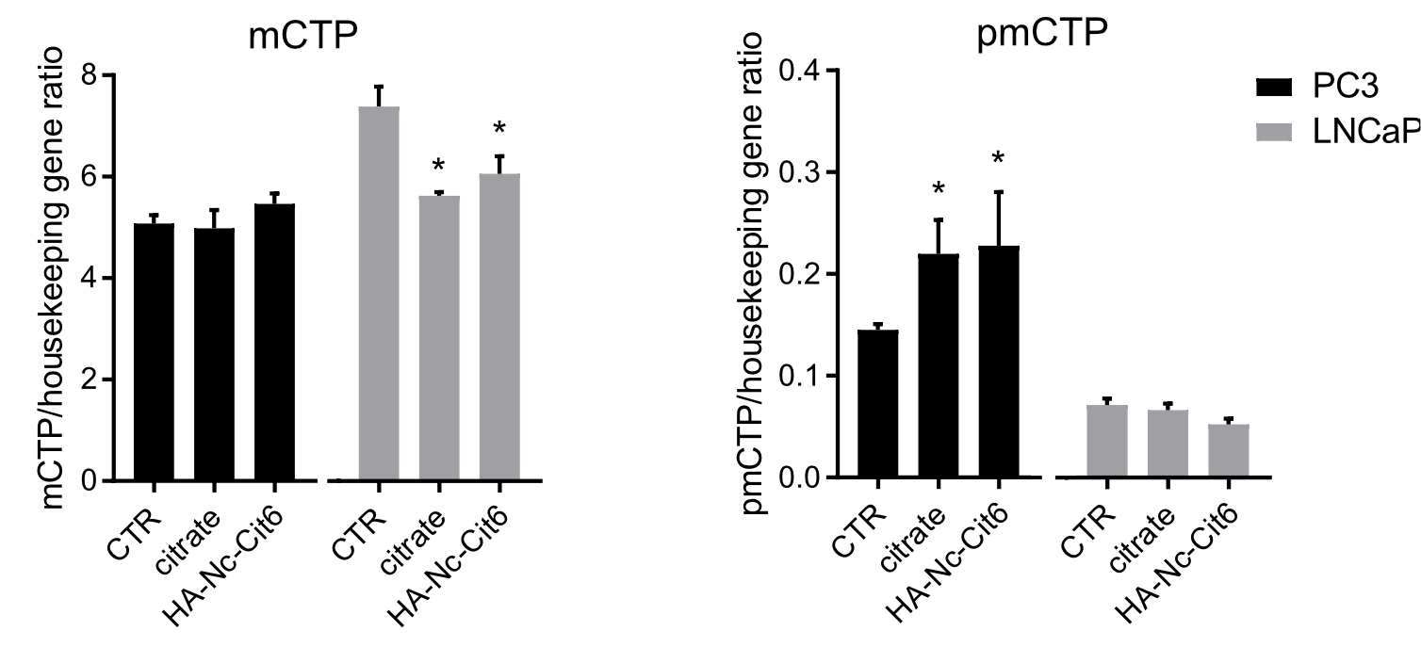
Supplementary Fig. 1. Citrate transporter mRNA expression in PCa cells after exposure to exogenous citrate. mRNA expression of citrate transporters (mCTP, pmCTP) were analyzed in PCa cells (PC3 and LNCaP), after 24 hrs incubation under three conditions: untreated control (CTR), treatment with free citrate (at concentrations equivalent to those released by HA-Nc-Cit6), or treatment with HA-Nc-Cit6 (*p < 0.05 vs CTR of the corresponding cell line; n = 3, mean ± SEM).

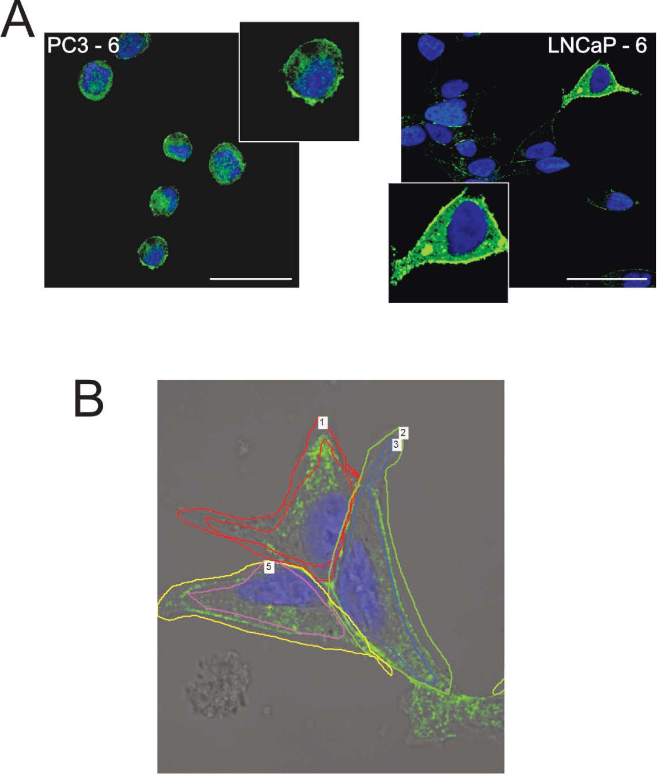

Supplementary Fig. 2. CTP protein expression in PCa and LNCaP cells by immunofluorescence after exposure to exogenous citrate. A. CTP protein expression were analyzed in PCa cells (PC3 and LNCaP), after 24 hrs incubation under treatment with free citrate (at concentrations equivalent to those released by HA-Nc-Cit3). B. Representative example of the ROI used for the quantification of membrane or cytoplasmic sum intensity of the green fluorescent signal of CTP, by immunofluorescence and confocal scan, and quantification by the software NIS element.

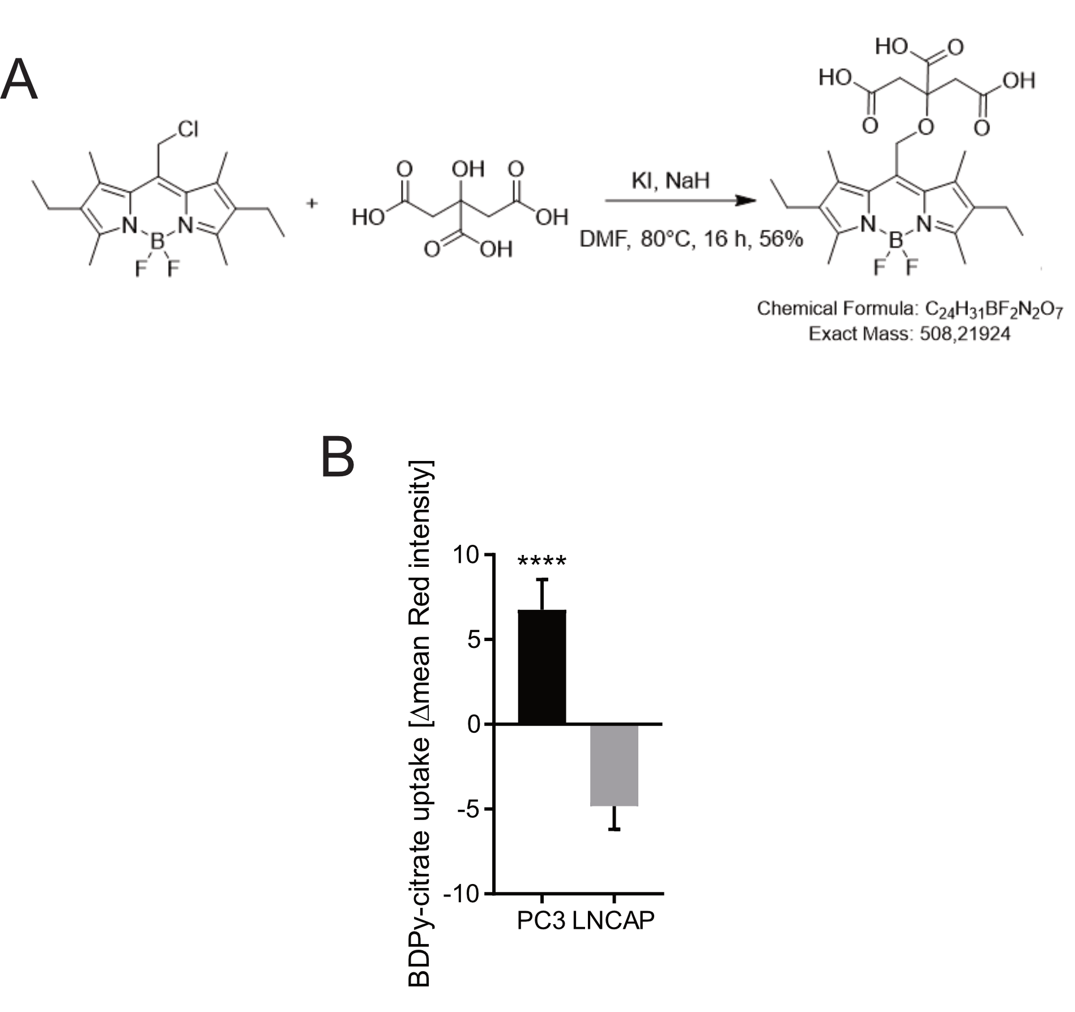

Supplementary Fig. 3. BDPy-citrate up take assay. A. Scheme of the synthetic pathway for BDPy-citrate; B. Quantification of BDPy–citrate uptake by the PCa cell line was performed by calculating the average change in red fluorescence intensity from time 0 to 5 min after confocal microscopy image acquisition (****p < 0.0001, n = 26, mean ± SEM).
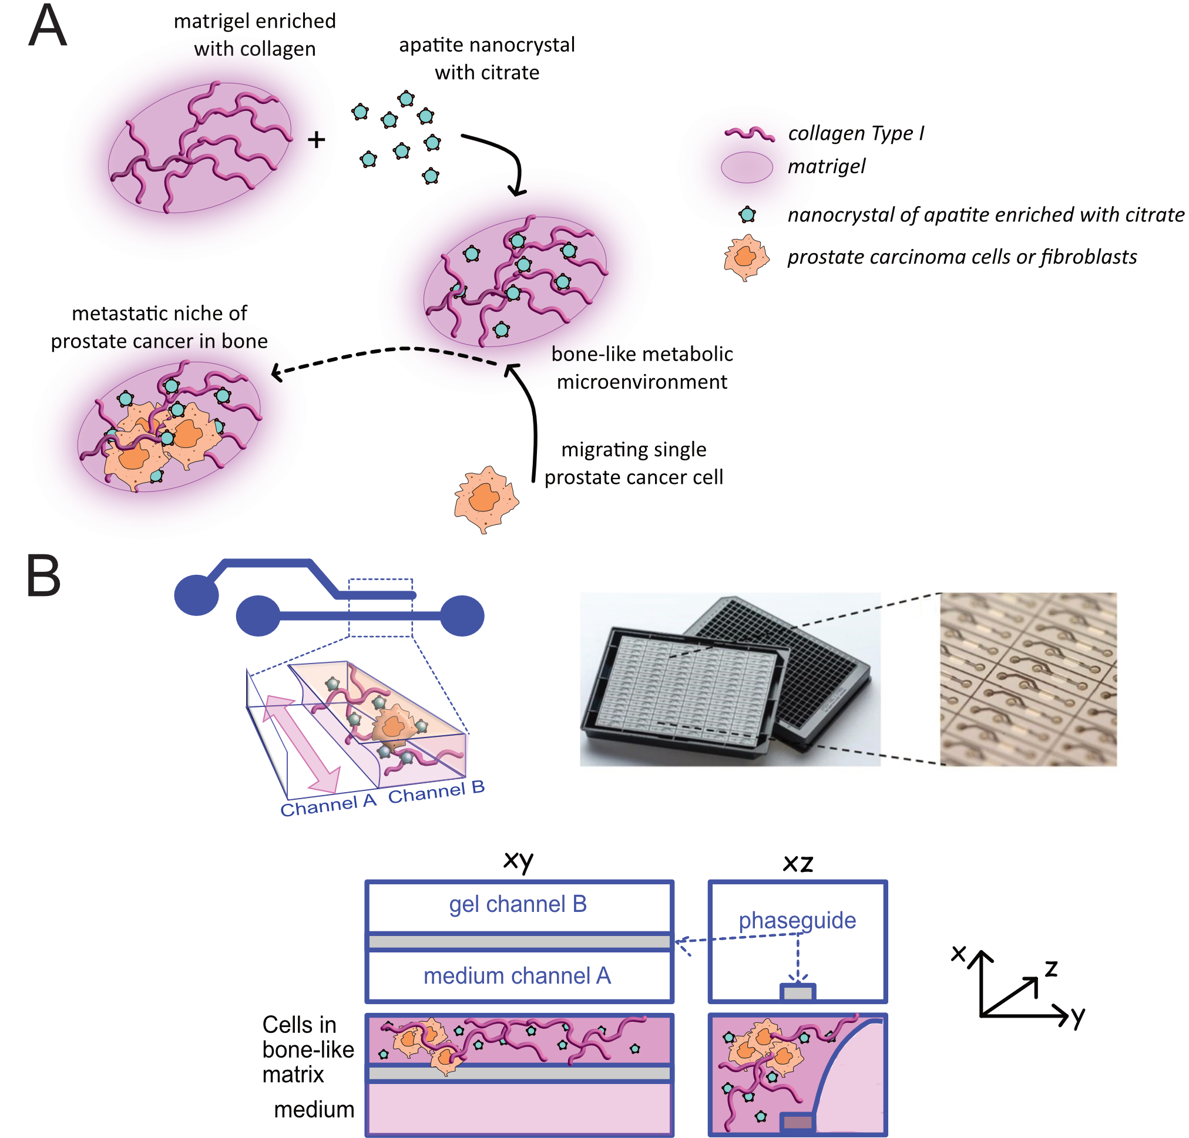

Supplementary Fig. 4. Set-up of the bone matrix-on-a-chip model. A. Schematic representation of hydrogel preparation. Type I collagen–based hydrogel was prepared starting from matrigel and Type I collagen, and enriched with citrate-functionalised hydroxyapatite nanocrystals (HA-Nc-Cit) to mimic the inorganic and organic components of the bone extracellular matrix. PCa cells were embedded within the hydrogel prior to polymerisation, generating a cell-laden bone-like matrix that recreates key features of the bone metabolic microenvironment; B. Microfluidic bone-on-a-chip platform. Up: representative image of the two-lane OrganoPlate® device used in this study, highlighting the parallel microfluidic architecture that enables multiplexed experiments. Bottom: schematic illustration of the two-lane microfluidic configuration showing the perfusion channel (channel A) and the adjacent gel channel (channel B), separated by membrane-free PhaseGuide™ technology. Channel B was used for injection and polymerisation of the cell-loaded bone-like hydrogel, while channel A was continuously perfused with culture medium to ensure nutrient and oxygen supply.

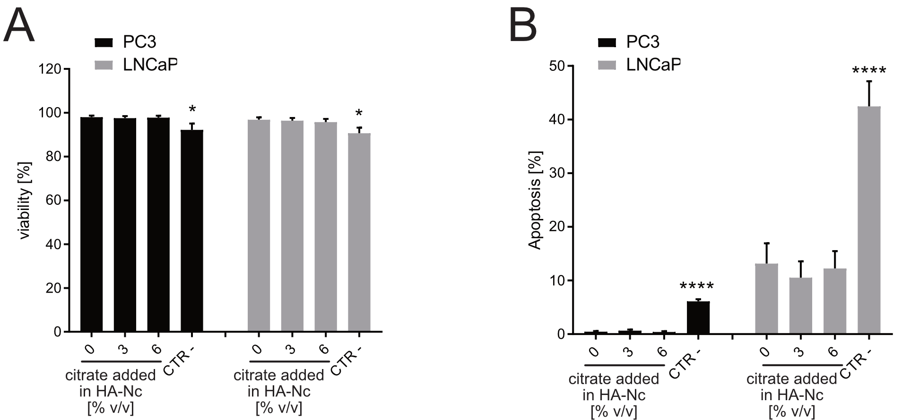
Supplementary Fig. 3. Effect of citrate-functionalized HA-Nc viability and apoptosis in 3D PCa cell cultures. PC3 and LNCaP cells were cultured under standard conditions in a 3D microfluidic chip containing a bone-like matrix with HA-Nc functionalized with different citrate concentrations (HA-Nc-Cit0-3-6). After 24 hrs, cell viability (A) was assessed using the Live/Dead assay combined with Hoechst 33342 staining (n = 12, *p < 0.05, CTR- vs HA-Nc-Cit), and apoptosis (B) was evaluated using the Alexa FluorTM 488 Annexin V/Dead Cell Apoptosis Kit, combined with Hoechst 33342 (n = 12, ****p < 0.0001, CTR- vs HA-Nc-Cit). In all experiments, staurosporine (1 µM) added to 3D cell cultures at the time of seeding, in the absence of HA-Nc, was used as the negative control (CTR-). Data are presented as mean ± SEM.

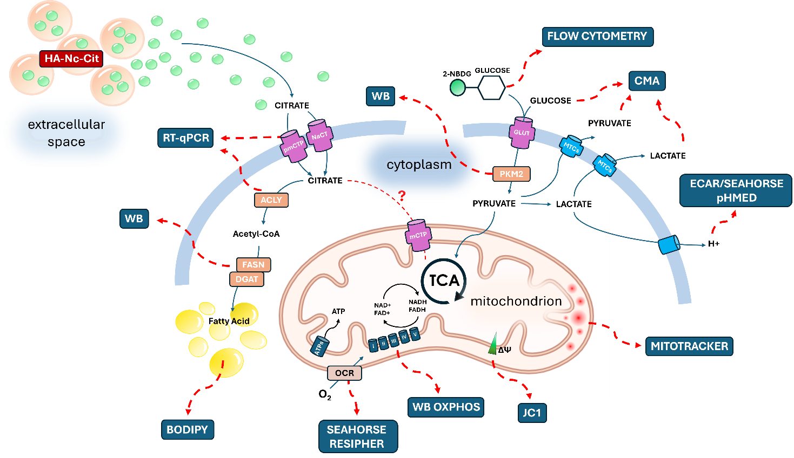
Supplementary Fig. 6. Schematic overview of the assays used to investigate metabolic pathway alterations in PCa cells following exposure to citrate-functionalized HA-Nc. Transporters involved in citrate uptake upon release from HA-Nc (pmCTP, mCTP, and NaCT) were analyzed in PCa cell lysates by qRT-PCR. Alterations in lipid biosynthesis and accumulation were assessed by capillary-based Western blot analysis of fatty acid synthase (FASN) and diacylglycerol O-acyltransferase (DGAT), respectively, and by qRT-PCR analysis of ATP-citrate lyase (ACLY), the enzyme responsible for cytosolic conversion of citrate to acetyl-CoA. Lipid droplets were visualized and quantified by BODIPY staining. Changes in cellular respiration, including oxygen consumption, electron transport chain components, and mitochondrial membrane potential, were evaluated using Seahorse or Resipher assays, capillary-based Western blot analysis, and JC1 staining, respectively, while mitochondrial content was assessed by MitoTracker staining. Glycolytic activity was evaluated by measuring glucose uptake using the 2-NBDG assay and flow cytometry, PKM2 expression by capillary-based Western blot, and real-time glycolytic flux in live cells using Seahorse analysis. Extracellular acidification activity was assessed using the pHMed assay. The metabolic alterations identified by these assays were further supported by analysis of changes in metabolite catabolism related to aerobic glycolysis (glucose and pyruvate) and lactic fermentation (lactate), which were quantified using the CMA assay.

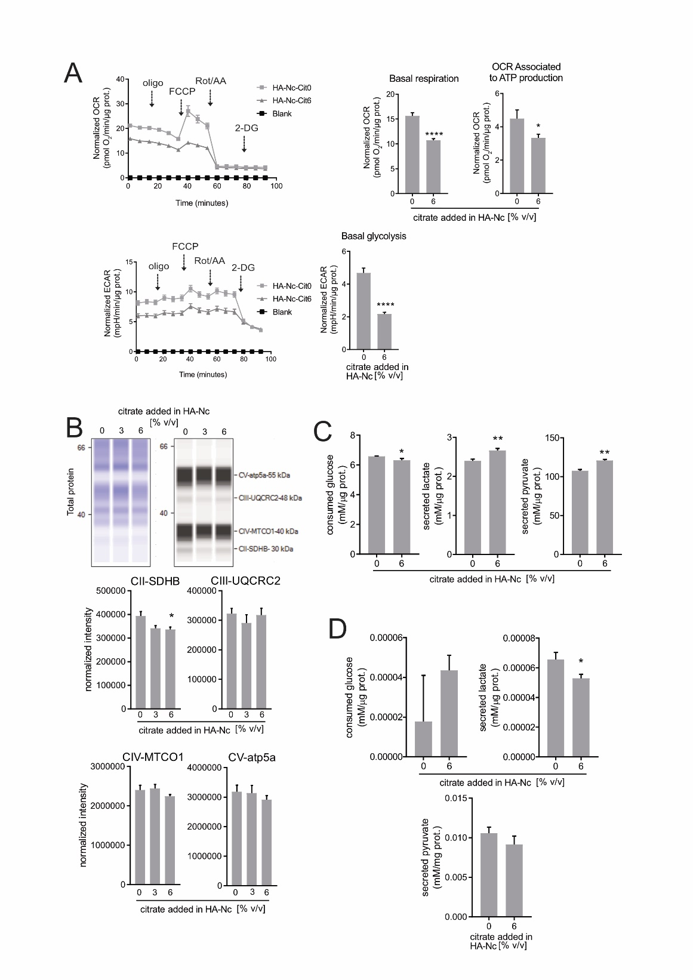

Supplementary Fig. 7. Effect of HA-Nc-Cit on energy metabolism in LNCaP cells. A. Seahorse Flux Analyzer assay. Left panel, time-course profiles of normalized oxygen consumption rate (OCR) and extracellular acidification rate (ECAR) of LNCaP cells under 2D conditions and treated with HA-Nc-Cit. Right panel, quantification of mitochondrial respiration (basal respiration and OCR associated ATP consumption rate, *p < 0.1 and ****p < 0.0001, n = 10), and glycolytic activity based on ECAR (basal glycolysis, n = 10; ****p < 0.0001); B. Representative images (upper panel) and relative quantification (lower panel) of capillary-based Western blot analysis using OXPHOS cocktail antibodies against Complex II subunit 30 kDa (CII-SDHB), Complex III core 2 subunit (CIII-UQCRC2), Complex IV subunit II (CIV-MTCO1), and ATP synthase subunit alpha (CV-ATP5A). Total protein staining is shown in the representative image (left). Graphs on the right show signal quantification (*p < 0.05 vs the corresponding HA-Nc-Cit0; n = 4); C. Glucose consumption and lactate and pyruvate secretion measured in the supernatant of PCa cells cultured in 2D and treated with HA-Nc-Cit at 0% or 6% citrate after 48 hrs of incubation (*p < 0.05 and **p < 0.01, n = 5); D. Glucose consumption and lactate and pyruvate secretion measured in the supernatant of cells cultured in 3D and treated with HA-Nc-Cit at 0% or 6% citrate after 48 hrs of incubation (*p < 0.05 , n = 5). Data are presented as mean ± SEM.

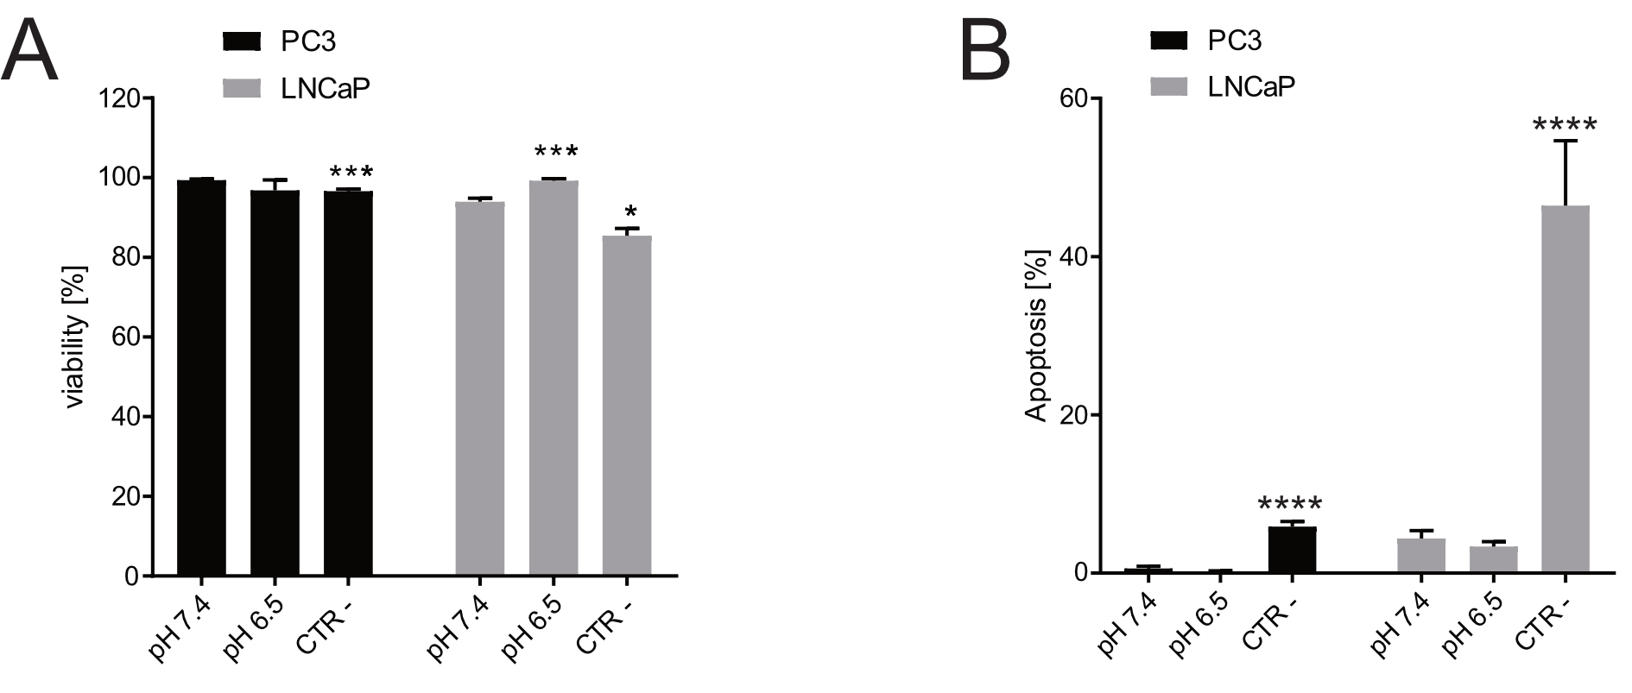
Supplementary Fig. 8. Effect of citrate-functionalized HA-Nc on viability and apoptosis of 3D PCa cell cultures under different extracellular pH conditions. PC3 and LNCaP cells were cultured in a 3D microfluidic chip containing a bone-like matrix with HA-Nc-Cit6 in complete standard medium. Staurosporine (1 µM) was added at the time of seeding to 3D cultures in the absence of HA-Nc and used as the negative control (CTR−). After 24 hrs, the culture medium was replaced with fresh medium buffered at pH 7.4 or pH 6.5. Following an additional 24 hrs incubation, cell viability (A) was assessed using the Live/Dead assay combined with Hoechst 33342 staining (n = 8; *p < 0.05, ***p < 0.001 vs pH 7.4), and apoptosis (B) was evaluated using the Alexa Fluor™ 488 Annexin V/Dead Cell Apoptosis Kit combined with Hoechst 33342 (n = 8; ****p < 0.0001 vs pH 7.4). Data are presented as mean ± SEM.

