Supplementary Material

TABLE S1. List of positive controls of the study.
Gene tested | Positive control | Reference
bla_{KPC 1-5} | Klebsiella pneumoniae ST258 bla_{KPC-3} | [1]
bla_{VIM} | pMBA::bla_{VIM-2} plasmid | [2]
bla_{IMP} | pMBA::bla_{IMP-2} plasmid | [2]
bla_{OXA-48} | Escherichia coli MDS42 :: pOXA-48 | Personal collection of the Antimicrobial Resistance Unit
bla _{NDM} | E. coli ST1196 BB1471 pCW-NDM-1 | [3]
bla_{CTX-M} group 1 | K.pneumoniae ST307 | Personal collection of the Laboratory of Veterinary Bacteriology
bla_{SHV,} | K.pneumoniae ST307 | Personal collection of the Laboratory of Veterinary Bacteriology
bla_{OXA-1}-like | K.pneumoniae ST307 | Personal collection of the Laboratory of Veterinary Bacteriology
bla_{TEM} | K.pneumoniae ST307 | Personal collection of the Laboratory of Veterinary Bacteriology
bla_{CMY-2}-bla_{CMY-7,} bla_{CMY-12}-bla_{CMY-18,} bla_{CMY-21}-bla_{CMY 23,} bla_{LAT-1}-bla_{LAT-3}, bla_{BIL-1} | E.coli ST 167 | Personal collection of the Laboratory of Veterinary Bacteriology

Figure 1. Image of the PCR results for bla_{NDM}. Amplicon size: 621 bp [4].

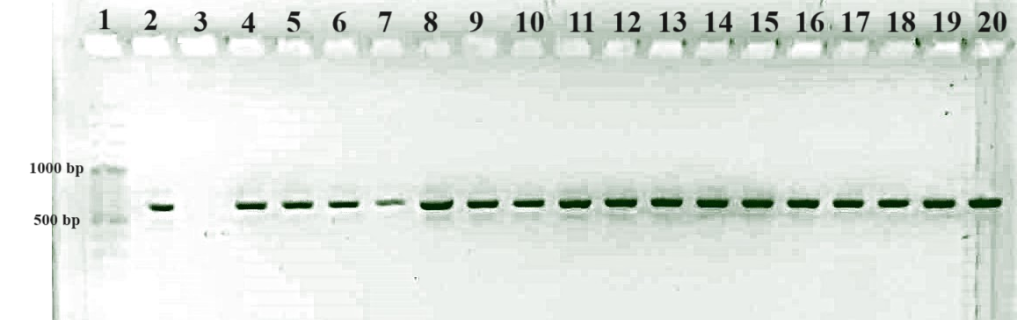

- 100 bp DNA ladder
- bla _{NDM} positive control (E. coli ST1196 BB1471 pCW-NDM-1)
- PCR negative control (water)
4-20) PCR positive isolates

References

- [1] A. Cannatelli et al., In vivo emergence of colistin resistance in Klebsiella pneumoniae producing KPC-type carbapenemases mediated by insertional inactivation of the PhoQ/PhoP mgrB regulator, Antimicrobial agents and chemotherapy 57,11 (2013)
- [2] A. Hipólito, L. García-Pastor, E. Vergara et al., Profile and resistance levels of 136 integron resistance genes, npj Antimicrob Resist 1, 13 (2023).
- [3] J.F Delgado-Blas, C.Valenzuela Agüi, E. Marin Rodriguez, C. Serna, N.Montero, C.K.S. Saba, B. Gonzalez-Zorn, Dissemination Routes of Carbapenem and Pan-Aminoglycoside Resistance Mechanisms in Hospital and Urban Wastewater Canalizations of Ghana. mSystems 22 (2022). doi: 10.1128/msystems.01019-21.
- [4] L. Poirel, T.R. Walsh, V. Cuvillier, P. Nordmann, Multiplex PCR for detection of acquired carbapenemase genes, Diagnostic Microbiology and Infectious Disease 70 (2011) 119–123. https://doi.org/10.1016/j.diagmicrobio.2010.12.002.

