Distribution of endocannabinoid system receptors in the equine hoof: dysregulation as a potential therapeutic target for laminitis
Histochemistry and Cell Biology
Rodrigo Zamith Cunha^{1,2}*, Francesca Gobbo¹, Maria Morini¹, Augusta Zannoni¹, Carlo Mainardi¹, Lorenzo D’arpe¹, Alessandro Gramenzi², Roberto Chiocchetti¹
¹ Department of Veterinary Medical Sciences (UNI EN ISO 9001:2008), University of Bologna, Italy
² Department of Veterinary Medicine, University of Teramo, Teramo, Italy
* Corresponding author email: rodrigo.zamithcunha@studio.unibo.it

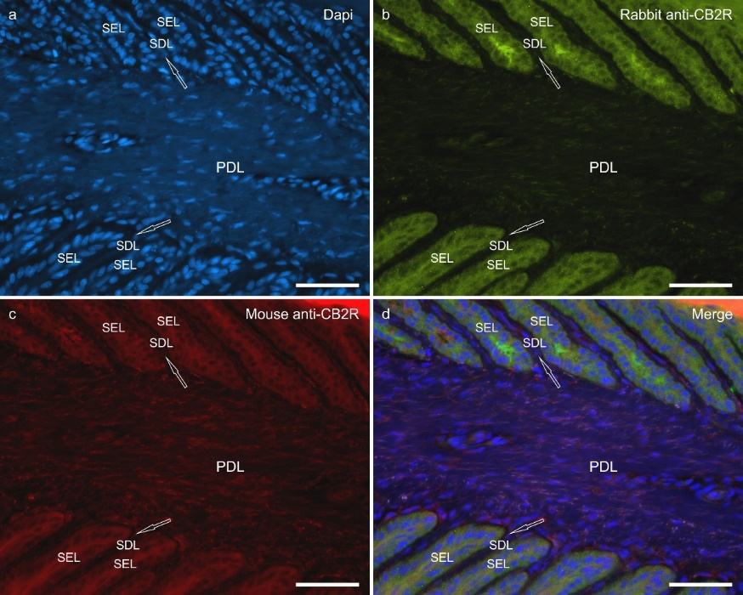
Supplementary item 1 – Immunolabelling of equine hoof lamellae using two different antibodies directed against cannabinoid receptor type 2 (CB2R). The arrows indicate secondary dermal lamellae (SDL). Abbreviations: PDL, primary dermal lamellae; SEL, secondary epidermal lamellae.

