Supporting information
for
Genomic and functional characterization of the novel marine bacterial isolate Lysinibacillus sphaericus PG22 highlights the potential for metals biomineralization via urease activity
Laura Vitale¹, Carmine Buonocore¹, Virginia Venezia², Christian Galasso³, Fortunato Palma Esposito¹, Daniela Coppola¹, Gerardo Della Sala¹, Luciana Mantovani⁴, Daniele Moro⁵, Gianfranco Ulian⁵, Giovanni Valdrè⁵, Donatella de Pascale¹, Giuseppe Vitiello², Valerio Funari⁶*, Pietro Tedesco¹*

1. Stazione Zoologica Anton Dohrn, Department of Ecosustainable Marine Biotechnology, Via Acton 55 80133 Napoli (IT)
2. University of Naples Federico II, Department of Chemical, Materials and Production Engineering, P.le Tecchio 80, 80125 Napoli (IT)
3. Stazione Zoologica Anton Dohrn, Department of Ecosustainable Marine Biotechnology, Calabria Marine Centre, C. da Torre Spaccata, 87071 Amendolara (IT)
4. Università di Parma, Dipartimento di Scienze Chimiche, della Vita e della Sostenibilità Ambientale, Parco Area delle Scienze 157/a, 43124 Parma (IT)
5. Università di Bologna “Alma Mater Studiorum”, Dipartimento di Scienze Biologiche, Geologiche e Ambientali, Plesso di Mineralogia, Piazza di Porta San Donato 1, 40126 Bologna (IT)
6. National Research Council of Italy (CNR), Marine Science Institute (ISMAR), Calata Porta di Massa – Porto di Napoli 80, Naples 80133, Italy

*Authors to whom correspondence should be addressed: pietro.tedesco@szn.it, valerio.funari@bo.ismar.cnr.it

CONTENT:

Table S1: Composition of BC17 sediment sample, representative of the topmost sediments prepared for bacterial isolation on board R/V Dallaporta. Chemical concentration of major, minor and trace elements by X-Ray Fluorescence (XRF).
TableS2: list of the urease gene cluster and carbonic anhydrases identified in Lysinibacillus sphaericus PG22 genome. Reported in order: conting, start and stop coordinates, gene length, aminoacidic length, gene function, closest homologue and e-value.
Table S3: Weight loss percentages derived from the thermo-gravimetric analysis.
Table S4: list of the metal resistance genes identified in Lysinibacillus sphaericus PG22 genome. Reported in order: gene code, PG22 scaffold, start and stop coordinates, gene length and gene function.
Table S5: Chemical determination of Ca, Fe, Pb, Mg, Ni, K, Na, V, and Zn by ICP-MS. DL is the detection limit based on procedural blanks. Values in ppb. In the “fraction”column P stands for precipitate, B for biomass, and S for supernatant. In the “conditions” column are reported the main components of each sample, i.e., PG22 as bacterium, Ca as calcium, and Pb as lead.
Table S6: Relative percentages into separated fractions calculated (see main text) starting from the chemical determination of Ca, Fe, Pb, Mg, Ni, K, Na, V, and Zn by ICP-MS. In the “fraction”column P stands for precipitate, B for biomass, and S for supernatant. In the “conditions” column are reported the main components of each sample, i.e., PG22 as bacterium, Ca as calcium, and Pb as lead

Figure S1: A) The BC17 station, site 15 of shipboard scientific party SeaGMA 2022. B) Schematic workflow of bacterial strain isolation and stereomicroscopic picture of PG22 colony showing mineral precipitates.
Figure S2: Elemental enrichments of BC17 sample based on XRF analysis and data normalization, using a similar approach used elsewhere (e.g., Ghani et al., 2023), where EF is the Enrichment Factor to the upper continental crust average values.
Figure S3: Concentration of calcite produced by Lysinibacillus sphaericus PG22 along a 72-hours growth. Plotted on graph the g/L of (A) calcite jointly with bacterial biomass, (B) PG22 biomass, (P) calcite.
Figure S4: DTG curves of P samples (only calcite).
Figure S5: Lysinibacillus sphaericus PG22 MRGs clusters and others identified in the genome (detailed info in Table S2) flanked by in vitro validation for As, Cd, Cu, Zn, Co, and Pb (NA= not analysed) reporting the maximum metal salt concentrations (ppm) tolerated by PG22, according to the MTC assay (Pb > Zn > Cu > As > Co > Cd).
Figure S6: Lysinibacillus sphaericus PG22 growth percentage at increasing concentrations of different PTEs soluble salts after 48 hours of growth. 0 ppm correspond to the control condition without metal fixed as 100% growth.

Figure S7: Elemental fractions into supernatant (S), pellet of biomass (B), and pellet of precipitate (P), as a relative percentage of element recovery by ICP-MS. (a) Growth of PG22 supplemented with urea and CaCl₂. (b) Growth of PG22 supplemented with urea, CaCl_{2,} and Pb(NO₃)₂.
Figure S8: Relative elemental abundances into supernatant (S) and precipitate (P), as a relative percentage of element recovery by ICP-MS from control experiments with Pb(NO₃)₂ and CaCl₂.
Figure S9: Example of confocal Raman microspectrometry analysis carried out on the mineral precipitates of PG22 grown in presence of Ca, Pb, and urea. (a) 20× picture of a large precipitate deposit. (b) Zoom of the region marked with red rectangle in panel (a). (c) Typical Raman spectra collected on the sample. The colours of the spectra match those of the crosses in panels (a) and (b).
Figure S10: (a) Raman microspectrometry analysis of a large assemblage of calcite precipitates (sample [NAME]). (b) Magnification of the area marked with red rectangle in panel (a). (c) 6 µm × 6 µm Raman map (20 points × 20 lines, 300nm resolution) of a selected region where small bright particles can be seen on the calcite precipitate. (d) representative spectra of the blue and red areas shown in panel (c), with the colours of the spectra matching those of the map.
Figure S11: Phase Contrast Microscope, Pictures of freeze-dried PG22 biomass pre (a) and post (b) heat shock treatment highlighting the presence of endospores in both the samples.
Figure S12: Phase Contrast Microscope, Pictures of PG22 bacterial suspension in presence of Pb(NO₃)₂ (a), CaCl₂ (b), and urea (c). In (a), the sample is predominantly composed of spores; in (b), a mixture of free spores and cell agglomerates is visible; while in (c), motile vegetative cells are the dominant form.

Table S1: Composition of BC17 sediment sample, representative of the topmost sediments prepared for bacterial isolation on board R/V Dallaporta. Chemical concentration of major, minor and trace elements by X-Ray Fluorescence (XRF).
Box coring sample BC17
SiO₂ | wt. % | 42.2
TiO₂ | wt. % | 0.7
Al₂O₃ | wt. % | 16.0
Fe₂O₃ | wt. % | 6.6
MnO | wt. % | 0.1
MgO | wt. % | 2.9
CaO | wt. % | 7.2
Na₂O | wt. % | 0.5
K₂O | wt. % | 2.8
P₂O₅ | wt. % | 0.1
LOI | wt. % | 20.9
As | ppm | 70
Ba | ppm | 353
Br | ppm | 19
Ce | ppm | 97
Cl | ppm | 150
Co | ppm | 25
Cr | ppm | 159
Cs | ppm | 6
Cu | ppm | 62
Ga | ppm | 21
Hf | ppm | 3
La | ppm | 47
Mo | ppm | 2
Nb | ppm | 19
Nd | ppm | 31
Ni | ppm | 85
Pb | ppm | 57
Rb | ppm | 138
S | ppm | 320
Sc | ppm | 20
Sm | ppm | 10
Sn | ppm | 2
Sr | ppm | 305
Th | ppm | 19
U | ppm | 5
V | ppm | 174
W | ppm | 2
Y | ppm | 21
Zn | ppm | 157
Zr | ppm | 136

TableS2: list of the urease gene cluster and carbonic anhydrases identified in Lysinibacillus sphaericus PG22 genome. Reported in order: conting, start and stop coordinates, gene length, aminoacidic length, gene function, closest homologue and e-value.
Conting | Start | Stop | Length (bp) | Lenght (aa) | Function | Closest Homologue | e-Value
Scaffold_2 | 1489215 | 1489517 | 303 | 100 | Urease gamma subunit (EC 3.5.1.5) | urease subunit gamma [Lysinibacillus sphaericus] | 1,00E-65
Scaffold_2 | 1489533 | 1489901 | 369 | 122 | Urease beta subunit (EC 3.5.1.5) | urease subunit beta [Lysinibacillus sphaericus] | 2,00E-79
Scaffold_2 | 1489898 | 1491613 | 1716 | 571 | Urease alpha subunit (EC 3.5.1.5) | urease subunit alpha [Lysinibacillus sphaericus] | 0
Scaffold_2 | 1491709 | 1492155 | 447 | 148 | Urease accessory protein UreE | urease accessory protein UreE [Lysinibacillus sphaericus] | 4,00E-99
Scaffold_2 | 1492229 | 1492837 | 609 | 202 | Urease accessory protein UreF | urease accessory protein [Lysinibacillus sphaericus OT4b.31] | 1,00E-142
Scaffold_2 | 1492858 | 1493487 | 630 | 209 | Urease accessory protein UreG | urease accessory protein UreG [Lysinibacillus sphaericus] | 4,00E-150
Scaffold_2 | 1493480 | 1494286 | 807 | 268 | Urease accessory protein UreD | urease accessory protein UreD [Lysinibacillus sphaericus] | 0
Scaffold_2 | 507951 | 507439 | 513 | 170 | Carbonic anhydrase, gamma class (EC 4.2.1.1) | gamma carbonic anhydrase family protein [Lysinibacillus] | 1,00E-118
Scaffold_2 | 4171176 | 4171739 | 564 | 187 | Carbonic anhydrase, beta class (EC 4.2.1.1) | beta-class carbonic anhydrase [Lysinibacillus sphaericus] | 3,00E-133

Table S3: Weight loss percentages derived from the thermo-gravimetric analysis.
ID sample | Weight loss %  [200-600 °C] | Weight loss %  [600-750 °C]
8 h-A | 36.30 | 24.13
16 h-A | 14.30 | 38.32
24 h-A | 14.78 | 38.05
40 h-A | 13.68 | 39.15
48 h-A | 12.31 | 40.52
64 h-A | 12.86 | 39.23
72 h-A | 9.85 | 41.14
16 h-P | - | 41.32
24 h-P | - | 41.16
40 h-P | - | 40.46
48 h-P | - | 40.76
64 h-P | - | 38.15
72 h-P | - | 40.13

Table S4: list of the metal resistance genes identified in Lysinibacillus sphaericus PG22 genome. Reported in order: gene code, PG22 scaffold, start and stop coordinates, gene length and gene function.
gene | scaffold | start | stop | lenght (bp) | function
Zinc
zupT | Scaffold_2 | 402680 | 403489 | 810 | Zinc transporter ZupT
znuC | Scaffold_2 | 1049033 | 1049779 | 747 | Zinc ABC transporter, ATP-binding protein ZnuC
zosA | Scaffold_2 | 4163977 | 4165881 | 1905 | Copper Transport System, Copper homeostasis
Copper
copA | Scaffold_2 | 4474960 | 4472549 | 2412 | Copper-exporting P-type ATPase
copZ | Scaffold_2 | 4475249 | 4475043 | 207 | Copper(I) chaperone CopZ
csoR | Scaffold_2 | 4475689 | 4475354 | 336 | Repressor of the copZA operon
czcD | Scaffold_2 | 4476713 | 4475766 | 948 | Cadmium, cobalt and zinc/H(+)-K(+) antiporter
czrA | Scaffold_2 | 4477113 | 4476772 | 342 | Transcriptional repressor CzrA, ArsR family
Tellurium
terA | Scaffold_2 | 4130996 | 4131628 | 633 | Tellurium resistance protein TerA
yceH | Scaffold_2 | 4132814 | 4131774 | 1041 | telA-like protein
yceG | Scaffold_2 | 4134468 | 4132837 | 1632 | FIG013452: putative tellurium resistance protein
yceD_1 | Scaffold_2 | 4139810 | 4139235 | 576 | Tellurium resistance protein TerD
yceD_2 | Scaffold_2 | 4140427 | 4139846 | 582 | Tellurium resistance protein TerD
yceC | Scaffold_2 | 4141178 | 4140552 | 627 | Tellurium resistance protein TerD
Manganese
MntH | Scaffold_2 | 3642335 | 3643600 | 1266 | Manganese transport protein MntH
mntP | Scaffold_2 | 3376393 | 3375896 | 498 | manganese efflux pump MntP
mneS | Scaffold_2 | 4081022 | 4081930 | 909 | manganese efflux system MntP
mntA | Scaffold_4 | 54879 | 55796 | 918 | Manganese ABC transporter, periplasmic-binding protein SitA
mntB_2 | Scaffold_4 | 55805 | 56533 | 729 | Manganese ABC transporter, ATP-binding protein SitB
mntC | Scaffold_4 | 56545 | 57417 | 873 | hypothetical protein
mntD | Scaffold_4 | 57414 | 58283 | 870 | Manganese ABC transporter, inner membrane permease protein SitD
_ | Scaffold_4 | 58770 | 59957 | 1188 | Uncharacterized MFS-type transporter
Nickel
nikB_1 | Scaffold_2 | 1495904 | 1496872 | 969 | Nickel transport system permease protein NikB
nikE | Scaffold_2 | 1989451 | 1988660 | 792 | Nickel ABC transporter, ATP-binding protein NikE (TC 3.A.1.5.3)
nikC | Scaffold_2 | 1991079 | 1990255 | 825 | Nickel ABC transporter, permease protein NikC (TC 3.A.1.5.3)
nikB_2 | Scaffold_2 | 1992058 | 1991081 | 978 | Nickel ABC transporter, permease protein NikB (TC 3.A.1.5.3)
nikA | Scaffold_2 | 1993792 | 1992170 | 1623 | Nickel ABC transporter, substrate-binding protein NikA (TC 3.A.1.5.3)
nikB_3 | Scaffold_2 | 2049998 | 2049057 | 942 | Nickel transport system permease protein NikB
Arsenic
arsB | Scaffold_2 | 363071 | 364366 | 1296 | Arsenite/antimonite:H+ antiporter
pstS | Scaffold_2 | 1081173 | 1082150 | 978 | Phosphate ABC transporter, substrate-binding protein PstS (TC 3.A.1.7.1)
pstC | Scaffold_2 | 1082215 | 1083162 | 948 | Phosphate ABC transporter, permease protein PstC (TC 3.A.1.7.1)
pstA | Scaffold_2 | 1083164 | 1084042 | 879 | Phosphate ABC transporter, permease protein PstA (TC 3.A.1.7.1)
pstB | Scaffold_2 | 1084055 | 1084888 | 834 | Phosphate ABC transporter, ATP-binding protein PstB (TC 3.A.1.7.1)
merR | Scaffold_2 | 1797458 | 1797808 | 351 | Cobalt-zinc-cadmium resistance
arsR | Scaffold_2 | 1800527 | 1800859 | 333 | Arsenical resistance operon repressor
acr3_1 | Scaffold_2 | 1800849 | 1801907 | 1059 | Arsenical-resistance protein ACR3
arsM | Scaffold_2 | 1801920 | 1802723 | 804 | Arsenite methyltransferase (EC 2.1.1.137)
_ | Scaffold_2 | 1827845 | 1827660 | 186 | Transcriptional regulator, ArsR family
HTH_arsR_2 | Scaffold_2 | 1834944 | 1834618 | 327 | Transcriptional regulator, ArsR family
arsC | Scaffold_2 | 1837175 | 1836756 | 420 | Arsenate reductase (EC 1.20.4.4) thioredoxin-coupled, LMWP family
acr3_2 | Scaffold_2 | 1838237 | 1837188 | 1050 | Arsenical-resistance protein ACR3
HTH_arsR | Scaffold_2 | 1838557 | 1838237 | 321 | Arsenical resistance operon repressor
Cadmium
cadC | Scaffold_2 | 424336 | 424707 | 372 | Cadmium efflux system accessory protein
cadA | Scaffold_2 | 424688 | 426817 | 2130 | Cadmium-transporting ATPase (EC 3.6.3.3)
mntR | Scaffold_2 | 427396 | 427815 | 420 | Mn-dependent transcriptional regulator MntR
Chromium
chrA | Scaffold_2 | 980309 | 981478 | 1170 | Resistance to chromium compounds
varius
fieF | Scaffold_2 | 963826 | 962960 | 867 | Ferrous-iron efflux pump FieF
_ | Scaffold_2 | 222746 | 223540 | 795 | Cobalt-zinc-cadmium resistance, Transcriptional regulator, MerR family
mta_2 | Scaffold_2 | 209025 | 209753 | 729 | Cobalt-zinc-cadmium resistance, Transcriptional regulator, MerR family

Table S5: Chemical determination of Ca, Fe, Pb, Mg, Ni, K, Na, V, and Zn by ICP-MS. DL is the detection limit based on procedural blanks. Values in ppb. In the “fraction”column P stands for precipitate, B for biomass, and S for supernatant. In the “conditions” column are reported the main components of each sample, i.e., PG22 as bacterium, Ca as calcium, and Pb as lead.
Internal Code | Fraction | Conditions | Ca | Fe | Pb | Mg | Ni | K | Na | V | Zn
DL |  |  | 5.3 | 0.0 | 17.2 | 0.2 | 0.0 | 0.0 | 0.4 | 0.5 | 0.0
MICP0a | B | PG22, Ca | 101.8 | 0.8 | 3.2 | 8.5 | 0.0 | 1.0 | 1.6 | 1.1 | 0.2
MICP0b | P | PG22, Ca | 1048.9 | 4.6 | 35.4 | 7.3 | 0.0 | 0.9 | 2.4 | 1.0 | 0.3
MICP0c | B | PG22, Ca, Pb | 23.6 | 0.5 | 389.3 | 1.2 | 0.0 | 0.8 | 1.2 | 0.9 | 0.1
MICP0d | P | PG22, Ca, Pb | 1212.3 | 5.0 | 912.0 | 4.8 | 0.0 | 0.5 | 1.5 | 0.9 | 0.2
MICP1 | S | Ca, Pb | 11493.4 | 38.1 | 1257.2 | 24.2 | 6.4 | 26.7 | 72.9 | 2.2 | 4.6
MICP2 | P | Ca, Pb | 8.2 | 0.1 | 474.0 | 0.7 | 0.0 | 0.4 | 3.5 | 0.6 | 0.1
MICP4 | S | PG22, Pb | 71.7 | 1.9 | 3030.8 | 286.9 | 3.1 | 137.5 | 1705.4 | 0.9 | 0.9
MICP3 | P | PG22, Pb | 1.1 | 0.2 | 693.1 | 0.4 | 0.0 | 0.3 | 4.3 | 0.7 | 0.0
MICP7 | S | PG22, Ca | 122.4 | 1.4 | 85.0 | 236.2 | 9.5 | 605.2 | 1363.3 | 2.8 | 1.0
MICP5 | B | PG22, Ca | 7.9 | 0.1 | 5.0 | 0.5 | 0.1 | 2.1 | 4.1 | 0.6 | 0.1
MICP6 | P | PG22, Ca | 1350.2 | 5.1 | 2.2 | 1.4 | 0.0 | 0.3 | 4.1 | 0.6 | 0.1
MICP10 | S | PG22, Ca | 102.6 | 1.1 | 15.3 | 260.6 | 9.3 | 647.7 | 1681.6 | 2.6 | 0.7
MICP8 | B | PG22, Ca | 12.1 | 0.2 | 0.3 | 0.4 | 0.0 | 2.2 | 3.8 | 0.7 | 0.1
MICP9 | P | PG22, Ca | 1341.5 | 5.1 | 0.4 | 1.7 | 0.0 | 0.2 | 4.4 | 0.7 | 0.1
MICP13 | S | PG22, Ca | 116.9 | 1.2 | 5.9 | 211.8 | 9.2 | 661.5 | 1174.5 | 2.5 | 0.7
MICP11 | B | PG22, Ca | 9.2 | 0.2 | 0.7 | 0.4 | 0.1 | 2.6 | 3.7 | 0.6 | 0.1
MICP12 | P | PG22, Ca | 1342.2 | 5.1 | 0.5 | 1.5 | 0.0 | 0.2 | 3.9 | 0.7 | 0.1
MICP16 | S | PG22, Ca, Pb | 132.1 | 1.0 | 6.5 | 239.0 | 9.0 | 596.4 | 1449.1 | 2.4 | 0.3
MICP14 | B | PG22, Ca, Pb | 5.4 | 0.1 | 61.9 | 0.1 | 0.0 | 0.9 | 3.1 | 0.8 | 0.0
MICP15 | P | PG22, Ca, Pb | 930.5 | 3.5 | 2516.3 | 1.3 | 0.0 | 0.3 | 3.0 | 0.6 | 0.2
MICP19 | S | PG22, Ca, Pb | 162.9 | 1.5 | 9.9 | 320.2 | 10.4 | 808.1 | 1781.8 | 2.9 | 0.6
MICP17 | B | PG22, Ca, Pb | 8.8 | 0.2 | 69.3 | 0.2 | 0.0 | 1.7 | 2.8 | 0.9 | 0.0
MICP18 | P | PG22, Ca, Pb | 1490.1 | 5.6 | 4004.8 | 2.1 | 0.0 | 0.5 | 3.6 | 0.7 | 0.2
MICP22 | S | PG22, Ca, Pb | 150.7 | 2.5 | 8.8 | 321.7 | 11.8 | 850.4 | 1855.7 | 5.7 | 3.9
MICP20 | B | PG22, Ca, Pb | 7.3 | 0.3 | 41.9 | 0.3 | 0.0 | 2.3 | 3.9 | 0.9 | 0.0
MICP21 | P | PG22, Ca, Pb | 1139.0 | 4.4 | 2640.0 | 1.5 | 0.0 | 1.2 | 3.6 | 0.7 | 0.2

Table S6: Relative percentages into separated fractions calculated (see main text) starting from the chemical determination of Ca, Fe, Pb, Mg, Ni, K, Na, V, and Zn by ICP-MS. In the “fraction”column P stands for precipitate, B for biomass, and S for supernatant. In the “conditions” column are reported the main components of each sample, i.e., PG22 as bacterium, Ca as calcium, and Pb as lead.
Internal Code | Fraction | Conditions | Ca | Pb | Fe | Mg | Ni | K | Na | V | Zn
MICP0a | B | PG22, Ca | 9% | 8% | 15% | 54% | 52% | 52% | 40% | 52% | 36%
MICP0b | P | PG22, Ca | 91% | 92% | 85% | 46% | 48% | 48% | 60% | 48% | 64%
MICP0c | B | PG22, Ca, Pb | 2% | 30% | 9% | 20% | 38% | 62% | 45% | 49% | 32%
MICP0d | P | PG22, Ca, Pb | 98% | 70% | 91% | 80% | 62% | 38% | 55% | 51% | 68%
MICP1 | S | Ca, Pb | 100% | 73% | 100% | 97% | 100% | 98% | 95% | 79% | 99%
MICP2 | P | Ca, Pb | 0% | 27% | 0% | 3% | 0% | 2% | 5% | 21% | 1%
MICP4 | S | PG22, Pb | 98% | 81% | 89% | 100% | 100% | 100% | 100% | 55% | 96%
MICP3 | P | PG22, Pb | 2% | 19% | 11% | 0% | 0% | 0% | 0% | 45% | 4%
MICP7 | S | PG22, Ca | 8% | 92% | 21% | 99% | 99% | 100% | 99% | 70% | 80%
MICP5 | B | PG22, Ca | 1% | 5% | 2% | 0% | 1% | 0% | 0% | 14% | 12%
MICP6 | P | PG22, Ca | 91% | 2% | 77% | 1% | 0% | 0% | 0% | 16% | 8%
MICP10 | S | PG22, Ca | 7% | 95% | 17% | 99% | 99% | 100% | 100% | 66% | 80%
MICP8 | B | PG22, Ca | 1% | 2% | 2% | 0% | 0% | 0% | 0% | 17% | 12%
MICP9 | P | PG22, Ca | 92% | 3% | 81% | 1% | 0% | 0% | 0% | 17% | 8%
MICP13 | S | PG22, Ca | 8% | 83% | 19% | 99% | 99% | 100% | 99% | 66% | 80%
MICP11 | B | PG22, Ca | 1% | 10% | 3% | 0% | 1% | 0% | 0% | 16% | 13%
MICP12 | P | PG22, Ca | 91% | 7% | 79% | 1% | 0% | 0% | 0% | 18% | 7%
MICP16 | S | PG22, Ca, Pb | 12% | 0% | 22% | 99% | 100% | 100% | 100% | 63% | 63%
MICP14 | B | PG22, Ca, Pb | 1% | 2% | 2% | 0% | 0% | 0% | 0% | 21% | 4%
MICP15 | P | PG22, Ca, Pb | 87% | 97% | 76% | 1% | 0% | 0% | 0% | 16% | 33%
MICP19 | S | PG22, Ca, Pb | 10% | 0% | 21% | 99% | 99% | 100% | 100% | 66% | 68%
MICP17 | B | PG22, Ca, Pb | 1% | 2% | 3% | 0% | 0% | 0% | 0% | 20% | 4%
MICP18 | P | PG22, Ca, Pb | 90% | 98% | 76% | 1% | 0% | 0% | 0% | 15% | 28%
MICP22 | S | PG22, Ca, Pb | 12% | 0% | 35% | 99% | 100% | 100% | 100% | 79% | 94%
MICP20 | B | PG22, Ca, Pb | 1% | 2% | 4% | 0% | 0% | 0% | 0% | 12% | 1%
MICP21 | P | PG22, Ca, Pb | 88% | 98% | 61% | 0% | 0% | 0% | 0% | 9% | 5%

Figure S1: A) The BC17 station, site 15 of shipboard scientific party SeaGMA 2022. B) Schematic workflow of bacterial strain isolation and stereomicroscopic picture of PG22 colony showing mineral precipitates.
Figure S2: Elemental enrichments of BC17 sediments sample based on XRF analysis and data normalization, using a similar approach used elsewhere (e.g., Ghani et al., 2023), where EF is the Enrichment Factor to the upper continental crust average values.

Figure S3: Concentration of calcite produced by Lysinibacillus sphaericus PG22 along a 72-hours growth. Plotted on graph the g/L of (A) calcite jointly with bacterial biomass, (B) PG22 biomass, (P) calcite.
Figure S4: DTG curves of P samples (only calcite).

Figure S5: Lysinibacillus sphaericus PG22 MRGs clusters and others identified in the genome (detailed info in Table S2) flanked by in vitro validation for As, Cd, Cu, Zn, Co, and Pb (NA= not analysed) reporting the maximum metal salt concentrations (ppm) tolerated by PG22, according to the MTC assay (Pb > Zn > Cu > As > Co > Cd).
Figure S6: Lysinibacillus sphaericus PG22 growth percentage at increasing concentrations of different PTEs soluble salts after 48 hours of growth. 0 ppm correspond to the control condition without metal fixed as 100% growth.

a)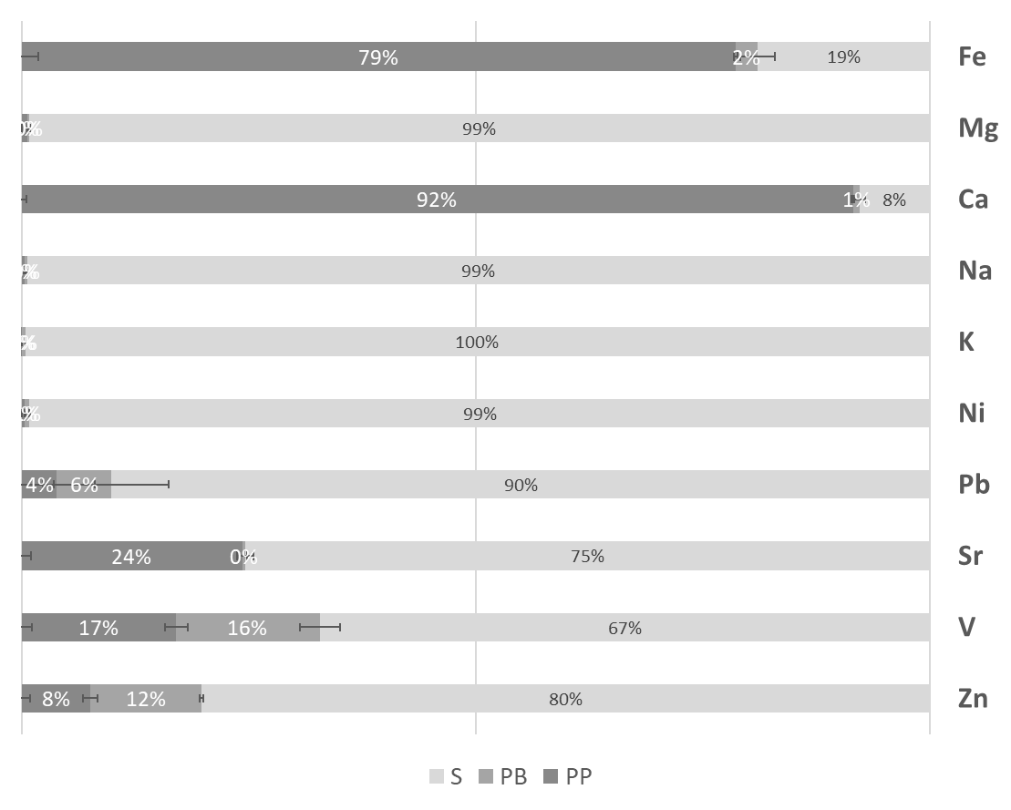 | b)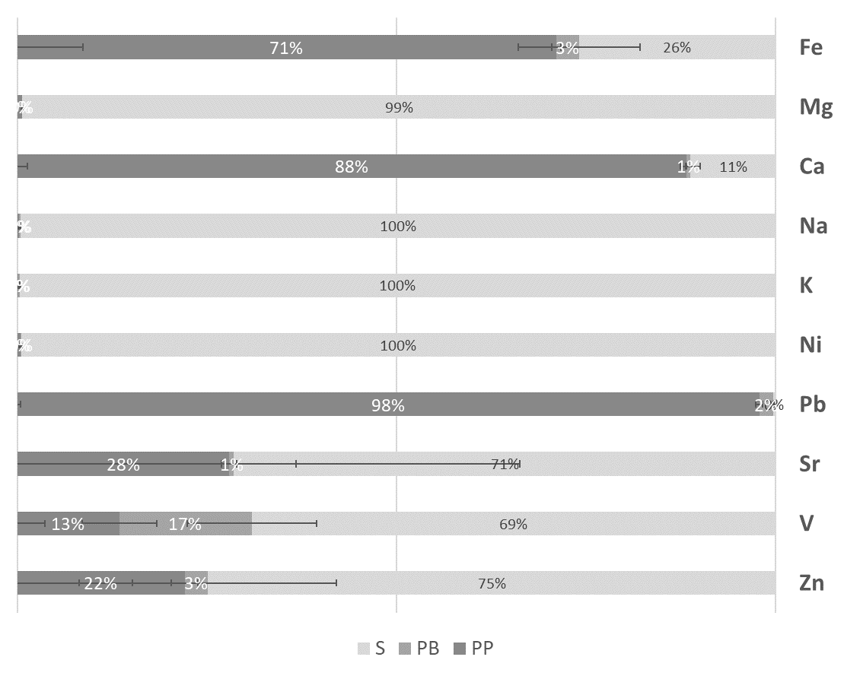
Figure S7: Elemental fractions into supernatant (S), pellet of biomass (B), and pellet of precipitate (P), as a relative percentage of element recovery by ICP-MS. (a) Growth of PG22 supplemented with urea and CaCl₂. (b) Growth of PG22 supplemented with urea, CaCl_{2,} and Pb(NO₃)₂.
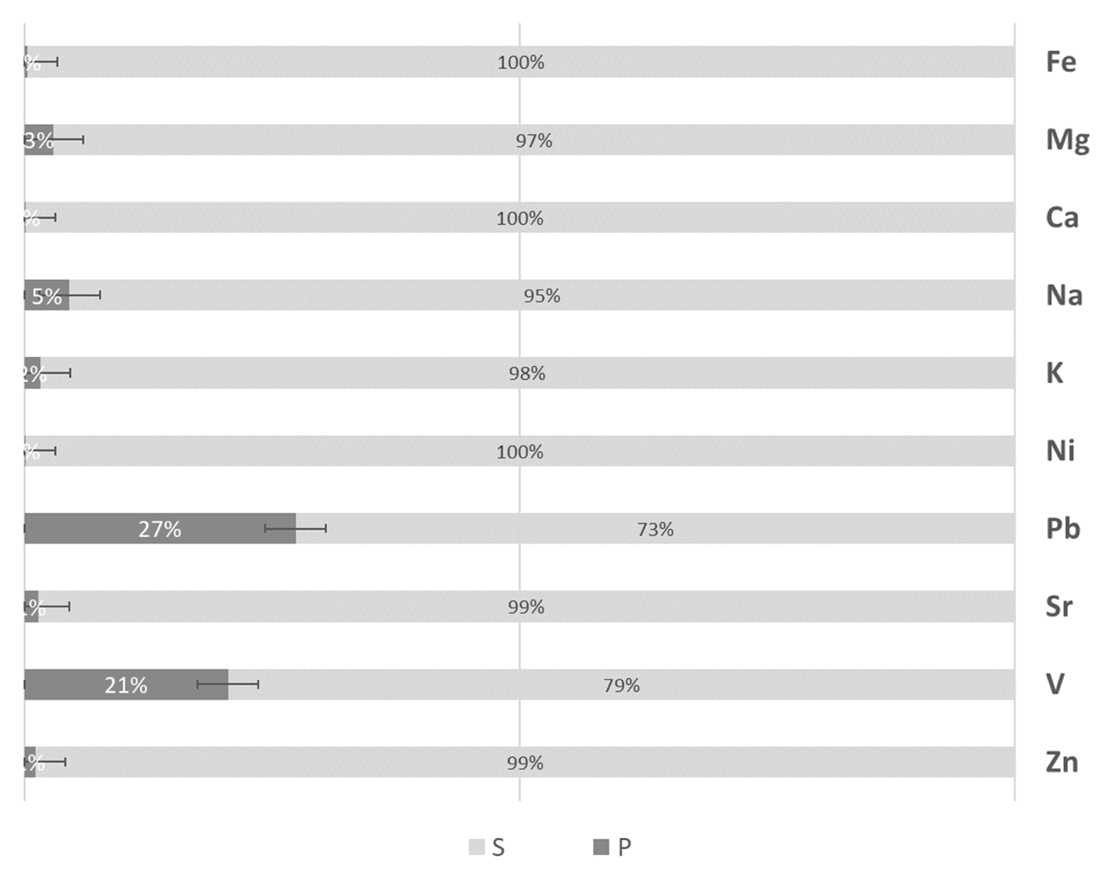
Figure S8: Relative elemental abundances into supernatant (S) and precipitate (P), as a relative percentage of element recovery by ICP-MS from control experiments with Pb(NO₃)₂ and CaCl₂.

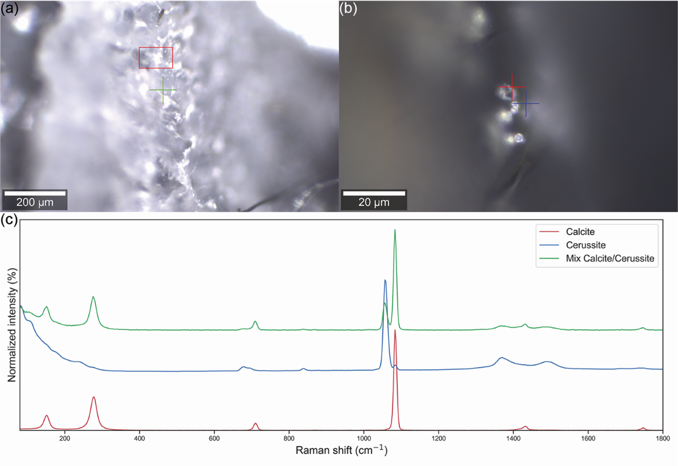
Figure S9: Example of confocal Raman microspectrometry analysis carried out on the mineral precipitates of PG22 grown in presence of Ca, Pb, and urea. (a) 20× picture of a large precipitate deposit. (b) Zoom of the region marked with red rectangle in panel (a). (c) Typical Raman spectra collected on the sample. The colours of the spectra match those of the crosses in panels (a) and (b).

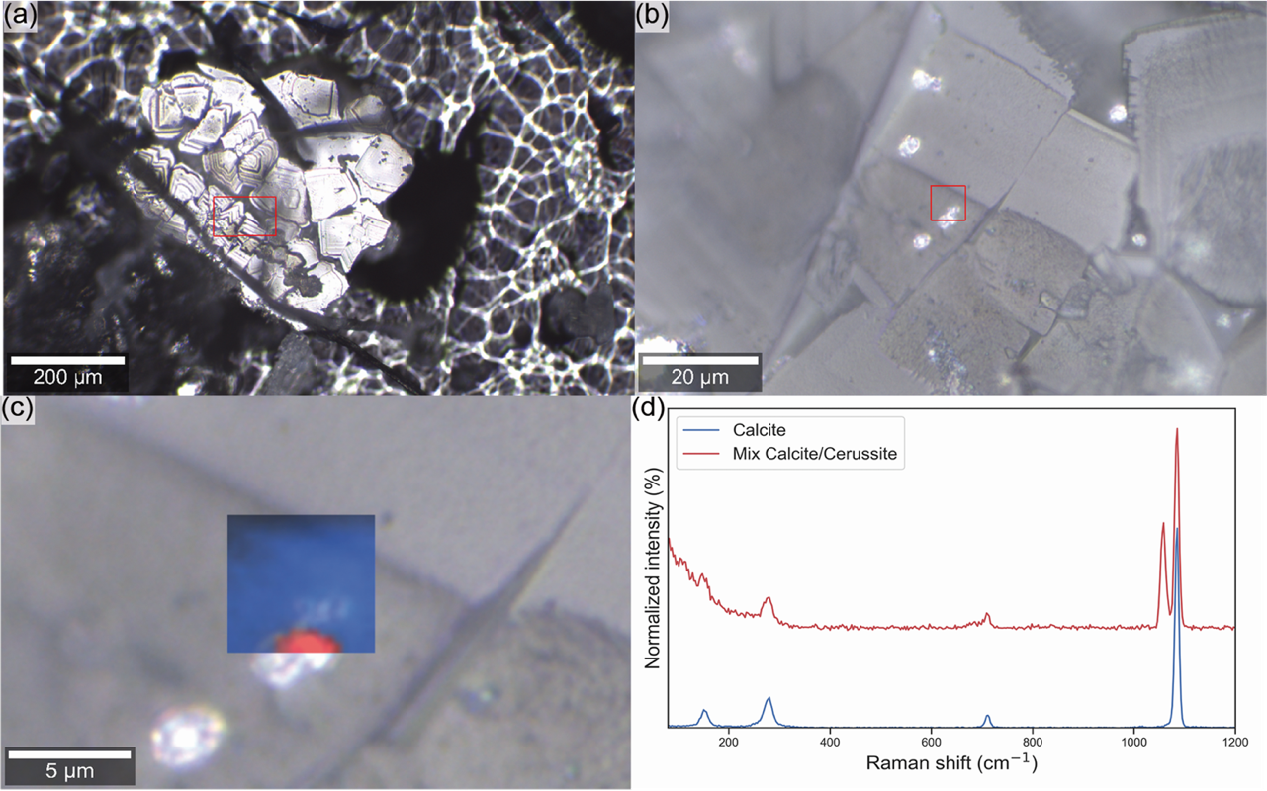
Figure S10: (a) Raman microspectrometry analysis of a large assemblage of calcite precipitates. (b) Magnification of the area marked with red rectangle in panel (a). (c) 6 µm × 6 µm Raman map (20 points × 20 lines, 300nm resolution) of a selected region where small bright particles can be seen on the calcite precipitate. (d) representative spectra of the blue and red areas shown in panel (c), with the colours of the spectra matching those of the map.

Spores’ formation and viability
The potential involvement of Lysinibacillus sphaericus PG22 spores in MICP has been evaluated trough sporulation and viability assays (Chen et al. 2024). Specifically, we have observed via microscopy that lyophilization induces spores' formation as reported in literature, and that these spores are then able to perform MICP (paragraph 3.3 page 11, line 25-29). Briefly, 15 mg/ml of freeze-dried PG22 biomass was resuspended in sterile water. A first aliquot was directly observed with a Zeiss Axio Observer A1 Colibri 2 Fluorescence Phase Contrast Microscope System 100X oil immersion objective (Fig. S11a), while a second one was observed after treatment at 80°C for 30 min to kill all the vegetative cells (Fig. S11b). Both the samples showed high abundance of endospores. The treated sample was serially diluted up to 10⁻⁷, and 0.1 mL from each dilution was spread onto LB agar plates, incubated at 28 °C for 24–48 hours, and CFU counts recorded. Spores resulted in viable colonies with a concentration 1*10⁸ CFU/mL. Two control sample of non-freeze-dried PG22, normally grown in MB for 24 and 48 h at 28°C and 150 rpm were tested for sporulation and viability resulting negative for both the assays.

Figure S11: Phase Contrast Microscope, Pictures of freeze-dried PG22 biomass pre (a) and post (b) heat shock treatment highlighting the presence of endospores in both the samples.
We have also performed microscopy investigations on PG22 incubated with 1600 ppm of Pb(NO₃)₂ and observed that such condition also induces spores' formation. In this case, a single colony was incubated in MB at 28°C with shaking at 150 rpm for 24 h. The bacterial suspension was then collected by centrifugation at 3000 g for 5 min, and the pellet resuspended in three conditions: a) Tris-HCl pH 8 20 mM and Pb(NO₃)₂ 1600 ppm; b) Tris-HCl pH 8 20 mM and CaCl₂ 20 mM; c) Tris-HCl pH 8 20 mM and urea 300 mM. After 24 h of incubation at 28°C with shaking at 150 rpm an aliquot was observed at the microscope. Results confirmed the presence of spores in conditions a and b, while active vegetative cells were observed in condition c (Fig. S12).

Figure S12: Phase Contrast Microscope, Pictures of PG22 bacterial suspension in presence of Pb(NO₃)₂ (a), CaCl₂ (b), and urea (c). In (a), the sample is predominantly composed of spores; in (b), a mixture of free spores and cell agglomerates is visible; while in (c), motile vegetative cells are the dominant form.
Spores’ formation in lyophilizate samples corroborate the hint they could guarantee process efficiency over time and in extreme conditions. Moreover, Figure S12 confirm our hypotheses that spores have a potential involvement in Pb-carbonates precipitation.

References:
Ghani, J., Toller, S., Dinelli, E., & Funari, V. 2023. Impact and recoverability of metals from waste: a case study on bottom ash from municipal solid waste incineration plants. https://doi.org/10.3389/fenvs.2023.1252313
Chen, H., Wang, X., Li, C. et al. 2024. Characterization of individual spores of two biological insecticides, Bacillus thuringiensis and Lysinibacillus sphaericus, in response to glutaraldehyde using single-cell optical approaches. Arch Microbiol 206, 227. https://doi.org/10.1007/s00203-024-03941-5

