SUPPLEMENTARY MATERIALS
Table S1. Search dates
Database / source | Last search date
Medline | 2 Dec 2019
Embase | 2 Dec 2019
Cochrane Central Register of Controlled Studies | 2 Dec 2019
Clinicaltrials.gov / EU-CTR | 22 Dec 2019
Search for conference abstracts:  Conference abstract books of 2017–2019 | 03–13 Mar 2020

Table S2. Search terms
Search location | Search category | Search term categories
Medline (Ovid), incl. Medline in Process, PubMed Not Medline, In Data Review, Publisher | Haemophilia A | exp Haemophilia A/  (h?emophilia a OR h?emophilia type a).ti,ab,kf.  (classical h?emophilia OR classic h?emophilia).ti,ab,kf.  ((factor viii or factor 8) adj4 deficienc$).ti,ab,kw.  (h?emophilia not h?emophilia b).ti.  (h?emophiliacs OR h?emophiliac patients).ti,kw.
 | Pharmaceutical Treatment (Prophylaxis) | exp Haemophilia A/pc, tu, th, dt  exp factor VIII/  Factor viii$.nm.  Recombinant Factor viii$.nm.  blood coagulation factors/tu  factor replacement.ti,ab.  (factor viii or fviii).ti,ab,kf.  (antih?emophilic factor$ or anti-h?emophilic factor$).ti,ab,kf.  (Prophylaxis or prophylactic).ti,kf.  (Prophylaxis or prophylactic).ab/freq=2  (immunate$3 or optivate$3 or haemoctin$3 or beriate$3 or haemate p$3 or octanate$3 or octanate lv$3 or wilate$3 or  recombinate$3 or factane$3 or emoclot$3 or fanhdi$3 or wilnativ$3 or octafil$3 or amofil$3 or humaclot$3 or talate$3 or  alphanate$3 or emowil$3 or klott$3 or aafact$3 or bioclate$3 or biostate$3 or wilate$3 or fibrogammin$ or voncento$ or  recombinate$3).ti,ab,kw.  f8 protein, human.nm.  (octocog alfa$ or octocog alpha$).ti,ab,kf,nm.  (bay 81-8973 or bay 818973 or bay81-8973 or bay w 6240 or rahf-pfm or bay14-2222 or bay 14-2222 or bay 142222 or  bay79-4980 or bay 79-4980 or bay 794980).ti,ab,kw,nm.  (helixate$ or iblias$3 or kogenate$ or kovaltry$3 or advate$3).ti,ab,kw.  p89dr4ny54.rn.  recombinant factor viii n8.nm.  (turoctocog alfa$ or turoctocog alpha$).ti,ab,kf,nm.
 | Clinical Trials (Phase II, III, IV, Controlled and  Uncontrolled), incl. Single Arm Studies, Open-Label Trials | Exp randomized controlled trial/ or controlled clinical trial/ or randomi?ed.mp. or placebo.mp. or clinical trials as topic/ or  randomly.ti,ab. or trial.ti.  (no#-randomi#ed adj5 (trial$ or study or studies or design)).mp.  (non-rct or nrct or cct or rct).ti,ab,kw.  ((non-controlled or uncontrolled or controlled) adj5 (trial$ or study or design)).ti,ab  (Single adj2 arm).ti,ab,kf.  (clinical trial or clinical trial, phase ii or clinical trial, phase iii or clinical trial, phase iv).pt.  ((phase 2 or phase 3 or phase 4 or phase I$3) adj5 (trial or study or design)).ti,ab.  ((phase 2$ or phase 3$ or phase 4$ or phase I$3) and (trial or study or design)).kf.  multicenter study.pt.  (multi cent## study or single cent## study).ti,ab.  open label.ti,ab,kf.  (open adj4 (trial or study or design)).ti,ab.  parallel group?.ti,ab,kf.  (crossover or cross over).ti,ab,kf.  Exp Product Surveillance, Postmarketing/  Adverse Drug Reaction Reporting Systems/  (post-marketing surveillance or post-marketing stud$3 or post-marketing drug surveillance or postmarketing surveillance or postmarketing stud$3 or postmarketing drug surveillance or post licensing surveillance or post licensing stud$3 or post licensing drug surveillance or post licensure surveillance or post licensure stud$3 or post licensure drug surveillance or pharmacovigilance or postlicensing surveillance or postlicensing stud$3 or postlicensing drug surveillance or postlicensure surveillance or postlicensure stud$3 or postlicensure drug surveillance or pharmacovigilance).kw.  (post-marketing or postmarketing or post licen$ or postlicen$ or pharmacovigilance).ti,ab,kf.  (adverse adj3 report$).ti,ab.  …not (exp animals/ not humans.sh.)
 | Registries | Exp registries/  (registry or registries or register$1 or disease regist$).kw.  (registries or registry or disease regist$3 or register$1 or national regist$ or h?emophilia regist$).ti,ab,kw.  (h?emophilia adj2 database$).ti,ab.  ... not (exp animals/ not humans.sh.)
 | Factual Databases, Electronic Health Records etc. | Databases, Factual/  Exp Electronic Health Records/  insurance claim review/  (real-world or real life).ti.  ((real world or real life) adj3 (data$ or setting or cohort$ or stud$ or experience$ or result$)).ti,ab.  (Database analys#s or database stud$ or claims data).ti,ab,kw.  (data adj (report$ or data system$1)).ti,ab.  (chart review or medical record review or (review adj5 patient records)).ti,ab.  (Claims data or health care database$ or claims database$ or health insurance database$ or health insurance claim$ or  health insurance research database$).ti,ab,kw.  (Health insurance adj5 database$).ti,ab.  … not (exp animals/ not humans.sh.)
 | Observational Studies, Surveys | Cross-sectional studies/  case control studies/  exp cohort studies/  Follow-Up Studies/  Retrospective Studies/  Controlled Before-After Studies/  observational studies as topic/ or observational study/  pragmatic clinical trial/ or Adaptive Clinical Trial/  Comparative Study/  (Long-term or observational or cohort? or longitudinal or prospective or retrospective or comparative or case-control or followup or follow-up or comparative or cross-sectional).ti.  (cohort analys$ or cohort stud$ or longitudinal stud$ or chart review$ or medical record review$ or observational stud$ or retrospective analys$ or retrospective chart review? or retrospective clinical stud$ or retrospective cohort$ or retrospective stud$ or retrospective database$ or retrospective observational$ or case control stud$ or case control setting or nested case control stud$ or matched case-control stud$ or case series or pragmatic stud$ or followup stud$ or follow-up stud$ or Follow-up or followup or open label extension stud$3 or cross-sectional stud$ or cross-sectional survey).kf.  ((Cohort or Case control or longitudinal or retrospective or pragmatic or adaptive) adj2 (study or studies)).ti,ab.  ((observational or prospective) adj3 (study or studies or cohort$1 or data$ or clinical or analys#s)).ti,ab.  ((Population-based or nationwide or community based) adj2 (study or studies or cohort$1 or survey$1)).ti,ab.  (pre-post intervention stud$3 or pre-post stud$3).ti,ab.  Health Surveys/ or health care surveys/  (health survey$1 or health care survey$1 or medical care survey$1 or treatment survey$1 or national survey$ or  survey$1).ti,kw.  ... not (exp animals/ not humans.sh.)
Embase | Haemophilia A | exp Haemophilia A/  (h?emophilia a OR h?emophilia type a).ti,ab,kw.  (classical h?emophilia OR classic h?emophilia).ti,ab,kw.  ((factor viii or factor 8) adj4 deficienc$).ti,ab,kw.  (h?emophilia not h?emophilia b).ti.  (h?emophiliacs OR h?emophiliac patients).ti
Embase | Pharmaceutical Treatment (Prophylaxis) | exp haemophilia A/dm, dt, pc  Exp blood clotting factor 8/ or Exp blood clotting factor 8a/  exp recombinant blood clotting factor 8/  Exp blood clotting factor 8 concentrate/  exp blood clotting factor 8 derivative/  Prophylaxis/  (Prophylaxis or prophylactic).ti.  (Prophylaxis or prophylactic).ab/freq=2  (immunate$3 or optivate$3 or haemoctin$3 or beriate$3 or haemate p$3 or octanate$3 or octanate lv$3 or wilate$3 or  recombinate$3 or factane$3 or emoclot$3 or fanhdi$3 or wilnativ$3 or octafil$3 or amofil$3 or humaclot$3 or talate$3 oralphanate$3 or emowil$3 or klott$3 or aafact$3 or bioclate$3 or biostate$3 or wilate$3 or fibrogammin$ or voncento$ or  recombinate$3).ti,ab,kw,tn.  ((factor viii or fviii or "factor 8") and (treatment or therapy or treated or regimen$ or concentrate$ or recombinanti or dose$ or dosing or prophylaxis or prophylactic or agent$ or medication$ or infusion$ or (adverse adj2 effect$) or complication$ or plasma-derived or pain or joint health or treatment burden or adherence or physical activity or quality of life or QoL or  HRQoL)).ti,ab.  (factor viii product or fviii product or factor 8 product).ti,ab,kw.  (recombinant factor viii or recombinant fviii or "recombinant factor 8").ti,ab,kw.  (rfviii or r-fviii or rhfviii).ti,ab,kw.  rahf-pfm.ti,ab.  (antih?emophilic factor$ or anti-h?emophilic factor$).ti,ab,kw.  (octocog alfa$ or octocog alpha$).ti,ab,kw,tn.  (bay 81-8973 or bay 818973 or bay81-8973 or bay w 6240 or rahf-pfm or bay14-2222 or bay 14-2222 or bay 142222 or  bay79-4980 or bay 79-4980 or bay 794980).ti,ab,kw.  (helixate$ or iblias$3 or kogenate$ or kovaltry$3 or advate$3).ti,ab,kw,tn.  139076-62-3.rn.  (turoctocog alfa$ or turoctocog alpha$).ti,ab,kw,tn.  (nn7008 or nn 7008 or n8-gp or nn-7088 or nn7088 or NN 7170).ti,ab,kw.  (novoeight$3 or zonovate$3 or esperoct$).ti,ab,kw,tn.  (1192451-26-5 or 1309086-46-1).rn.  (moroctocog alfa$ or moroctocog alpha$).ti,ab,kw,tn.  (pf-05208756 or pf-5208756 or bddrfviii).ti,ab,kw.  (refacto? or xyntha$3).ti,ab,kw,tn.  284036-24-4.rn.  (efmoroctocog alfa$ or efmoroctocog alpha$ or efraloctocog alfa$ or efraloctocog alpha$).ti,ab,kw,tn.  (biib031 or biib 031 or rfviiifc).ti,ab,kw.  (Elocta$3 or Eloctate$3).ti,ab,kw,tn.  284036-24-4.rn.  (simoctocog alfa$ or simoctocog alpha$).ti,ab,kw,tn.  nuwiq$3.ti,ab,kw,tn.  1219013-68-9 .rn.  (lonoctocog alfa$ or lonoctocog alpha$).ti,ab,kw,tn.  (CSL627 OR CSL-627 OR NBP-601 OR NBP601).ti,ab,kw.  Afstyla$.ti,ab,kw,tn.  1388129-63-2.rn.  (Rurioctocog alfa$ or rurioctocog alpha$).ti,ab,kw,tn  (bax 855 or bax855 or SHP-660).ti,ab,kw.  (Adynovate$ or Adynovi$).ti,ab,kw,tn.  1417412-83-9.rn.  (Damoctocog alfa$ or damoctocog alpha$).ti,ab,kw,tn.  (bay94-9027 or bay 94-9027 or bay 949027).ti,ab,kw.  Jivi$3.ti,ab,kw,tn.  1363853-26-2.rn.  (beroctocog alfa$ or beroctocogt alpha$ or greengene$3).ti,ab,kw,tn.  Marstacimab/  (marstacimab or pf-06741086 or pf-05280602 or pf-528060 2).ti,ab,kw,tn.  1985638-39-8.rn.  (sct800 or sct 800).ti,ab,kw.  desmopressin/  (desmopressin or ddavp or minirin$3 or stimate$).ti,ab,kw,tn.  antifibrinolytic agent/  tranexamic acid/ or tranexamic acid.ti,ab,tn.  aminocaproic acid/ or aminocaproid acid.ti,ab,tn.
Embase | Clinical Trials (Phase II, III, IV, Controlled and  Uncontrolled), incl. Single Arm Studies, Open-Label Trials | clinical trial/  randomized controlled trial/  controlled clinical trial/  Placebo/  Crossover Procedure/  (rct OR random$).ti,ab.  (((single or double or treble or triple) adj (blind$ or mask$)) and (trial$ or study or rct or cct)).ti,ab.  Placebo$.ti,ab.  Phase 2 clinical trial/ or Phase 3 clinical trial/ or Phase 4 clinical trial/  (no#-randomi#ed adj5 (trial$ or study or studies or design)).mp.  (non-rct or nrct or cct or rct).ti,ab,kw.  ((non-controlled or uncontrolled or controlled) adj5 (trial$ or study or design)).ti,ab  ((Single adj2 arm) and (trial$ or study or design)).ti,ab  ((phase 2 or phase 3 or phase 4 or phase I$3) adj5 (trial or study or design)).ti,ab.  open label.ti,ab.  (open adj4 (trial or study or design)).ti,ab.  parallel group?.ti,ab.  (crossover or cross over).ti,ab.  exp postmarketing surveillance/  exp drug surveillance program/  (post-marketing surveillance or post-marketing stud$3 or post-marketing drug surveillance or postmarketing surveillance or postmarketing stud$3 or postmarketing drug surveillance or post licensing surveillance or post licensing stud$3 or post licensing drug surveillance or post licensure surveillance or post licensure stud$3 or post licensure drug surveillance or pharmacovigilance or postlicensing surveillance or postlicensing stud$3 or postlicensing drug surveillance or postlicensure  surveillance or postlicensure stud$3 or postlicensure drug surveillance or pharmacovigilance).ti,od,dj,kw.  (post-marketing or postmarketing or post licen$ or postlicen$ or pharmacovigilance).ti,ab,ox,dq,kw.  (adverse adj3 report$).ti,ab.  …not (exp animal/ not exp human/)
Embase | Registries | Disease registry/  register/  (registries or registry or disease regist$3 or register$1 or national regist$ or h?emophilia regist$).ti,ab,kw.  (h?emophilia adj2 database$).ti,ab.  …not (exp animal/ not exp human/)
Embase | Factual Databases, Electronic Health Records etc. | Factual database/  Electronic Health Records/  exp "medical record review"/  (real-world or real life).ti.  ((real world or real life) adj3 (data$ or setting or cohort$ or stud$ or experience$ or result$)).ti,ab.  (data adj (report$ or data system$1)).ti,ab.  (chart review or medical record review or (review adj5 patient records) or electronic health records).ti,ab.  (Database analys#s or database stud$ or claims data$ or cancer database$ or tumo?r database$).ti,ab.  (Claims data or health care database$ or claims database$ or health insurance database$ or health insurance claim$ or  health insurance research database$).ti,ab,kw.  (Health insurance adj5 database$).ti,ab.  …not (exp animal/ not exp human/)
Embase | Observational Studies, Surveys | prospective study/  Pragmatic Trial/ or Adaptive clinical Trial/  cohort analysis/  longitudinal study/  observational study/  retrospective study/  Major clinical study/  comparative study/ or Controlled Study/  Exp case control study/  cross-sectional study/  Family study/  Follow up/(Long-term or observational or cohort? or longitudinal or prospective or retrospective or comparative or case-control or followup or follow-up or comparative or cross-sectional).ti.  ((follow-up or followup) adj (study or studies)).ti,ab. and (article-in-press or conference abstract or in-process).st.  Cohort$.ti,ab. and (article-in-press or conference abstract or in-process).st.  ((longitudinal or case-control or pragmatic or adaptive) adj (study or studies)).ti,ab. and (article-in-press or conference abstract or in-process).st.  ((observational or retrospective or prospective) adj3 (study or studies or cohort$1 or data$ or clinical or analys#s)).ti,ab. and (article-in-press or conference abstract or in-process).st.  (Open label extension or open-label trial or open label study).ti,ab.  Health survey/  (health survey$1 or health care survey$1 or medical care survey$1 or treatment survey$1 or national survey$ or  survey$1).ti,kw.  …not (exp animal/ not exp human/)
Cochrane Central Register of  Controlled Trials | Haemophilia A | exp Haemophilia A/  (h?emophilia a OR h?emophilia type a).ti,ab,kw.  (classical h?emophilia OR classic h?emophilia).ti,ab,kw  ((factor viii or factor 8) adj4 deficienc$).ti,ab,kw.  (h?emophilia not h?emophilia b).ti.  (h?emophiliacs OR h?emophiliac patients).ti,kw.
Cochrane Central Register of  Controlled Trials | Pharmaceutical Treatment (Prophylaxis) | exp Haemophilia A/pc, tu, th, dt  exp factor VIII/  blood coagulation factors/tu  coagulants/  factor replacement.ti,ab.  (factor viii or fviii).ti,ab,kw.  (antih?emophilic factor$ or anti-h?emophilic factor$).ti,ab,kw.  (Prophylaxis or prophylactic).ti,kw.  (Prophylaxis or prophylactic).ab/freq=2  (immunate$3 or optivate$3 or haemoctin$3 or beriate$3 or haemate p$3 or octanate$3 or octanate lv$3 or wilate$3 or  recombinate$3 or factane$3 or emoclot$3 or fanhdi$3 or wilnativ$3 or octafil$3 or amofil$3 or humaclot$3 or talate$3 or  alphanate$3 or emowil$3 or klott$3 or aafact$3 or bioclate$3 or biostate$3 or wilate$3 or fibrogammin$ or voncento$ or  recombinate$3).ti,ab,kw.  (octocog alfa$ or octocog alpha$).ti,ab,kw.  (bay 81-8973 or bay 818973 or bay81-8973 or bay w 6240 or rahf-pfm or bay14-2222 or bay 14-2222 or bay 142222 or  bay79-4980 or bay 79-4980 or bay 794980).ti,ab,kw.  (helixate$ or iblias$3 or kogenate$ or kovaltry$3 or advate$3).ti,ab,kw.  (turoctocog alfa$ or turoctocog alpha$).ti,ab,kw.  (nn7008 or nn 7008 or n8-gp or nn-7088 or nn7088 or NN 7170).ti,ab,kw.  (novoeight$3 or zonovate$3 or esperoct$).ti,ab,kw.  (moroctocog alfa$ or moroctocog alpha$).ti,ab,kw.  (pf-05208756 or pf-5208756 or bddrfviii).ti,ab,kw.  (refacto? or xyntha$3).ti,ab,kw.  (efmoroctocog alfa$ or efmoroctocog alpha$ or efraloctocog alfa$ or efraloctocog alpha$).ti,ab,kw  (biib031 or biib 031 or rfviiifc).ti,ab,kw.  (Elocta$3 or Eloctate$3).ti,ab,kw.  (simoctocog alfa$ or simoctocog alpha$).ti,ab,kw.  nuwiq$3.ti,ab,kw.  (lonoctocog alfa$ or lonoctocog alpha$).ti,ab,kw.  (CSL627 OR CSL-627 OR NBP-601 OR NBP601).ti,ab,kw.  Afstyla$.ti,ab,kw.  (Rurioctocog alfa$ or rurioctocog alpha$).ti,ab,kw.  (bax 855 or bax855 or SHP-660).ti,ab,kw.  (Adynovate$ or Adynovi$).ti,ab,kw.  (Damoctocog alfa$ or damoctocog alpha$).ti,ab,kw  (bay94-9027 or bay 94-9027 or bay 949027).ti,ab,kw  (beroctocog alfa$ or beroctocogt alpha$ or greengene$3).ti,ab,kw.  (marstacimab or pf-06741086 or pf-05280602 or pf-528060 2).ti,ab,kw.  (sct800 or sct 800).ti,ab,kw.  deamino arginine vasopressin/  (desmopressin or ddavp or minirin$3 or stimate$).ti,ab,kw.  antifibrinolytic agents/  tranexamic acid/ or aminocaproic acid/  (tranexamic acid or aminocaproic acid).ti,ab,kw.

Overview of observational studies with ABR outcomes
Study | Cohort description | Country | Data collection period | Observational period | Outcomes |  | Outcome result
 |  |  |  |  | Overall | Joint | Overall | Joint
Europe
Berntorp, 2017 | People with severe haemophilia A (n = 24) | Belgium | 2012–2014 | 1 year | ABR, Mean (SD); Median (range); [ABRs estimated based on the total number of bleeds perceived by each individual during 12 months] | AJBR, Mean (SD); Median (range) | 4.1 (6.9); 1.0 (0–6) | 3.4 (5.7); 1.0 (0–5)
Berntorp, 2017 | People with moderate haemophilia A (n = 4) |  |  |  |  |  | 9.0 (8.9); 8.0 (2–16) | 9.0 (8.9); 8.0 (2–16)
Berntorp, 2017 | People with severe haemophilia A (n = 34) | France |  |  |  |  | 8.0 (9.4); 4.0 (1–12) | 5.5 (7.5); 2.5 (1–6)
Berntorp, 2017 | People with moderate haemophilia A (n = 1) |  |  |  |  |  | 5.0; 5.0 (5–5) | 2.0; 2.0 (2–2)
Berntorp, 2017 | People with severe haemophilia A (n = 106) | Germany |  |  |  |  | 4.5 (5.3); 2.0 (1–6) | 1.7 (2.4); 1.0 (0–2)
Berntorp, 2017 | People with severe haemophilia A (n = 93) | Italy |  |  |  |  | 2.8 (4.7); 1.0 (0–4) | 1.8 (4.3); 0.0 (0–1)
Berntorp, 2017 | People with moderate haemophilia A (n = 18) |  |  |  |  |  | 4.6 (5.0); 2.5 (1–8) | 2.8 (3.4); 2.0 (0–4)
Berntorp, 2017 | People with severe haemophilia A (n = 19) | Spain |  |  |  |  | 2.7 (2.5); 2.0 (1–3) | 1.4 (2.1); 1.0 (0–2)
Berntorp, 2017 | People with moderate haemophilia A (n = 1) |  |  |  |  |  | 3.0; 3.0 (3–3) | 1.0; 1.0 (1–1)
Berntorp, 2017 | People with severe haemophilia A (n = 75) | Sweden |  |  |  |  | 1.9 (2.9); 1.0 (0–2) | 1.2 (2.5); 0.0 (0–1)
Berntorp, 2017 | People with moderate haemophilia A (n = 19) |  |  |  |  |  | 1.9 (2.2); 2.0 (0–2) | 1.1 (1.6); 0.0 (0–2)
Berntorp, 2017 | People with severe haemophilia A (n = 126) | UK |  |  |  |  | 5.8 (7.0); 4.0 (1–7) | 4.0 (5.4); 2.0 (0–6)
Berntorp, 2017 | People with moderate haemophilia A (n = 62) |  |  |  |  |  | 7.1 (14.3); 4.0 (1–7) | 5.3 (11.4); 2.0 (0–6)
Scott, 2019 | People with severe haemophilia A (n = 465) | UK | 2015 | 1 year | ABR, Median (IQR) | AJBR, Median (IQR) | 2.0 (0.0–7.0) | 1.0 (0.0–4.0)
Scott, 2019 | People with moderate haemophilia A (n = 106) |  |  |  |  |  | 3.0 (1.0–7.0) | 2.0 (0.0–5.0)
Altisent, 2016 | Early prophylaxis in children with severe haemophilia A (n = 25) | Spain | 2009–2014 | 5 years | NR | AJBR, Median (range); (IQR) |  | 0.2 (0–1.1); (0–0.5)
Table S3. Characteristics of included observational studies
US
Watt, 2018 | SHL prophylaxis in HA people (n = 40) | US | NR | NR | ABR, Mean | NR | 5.7 | NR
Watt, 2018 | EHL prophylaxis in HA people (n = 5) |  |  |  |  |  | 6.2 | NR
Watt, 2018 | BAX 855 prophylaxis in HA people (n = 57) |  |  |  |  |  | 1.7 | NR
Feldman, 2018 | Primary prophylaxis for severe haemophilia A people (n = 56) | US | November 2015–September 2018 | NR | NR | AJBR, Median (IQR; range) | NR | 0.95 (0.44–1.35; 0.00–13.43)
 |  |  |  |  |  | ABR for other hemarthroses, Median (IQR; range) | NR | 0.11 (0.00–0.30; 0.00–1.76)
Milligan, 2019 | Moderate-severe HA people on prior therapy (n = 47) | US | November 2015–September 2018 | NR | ABR | NR | 3.1 | NR
Milligan, 2019 | Moderate-severe HA people after switch to SHP660, BAX 855 (EHL) (n = 47) |  |  |  |  |  | 1.7 | NR
South America
Mora, 2018 | People with moderate-severe haemophilia A on BAY 81-8973 routine prophylaxis (twice or three times weekly)  (n = 9) | Colombia | NR | NR | ABR, Median | NR | 1 | NR
Asia
Yao, 2017 | Pediatric people with severe haemophilia A on primary prophylaxis  (n = 3) | China | 2007–2013 | The primary, secondary and tertiary prophylaxes were analyzed between the treatment periods of >24 and <24 weeks | ABR, Median baseline (min-max) | AJBR, Median baseline (min-max) | 0.0 (0.0–0.9) | 0 (0.0–0.0)
Yao, 2017 | Pediatric people with severe haemophilia A on secondary prophylaxis  (n = 21) |  |  |  |  |  | 1.9 (0.0–12.6) | 0.8 (0.0–9.7)
Yao, 2017 | Pediatric people with severe haemophilia A on tertiary prophylaxis  (n = 33) |  |  |  |  |  | 9.0 (0.0–50.3) | 5.1 (0.0–45.2)
Li, 2017 | Pediatric people with severe haemophilia A overall (n = 90),  joint (n = 59) | China | 2007–2013 | NR | ABR, Mean (SD) | AJBR, Mean (SD) | 8.44 (10.9) | 4.91 (8.11)
Taki, 2019 | Previously untreated people with haemophilia A (n = 53) | Japan | 2007–2013 | 6 years | ABR, Mean (SD); Median (IQR) | NR | 7.2 (7.58); 5.2 (2.3–9.3) | NR
International
Su, 2018 | Severe haemophilia A people on prophylaxis with rFVIII (n = 51) | International | 2014–2015 | 1 year | ABR | NR | 2.75 | NR
Su, 2018 | Severe haemophilia A people on prophylaxis with rFVIIIFc (EHL)  (n = 45) |  |  |  |  |  | 1.78 | NR
Khair, 2018 | People with moderate-severe haemophilia A;  1st year (n = 353),  2nd year (n = 244),  3rd year (n = 177),  4th year (n = 103) | International | NR | 4 years | ABR in year 1, Median | AJBR in year 1, Median | 1.7 | 0.9
 |  |  |  |  | ABR in year 2, Median | AJBR in year 2, Median | 1.3 | 1.0
 |  |  |  |  | ABR in year 3, Median | AJBR in year 3, Median | 1.5 | 1.0
 |  |  |  |  | ABR in year 4, Median | AJBR in year 4, Median | 1.0 | 0.0
Kruse, 2019 | People with severe haemophilia A (n = 49) | International | 4/4/2016–22/7/2016 | 24 weeks | ABR, Mean (95% CI);  Median (IQR);  ABR (95% CI) [based on negative binomial regression model] | NR | 6.2 (4.2–9.2);  2.7 (0.0–9.4) | NR
Overview of observational studies with proportion of participants with zero bleeding events
Study | Population | Country | Data collection period | Observational period | Definition of outcome |  | Bleeding result
Altisent, 2016 | Early prophylaxis in children with severe haemophilia A (n = 25) | Spain | 2009–2014 | 5 years | Participants without joint bleeds, n (%) |  | 7 (28.0)
Kruse, 2019 | People with severe haemophilia A (n = 49) | International | 04/04/2016–22/07/2016 | 24 weeks | Proportion of participants with zero bleeding events, % (95% CI) |  | 32.7 (19.9–47.5)
Saxena, 2017 | Prophylaxis 2x per week (n = 6) | International | NR | NR | Participants without bleeds, % |  | 35.3
Saxena, 2017 | Prophylaxis 2x per week (n = 12) |  |  |  |  |  | 31.6
Meunier, 2017 | Children with severe haemophilia A  (n = 68) | International | NR | NR | Participants without bleeds, % |  | 42.6
Ljung, 2016 | People aged <6 years, Prophylaxis (n = 25) | International | NR | NR | Participants without bleeds, % |  | 40.0
Ljung, 2016 | People aged 6–<12 years, Prophylaxis (n = 26) |  |  |  |  |  | 50.0
Chuansumrit, 2018 | Previously treated Thai people with severe and moderate haemophilia A (n = 50) | Thailand | January 2016–December 2017 | NR | Participants without bleeds, % |  | 48.0
Sajeev, 2017 | Q2W prophylaxis  (n = 18) | International | NR | NR | Participants without bleeds, % |  | 33.3
Sajeev, 2017 | Q3W prophylaxis  (n = 44) |  |  |  |  |  | 22.7
Nolan, 2016 | Individualised prophylaxis groups in ASPIRE | International | Data cut off 06/01/2014 | NR | Subjects experienced zero bleeding events on study, % |  | 38.9
Nolan, 2016 | Weekly prophylaxis groups in ASPIRE |  |  |  |  |  | 22.2
Nolan, 2016 | Modified prophylaxis groups in ASPIRE |  |  |  |  |  | 23.5
Nolan, 2016 | Modified prophylaxis groups in Kids A-Long |  |  |  |  |  | 50.0
Konkle, 2015 | People with severe HA | International | NR | NR | Participants with zero bleeding events, % |  | 39.6
Reding, 2017 | Prophylaxis every 5 days (n = 43) | International | NR | 36 weeks | Participants treated with prophylaxis with zero bleeding events during weeks 11–36, n (%) |  | 19 (44.2)
Reding, 2017 | Prophylaxis every 7 days  (n = 43) |  |  |  |  |  | 16 (37.2)
Reding, 2017 | All prophylaxis  (n = 110) |  |  |  |  |  | 42 (38.2)
Giangrande, 2017 | Severe congenital haemophilia | International | NR | 1.8 years | Participants with no bleeds, n (%) |  | 70 (40.0)
Valentino, 2012 | People with HA | USA and Europe | January 2006–June 2010 | NR | Participants on prophylaxis experiencing no bleeding episodes, n (%) |  | 22 (33.3)

ABR, annualized bleeding rate; AJBR, annualized joint bleeding rate; CI, confidence interval; EHL, extended half-life; Fc, Fragment crystallizable; FVIII, factor VIII; HA, haemophilia A; IU, international units; IQR, interquartile range; NR, not reported; Q2W, every 2 weeks; Q3W, every 3 weeks; Q4W, every 4 weeks;
r, recombinant, SD, standard deviation
Table S4. Characteristics of included interventional studies
Overview of interventional studies with ABR outcomes and/or proportion of participants with zero bleeding events
Study | Cohort description | Country | Data collection period | Observational period | Outcomes
 |  |  |  |  | ABR | AJBR | % with zero bleeding events
Abraham, 2018 | Children between 3-7 years with severe HA (n = 32) | Multi-country | NR | 10 months | Median 0 (0–3) | NR | NR
Auerswald, 2012 | Severe or moderately severe HA children (14 days-6 months) (n = 55) | Multi-country | NR | 3 years | Median 4.83 (0–33.71) | NR | 9.1
Karimi, 2018 | Patients with severe HA  (n = 33) | Iran | 2014–2015 | 1 year | Mean 1.08±2.21 | NR | NR
Apte, 2017 | Patients with severe HA (n = 34) | India | 2016–17 | NR | 3 (3-9)* | NR | NR
Rusen, 2018 | PUPs with severe HA (n = 23)  PTPs with severe HA (n = 37) | Multi-country | PUPs: 2010–2016  PTPs: 2009–2016 | 24 months or 100 exposure days, whichever occurred first | Mean (PUPs) 5.9±8.1  Mean (PTPs) 4.2±3.8 | NR | NR
Kavakli, 2017 | Patients with severe HA (n = 23) | Multi-country | NR | Median 476 days | 5.9±8.08* | NR | NR
Smith, 2018 | Patients with moderate-severe HA (n = 42) | Multi-country | NR | 1 year | Mean (RP segment) 1.5±2.2  Mean (HF) 2.2±4.1  Mean (LF) 3.3±5.3 | NR | NR
Zhao, 2015 | Patients with severe HA (n = 30) | China | NR | NR | Median 0 (0–4) | Median 0 (0–4) | NR
Ledger, 2016 | Patients with severe HA (n = 81) | NR | NR | NR | Median 3.69 (0–7.20) | NR | NR
Mahlangu, 2016 | Patients with severe HA (n = 146) | Multi-country | NR | Up to 24 weeks | Median 1.14 (0–4.2) | NR | 43.2
Mahlangu, 2014 | Patients with severe HA (n=142)  (individualised = 118; weekly = 24) | Multi-country | 2010–2012 | Median (individualised) 32.1 weeks  Median (weekly) 28.0 weeks | Median (individualised) 1.6 (0–4.7)  Median (weekly) 3.6 (1.9–8.4) | NR | 45.3 (individualised)  17.4 (weekly)
Young, 2015 | Patients with severe HA | Multi-country | NR | ≥50 EDs | Median 1.96 (0–27.2) | NR | 46.4
Nolan, 2016 | Patients with severe HA (A-long individualised = 108; weekly prophy = 27; modified prophy = 17; Kids-A-long <6 years = 29; Kids-A-long 6-<12 years = 30) | Multi-country | 2011–2017 | Median 80.9 weeks in A-long Median 23.9 weeks in kids A-long | Median (individualised A-long) 0.66 (0–2.63)  Median (weekly A-long) 2.03 (0.6–4.39)  Median (modified A-long) 1.97 (0.96–7.03)  Median (individualised kids A-long <6) 0 (0–2)  Median (individualised kids A-long <6-<12): 1.54 (0–3.41) | NR | Individualised A-long  38.9  Weekly A-long 22.2  Modified A-long  23.5  Individualised kids A-long 59.3  Modified kids A-long: 50.0
Wu, 2019 | Patients with severe HA (n = 33) | China | 2017–2018 | 12 months | Median (range) 12 (0-48) | Median (range)  3 (0-8) | NR
Mullins, 2019 | Patients with severe HA (n = 216)  (Twice weekly = 215; PK = 25) | US | 2013–2018 | Mean 2.2 years | Mean (Twice weekly) 2.23 (95% CI 1.85–2.69)  Mean (PK) 2.64 (1.70–4.08) | NR | NR
Stasyshyn, 2017 | Patients with severe HA (n = 80) | Multi-country | NR | 5.6 months | Mean 5.5 (95% CI 4.8–6.3) | 3.3 (95% CI 2.7-3.9) | NR
Bayer, 2013 | Children (age <12 years) with severe HA | Multi-country | 2013–2020 | NR | Median (IQR)  Age group <6 years: 2.68 (1.08–6.79)  Age group 6 to <12 years  2.92 (0–6.66) | NR | NR
Klukowska, 2016 | Patients with severe HA (n = 59) | Multi-country | NR | ≥6 months | Mean 4.12±5.22 | Mean 1.53±2.96 | 33.9
Lissitchkov, 2016 | Patients with severe HA (n = 32) | Multi-country | NR | Mean (SD) 6 (0.9) months | Mean 2.28±3.73 | Mean 1.14±1.98 | 50.0
Klukowska, 2018 | Patients with severe HA (n = 49) | Multi-country | NR | Mean 29.2 months | Mean 2.91±4.66 | Mean 0.85±1.39 | 16.3
Lissitchkov, 2017 | Patients with severe HA (n = 65) | Multi-country | NR | Mean 2.7 months | Mean 3.16±7.64 | Mean 0.91±2.40 | 73.8
Octapharma, 2019 | Patients with severe HA (individualised = 56; weekly = 29) | Multi-country | NR | NR | Mean 4.67±6.46  Mean 4.82±6.98 | NR | NR
Lentz, 2013 | Patients with severe HA (n = 150) | Multi-country | NR | 6 months | Mean 6.5 (95% CI 5.3–8.0) | NR | 30.0
Lentz, 2018 | Patients with severe HA (n = 207) | Multi-country | NR | NR | Mean 2.06  (95% CI 2.06–2.89)  Median 1.37  (range: 0.00–17.82) | NR | 17.9
Kulkarni, 2013 | Patients with severe HA (n = 63) | Multi-country | NR | Mean 60 EDs | Mean 5.33 (95% CI 3.90–7.28) | NR | 34.9
Ozelo, 2018 | Patients with severe HA (n = 59) | Multi-country | 2012–2017 | 4.4 years | Mean 4.23 (95% CI 3.17–5.64) | NR | NR
Escuriola-Ettingshausen, 2019 | Patients with severe and moderately severe HA (n = 43) | Multi-country | NR | 1.05 years | Mean 3.92 (95% CI 2.60–5.92) | NR | NR
Sun, 2019 | Patients with severe HA (n = 68) | China | NR | 24 months | Mean (Small children) 2.81 (95% CI 1.67–4.73)  Mean (Older children) 3.57 (95% CI 2.19–5.82)  Mean (Adolescents) 2.42 (95% CI 0.89–6.61)  Mean (Adults) 6.96  (95% CI 3.82–12.67) | NR | 22.2 (Small children)  27.3 (Older children)  36.4 (Adolescents)  0 (Adults)
Saxena, 2016 | Patients with severe HA (n = 62) | Multi-country | 2009–2013 | 12 months | Mean 3.8±5.2 | Mean 3.1±4.7 | 27.4
Kavakli, 2015 | Patients with severe HA (n = 59) | Multi-country | 2011–2012 | NR | Mean 4.9±6.8 | Mean 4.3±6.5 | 27.1
Ljung, 2016 | Patients with severe HA (n = 51) | Multi-country | 2011–2013 | Mean 182.9 days | Median 1.90 (IQR 0.00–6.02) | Median 0.00 (IQR 0.00–2.01) | 45.1
Powell, 2012 | Patients with severe HA (n = 131)  (BAY-79, n = 63; rFVIII, n = 68) | Multi-country | 2008–2010 | 52 weeks | Mean (BAY 79) 15±14.2  Mean (rFVIII) 5.8±6.9 | Mean (BAY 79) 12.2±14.2  Mean (rFVIII) 5.0±6.3 | NR
Liesner, 2018 | Patients with severe HA (n = 45) | Multi-country | NR | Up to 100 EDs or 5 years | Mean 3.94±5.53 | Mean 0.95±2.22 | 32.3
Zhao, 2017 | Patients with severe HA (n = 30) | China | NR | 12 weeks | Mean 3.0±5.9 | Mean 2.2±.4.7 | NR
Chowdary, 2018 | Patients with severe HA (n = 298) | Multi-country | NR | NR | Mean (Pathfinder 2 main) 3.04 (95% CI 2.45–3.77)  Mean (Pathfinder 2 extension 50IU) 1.66 (95% CI 0.69–4.04)  Mean (Pathfinder 2 extension 75IU) 1.65 (95% CI 0.87–3.13)  Mean (Pathfinder 5) 2.13 (95% CI 1.48–3.06) | Mean (Pathfinder 2 main) 2.27 (95% CI 1.76–2.92)  Mean (Pathfinder 2 extension 50IU) 0.9 (95% CI 0.25–3.25)  Mean (Pathfinder 2 extension 75IU) 1.12 (95% CI 0.49–2.57)  Mean (Pathfinder 5) 1.03 (95% CI 0.59–1.81) | 40 (Pathfinder 2 main)  52.9%(Pathfinder 2 extension 50IU)  57.9 (Pathfinder 2 extension 75IU)  42.6 (Pathfinder 5)
Manco-Johnson, 2017 | Previously treated HA patients (n = 101) | NR | NR | NR | NR | Mean 1.8±3 | NR
Ewenstein, 2016 | Patients with severe HA (n = 66) | Multi-country | NR | ≥6 months | Mean 3 (95% CI 2.2–4.2) | Mean 1.1 (95% CI 0.6–1.9) | NR
Konkle, 2015 | Patients with severe HA (n = 101) | Multi-country | NR | 50 or more EDs or 6 months ±2 weeks | Median 1.9 (0–5.8) | Median 0 (0–2.0) | 39.6
Klamroth, 2019 | Patients with severe HA (n = 115) | Multi-country | NR | 12 months; ABR reported for second 6 months | Mean (Low) 3.6±7.3  Mean (High) 1.6±3.3 | NR | NR
Pabinger, 2018 | Patients with severe HA (n = 107) | Multi-country | NR | 36 weeks | Median 1.5 (0.3–4.6) | Median 1.0 (0–3.1) | NR
Santagostino, 2016 | Patients with severe HA (n = 53) | Multi-country | NR | NR | Mean 5.29±6.77 | NR | 24.5
Hua, 2016 | Patients with severe HA (n = 33) | China | 2009–2013 | NR | Mean 11.8±7.6 | NR | NR
Manco-Johnson, 2017 | Patients with severe HA (n = 42) | Multi-country | 2008–2013 | NR | Median 0.7 (0–1.6) | Median 0.3 (0–1.2) | 35.7
Mullins, 2017 | Patients with severe HA (n = 66) | Multi-country | NR | NR | Mean 3.04 (95% CI 2.21–4.19) | Mean 1.10 (95% CI 0.64–1.91) | 37.9
Valentino, 2012 | Patients with severe HA (Standard = 32; Tailored = 34) | Multi-country | NR | 12 months | Mean (Standard) 1.6±1.2  Mean (Tailored) 1.9±1.1 | Mean (Standard) 1.0±2.1  Mean (Tailored) 2.0±5.9 | 33.3
Skotnicki, 2016 | Patients with severe HA (Standard = 32; Tailored = 29) | Multi-country | 2009–2010 | NR | Mean 6.69±11.29 | NR | NR
Chuansumrit, 2018 | Patients with severe (n = 39) or moderate HA (n = 11) | Thailand | 2016–2017 | 3 months | NR | NR | 48
Badle, 2018 | Patients with severe HA (n = 42) | UK | NR | 12 months | NR | NR | 47.6
Octapharma, 2019 | Patients with severe HA (n = 52) | Multi-country | NR | NR | Mean 2.1±3.44 | NR | NR
Nijdam, 2016 | Early prophylaxis in people with severe HA (n = 36) | Netherlands | Up to April 2014 | 10 years | NR | NR | 44.0
Van Os, 2018 | People with severe HA on Advate prophylaxis (n = 42) | UK | NR | 12 months | NR | NR | 47.6
Manco-Johnson, 2013 | Adults with severe HA (SPINART) (n = 42) | International | March 2008–September 2011 | 3 years |  |  | 52.0

*Unclear whether the ABR is the mean or median value. ABR, annualized bleeding rate; AJBR, annualized joint bleeding rate; CI, confidence interval; ED, exposure day; EHL, extended half-life; Fc, Fragment crystallizable; FVIII, factor VIII; HA, haemophilia A; HF, high frequency; IU, international units; IQR, interquartile range; LF, low frequency; NR, not reported; PK, pharmacokinetic; PUP, previously untreated patient; PTP, previously treated patient; Q2W, every 2 weeks; Q3W, every 3 weeks; Q4W, every 4 weeks; r, recombinant; RP, routine prophylaxis; SD, standard deviation

Table S5. Bleed outcomes (ABR, AJBR and proportions of PwCHA with zero bleeding event) by other subgroups among interventional studies
 | No. of cohorts | No. of participants | Median (IQR) | Pooled estimate (95% CI) | I² (%)* | P-value for difference
ABR
Method
Observed | 47 | 2309 | 3.5 (2.2–5.3) | 3.5 (3.0–4.0) | 89.9 | 0.1428
Model-based | 20 | 1279 | 2.9 (2.2–3.8) | 3.0 (2.6–3.5) | 74.2 | 0.1428
Remove estimated | 46 | 3123 | 3.0 (2.2–4.2) | 3.3 (2.9–3.7) | 84.4 | -
Sample size
<100 | 58 | 2369 | 3.2 (2.1–4.9) | 3.4 (3.0–3.8) | 87.9 | 0.5931
≥100 | 9 | 1219 | 3.1 (2.6–3.7) | 3.3 (2.6–3.9) | 83.8 | 0.5931
Individualised treatment
Yes | 8 | 466 | 2.9 (1.7–4.4) | 3.0 (2.0–4.1) | 91.7 | 0.8042
No | 59 | 3122 | 3.2 (2.2–4.9) | 3.4 (3.0–3.8) | 87.2 | 0.8042
Remove extreme >8† | 63 | 3442 | 3.1 (2.1–4.2) | 3.0 (2.7–3.4) | 84.9 | -
AJBR
Method
Observed | 17 | 998 | 1.8 (1.1–3.0) | 2.3 (1.7–3.0) | 90.9 | 0.1410
Model-based | 8 | 542 | 1.1 (1.0–1.7) | 1.5 (0.9–2.2) | 84.9 | 0.1410
Remove estimated | 19 | 1176 | 1.2 (1.0–3.1) | 2.1 (1.5–2.7) | 90.3 | -
Sample size
<100 | 21 | 1056 | 1.2 (1.0–3.0) | 2.0 (1.5–2.6) | 90.4 | 0.7208
≥100 | 4 | 484 | 2.0 (1.8–2.4) | 2.1 (1.7–2.4) | 2.7 | 0.7208
Individualised
Yes | 1 | 33 | 2.9 (2.9–2.9) | 3.0 (2.3–3.7) | - | 0.1500
No | 24 | 1507 | 1.5 (1.1–2.4) | 2.0 (1.5–2.5) | 89.2 | 0.1500
Remove extreme >8† | 23 | 1409 | 1.4 (1.0–2.3) | 1.7 (1.3–2.0) | 80.7 | -
Proportion of participants with zero bleeding events
Sample size
<100 | 30 | 1266 | 37.1 (26.5–48.5) | 41.4 (35.5–47.5) | 82.2 | 0.3026
≥100 | 7 | 1046 | 40.0 (30.0–45.3) | 38.3 (28.5–48.7) | 91.5 | 0.3026
Individualised
Yes | 7 | 467 | 47.6 (45.3–64.6) | 51.5 (42.1–60.9) | 72.6 | <0.0001
No | 30 | 1845 | 36.0 (24.5–46.4) | 35.4 (29.9–41.1) | 82.6 | <0.0001
Remove extreme <10%† | 35 | 2242 | 40.0 (27.3–48.5) | 40.7 (35.6–45.8) | - | -

*I², the percentage of variation across studies due to heterogeneity rather than chance. †Remove extreme, the analysis without extreme values
ABR, annualized bleeding rate; AJBR, annualized joint bleeding rate; CI, confidence interval; IQR, interquartile range; PwcHA, people with congenital haemophilia A

Table S6. Bleed outcomes (ABR, AJBR and proportion of PwcHA with zero bleeding events) by other subgroups among observational studies
 | No. of cohorts | No. of participants | Median (IQR) | Pooled estimate (95% CI) | I² (%)* | P-value for difference
ABR
Method
Observed | 28 | 2195 |  | 4.7 (3.9–5.5) | 88.4 | 0.3068
Model based | 1 | 49 | 6.2 (6.2–6.2) | 6.2 (3.7–8.7) | - | 0.3068
Exclude estimated | 22 | 1437 |  | 4.2 (3.4–4.9) | 86.8 | -
Sample size
<100 | 19 | 930 | 3.5 (2.7–6.2) | 3.7 (3.0–4.4) | 78.3 | 0.006
≥100 | 10 | 1314 | 6.5 (4.5–8.9) | 6.3 (5.0–7.6) | 87.9 | 0.006
Remove extreme >8† | 24 | 1709 | 4.3 (2.7–5.7) | 4.1 (3.4–4.8) | 85.4 | -
By country
China | 1 | 90 | 8.4 (8.4–8.4) | 8.4 (6.2–10.7) | - | <0.001
Belgium | 2 | 28 | 6.6 (4.1–9.0) | 4.7 (1.5–8.0) | 9.3 | <0.001
France | 1 | 34 | 8.0 (8.0–8.0) | 8.0 (4.8–11.2) | - | <0.001
Germany | 1 | 106 | 4.5 (4.5–4.5) | 4.5 (3.5–5.5) | - | <0.001
Italy | 2 | 111 | 3.7 (2.8–4.6) | 3.4 (1.7–5.0) | 49.8 | <0.001
Japan | 1 | 114 | 7.2 (7.2–7.2) | 7.2 (5.8–8.6) | - | <0.001
Sweden | 2 | 94 | 1.9 (1.9–1.9) | 1.9 (1.4–2.5) | 0.0 | <0.001
Spain | 1 | 19 | 2.7 (2.7–2.7) | 2.7 (1.6–3.8) | - | <0.001
UK | 7 | 759 | 5.8 (5.3–8.9) | 5.7 (4.8–6.5) | 24.1 | <0.001
US | 4 | 201 | 2.5 (2.0–2.7) | 2.3 (1.8–2.8) | 0.0 | <0.001
Multi-country | 7 | 688 | 5.4 (3.5–7.2) | 5.7 (3.9–7.6) | 90.0 | <0.001
AJBR
Method
Observed | 21 | 1423 | 2.4 (1.7–4.7) | 2.6 (2.1–3.2) | 97.7 | -
Model based | - | - | - | - | - | -
Exclude estimated | 15 | 827 | 2.8 (1.7–2.9) | 2.6 (2.1–3.2) | 90.6 | -
Sample size
<100 | 14 | 568 | 2.6 (1.4–4.9) | 2.5 (1.8–3.2) | 96.3 | 0.6197
≥100 | 7 | 855 | 2.3 (1.7–4.7) | 2.9 (1.6–4.2) | 98.9 | 0.6197
Remove extreme >8† | 20 | 1419 | 2.3 (1.6–4.4) | 2.5 (2.1–3.0) | 97.8 | -
By country
China | 1 | 59 | 4.9 (4.9–4.9) | 4.9 (3.7–6.2) | - | <0.0001
Belgium | 2 | 28 | 6.2 (3.4–9.0) | 4.4 (0.2–8.8) | 33.9 | <0.0001
France | 1 | 34 | 5.5 (5.5–5.5) | 5.5 (3.7–7.5) | - | <0.0001
Germany | 1 | 106 | 1.7 (1.7–1.7) | 1.7 (1.4–2.0) | - | <0.0001
Italy | 2 | 111 | 2.3 (1.8–2.8) | 2.1 (1.2–3.0) | 53.0 | <0.0001
Sweden | 2 | 94 | 1.2 (1.1–1.2) | 1.2 (0.9–1.4) | 0.0 | <0.0001
Spain | 2 | 44 | 0.8 (0.2–1.4) | 0.8 (0.4–1.9) | 92.3 | <0.0001
UK | 7 | 759 | 4.0 (2.3–5.2) | 3.4 (1.8–5.1) | 98.8 | <0.0001
Multi-country | 3 | 188 | 2.3 (1.8–2.8) | 2.1 (1.7–2.6) | 41.6 | <0.0001
Proportion of participants with zero bleeding events
Sample size
<100 | 10 | 397 | 28.1 (5.6–32.7) | 19.9 (10.4–31.3) | 81.8 | 0.5372
≥100 | 6 | 1249 | 26.5 (22.2–30.2) | 24.0 (15.3–33.9) | 92.9 | 0.5372
Remove extreme <10%† | 12 | 1469 | 30.7 (24.5–35.1) | 29.6 (25.2–34.1) | 60.9 | -
By country
China | 1 | 181 | 41.4 (41.4–41.4) | 41.4 (34.2–48.9) | - | <0.0001
Belgium | 2 | 28 | 31.3 (25.0–37.5) | 34.8 (16.5–55.3) | - | <0.0001
France | 1 | 34 | 2.9 (2.9–2.9) | 2.9 (0.0–15.3) | - | <0.0001
Germany | 1 | 106 | 3.8 (3.8–3.8) | 3.8 (1.0–29.4) | - | <0.0001
Italy | 2 | 111 | 18.4 (5.6–31.2) | 25.9 (17.9–34.7) | - | <0.0001
Sweden | 2 | 94 | 36.5 (31.6–41.3) | 39.2 (29.4–49.5) | - | <0.0001
Spain | 1 | 19 | 0.0 (0.0–0.0) | 0.0 (0.0–17.7) | - | <0.0001
UK | 4 | 759 | 23.1 (19.2–26.5) | 23.9 (18.8–29.4) | 54.8 | <0.0001
Multi-country | 2 | 314 | 31.5 (30.2–32.7) | 30.5 (25.4–35.7) | - | <0.0001

*I², the percentage of variation across studies due to heterogeneity rather than chance. †Remove extreme, the analysis without extreme values.
ABR, annualized bleeding rate; AJBR, annualized joint bleeding rate; CI, confidence interval; IQR, interquartile range; PwcHA, people with congenital haemophilia A
Figure S1. Search strategy summary
Previous search: December 2016
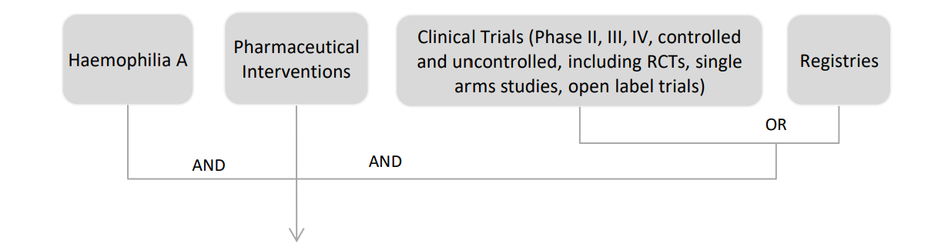

Current search: update of previous search from December 2016
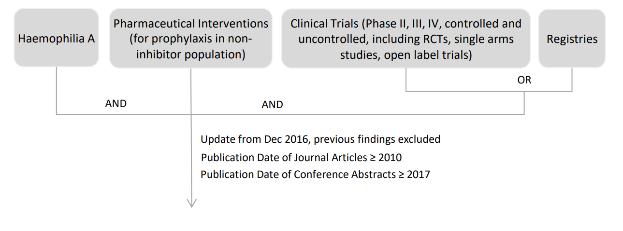

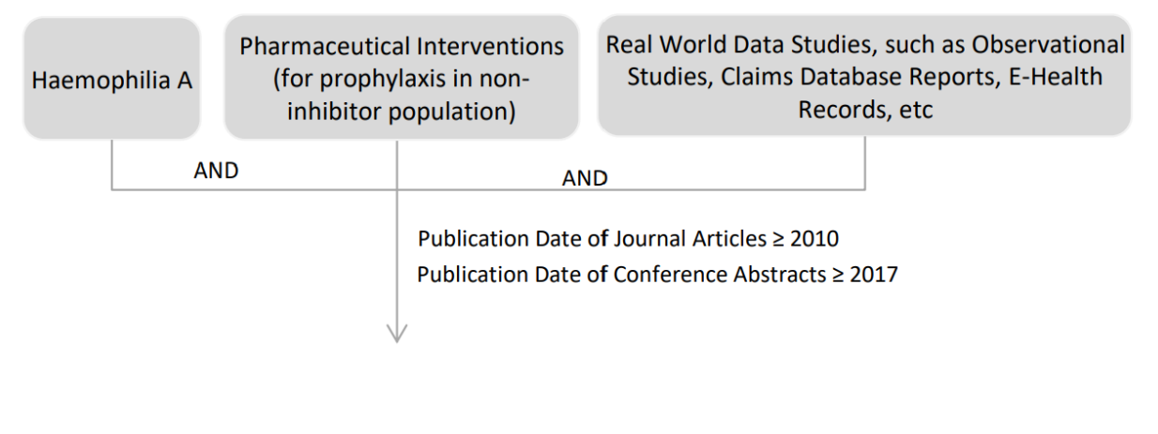
Current search: supplementary search

RCT, randomized clinical trial
Figure S2. Bubble plots showing trends relative to sample size across interventional and observational studies for A) ABR; B) AJBR; C) proportion of participants with zero bleeding events
Interventional studies
Observational studies
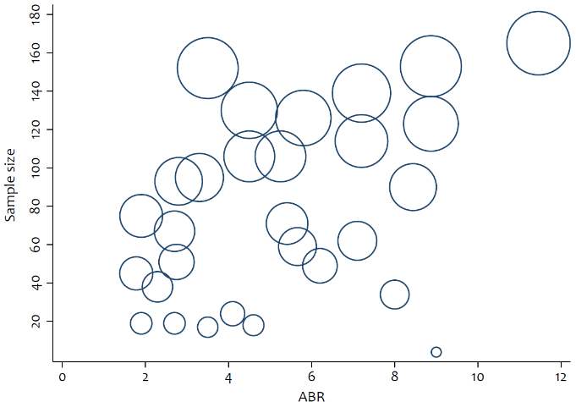
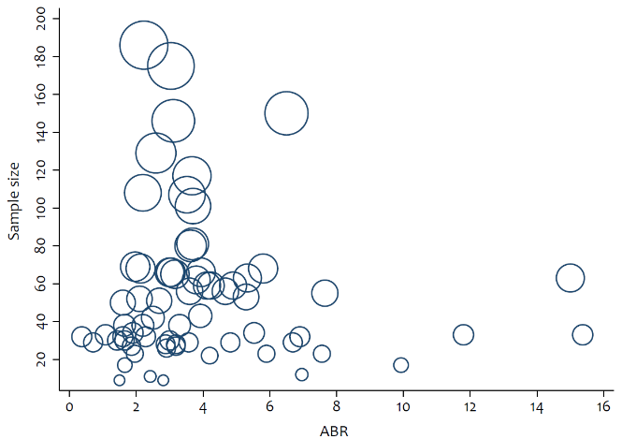
A

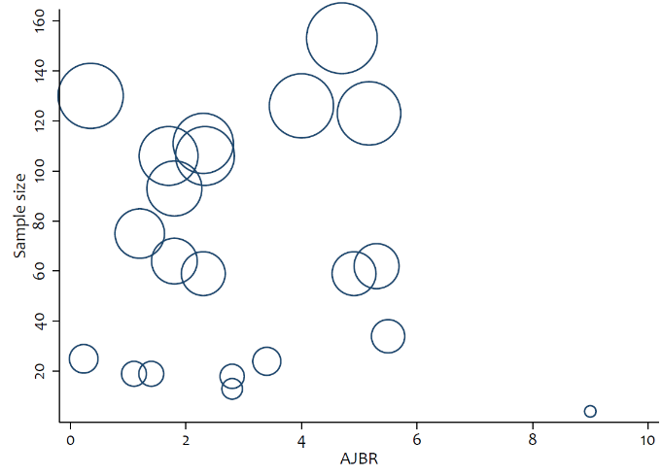
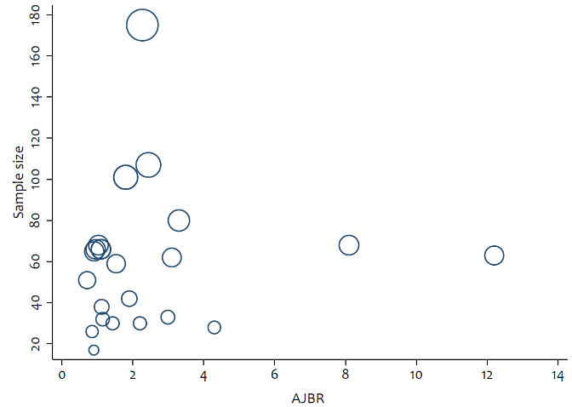
B
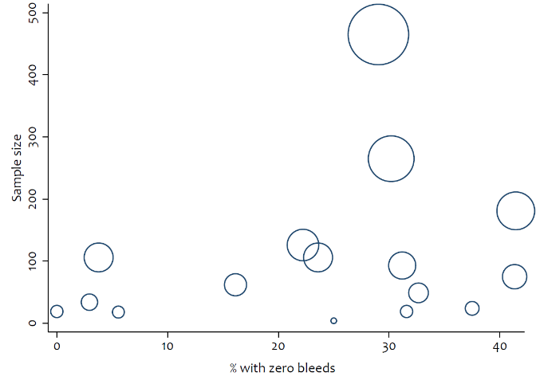
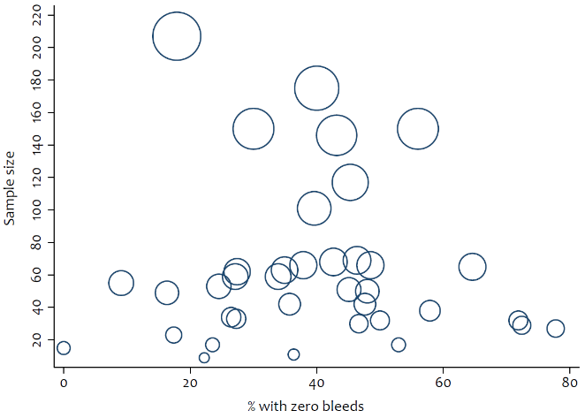
C

ABR, annualized bleeding rate; AJBR, annualized joint bleeding rate
Figure S3. Forest plots of the effect sizes in interventional cohorts A) ABR; B) AJBR; C) proportion of participants with zero bleeding events
A

B
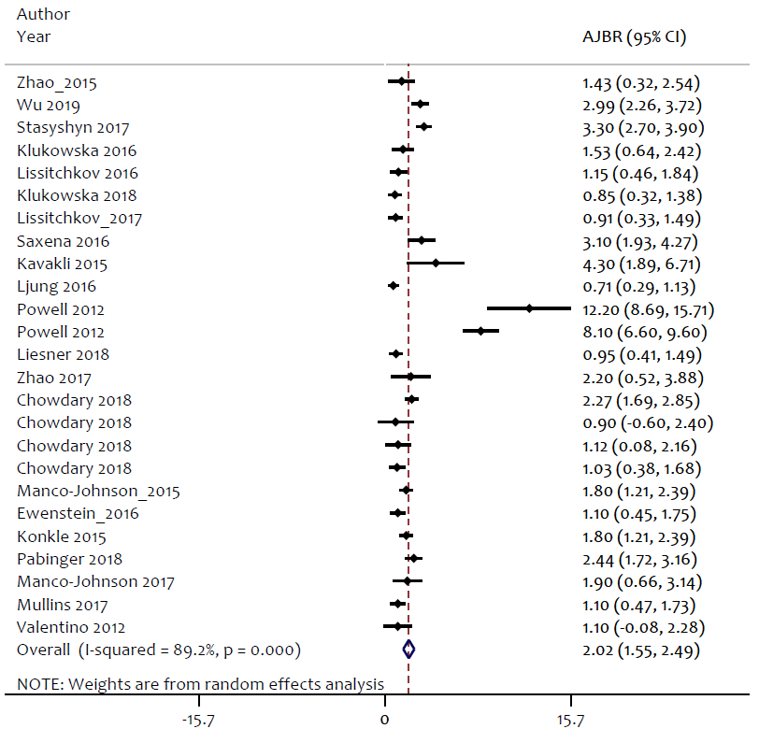

C

Repeated references are indicative of different cohorts from the same study
ABR, annualized bleeding rate; AJBR, annualized joint bleeding rate; CI, confidence interval; ES, effect size
Figure S4. Forest plots of the effect sizes in observational cohorts A) ABR; B) AJBR; C) proportion of participants with zero bleeding events
A

B

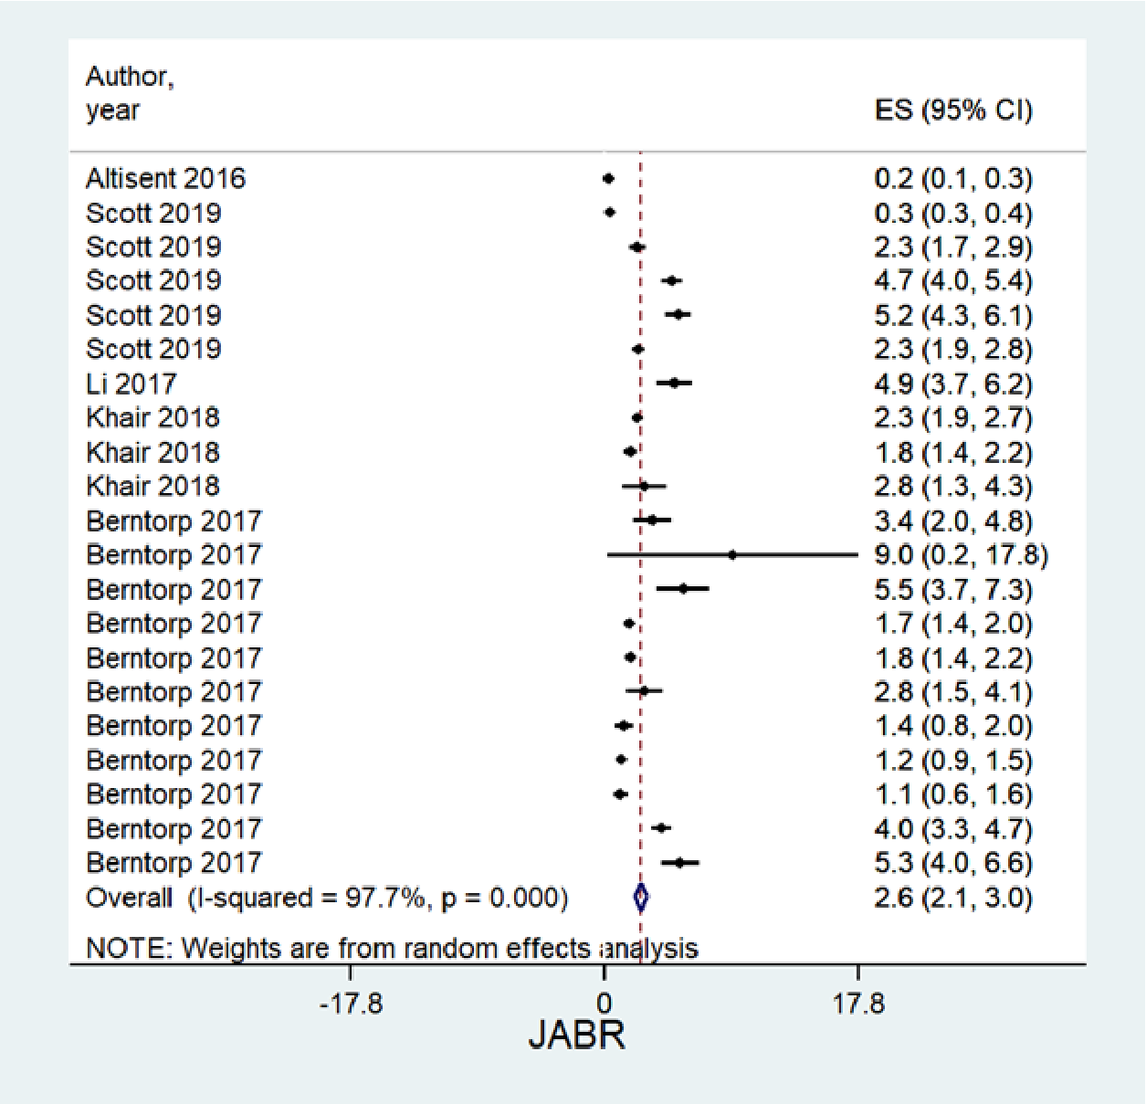

C

Repeated references are indicative of different cohorts from the same study
ABR, annualized bleeding rate; AJBR, annualized joint bleeding rate; CI, confidence interval; ES, effect size
Figure S5. Publication bias funnel plots (pseudo 95% confidence limits) for interventional and observational studies A) ABR; B) AJBR; C) proportion of participants with zero bleeding events
Interventional studies
Observational studies
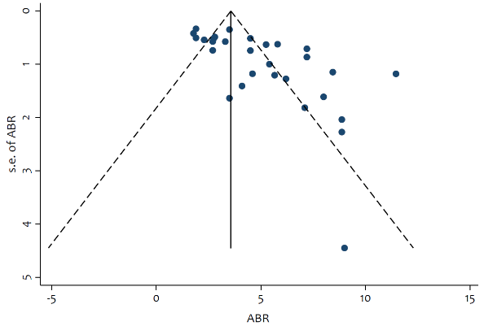
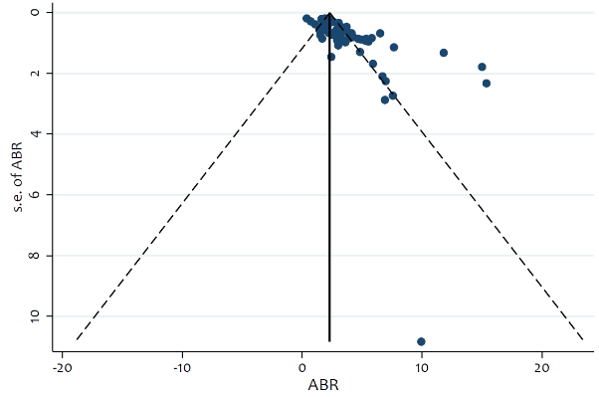
A
Egger test; P < 0.01
Egger test; P < 0.001
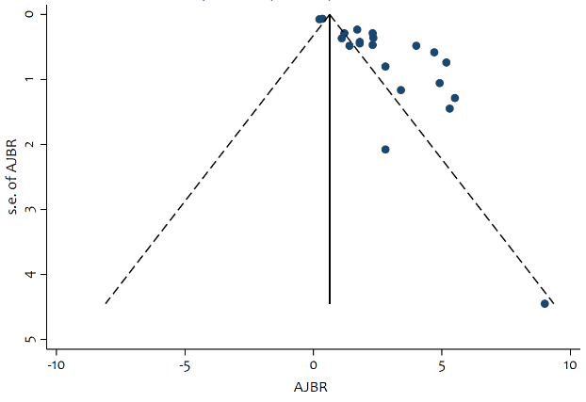
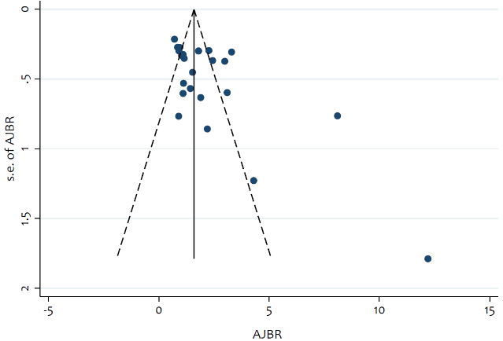
B
Egger test; P < 0.01
Egger test; P < 0.01
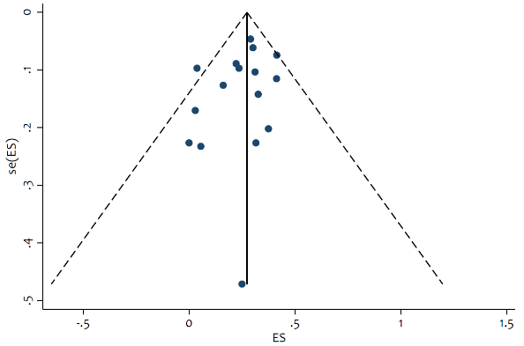
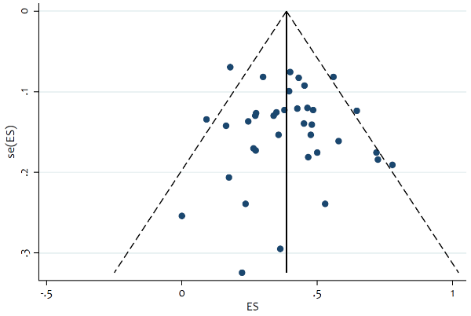
C

Egger test; P = 0.226
Egger test; P = 0.612

ABR, annualized bleeding rate; AJBR, annualized joint bleeding rate; ES, effect size
REFERENCES
Abraham A, Apte S, Singh A, et al. Meaningful reduction of annual bleeding rate with lower dose prophylaxis in minimally treated children with haemophilia in India. Blood. 2018;130(Suppl 1):1079.
Altisent C, Martorell M, Crespo A, Casas L, Torrents C, Parra R. Early prophylaxis in children with severe haemophilia A: clinical and ultrasound imaging outcomes. Haemophilia. 2016;22:218-224.

Apte S, Joshi A, Subramanian K, Dange R, Phatale R. Low dose (20 iu/kg/week) single infusion prophylaxis per week using long acting FVIIIc (ELOCTATE, Biogen) in severe haemophilia A: A cost effective & feasible protocol for resource constraint situation. Haemophilia. 2017;24(S5):3-196.
Auerswald G, Thompson AA, Recht M, et al. Experience of Advate rAHF-PFM in previously untreated patients and minimally treated patients with haemophilia A. Thromb Haemost. 2012;107(6):1072-1082.

Badle S, Hart D, Batty P, Van Os S. UKPK trial interim analysis: Use of pharmacokinetic intervention to optimise factor VIII prophylaxis in severe haemophilia A. Br J Haematol. 2018;181(Suppl 1):5-211.
Bertorp E, Dolan G, Hay C, et al. European retrospective study of real-life haemophilia treatment. Haemophilia. 2017;23:105-114.
Chowdary P, Hvitfeldt Poulsen L, Escobar MA, et al. Efficacy of an extended half-life GlycoPEGylated rFVIII (N8-GP): Pooled analysis of ABR (results from two clinical trials). Blood. 2018;132(Suppl 1):1177.
Chuansumrit A, Sosothikul D, Natesirinilkul R, Lektrakul Y, Charoonruangrit U. Efficacy and safety of low-dose prophylaxis of highly purified plasma-derived factor VIII concentrate produced by the National Blood Centre, Thai Red Cross Society. Haemophilia. 2018;e387-e390.
Escuriola-Ettingshausen C, Korsholm L, Matytsina I, Schutgens R. Safety and efficacy of Turoctocog Alfa in severe and moderately severe previously treated patients with haemophilia A: Interim results after >4,000 exposure days (Guardian 5). Hamostaseologie. 2019;39(S01):S1-S92.
Ewenstein B, Mullins E, Stasyshyn O, et al. Safety and efficacy of a pegylated full-length recombinant factor VIII with extended half-life in previously treated children with haemophilia A. Haemophilia. 2016;22(Suppl 4):46.
Feldman BM, Rivard GE, Babyn P, et al. Tailored frequency-escalated primary prophylaxis for severe haemophilia A: results of the 16-year Canadian haemophilia prophylaxis study longitudinal cohort. Lancet Haematol. 2018;5:e252-e260.
Giangrande P, Andreeva T, Chowdary P, et al. Clinical evaluation of glycoPEGylated recombinant FVIII: Efficacy and safety in severe haemophilia A. Thromb Haemost. 2017;117:252-261.
Hua B, Lian X, Li K, Lee A, Poon M-C, Zhao Y. Low-dose tertiary prophylactic therapy reduces total number of bleeds and improves the ability to perform activities of daily living in adults with severe haemophilia A: a single-centre experience from Beijing. Blood Coagul Fibrinolysis. 2016;27:136-140.
Karimi M, Eshghi P, Safarpour M, et al. Modified primary prophylaxis in previously untreated patients with severe haemophilia A in Iran. J Pediatr Hematol Oncol. 2018;40:118-191.

Kavakli K, Baumann J, Huard FP, et al. An open-label study of the safety and efficacy of Morotocog Alfa (AF-CC) in previously untreated patients aged <6 years in usual care settings. Blood. 2017;130(Suppl 1):1091.

Kavakli K, Yang R, Rusen L, Beckmann H, Tseneklidou-Stoeter D, Maas Enriquez M. Prophylaxis vs. on-demand treatment with BAY 81-8973, a full-length plasma protein-free recombinant factor VIII product: results from a randomized trial (LEOPOLD II). J Thromb Haemost. 2015;13:360-369.

Khair J, Mazzucconi MG, Parra R, et al. Pattern of bleeding in a large prospective cohort of haemophilia A patients: A three-year follow-up of the AHEAD (Advate in HaEmophilia A outcomes Database) study. Haemophilia. 2018;24:85-96.
Khair K, Oldenburg J, Baldacci E, et al. Persistent effectiveness of prophylaxis with recombinant factor VIII concentrate in patients with haemophilia A in a real world setting over 4 years (international AHEAD study). Haemophilia. 2018;24(Suppl 1):34.
Klamroth R, Windyga J, Radulescu V, et al. Results from a phase 3, randomized, multicenter study of rurioctocog alfa pegol PK-guided prophylaxis targeting 2 FVIII trough levels in patients with severe haemophilia A (PROPEL study). Haemophilia. 2019;25:57-58.
Klukowska A, Szczepanski T, Vdovin V, et al. Long-term tolerability, immunogenicity and efficacy of Nuwiq® (human-cl rhFVIII) in children with severe haemophilia A. Haemophilia. 2018;24:595-603.

Klukowska A, Szczepanski T, Vdovin V, Knaub S, Jansen M, Liesner R. Novel, human cell line-derived recombinant factor VIII (Human-cl rhFVIII, Nuwiq) in children with severe haemophilia A: efficacy, safety and pharmacokinetics. Haemophilia. 2016;22:232-239.
Konkle BA, Stasyshyn O, Chowdary P, et al. Pegylated, full-length, recombinant factor VIII for prophylactic and on-demand treatment of severe haemophilia A. Blood. 2015;126(9):1078-1085.

Kruse-Jarres R, Oldenburg J, Santagostino E, et al. Bleeding and safety outcomes in persons with haemophilia A without inhibitors: Results from a prospective non-interventional study in a real-world setting. Haemophilia. 2019;25:213-220.
Kulkarni R, Karim FA, Glamocanin S, et al. Results from a large multinational clinical trial (guardianTM3) using prophylactic treatment with turoctocog alfa in paediatric patients with severe haemophilia A: safety, efficacy and pharmacokinetics. Haemophilia. 2013;19:678-705.

Ledger KSt, Bensen-Kennedy D, Backman N, Veldman A. Clinical decision making is effective in reducing bleeding rates without the need to monitor FVIII trough levels in patients with severe haemophilia A receiving prophylaxis with rVIII-SingleChain. J Thromb Haemost. 2016;14;49.
Lentz SR, Janic D, Kavakli K, et al. Long-term safety and efficacy of turoctocog alfa in prophylaxis and treatment of bleeding episodes in severe haemophilia A: Final results from the guardian 2 extension trial. Haemophilia. 2018;24:e391-e394.

Lentz SR, Misgav M, Ozelo M, et al. Results from a large multinational clinical trial (guardianTM1) using prophylactic treatment with turoctocog alfa in adolescent and adult patients with severe haemophilia A: safety and efficacy. Haemophilia. 2013;19:691-697.

Li C, Zhang X, Zhao Y, et al. Long-term efficacy and safety of prophylaxis with recombinant factor VIII in Chinese pediatric patients with haemophilia A: A multi-center, retrospective, non-interventional, phase IV (ReCARE) study. Curr Med Res Opin. 2017;33(7);1233-1230.
Liesner RJ, Abashidze M, Aleinikova O, et al. Immunogenicity, efficacy and safety of Nuwiq® (human-cl rhFVIII) in previously untreated patients with severe haemophilia A—Interim results from the NuProtect Study. Haemophilia. 2018;24:211-220.

Ljung R, Kenet G, Mancuso ME, et al. BAY 81-8973 safety and efficacy for prophylaxis and treatment of bleeds in previously treated children with severe haemophilia A: results of the LEOPOLD kids trial. Haemophilia. 2016;22:354-360.
Lissitchkov T, Hampton K, Von Depka M, et al. Novel, human cell line-derived recombinant factor VIII (human-cl rhFVIII; Nuwiq) in adults with severe haemophilia A: efficacy and safety. Haemophilia. 2016;22:225-231.
Lissitchkov T, Rusen L, Georgiev P, et al. PK-guided personalized prophylaxis with Nuwiq (human-cl rhFVIII) in adults with severe haemophilia A. Haemophilia. 2017;23:697-704.
Mahlangu J, Kuliczkowski K, Karim FA, et al. Efficacy and safety of rVIII-SingleChain: results of a phase 1/3 multicenter clinical trial in severe haemophilia A. Blood. 2016;128(5):630-637.

Mahlangu J, Powell JS, Ragni MV, et al. Phase 3 study of recombinant factor VIII Fc fusion protein in severe haemophilia A. Blood. 2014;123(3):317-325.

Manco-Johnson MJ, Kempton CL, Reding MT, et al. Randomized, controlled, parallel-group trial of routine prophylaxis vs. on-demand treatment with sucrose-formulated recombinant factor VIII in adults with severe haemophilia A (SPINART). J Thromb Haemost. 2013;11:1119-1127.

Manco-Johnson MJ, Lundin B, Funk S, et al. Effect of late prophylaxis in haemophilia on joint status: a randomized trial. J Thromb Haemost. 2017;15:2115-2124.

Meunier S, Alamelu J, Ehrenforth S, et al. Safety and efficacy of a glycoPEGylated rFVIII (turoctocog alpha pegol, N8-GP) in paediatric patients with severe haemophilia A. Thromb Haemost. 2017;117:1705-1713.

Milligan S, Watt M. A retrospective, observational study using speciality pharmacy data of rurioctocog alfa pegol use in the United States. Res Prac Thromb Haemost. 2019;3(Suppl 1):330.

Mora Figueroa GE, Plata Garcia A, Camacho Grimaldos R. Real-world use of BAY 81-8973 for routine prophylaxis in Colombia: A preliminary report. Res Prac Thromb Haemost. 2018;2(Suppl 1):352.

Mullins E, Chowdary P, Stasyshyn O, Zhang J, Engl W, Tangada S. Results from a phase 3b, open-label, multicenter, CONTINUATION study of Rurioctocog Alfa Pegol for prophylaxis in previously treated patients with severe haemophilia A: Analysis by US age categories. Haemophilia. 2019:48.

Mullins ES, Stasyshyn O, Alvarez-Roman MT, et al. Extended half-life pegylated, full-length recombinant factor VIII for prophylaxis in children with severe haemophilia A. Haemophilia. 2017;23:238-246.

Nijdam A, Foppen W, Klejin PD, et al. Discontinuing early prophylaxis in severe haemophilia leads to deterioration of joint status despite low bleeding rates. Thromb Haemost. 2016;115(5):931.

Nolan B, Mahlangu J, Perry D, et al. Long-term safety and efficacy of recombinant factor VIII Fc fusion protein (rFVIIIFc) in subjects with haemophilia A. Haemophilia. 2016;22:72-80.

Octapharma. Assess the efficacy and safety of personalized prophylaxis human-cl rhFVIII in patients with severe haemophilia A. 2019. NTC02256917. https://clinicaltrials.gov/ct2/show/NCT02256917 [Accessed October 2022].

Octapharma. Clinical study to investigate the PK, efficacy, and safety of Wilate in patients with severe haemophilia A. 2019. NTC02954575. https://clinicaltrials.gov/ct2/show/NCT02954575 [Accessed October 2022].

Octapharma. Study to investigate immunogenicity, efficacy and safety of treatment with human-cl rhFVIII. 2019. NTC01992549. https://clinicaltrials.gov/ct2/show/NCT01992549 [Accessed October 2022].

Ozelo M, Wu R, Belhani M, et al. Guardian TM 4: safety and efficacy of turoctocog alfa in prevention and treatment of bleeds in previously untreated patients with haemophilia A. Haemophilia. 2018;24(Suppl 1):101-102.

Pabinger I, Poulsen LH, Lalezari S, Wang M, Tseneklidou-Stoeter D, Maas Enriquez M. BAY 94–9027 provides effective long-term prophylaxis: Interim analysis of the PROTECT VIII extension study. Hamostaseologie. 2018; poster 055.

Powell J, Martinowitz U, Windyga J, et al. Efficacy and safety of prophylaxis with once-weekly BAY 79–4980 compared with thrice-weekly rFVIII-FS in haemophilia A patients. Thromb Haemost. 2012;108:913-922.

Reding MT, NG HJ, Poulsen LH, et al. Safety and efficacy of BAY 94-9027, a prolonged-half-life factor VIII. J Thromb Haemost. 2017;15:411-419.

Rusen L, Kavakli K, Korth-Bradley J, et al. Clinical experience with moroctocog alfa (AF-CC) in younger paediatric patients with severe haemophilia A: Two open-label studies. Haemophilia. 2018;24:604-610.

Santagostino E, Janic D, Karim FA, et al. Efficacy and safety of turoctocog alfa for prophylaxis and treatment of bleeding episodes in patients with severe haemophilia A: results from the guardianTM2 trial. Haemophilia. 2016;22(Suppl 4):48.

Santagostino E, Saxena K, Kenet G, et al. PROTECT VIII Kids trial results: BAY 94-9027 safety and efficacy in previously treated children with severe haemophilia A. Haemophilia. 2016;22(Suppl 4):41.

Sajeev G, Ayyagari R, Shah A, et al. Pharmacokinetic parameters, prophylaxis frequency and bleed outcomes of severe Haemophilia A patients treated with BAY 81-8973. Haemophilia. 2017;23(Suppl 3):3-49.

Saxena K, Lalezari S, Oldenburg J, et al. Efficacy and safety of BAY 81-8973, a full-length recombinant factor VIII: results from the LEOPOLD I trial. Haemophilia. 2016;22:706-712.

Saxena K, Sajeev G, Ayyagari R, et al. Bay 81-8973 prophylaxis frequency and long-term bleed outcomes in the LEOPOLD I extension study. Blood. 2017;130(Suppl 1):1076.

Scott MJ, Xiang H, Hart DP, et al. Treatment regimens and outcomes in severe and moderate haemophilia A in the UK: The THUNDER study. Haemophilia. 2019;25:205-212.

Skotnicki A, Lissitchkov TJ, Mamonov V, et al. Efficacy, safety and pharmacokinetic profiles of a plasma-derived VWF/FVIII concentrate (VONCENTO®) in subjects with haemophilia A (SWIFT-HA study). Thromb Res. 2016;137:119-125.
Smith MP, Rupon J, Wali Y, et al. Impact of treatment regimen with Moroctocog Alfa (AF-CC) on bleeding frequency in pediatric aged subjects with moderately severe to severe haemophilia A. Blood. 2018;132(Suppl 1):1205.

Stasyshyn O, Djambas Khayat C, Iosava G, et al. Safety, efficacy and pharmacokinetics of rVIII-SingleChain in children with severe haemophilia A: results of a multicenter clinical trial. J Thromb Haemost. 2017;15:636-644.

Su J, Li N, Shrestha A, et al. Real-world bleeding outcomes in severe haemophilia A patients on prophylaxis with rFVIIIFc versus conventional rFVIII. J Manag Care Spec Pharm. 2018;24(4a):S35.

Sun J, Xu W, Wu R, et al. Successful haemostatic response during the treatment of bleeding episodes and effective prophylaxis with Turoctocog Alfa in previously treated patients from China with severe haemophilia A (Guardian 7). Res Prac Thromb Haemost. 2019;3(Suppl 1):265.

Sun X, Zhuang J, Zhou X, Liu Z, Sun J. Efficacy of short-term individualized prophylaxis guided by PK and joint evaluation in Chinese adult patients with severe haemophilia A. Res Prac Thromb Haemost. 2019;3(Suppl 1):321.

Taki M, Fukutake K, Matsushita T, et al. Inhibitor development, safety, and efficacy of Advate® in previously untreated patients with haemophilia A in a postmarketing surveillance in Japan. Int J Hematol. 2019;109:70-78.

Valentino LA, Mamonov V, Hellmann A, et al. A randomized comparison of two prophylaxis regimens and a paired comparison of on-demand and prophylaxis treatments in haemophilia A management. J Thromb Haemost. 2012;10:359-367.

Van Os S, Batty P, Hart D, Badle S. Pharmacokinetic intervention to optimise FVIII prophylaxis: UKPK trial interim analysis. Haemophilia. 2018;24(Suppl 5):88.

Watt M, Booth J, Milligan S, Aledort L. A retrospective, observational study of BAX 855 in clinical practice in the United States. J Manag Care Spec Pharm. 2018;24(4a):S34.

Wu R, Tang L, Zhang Q, et al. The first Chinese haemophilia individualized prophylaxis study (CHIPS): Improvement in health-related quality of life (HRQoL) CHO-KLAT scores in boys with severe haemophilia A in China. Res Prac Thromb Haemost. 2019;3(Suppl 1):352.

Wu R, Yao W, Zhang Q, et al. Results from a prospective, multicenter, dose escalating, prophylaxis study in young boys with severe haemophilia A in China: The China haemophilia individualized prophylaxis study (CHIPS) (NCT02999308). Res Prac Thromb Haemost. 2019;3(Suppl 1):451.

Yao M, Xiao J, Cheng X, et al. The efficacy of recombinant FVII low-dose prophylaxis in Chinese pediatric patients with severe haemophilia A: A retrospective analysis from the ReCARE study. Clin Appl Thromb/Hemost. 2017;23(7):851-858.
Young G, Mahlangu J, Kulkarni R, et al. Recombinant factor VIII Fc fusion protein for the prevention and treatment of bleeding in children with severe haemophilia A. J Thromb Haemost. 2015;13:967-977.

Zhao Y, Xiao J, Yang R, et al. Efficacy of standard prophylaxis versus on-demand treatment with Bayer's sucrose-formulated recombinant FVIII (rFVIII-FS) in Chinese children with severe haemophilia A. Pediatr Hematol Oncol J. 2017;34(3):146-156.

Zhao H, Yang L, Long C, et al. Haemophilia care in China: review of care for 417 haemophilia patients from 11 treatment centers in Shanxi Province. Expert Rev Hematol. 2015;8(4):543-550.

