Supplemental material
Figure S1. Propensity score distribution in the unweighted and weighted cohort
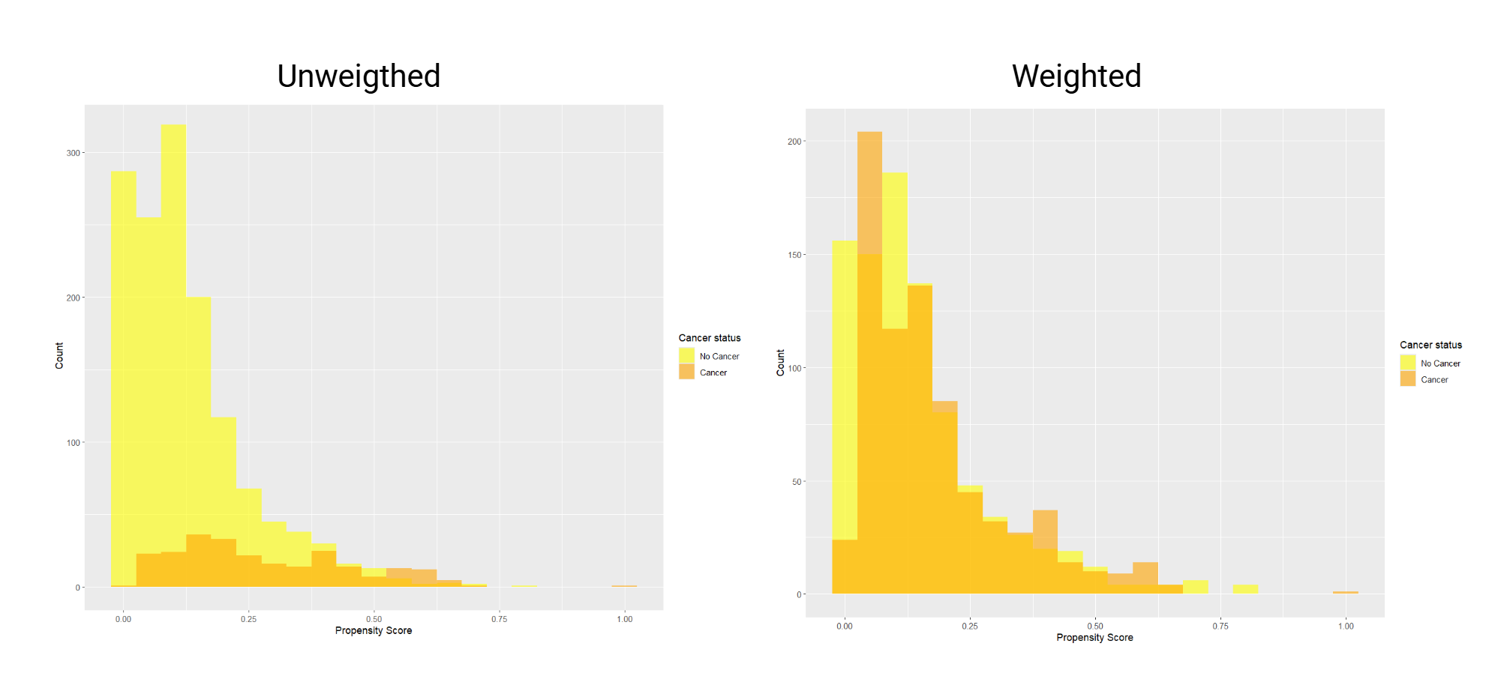

Figure S2. Love plot of covariate balance in the unweighted and weighted cohort
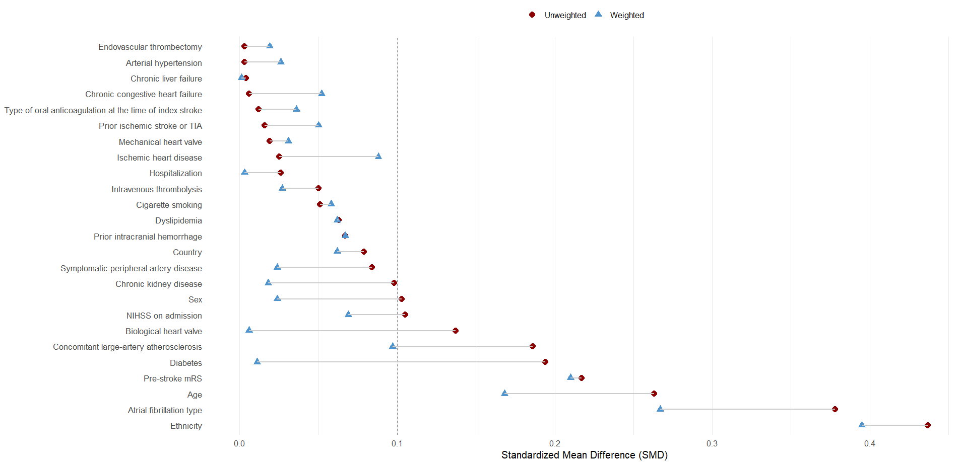

Figure S3. Competing risk analysis for 90-day new ischemic stroke or TIA and 90-day all-cause death (Fine-Gray model)
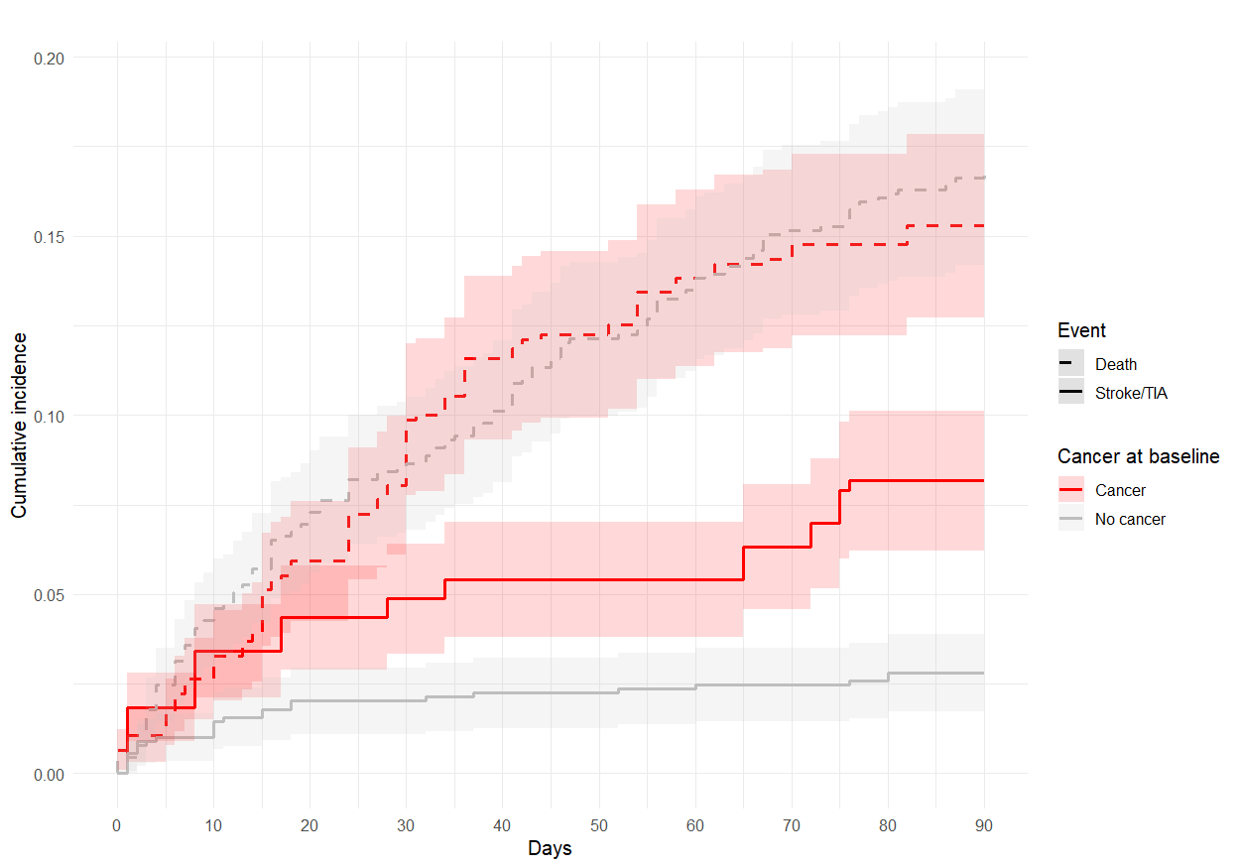
Shaded areas indicate 95% confidence intervals.

Figure S4. Kaplan-Meier cumulative estimates of A) 90-day new ischemic stroke or TIA and B) 90-day moderate-to-severe bleeding in patients with hematological versus solid malignancies in the weighted cohort

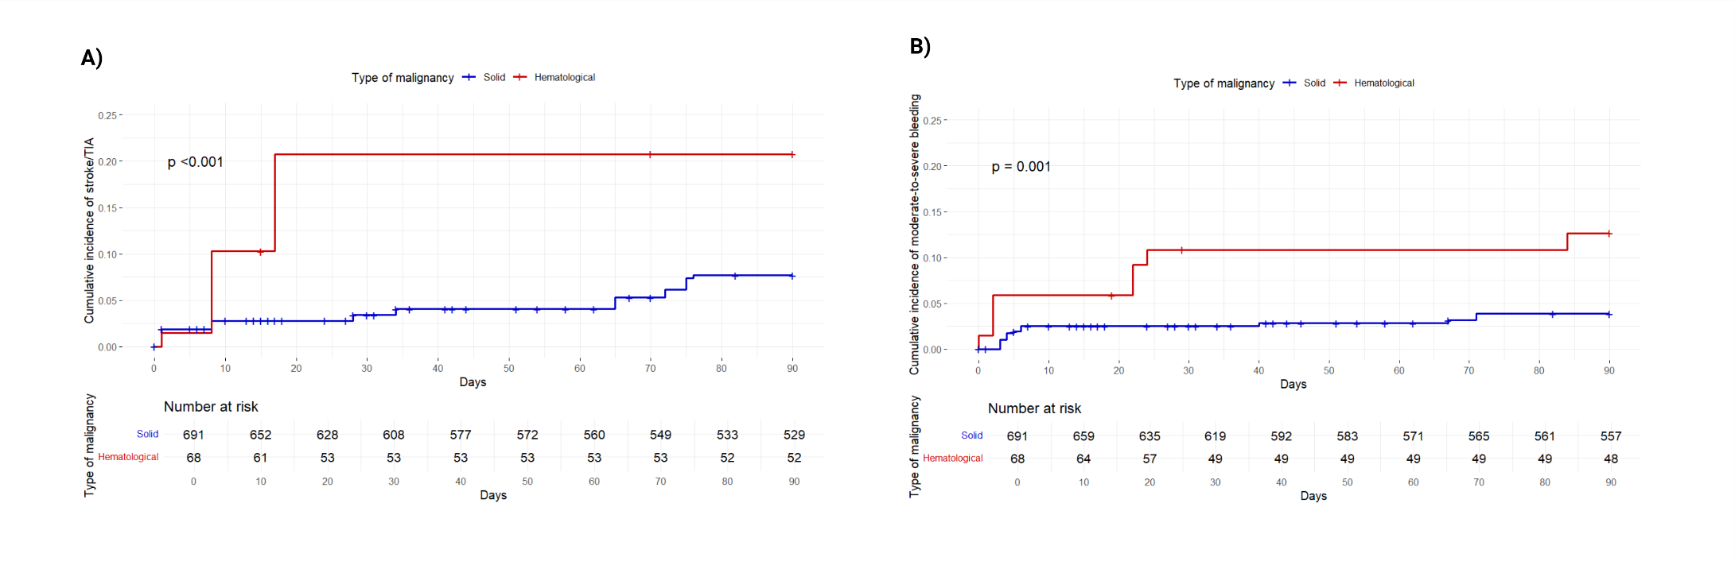
p: log-rank test p-value.

Table S1. Comparison of 90-day new ischemic stroke or TIA and 90-day moderate-to-severe bleeding between patients with active cancer, cancer in remission and no cancer in the weighted cohort
 |  | N/total (%) | HR (vs no cancer) | 95% CI | P value
90-day new ischemic stroke and other vascular events | No cancer | 25/890 (2.8) | 1 | Ref. | -
90-day new ischemic stroke and other vascular events | Cancer in remission | 43/594 (7.2) | 2.60 | 1.59-5.25 | 0.001
90-day new ischemic stroke and other vascular events | Active cancer | 19/165 (11.5) | 4.48 | 2.46-8.13 | <0.001
90-day moderate-to-severe bleeding | No cancer | 21/890 (2.4) | 1 | Ref. | -
90-day moderate-to-severe bleeding | Cancer in remission | 23/594 (3.9) | 1.64 | 0.91-2.96 | 0.103
90-day moderate-to-severe bleeding | Active cancer | 10/165 (6.1) | 2.77 | 1.30-5.88 | 0.008

Abbreviations. CI: confidence intervals; HR: hazard ratio. Statistically significant (<0.05) p-values are reported in bold.

Table S2. Comparison of 90-day new ischemic stroke or TIA and 90-day moderate-to-severe bleeding between patients with hematologic versus solid malignancies in the weighted cohort
 |  | N/total (%) | HR (vs solid malignancies) | 95% CI | P value
90-day new ischemic stroke or TIA | Solid | 48/691 (6.9) | 1 | Ref. | -
90-day new ischemic stroke or TIA | Hematological | 14/68 (20.6) | 3.06 | 1.69-5.54 | 0.001
90-day moderate-to-severe bleeding | Solid | 25/666 (3.6) | 1 | Ref. | -
90-day moderate-to-severe bleeding | Hematological | 8/60 (11.8) | 3.47 | 1.57-7.70 | 0.006

Abbreviations. CI: confidence intervals; HR: hazard ratio. Statistically significant (<0.05) p-values are reported in bold.

Appendix S1. Distribution of patients by country in the ASPERA-R study
Country | Enrolling center(s) | No. of patients/total no. included in the ASPERA-R(%) | No. of patients/total no. included in the study analysis (%)
Italy | - Stroke Unit and Neurology Unit, S.S. Filippo e Nicola Hospital, Avezzano.  - Stroke Unit, Maggiore Hospital, Bologna.  - Neurology Unit, IRCCS Policlinico S.Orsola-Malpighi, Bologna.  - Stroke Unit, IRCCS Policlinico Universitario Agostino Gemelli, Rome.  - Stroke Unit – Neurology Unit, S.Maria delle Croci Hospital, Ravenna.  - Stroke Unit, ASST Grande Ospedale Metropolitano Niguarda, Milano.  - Stroke Unit, Luigi Sacco Hospital, Milano.  - Stroke Unit, Policlinico San Matteo, Pavia.  - Stroke Unit – Neurology Unit, Vito Fazzi Hospital, Lecce.  - Stroke Unit, Fabrizio Spaziani Hospital, Frosinone.  - Stroke Unit, S.Maria della Misericordia Hospital, Perugia.  - Stroke Unit, Azienda Ospedaliera Ospedali Riuniti Villa Sofia – Cervello, Palermo.  - Stroke Unit, Arcispedale Santa Maria Nuova, Reggio Emilia.  - Stroke Unit, AORN Cardarelli Hospital, Napoli.  - Stroke Unit, Azienda Ospedaliero Universitaria Careggi, Firenze.  - Stroke Unit, S.Maria della Misericordia Hospital, Udine.  - Stroke Unit, Ospedale Riuniti di Ancona, Ancona.  - Stroke Unit, Maggiore Hospital, Crema.  - Stroke Unit – Neurology Unit, “Di Venere” Hospital, Bari. | 1010/1772 (57.0) | 989/1649 (60.0)
France | - Stroke Unit, Université Côte d’Azur, Nice. | 79/1772 (4.5) | 78/1649 (4.7)
Germany | - Stroke Unit – Neurology Unit, Martin Luther University, Halle-Wittenberg.  - Stroke Unit, Saarland University Hospital, Homburg. | 67/1772 (3.8) | 43/1649 (2.6)
Spain | - Stroke Unit, Hospital Universitario La Paz, Madrid | 81/1772 (4.6) | 80/1649 (4.9)
Portugal | - Stroke Unit, São José Hospital, Lisbon.  - Stroke Unit, Hospital de Santa Maria, Lisbon. | 124/1772 (7.0) | 101/1649 (6.1)
United Kingdom | - Stroke Unit, Charing Cross Hospital, London.  - Stroke Unit, St George University Hospital, London.  - Stroke Unit, North Bristol NHS Trust, Bristol. | 180/1772 (10.2) | 178/1649 (10.8)
Croatia | - Stroke Unit, Sveti Duh University Hospital, Zagreb. | 35/1772 (19.7) | 32/1649 (19.4)
Egypt and Saudi Arabia | - Stroke Unit – Neurology Unit, Aim Shams University Hospital, Cairo.  - Stroke Unit, Armed Forces Medical Complex Kobry El Kobba, Cairo.  - Stroke Unit, Cairo University Hospital, Cairo.  - Stroke Unit, Assiut University Hospital, Asyut.  - Stroke Unit – Neurology Unit, King Fahd Hospital, Riyahd. | 196/1772 (11.1) | 148/1949 (9.0)

Appendix S2. List of baseline variables collected in the ASPERA-R study

Variable | Mandatory | Notes
Demographics
Date of index ischemic stroke on oral anticoagulation | Yes | -
Hospitalization (Yes/No) | Yes | -
Hospitalization setting  - Stroke unit  - Intensive care unit  - Other hospital unit  - Emergency department only | Yes | -
Date of admission | Yes | -
Sex  - Male  - Female  - Other | Yes | -
Ethnicity  - Non-Hispanic white  - Hispanic white  - Black  - Asian  - Other | Yes | -
Date of birth | Yes | -
Weight – kg | No | -
Height – cm | No | -
Risk factors
Current cigarette smoking (Yes/No) | Yes | Consumption of ≥1 cigarette per day over the last year
Arterial hypertension (Yes/No) | Yes | Blood pressure of ≥140/90 mmHg at least twice before stroke or already under treatment with antihypertensive drugs
Dyslipidemia (Yes/No) | Yes | History of total blood cholesterol levels >220 mg/dL and/or total triglycerides levels >130 mg/dL and/or current used lipid-lowering drugs
Diabetes (Yes/No) | Yes | History of fasting glucose >126 mg/dL or the current use of hypoglycemic medications
Ischemic heart disease (Yes/No) | Yes | History of myocardial infarction, angina or prior evidence of coronary disease on coronary angiography
Chronic congestive heart failure (Yes/No) | Yes | History of stage C (structural heart disease and current or past history of heart-failure symptoms) or stage D (refractory symptoms that interfere with daily life or recurrent hospitalization despite targeted guideline-directed medical therapy) chronic heart failure
Chronic kidney disease (Yes/No) | Yes | History of estimated creatinine clearance of less than 60 for 3 months or more (including dialysis)
Chronic liver failure (Yes/No) | Yes | History of cirrhosis or end-stage liver disease
Symptomatic peripheral artery disease (Yes/No) | Yes | History of intermittent claudication of presumed atherosclerotic origin
Prior ischemic stroke or TIA (Yes/No) | Yes | -
Prior intracranial hemorrhage (Yes/No) | Yes | -
History of malignancy (Yes/No) | Yes | -
Type of malignancy  - Active  - In remission | Yes | We defined active malignancy as (1) a diagnosis of cancer that occurred within 6 months of the index event or during hospitalization, (2) cancer treatment with radiotherapy, chemotherapy or surgery or a combination of them within 6 months of the index event, (3) a previous history of malignancy and a diagnosis of recurrence or metastasis within 6 months of the index event. In remission was defined as a previous history of malignancy in the absence of active cancer criteria.
Site of malignancy  - Gastrointestinal  - Lung  - Genitourinary  - Breast  - Hematological  - Skin  - Other | Yes | -
Metastatic malignancy? (Yes/No) | Yes | -
Metastasis location  - Lymph nodes  - Liver  - Lung  - Bones  - Brain/spine/meningeal  - Other | Yes | -
Atrial fibrillation type  - Paroxysmal  - Persistent  - Long-standing persistent  - Permanent | Yes | According to the ACC/AHA/HRS guidelines classification
History of valvular heart disease (multiple choice)  - Sever mitral stenosis  - Sever aortic stenosis  - Severe mitral insufficiency  - Severe aortic insufficiency  - Mechanical heart valve  - Biological heart valve | Yes | -
Pacemaker (Yes/No) | Yes | -
Left atrial volume index at transthoracic echocardiography – mL/m² | No | -
Left ventricle end-diastolic volume at transthoracic echocardiography – mL | No | -
Left ventricle end-systolic volume at transthoracic echocardiography – mL | No | -
Left ventricle ejection fraction at transthoracic echocardiography – mL | No | -
Drugs history
Type of oral anticoagulant ongoing at the time of the index ischemic stroke  - Vitamin K antagonist  - Direct oral anticoagulant | Yes | -
Type of direct oral anticoagulant  - Apixaban  - Rivaroxaban  - Edoxaban  - Dabigatran | Yes | -
Type of vitamin K antagonist  - Warfarin  - Acenocoumarol  - Other | Yes | -
Time from last direct oral anticoagulant intake to admission  - <12 hours  - 12-24 hours  - 24-48 hours | Yes | -
Direct oral anticoagulant plasma levels or anti-factor Xa activity available on admission | Yes | -
Direct oral anticoagulant plasma levels (ng/mL) or anti-factor Xa activity on admission | Yes | -
Direct oral anticoagulant plasma levels or anti-factor Xa activity on admission  - Below range  - Within range  - Above range | Yes | In respect to the range locally determined for therapeutic anticoagulation
Direct oral anticoagulant at reduced dose at the time of the index ischemic stroke (Yes/No) | Yes | Apixaban 2.5mg BID, dabigatran 75mg BID, edoxaban 30mg daily, rivaroxaban 15mg daily
Direct oral anticoagulant reduced dose appropriate (Yes/No) | Yes | Reduced dose of apixaban was considered appropriate if 2 of 3 factors were present: 1) Age ≥80 years; 2) serum creatinine ≥1.5 mg/dL; 3) Weight ≤60 kg OR if apixaban is co-administered with combined P-gp and strong CYP3A4 inhibitors (e.g., ketoconazole, itraconazole, ritonavir). Reduced dose of dabigatran was considered appropriate if creatinine clearence 15-30 mL/min OR, creatinine clearence 30-50 mL/min with concomitant dronedarone or ketoconazole. Reduced dose of edoxaban was considered appropriate if creatinine clearence 15-50 mL/min. Reduced dose of rivaroxaban was considered appropriate if creatinine clearence ≤50 mL/min
Antihypertensive drugs on admission (Yes/No) | Yes | -
Lipid-lowering drugs on admission (Yes/No) | Yes | -
Antidiabetic drugs on admission (Yes/No) | Yes | -
Rhythm control drugs on admission (Yes/No) | Yes | -
Type of rhythm control drugs on admission  - Class I – Sodium channel blockers  - Class II – Beta-blockers  - Class III – Potassium channel blockers  - Class IV – Calcium channel blockers  - Class V – Miscellaneous agents (i.e., digoxin, ivabradine, adenosine) | Yes | According to the Vaughan Williams classification of antiarrhythmic drugs
Drugs potentially interfering with oral anticoagulation at the time of the index stroke (multiple choice)  - Itraconazole  - Ketoconazole  - Clarithromycin  - Lopinavir  - Indinavir  - Ritonavir  - Telaprevir  - Voriconazole  - Any H2 inhibitor (i.e., cimetidine)  - Any proton pump inhibitor (i.e. omeprazole, pantoprazole)  - Doxorubicin  - Vinblastine  - Carbamazepine/ Oxcarbazepine  - Phenytoin  - Phenobarbital  - Rifampin  - Levetiracetam  - Valproic acid  - Dexamethasone  - Tocilizumab |  | -
Antiplatelet therapy on admission (Yes/No) | Yes | -
Type of antiplatelet therapy on admission (multiple choice)  - Aspirin  - Clopidogrel  - Ticagrelor  - Ticlopidine  - Other | Yes | -
Antihypertensive drugs on admission (Yes/No) | Yes | -
Clinical characteristics
Modified Rankin Scale (mRS) score before the index ischemic stroke | Yes | -
Type of ischemic stroke onset  - Known onset  - Wake-up stroke  - Unwitnessed stroke | Yes
National Institute of Health Stroke Scale (NIHSS) score on admission (prior to any acute reperfusion therapy) | Yes | -
Acute ischemic stroke symptoms (multiple choice)  - Motor weakness  - Aphasia  - Dysarthria  - Sensory defect  - Visual field defect  - Diplopia  - Vertigo  - Loss of balance  - Hemineglect  - Other | No | -
Clinical classification of the acute ischemic stroke  - Total anterior circulation stroke (TACS)  - Partial anterior circulation stroke (PACS)  - Posterior circulation syndrome (PoCS)  - Lacunar stroke (LACS) | Yes | According to the Oxfordshire Stroke Project Classification
Admission systolic blood pressure - mmHg | No | -
Admission diastolic blood pressure – mmHg | No | -
Admission Glasgow Coma Scale (GCS) score | No | -
Presence of competing stroke etiology other than cardioembolism (Yes/No) | Yes | -
Type of competing stroke etiology other than cardioembolism  - Lacunar  - Large artery atherosclerosis  - Other determined etiology | Yes | According to the Trial of Org 10172 in the Acute Stroke Treatment (TOAST) classification system
Type of other determined etiology (specify) | Yes | -
Competing cardioembolic mechanisms other than atrial fibrillation (Yes/No) | Yes | -
Type of competing cardioembolic mechanisms other than atrial fibrillation (multiple choice)  - Reduced left ventricle ejection fraction (30-40%)  - Severely reduced left ventricle ejection fraction (< 30%)  - Left ventricle thrombus  - Endocarditis  - Mechanical heart valve  - Biological heart valve  - Atrial myxoma  - Fibroelastoma  - Other cardiac tumors  - Patent foramen ovale (PFO)  - Interventricular defect (IVD)  - Left ventricular aneurysm  - Left atrial aneurysm  - Other cardiac congenital alterations | Yes | -
Intravenous thrombolysis (Yes/No) | Yes | -
Endovascular thrombectomy (Yes/No) | Yes | -
Onset-to-needle time – minutes | Yes | -
Onset-to-groin time – minutes | Yes | -
Hemorrhagic infarction  - Yes - asymptomatic  - Yes – symptomatic  - No | Yes | Symptomatic hemorrhagic infarction was defined according to SITS-MOST as a neurologic deterioration of ≥4 NIHSS points or leading to death within 24 hours
Hemorrhagic infarction type (multiple choice)  - HI1: Scattered small petechiae, no mass effect  - HI2: Confluent petechiae, no mass effect  - PH1: Hematoma within infarcted tissue, occupying < 30%, no substantive mass effect  - PH2: Hematoma occupying 30% or more of the infarcted tissue, with obvious mass effect PH remote from infarcted brain tissue  - rPH: Remote parenchymal hematoma  - Intraventricular hemorrhage  - Subarachnoid hemorrhage  - Subdural hemorrhage | Yes | According to the Heidelberg classification system
National Institute of Health Stroke Scale (NIHSS) score at 24 hours | No | -
Neuroimaging information
Type of brain neuroimaging performed on admission  - Non-contrast computed tomography  - Magnetic resonance imaging  - Both | Yes | -
Type of brain neuroimaging performed at 24 hours follow-up  - Non-contrast computed tomography  - Magnetic resonance imaging  - Both  - None | Yes | -
Type of brain vessel imaging performed (multiple choice)  - Computed tomography angiography - extracranial vessels  - Computed tomography angiography - intracranial vessels  - Magnetic resonance angiography - extracranial vessels  - Magnetic resonance angiography - intracranial vessels  - Color Doppler ultrasonography - extracranial vessels  - Color Doppler ultrasonography - intracranial vessels  - X-ray angiography  - None | Yes | -
Large vessel occlusion (Yes/No/Unknown) | Yes | -
Large vessel occlusion site (multiple choice)  - Middle cerebral artery - M1  - Middle cerebral artery - M2  - Middle cerebral artery - More distal than M2  - Tandem occlusion  - Anterior cerebral artery  - Posterior cerebral artery  - Basilar artery  - Internal carotid artery  - Vertebral artery | Yes | -
Baseline modified Thrombolysis in Cerebral Infarction score  - Grade 0: no perfusion  - Grade 1: antegrade reperfusion past the initial occlusion, but limited distal branch filling with little or slow distal reperfusion  - Grade 2a: antegrade reperfusion of less than half of the occluded target artery previously ischemic territory (i.e., in one major division of the middle cerebral artery and its territory)  - Grade 2b: antegrade reperfusion of more than half of the previously occluded target artery ischemic territory (i.e., in two major divisions of the MCA and their territories)  - Grade 2c: near complete perfusion except for slow flow or distal emboli in a few distal cortical vessels  - Grade 3: complete antegrade reperfusion of the previously occluded target artery ischemic territory, with absence of visualized occlusion in all distal branches | Yes | -
Post-endovascular thrombectomy modified Thrombolysis in Cerebral Infarction score  - Grade 0: no perfusion  - Grade 1: antegrade reperfusion past the initial occlusion, but limited distal branch filling with little or slow distal reperfusion  - Grade 2a: antegrade reperfusion of less than half of the occluded target artery previously ischemic territory (i.e., in one major division of the middle cerebral artery and its territory)  - Grade 2b: antegrade reperfusion of more than half of the previously occluded target artery ischemic territory (i.e., in two major divisions of the MCA and their territories)  - Grade 2c: near complete perfusion except for slow flow or distal emboli in a few distal cortical vessels  - Grade 3: complete antegrade reperfusion of the previously occluded target artery ischemic territory, with absence of visualized occlusion in all distal branches | Yes | -
Presence of extracranial internal artery stenosis ≥50% ipsilateral to the acute ischemic stroke lesion (Yes/No) | Yes | -
Degree of extracranial internal artery stenosis ≥50% ipsilateral to the acute ischemic stroke lesion  - 50-69%  - 70-79%  - 80-99%  - Occlusion (100%) | Yes | -
Presence of extracranial vertebral artery stenosis ≥50% ipsilateral to the acute ischemic stroke lesion (Yes/No) | Yes | -
Degree of extracranial vertebral artery stenosis ≥50% ipsilateral to the acute ischemic stroke lesion  - 50-69%  - 70-79%  - 80-99%  - Occlusion (100%) | Yes | -
Presence of intracranial artery stenosis (Yes/No) | Yes | -
Site of intracranial artery stenosis (multiple choice)  - Middle cerebral artery  - Anterior cerebral artery  - Posterior cerebral artery  - Basilar artery  - Internal carotid artery  - Vertebral artery | Yes | -
Presence of symptomatic intracranial artery stenosis (Yes/No) | Yes | -
Laboratory tests
International Normalized Ratio (INR) | Yes | -
aPTT – seconds | No | -
PT – seconds | No | -
Red blood cells – millions/mm³ | No | -
White blood cells – millions/mm³ | No | -
Lymphocytes – millions/mm³ | No | -
Neutrophiles – millions/mm³ | No | -
Platelets – thousands/mm³ | No | -
Hemoglobin – mg/dL | No | -
Admission blood glucose levels – mg/dL | No | -
Fasting blood glucose levels – mg/dL | No | -
C reactive protein – mg/dL | No | -
Creatinine – mg/dL | No | -
Creatinine clearance – mL/min | No | -
Glycate hemoglobin – mmol/L | No | -
Total cholesterol – mg/dL | No | -
High density lipoprotein (HDL) – mg/dL | No | -
Low density lipoprotein (LDL) – mg/dL | No | -
Triglycerides – mg/dL | No | -
ALT/GPT – U/L | No | -
AST/GOT – U/L | No | -
Gamma-GT – U/L | No | -
Total bilirubin – mg/dL | No | -

