Failed genesis of a Fe-skarn deposit caused by redox states of intrusion and wall rocks (Torre di Rio, Island of Elba, Italy)

Paolo S. Garofalo¹, Daniele Redi¹, Nikita Malafeevskiy^{1,2}; Gunnar Schwarz³, Christoph Neff³, Peter Keresztes Schmidt^{3,4}, Detlef Günther³

¹ University of Bologna, Department of Biological, Geological and Environmental Sciences, Via Zamboni, 67, Bologna, Italy. Tel: +39 051 2094537; paolo.garofalo@unibo.it
² Norwegian University of Science and Technology, Department of Geosciences and Petroleum
³ ETH Zurich, Department of Chemistry and Applied Biosciences, Trace Element and Microanalysis Group, Vladimir-Prelog-Weg 1 Zurich, Switzerland.
⁴ Space Research and Planetary Sciences, Physics Institute, University of Bern, 3012 Bern, Switzerland

corresponding author: Paolo S. Garofalo

Supplementary Material

Table S1. Representative EPMA of pyroxenes and ilvaite from Torre di Rio
Analysis | 28 | 30 | 105 | 107 | 178 | 187 | 118 | 226 | Analysis | 8 | 26 | 90 | 91 | 152 | 228 | 230 | 231
Zone | I-H | I-H | E-H | E-H | E-H | E-H | E-H | E-H | Zone | E-H | E-H | E-H | E-H | I | I | I | I
Sample | RM3 | RM3 | RM9 | RM9 | RM15 | RM15 | RM16 | RM16 | Sample | RM3 | RM3 | RM9 | RM9 | RM12 | RM12 | RM12 | RM12
SiO₂ | 49.89 | 48.38 | 49.49 | 48.75 | 49.84 | 49.12 | 49.15 | 50.11 | SiO₂ | 30.14 | 29.93 | 30.00 | 29.68 | 29.53 | 29.39 | 29.54 | 29.41
TiO₂ | 0.00 | 0.04 | 0.05 | 0.05 | 0.01 | 0.00 | 0.02 | 0.00 | TiO₂ | 0.00 | 0.08 | 0.37 | 0.11 | 0.00 | 0.00 | 0.01 | 0.05
Al₂O₃ | 0.08 | 1.79 | 0.18 | 0.97 | 0.22 | 0.13 | 0.17 | 1.45 | Al₂O₃ | 1.31 | 0.84 | 0.70 | 0.69 | 0.90 | 0.81 | 0.71 | 0.77
FeO* | 24.02 | 25.47 | 24.21 | 25.97 | 21.55 | 25.65 | 25.02 | 18.47 | Fe₂O₃ | 34.86 | 34.51 | 35.33 | 34.52 | 33.55 | 33.21 | 33.62 | 33.54
MnO | 0.93 | 0.74 | 1.35 | 0.81 | 0.39 | 0.78 | 0.87 | 0.64 | FeO | 16.57 | 17.50 | 16.65 | 18.04 | 18.37 | 18.91 | 18.95 | 19.19
MgO | 2.83 | 2.00 | 2.31 | 1.72 | 4.51 | 1.90 | 1.82 | 5.78 | MnO | 1.04 | 0.98 | 1.06 | 1.03 | 1.83 | 1.78 | 1.80 | 1.71
CaO | 22.71 | 21.86 | 22.59 | 21.74 | 22.30 | 22.34 | 22.49 | 22.35 | MgO | 0.11 | 0.18 | 0.10 | 0.18 | 0.21 | 0.19 | 0.19 | 0.22
Na₂O | 0.13 | 0.50 | 0.14 | 0.40 | 0.12 | 0.12 | 0.13 | 0.35 | CaO | 13.81 | 13.77 | 13.44 | 13.41 | 13.49 | 13.49 | 13.30 | 13.43
K₂O | 0.00 | 0.00 | 0.02 | 0.04 | 0.01 | 0.00 | 0.00 | 0.00 | Na₂O | 0.01 | 0.02 | 0.02 | 0.04 | 0.00 | 0.04 | 0.03 | 0.01
Cr₂O₃ | 0.00 | 0.00 | 0.00 | 0.01 | 0.03 | 0.00 | 0.00 | 0.00 | K₂O | 0.00 | 0.00 | 0.00 | 0.01 | 0.00 | 0.00 | 0.02 | 0.00
NiO | 0.01 | 0.00 | 0.01 | 0.00 | 0.00 | 0.00 | 0.03 | 0.01 | H₂O | 2.14 | 2.20 | 2.33 | 2.29 | 2.12 | 2.18 | 1.82 | 1.68
Σ | 100.61 | 100.78 | 100.36 | 100.46 | 98.98 | 100.04 | 99.71 | 99.16 | Σ | 100.00 | 100.00 | 100.00 | 100.00 | 100.00 | 100.00 | 100.00 | 100.00
Cations*6/O | 4.001 | 4.025 | 4.001 | 4.015 | 3.997 | 3.998 | 4.003 | 3.994 | Cations*9/O | 6.978 | 6.993 | 7.033 | 7.022 | 6.974 | 6.992 | 6.889 | 6.848
Class | Hd | Hd | Hd | Hd | Hd | Hd | Hd | Hd |  | Ilv | Ilv | Ilv | Ilv | Ilv | Ilv | Ilv | Ilv
Wo | 50 | 49 | 51 | 49 | 49 | 50 | 50 | 50 | Ca | 26 | 25 | 25 | 25 | 25 | 25 | 24 | 24
En | 9 | 6 | 7 | 5 | 14 | 6 | 6 | 18 | Mn | 2 | 2 | 2 | 2 | 3 | 3 | 3 | 3
Fs | 41 | 45 | 42 | 46 | 37 | 44 | 44 | 32 | Fe | 72 | 73 | 73 | 73 | 72 | 72 | 72 | 72
Si | 2.002 | 1.939 | 1.998 | 1.969 | 2.007 | 1.997 | 2.004 | 1.983 | Si | 2.03 | 2.02 | 2.02 | 2.01 | 2.11 | 1.99 | 2.01 | 2.01
Ti | 0.000 | 0.001 | 0.002 | 0.002 | 0.000 | 0.000 | 0.001 | 0.000 | Ti | 0.00 | 0.00 | 0.02 | 0.01 | 0.00 | 0.00 | 0.00 | 0.00
Al^{T} | 0.000 | 0.061 | 0.002 | 0.031 | 0.000 | 0.003 | 0.000 | 0.017 | Al | 0.10 | 0.07 | 0.06 | 0.06 | 0.08 | 0.07 | 0.06 | 0.06
Al^{O} | 0.004 | 0.023 | 0.007 | 0.015 | 0.011 | 0.003 | 0.008 | 0.051 | Fe³⁺ | 0.84 | 0.89 | 0.85 | 0.92 | 0.99 | 0.96 | 0.97 | 0.99
Fe²⁺ | 0.804 | 0.779 | 0.813 | 0.832 | 0.726 | 0.862 | 0.853 | 0.611 | Fe²⁺ | 1.97 | 1.95 | 1.99 | 1.95 | 2.01 | 1.88 | 1.92 | 1.92
Mn | 0.032 | 0.025 | 0.046 | 0.028 | 0.013 | 0.027 | 0.030 | 0.021 | Mn | 0.06 | 0.06 | 0.06 | 0.06 | 0.11 | 0.10 | 0.10 | 0.10
Mg | 0.169 | 0.119 | 0.139 | 0.104 | 0.271 | 0.115 | 0.111 | 0.341 | Mg | 0.01 | 0.02 | 0.01 | 0.02 | 0.02 | 0.02 | 0.02 | 0.02
Ca | 0.976 | 0.939 | 0.977 | 0.941 | 0.962 | 0.973 | 0.982 | 0.948 | Ca | 1.00 | 1.00 | 0.97 | 0.97 | 1.03 | 0.98 | 0.97 | 0.98
Na | 0.010 | 0.039 | 0.011 | 0.031 | 0.009 | 0.010 | 0.010 | 0.027 | Na | 0.00 | 0.00 | 0.00 | 0.01 | 0.00 | 0.01 | 0.00 | 0.00
K | 0.000 | 0.000 | 0.001 | 0.002 | 0.000 | 0.000 | 0.000 | 0.000 | K | 0.00 | 0.00 | 0.00 | 0.00 | 0.00 | 0.00 | 0.00 | 0.00
Cr | 0.000 | 0.000 | 0.000 | 0.000 | 0.001 | 0.000 | 0.000 | 0.000 | OH | 0.97 | 0.99 | 1.05 | 1.03 | 0.96 | 0.99 | 0.83 | 0.77
Ni | 0.000 | 0.000 | 0.000 | 0.000 | 0.000 | 0.000 | 0.001 | 0.000
Note: total iron (FeO*) considered as ferrous iron. Mineral structural formulae calculated through an excel template developed by Brandelik (2009). I: Ilvaite zone; I-H: Ilvaite-hedenbergite zone; E-H: Epidote-hedenbergite zone. Abbreviations: Wo = wollastonite; En = enstatite; Fs = ferrosilite; Hd = hedenbergite; Ilv = ilvaite. Al^{T} = tetrahedral site; Al^{O} = octahedral site
Table S2. Representative EMPA of epidote and allanite from Torre di Rio
Analysis | 77 | 65 | 196 | 207 | 136 | 133 | Analysis | 3 | 7 | 12 | 9
Zone | AS | AS | E-H | E-H | E-H | E-H | Zone | E-H | E-H | E-H | E-H
Sample | RM6 | RM6 | RM15 | RM15 | RM16 | RM16 | Sample | RM9 | RM9 | RM16 | RM16
SiO₂ | 38.96 | 37.23 | 37.86 | 37.31 | 37.73 | 36.93 | SiO₂ | 34.38 | 32.26 | 33.76 | 34.52
TiO₂ | 0.05 | 0.02 | 0.18 | 0.05 | 0.30 | 0.09 | TiO₂ | 0.06 | 0.04 | 0.00 | 0.01
Al₂O₃ | 25.69 | 21.56 | 25.39 | 20.72 | 24.89 | 19.67 | Al₂O₃ | 21.93 | 17.72 | 19.57 | 19.86
Fe₂O₃ | 9.77 | 16.78 | 11.18 | 17.97 | 12.04 | 18.68 | FeO* | 10.07 | 13.13 | 11.91 | 13.38
Mn₂O₃ | 0.29 | 0.05 | 0.04 | 0.10 | 0.09 | 0.07 | MnO | 0.16 | 0.25 | 0.60 | 0.39
MgO | 0.09 | 0.01 | 0.00 | 0.00 | 0.05 | 0.01 | MgO | 0.48 | 0.63 | 0.14 | 0.10
CaO | 22.52 | 22.31 | 23.09 | 22.38 | 22.79 | 22.40 | CaO | 14.36 | 10.95 | 12.49 | 14.57
Na₂O | 0.02 | 0.03 | 0.00 | 0.00 | 0.00 | 0.04 | Na₂O | 0.00 | 0.00 | 0.29 | 0.18
Cr₂O₃ | 0.04 | 0.00 | 0.00 | 0.00 | 0.01 | 0.01 | NiO | 0.00 | 0.04 | 0.01 | 0.02
H₂O | 1.91 | 1.87 | 1.90 | 1.87 | 1.90 | 1.85 | La₂O₃ | 7.44 | 10.66 | 2.36 | 2.35
Total | 99.33 | 99.86 | 99.65 | 100.40 | 99.80 | 99.76 | Ce₂O₃ | 5.99 | 8.85 | 8.70 | 5.49
 |  |  |  |  |  |  | Pr₂O₃ | 1.21 | 1.40 | 1.32 | 1.04
Cations*13/O | 8.949 | 8.979 | 8.984 | 8.975 | 8.978 | 8.986 | Nd₂O₃ | 3.33 | 3.83 | 4.58 | 4.32
Class | Ep | Ep | Ep | Ep | Ep | Ep | Total | 99.41 | 99.76 | 95.74 | 96.23
X_{Fe} | 19.54 | 33.19 | 21.95 | 35.64 | 23.59 | 37.75
 |  |  |  |  |  |  | Cations*12.5/O | 8.047 | 8.071 | 8.071 | 8.137
Si | 3.061 | 2.992 | 2.990 | 2.995 | 2.983 | 2.997 | Class | Aln | Aln | Aln | Aln
Ti | 0.003 | 0.001 | 0.011 | 0.003 | 0.018 | 0.006
Al | 2.379 | 2.042 | 2.364 | 1.960 | 2.319 | 1.882 | Si | 3.049 | 3.055 | 3.147 | 3.143
Fe³⁺ | 0.578 | 1.014 | 0.664 | 1.085 | 0.716 | 1.141 | Ti | 0.004 | 0.003 | 0.000 | 0.001
Mn³⁺ | 0.018 | 0.003 | 0.002 | 0.006 | 0.005 | 0.004 | Al | 2.292 | 1.978 | 2.150 | 2.131
Mg | 0.011 | 0.001 | 0.000 | 0.000 | 0.006 | 0.002 | Fe²⁺ | 0.747 | 1.040 | 0.928 | 1.019
Ca | 1.895 | 1.921 | 1.954 | 1.925 | 1.930 | 1.948 | Mn | 0.012 | 0.020 | 0.048 | 0.030
Na | 0.003 | 0.005 | 0.000 | 0.000 | 0.000 | 0.006 | Mg | 0.063 | 0.089 | 0.020 | 0.013
Cr | 0.002 | 0.000 | 0.000 | 0.000 | 0.001 | 0.001 | Ca | 1.364 | 1.111 | 1.247 | 1.421
OH | 1.000 | 1.000 | 1.000 | 1.000 | 1.000 | 1.000 | Na | 0.000 | 0.000 | 0.053 | 0.032
 |  |  |  |  |  |  | Ni | 0.000 | 0.003 | 0.000 | 0.002
 |  |  |  |  |  |  | La | 0.243 | 0.372 | 0.081 | 0.079
 |  |  |  |  |  |  | Ce | 0.194 | 0.307 | 0.297 | 0.183
 |  |  |  |  |  |  | Pr | 0.039 | 0.048 | 0.045 | 0.034
 |  |  |  |  |  |  | Nd | 0.105 | 0.130 | 0.152 | 0.140
Note: Fe reported as ferric iron for epidote s.s. and as ferrous iron (FeO*) for allanite. Mineral structural formulae calculated with the excel template developed by Brandelik (2009). X_{Fe} equal to 100·(Fe³⁺/(Fe³⁺+Al)). AS: Acquadolce schists. E-H: Epidote-hedenbergite zone. Abbreviations: Ep = epidote, Aln = allanite.

Table S3. Representative EPMA of feldspars and micas from Torre di Rio
Analysis | 48 | 83 | 159 | 161 | 162 | 164 |  | Analysis | 80 | 81 | 84 | 85 | 167 | 171
Zone | AS | AS | I | I | I | I |  | Zone | AS | AS | AS | AS | I | I
Sample | RM6 | RM6 | RM12 | RM12 | RM12 | RM12 |  | Sample | RM6 | RM6 | RM6 | RM6 | RM12 | RM12
SiO₂ | 64.41 | 63.50 | 68.21 | 67.71 | 68.06 | 67.57 |  | SiO₂ | 53.98 | 39.79 | 52.45 | 38.00 | 37.65 | 37.93
TiO₂ | 0.03 | 0.03 | 0.00 | 0.08 | 0.00 | 0.00 |  | TiO₂ | 0.07 | 0.45 | 0.09 | 0.09 | 0.10 | 0.00
Al₂O₃ | 18.67 | 20.77 | 19.85 | 19.66 | 19.75 | 19.65 |  | Al₂O₃ | 26.17 | 14.05 | 28.03 | 13.26 | 9.49 | 9.42
Fe₂O₃ | 0.03 | 0.73 | 0.21 | 0.64 | 0.14 | 0.16 |  | FeO* | 2.06 | 19.97 | 2.18 | 24.57 | 35.83 | 34.72
CaO | 0.04 | 0.04 | 0.03 | 0.05 | 0.00 | 0.01 |  | MnO | 0.02 | 0.24 | 0.03 | 0.32 | 0.25 | 0.18
Na₂O | 0.74 | 0.37 | 11.44 | 11.71 | 11.19 | 11.45 |  | MgO | 3.54 | 10.28 | 3.00 | 9.17 | 5.46 | 4.88
K₂O | 15.57 | 14.27 | 0.00 | 0.01 | 0.00 | 0.02 |  | CaO | 0.07 | 0.21 | 0.03 | 0.25 | 0.14 | 0.16
Cr₂O₃ | 0.00 | 0.03 | 0.00 | 0.00 | 0.00 | 0.00 |  | Na₂O | 0.11 | 0.14 | 0.10 | 0.13 | 0.06 | 0.04
Σ | 99.49 | 99.73 | 99.74 | 99.86 | 99.14 | 98.86 |  | K₂O | 9.88 | 8.10 | 8.79 | 7.69 | 5.76 | 6.75
 |  |  |  |  |  |  |  | Cr₂O₃ | 0.00 | 0.00 | 0.01 | 0.00 | 0.00 | 0.07
Cations*8/O | 4.997 | 4.972 | 5.014 | 4.989 | 4.995 | 4.973 |  | H₂O | 3.70 | 3.10 | 4.00 | 2.80 | 3.20 | 3.20
Class | Or | Or | Ab | Ab | Ab | Ab |  | Σ | 99.61 | 96.34 | 98.72 | 96.28 | 97.93 | 97.36
An | 0.4 | 0.5 | 0.5 | 0.3 | 0.1 | 0.0 |  | Cations*22/O | 13.924 | 16.091 | 13.797 | 16.214 | 15.919 | 15.913
Ab | 6.7 | 3.7 | 99.5 | 99.7 | 99.7 | 100.0 |  | Class | Ms | Bt | Ms | Bt | Ann | Ann
Or | 92.9 | 95.8 | 0.0 | 0.0 | 0.1 | 0.0
 |  |  |  |  |  |  |  | Si | 6.482 | 5.617 | 6.340 | 5.499 | 5.649 | 5.726
Si | 2.985 | 2.895 | 2.983 | 2.969 | 2.991 | 2.983 |  | Ti | 0.007 | 0.048 | 0.009 | 0.010 | 0.011 | 0.000
Ti | 0.001 | 0.001 | 0.000 | 0.003 | 0.000 | 0.000 |  | Al | 3.704 | 2.338 | 3.994 | 2.261 | 1.678 | 1.676
Al | 1.020 | 1.116 | 1.023 | 1.016 | 1.023 | 1.023 |  | Fe²⁺ | 0.207 | 2.357 | 0.220 | 2.973 | 4.495 | 4.383
Fe⁺³ | 0.001 | 0.025 | 0.007 | 0.021 | 0.005 | 0.005 |  | Mn | 0.002 | 0.028 | 0.004 | 0.039 | 0.031 | 0.023
Ca | 0.002 | 0.002 | 0.001 | 0.002 | 0.000 | 0.001 |  | Mg | 0.634 | 2.164 | 0.541 | 1.978 | 1.221 | 1.098
Na | 0.066 | 0.032 | 0.970 | 0.996 | 0.953 | 0.980 |  | Ca | 0.009 | 0.032 | 0.004 | 0.038 | 0.022 | 0.026
K | 0.921 | 0.830 | 0.000 | 0.000 | 0.000 | 0.000 |  | Na | 0.026 | 0.039 | 0.023 | 0.036 | 0.018 | 0.011
Cr | 0.000 | 0.001 | 0.000 | 0.000 | 0.000 | 0.001 |  | K | 1.513 | 1.459 | 1.356 | 1.420 | 1.102 | 1.300
 |  |  |  |  |  |  |  | Cr | 0.000 | 0.000 | 0.001 | 0.000 | 0.000 | 0.009
 |  |  |  |  |  |  |  | OH | 3.499 | 3.039 | 3.973 | 2.875 | 2.631 | 2.648
Notes: Mineral structural formulae calculated through an excel template developed by Brandelik (2009). FeO* reported as total iron. AS: Acquadolce schists. I: Ilvaite zone. Abbreviations: Ab = albite; Or = orthoclase; Ms = muscovite; Bt = biotite; Ann = annite; Fsp = Feldspar; Mca = mica.

Table S4. Microthermometric properties of fluid inclusion assemblages from Torre di Rio.
Sample | FIA no. | Type | Host mineral | N | ϕ \ % | Phase State | Te | Tmice | Mass% NaCl | Thtot | Hom. Mode
RM12 | 5 | P | Interstitial quartz | 5 | 10-90 | L-V |  |  |  | L: 275-340  V: 285 | L+V
RM13a | 10 | P | Calcite in geode | 23 | 10-90 | L-V |  | L: -0.8  V: - | L: 1.4  V: - | L: 275-350  V: 295-325 | L+V
S. Filomena | 19 | P | Calcite in geode | 6 | 30-90 | L-V |  | L: -  V: -4.1 | L: -  V: 6.6 | L: 330-345  V: 340-425 | L+V
RM12 | 4 | P | Calcite in geode | 13 | 10 | L-V | -28 (7) | -10.1±0.04 | 14.06±0.04 | 205±1 | L
RM12 | 6 | PS | Calcite in geode | 13 | 10 | L-V | -23 (9) | -6.11±0.03 | 9.35±0.04 | 150±6 | L
RM12 | 8 | P | Interstitial calcite | 7 | 20 | L-V |  | -6.5±0.0 | 9.8±0.0 | 253±0.0 | L
RM13a | 9 | P | Calcite in geode | 18 | 20 | L-V | -16 (4) | -3.1 | 5.1±0.1 | 305±4 | L
RM13a | 12 | P | Interstitial calcite | 37 | 20 | L-V | -33 (9) | -12.4 | 16.3±0.0 | 249±1 | L
RM13a | 13 | P | Interstitial calcite | 8 | 20 | L-V | -27 (1) | -13.6 | 17.4±0.0 | 245±1 | L
RM13a | 14 | PS | Interstitial calcite | 14 | 10 | L-V | -23 (5) | -4.6±0.05 | 7.4±0.1 | 194±1 | L
RM13a | 15 | P | Quartz in geode | 14 | 20 | L-V |  | -1.0±0.0 | 1.7±0.0 | 293±30 | L
RM13a | 16 | P | Interstitial calcite | 10 | 20 | L-V |  | -1.2±0.0 | 2.1±0.0 | 271±12 | L
RM13a | 17 | P | Interstitial calcite | 8 | 20 | L-V | -21 (1) | -2.1 | 3.5 | 235±1 | L
S. Filomena | 18 | P | Interstitial calcite | 4 | 20 | L-V |  | -3.5±0.0 | 5.7±0.0 | 212±2 | L
RM 8 | 1 | P | Quartz in geode | 18 | 20 | L-V |  | -0.9±0.0 | 1.6±0.0 | 233±3 | L
RM 8 | 2 | P | Quartz in geode | 12 | 20 | L-V |  | -0.7±0.2 | 1.2±0.4 | 244±23 | L
RM 8 | 3 | P | Quartz in geode | 21 | 20 | L-V |  | -0.46±0.05 | 0.81±0.09 | 205±11 | L
Notes: all temperatures in °C. N = number of measurements for each FIA. Types of fluid inclusions: P = primary; S = secondary; PS = pseudosecondary; Te = eutectic temperature (no. of measurements); Tmice = temperature of ice melting. Thtot = temperature of total homogenization. Mass% NaCl = bulk salinity of FIA calculated using phase transitions and the software package Fluids 1 of Bakker (2003).

Historical notes on the Torre di Rio skarn
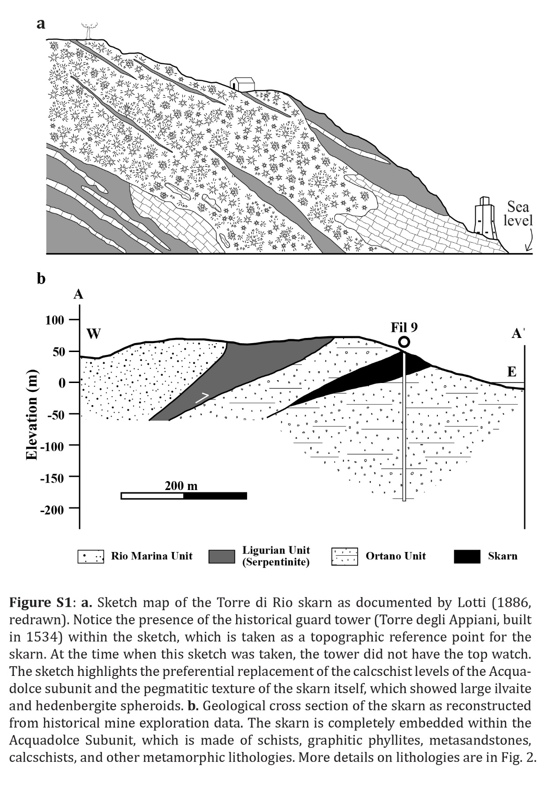
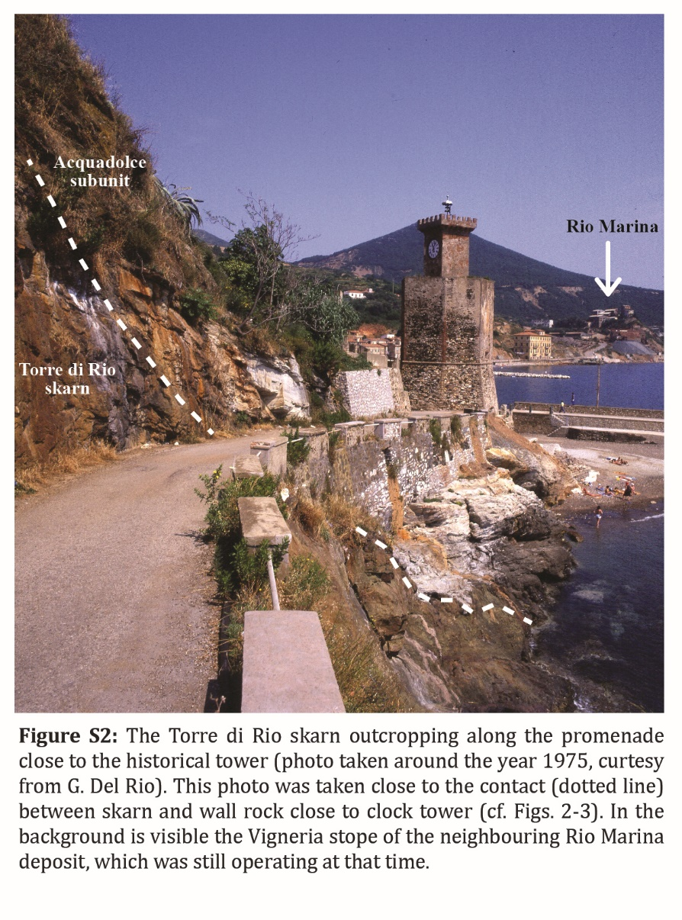
Although the occurrence of an ilvaite-pyroxene skarn was acknowledged at Torre di Rio by the earliest ore deposit studies of the Island of Elba (Lotti, 1886, 1910), little was reported about its economic value. The geological map of the island carried out during those studies (Lotti, 1886) reported the occurrence of an ilvaite-hedenbergite-epidote-pyrite skarn made of “thick layers embedded within pre-silurian calcschists” (Fig. S1a). This skarn outcropped at the seashore, close to the historical guard tower of Torre di Rio (Figs. S1a, S2, cf. Fig. 2) and along the municipal road of S Filomena (Tanelli, 1977). Its dimensions were estimated by exploration drill holes (Fig. S1b), but it was identified as subeconomic (Tanelli, 1977).
In several localities between Torre di Rio and Punta delle Cannelle, ilvaite was reported as “beautifully developed” (Gottardi, 1962) and Torre di Rio provided many museum-quality samples that are on display in the Natural History Museum of the city of Florence, Italy (Fig. S3).
Interestingly, ilvaite is one of the two minerals named after its type locality, i.e., the Island of Elba (Ilva is the Latin name for Elba). The other one is elbaite, i.e., the colorful Li-Na-bearing tourmaline end-member that was discovered at the beginning of the 19th century (Ertl, 2008), just like ilvaite. The peculiarity about ilvaite is the definition of its name, which came after a long “debate” (Tanelli and Poggi, 2012). The mineral was first discovered during the Napoleon reign, and it was named jenite in honor of the battle of Jena won by the Napoleon army in 1806. After Napoleon’s dominion, the mineral name was changed into lievrite in honor of M. Lelievre, who was believed by some to be its discoverer. However, a discussion arose afterwards as to the identity of the mineralogist who really discovered this mineral. Some workers claimed that F. de Bellevue was the actual discoverer; however, others claimed that it was D. de Dolomieu. As a result of an unfruitful and long-lasting “dispute”, the name ilvaite was finally proposed in 1811 based on the locality of its discovery.

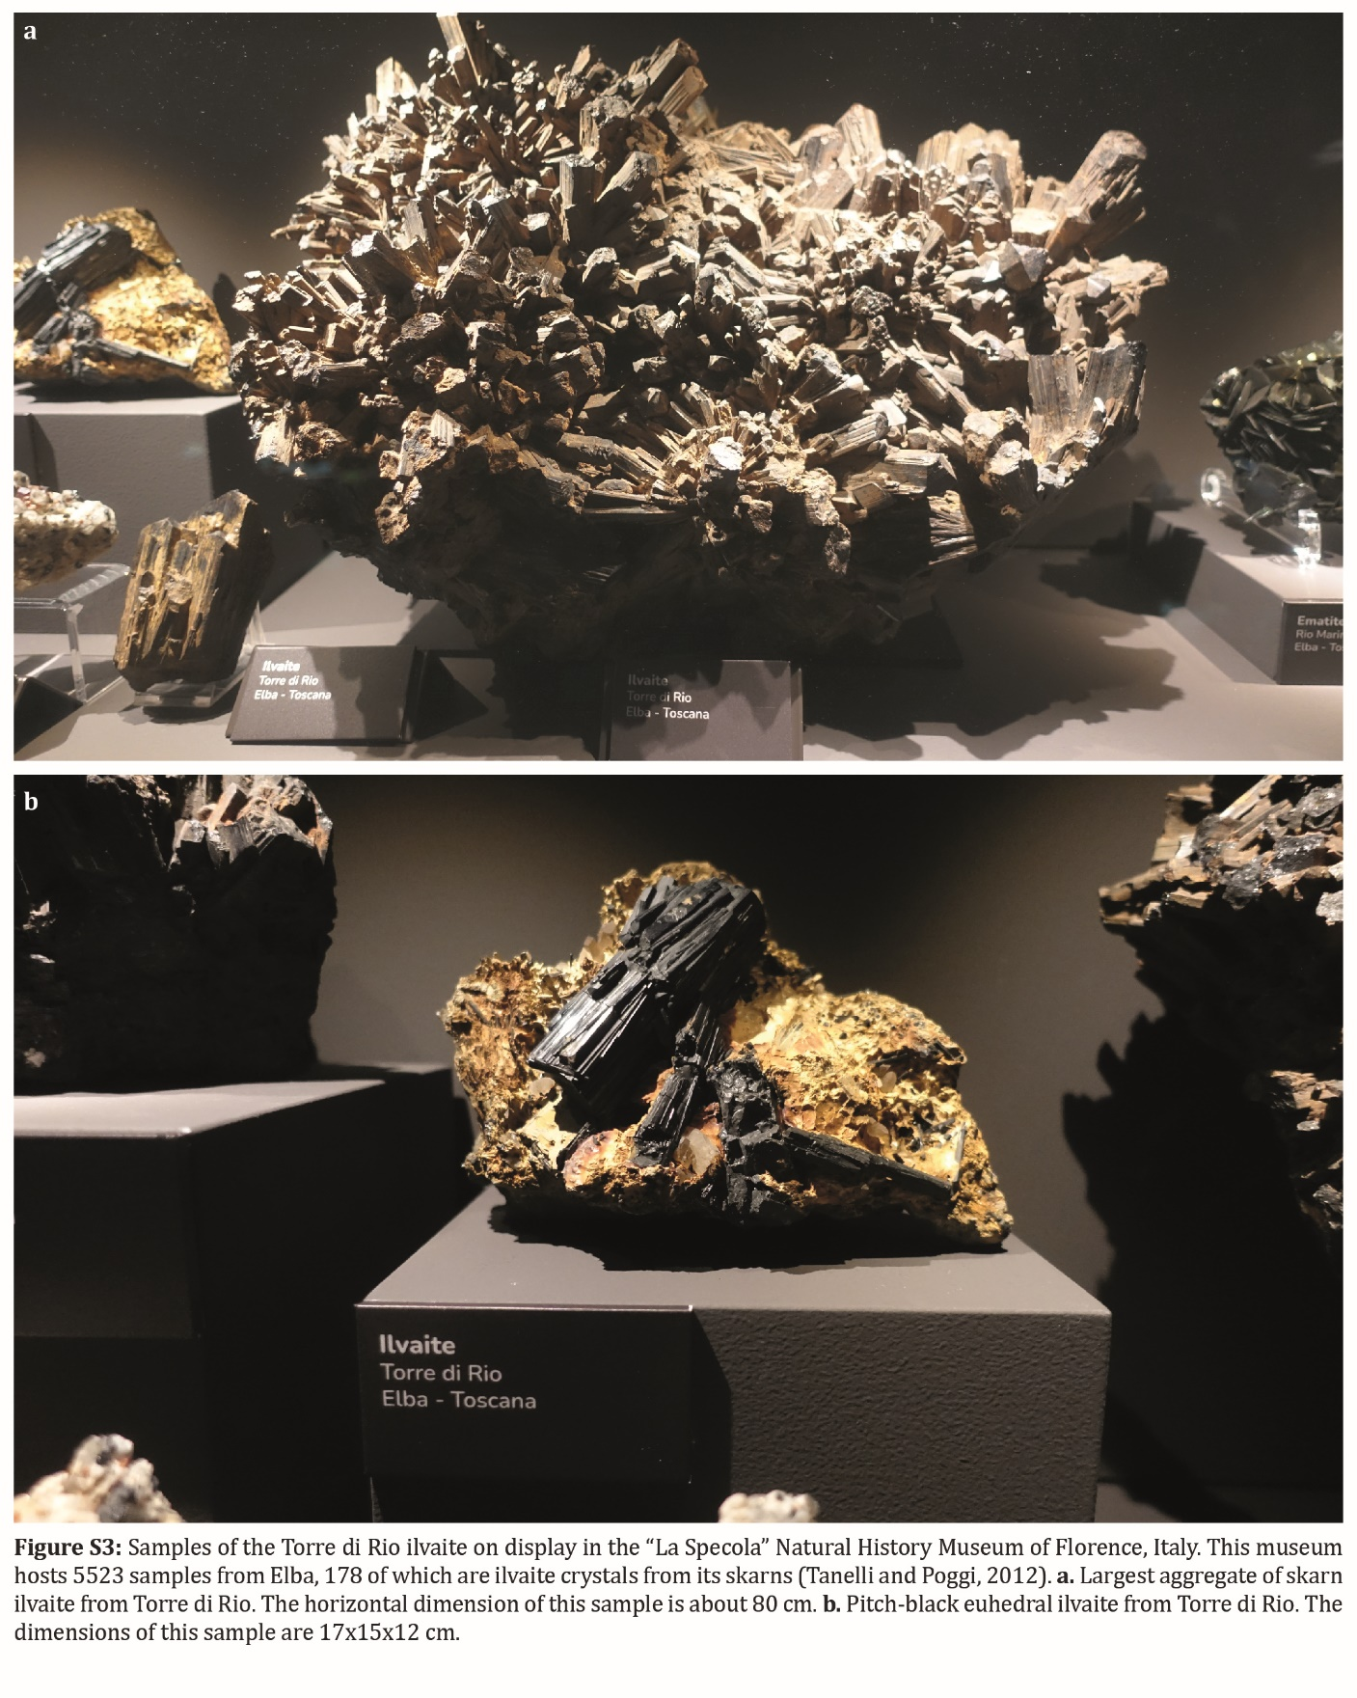
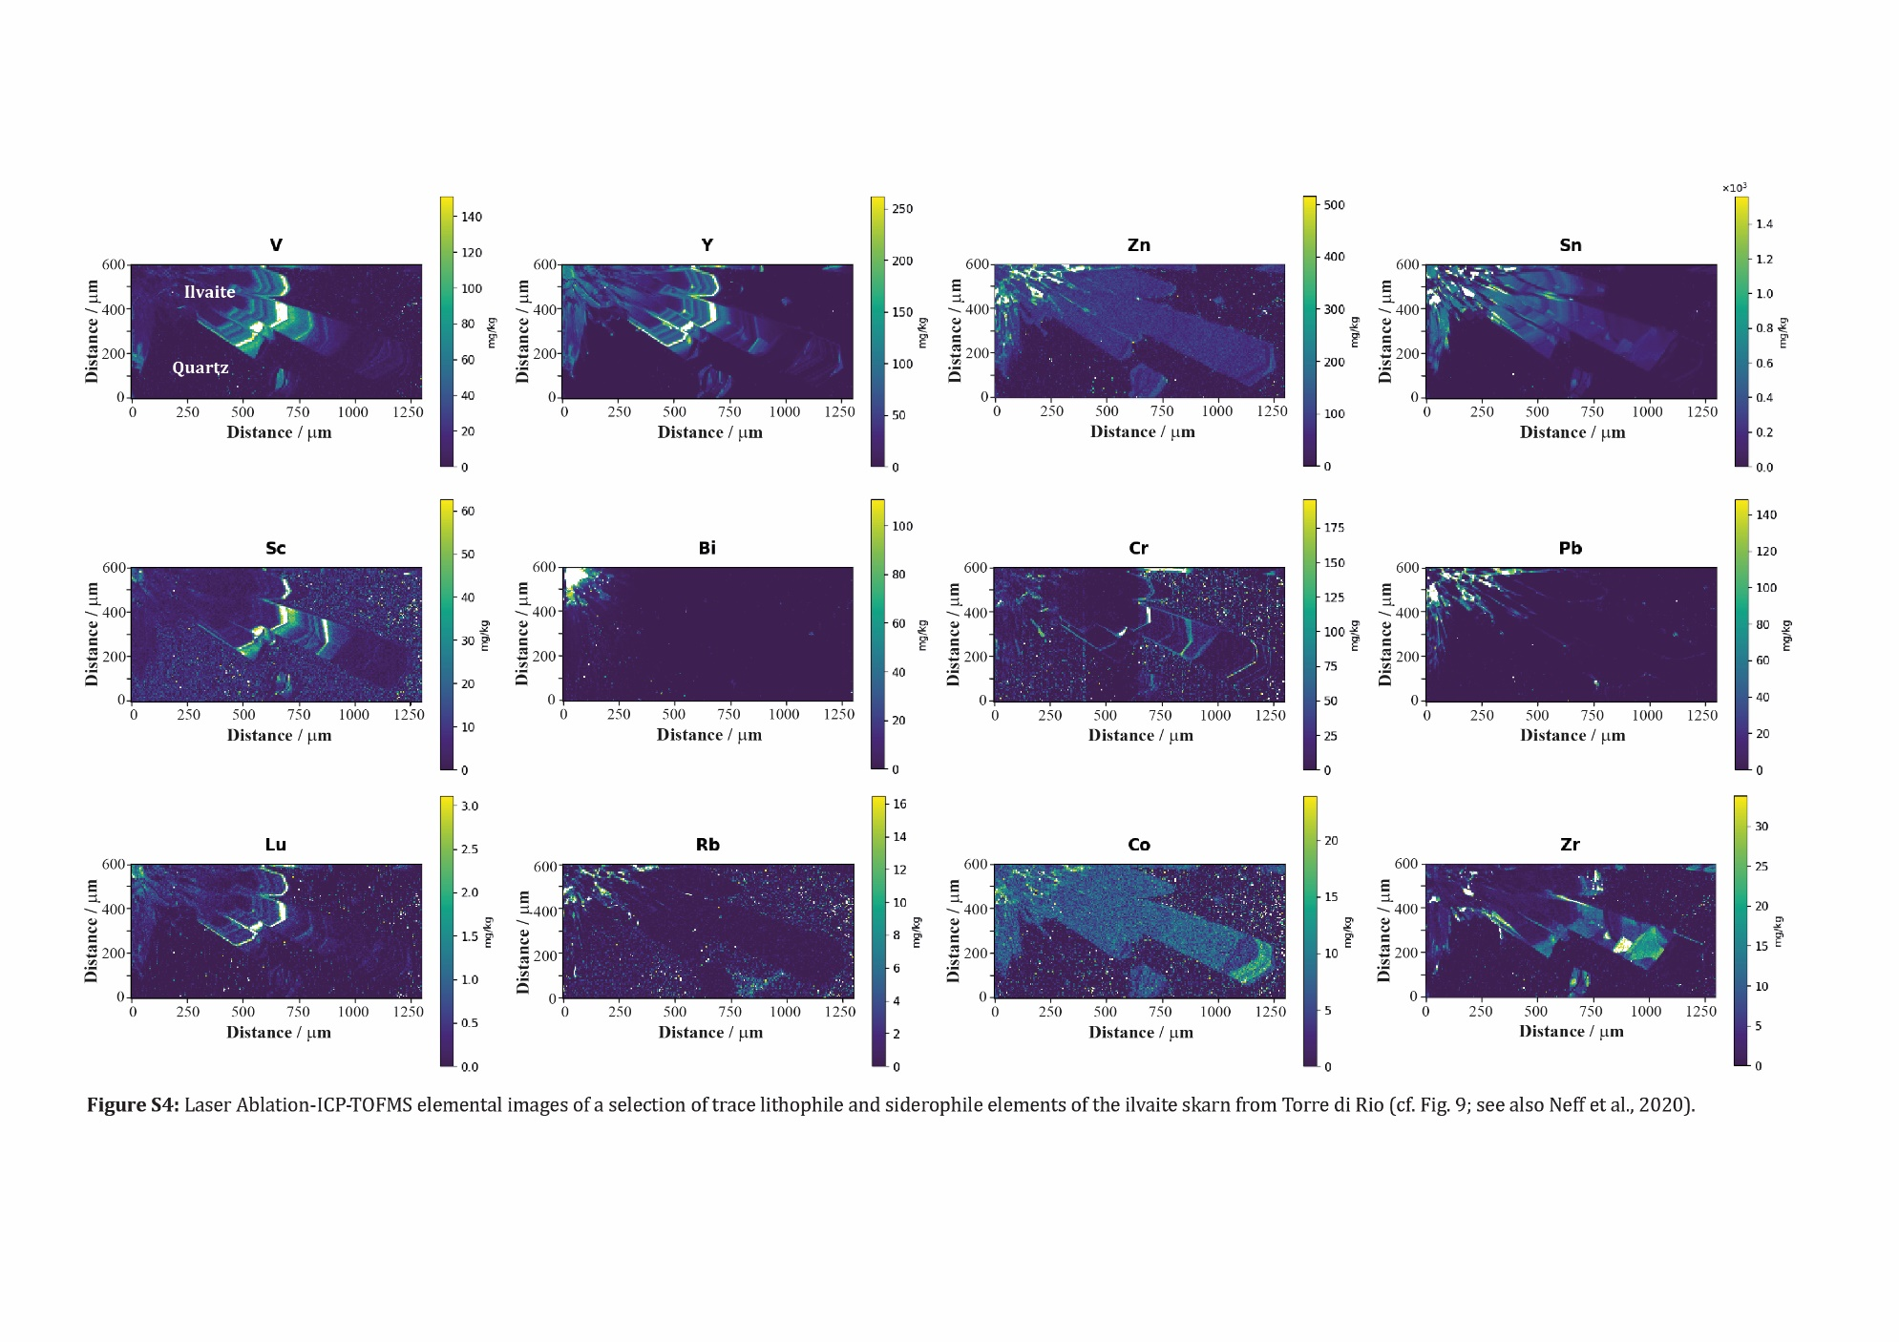

Table S5: Typical concentrations of trace elements in skarns and in the ilvaite and quartz of Torre di Rio
Element | Typical conc. in skarns (μg g⁻¹) | Concentrations at Torre di Rio (μg g⁻¹)
Cu | 100 | -
Pb | 100 | 150 (ilv)
Zn | 200 | 100-200 (ilv)
W | 100 | 7-8 (qtz)
Ni | 75 | -
As | 50 | 1000-3000 (ilv)
Bi | 50 | c. 100 (ilv)
Co | 50 | 5-30 (ilv)
Mo | 25 | 25-30 (qtz)
Cr | 25 | 50-75 (ilv)
Cd | 10 | 25-30 (qtz)
Ag | 5 | 10-15 (qtz)
Se | 5 | 1000-1200 (qtz)
Te | 1 | 50-60 (qtz)
Sb | 1 | 250-300 (qtz)
Hg | 0.25 | -
Au | 0.08 | -
Ti | - | 2000-3000 (ilv)
V | - | 50-150 (ilv)
Sc | - | 50-60 (ilv)
Ga | - | 10-40 (ilv)
Ge | - | 50-200 (ilv)
In | - | 15-20 (ilv)
Zr | - | 10-40 (ilv)
Y | - | 150-300 (ilv)
REEs | - | 1-15 (ilv)+
Rh | - | 2 (qtz)
Pd | -
Pt | - | 3-4 (qtz)
Re | - | 2-3 (qtz)
Ta | - | 3-4 (qtz)
Nb | - | 1-6 (ilv)
U | - | 2-3 (ilv, qtz)
Th | - | 1-2 (ilv, qtz)
Note: the typical concentrations of trace elements in skarns are taken from Meinert et al. (2005) and are those above which the given element should be considered anomalous in these deposits. The concentrations at Torre di Rio refer to the ranges determined in ilvaite and quartz by LA-ICPTOFMS (cf. Figs. 9 and S4).
-: not determined or <LOD

References
Bakker, R.J., 2003. Package FLUIDS 1. Computer programs for analysis of fluid inclusion data and for modelling bulk fluid properties. Chemical Geology 194(1-3), 3-23.
Brandelik, A., 2009. CALCMIN – an EXCEL™ Visual Basic application for calculating mineral structural formulae from electron microprobe analyses. Computers & Geosciences 35(7), 1540-1551. doi.org/https://doi.org/10.1016/j.cageo.2008.09.011.
Ertl, A., 2008. About the nomenclature and the type locality of elbaite: a historical review Mitteilungen der Österreichischen Mineralogischen Gesellschaft 154, 35-44.
Gottardi, G., 1962. Solfuri ed ossidi di ferro del giacimento di Ortano (Isola d'Elba). Atti della Società Toscana di Scienze Naturali 66, 327-343.
Lotti, B., 1886. Descrizione geologica dell'isola d'Elba. Tipografia nazionale, Roma.
Lotti, B., 1910. Geologia della Toscana, in: Geologico, R.U. (Ed.) Memorie Descrittive della Carta Geologica d'Italia. Tipografia Nazionale, Roma, pp. 303-343.
Meinert, L.D., Dipple, G.M., Nicolescu, S., 2005. World skarn deposits, in: Hedenquist, J.W., Thompson, J.F.H., Goldfarb, R.J., Richards, J.P. (Eds.), Economic Geology 100th Anniversary Volume 1905-2005. pp. 299-336.
Tanelli, G., 1977. I giacimenti a skarn della Toscana. Rendiconti della Società Italiana di Mineralogia e Petrografia 33, 875-903.
Tanelli, G., Poggi, L., 2012. La collezione elbana, in: Pratesi, G. (Ed.) Il Museo di Storia Naturale dell'Università degli Studi di Firenze: le collezioni litologiche e mineralogiche. Florence, Italy, pp. 67-81.

