Analyte | Isotope dilution Analogue | Injection standard
PFBA | 13C4-PFBA | 13C3-PFBA
PFPeA | 13C5-PFPeA | 13C3-PFBA
PFMBA | 13C5-PFPeA | 13C3-PFBA
PFBS | 13C3-PFBS | 13C4-PFOS
PFEESA | 13C3-PFBS | 13C4-PFOS
PFHxA | 13C5-PFHxA | 13C2-PFOA
4:2FTS | 13C2-4:2FTS | 13C4-PFOS
6:2FTS | 13C2-6:2FTS | 13C4-PFOS
8:2 FTS | 13C2-8:2FTS | 13C4-PFOS
PFPeS | 13C3-PFHxS | 13C4-PFOS
PFHxS | 13C3-PFHxS | 13C4-PFOS
HFPO-DA | 13C3-HFPO-DA | 13C2-PFOA
PFHpA | 13C4-PFHpA | 13C2-PFOA
ADONA | 13C4-PFHpA | 13C2-PFOA
PFOA | 13C8-PFOA | 13C2-PFOA
PFHpS | 13C8-PFOS | 13C4-PFOS
PFOS | 13C8-PFOS | 13C4-PFOS
9Cl-PF3ONS | 13C8-PFOS | 13C4-PFOS
11Cl-PF3OUdS | 13C8-PFOS | 13C4-PFOS
PFNA | 13C9-PFNA | 13C2-PFOA
PFDA | 13C6-PFDA | 13C2-PFOA
PFUnA | 13C7-PFUnA | 13C2-PFOA
PFDoA | 13C2-PFDoA | 13C2-PFOA
Table 1. Analytes and associated isotope analogues used as surrogate and injection standards respectively.
List of the structures of the analysed PFAS
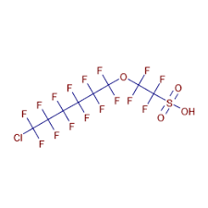
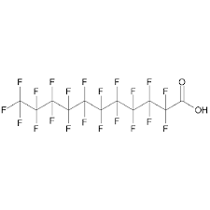
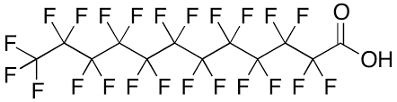
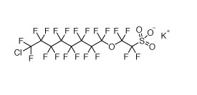
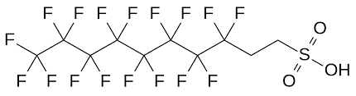
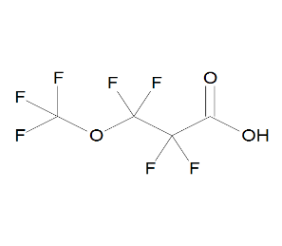
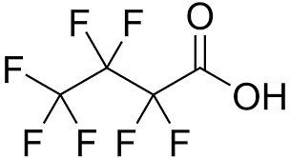
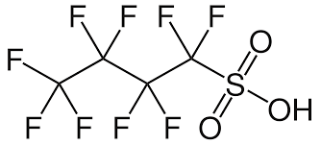
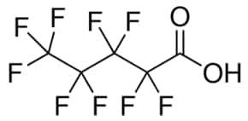
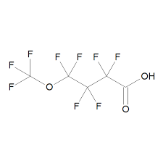
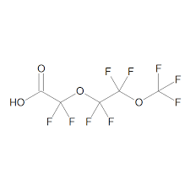
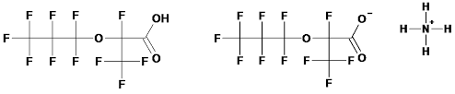
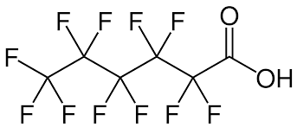
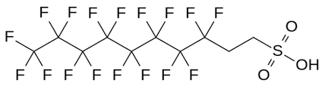
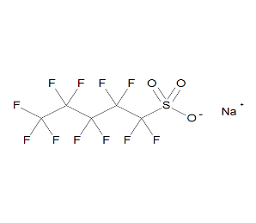
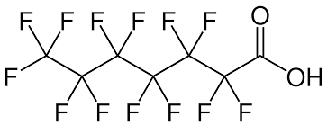
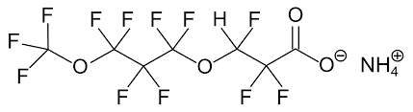
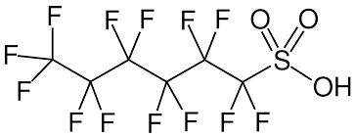
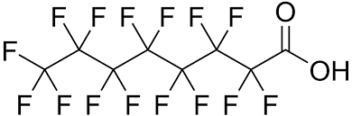
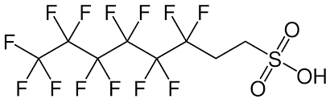
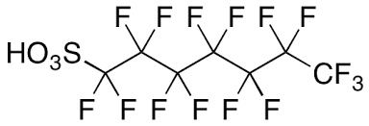
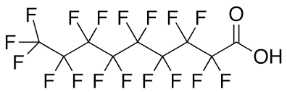
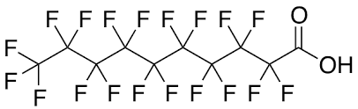
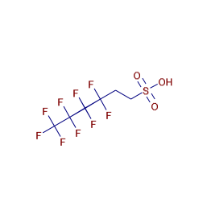
8:2 FTS
9-Cl-PF3ONS
PFUnA
PFDoA
H
11-Cl-PF3ONS
PFMPA
PFBA
PFBS
PFPeA
PFMBA
NFDHA
HFPO-DA (GenX)
PFHxA
PFEESA
4:2 FTS
H
PFPeS
PFHpA
ADONA
PFHxS
PFOA
PFHpS
6:2 FTS
PFNA
PFOS
PFDA

Table 2. LC gradient

Time  (min) | Mobile phase A  (%) | Mobile phase B  (%)
0.0 | 97 | 3
1.0 | 75 | 25
9.0 | 15 | 85
10.0 | 3 | 97
13.0 | 3 | 97
13.1 | 97 | 3
17.0 | 97 | 3

Table 3. Validation parameters of the LC-QTOF method.
Analyte | LOD  (ng/g) | LOQ  (ng/g) | Calibration range  (ng/mL) | Recovery  (%) | Matrix effect  (%) | Intraday  QC @ 0.5 ng/ml  (% bias) | Interday  QC @ 0.5 ng/ml  (% bias) | Intraday  QC @ 1.0 ng/ml  (% bias) | Interday  QC @ 1.0 ng/ml  (% bias)
11-Cl-PF3OUdS | 0.003 | 0.008 | 0.05-5 | 92 | 88 | 5 | 6 | -2 | -3
4:2 FTS | 0.002 | 0.007 | 0.05–5 | 100 | 125 | 1 | 1.2 | -1 | 0.8
6:2 FTS | 0.002 | 0.006 | 0.05–5 | 92 | 93 | 3 | -8 | -3 | -8
8:2 FTS | 0.002 | 0.006 | 0.05–5 | 87 | 85 | 15 | 17 | 5 | 15
9-Cl- PF3ONS | 0.003 | 0.008 | 0.05-5 | 92 | 88 | -5 | 8 | -6 | -3
ADONA | 0.008 | 0.02 | 0.1-5 | 94 | 93 | -1 | -1 | -8 | 0.3
HFPO-DA | 0.02 | 0.05 | 0.25-5 | 112 | 54 | 15 | 19 | 18 | 20
PFBA | 0.007 | 0.02 | 0.1-5 | 112 | 109 | * | * | * | *
PFBS | 0.002 | 0.005 | 0.05–5 | 103 | 93 | 6 | 11 | 2 | 10
PFDA | 0.003 | 0.008 | 0.05-5 | 112 | 118 | 2 | -10 | 3 | -9
PFDoA | 0.003 | 0.008 | 0.05-5 | 98 | 96 | 11 | 12 | 15 | 14
PFEESA | 0.003 | 0.008 | 0.05-5 | 103 | 93 | 4 | 3 | -4 | 10
PFHpA | 0.006 | 0.02 | 0.1-5 | 94 | 93 | 6 | 4 | -8 | 12
PFHpS | 0.002 | 0.008 | 0.05–5 | 92 | 88 | * | * | * | *
PFHxA | 0.003 | 0.01 | 0.1-5 | 117 | 115 | -7 | -10 | 10 | -9
PFHxS | 0.002 | 0.008 | 0.05–5 | 93 | 90 | * | * | * | *
PFMBA | 0.02 | 0.04 | 0.25-5 | 109 | 117 | -2 | 2 | 1 | 3
PFNA | 0.009 | 0.02 | 0.1-5 | 104 | 72 | -13 | -10 | -13 | -20
PFOA | 0.003 | 0.008 | 0.05-5 | 98 | 80 | * | * | * | *
PFOS | 0.003 | 0.008 | 0.05-5 | 92 | 88 | * | * | * | *
PFPeA | 0.007 | 0.02 | 0.1-5 | 109 | 117 | 11 | 18 | 3 | 11
PFPeS | 0.003 | 0.008 | 0.05–5 | 93 | 90 | 5 | 13 | 9 | 18
PFUnA | 0.003 | 0.008 | 0.1-5 | 100 | 71 | 10 | 20 | -6 | -18
*Intraday and interday bias was obtained from spiked blood samples. However, for PFOA, PFOS, PFHxS, PFHpS and PFBA they were not calculated due to endogenous presence above the spiked concentrations.

