Supplementary data

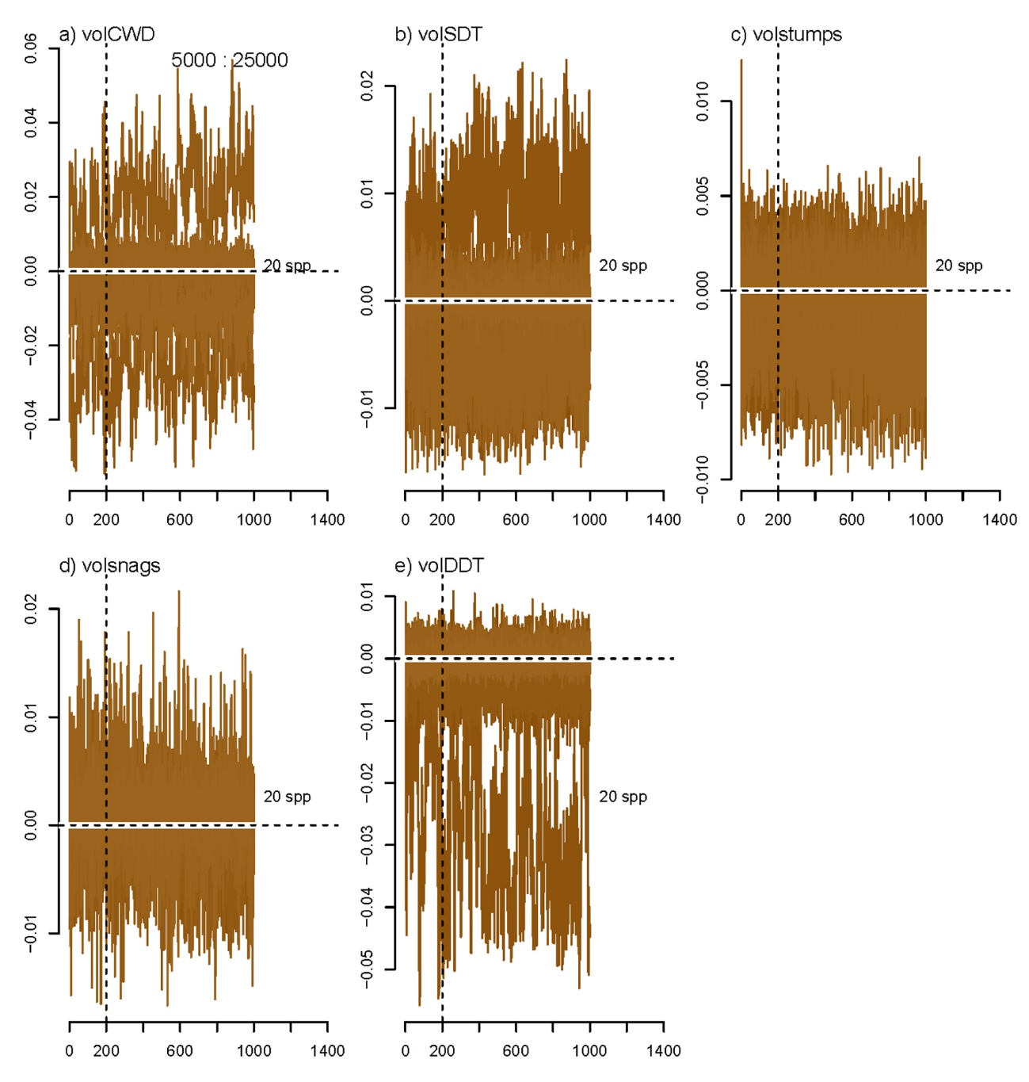

Fig. S1. Chain convergence for the deadwood predictors.

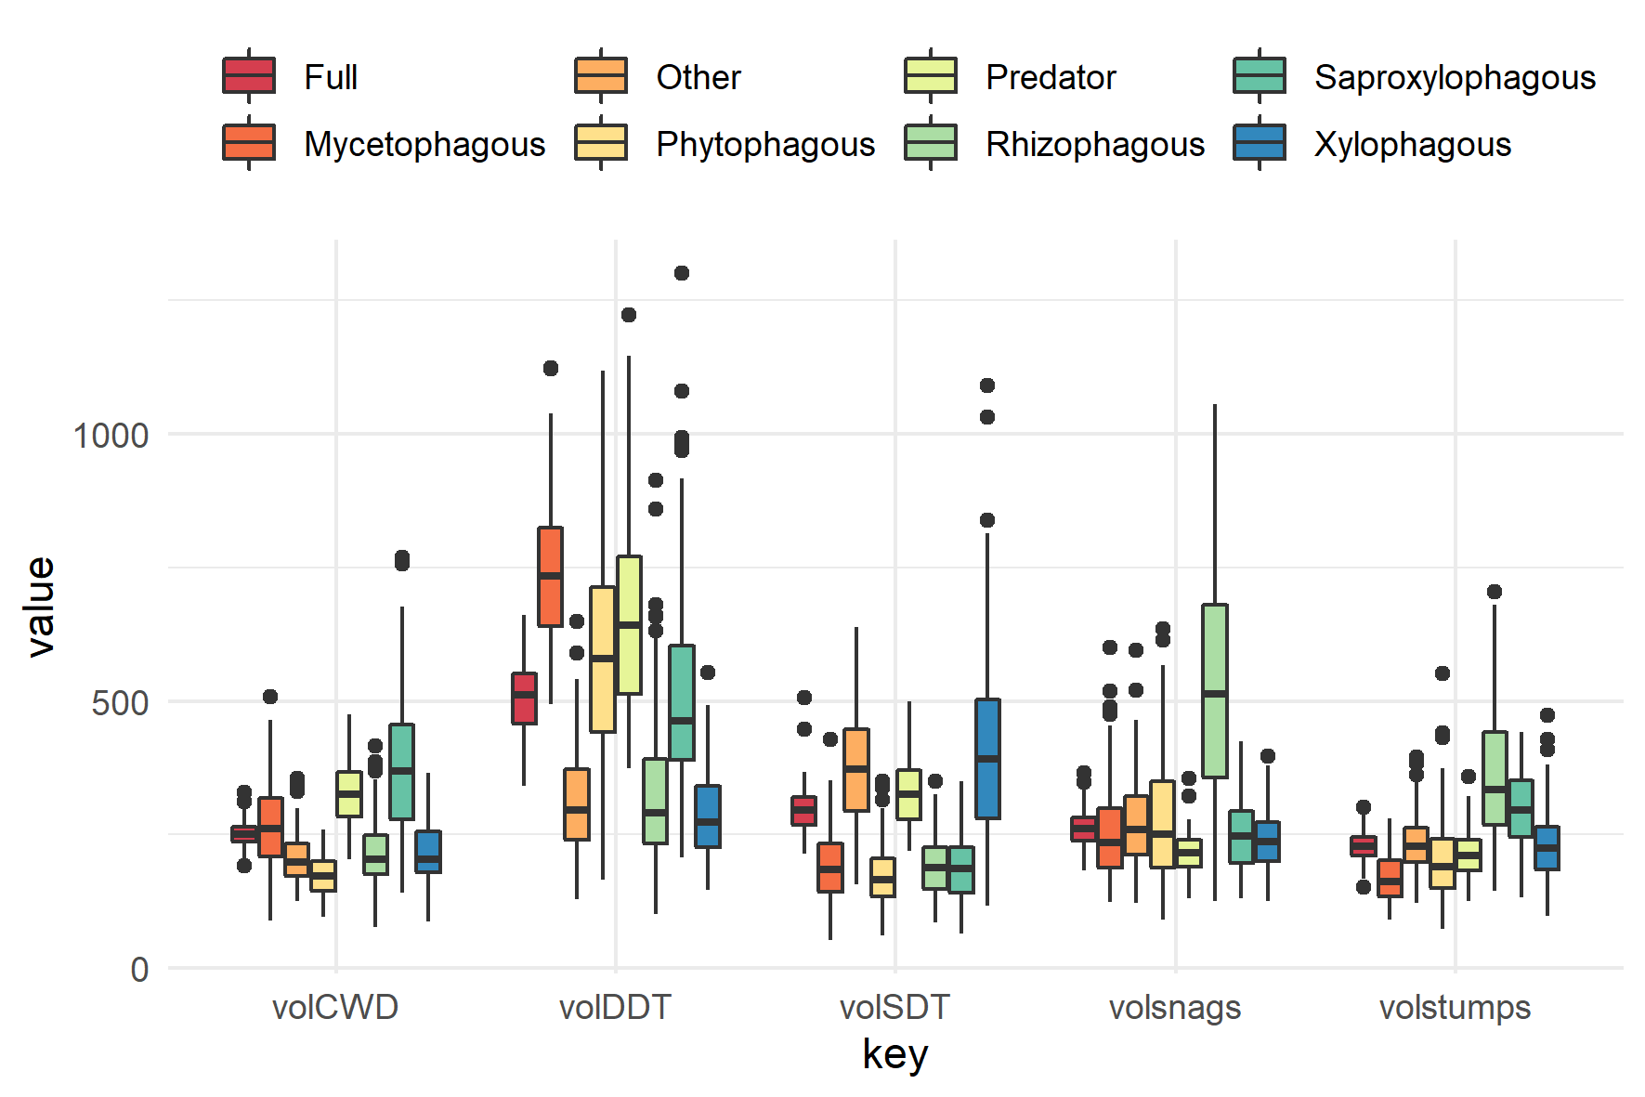

Fig. S2. Sensitivity of the model estimates of the entire response matrix (Full) and for subset of it including each trophic group.

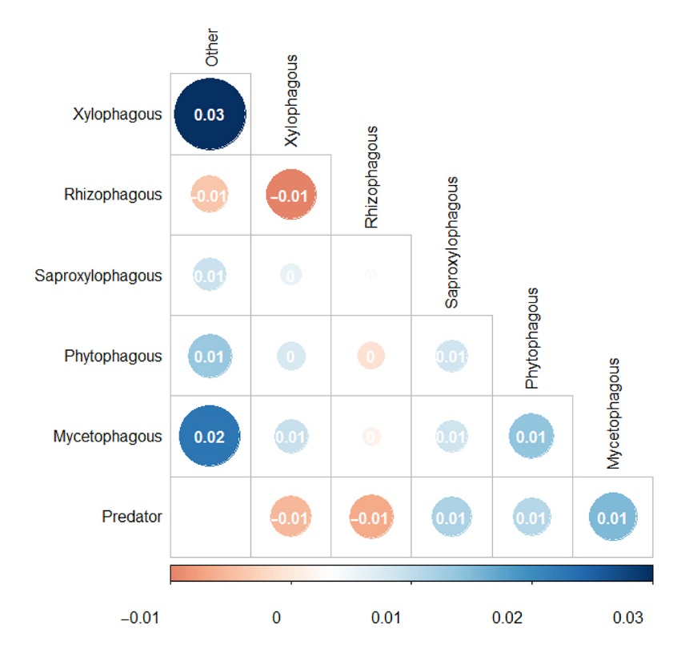

Fig. S3. Covariance of the model estimates between trophic groups.

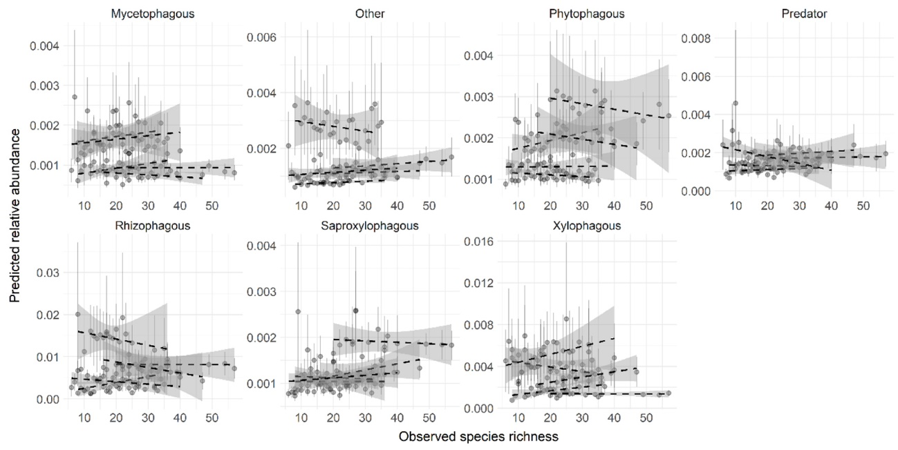
Fig. S4. Linear regressions between observed species richness and fitted relative abundance for the species in each trophic group and at each site. Circles show mean abundances with standard errors. Lines and shades show the regression with 95% confidence intervals for each site.

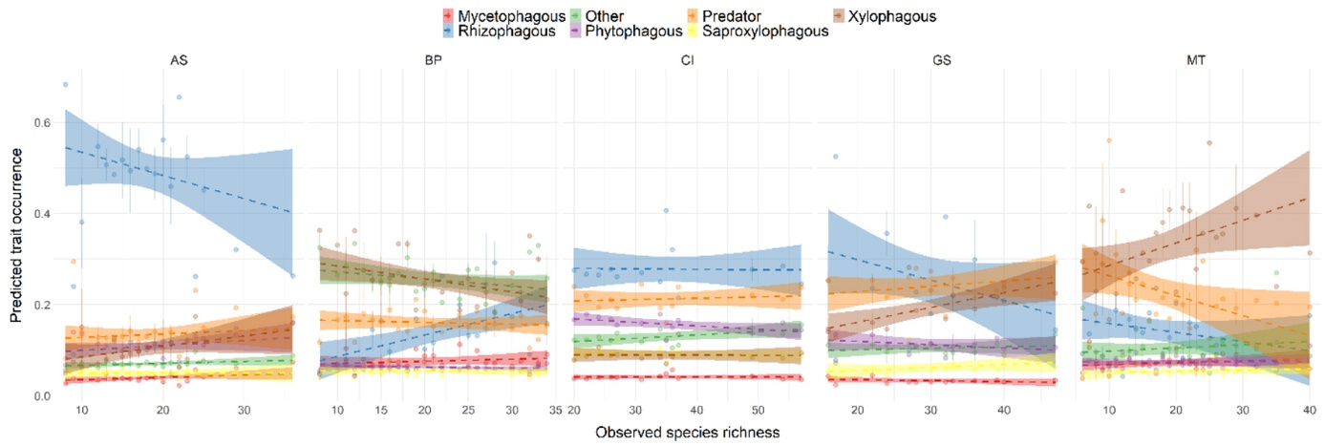
Fig. S5. Linear regressions between observed species richness and fitted community-weighted trait means, indicating trait occurrence of each trophic group for the five study sites. Circles show means with standard errors. Lines and shades show the regressions with 95% confidence intervals.

