Supporting Information

Efficient Bulk-Heterojunction Solar Cells Based on Symmetrically Disubstituted Polyalkyloxythiophenes at Low Synthetic Complexity

Massimiliano Lanzi*, Filippo Pierini, Riccardo Medri, Elisabetta Salatelli, Martina Marinelli

1. Materials and Methods
1,6-Hexanediol (OH(CH₂)₆OH, 99%), 1,10-decanediol (OH(CH₂)₁₀OH, 98%), 1-methylimidazole (C₄H₆N₂, >99%), [1,3-Bis(diphenylphosphino)propane]dichloronickel(II) (Ni(dppp)Cl₂), tetrahydrofuran (THF, >99.9%), toluene (C₇H₈, >99.9%), diethyl ether (Et₂O, >99.5%), ethyl acetate (EtOAc, >99.5%), petroleum ether (Etp, >90%), dimethyl sulfoxide (DMSO, ≥99%), and chloroform (CHCl₃, 99.0-99.4%) were purchased from Sigma Aldrich Chemical Co. (USA); hexane (≥99%) and dichloromethane (CH₂Cl₂, ≥99.9%) were purchased from Sigma Aldrich (France); nitromethane (CH₃NO₂, ≥98.5%), hydrochloric acid (HCl, ≥37%), hydrobromic acid (HBr, 48%), and ferric trichloride (FeCl₃, ≥98%) were purchased from Fluka (Switzerland); 3,4-dimethoxythiophene (>98%) was purchased from Tokyo Chemical Industry (Japan); p-toluensulfonic acid monohydrate (pTSA) was purchased from Carlo Erba (Italy); sodium sulfate (Na₂SO₄, anhydrous) and sodium bicarbonate (NaHCO₃) were purchased from Riedel-deHaën (Poland); isopropylmagnesium chloride – LiCl complex 1.3M in THF was purchased from Avantor (Italy); sodium methoxide solution (NaOMe 30% wt in methanol) was purchased from Acros Organics; methanol (MeOH, >99.8%) was purchased from Honeywell (Germany).
3,4-(6,6’-Dibromohexyloxy)thiophene (1a) and 3,4-(10,10’-dibromodecyloxy)thiophene (2a) as precursor monomers were synthesized according to literature methods [,], starting from commercially available 3,4-dimethoxythiophene and 6-bromo-1-hexanol (B6OH) or 10-bromo-1-decanol (B10OH), prepared according to ref. []. Polymers P1 and P2 were synthesized according to ref. [], while the ionic polymer P3 was obtained by post-functionalization of the regioregular poly-3[(6-bromohexyl)thiophene] (3) [] with 1-methylimidazole []. Regioregular poly[3-(6-bromohexyloxy)thiophene] (PTO6Br) [] was synthesized from 2,5-dibromo-3-(6-bromohexyloxy)thiophene (BTO6Br), and then reacted with NaOMe to give the reference polymer poly[3-(6-methoxyhexyl-1-oxy)thiophene] (PR). All the materials were used as received, unless otherwise noted. To remove the stabilizer, Et₂O and THF were freshly distilled before the use. All manipulations involving moisture-sensitive reagents were performed under argon atmosphere.
2. Synthesis
6-Bromo-1-hexanol (B6OH). Starting from 5.90 g (50.0 mmol) of 1,6-hexanediol, 75.0 mL of toluene, and 6.70 mL (60.0 mmol) of HBr 48% wt., B6OH was obtained as a colorless oil (6.45 g, 36.0 mmol, yield 72%). δ ¹H-NMR (CDCl₃, ppm): 3.65 (t, 2H, CH₂OH), 3.41 (t, 2H, CH₂Br), 1.88 (m, 2H, CH₂CH₂OH), 1.58 (m, 2H, CH₂CH₂Br), 1.47 (m, 2H, CH₂), 1.41 (m, 2H, CH₂); δ ¹³C-NMR (CDCl₃, ppm): 62.94 (CH₂OH), 33.96 (CH₂Br), 32.85, 32.66, 28.08, 25.08 (aliphatic CH₂); FT-IR (KBr, cm⁻¹): 3339, 2932, 2859, 1053, 728, 644, 561.
10-Bromo-1-decanol (B10OH). Starting from 8.88 g (50.0 mmol) of 1,10-decanediol, 75.0 mL of toluene, and 6.70 mL (60.0 mmol) of HBr 48% wt., B10OH was obtained as a colorless oil (7.71 g, 32.5 mmol, yield 65%). δ ¹H-NMR (CDCl₃, ppm): δ 3.63 (t, 2H, CH₂OH), 3.40 (t, 2H, CH₂Br), 1.85 (m, 2H, CH₂CH₂OH), 1.56 (m, 2H, CH₂CH₂Br), 1.42 (m, 2H, CH₂), 1.29 (m, 10H, (CH₂)₅); δ ¹³C-NMR (CDCl₃, ppm): 63.20 (CH₂OH), 34.18 (CH₂Br), 32.95, 32.92, 29.60, 29.50, 29.49, 28.87, 28.29, 25.85 (aliphatic CH₂); FT-IR (KBr, cm⁻¹): 3338, 2925, 2854, 1056, 722, 645, 562.
3,4-(6,6’-Dibromohexyloxy)thiophene (1a). Starting from 0.608 mL (0.736 g, 5.00 mmol) of 3,4-dimethoxythiophene, 2.71 g (15.0 mmol) of B6OH, 0.095 g (0.50 mmol) of p-toluensulfonic acid monohydrate (pTSA), and 25.0 mL of anhydrous toluene, 1a was obtained as a yellow-greenish oil (1.02 g, 2.30 mmol, yield 46%). δ ¹H-NMR (CDCl₃, ppm): 6.17 (d, 2H, Th H2 and H5), 3.98 (t, 4H, ThOCH₂), 3.42 (t, 4H, CH₂Br), 1.89 (m, 4H, ThOCH₂CH₂), 1.83 (m, 4H, CH₂CH₂Br), 1.50 (m, 8H, (CH₂)₂); δ ¹³C-NMR (CDCl₃, ppm): 147.55 (Th C3 and C4), 97.16 (Th C2 and C5), 70.41 (OCH₂), 33.92 (CH₂Br), 32.82, 28.99, 28.04, 25.38 (aliphatic CH₂); FT-IR (KBr, cm⁻¹): 3109, 3002, 2937, 2859, 1563, 1499, 1467, 1242, 1144, 1048, 866, 747, 644, 560.
3,4-(6,6’-Dibromodecyloxy)thiophene (2a). Starting from 0.608 mL (0.736 g, 5.00 mmol) of 3,4-dimethoxythiophene, 3.57 g (15.0 mmol) of B10OH, 0.095 g (0.50 mmol) of pTSA, and 25.0 mL of anhydrous toluene, 2a was obtained as a yellowish oil (1.69 g, 3.05 mmol, yield 61%). δ ¹H-NMR (CDCl₃, ppm): 6.16 (s, 2H, Th H2 and H5), 3.97 (t, 4H, ThOCH₂), 3.40 (t, 4H, CH₂Br), 1.83 (m, 8H, ThOCH₂CH₂ and CH₂CH₂Br), 1.42 (bm, 8H, (CH₂)₂), 1.30 (bm, 16H, (CH₂)₄); δ ¹³C-NMR (CDCl₃, ppm): 147.66 (Th C3 and C4), 97.01 (Th C2 and C5), 70.68 (ThOCH₂), 34.17 (CH₂Br), 32.97, 29.58, 29.50, 29.46, 29.14, 28.89, 28.31, 26.08 (aliphatic CH₂); FT-IR (KBr, cm⁻¹): 3109, 2927, 2853, 1563, 1499, 1466, 1259, 1203, 1152, 1018, 870, 723, 644, 561.
3,4-Bis(6-methoxyhexyl-1-oxy)thiophene (1b). A solution of 1a (0.442 g, 1.00 mmol) dissolved in MeOH (5.0 mL) was quickly added to a flask containing a solution of NaOMe 30% in MeOH (0.28 mL, 1.50 mmol). The mixture was allowed to react under reflux for 3h. The system was then cooled down to room temperature and 10 mL of distilled water was added to the mixture. The crude product was extracted with Et₂O (3×10 mL) and the collected organic phases were subsequently washed with water to neutrality, dried with Na₂SO₄, filtered and concentrated under reduced pressure. Compound 1b was obtained as a white solid (0.293 g, 0.85 mmol, yield 85%) and used without any further purification. δ ¹H-NMR (CDCl₃, ppm): 6.16 (s, 2H, Th H2 and H5), 3.97 (t, 4H, ThOCH₂), 3.37 (t, 4H, CH₂OCH₃), 3.33 (s, 6H, OCH₃), 1.82 (m, 4H, ThOCH₂CH₂), 1.60 (m, 4H, CH₂CH₂OCH₃), 1.43 (m, 8H, (CH₂)₂); δ ¹³C-NMR (CDCl3, ppm): 147.63 (Th C3 and C4), 97.04 (Th C2 and C5), 72.92 (CH₂OCH₃), 70.57 (ThOCH₂), 58.69 (OCH₃), 29.73, 29.14, 26.08, 26.01 (aliphatic CH₂); FT-IR (KBr, cm⁻¹): 3103, 2976, 2940, 2859, 1564, 1499, 1472, 1378, 1229, 1206, 1157, 1120, 1031, 873, 735.
3,4-Bis(10-methoxydecyl-1-oxy)thiophene (2b). Prepared according to compound 1b, starting from 0.555 g (1.00 mmol) of 2a, 0.28 mL (1.50 mmol) of NaOMe 30% in MeOH and 5.0 mL of MeOH; the system was heated at 65°C for 5h and then the reacted mixture was cooled down to room temperature, washed with distilled water and extracted with diethyl ether. Compound 2b was obtained as a white solid (0.379 g, 0.83 mmol, yield 83%) and used without any further purification. δ ¹H-NMR (CDCl₃, ppm): 6.15 (s, 2H, Th H2 and H5), 3.96 (t, 4H, ThOCH₂), 3.36 (t, 4H, CH₂OCH₃), 3.32 (s, 6H, OCH₃), 1.81 (m, 4H, ThOCH₂CH₂), 1.56 (m, 4H, CH₂CH₂OCH₃), 1.42 (m, 4H, CH₂), 1.30 (bm, 20H, (CH₂)₅); δ ¹³C-NMR (CDCl₃, ppm): 147.68 (Th C3 and C4), 96.99 (Th C2 and C5), 73.11 (CH₂OCH₃), 70.71 (ThOCH₂), 58.68 (OCH₃), 29.80, 29.67, 29.63, 29.51, 29.15, 26.28, 26.09 (aliphatic CH₂); FT-IR (KBr, cm⁻¹): 3103, 2974, 2921, 2848, 1563, 1499, 1471, 1378, 1210, 1202, 1157, 1123, 1043, 875, 724.
Poly[3,4-bis(6-methoxyhexyl-1-oxy)thiophene] (P1). 0.172 g (0.50 mmol) of 1b, 0.649 g (2.0 mmol) of FeCl₃, 11.0 mL of anhydrous CHCl₃ and 2.0 mL of CH₃NO₂ were reacted under a vigorous flux of argon for 30 minutes at room temperature. 10 mL of CHCl₃ was added to the reaction mixture and the resulting dark suspension was washed several times with an aqueous solution of HCl (5% v/v). 20 mL of MeOH was then added to the organic phase and, after filtration on a glass crucible (porosity grade 4), the crude polymer was washed several times with further methanol and dried. Polymer P1 was obtained as a dark purplish solid (0.096 g, 0.28 mmol, yield 56%). ¹H-NMR (CDCl₃, ppm, δ): 4.11 (bs, 4H, ThOCH₂), 3.36 (bt, 4H, CH₂OCH₃), 3.31 (bs, 6H, OCH₃), 1.90 (bs, 4H, ThOCH₂CH₂), 1.60 (bs, 4H, CH₂CH₂OCH₃), 1.44 (bm, 8H, (CH₂)₂); ¹³C-NMR (CDCl₃, ppm, δ): 145.20 (Th C3+C4), 116.92 (Th C2+C5), 73.56 (CH₂OCH₃), 73.10 (ThOCH₂), 58.86 (OCH₃), 30.56, 30.07, 26.53, 26.33 (aliphatic CH₂). FT-IR (KBr, cm⁻¹): 2975, 2858, 1515, 1462, 1432, 1375, 1261, 1163, 1117, 1021, 730; Elemental analysis (C₁₈H₃₀O₄S)_{n} (342.49)_{n} Calcd.: C 63.12, H 8.83, O 18.69, S 9.36. Found: C 62.83, H 8.24, O 18.91, S 10.02.
Poly[3,4-bis(10-dimethoxydecyl-1-oxy)thiophene] (P2). Prepared according to P1, starting from 0.228 g (0.50 mmol) of 2b, 0.649 g (2.0 mmol) of FeCl₃, 11.0 mL of anhydrous CHCl₃, and, 2.0 mL of CH₃NO₂. Polymer P2 was obtained as a dark purplish solid (0.145 g, 0.32 mmol, yield 64%). ¹H-NMR (CDCl₃, ppm, δ): 4.10 (bs, 4H, ThOCH₂), 3.35 and 3.31 (bt and bs, 10H, CH₂OCH₃ and OCH₃), 1.90 (bs, 4H, ThOCH₂CH₂), 1.55 (bs, 4H, CH₂CH₂OCH₃), 1.45 (bs, 4H, CH₂), 1.30 (bs, 20H, (CH₂)₅). ¹³C-NMR (CDCl₃, ppm, δ): 145.12 (Th C3+C4), 116.89 (Th C2+C5), 73.56 (CH₂OCH₃), 73.18 (ThOCH₂), 58.75 (OCH₃), 30.54, 30.05, 29.96, 29.87, 26.46, 26.40 (aliphatic CH₂). FT-IR (KBr, cm⁻¹): 2973, 2922, 2853, 1516, 1465, 1435, 1376, 1261, 1173, 1125, 1020, 723; Elemental analysis (C₂₆H₄₆O₄S)_{n} (454.71)_{n} Calcd.: C 68.68, H 10.20, O 14.07, S 7.05. Found: C 68.25, H 9.88, O 14.59, S 7.28.
Poly{3-[6-(1-methyl-1H-imidazol-3-ium)-hexyl]-thiophene}bromide (P3). In a three-neck flask, 36.0 mL of DMSO, 36.0 mL of MeOH and 24.0 mL of water were added to a solution of 3 (0.735 g, 3.0 mmol) in THF (105.0 mL). 4.80 mL (4.92 g, 60.0 mmol) of 1-methylimidazole was then added and the system heated until reflux for 48h. The system was cooled down to room temperature and the crude polymer was added to 500 mL of THF. The precipitate was filtered on a PFTE membrane (pore size 0.45 μm), washed with further THF and dried. Polymer P3 was obtained as a dark red solid (0.810 g, 2.55 mmol, yield 85%). ¹H-NMR (CD₃OD, δ ppm): 9.10 (bs, 1H, N⁺CHNCH₃), 7.69 (bs, 1H, CHNCH₃), 7.51 (bs, 1H, N⁺CH), 6.96 (bs, 1H, Th H4), 4.28 (bs, 2H, CH₂N⁺), 3.94 (bs, 3H, NCH₃), 3.57 (bs, 2H, CH₂Br), 2.83 (bs, 2H, ThCH₂), 1.95 (bs, 2H, CH₂CH₂N⁺), 1.73 (bm, 2H, ThCH₂CH₂), 1.49 (bs, 4H, (CH₂)₂); FT-IR (KBr, cm⁻¹): 3145, 3078, 2930, 2856, 1627, 1572, 1511, 1461, 1451, 1259, 1178, 1169, 1098, 1044, 832, 752, 725, 644, 560; Elemental analysis (C₁₄H₁₉BrN₂S)_{n} (327.28)_{n} Calcd.: C 51.38, H 5.85, N 8.56, S 9.80, Br 24.41. Found: C 50.93, H 5.69, N 8.68, S 9.83, Br 24.87.
2,5-Dibromo-3-(6-bromohexyloxy)thiophene (BTO6Br). 0.743 g of N-bromosuccinimide (NBS, 4.18 mmol) was added to a solution of 3-(6-bromohexyloxy)thiophene (0.500 g, 1.90 mmol) in CH₂Cl₂ (13.0 mL); the solution was stirred for 21h at room temperature, in the dark and under inert atmosphere. The reaction mixture was added to 100 mL of CH₂Cl₂ and washed several times with distilled water. The organic phase was dried with Na₂SO₄, filtered and concentrated under reduced pressure. The crude product was purified by column chromatography (SiO₂; cyclohexane/CH₂Cl₂ 90:10) giving 0.640 g (1.52 mmol) of BTO6Br as a light-yellow oil (80% yield). ¹H-NMR (CDCl₃, ppm, δ): 6.76 (s, 1H, Th H4), 4.00 (t, 2H, ThOCH₂), 3.42 (t, 2H, CH₂Br), 1.90 (m, 2H, ThOCH₂CH₂), 1.75 (m, 2H, CH₂CH₂Br), 1.50 (m, 4H, (CH₂)₂). ¹³C (CDCl₃, ppm, δ): 153.89 (Th C3), 121.01 (Th C4), 109.86 (Th C5), 90.88 (Th C2), 72.45 (ThOCH₂), 33.88 (CH₂Br), 32.78 (CH₂CH₂Br), 29.34 (ThOCH₂CH₂), 27.96, 25.17 ((CH₂)₂). FT-IR (KBr, cm⁻¹): 3050, 2958, 2927, 2874, 1501, 1465, 1270, 1163, 1088, 992, 841, 750, 561.
Poly[3-(6-bromohexyloxy)thiophene] (PTO6Br). 2,5-Dibromo-3-(6-bromohexyloxy)thiophene (0.500 g, 1.19 mmol) was added to a three-neck flask and dissolved in 12.0 ml of anhydrous THF, then i-PrMgCl·LiCl (0.900 mL, 1.17 mmol; 1.3 M in THF) was added dropwise to the mixture at room temperature and under inert atmosphere. After stirring for 6h, 0.3 mmol (0.16 mg) of Ni(dppp)Cl₂ was added and after 18h the mixture was quenched with a solution of HCl in methanol (5% v/v). The reaction mixture was diluted with CHCl₃, washed several times with water and the organic phase was dried and concentrated giving 0.186 g (0.712 mmol) of regioregular PT6OBr as a dark-blue solid (60% yield). ¹H-NMR (CDCl₃, ppm, δ): δ 6.86 (bs, 1H, Th H4), 4.04 e 3.89 (bs, 2H, HT e HH/TT ThOCH₂), 3.42 (bs, 2H, CH₂Br), 1.89 (bs, 2H, CH₂), 1.77 (bs, 2H, CH₂), 1.25 (bs, 4H, (CH₂)₂). ¹³C-NMR (CDCl₃, ppm, δ): 154.82 (Th C3), 136.32 (Th C5), 107.99 (Th C4), 106.72 (Th C2), 68.00, 67.78 (ThOCH₂), 32.67 (CH₂Br), 29.85 (ThOCH₂CH₂), 30.04, 28.14, 24.16, 23.04 (aliphatic CH₂). FT-IR (KBr, cm⁻¹): 3055, 2917, 2849, 1511, 1459, 1260, 1170, 1089, 832, 728, 646, 562.
Poly[3-(6-methoxyhexyloxy)thiophene] (PR). 0.123 g (2.28 mmol) of sodium methoxide in 10 ml of DMF were added to a solution of 0.150 g (0.57 mmol) of PTO6Br in 20 ml of anhydrous THF. The mixture was refluxed for 6 h in an inert atmosphere, cooled down to room temperature and added with 50 ml of methanol. The precipitated polymer was filtered on a Teflon septum (0.45 μm pore size), washed again with methanol and dried, giving 0.118 g (0.56 mmol) of regioregular PR as a dark blue solid (98% yield). ¹H-NMR (CDCl₃, ppm, δ): δ 6.91 (bs, 1H, Th H4), 4.16 (bs, 2H, ThOCH₂), 3.39 (bs, 5H, CH₂OCH₃), 1.84 (bs, 2H, CH₂), 1.56 (bs, 4H, (CH₂)₂), 1.24 (bs, 2H, CH₂). ¹³C (CDCl₃, ppm, δ): 156.55 (Th C3), 123.21 (Th C5), 111.16 (Th C4), 95.29 (Th C2), 73.65 (CH₂OCH₃), 69.92(ThOCH₂), 57.14 (OCH₃), 30.68, 29.55, 28.68, 25.77 (aliphatic CH₂). FT-IR (KBr, cm⁻¹) 3052, 2977, 2928, 2856, 1509, 1454, 1387, 1260, 1193, 1019, 823, 752. Elemental analysis (C₁₁H₁₆O₂S) Calcd.: C 62.23, H 7.60, O 15.07, S 15.10. Found: C 61.91, H 7.49, O 15.19, S 15.41.
3. Measurements and Characterization
NMR spectra (¹H-NMR and ¹³C-NMR) were recorded on a Varian Mercury Plus 400 spectrometer using TMS as a reference. IR spectra were taken on KBr disks using a Perkin Elmer Spectrum One spectrophotometer. UV-Vis spectra were recorded on a Perkin Elmer Lambda 19 spectrophotometer using 10⁻⁵ M polymer solutions in spectroquality solvents in Suprasil quartz cuvettes (1×1 cm) or films on quartz slides. Fluorescence spectra of polymers and blends were measured by means of an Edinburgh FLSP 920 spectrofluorimeter using thin films on quartz slides. Elemental analyses were performed by Redox Laboratories, Monza, Italy.
The molecular weight of polymers was determined by gel permeation chromatography (GPC) using THF solutions on a HPLC Lab Flow 2000 apparatus equipped with a Rheodyne 7725i injector, a Phenomenex MXL 5 μm mixed bed column, and an RI K-2301 KNAUER detector. The calibration curve was recorded using monodisperse polystyrene standards. Thermogravimetric analyses (TGA) were recorded on a NETZSCH TG 209 F1 Libra operating in air flux, which was used to determine the sample decomposition temperatures by heating from 30°C to 600°C with a ramp of 10°C min⁻¹.
A TA Instruments Q2000 differential scanning calorimeter (DSC) was used for thermal analysis by varying the temperature from 20 to 300°C with a heating and cooling ramp of 10°C min⁻¹ in a nitrogen atmosphere.
Cyclic voltammetry (CV) analyses were performed using an Autolab PGSTAT 204 (Metrohm) potentiostat/galvanostat at a scan rate of 100 mV/s on polymer films deposited on Pt electrodes from CHCl₃ (P1, P2, PR) or CH₃OH (P3) solutions. The working electrode (Pt disk), the auxiliary electrode (Pt wire) and the reference electrode (SCE, absolute potential 4.24 eV in CH₃CN solution [4]) were immersed in a CH₃CN solution with tetrabuylammonium hexafluorophosphate (TBAPF₆) 0.1M as the supporting electrolyte using a single compartment three-electrodes cell.
X-ray diffraction data were recorded at room temperature by using a CuKα (λ = 1.5406 Å) radiation source (Philips PW 1050) and a Bragg-Brentano diffractometer (Philips PW 1710) equipped with a graphite monochromator in the diffracted beam. The 2θ range between 2.0 and 90.0° was scanned by 881 steps of 0.1° with a counting time of 15 s for each step. The XRD characterization was carried out on polymer films on glass slides deposited by doctor blading (150 nm average thickness) after the annealing procedure (heating at 120°C for 30 min under vacuum).
The sample surface topography was evaluated with an atomic force microscope (AFM, Ntegra, NT-MDT) equipped with a silicon cantilever (HA_NC, NT-MDT, tip radius of 10 nm, and spring constant of 12 N/m). Measurements were performed in a semi-contact mode with a resonance frequency of around 150 kHz; the scanning rate was 0.5 Hz, while the size of the scanned sample was 10 µm × 10 µm per image.

4. Device fabrication and characterization
Bulk-Heterojunction (BHJ) Organic Solar Cells
The ITO glass substrate (surface resistance 21 Ω/sq) was etched on one side by using a 10% wt aqueous solution of HCl and heating at 60°C for 15 min, in order to leave a small area uncovered by indium tin oxide. The glass was then rinsed with distilled water, 2-propanol and dried with a nitrogen flow (final resistance 12 Ω/sq). Poly(3,4-ethylenedioxythiophene):polystyrene sulfonic acid (PEDOT:PSS, 2.8 wt% dispersion in water, viscosity 20 cps) was diluted 1:1 v/v with 2-propanol, sonicated for 15 min using an ultrasonic bath (Elmasonic S 30H), filtered on a Gooch G2 and the resulting solution (viscosity 12 cps) deposited over the previously treated ITO glass with the Doctor Blade technique (Sheen Instrument Model S265674), leaving only a small area uncovered at the opposite side of the previously etched area. The PEDOT:PSS film was heated in a Buchi GKR-50 glass oven at 120°C for 90 min under vacuum (10⁻³ mmHg). A solution made by mixing 2.5 mg of electron-donor polymer (P1 or P2 or PR) and 2.5 mg of phenyl-C61-butyric acid methyl ester (PC₆₁BM) in 1 mL of chlorobenzene was sonicated for 15 min, filtered on a PTFE septum (0.45 μm pore size) and deposited by Doctor Blade on the slide in order to cover the PEDOT:PSS layer. The sample was then annealed in the glass oven under vacuum (10⁻³ mmHg) at 120°C for 45 min. Only for the samples with the cathode interlayer, 0.1 mL of a solution of P3 in MeOH (2 mg/mL) was deposited by Doctor Blade on the ED polymer surface and subsequently annealed at 120°C for 30 min. Finally, a thin film of Al (electrode, 50 nm of thickness) was deposited over the polymeric layer through a shadow mask using an Edwards 6306A coating system operating at 10⁻⁶ mmHg. The resulting active area of the cell was 1 cm². The current-voltage characteristics were measured in air using a Keithley 2401 source meter under the illumination of an Abet Technologies LS150 Xenon Arc Lamp Source AM 1.5 Solar Simulator (100 mW/cm²) calibrated with an ILT 1400-BL photometer. The structure of the final devices was made of: ITO (80 nm)/PEDOT:PSS (100 nm)/P1 or P2 or PR (150 nm)/P3 (when employed) (10 nm)/Al (50 nm). The solar cell spectral response was measured using a 7-SC Spec III Modularized Solar Cell Spectral Test System (SevenStar Optics, Beijing, PRC). Layer thickness was measured using a FTPAdvances FTPadv-2 Film Thickness Probe (Sentech GmbH, Germany) equipped with the FTPExpert software.

5. Evaluation of Synthetic Complexity (SC) parameter
SC of a synthetic procedure was evaluated according to [] using the following equation:

$$SC=35 × \frac{NSS}{{NSS}_{max}}+25 × \frac{log⁡(RY)}{log⁡({RY}_{max})}+15×\frac{NUO}{{NUO}_{max}}+15×\frac{NCC}{{NCC}_{max}}+10×\frac{NHC}{{NHC}_{max}}$$

where:
NSS = number of synthetic steps (required to obtain the final product);
RY = sum of reciprocal yields of each synthetic step;
NUO = number of purification steps (without chromatography);
NCC = number of column chromatography purification steps;
NHS = number of hazardous chemicals used for the synthetic procedure
Hazardous chemicals are counted as many times as the number of their selected H risk phrases; in detail:
H340, H341, H350, H351 (carcinogenic/mutagenic)
H360, H361 (toxic for reproduction)
H300, H304, H310, H330, H370, H372 (very toxic)
H400, H410, H411 (toxic for the environment or aquatic organisms)
H260, H261 (highly reactive with water)
H220, H222, H224, H250 (highly flammable)
H290, H314, H318 (highly corrosive)
H200, H201, H202, H203, H204, H205, H240, H241, H271 (explosive).
The values of the normalization factors are: NSS_{max} = 22, RY_{max} = 86.9, NUO_{max} = 39, NCC_{max} = 13, NHC_{max} = 44. SC can then be considered proportional to the cost of the final material, while the Figure Of Merit (FOM) can be estimated by the SC/PCE (power conversion efficiency) ratio, which roughly represents the cost/efficiency balance of a donor polymer.

Evaluation of SC for the electron-donor polymers
P1
NSS = 4; RY = 4.8; NUO = 8; NCC = 2; NHC = 19
SC = 24.64

P2

NSS = 4; RY = 4.62; NUO = 7; NCC = 1; NHC = 19
SC = 22.95

Evaluation of SC for the cathodic interlayer P3
The polymer P3, to be used as a cationic interlayer to boost the final device efficiency [,] was obtained by post-functionalization of the regioregular PT6Br with 1-methylimidazole.
NSS = 6; RY = 13.14; NUO = 10; NCC = 2; NHC = 30 (including precursor 3 synthesis)
SC = 36.92

Evaluation of SC for the reference polymer poly[3-(6-methoxyhexyl-1-oxy)thiophene] (PR)

NSS = 5; RY = 5.9; NUO = 8; NCC = 2; NHC = 14
SC = 26.45

6. Additional Figures and Tables

Figure S1. ¹H-NMR spectrum of P1.

Figure S2. ¹H-NMR spectrum of P2.

Figure S3. ¹H-NMR spectrum of P3.

Figure S4. ¹H-NMR spectrum of PR.

Figure S5. ¹³C-NMR spectrum of P1.

Figure S6. ¹³C-NMR spectrum of P2.
Figure S7. ¹³C-NMR spectrum of P3.

Figure S8. ¹³C-NMR spectrum of PR.
Figure S9. PL spectra of pristine polymer films (solid line) and with PCBM (dotted line; 1:1 polymer:PCBM w/w).

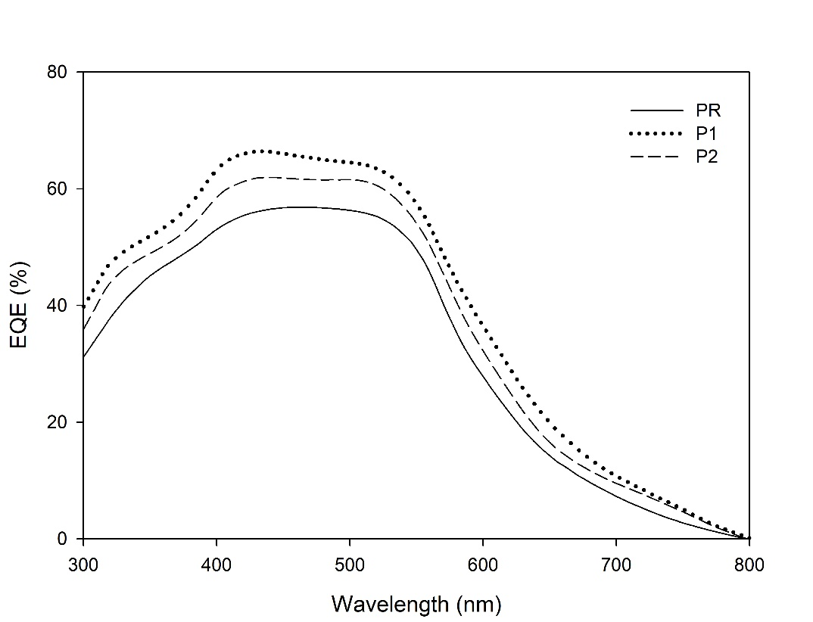

Figure S10. EQE spectra of average performing devices (without interlayer).

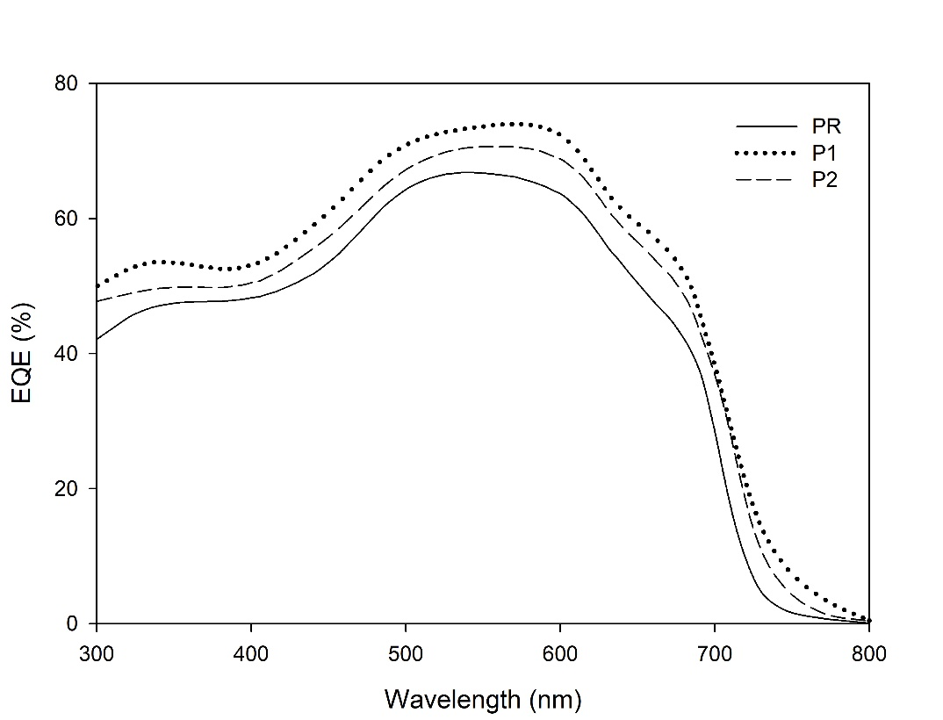

Figure S11. EQE spectra of average performing devices (with interlayer).

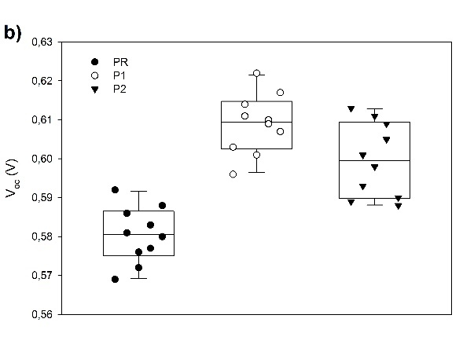
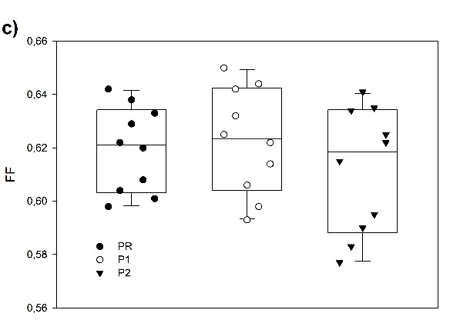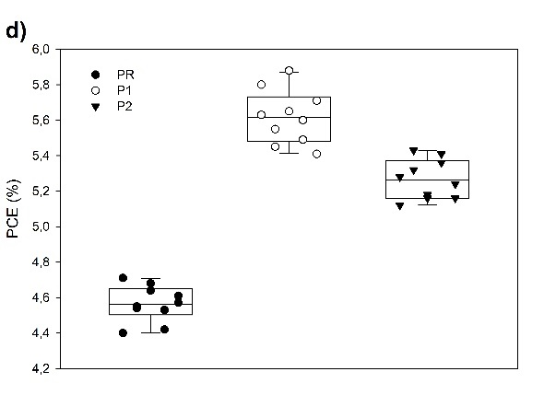

Figure S12. Statistical analysis of the performance parameters of the examined OSCs (10 devices for each type) without cationic interlayer: a) J_{sc}, b) V_{oc}, c) FF, d) PCE.

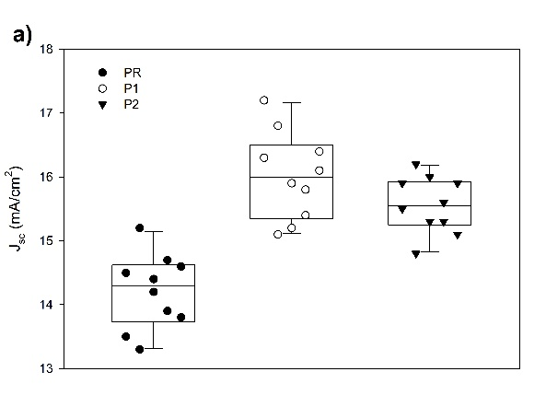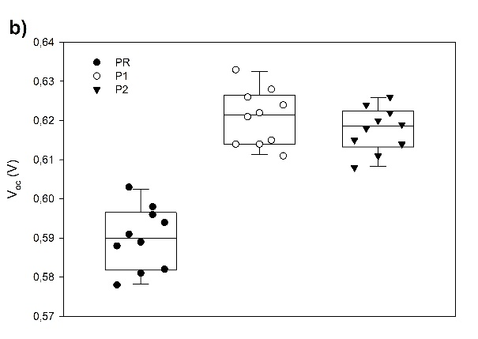
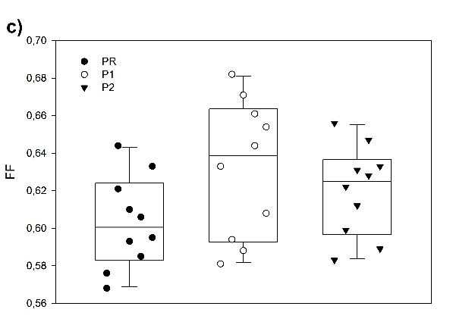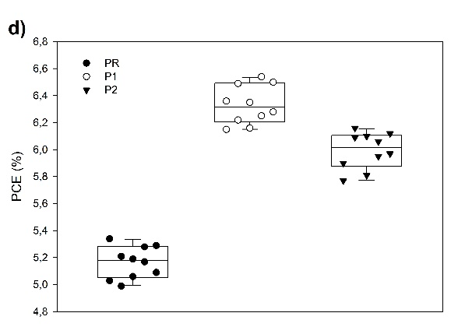

Figure S13. Statistical analysis of the performance parameters of the examined OSCs (10 devices for each type) with cationic interlayer (P3): a) J_{sc}, b) V_{oc}, c) FF, d) PCE.

Figure S14. Hole mobility of the examined cells without and with (*) cathodic interlayer.

Figure S15. Electron mobility of the examined cells without and with (*) cathodic interlayer.

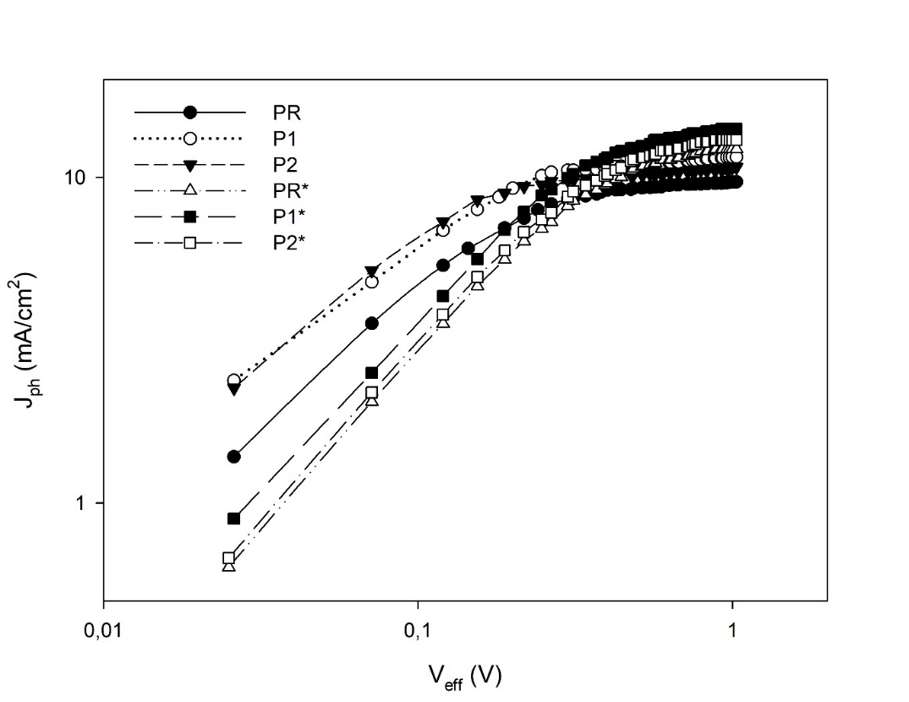

Figure S16. J_{ph}-V_{eff} curves of the examined cells without and with (*) cathodic interlayer.

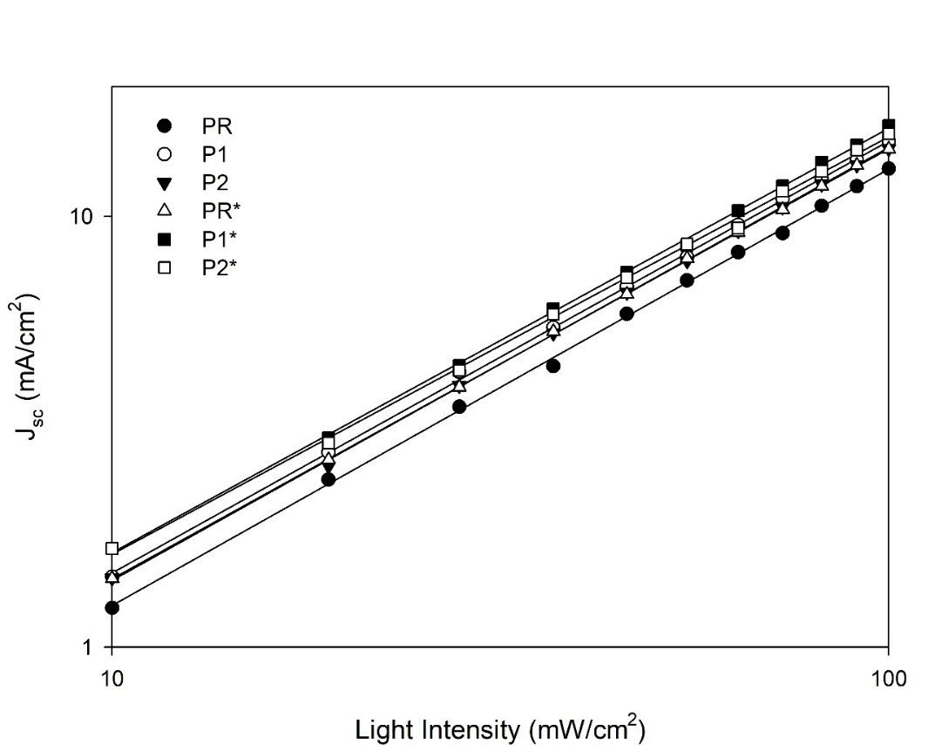

Figure S17. J_{sc} dependence on light illumination intensity curves of the examined cells without and with (*) cathodic interlayer.

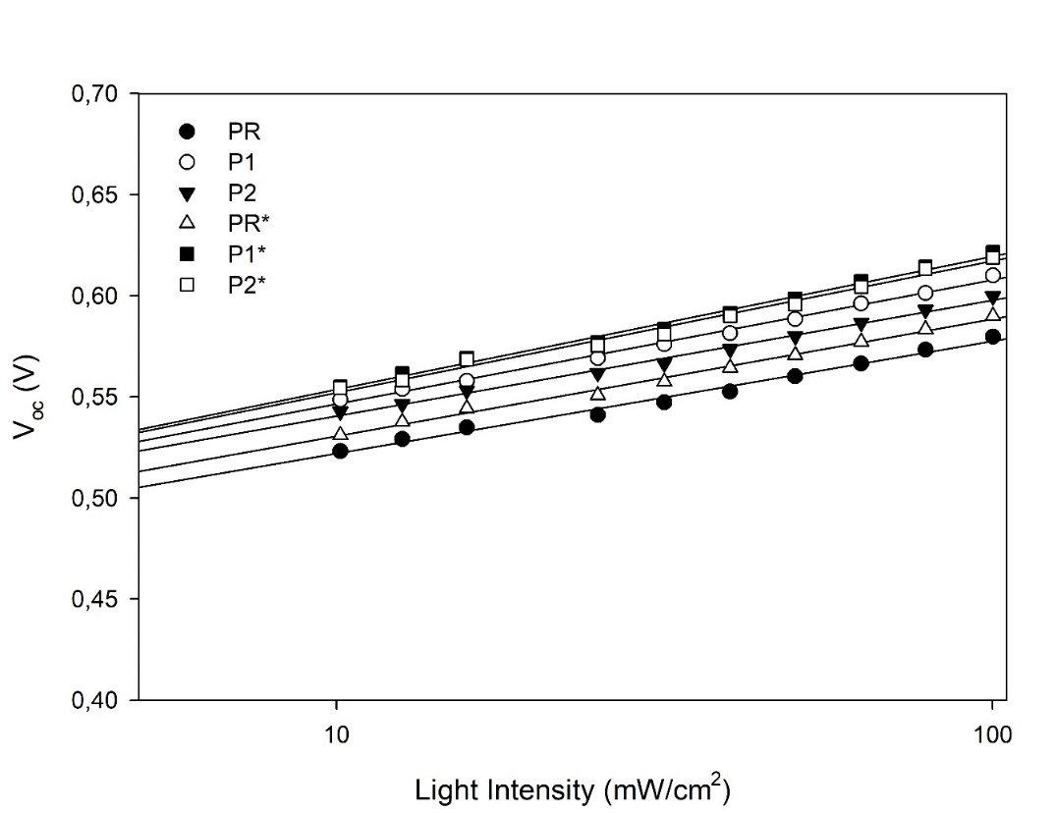

Figure S18. V_{oc} dependence on light illumination intensity curves of the examined cells without and with (*) cathodic interlayer.

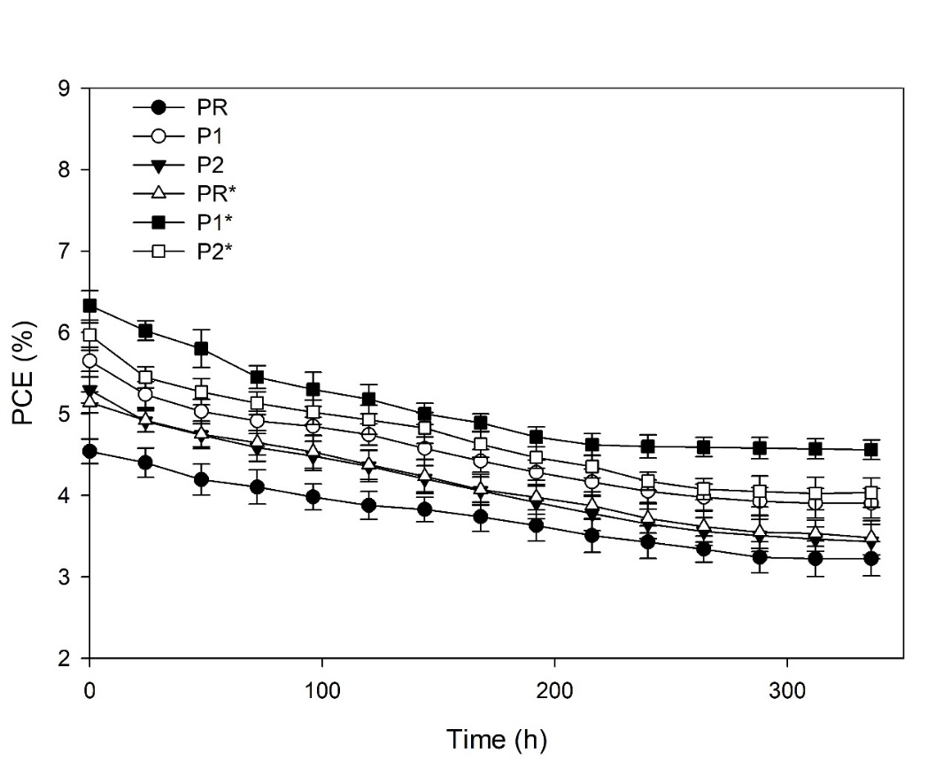
Figure S19. Power conversion efficiencies (PCE)s of solar cells heated at 80°C vs. time: Ten devices of each type were prepared and tested.

Figure S20. Morphological characterization of BHJ OSCs samples without P3 interlayer. Top: topology, bottom: phase images. A) PR sample, RMS 7.83 ± 2.5 nm; B) P1 sample, RMS 3.54 ± 1.5 nm; C) P2 sample, RMS 5.67 ± 1.6 nm.

Figure S21. Morphological characterization of BHJ OSCs samples with P3 interlayer. Top: topology, bottom: phase images. A) PR sample, RMS 3.93 ± 1.1 nm; B) P1 sample, RMS 2.25 ± 0.8 nm; C) P2 sample, RMS 2.8 ± 0.9 nm.

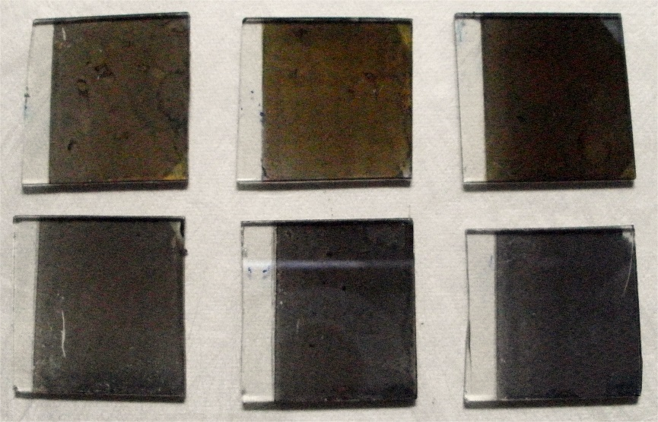

Figure S22. Image of the different examined blends (films on quartz slides): up (from left to right): P1, P2, PR; down: P1*, P2*, P3*.

Table S1. Main IR absorption bands (cm⁻¹) of P1, P2, P3 and PR.
P1 | P2 | P3 | PR | Assignments
- | - | 3145 | - | υ_{as} C-H imidazolium
- | - | 3078 | - | υ_{sym} C-H imidazolium
- | - | 3055 | 3052 | υ C-H thiophene
2975 | 2973 | 2930 | 292928 | υ_{as} -CH₂- side chain
2858 | 2853 | 2856 | 2856 | υ_{sym} -CH₂- and –CH₃
- | - | 1627, 1572 | - | υ_{as} imidazolium
1515 | 1516 | 1511 | 1509 | υ_{as} -C=C- thiophene
1462 | 1465 | 1461 | 1454 | υ_{sym} C=C thiophene
- | - | 1451 | - | υ_{sym} imidazolium ring
1375 | 1376 | - | 1387 | –CH₃ deformation
1261 | 1261 | 1259 | 1260 | υ C-C thiophene-thiophene
- | - | 1178 | - | υ_{as} N-CH₃
- | - | 1169 | - | υ_{sym} N-CH₃
1117 | 1125 | - | 1193 | υ_{as} C-O-C
- | - | 1044 | - | δ –CH imidazolium
1021 | 1020 | - | 1019 | υ_{sym} C-O-C
- | - | 832 | 823 | γ C-H 2, 3, 5-trisubstituted thiophene
- | - | 752 | - | γ C-H imidazolium
730 | 723 | 725 | 752 | rocking -CH₂-
- | - | 644 | - | υ C-Br aliphatic

* υ = stretching; γ = out of plane bending; δ = in plane bending.

Table S2. PCEs of the obtained cells before and after the thermal accelerated ageing (average values collected from 5 devices).
Sample | PCE (%)ª | PCE (%)^{b} | Δ (%)^{c}
PR | 4.55±0.18 | 3.22±0.21 | 29
P1 | 5.65±0.22 | 3.90±0.23 | 31
P2 | 5.24±0.21 | 3.43±0.20 | 35
PR* | 5.15±0.20 | 3.48±0.22 | 32
P1* | 6.33±0.22 | 4.56±0.21 | 28
P2* | 5.98±0.20 | 4.03±0.22 | 32
* With interlayer. ª Before heating. ^{b} After heating (80°C under vacuum). ^{c} PCE relative decrease.

References

[] M. Marinelli, M. Lanzi, D. Quadretti, Y. Ziai, F. Pierini, A. Zanelli, R. Medri, E. Salatelli, A new alcohol-soluble dye-tetraphenyl porphyrin functionalized copolymer: Inside the role as a third component/cathode interlayer in halogen-free OSCs, React. Funct. Polym. 2024, 200, 105928, https://doi.org/10.1016/j.reactfunctpolym.2024.105928
[] X. Chen, Q. Qu, Synthesis and optoelectrochemical properties of a magenta-to-transmissive electrochromic polymer based on 3, 4-dioxythiophene, Sol. Energy Mater. Sol. Cells 2018, 179, 270-275, https://doi.org/10.1016/j.solmat.2017.12.017
[] J. Chang, S.-J. Zhang, Y.-W. Jiang, L. Xu, J.-M. Yu, W.-J. Zhou, X. Sun, Design, Synthesis, and Antibacterial Activity of Demethylvancomycin Analogues against Drug-Resistant Bacteria, ChemMedChem 2013, 8, 976-984, https://doi.org/10.1002/cmdc.201300011
[] D. Quadretti, M. Marinelli, E. Salatelli, F. Pierini, A. Zanelli, M. Lanzi, Effects of Water/Alcohol Soluble Cationic Polythiophenes as Cathode Interlayers for Eco-Friendly Solar Cells, Macromol. Chem. Phys., 2023, 224, 2200422, https://doi.org/10.1002/macp.202200422
[] R. S. Loewe, P. C. Ewbank, J. Liu, L. Zhai, R. McCullough, Regioregular, Head-to-Tail Coupled Poly(3-alkylthiophenes) Made Easy by the GRIM Method: Investigation of the Reaction and the Origin of Regioselectivity, Macromolecules 2001, 34, 4324-4333, https://doi.org/10.1021/ma001677+
[] P. Urbánek, A. Di Martino, S. Gladyš, I. Kuřitka, A. Minařík, E. Pavlova, D. Bondarev, Polythiophene-based conjugated polyelectrolyte: Optical properties and association behavior in solution, Synth. Met. 2015, 202, 16-24, https://doi.org/10.1016/j.synthmet.2015.01.015
[] H. Zhao, B. Zhu, J. Sekine, S.-C. Luo, H. Yu, Oligoethylene-Glycol-Functionalized Polyoxythiophenes for Cell Engineering: Syntheses, Characterizations, and Cell Compatibilities, ACS Appl. Mater. Interfaces 2012, 4, 680−686, https://doi.org/10.1021/am2012905
[] R. Po, G. Bianchi, C. Carbonera, A. Pellegrino, “All That Glisters Is Not Gold”: An Analysis of the Synthetic Complexity of Efficient Polymer Donors for Polymer Solar Cells, Macromolecules 2015, 48, 453-461, https://doi.org/10.1021/ma501894w
[] S. Govaerts, J. Kesters, M. Defour, B. Van Mele, H. Penxten, S. Neupane, F. U. Renner, L. Lutsen, D. Vanderzande, W. Maes, Conjugated ionic (co)polythiophene-based cathode interlayers for bulk heterojunction organic solar cells, Eur. Polym. J. 2017, 97, 49-56, https://doi.org/10.1016/j.eurpolymj.2017.09.043
[] J. H. Seo, A. Gutacker, Y. Sun, H. Wu, F. Huang, Y. Cao, U. Scherf, A. J. Heeger, G. C. Bazan, Improved High-Efficiency Organic Solar Cells via Incorporation of a Conjugated Polyelectrolyte Interlayer, J. Am. Chem. Soc. 2011, 133, 8416-8419, https://doi.org/10.1021/ja2037673

