Appendix 1: Search Strategy
TOPIC: | Tailored Prophylaxis in Hemophilia
Databases: | PubMed, Embase, Medline, Cynahl, Cochrane Database
CONCEPT | MeSH | Keywords
Hemophilia | hemophilia a/ or hemophilia b/ | (hemophilia or haemophilia).mp
Tailored Prophylaxis | Antibodies, Monoclonal, Humanized / therapeutic use | tailored prophylaxi*
 | Factor VIII / administration & dosage | personalized prophylaxi*
 | Factor IX / pharmacokinetics* | Pharmacokinetic*
 | Factor IX / therapeutic use* | individual* prophylaxi*
 | Factor VIII / pharmacokinetics* | tailoring of therapy
 | Factor VIII / therapeutic use* | tailor* therapy
 | Hemophilia A / prevention & control* | personali* therapy
 |  | individual* therapy
 |  | treatment individualization
 |  | individual PK
 |  | individual pharmacokinetic*
STRATERGIES:
PubMed: | (hemophilia A[MeSH] or hemophilia B[MeSH] OR hemophilia[TIAB] or haemophilia[TIAB]) AND (tailored prophylaxi*[TIAB] OR personalized prophylaxi*[TIAB] OR individual* prophylaxi*[TIAB] OR tailoring of therapy[TIAB] OR tailor* therapy[TIAB] OR personali* therapy[TIAB]) NOT gene therapy[MeSH] |  | 142
Medline: | OVID Medline Epub Ahead of Print, In-Process & Other Non-Indexed Citations, Ovid MEDLINE(R) Daily and Ovid MEDLINE(R) 1946 to Present
 | 1 | hemophilia A/ or hemophilia B/ or hemophilia.mp. or haemophilia.mp. | 28308
 | 2 | (tailored prophylaxi* or personalized prophylaxi* or individual* prophylaxi* or tailoring of therapy or tailor* therapy or personali* therapy or treatment individualization or individual pk or individual pharmacokinetic*).mp. | 6056
 | 3 | 1 and 2 | 135
Embase | Embase <1996 to 2022 January 03>
 | 1 | exp hemophilia/or hemophilia A/ or hemophilia B/ or hemophilia.mp. or haemophilia.mp. | 44968
 | 2 | (tailored prophylaxi* or personalized prophylaxi* or individual* prophylaxi* or tailoring of therapy or tailor* therapy or personali* therapy or treatment individualization or individual pk or individual pharmacokinetic*).mp. | 10117
 | 3 | 1 and 2 | 449
CINAHL | (MH "Hemophilia+" OR MH "Hemophilia B" OR TX hemophilia OR TX haemophilia) AND (TX tailored prophylaxi* OR TX personalized prophylaxi* OR TX individual* prophylaxi* OR TX tailoring of therapy OR TX tailor* therapy OR TX personali* therapy OR TX treatment individualization OR TX individual pk OR TX individual pharmacokinetic* OR MH "Individualized Medicine") |  | 19
COCHRANE | (MeSH descriptor: [Hemophilia A] explode all trees OR MeSH descriptor: [Hemophilia B] explode all trees OR hemophilia or haemophilia) AND (tailored prophylaxi* or personalized prophylaxi* or individual* prophylaxi* or tailoring of therapy or tailor* therapy or personali* therapy or treatment individualization or individual pk or individual pharmacokinetic*) |  | Reviews = 22 Trials= 157

Appendix 2: Clinical Outcome Data from Included Studies
Author | Outcome | Comparison |  |  |  |  |  |  |  | pK tailored
Chowdary (2020) | Prophylaxis regimen | Twice weekly FD prophylaxis |  |  |  |  |  |  | pK-tailored prophylaxis
Chowdary (2020) | Age group | Age < 6 y |  | Age 6 to <12 |  | Age 12 to < 18 yr |  | Age 18 |  | Age < 6 y | Age 6 to <12 |  | Age 12 to < 18 yr |  | Age 18
Chowdary (2020) | Spontaneous bleeds (n) | 43 |  | 40 |  | 81 |  | 208 |  | 4 | 9 |  | 6 |  | 16
Chowdary (2020) | Spontaneous ABR, point estimate (95% CI) | 0.66 (0.39-1.09) |  | 0.76 (0.44-1.33) |  | 1.77 (1.09-2.86) |  | 1.26 (0.88-1.81 |  | 0.92 (0.22-3.79) | 0.87 (0.41-1.88) |  | 0.84 (0.12-5.82) |  | 1.01 (0.45-2.25)
Chowdary (2020) | Joint bleeds (n) | 14 |  | 46 |  | 73 |  | 255 |  | 2 | 20 |  | 15 |  | 21
Chowdary (2020) | AJBR, point estimate (95% CI) | 0.18 (0.10-0.33) |  | 0.91 (0.47-1.74) |  | 1.80 (1.25-2.58) |  | 1.47 (1.08-2.01) |  | 0.53 (0.22-1.24) | 1.80 (1.47-2.20) |  | 1.62 (0.52-0.56) |  | 1.21 (0.46-3.18)
Chowdary (2020) | Total (spontaneous and traumatic bleeds), n | 88 |  | 101 |  | 136 |  | 361 |  | 9 | 49 |  | 22 |  | 23
Chowdary (2020) | Total ABR, point estimate (95% CI) | 1.52 (1.04-2.23) |  | 2.00 (1.32-3.03 |  | 3.15 (2.26-4.40) |  | 2.17 (1.67-2.81) |  | 2.44 (0.71-8.36) | 4.98 (3.15-7.86) |  | 2.55 (0.65-9.95) |  | 1.38 (0.58-3.32)
Li (2019) | Treatment groups | Maintenance group (n=7) |  |  |  |  |  |  |  | pK tailored group (n=8)
Li (2019) | Treatment groups | Phase I |  |  |  | Phase II |  |  |  | Phase I |  |  | Phase II
Li (2019) | Median AJBR | 7.8 (0-14.0) |  |  |  | 1.4 (0-10.8) |  |  |  | 0 (0-10.0) |  |  | 2.0 (0-6.0)
Li (2019) | Mean factor consumption +/- SD [IU/(kg ∙ year)] | 1364.6 ± 211.6 |  |  |  | 2341.2 ± 663.4 |  |  |  | 1713.2 ± 860.9 |  |  | 1713.2 ± 860.9
Li (2019) | Mean total consumption +/- SD [IU/(kg ∙ year)] | 1619.0 ± 337.6 |  |  |  | 2401.9 ± 633.7 |  |  |  | 1767.9 ± 897.0 |  |  | 1765.8 ± 902.4
Li (2019) | Median infusion for prophylaxis (times/year) (range) | 104 (104-182) |  |  |  | 156 (104-365) |  |  |  | 104 (104-156) |  |  | 104 (104-156)
Li (2019) | Median total infusion frequency (times/year) (range) | 121 (108-203) |  |  |  | 161 (106-376) |  |  |  | 112 (104-160) |  |  | 107 (104-158)
Lissitchkov (2017) | Treatment Groups | Standard Prophylaxis |  |  |  |  |  |  |  | Personalized Prophylaxis
Lissitchkov (2017) | Weekly dose (Compartment, IQR) | 100.0 (91.8, 107.8) IU |  |  |  |  |  |  |  | 95.0 (82.7, 108.9)
Lissitchkov (2017) | ABR (mean (SD)) | All bleeds: 3.16 (7.64) |  |  |  |  |  |  |  | Spontaneous bleeds: 0.79 (2.31)
Lissitchkov (2017) | ABR (mean (SD)) |  |  |  |  |  |  |  |  | Traumatic bleeds: 0.64 (1.91)
Lissitchkov (2017) | ABR (mean (SD)) |  |  |  |  |  |  |  |  | Joint bleeds: 0.91 (2.40)
Sun (2017) | Treatment regimen | Sustained daily prophylaxis (n=6) |  |  |  |  |  |  |  | Non-daily personalized prophylaxis (n=12)
Sun (2017) | Median adherence to prophylaxis frequency in the control period (range) | 79% (38%-97%) |  |  |  |  |  |  |  | 64% (32%-98%)
Sun (2017) | Median adherence to prophylaxis frequency in the intervention period (range) | 84% (59%-96%) |  |  |  |  |  |  |  | 72% (53%-88%)
Sun (2017) | Median ABR (study period, range) | 2 (0-11) |  |  |  |  |  |  |  | 2 (0-10)
Sun (2017) | Relative reduction in median ABR in the study period | 68% (0-100%) |  |  |  |  |  |  |  | 80 (25-100%)
Sun (2017) | Pre vs. on study factor utilization (median) U/kg/y | 3028 vs. 4356 |  |  |  |  |  |  |  | 2938 vs. 2740
Sun (2017) | Median dose per infusion, units (range) | 1145 (1084-1278) |  |  |  |  |  |  |  | 1620 (972-2727)
Sun (2017) | Median actual number of infusions per week (range) | 6.4 (5.23-7.11) |  |  |  |  |  |  |  | 2.7 (1.78-5.80)
Nagao (2019) | Treatment groups | Group A – higher dose (n=8) | Group A – shorter interval (n=5) |  |  |  | Group B – no change  (n=19) |  |  | Group A – higher dose (n=8) |  | Group A – shorter interval (n=5) |  | Group B – no change  (n=19)
Nagao (2019) | Median dose (median (IQR)) | 24.7 IU/kg (19.2-37.7 IU/kg) |  |  |  |  |  |  |  | 43.2 IU/kg (37.3-57.6 IU/kg)
Nagao (2019) | ABR/AjBR |  |  |  |  |  |  |  |  | Decrease (n=8) |  | Decrease (n=2) |  | No change  (n=18)
Nagao (2019) | Maximal dosing interval |  |  |  |  |  |  |  |  | Every other day
Nagao (2019) | Adherence | 7/8 | 1/5 |  |  |  | 14/19 |  |  | 7/8 (no change) |  | 4/5 (improved) |  | 15/19 (improved)
Stemberger (2019) |  | Previous Prophylaxis (12 months prior) |  |  |  |  |  |  |  | pK Tailored Prophylaxis
Stemberger (2019) | Previous Treatment Regimen | Regular Prophylaxis |  |  |  | Situational Prophylaxis |  |  |  | Regular Prophylaxis |  |  | Situational Prophylaxis
Stemberger (2019) | AjBR | 2.0 (0, 4.0) (n=11) |  |  |  | 2.0 (2.0, 13.6) (n=7) |  |  |  | 0.0 (0.0, 1.6) (n=11) |  |  | 3.0 (1.4, 7.2) (n=7)
Stemberger (2019) | Haemo-QoL-A score | 83.7 (73.2, 87.7) (n=11) |  |  |  | 74.5 (54.3, 82.7) (n=7) |  |  |  | 86.6 (83.4, 91.8) (n=11) |  |  | 81.8 (80.8, 84.5) (n=7)
 |  | Standard Prophylaxis (n=32) |  |  |  |  |  |  |  | pK Tailored Prophylaxis (n=34)
Valentino (2012) | Annualized bleeding rate (mean +/- SD) | 1.6 ± 1.2 |  |  |  |  |  |  |  | 1.9 ± 1.1
Valentino (2012) | Annualized bleeding rate (median (IQR)) | 1.0 [3.5] |  |  |  |  |  |  |  | 2.0 [6.9]
Valentino (2012) | rFVIII | 5768.2 [1697.4] IU kg1 |  |  |  |  |  |  |  | 5197.8 [5005.1] IU kg1
Valentino (2012) | Adverse event rates | 0.356 ± 2.012 |  |  |  |  |  |  |  | 0.089 ± 0.383
 |  | Direct Costs Standard Phase (€/year) |  |  | Indirect Costs Standard Phase (€/year) |  | Total Cost Standard Phase (€/year) |  |  | Direct Costs PK-Driven Phase (€/year) |  | Indirect Costs PK-Driven Phase (€/year) |  | Total Cost PK-Driven Phase (€/year)
Pasca (2017) | Total | 512,525.0 |  |  | 999.8 |  | 513,524.8 |  |  | 458,608.0 |  | 119.4 |  | 458,727.4

Supplementary Figure 1: Study Flow Diagram
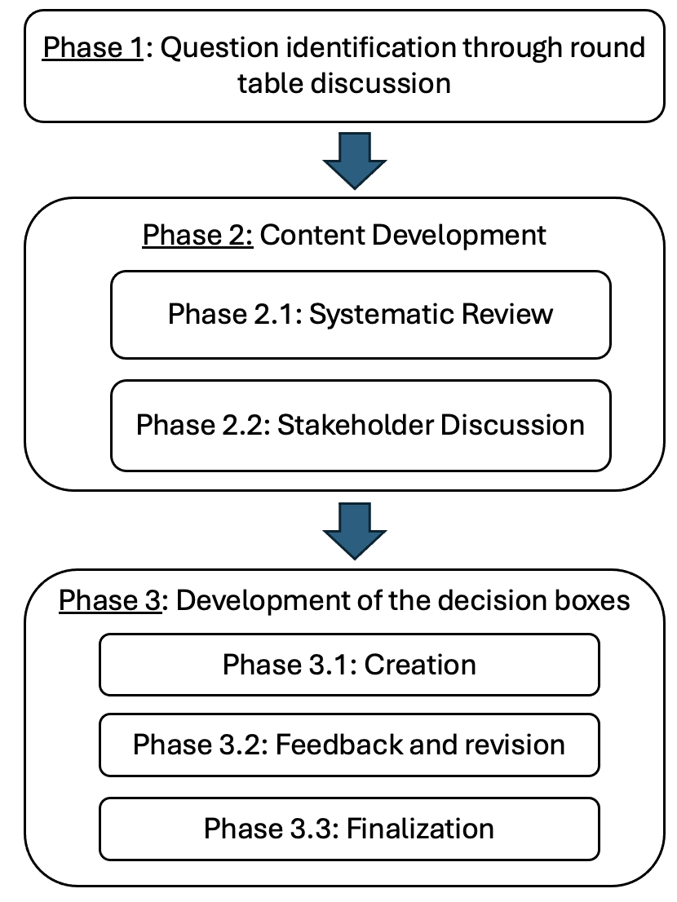

Supplementary Figure 2: Systematic Review Study Flow Diagram
