
Applied Materials Today 468 (2024) 110479
Contents lists available at ScienceDirect

Applied Materials Today
journal homepage: www.elsevier.com/locate/apmt



Bamboo-inspired metamaterials design: microstructure dielectrophoretic  orientation for enhancing insulation performance of advanced power modules
Huanmin Yaoa , Haibao Mua* , Maoqun Shena , Andrea Cavallinib , He Lia , Haoxiang Zhaoa,c,d* , Wendong Lia , Daning Zhanga , Guanjun Zhanga*
ªState Key Laboratory of Electrical Insulation and Power Equipment, Xi’an Jiaotong University, 710049 Shaanxi, China
^{b}The Department of Electrical, Electronic, and Information Engineering "Guglielmo Marconi", University of Bologna, Italy
^{c}Department of Mathematics and Computer Science, Eindhoven University of Technology, Eindhoven 5600MB, The Netherlands
^{d}Department of Applied Physics, Eindhoven University of Technology, Eindhoven 5600MB, The Netherlands

A R T I C L E I N F O

Keywords:
B. Directional orientation
B. Electrical properties
B. Non-linear behavior
E. Assembly
A B S T R A C T

The application of nonlinear conductivity coatings in high-voltage power module is a promising strategy for significantly improving electrical insulation performance. The core of the improvement principle is that the nonlinear conductivity realizes a dynamic optimization of the discharge risk inside the material. The realization of this nonlinear conductivity requires sufficient microscopic arrangement of fillers that align with the macroscopic insulation structure. However, conventional methods fail at precise arrangement control so that typically require high filler concentration, which markedly increases dielectric loss and leakage current. Drawing inspiration from the bamboo structure, metamaterials offer an efficient tuning of nonlinear characteristics with lower filler concentrations through thoughtful design. In this context, we introduce a novel approach to fabricate SiC whisker / silicon elastomer metamaterial coatings leveraging the dielectrophoretic effect. Comprehensive testing of the physical and chemical properties of the composites confirmed the successful preparation of the material. And the metamaterial exhibits excellent nonlinear conductivity and low dielectric loss across various temperatures. Notably, after applying the metamaterial coating, the maximum electric field stress within the power module was reduced by nearly ten times, and the partial discharge inception voltage (PDIV) increased by 58.9%, 74.7%, and 32.8% at 30°C, 60°C, and 90°C, respectively. From solid physical mechanism to exquisite material design and practical device-level implementation, this study offers valuable insights into enhancing the insulation performance of power module and demonstrates substantial potential for further industrial applications.

Introduction
The widespread access of various new energy sources places increasing demands on highly efficient power conversion in power systems. Advanced power modules are poised to become the core components of these systems due to their high power density and rapid switching speeds [1, 2]. To meet the growing demands for high power density, power modules are being developed with higher voltage capabilities and more compact designs [3]. However, this trend significantly elevates the risk of partial discharges within the electrical insulation, presenting a major challenge to the reliability of power system [4].
In recent years, utilizing nonlinear conductive coatings has proven to be an efficient approach for enhancing the insulation performance of power modules [5-7]. The electric field stress taken by material is inversely proportional to its conductivity, and usually the conductivity is fixed thus the electric field distribution is fixed. However, if we design a material with nonlinear conductivity varying with electric field stress, a negative regulation loop of electric field distribution will form: where the electric field exceed switch-field stress (E_{th}), the conductivity sharply increases with a slope of the nonlinear coefficient (γ), then the electric field stress decreases inversely with the conductivity increase [8]. This mechanism lowers the risk of electrical discharges under high electric fields, and the negative regulation loop makes this strategy even more effective in challenging conditions.
Uniformly doping semiconductor fillers into the insulating matrix can result in composites with exceptional nonlinear conductivity properties [9, 10]. Two critical factors are necessary for these composites to exhibit significant nonlinear conductivity: 1) a substantial effective contact area between fillers, which generates nonlinear potential barriers and increases the nonlinear coefficient γ; 2) the formation of a complete conductance path, which reduces path resistance and the switch-field strength E_{th}. It has been found that establishing effective contact between fillers in the insulation is crucial for achieving nonlinear conductivity. Currently, this is primarily accomplished by increasing the filler concentration, but this approach inevitably raises the dielectric loss and accelerates insulation degradation [11]. Moreover, traditional approaches often fail to adapt to varying power module structures. An inappropriate coupling between the structures and nonlinear parameters (γ and E_{th}) can even degrade insulation performance, worsening the overall power system reliability. Therefore, achieving widely applicable nonlinear parameters with low filler concentrations is of critical importance.

* Corresponding author.
E-mail address: haibaomu@mail.xjtu.edu.cn (H. Mu), xiang-yu@stu.xjtu.edu.cn (H. Zhao), gjzhang@xjtu.edu.cn (G. Zhang).
https://doi.org/10.1016/j.apmt.2024.106843
Received 21 Spetember 2024; Received in revised form
Available online 12 October 2024
0141-3910/© 2024 Elsevier Ltd. All rights reserved
Fortunately, controlling filler orientation within the insulating matrix to fabricate metamaterials tailored to specific needs aligns well with these requirements. Inspired by the anisotropic structure of vertically arranged fiber channels in natural bamboo, researchers are increasingly employing structural manipulation to enhance the mechanical, thermal, and dielectric properties of materials [12, 13]. Specific methods for controlling filler orientation include magnetic field induction, electrospinning, and AC dielectrophoresis. Luzinov et al. [14] used a magnetic field to induce the orientation of SiC whisker (SiCw), modified with magnetic particles, resulting in composites with superior thermomechanical properties compared to randomly doped samples. Deng et al. [15] employed electrospinning to fabricate highly oriented SiC@SiO₂ whiskers, resulting in a material with outstanding thermal performance. Shen et al. [16], leveraging the polarization effect of BaTiO₃ fillers under an AC electric field, induced the formation of filler chains through dielectrophoretic forces, creating a functionally graded composite insulation with exceptional dielectric properties. In contrast, the AC dielectrophoresis method offers unique advantages: 1) It is applicable to a broader range of material types without requiring particle surface modification; 2) It does not necessitate direct contact with the sample during filler orientation, thereby avoiding potential contamination and damage. However, due to the limited theoretical foundation and preparation technology, current research remains confined to the material preparation stage and has yet to achieve practical application in power module.
Inspired by the bamboo’s microscopic structure and dielectrophoretic orientation control method, we develop a metamaterial with adjustable nonlinear characteristics at low filler concentrations, based on the dielectrophoretic effect. Here, silicone elastomer (SE) serves as the insulating matrix, and SiCw acts as the nonlinear conductive filler, providing enhanced conductive properties. Initially, metamaterials with varying filler orientation degrees were prepared, and their physical and chemical properties were thoroughly characterized, including filler morphology, cross-sectional observation, and XRD testing, all of which validated the successful preparation of the designed sample. Subsequently, the nonlinear conductivity, trap characteristics, and dielectric response of the metamaterials were thoroughly analyzed to elucidate the mechanisms by which metamaterials enhance conductivity. Notably, we implemented the preparation and testing of metamaterial coatings in chipless power modules, achieving a significant reduction in partial discharge inception voltage (PDIV) across different temperatures.
Fundamentally, the nonlinear conductivity, which is the core of this strategy, were further explained through the charge transport mechanism, providing solid theoretical basis. This work has achieved excellent insulation performance improvement effect, providing a breakthrough and comprehensive reference from material design to device application.

Experimental section
  - Experimental materials
In this study, SE was chosen as the insulation matrix, consisting of components A and B. Component A is side-chain hydrogenated silicone oil, serving as a crosslinker, while component B is polymethyl-vinylsiloxane, the base silicone oil, which contains a platinum catalyst. One-dimensional SiC whisker, known for its excellent nonlinear conductivity and high aspect ratio, was selected as the filler. To enhance filler dispersion, KH560 was grafted on the surface of SiCw. SiCw has an aspect ratio of approximately 100 and a length of about 10 μm, and was supplied by Shanghai Aladdin Biochemical.
In addition, the filler volume fraction was optimized by considering both the viscosity of the SiCw/SE suspension and nonlinear conductivity characteristics of the composites. When the filler volume fraction is below 8%, the viscosity of the suspension remains relatively stable at approximately 10 Pa·s, showing little change with increasing volume fraction. However, when the filler volume fraction exceeds 8%, the viscosity increases rapidly, reaching 50 Pa·s. At this point, the suspension loses its fluidity and no longer meets the requirements for material preparation. On the other hand, we pursue a superior nonlinear conductivity characteristic which is attributed to a higher filler content [11]. Considering these factors, the volume fraction of SiCw was set at 8%.
  - The preparation of metamaterials
The preparation process of metamaterials is shown in Fig. 1, which mainly includes the following steps: 1) SiCw with a volume fraction of 8% were added to the A and B components of the SE in a mass ratio of 10:1. To minimize bubble formation during mixing, the uncured SE/SiCw mixture was stirred at 1500 r/min for 8 minutes under vacuum 1500 r/min. 2) The mixture was then carefully poured into an electrode mold using a glass rod. The mold consisted of parallel electrode plates, with the upper and lower plates separated by a 0.4 mm high polytetrafluoroethylene ring. After the upper electrode was removed, the mold was placed in a vacuum oven for multiple decompression cycles and degassed for 20 minutes. 3) An AC voltage with a frequency of 1 kHz and different amplitudes was then applied between the electrodes to create electric field stress of 0 V/mm, 200 V/mm, 400 V/mm, 600 V/mm, and 800 V/mm for one minute, aligning the SiCw fillers in the mixture along the direction of the electric field. Finally, the sample was cured at 80°C. The samples prepared under the five auxiliary electric field stress were labeled D0~D4, while the pure silicone elastomer sample was labeled SE.
  - The mechanism of fillers orientation
The orientation of SiCw is mainly due to the dielectrophoresis effect under AC voltage. SiCw undergoes electrical polarization at the AC electric field, leading to the separation of positive and negative charges within it, effectively forming a dipole. Due to the significant disparity between the long and short axis lengths of SiCw, polarization along the long axis is predominant. Consequently, the motion of SiCw can be approximated using a two-dimensional model [17, 18].
Assuming the angle between the filler particles and the electric field lines at a particular moment is θ. The expressions for the dielectrophoretic force (F_{DEP}) and the alignment torque (T_{align}) exerted on the filler can be derived:
where, V_{p} is the volume of one-dimensional filler; ε_{m} is the relative permittivity of the insulating matrix; α* is the equivalent Clausius-Mossotti (CM) factor, and its expression is:
where, ε_{p} is the permittivity of the filler; P is the depolarisation factor.
In addition, once the rod-shaped fillers are polarized, equivalent macroscopic charges are generated at their ends, resulting in an interaction force between the fillers. The force is [19]:
where, r is the length of the minor semi-axis of the filler; x is the distance between the fillers; β* is the repolarization factor.
Under the action of AC voltage, the microscopic arrangement of the one-dimensional filler in the insulating matrix will change, showing a dynamic process of random alignment → rotation → mutual attraction → complete orientation, as shown in Fig. 1(b).
  - The filler morphology and orientation test
To qualitatively analyze the morphology of SiCw and its arrangement in the composite, the sample's cross-section was observed using a Zeiss GeminiSEM-500 field emission scanning electron microscope (SEM), with a maximum resolution of 0.9 nm and a measurement voltage of 1 kV. For quantitative characterization of SiCw orientation, the sample was tested using a Bruker X-ray diffractometer (XRD-D8), operating in Theta-2Theta scanning mode, with an operating voltage of 40 kV and a current of 40 mA.
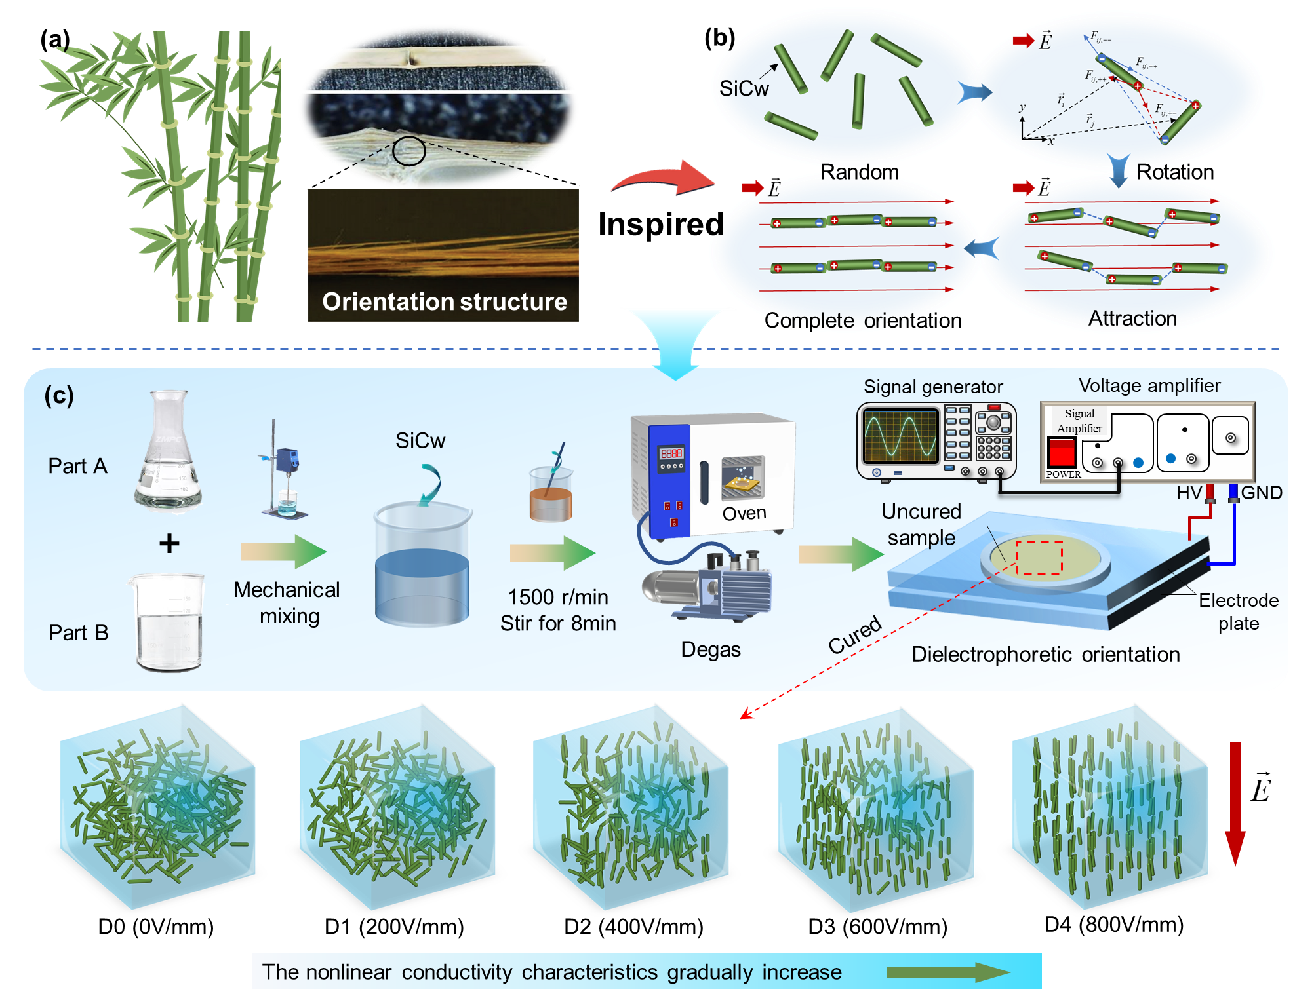
Fig. 1. The design of bamboo-inspired metamaterials with dielectrophoretic orientation. (a) The orientation structure of bamboo. (b) The schematic diagram of dielectrophoresis. (c) The preparation process of metamaterial.
  - Nonlinear conductivity characteristics test
The nonlinear conductivity characteristics of the samples at different temperatures was measured using 6517B electrometer. The test electric field stress ranged from 0.25 to 3 kV/mm. The measurements were taken at 30°C, 60°C, and 90°C, respectively. This temperature range was chosen because power modules typically operate from ambient to elevated temperatures. When inactive, the module's temperature approaches ambient levels. In contrast, during operation, the maximum temperature reaches approximately 90°C, largely due to the cooling system’s effectiveness [20].
  - Thermally stimulated depolarization current test
The rise in temperature triggers the release of charges as depolarization current, effectively revealing the trapping characteristics within the composites. This process is known as thermally stimulated depolarization current (TSDC) testing. TSDC measurements were performed using Concept 80 equipment from Novocontrol, Germany. The sample is first heated to a specific temperature (polarization temperature, 80°C) to excite the carriers within the material. A DC voltage (polarization voltage, 1 kV) is then applied to fully polarize the sample. Defects, such as dipoles or carriers, actively respond to the temperature and electric fields, leading to redistribution or the formation of a metastable state. The sample temperature is then rapidly reduced to -70°C by injecting liquid nitrogen, significantly decreasing the charge transport rate. Finally, the polarization voltage is removed, and the two ends of the sample are short-circuited to measure the depolarization current. During the depolarization process, the temperature is increased at a rate of 5°C/min, resulting in the TSDC curve.
  - Dielectric properties test
The dielectric loss and relative permittivity were measured at various temperatures and frequencies using the DIRANA analyzer from Omicron, Austria. The measurements covered a frequency range of 1 mHz to 5 kHz, and the test temperatures were set at 30°C, 60°C, and 90°C.
  - Partial discharge characteristics test
In the tested chipless power module, the left upper electrode is connected to high voltage, while the right upper and lower electrodes are grounded. partial discharge (PD) detection is performed using the Omicron MPD600, in accordance with the IEC 60270 standard [21]. The step-by-step voltage increase method was employed, starting at 1 kV, with an interval of two seconds, ensuring no partial discharge occurred during the process. At each stage, the voltage was incrementally increased and then held steady for five minutes until partial discharge was observed. The voltage at which discharge first occurred was recorded as the PDIV. Each sample was tested 12 times to ensure accuracy.

Results and discussion
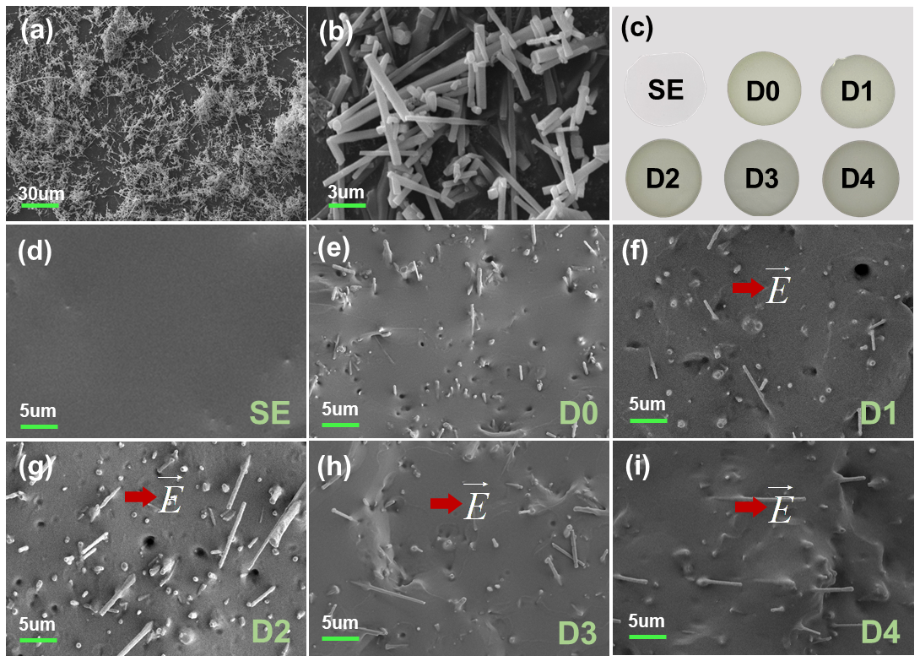
Fig. 2. The physical and chemical properties of metamaterials. (a) The overall SEM image of SiCw. (b) The local SEM of SiCw. (c) The prepared samples. (d) The SEM of SE cross section. (e) The SEM of D0 cross section. (f) The SEM of D1 cross section. (g) The SEM of D2 cross section. (h) The SEM of D3 cross section. (i) The SEM of D4 cross section.
  - Metamaterials s morphology characterization
The overall state of SiCw is shown in Fig. 2 (a), and it can be seen that the filler has good dispersion. In addition, Fig. 2 (b) shows the morphological characteristics of SiCw more apparently, which is a rod-like structure with a length and diameter of about 10um and 100nm, respectively. SiCw is doped into SE, and the composite material obtained after applying an auxiliary electric field is shown in Fig. 2 (c). It can be found that the greater the orientation of the filler, the darker the color of the sample surface, which is caused by the filler being arranged perpendicular to the sample surface. Further, the cross section of the prepared sample was also observed by SEM. Fig. 2 (d) shows that SE is not doped with SiCw, and its cross section is very smooth. In Fig. 2 (e), when SiCw is doped without dielectrophoresis induction, SiCw is evenly distributed throughout the matrix without agglomeration. Fig. 2 (f)-(i) show that with the increase of the dielectrophoresis electric field stress, the degree of directional arrangement of SiCw along the electric field direction gradually increases.
Fig. 3. The XRD spectrum. (a) The XRD of all samples. (b) The XRD diffraction peak ratio of samples with different filler orientation degrees.
XRD is recognized as an effective method for quantitatively characterizing the orientation of fillers in composites [22, 23]. The XRD spectrum of SiCw exhibits diffraction peaks at 2θ=35°, 60°, and 72°. The XRD spectra of composite materials subjected to different auxiliary field strengths are shown in Fig. 3 (a). Compared to the SE sample, the composite material displays only the XRD diffraction peaks corresponding to pure SE and SiCw, indicating that the addition of fillers has not altered the stacking form of some molecular chains in the matrix. Due to the varying orientations of SiCw, the intensity of the diffraction peaks at 35.7° (111 lattice plane) and 60.0° (220 lattice plane) differ significantly. A higher diffraction peak intensity ratio, I(111) / I(220), corresponds to a stronger alignment of SiCw along the electric field direction. As the auxiliary field strength increases, the orientation index of the sample rises from 1.12 to 10.18, showing a clear upward trend, as depicted in Fig. 3 (b). Thus, the diffraction peak intensity ratio is employed to quantitatively characterize the filler orientation degree.
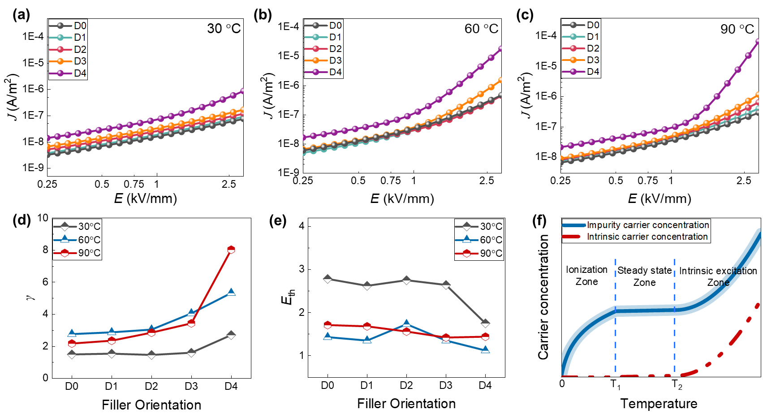
Fig. 4. The nonlinear conductivity characteristics of metamaterials. (a) The J-E curves at 30℃. (b) The J-E curves at 60℃. (c) The J-E curves at 90℃. (d) The effect of filler orientation on γ at different temperature. (e) The effect of filler orientation on E_{th} at different temperature. (f) The effect of temperature on carrier concentration.
  - Nonlinear conductivity characteristics analysis
Temperature and filler orientation are key factors influencing the nonlinear conductivity of the composite. Conductivity and current density are positively correlated. Fig. 4 (a)-(c) illustrate the effect of filler orientation on current density at three different temperatures. These results align with the predictions of formula [24-26]:
where, J is the current density, k is a constant. γ represents nonlinear coefficient. E_{th} is the switch-field strength, which represents the electric field stress corresponding to a sudden change in current density J. γ and E_{th} are collectively referred to as the nonlinear parameters. The current density curves at three different temperatures were fitted using (6). The R² values of the fitting results were all greater than 0.9, proving that the obtained nonlinear parameters were accurate.
Fig. 4 (d)-(e) illustrates the variation of the nonlinear parameters (E_{th} and γ) at different temperatures and orientations. It is worth noting that the changes of sample nonlinear parameters between 30°C and 60°C is more pronounced than that between 60°C and 90°C. The movement of carriers is the primary factor influencing current density. In order to clarify the microscopic hopping conduction process of carriers under the influence of electric field stress and temperature, (6) can be transformed as follows [27]:
where, n is the carrier concentration, m is the basic charge, λ is the average jump distance, ν is the charge escape frequency, φ_{h} is the charge jump barrier, k_{B} is the Boltzmann constant, and T is the temperature. Considering only the effect of temperature, (7) can be rewritten as:
The nonlinear relationship between carrier concentration and temperature in the composites is depicted in Fig. 4 (f). The analysis reveals that the carrier concentration of the composites lies in the ionization zone between 30°C and 60°C, and in the steady-state zone at 60°C and 90°C. Consequently, when the test temperature shifts from 30°C to 60°C, the carrier concentration term A₁ in (8) increases rapidly, term A₂ decreases exponentially, and term A₃ gradually rises. Overall, γ increases significantly while E_{th} decreases. As the test temperature changes from 60°C to 90°C, with the carrier concentration term A₁ in (8) remaining relatively constant, the changes in γ and E_{th} become less pronounced.
Additionally, at a constant temperature, as the filler orientation degree increases, E_{th} gradually decreases and γ steadily increases. This is attributed to the alignment of fillers along the electric field direction, which shortens the conductivity path, facilitating carriers in overcoming the Schottky barrier for transmission, thereby increasing γ. Moreover, the increased of carriers hastens the transition of the composites' conductivity into the nonlinear region, thus reducing E_{th}.
  - Trap characterization analysis
In order to further analyze the charge transport mechanism in metamaterials, their trap characteristics were studied, as shown in Fig. 5. For SE samples, the shallow trap energy level is 0.62 eV, while the deep trap energy level is 1.05 eV. Shallow traps primarily originate from physical traps caused by the disorder in polymer molecules, whereas deep trap energy levels are influenced by matrix defects and impurities [27].
Compared to SE, SiCw/SE composites exhibit lower trap energy levels and densities. Furthermore, as the orientation of SiCw increases, the composite’s trap energy level gradually decreases while the trap density increases. This occurs because the chain structure formed by SiCw alignment reduces the likelihood of deep traps in the matrix capturing charges. This more coherent path reduces the influence of deep traps in the matrix on the charges, leading to a gradual decrease in the overall trap energy level of the composite. Additionally, the orientation of SiCw creates more SiCw-SiCw interfaces, which introduce band bending in the material and result in an increase in trap density.
Fig. 5. The trap characteristics of samples with different filler orientation
These microscopic characteristics significantly impact the composite's macroscopic insulating properties, including nonlinear conductivity, dielectric polarization, and breakdown characteristics.
Specifically, shallow traps at the interfaces and the ordered SiCw network structure facilitate charge movement. Compared to samples with low filler orientation, the conduction paths dominated by shallow traps in high filler orientation samples allow the material to conduct electricity at lower electric fields. This results in superior nonlinear conductivity, characterized by a higher nonlinear coefficient and lower switch-field strength.
In addition, the easier release of charges from shallow traps enhances space charge polarization under low-frequency electric fields. This process promotes the formation of electric dipole moments, strengthening the space charge polarization effect and its relaxation process, which leads to a rapid increase in the dielectric constant in the low-frequency range.
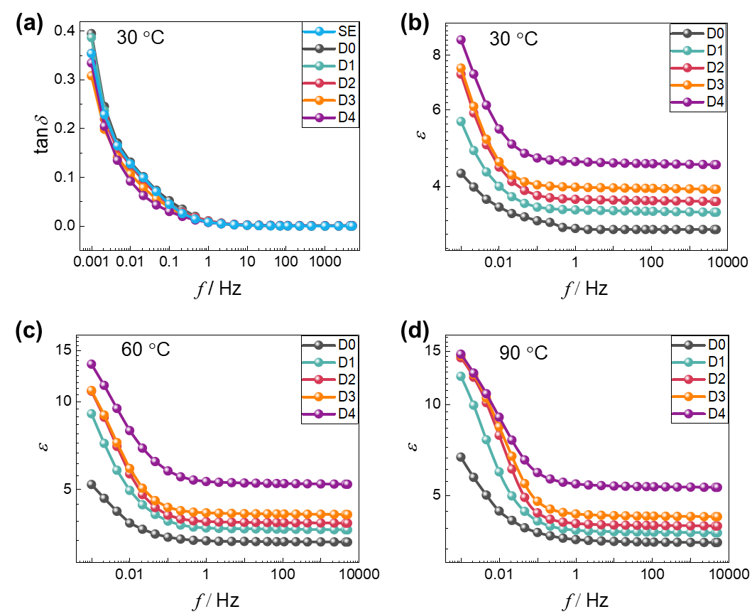
Fig. 6. The dielectric property of metamaterials. (a) The ε-f curves at 30℃. (b) The ε-f curves at 60℃. (c) The ε-f curves at 90℃. (d) The tanδ-f curves at 30℃.
Finally, the density and energy levels of traps directly influence the breakdown characteristics of the material. High-density deep traps help suppress leakage current and enhance breakdown strength. In contrast, materials with shallower traps can release charges more readily under high electric fields, effectively suppressing space charge accumulation. Consequently, although the breakdown field strength of composites is lower than that of SE, these composites, as nonlinear conductive coatings, can rapidly release charges accumulated in high electric field regions of power modules. This can suppress electric field distortion and significantly reduce the risk of insulation breakdown in the device.
  - Dielectric property analysis
Due to the low filler doping content, the prepared metamaterial exhibits small dielectric loss. Fig. 6(a) shows the dielectric loss (tanδ) characteristics of all samples at 30℃. When the frequency is lower than 1 Hz, samples with higher filler orientation show lower tanδ. Compared with SE, the tanδ of the prepared composites does not increase significantly in the entire frequency band. It is worth noting that, thanks to the orientation of the filler along the direction of the electric field, the sample achieves excellent nonlinear conductivity properties while maintaining low dielectric loss.
In addition, the effects of temperature and orientation on the relative permittivity (ε) of the samples were also studied, which is shown in Fig. 6(b)-(d). It can be found that at the same temperature and orientation, as the frequency decreases, the ε of all samples show a trend of gradual increase, which is consistent with the frequency dependence of the classical Debye model. At a frequency of 50 Hz, ε shows a trend of gradual increase with increasing temperature. The increase of ε in the 30℃~60℃ stage is significantly greater than that in the 60℃~90℃ stage. This can be explained by the relaxation process of charge crossing barriers. As temperature increases, charge barrier-crossing within the material becomes easier, enhancing the polarization process and leading to an increase in ε, which manifests as a positive temperature coefficient. However, at higher temperatures, intensified thermal motion of charges makes it more challenging to maintain stable polarization. This weakens the polarization strength, resulting in a decrease in ε, which appears as a negative temperature coefficient. When the temperature is relatively low, the thermal motion of charges is weaker and has less influence on polarization, allowing the polarization process to establish more easily. Consequently, within 30~60℃, ε increases significantly with temperature. However, within 60~90℃, as the temperature rises further, the enhanced thermal motion weakens polarization, leading to a reduced rate of increase in ε. At the same temperature, as the filler orientation degree increases, ε also gradually increases. This is because the higher the orientation degree formed by the fillers along the electric field direction, the more induced charges can be generated during the dielectric polarization process, and the stronger the ability to weaken the external electric field, thus having a larger ε.
  - Construction and design of SiCw/SE metamaterial coating
In order to suppress the electric field distortion of the power module, a metamaterial coating with an oriented filler structure needs to be formed at the triple point. Fortunately, the in-situ electrodes of the power module are arranged in a parallel structure (Fig. 7(a)). By applying an AC electric field to the in-situ electrodes, the filler orientation in the uncured composites can be controlled. However, determining the optimal filler orientation that aligns with the electric field distribution remains a challenging task.
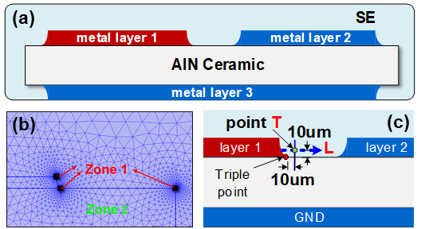
Fig. 7. The simulation model of power module. (a) The overall schematic diagram of the simulation model. (b) Mesh generation. (c) The equivalent point of the triple point and line L.
The application of the 'simulation-guided experimental research' approach is an effective strategy for material development, as it can significantly reduce R&D costs while enhancing efficiency and success rates. To determine the nonlinear parameters of the coating that correspond to the optimal electric field distribution at different temperatures, a simulation model, as shown in Fig. 7(a), was established.
The model consists of a metal layer, SE, and a ceramic substrate. Additionally, the simulated electric field stress is dependent on the mesh size. As the mesh size increases, the electric field stress gradually decreases. As shown in Fig. 7(b), to account for this, the mesh size at the vertex of the simulation model is set to 6 μm (Zone 1), while the rest of the area is set to 60 μm (Zone 2), ensuring that the change in electric field stress remains below 1% [28].
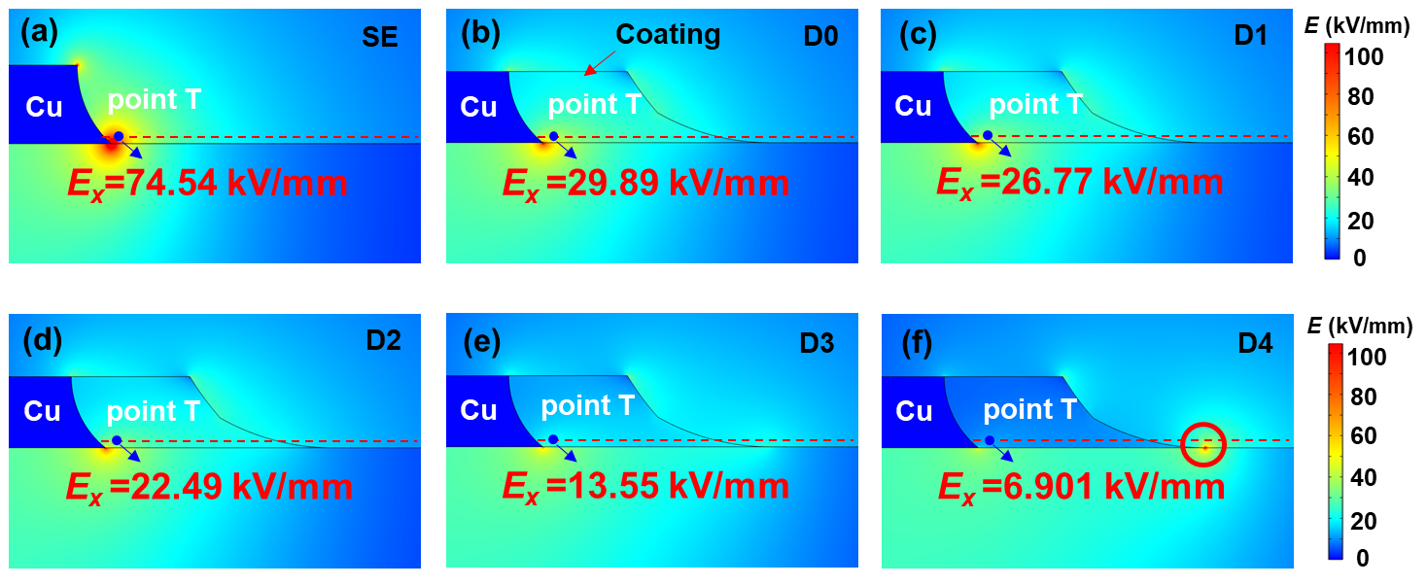
Fig. 8. The E_{x} distribution in power module. (a) The E_{x} distribution with SE. (b) The E_{x} distribution with D0 coating. (c) The E_{x} distribution with D1 coating. (d) The E_{x} distribution with D2 coating. (e) The E_{x} distribution with D3 coating. (f) The E_{x} distribution with D4 coating.
Evaluating the electric field optimization effect requires considering both the maximum field stress and electric field uniformity. The maximum electric field stress occurs at the triple point of the power module. However, due to the singularity effect, the electric field stress at this point is theoretically infinite in the simulation model. To avoid this issue, point T, located 10 μm away from the triple point in both horizontal and vertical directions, is selected as the reference for maximum electric field stress, denoted as E_{x}, as shown in Fig. 7(c). The electric field uniformity is represented by the ratio of the average electric field stress to the maximum electric field stress along line L, denoted as η. The expression for η is:
Fig. 8(a)-(f) illustrates the electric field stress along the surface in the x direction (E_{x}) distribution without coating and with coatings exhibiting different nonlinear parameters at 60°C. The diagram reveals that without the coating, the maximum E_{x} reaches 74.54 kV/mm, significantly exceeding the insulation strength of the SE, which is 21 kV/mm. This condition will increase the probability of surface discharge. In contrast, the application of metamaterial coating effectively reduces the E_{x} at the triple point by approximately 59.9%. As the filler orientation degree increases, the E_{x} at point T becomes smaller. This reduction is attributed to the superior nonlinear conductivity properties of the coating. However, a higher degree of filler orientation will also increase the electric field inhomogeneity, and the maximum E_{x} will be transferred to the edge of the coating, as shown in the red circle in Fig. 8(f).
The variation curves of E_{x} at point T and the histograms of electric field uniformity η at 30°C, 60°C, and 90°C were plotted, as shown in Fig. 9(a)-(f). It can be seen from Fig. 9(a) that at 30°C, as the filler orientation degree of coating increases, the E_{x} at point T first decreases slowly and then decreases rapidly. Under D4 conditions, the electric field stress is below 21 kV/mm, meeting the insulation design requirements. Conversely, electric field uniformity η shows the opposite trend, peaking under the nonlinear parameter corresponding to D4. This results in the D4 sample having the highest PDIV at 30 °C. And Fig. 9(b) shows that the E_{x} along line L does not experience significant distortion in any of the five cases. As shown in Fig. 9(c) and (e), at 60°C and 90°C, the E_{x} at point T consistently decreases with increasing filler orientation degree. The η initially rises and then falls, reaching its maximum under the nonlinear parameter corresponding to D3. This occurs because, as the filler orientation degree increases, the coating causes the high electric field stress area to gradually shift from the point T to the edge of the coating, as shown in Fig. 9(d) and (f). This also increases the probability of discharge at the coating edge, resulting in the PDIV of D4 being lower than that of D3.
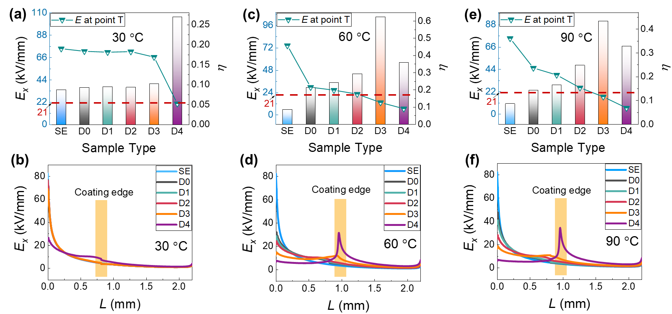
Fig. 9. The E_{x} of all samples and their changing trends on line L. (a) E_{x} at point T and η at 30℃, (b) E_{x} on line L at 30℃, (c) E_{x} at point T and η at 60℃, (d) E_{x} on line L at 60℃, (e) E_{x} at point T and η at 90℃, (f) E_{x} on line L at 90℃.
In summary, considering both the uniformity of the electric field distribution and the magnitude of E_{x} at point T, the filler orientation degree of metamaterial coatings corresponding to the optimal electric field distribution at 30°C, 60°C, and 90°C are D4, D3, and D3, respectively.
In order to verify the validity of the simulation results, the coatings with five different filler orientation degrees were prepared. Fig 10(a) shows the chipless power module used to measure PDIV. Initially, metamaterial was applied to the triple point using a brush, followed by transferring the sample to a vacuum oven for degassing for about ten minutes. Subsequently, four AC voltages of varying amplitude were applied between the upper metal plates at 25°C. This process aligned the filler in the coating with the electric field direction, leading to variations in the nonlinear parameters, as shown in Fig. 10(b)~(c). The samples were then cured in an oven at 80°C for four hours. It should be noted that during the heating and curing process, a balancing electric field stress must be continuously applied to ensure that the filler orientation structure is not destroyed. For rod-shaped fillers, the formula for calculating the balancing electric field stress is as follows [16]:
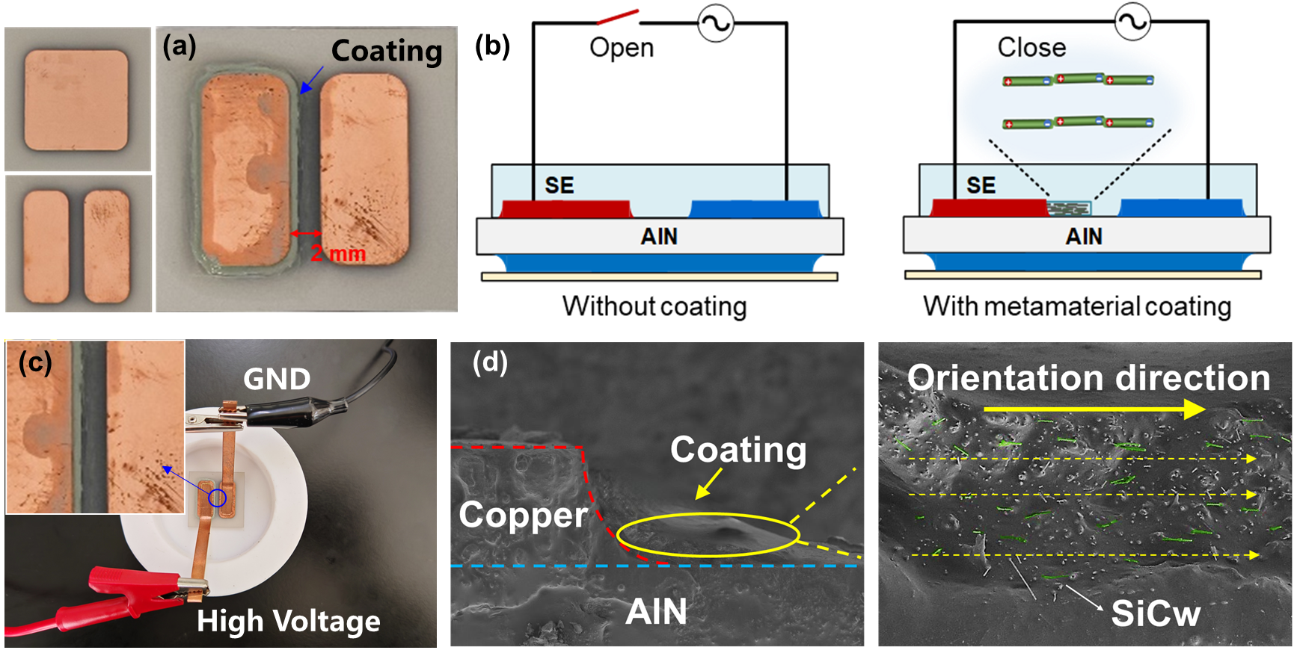
Fig. 10. The construction of metamaterial coatings. (a) The chipless power module. (b) The schematic diagram of SiCw/SE metamaterial coating preparation method. (c) The actual picture of SiCw/SE metamaterial coating preparation method. (d) The SEM of the coating cross section after filler orientation.
where, l is the long axis of the filler. CM is the Clausius-Mossotti factor, and ε_{m} is the dielectric constant of the liquid SE. Following this, the power module with the cured coating was placed in a mold, and SE was potted around it. The assembled sample and mold were cured at 80°C for an additional 12 hours. Taking the orientation degree of 600 V/mm as an example, the arrangement of SiCw in the coating cross section was observed using the SEM, as shown in Fig. 10(d), proving that the coating was successfully prepared.
  - Insulation performance improvement
The PDIV of different samples at 30°C, 60°C, and 90°C were tested. It can be found from Fig. 11(a)~(c) that the PDIV of the power module with D0 coating at 30°C, 60°C, and 90°C are 3.65 kV, 4.23 kV, and 2.73 kV, respectively.
At 30°C, when the filler orientation degree in the coating is low, the PDIV does not significantly improve compared to the uncoated module. The PDIV reaches its maximum when the orientation degree is D4, resulting in a 58.9% increase compared to the D0 coating. At both 60°C and 90°C, the PDIV increases with the degree of filler orientation in the coating, peaking at D3, with PDIV increases of 74.7% and 32.8%, respectively. Therefore, the filler orientation degree of NCP coatings corresponding to the optimal electric field distribution at 30°C, 60°C, and 90°C are D4, D3, and D3, respectively. Compared with traditional nonlinear conductive coatings, coatings with adjustable nonlinear parameters prepared based on AC dielectrophoresis can more effectively alleviate local electric field distortion and further improve the PDIV.
To uncover the mechanism by which nonlinear conductive coatings improve insulation performance, the charge transport mechanism of the sample was analyzed, as illustrated in Fig. 11(d)-(e). SE contains a large number of deep traps where charges are transported via hopping conduction and are easily captured, leading to space charge accumulation at the electrode-interface. This accumulation increases the likelihood of local discharge and decreases the PDIV. When SiCw is introduced into SE, the trap energy level and trap density of the composites decrease (Fig. 5).
The composite primarily consists of interfaces between SiCw and SE, as well as between SiCw fillers. When the filler orientation is low, as shown in Fig. 11(d), the SiCw fillers are largely separated, with significant distances between them. This creates numerous isolated SiCw-SE interfaces within the composite. These interfaces introduce deep traps that capture charges injected from the electrodes, leading to space charge accumulation near the electrodes and subsequent electric field distortion.
As shown in Fig. 11(e), with increased filler orientation, the number of SiCw-SiCw interfaces rises, and many of these interfaces begin to overlap. This overlap significantly distorts the electric field at the interface, giving electrons higher energy. This facilitates electrons crossing the barrier energy level via the tunnel breakdown effect, accelerating the electron hopping conduction process. As a result, space charges dissipate faster, reducing charge accumulation at the triple point.
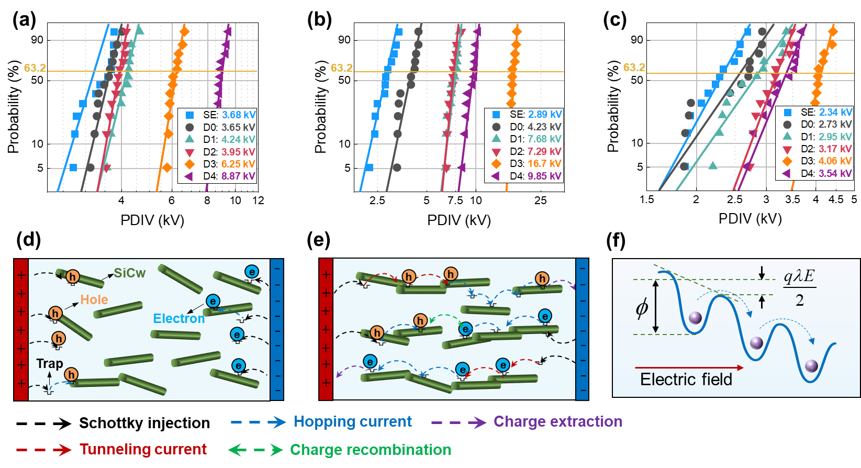
Fig. 11. The insulation performance test and mechanism explanation. (a) PDIV at 30℃. (b) PDIV at 60℃. (c) PDIV at 90℃. (d) Filler orientation is low. (e) Filler orientation is high. (f) Charge transport model.
Fig. 11(f) illustrates the charge transport model in the composite. According to the Poole-Frenkel effect, the trap barrier decreases by qλE/2 along the direction of the external electric field. The probability of charge hopping can be expressed as [29]:
where v is the frequency of the thermal vibration, ϕ is the trap energy level, k_{B} is the Boltzmann constant, T is the temperature, q is the charge, λ is the distance between two neighboring traps. From this relationship, it is evident that increased temperatures enhance the probability of charges crossing the barrier, which is equivalent to reducing the trap depth of the composites and significantly improving its conductivity. Under such conditions, the charge transport behavior of the composite approaches that of a conductor. Charges injected at the triple point are rapidly transferred to the coating's edge, leading to space charge accumulation and local electric field distortion.
These findings clearly demonstrate that regulating the nonlinear parameters of the insulating material to match the actual electric distribution is crucial for achieving optimal electric field stress. This approach effectively suppresses electric field distortion in power modules at different temperatures and significantly enhances operational stability. Furthermore, using the in-situ electrodes of the device to control the coating parameters makes the preparation process simple and efficient. This method shows great potential for further industrial applications and offers a practical and efficient solution for improving the insulation reliability of high-voltage power modules.

Conclusion
In summary, this paper demonstrates the groundbreaking potential of bamboo-inspired metamaterials in enhancing the insulation performance of power modules. By utilizing the in-situ electrodes of the power module to apply AC voltage, and harnessing the dielectrophoresis effect to induce filler orientation, we have successfully developed a metamaterial coating with adjustable nonlinear parameters that optimizes local electric field stress. The key findings of this study are as follows:
1) Under the influence of dielectrophoretic force, the filler within the composite cross-section forms a distinct chain structure, undergoing sequential processes of random distribution, rotation, and mutual attraction. The scattering effect of the filler lattice causes an increase in the ratio of the diffraction peak I(111) to (220) in the XRD pattern as filler orientation improves, providing a quantitative metric for evaluating filler orientation degree.
2) Conductivity tests reveal that as the filler orientation increases, the nonlinear coefficient γ increases while the switch-field strength E_{th} decreases. This confirms that precise control of E_{th} and γ is achievable through the adjustment of filler orientation. Additionally, dielectric response results indicate that the sample maintains low dielectric loss while achieving excellent nonlinear conductivity.
3) Compared to coatings with unoriented fillers, the metamaterial coating enhances the PDIV by 58.9%, 74.7%, and 32.8% at 30°C, 60°C, and 90°C, respectively. The careful management of the charge transport properties in the developed metamaterial is critically important for advancing insulation performance.
The preparation strategy proposed in this paper offers an innovative approach to the design and production of nonlinear conductive metamaterials, which hold significant potential for industrial applications.

CRediT authorship contribution statement
Huanmin Yao: Conceptualization, Data curation, Formal analysis, Investigation, Methodology, Writing-original draft, Funding acquisition. Haibao Mu: Conceptualization, Formal analysis, Methodology, Supervision, Writing–review & editing. Maoqun Shen: Formal analysis, Writing – review & editing. Andrea Cavallini: Formal analysis, Writing-review & editing. He Li: Formal analysis, Writing – review & editing. Haoxiang Zhao: Conceptualization, Writing – review & editing. Wendong Li: Conceptualization, Writing–review & editing. Daning Zhang: Conceptualization, Writing–review & editing. Guanjun Zhang: Formal analysis, Writing–review & editing, Supervision.

Declaration of Competing Interest
The authors declare that they have no known competing financial interests or personal relationships that could have appeared to influence the work reported in this paper.

Acknowledgement
This paper was supported by the National Natural Science Foundation of China Youth Student Basic Research Project (523B2081).

References
- Zhao S, Chen C, Haga M, et al. Failure mechanisms of the bonded interface between mold epoxy and metal substrate exposed to high temperature. Compos Part B-Eng 2023; 254: 110562.
- Liu Y, Chen C, Wang Y, et al. Development of Ag@ Si composite sinter joining with ultra-high resistance to thermal shock test for SiC power device: Experiment validation and numerical simulation. Compos Part B-Eng 2024; 281: 111519.
- Yan F, Wang L, Wang H, et al. Electrical Trees in Silicone Gel Influenced by Different Frequency and Pulse Width under Unipolar High Frequency Square Wave Voltage. IEEE Trans Dielectrics Elect Insul 2024; 31(3): 1208-1216.
- Yao H, Mu H, Li W, et al. Two-Stage Electric Field Optimization Method for High-Voltage Power Module Using Dielectrically Graded Insulation Micro-Region. IEEE Trans Dielectrics Elect Insul 2023; 30(3): 1005-1015.
- Chen M, Wang Y, Ding Y, et al. Self-Adaptive Field-Grading Coating for Partial Discharge Mitigation of High Voltage Power Module under High dv/dt Square Wave Voltage. IEEE Trans Power Electron 2024.
- Mao S, Pan Z, Ye Y, et al. Electric-field-induced assists fabrication of micro-SiC/Epoxy coating with low additive amount to improve surface insulating performance of HVDC insulator. Compos Sci Technol 2024; 110696.
- Zhang Z, Lu S, Wang B, et al. Packaging of a 10-kV double-side cooled Silicon Carbide diode module with thin substrates coated by a nonlinear resistive polymer-nanoparticle composite. IEEE Trans Power Electron 2022; 37(12): 14462-14470.
- Zhao X, Meng P, Yang X, et al. Gradient structure design of zinc oxide varistor microsphere composites for efficient electric field grading. Compos Part A-Appl S 2022; 153: 106731.
- Markandan K, Lai C Q. Fabrication, properties and applications of polymer composites additively manufactured with filler alignment control: A review. Compos Part B-Eng 2023; 256: 110661.
- Chanda A, Sinha S K, Datla N V. Fiber alignment and mode-mixity effects on fracture behavior of CNF/epoxy nanocomposite adhesive joints. Compos Part B-Eng 2022; 247: 110341.
- Xu H, Gou B, He J, et al. Tunable nonlinear conductive behavior without percolation threshold and high thermal conductivity of epoxy resin/SiC ceramic foam co-continuous phase composites. Compos Sci Technol 2023; 236: 109984.
- Zhang Y, Huang Z, Wang F, et al. Design of bioinspired highly aligned bamboo-mimetic metamaterials with structural and functional anisotropy. IEEE Trans Dielectrics Elect Insul 2023; 30(3): 1170-1177.
- Li Z, Chen C, Mi R, et al. A strong, tough, and scalable structural material from fast‐growing bamboo. Adv Mater 2020; 32(10): 1906308.
- James T, Ruslan B, Pavel A, et al. Enhancing mechanical and thermal properties of epoxy nanocomposites via alignment of magnetized SiC whiskers. ACS Appl Mater Interfaces 2017; 9(27): 22927-22940.
- He D, Wang Y, Song S, et al. Significantly enhanced dielectric performances and high thermal conductivity in poly (vinylidene fluoride)-based composites enabled by SiC@ SiO2 core–shell whiskers alignment. ACS Appl Mater Interfaces 2017; 9(51): 44839-44846.
- Shen Z, Wang X, Zhang T, et al. In situ electric field driven assembly to construct adaptive graded permittivity BaTiO₃/epoxy resin composites for improved insulation performance. Appl Mater Today 2020; 20: 100647.
- Cui B, Pan F, Zhang F, et al. Evaluating the optimum nanofiber alignment in conductive composites with a stereology-based anisotropic degree. Compos Part A-Appl S 2023; 168: 107485.
- Oliva-Avilés A I, Avilés F, Sosa V, et al. Dielectrophoretic modeling of the dynamic carbon nanotube network formation in viscous media under alternating current electric fields. Carbon 2014; 69: 342-354.
- Shen Z, Wang X, Zhang Y, et al. Tuning dielectric/mechanical performance of polymeric composites for flexible electronics based on electric field-driven configurational entropy change: High throughput simulation and application. Compos Commun 2023; 38: 101513.
- Zhao Z, Deng E, Zhang P. Review of the Difference between the Press Pack IGBT Using for Converter Valve and for DC Breaker. Trans China Electrotech Socie 2017; 32(19): 125-133.
- Wang L, Zeng Z, Sun P, et al. Electric-field-dominated partial discharge in medium voltage SiC power module packaging: model, mechanism, reshaping, and assessment. IEEE Trans Power Electron 2021; 37(5): 5422-5432.
- Zhao C, Zhang P, Zhou J, et al. Layered nanocomposites by shear-flow-induced alignment of nanosheets. Nature 2022; 580(7802): 210-215.
- Wang H, Huang Z, Li J, et al. Design of 3D printed bioinspired nacre-like structured materials with significantly enhanced thermal conductivity. Appl Phys Lett 2021; 118(13).
- Chi Q, Li Z, Zhang T, et al. Study on nonlinear conductivity of copper-titanate-calcium/liquid silicone rubber composites. IEEE Trans Dielectrics Elect Insul 2019, 26(3): 681-688.
- Zhao X, Yang X, Hu J, et al. Grading of electric field distribution of AC polymeric outdoor insulators using field grading material. IEEE Trans Dielectrics Elect Insul 2019, 26(4): 1253-1260.
- Liu C, Zheng Y, Zhang B, et al. Review of nonlinear conductivity theory research of modified composite materials. IEEE Access, 2019, 7: 50536-50548.
- Wang Q, Chen X, Huang X, et al. Enhanced field-dependent conductivity and material properties of nano-AlN/micro-SiC/silicone elastomer hybrid composites for electric stress mitigation in high-voltage power modules. Nanotechnology 2022; 33(47): 475706.
- Bayer C F, Baer E, Waltrich U, et al. Simulation of the electric field strength in the vicinity of metallization edges on dielectric substrates. IEEE Trans Dielectrics Elect Insul 2015; 22(1): 257-265.
- Zhao H, Mu H, Zhang D, et al. Mechanism study of the conductivity characteristics of cellulose electrical insulation influenced by moisture. J. Appl. Phys 2022, 132(21).

