SUPPLEMENTARY FILE
Current and Evolving Multimodality Imaging in Diagnostic Work-up of Patients with Cardiac Masses
Brief Title: “Multimodality imaging in cardiac masses”

CONTENTS
Diagnostic Scenario: suspicion of a benign mass (Figure 4) …………………………………Page 2
Diagnostic Scenario: suspicion of a malignant mass (Figure 4) ...…………………………....Page 4
Bibliography ………………………………………………………………………….……….Page 7
Supplementary Figure Legend ………………………………………………………………...Page 8
Supplementary Figures ……………………………………………………………………….Page 11

DIAGNOSTIC SCENARIO: SUSPICION OF A BENIGN MASS (Figure 4)
Clinical Presentation. Benign cardiac masses are mainly encountered as incidental findings in asymptomatic patients undergoing cardiac and non-cardiac diagnostic tests for other reasons, e.g. cardiovascular or oncological screening. In symptomatic patients, the clinical presentation is usually heterogeneous and non-specific, often raising the suspicion of cardiac disease but not specifically of the presence of a cardiac mass. In fact, the symptoms associated with the presence of cardiac masses are similar to those associated with common cardiovascular diseases (most commonly, dyspnea). In the case of a benign mass, the main determinants of the clinical presentation are: i) cardiac mass’s size and location (left-sided cardiac masses might provoke earlier symptoms due to outflow tract or valve obstruction), ii) rapidity of growth and infiltrative pattern, and iii) risk of embolization (which is systemic in most cases, due to the left side localization).
Initial approach and red flags. The diagnostic work-up usually starts with a trans-thoracic echocardiogram, which is a non-invasive, low-cost, and easily accessible technique. In the case of a cardiac mass reported at computed tomography (CT), a step back to echocardiography could be considered.
The step-by-step protocol includes: i) identification of the cardiac mass’s location; ii) exclusion of anatomic variants; iii) assessment of cardiac mass’s size and morphology; iv) assessment of the hemodynamic impact of cardiac mass; v) assessment of infiltration of surrounding tissues; vi) assessment of the presence and severity of pericardial effusion; vii) assessment of the hemodynamic impact of cardiac mass.
Echocardiographic features associated with high likelihood of benign mass: left-side location, implantation at the interatrial septum, size < 4 cm, mobile and pedunculated masses with regular margins and shape, homogeneous appearance, absence of invasion of surrounding structures, absence of significant pericardial effusion.
Inconclusive findings or poor acoustic window: it is recommended to perform a transesophageal echocardiogram and/or contrast echocardiography to better define the above-mentioned features. If inconclusive, a second-level imaging technique (most commonly, cardiac magnetic resonance - CMR) should be performed for a multimodal characterization of the cardiac mass.
Next steps in the case of the high likelihood of benign mass. Considering local resources and expertise, it is recommended to perform at least one II-level imaging modality among CMR (gold standard) or cardiac computed tomography (CT) to confirm the benign nature of the cardiac mass and to obtain further information required for pre-surgical planning.
Imaging-based treatment strategy. The management strategy in the case of a high likelihood of benign cardiac mass depends on the following:
1. Presence of symptoms: in this case, it is necessary to understand whether the symptoms reported by the patient are attributable to the cardiac mass or to other cardiac or extra-cardiac diseases.
2. The size, location, and hemodynamic impact of the mass.
3. The risk of embolization.
In the case of large, mobile, and pedunculated cardiac mass, especially with a relevant degree of hemodynamic impact, surgical removal of the mass should be considered if the patient's clinical characteristics are permissive. There are currently no data supporting the use of anticoagulant therapy in cardiac mass in the absence of atrial fibrillation or surface thrombosis of cardiac mass to reduce the risk of embolization.
Imaging-based surgical planning. If the mass is likely to be benign, conservative surgery limited to the sole mass excision of the mass alone should be preferred. If surgical removal is indicated, cardiac CT could be performed to characterize the cardiac mass and to evaluate the presence and severity of coronary artery disease, as required for optimal surgical planning.
Follow-up. Echocardiography is the most used imaging modality for the follow-up of patients after surgical resection. CMR and/or cardiac CT should be performed to assess the cardiac mass growth/progression over time in the absence of surgery or in the case of incomplete resection or local recurrence. The timing of follow-up may vary according to the histotype of cardiac mass and the clinical scenario.
DIAGNOSTIC SCENARIO: SUSPICION OF A MALIGNANT MASS (Figure 4)
Clinical Presentation. Patients with malignant tumors are usually referred for cardiological evaluation for symptoms, mainly worsening dyspnea. As the right heart chambers and great vessels (vena cava and pulmonary artery) are predominantly involved, pulmonary embolism and clinically significant pericardial effusion/cardiac tamponade are red flags that should raise suspicion of malignancy in the presence of cardiac mass during the diagnostic work-up^{1,2}. A wide range of electrocardiographic changes has been described (ST-tract deviation, negative T-waves, and tachyarrhythmias); however, electrocardiography is a nonspecific tool in investigating cardiac malignancy^{3,4}. Similarly, laboratory tests do not provide significant additional information. Nonetheless, it is not uncommon for cardiac involvement to be detected in patients with malignant tumors as an incidental finding during cardiotoxicity screening or on systemic CT or positron emission tomography (PET) for the global staging of the malignancy.
Initial approach and red flags. In symptomatic patients, transthoracic echocardiography (TTE) represents the initial imaging technique to explore cardiac mass. Even in the case of a cardiac mass reported at other imaging modalities, a step back to echocardiography could be considered to assess red flags of malignancy, the hemodynamic impact of the mass, and global cardiac function. The echocardiographic protocol follows the same steps as described for the assessment of benign masses. Red flags of malignancy include moderate-severe pericardial effusion, non-left localization, sessile, polylobate, and inhomogeneity. The presence of ≥3 any of these echocardiographic features should promptly raise the suspicion of malignancy ⁵. Although not easily detected, infiltration per se is highly suggestive of malignancy. In the absence of infiltration, localization should be prioritized, as the evidence of a non-left localization of the mass raises the suspicion of malignancy. Finally, sessile appearance is a strong predictor of malignancy even without infiltration and when located in the left chambers⁵.
Inconclusive findings or poor acoustic window: a transesophageal echocardiogram should be considered when there are inconclusive findings of a cardiac mass that could be very likely an anatomical variant or a prominent normal structure. In addition, it might guide biopsy to obtain specimens for histological examination. Contrast echocardiography provides additional information regarding cardiac mass vascularization, which might suggest malignancy.
Next steps in the case of the high likelihood of malignant mass. Considering the local resources and expertise, a comprehensive assessment with second and third-level imaging should always be considered to confirm the malignant nature of the cardiac mass and to obtain further information needed to guide the therapeutical approach (e.g. local invasion and the global staging of the malignant tumor – localization of the primary tumor in case of cardiac metastasis). CMR should be performed in all cases for tissue characterization, assessment of infiltration, and pericardial involvement. CT should be performed in combination or as an alternative to CMR as previously discussed. In case of inconclusive findings, 18-Fluorodeoxyglucose (18-FDG) PET should be performed. Of note, 18-FDG PET might be combined with cardiac CT for the global staging of the neoplasia.
Imaging-based treatment strategy. If there is a high likelihood of malignancy, the treatment strategy should be discussed in a multidisciplinary Team, including a cardiologist, cardiac imager, radiologist, cardiac surgeon, oncologist, and radiotherapist. Different therapeutic approaches depend on:
1. Histology: in patients with systemic or cardiac metastases, PET-CT is pivotal to delineate whether the lesions are biologically similar in order to perform the biopsy on the most accessible lesion.
2. Size, location, vascular involvement, and extension of infiltration.
3. Overall prognosis to avoid futility.
For hematological tumors such as lymphomas, chemotherapy and radiotherapy are the treatments of choice with good response regardless of the extent of cardiac infiltration⁶. Conversely, for cardiac sarcomas, surgical resection represents the only proven therapy to offer some improvement in survival and prevent local complications^{7,8}. In selected cases, neo-adjuvant chemotherapy might be considered to reduce the tumor’s volume for an easier/complete resection and to reduce the risk of systemic relapse. The role of radiotherapy in neo-adjuvant or adjuvant settings has not been defined yet. Finally, in systemically advanced cases with multiple metastasis/localization, palliative chemotherapy is usually considered the only option.
Imaging-based surgical planning. A multimodality imaging approach is pivotal to assessing the eligibility for surgical resection. The cardiac mass is considered suitable for resection when it is possible to preserve sufficient cardiac function, which occurs when the mass is limited to the endocardium^{7,9}. CMR and cardiac CT are helpful in surgical planning, especially in the case of complex cardiac resection/debulking surgery. Specifically, cardiac CT allows a more accurate depiction of vascular involvement, coronary evaluation, and infiltration of surrounding thoracic structures.
Follow-up. Echocardiography is the most used technique in the follow-up of patients undergoing surgical resection and to detect chemotherapy-induced cardiotoxicity. CMR and/or cardiac CT are preferred to assess the response to oncological treatment, the cardiac mass growth/progression over time, or in the case of incomplete resection or local recurrence.

BIBLIOGRAPHY
1. Foà A, Paolisso P, Bergamaschi L, et al. Clues and pitfalls in the diagnostic approach to cardiac masses: are pseudo-tumours truly benign? Eur J Prev Cardiol 2022;29:e102–e104.
2. D’Angelo EC, Paolisso P, Vitale G, et al. Diagnostic Accuracy of Cardiac Computed Tomography and 18-F Fluorodeoxyglucose Positron Emission Tomography in Cardiac Masses. J Am Coll Cardiol Img 2020;13:2400–2411.
3. Angeli F, Bergamaschi L, Paolisso P, et al. The Spectrum of ECG Abnormalities in a Large Cohort of Cardiac Masses. Heart Rhythm 2024:S1547-5271(24)02809-1.
4. Akgun T, Gulsen K, Cinier G, et al. Electrocardiographic Ccharacteristics of metastatic cardiac tumors presenting with ST-segment elevation. J Electrocardiol 2020;59:93–99.
5. Paolisso P, Foà A, Bergamaschi L, et al. Echocardiographic Markers in the Diagnosis of Cardiac Masses. J Am Soc Echocardiogr. 2023 May;36(5):464-473.e2
6. Lyon AR, López-Fernández T, Couch LS, et al. 2022 ESC Guidelines on cardio-oncology developed in collaboration with the European Hematology Association (EHA), the European Society for Therapeutic Radiology and Oncology (ESTRO) and the International Cardio-Oncology Society (IC-OS). Eur Heart J 2022;43:4229–4361.
7. Yanagawa B, Mazine A, Chan EY, et al. Surgery for Tumors of the Heart. Semin Thorac Cardiovasc Surg 2018;30:385–397.
8. Look Hong NJ, Pandalai PK, Hornick JL, et al. Cardiac angiosarcoma management and outcomes: 20-year single-institution experience. Ann Surg Oncol 2012;19:2707–2715.
9. Simpson L, Kumar SK, Okuno SH, et al. Malignant primary cardiac tumors: review of a single institution experience. Cancer 2008;112:2440–2446.
SUPPLEMENTARY FIGURE LEGEND

Supplementary Figure 1. Examples of cardiac mass features assessed at echocardiography.
Panel A: Trans-thoracic 4-chamber apical view showing a left ventricle apical thrombus. Panel B*: Trans-thoracic 4-chamber view showing a right-sided non-Hodgkin lymphoma. Panel C: Mid-esophageal 4-chamber view of a pedunculated, regular-shaped left atrial myxoma. Panel D*: Parasternal long-axis view showing sessile and polylobate pericardial mesothelioma. Panel E: Trans-thoracic parasternal long axis view of a left atrial myxoma, without signs of infiltration to the surrounding structures and no pericardial effusion; Panel F*: Trans-thoracic parasternal short axis view of a primitive pericardial mesothelioma with a massive infiltration of aortic root and pulmonary artery and severe pericardial effusion. Panel G: Mid-esophageal 4-chamber view showing a left atrial myxoma prolapsing through the mitral valve with valvular impingement and functional mitral stenosis. Panel H*: Trans-thoracic 4-chamber view with pulsed-waved doppler at mitral inflow showing pericardial mesothelioma with signs of pericardial tamponade.
Abbreviations: PE: Pericardial Effusion. Panels showing malignant masses are marked with *. The gray arrows indicate the cardiac mass.

Supplementary Figure 2. Examples of cardiac mass features assessed at Cardiac Magnetic Resonance.
Panel A: Steady-state free procession (SSFP) imaging at 4-chamber view showing a left ventricle apical thrombus. Panel B*. SSFP imaging of a primitive infiltrating pericardial mesothelioma involving aortic root and pulmonary artery with severe pericardial effusion. Panel C: T2- Short tau inversion recovery (STIR) imaging at 4-chamber view showing a hyperintense thickening of right atrial walls in Erdheim-Chester disease. Panel D*: T2-STIR imaging at 4-chamber view demonstrating a hyperintense primitive angiosarcoma. Panel E: First pass contrast perfusion showing mild contrast uptake by a left atrial myxoma. Panel F*: First pass contrast perfusion demonstrating heterogeneous contrast uptake by right atrial involvement of a hepatocarcinoma metastasis. Panel G: Phase-sensitive inversion recovery (PSIR) imaging, 2-chamber view, demonstrating mild and inhomogeneous late gadolinium enhancement (LGE) of a left atrial myxoma; Panel H*: PSIR imaging, 4-chamber view, demonstrating widespread and inhomogeneous LGE in a cardiac angiosarcoma involving right chambers, pericardium, and great vessels. Panels showing malignant masses are marked with *. The arrows indicate the cardiac mass.
Abbreviations: LGE: Late Gadolinium enhancement. Panels showing malignant masses are marked with *. The gray arrows indicate the cardiac mass.

Supplementary Figure 3. Examples of cardiac mass features assessed at Cardiac Computed Tomography.
Panel A: CT axial view showing a left ventricular apical thrombus. Panel B*: CT axial plane showing infiltrating cardiac metastases from urothelial cancer partially obliterating the right ventricular cavity. Panel C: CT axial view of a pericardial angioma, which appears hypodense compared to the myocardium. Panel D*: CT axial view of a right-sided primitive lymphoma, which appears isodense to the myocardium. Panel E: Pre-contrast CT axial view showing calcifications in a left atrial myxoma. Panel F*: Pre-contrast CT sagittal plane showing the absence of calcifications in a pericardial mesothelioma. Panel G: Post-contrast CT showing mild contrast uptake of a left atrial myxoma. Panel H*: Post-contrast CT axial plane showing significant contrast uptake and vascular encasement by a primitive B-cell lymphoma.
Panels showing malignant masses are marked with *. The gray arrows indicate the cardiac mass.

Supplementary Figure 4. Examples of cardiac masses features assessed at Positron Emission Tomography with 18-Fluorodeoxyglucose.
Panel A: On the left, CT axial plane showing right atrial myxoma, which does not show significant radiotracer uptake (SUVmax 2.1) at PET evaluation (on the right). Panel B*: On the left, CT axial plane demonstrating primitive B-Cell lymphoma with intense radiotracer uptake (SUVmax 18) at PET imaging (on the right). Panel C: No significant pathological radiotracer uptake (on the right) at the abdominal level (CT axial plane, on the left). Panel D*: Systemic metastases involving the thyroid and right shoulder area (on the left, SUVmax 15 and 16, respectively) and the stomach (on the right, SUV max 19) in a patient with cardiac lymphoma. Panels showing malignant masses are marked with *. The arrows indicate the cardiac mass.
Abbreviations: Cardiac Mass; FDG: fluorodeoxyglucose; SUVmax: Maximum Standardized Uptake Value.
Panels showing malignant masses are marked with *. The gray arrows indicate the cardiac mass.

Supplementary Figure 1. Examples of cardiac mass features assessed at echocardiography.

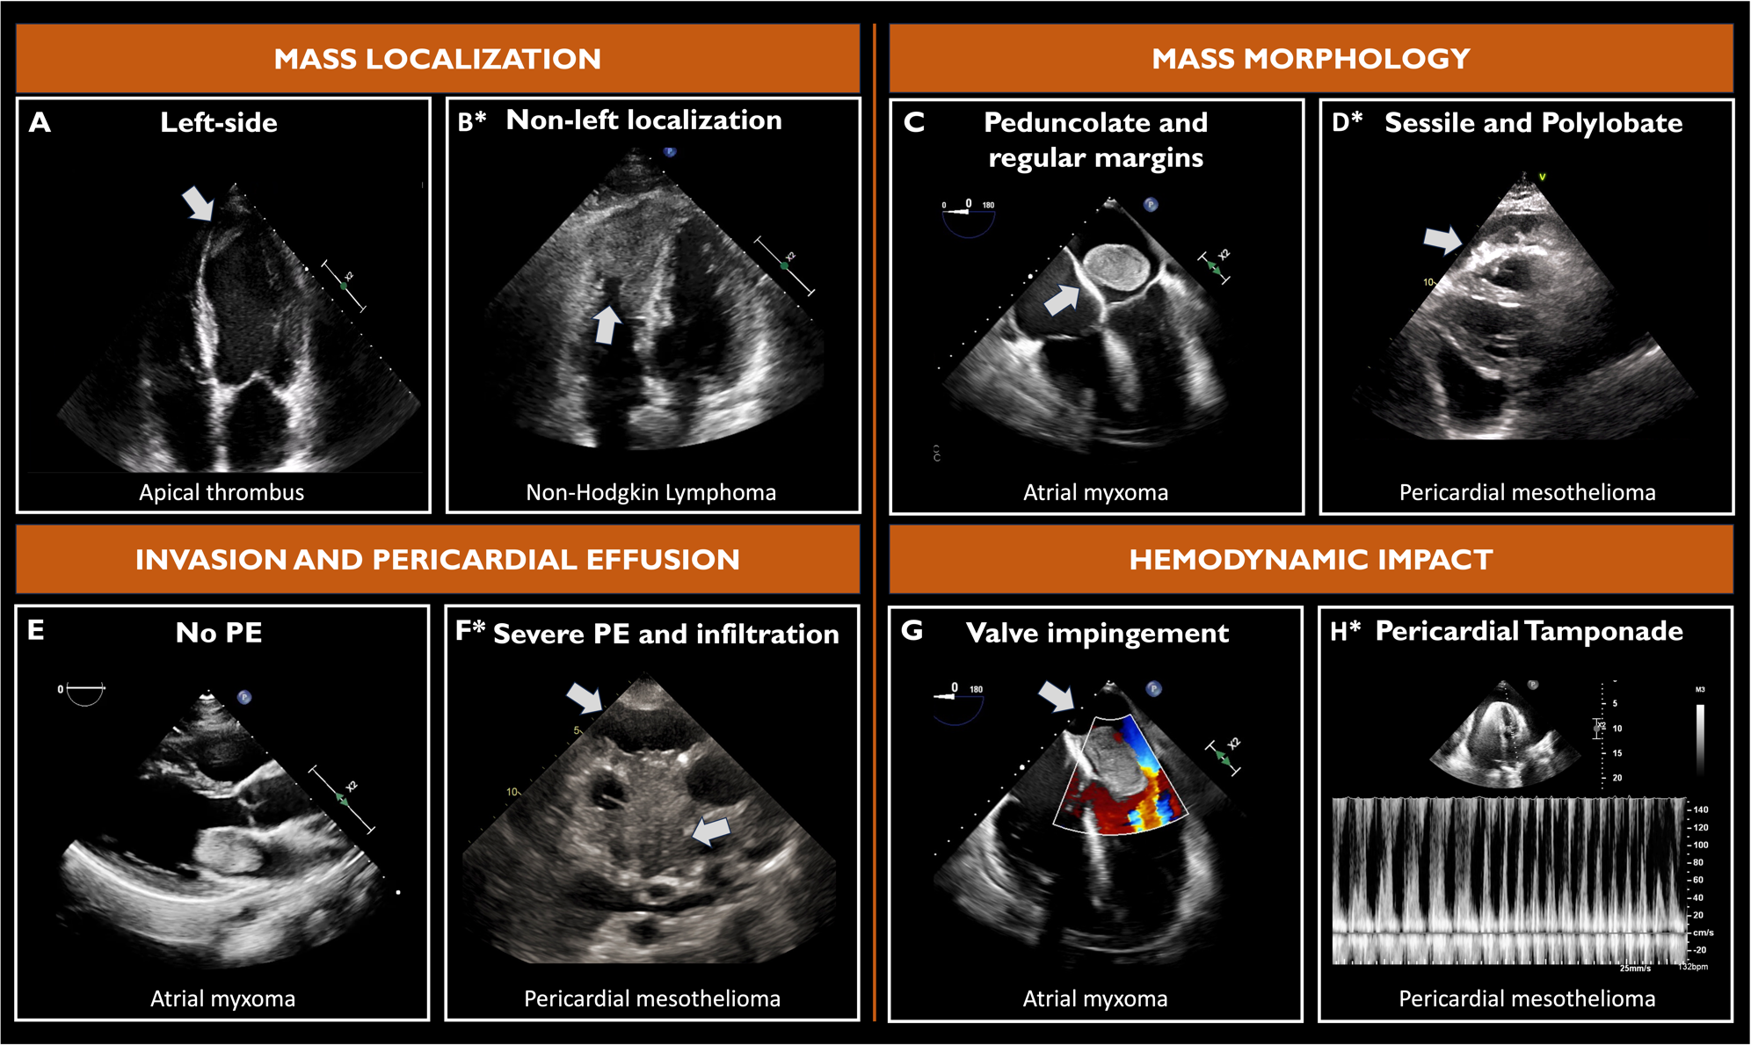
Supplementary Figure 2. Examples of cardiac mass features assessed at Cardiac Magnetic Resonance.

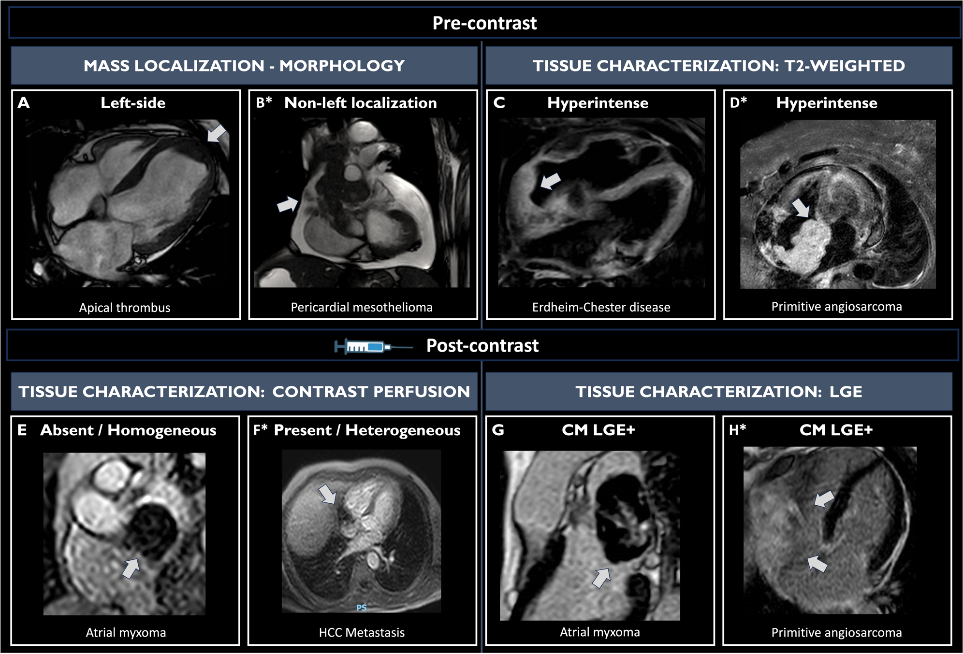
Supplementary Figure 3. Examples of cardiac mass features assessed at Cardiac Computed Tomography.

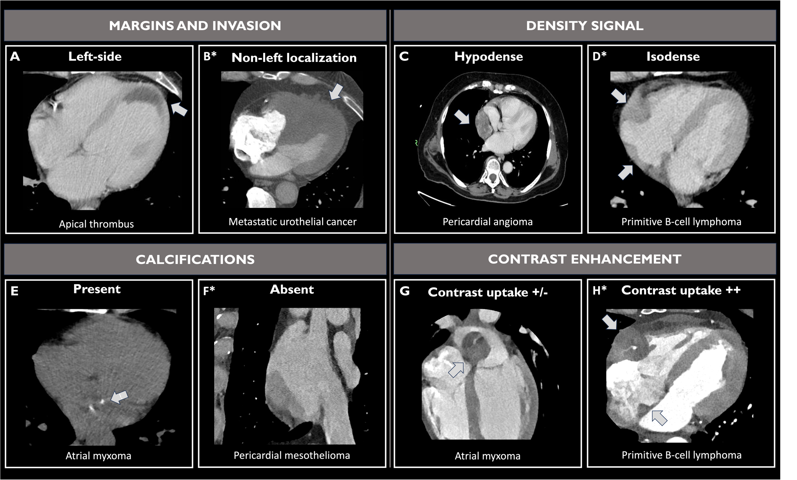

Supplementary Figure 4. Examples of cardiac masse features assessed at Positron Emission Tomography with 18-Fluorodeoxyglucose.

