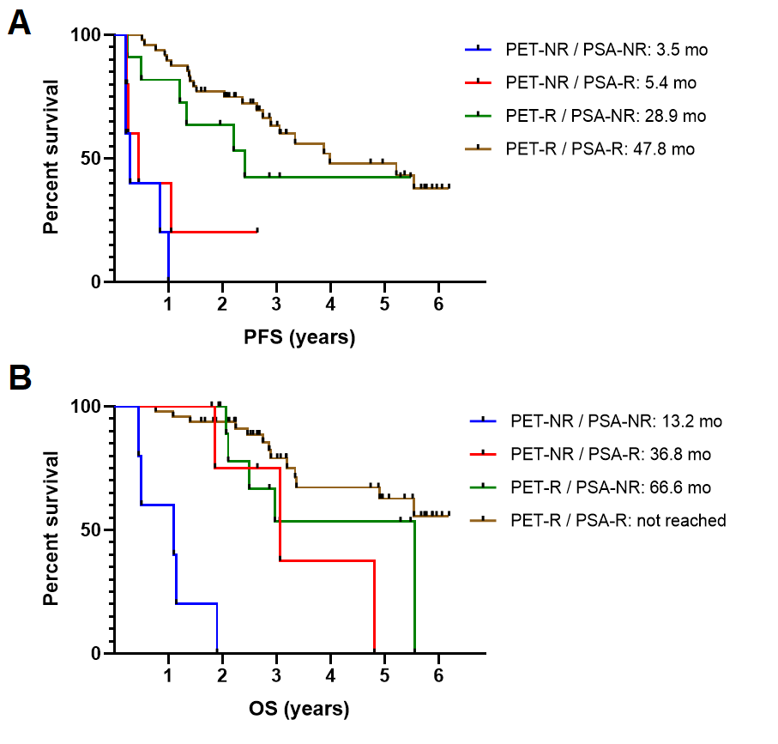
Figure S1. PFS and OS according to the division in these 4 groups. Mo, months; OS, overall survival; PET-NR, PSMA PET non-responder; PET-R, PSMA PET responder; PFS, progression free survival; PSA-NR, PSA non-responder; PSA-R, PSA responder.

