Supplementary Material

Supplementary Figures

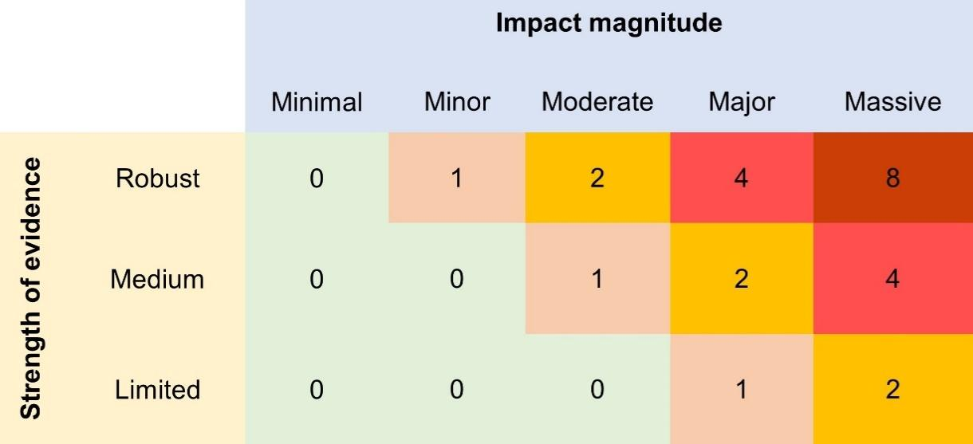
Supplementary Figure 1 Impact weights 𝑤_{i,j} are defined on the basis of the magnitude of the impact (according to Blackburn et al. 2014) and the related strength of evidence (according to Katsanevakis et al., 2014).

Strength of evidence
Robust | The impact is estimated by experimental studies. The different types of experiments are Manipulative Experiments (field and lab experiments based on a random selection of experimental units and include treatments and controls) and Natural Experiments (field experiments based on natural selection of experimental units).
Medium | Impact assessment is derived from Direct Observations (direct observations or measurements of impact without doubt), Modelling (ecosystem models that simulate alien species impacts on biodiversity) and non-experimental based correlations (significant correlations between an alien species and an impact on native biodiversity, not based on an experimental design).
Limited | Qualitative Impact assessment based on Expert Judgement through the empirical knowledge of experts based on alien species’ traits.
Impact magnitude
Massive | Changes in community composition through local or global extinction (negative) because of competition, predation, grazing, parasitism, toxicity or bio-fouling; impact on ecosystem processes and ecosystem functioning resulting in species composition changes; or ecological engineering, resulting in change in community composition. Massive magnitude applies when under the hypothetical scenario of the alien species extinction, the induced changes are considered as irreversible within 10 years or within 3 generations of the extinct native taxon/ -a, whichever is longer.
Major | Changes in community composition through local or global extinction (negative) because of competition, predation, grazing, parasitism, toxicity or bio-fouling; impact on ecosystem processes and ecosystem functioning resulting in species composition changes; or ecological engineering, resulting in change in community composition. Major magnitude applies when under the hypothetical scenario of the alien species extinction, the induced changes are considered as reversible within 10 years or within 3 generations of the extinct native taxon/ -a, whichever is longer.
Moderate | Native species population changes due to competition, predation, grazing, parasitism, toxicity or bio-fouling, but without changes in community composition; or impact on ecosystem processes and ecosystem functioning resulting in population declines but no substantial change in community composition; or ecological engineering, resulting in population declines but no substantial change in community composition.
Minor | Impact on individual fitness of a native species due to competition, predation, grazing, parasitism, toxicity or bio-fouling without substantial population changes; minor impact on ecosystem processes and ecosystem functioning with no related population changes; any environmental or habitat alterations in chemical, physical or structural characteristics do not result in population changes.
Minimal | No effect on fitness of native species; negligible impact on native species due to competition, predation, grazing, parasitism, toxicity or bio-fouling; no effects on ecosystem processes and ecosystem functioning; no chemical, physical or structural impact on the ecosystem (not an ecosystem engineer).
Supplementary Figure 2 The types of strength of evidence, as described by Katsanevakis et al. (2014), and the categories of impact magnitude, as outlined by Blackburn et al. (2014) and Volery et al. (2020).
 |  | Concentration
 |  | Low | Medium | High
Duration | Low | 0 | 0.25 | 0.5
Duration | Medium | 0.25 | 0.5 | 0.75
Duration | High | 0.5 | 0.75 | 1

Supplementary Figure 3 The population state of species i (Ai) can be determined based on concentration and duration, in accordance with species-specific thresholds.

