Changes in physical-chemical and electrical properties of XLPE-insulated cable subjected to radio-thermal aging and loss of coolant accident (LOCA) simulation
Authors: Simone Vincenzo Suraci and Davide Fabiani
¹ LIMES – Department of Electrical Engineering - University of Bologna, Bologna, Italy

ABSTRACT
This article examines the electrical and chemical properties of low-voltage instrumentation and control (LV I&C) cables used in nuclear power plants under normal and accidental conditions, by simulating a Design Basis Event (DBE). The study highlights how different aging treatments -radiation and thermal- significantly alter both the physical-chemical and electrical properties of the insulating material of the analyzed cables. Radiation aging primarily introduces highly reactive radicals and charged species, affecting the PE matrix and increasing electrical conductivity and dielectric losses. Thermal treatment catalyzes thermo-oxidation, which results in the reduction of conductivity and a further increase of dielectric losses. After the Design Basis Event (DBE) simulation, cables exhibit significant oxidation, attributed to the high pressure and temperatures during the Loss of Coolant Accident (LOCA) tests. This results in a substantial decrease in crystallinity ratio and a lower melting point of the polymer. Electrically, this leads to increased dielectric losses and reduced conduction current, indicating the formation of less-conducting species.

Introduction
The presence of medium and low voltage (MV and LV) cables within a power plant is extensive and critical to its operation. Cable structure, along with employed materials, significantly varies depending on the specific application and final purpose, addressing a range of endurance requirements. Different areas of the power plant may necessitate distinct cable specifications to ensure reliable performance and safety. For instance, cables in high-stress environments might need enhanced thermal resistance, while those in other areas might prioritize flexibility or moisture resistance. Consequently, the selection and installation of MV and LV cables must be meticulously planned and executed to meet the diverse operational demands and endurance criteria of the entire power plant [1], [2], [3], [4], [5].
This approach is particularly evident in the case of nuclear power plants (NPPs) where safety standards are extremely high due to the possible consequences of unexpected failures. For this reason, cables within NPPs are considered as equipment important to safety and, prior to their application, they face meticulous qualification procedures which change depending on the installation site of the NPPs.
In terms of types of cables, NPPs usually feature MV and LV cables which are used to deliver power (MV and LV), signal and data (LV). These latter fall within the class of instrumentation and control (I&C) cables, and they are used to connect various areas of the plant, i.e., from the reactor hall up to the control room. Depending on their final application, I&C cables are classified as important to safety or not important to safety according to the IEEE 308 and IEC 61226:2021 standards [6, 7], as it will be discussed in the following.
In terms of quantity, typical pressurized and boiling water reactors (PWRs and BWRs) are estimated to own more than 3000 km of LV I&C cables (~1500 km of which are classified as important to safety), making them the most extensively distributed equipment in the NPPs.
There are various international standards which, in addition to the classification of the different types of cables, describe the cable qualification procedures and the approval among the Technical Safety Organizations (TSOs), the NPP owner and the country authority.
Available standards depict procedures to qualify cables for operation for a lifespan of 40 up to 60 years, a time during which cables may be subjected to different environmental stresses including e.g. radiation, high temperature and moisture. For this reason, qualification processes commonly imply the use of accelerated aging conditions, aiming at simulating real in-operation stresses.
Figure 1 reports the schematic of a NPP with details on the types of cable and the relative areas, according to the two standards considered in this work (IEEE/IEC international and French ones). In particular, the upper division (1E, Not-1E) refers to the former, while the lower (K1, K2, K3, Not-classified) refers to the latter.
It is seen that cables important to safety (1E, K1, K2 and K3), are placed mostly inside the nuclear reactor building. Conversely, non-safety classified cables are placed mostly in the other areas of the plant.
Thanks to the extensive presence of NPP energy within its energy mix, French standard is used a reference one, for the purpose of this work.
Among the different types of cables used in NPPs the ones important to safety are required to fulfil their operation even after the occurrence of a nuclear accident. For this reason, the qualification of this kind of cable is very complex and implies various steps including Design Basis Event (DBE) simulation. During a DBE simulation, the cables are subjected to an abrupt increase of temperature and pressure with a coexistent increase in dose rates in a short period of time. This procedure simulates typical conditions occurring during a loss of coolant accident (LOCA).
The French standard further divides the safety-classified cables into three groups (K1, K2 and K3) which differ based on type of qualification procedure and on the need to be operational even after a nuclear accident-like event. In particular, K1 and K2 cables are cables installed in the nuclear reactor hall. Their qualification sees the most complex procedure having to verify cable lifetime demonstration by means of (i) accelerated thermal aging (through the Arrhenius law), (ii) accelerated irradiation aging and, in the case of K1 cables, also (iii) simulation of accidental conditions e.g., DBE.
Finally, the qualification procedure of cables not important to safety, which are cable placed outside the containment area, usually requires just the lifetime demonstration without irradiation aging, following the Arrhenius law.
After accelerated aging and DBE simulation, cables are tested by means of electrical tests i.e., voltage withstand while the cable is coiled on a mandrel and insulation resistance.
In addition, on new and after pre-aging (without accident simulations), cables need also to pass flammability tests, which verify the resistance of cables to flame propagation.
Figure 1 Schematic of a nuclear power plant with classification of cables related to the different areas according to the (up) IEEE 383 and (bottom) French standard
After installation, the cable state-of-health should be continuously checked in order to adequately plan maintenance and, in case, substitution of the equipment. To date, the suitability of LV cables for operation within the power plant has been verified through tensile tests. Specifically, it was demonstrated that cables with an elongation-at-break (EaB) value exceeding 50% are capable of withstanding a DBE, if requested by the qualification type test, while continuing to properly operate under normal conditions [8]. Nonetheless, it is somehow unfeasible to verify the state of installed cables by performing tensile tests due to the excessive length distribution of the cable network, which often includes difficulty-accessible areas, as mentioned above. Moreover, tensile tests suffer various drawbacks such as the fact that they are dependent on local weak spots, which make the measurement, on the one hand, not directly relatable to the entire cable, and, on the other hand, with high data scattering. More importantly, tensile test measurements are destructive, which presents challenges for their use as a continuous monitoring technique for cables.
Under these circumstances, the need to find innovative non-destructive testing techniques for the condition assessment of these cables accelerated the research interest towards electrical tests. These latter are usually nondestructive and related to the entire length, extremely minimizing the impact of locally aged spots and high data scattering. Among those, dielectric spectroscopy proved to be a valuable candidate for the condition monitoring of LV cables, also for cables facing LOCA simulation [9], having shown good agreements with polymer degradation level as verified by means of both physical-chemical and mechanical (including tensile tests) analyses [10], [11], [12].
As follows, it has been shown how, for cables important to safety, the evaluation of the proper operability of cables after a LOCA is a key factor for guaranteeing the required high safety standards inside NPPs, whatever the considered standard.
Within this framework, the paper aims to analyze the performance of nuclear-grade LV cables that have been subjected to a DBE simulation. The study encompasses a comprehensive evaluation of the electrical properties and physical-chemical characterization of the insulation system. The analysis includes detailed assessments of dielectric properties, thermal stability, and chemical composition to understand the cable performance and lifespan under stress. By providing an in-depth investigation of these parameters, the paper seeks to ensure the reliability and safety of LV cables in nuclear power plant environments, ultimately contributing to the improvement of existing safety standards and operational protocols.

Materials and methods

2.1 Cable samples
The analyzed samples are LV I&C coaxial cables specifically designed for the Horizon 2020 TeaM Cables project [13]. Figure 2 reports the section and the description of the different concentric layers of the cable samples. Tested specimens were about 50 cm long and insulation thickness was ~0.8 mm.
- Conductor – Copper (the innermost);  - Primary insulation – Silane crosslinked polyethylene (Si-XLPE);  - Polymeric film;  - Shielding – Copper wire braid;  - Outer sheath – Low Smoke Zero Halogen. | 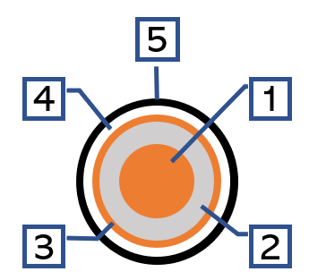
Figure 2 Morphology of the investigated coaxial cables
The primary insulation is a silane crosslinked polyethylene stabilized with 1 phr of primary antioxidant (phenol-based) and 1 phr of secondary antioxidant (thioether-based). Such concentration of antioxidant is very high in comparison to typical values used in LV cables, possibly leading to an increase of cable endurance during aging and reduced degradation phenomena.

2.2 Accelerated aging
The cable samples were aged simultaneously under radiation and high temperature to simulate typical nuclear environment stresses on cables. In particular, in this work, two aging temperatures (47°C and 87°C) along with a constant dose rate (7.2 Gy/h) were applied to the cables for a total of 678 days (1.85 years). The chosen aging parameters, in terms of radiation, are way higher than typical ones present inside NPPs, with a 20x higher radiation stress. On the contrary, the chosen aging temperatures (47 °C and 87 °C) are common temperatures inside the steam generator room and hot-spots within the NPPs, respectively.
Radiation aging was performed in the Panoza facility at UJV Rez, Czech Republic, through a ⁶⁰Co γ-ray source [9]. Aging properties and durations are summarized in Table 1. The reason beyond use of gamma irradiation source in place of other sources (alpha or beta) is twofold. (a) It is an electromagnetic source, this implies that the material does not become radioactive, easing the handling and testing. (b) The source releases higher values of energy in the material since gamma rays are more energetic than the other radiation sources. Moreover, it has been demonstrated [14] that, up to significantly high values of absorbed doses, the effects of the different radiation sources on the material properties follow the same trend, despite different amplitudes.
The equivalence of these accelerated aging conditions to real service conditions over a 40-year application period is established using the Arrhenius approach for thermal aging. For radiation aging, the equivalence is based on the total absorbed dose, taking into account an average dose rate of approximately 0.33 Gy/h in actual nuclear power plants (NPPs) over the same 40-year period.

Design Basis Event (DBE) simulation
As reported in the introduction, during a loss of coolant accident (LOCA), cables in the reactors undergo various severe stresses i.e., high temperatures, high dose rates, pressure and chemical sprays coming from the surrounding environment. Standard IEEE 383 requires that the qualification for a DBE-LOCA cable passes through various steps, namely:
- Thermal and radiation exposure
- LOCA thermo-dynamic profile
- Post LOCA simulation
Nonetheless, the parameters chosen by the utilities to efficiently simulate a DBE-LOCA accident may differ among countries and NPPs. As an example, the accident dose may vary from 10 kGy to 2200 kGy. For the sake of this research, it was chosen to employ parameters which meet the chosen reference requirements. Moreover, given the complexity of mimicking the numerous conditions conjointly, the simulation was split into four subsequent stages:
- Accelerated aging: cables were aged to an equivalent of 40-year aging, considering a radiation-only (RA) and a combined (radiation and temperature -TA/RA-) aging. Aging parameters are reported in the first two columns of Table 1.
- Accident radiation: aged cables were subjected to dose rate ~1.4 kGy/h until the reaching of a total absorbed dose ~610 kGy.
- LOCA thermodynamic profile: In this phase high temperature and overpressure are applied to the cables (coiled on a drum (Figure 3) in a vessel for 10 hours. After this phase, cables were kept for an additional 12h under uncontrolled cooling. Temperature and overpressure are not constant during this phase, but they vary depending on the requirements of the given NPP. The profile of temperature and pressure of LOCA used in this work is reported in Figure 4. During this phase, chemical spray is released in the vessel. Also in this case, the parameters and types of chemicals depend on the considered NPP. In this study, a chemical spray containing 15 g H₃BO₃ + 2 g NaOH in 1 kg distilled water was used. The inlet rate was set at ~3 L/h.
- Post LOCA simulation. After LOCA, cables were immersed in the same spray solution as phase #3 at 65°C for ~1 year at ambient pressure.
Table 1 summarizes some of the aging parameters of the cables under test.
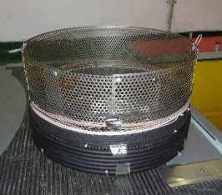
Figure 3 Samples coiled on the drum prepared for accident dose irradiation.
Figure 4 LOCA simulation temperature and overpressure profile.
Table 1 Aging parameters of cables
Parameter | Aging name
Parameter | RA | TA/RA | RA+LOCA | TA/RA+LOCA
Temperature (°C) | 47 | 87 | 47 (RA), RT (DBE) | 87 (TA/RA), RT (DBE)
Dose rate (Gy/h) | 7.2 | 7.2 | 7.2 (RA), 1400 (DBE) | 7.2 (TA/RA), 1400 (DBE)
Total dose (kGy) | 117 | 117 | 117 (RA) + 610 (DBE) | 117 (TA/RA) + 610 (DBE)
Total aging time (h) | 16 261 (1.85 y) | 16 261 (1.85 y) | 25 021 (2.85 y) | 25 021 (2.85 y)

2.3 Cable characterization

2.3.1 Physical-chemical characterization

2.3.1.1 Fourier Transform Infra-Red (FTIR) spectroscopy measurements
In order to investigate the buildup of oxidation products, Fourier transform infra-red (FTIR) spectroscopy tests were performed on the surface of cable samples using a Bruker Alpha spectrometer.
Tests were conducted in attenuated total reflectance (ATR) mode. Indeed, due to the roundness of cable samples, it was not possible to perform FTIR tests in transmission mode. ATR mode allows the investigation of the chemical functional groups on the material surface. For this reason, it normally does not provide a quantitative analysis i.e., concentration of chemical species arising from aging. To overcome this limitation, FTIR spectra have to be normalized by a peak which is supposed not to change with aging conditions. In the case of polyethylene (PE), the peak usually taken as reference is the one at 1472 cm⁻¹, which is associated with the crystalline phase of -CH₂-. In this way, it would be possible to obtain a quantitative comparison among the different materials under test.

2.3.1.2 Differential scanning calorimetry (DSC)
Differential scanning calorimetry (DSC) analyses were carried out using a TA Instruments Q2000 DSC apparatus, calibrated with Indium standard, and equipped with a refrigerated cooling system (RCS90). Samples (8-10 mg) were loaded into standard aluminum pans and underwent the following thermal treatments: i) 1st heating ramp from –88 to 200 °C; ii) cooling ramp to –88 °C; iii) 2nd heating ramp to 200 °C. Heating/cooling rate was 20 °C/min. For the sake of the study, two key parameters, i.e., melting temperature and crystallinity ratio are used for the evaluation of the aging of the cables. The chosen ramp used for the aging investigation is the first one which considers the whole aging treatment (both permanent and nonpermanent modifications).
The crystallinity ratio (χ_{c}) of the polymer was determined as follows:
$$χ_{c}= \frac{{ΔH}_{m}}{{ΔH}_{m,∞}}$$ | (1)
where ΔH_{m} and ${ΔH}_{∞}$ are the melting enthalpies (J.g⁻¹) of the sample and PE crystal, respectively. In literature, the commonly used value for ${ΔH}_{∞}$ is 290 J.g⁻¹ [10], [15].

2.3.1.3 Thermogravimetric analysis (TGA)
Thermal and thermoxidative behaviour of samples were assessed via thermogravimetric analysis (TGA), using a TG 209 F1 Libra, Netzsch. The technique records the mass loss over the specified temperature range from which it is possible to obtain a compositional analysis of the sample. In particular, it is possible to evaluate the concentration of fillers e.g. flame retardants and plasticizers. For this reason, it is particularly interesting for polymers with specific additives and fillers e.g., PVC-insulated cables with plasticizers.
For the sake of this work, XLPE samples (10-12 mg) were placed into alumina crucibles and heated at a 20 °C/min rate, from room temperature (26-28 °C) to 700 °C, adding a final isothermal step of 15 min for residue evaluation. The samples underwent the same thermal treatment both under nitrogen (thermal degradation) and air (thermoxidative degradation) atmosphere.
From the obtained thermograph, the temperatures corresponding to 5% and 50% of the weight loss are usually used as end-of-life point in various applications, including cables. Thus, these parameters will be discussed in the text with reference to the aging of cables.

2.3.1 Electrical characterization
In order to properly perform electrical tests on the primary insulation, layers #3,4,5 were removed from the cable before testing. In addition, a 10cm-long external copper wire braid was placed on the primary insulation, and it was used as signal electrode for electrical characterization tests. Figure 5 represents the schematics of the connections for the dielectric spectroscopy (Figure 5.a) and DC current (Figure 5.b) measurements.

2.3.2.1 Dielectric spectroscopy measurements
The dissipation factor (tanδ) of cables under test was measured by means of a Novocontrol Alpha Dielectric analyzer V2.2. Measurements were performed at room temperature with applied voltage of 3V_{rms} in the frequency region 1 mHz – 1 MHz. Reported results are averaged over three sequentially performed tests. Among the different parameters, it has been chosen to report the dissipation factor as it is invariant from cable geometry which is usually partly unknown in the case of onsite measurements in real environments.

2.3.2.2 DC current measurements
Insulation resistance measurements were performed on cables by means of a Keithley 2290E-5 5kV HVDC generator and a Keysight B2981A picoamperemeter. The applied voltage was set at 2kV_{DC}, which was verified to be enough to get reliable and stable values of current. Voltage has been applied to the inner conductor while current was acquired through the external copper wire braid used as signal electrode (Figure 5.b).
Since the aim of this test was not to get the absolute value of insulation resistance but a comparison among the different aging conditions, tests were stopped after ~1h. This time showed to be enough to get a reliable comparison among the different aging conditions.
(a) | (b)
Figure 5 Schematics of the connections used for (a) dielectric spectroscopy measurements and (b) insulation resistance measurements.

Results and discussion

Chemical characterization

3.1.1 FTIR spectroscopy results
The presence of new chemical groups formed during aging may be analyzed through the FTIR spectroscopy. In general, the types and concentrations of degradation products vary depending on e.g., main polymer matrix, aging conditions, additives, etc. [16], [17], [18]. It is widely recognized that oxidation is one of the primary degradation mechanisms affecting polymers during aging. However, a comprehensive understanding of these degradation mechanisms is essential to accurately attribute the formation of new species to the degradation phenomena.
The main chemical groups, in terms of concentration, arising from oxidation are ketones, esters and alcohols. For this reason, it was chosen to report (Figure 6) the FTIR spectra related to the cables under test in the wavenumber region 1800-900 cm⁻¹ related to these species, normalized by the -CH₂- bond of the crystalline phase.
Focusing on the ketone part, one can notice that a peak occurring at ~1730 cm⁻¹ is present also for the unaged sample. This was imputed to the primary antioxidant (phenol-based) which is commonly added to the base insulating material to prevent oxidation, as seen in our previous works [10], [19], [20]. Consumption of antioxidants due to aging causes the reduction of this peak, together with the formation of a new peak at ~1715 cm⁻¹. This dual peak pattern is a characteristic indicator of the formation of different species of ketones and carbonyls, also associated with oxidized species formed during radiation aging as seen in [21]. Nonetheless, in terms of amplitude, these new peaks exhibit very low absorbance, highlighting that the contribution of oxidation in the case of RA and RA/TA aged cables is very limited. The reason for that may be linked to the very low concentration of oxygen inside the multilayer structure of the cables during aging, as already discussed in [10].
On the other hand, cables which faced the DBE simulation show extremely high increase of the absorbance of ketones with a unique peak.
At high dose rates and high temperatures, oxygen diffusion acts as a limiting factor, resulting in oxidation predominantly occurring near the surface. This phenomenon, called diffusion limited oxidation (DLO), causes the inhibition of degradation in the material bulk as oxidation is localized on the outmost layers of the insulation (external surface), leading to inhomogeneous degradation throughout the bulk of the insulation. Indeed, particularly inside a cable structure, oxygen concentration may be not enough to provide a stoichiometric ratio to the oxidation reaction scheme. In such a way, oxidized structures are formed only on the surface of the insulation, while the material bulk experiences reduced degradation. The DLO effect can result in a brittle, oxidized surface layer, which compromises the mechanical properties of the polymer.
The maximum thickness beyond which a polymer is expected to experience DLO is derived by diffusion laws [22]. As an example, common limit values for PE-based material are ~110 Gy/h per mm (thickness). The limit in terms of temperature is found to be close to the melting peak of PE (110°C) so that it is difficult to distinguish contribution of oxygen diffusion from polymer re-crystallization and annealing.
This being said, in this work, cables which face DBE-LOCA simulation are expected to experience DLO. To investigate this phenomenon, the use of surface analysis is needed. Although the use of ATR-FTIR may have limitations in terms of quantitative analysis of chemical species, it effectively highlights the contribution of oxidation effect of the DBE-LOCA treatment on the cable under consideration.
Moreover, during DBE-LOCA simulation, concentration of oxygen on the cable insulation surface may be increased due to the presence of high pressure applied during the LOCA tests which facilitate the permeation of oxygen in the cable structure. This phenomenon, along with the high temperatures (up to 150°C) catalyzes the oxidative reactions to occur. Moreover, the post-LOCA simulation over a long period of one year, further facilitates the diffusion phenomena of the species, enhancing additional degradation mechanisms due to the so-called post-irradiation effect [23], [24], [25]. This phenomenon causes the continuation of degradation reactions even if the external environmental stresses (in this case high temperatures and radiation) are limited or stopped, leading to significant modification in the polymer properties over a long period of time. As an example, previous works [25] show how modifications may be recorded up to after 5 years from the turning off the irradiation source.
Finally, despite the same post-irradiation treatment, it is worth noting that the highest peak is recorded for the cables which previously faced combined (TA/RA) aging, while the peak height of the radiation-only aged cables exhibits lower amplitudes. This may be likely imputed to the additional radicals formed in the crystalline area during the previous aging phase. These radicals require the aforementioned diffusion processes to occur in order to properly react, due to the post-irradiation effect.
Similar reasoning may be extended to the peaks related to the other degradation groups (esters and alcohols), which are predominant in the samples after the DBE simulation. However, it is noteworthy that, these groups, even if likely related to aging, may be also created by the interaction of the chemical species (used in the spray and in the bath of phases #3 and 4) with the cable during the LOCA e post-LOCA treatment.
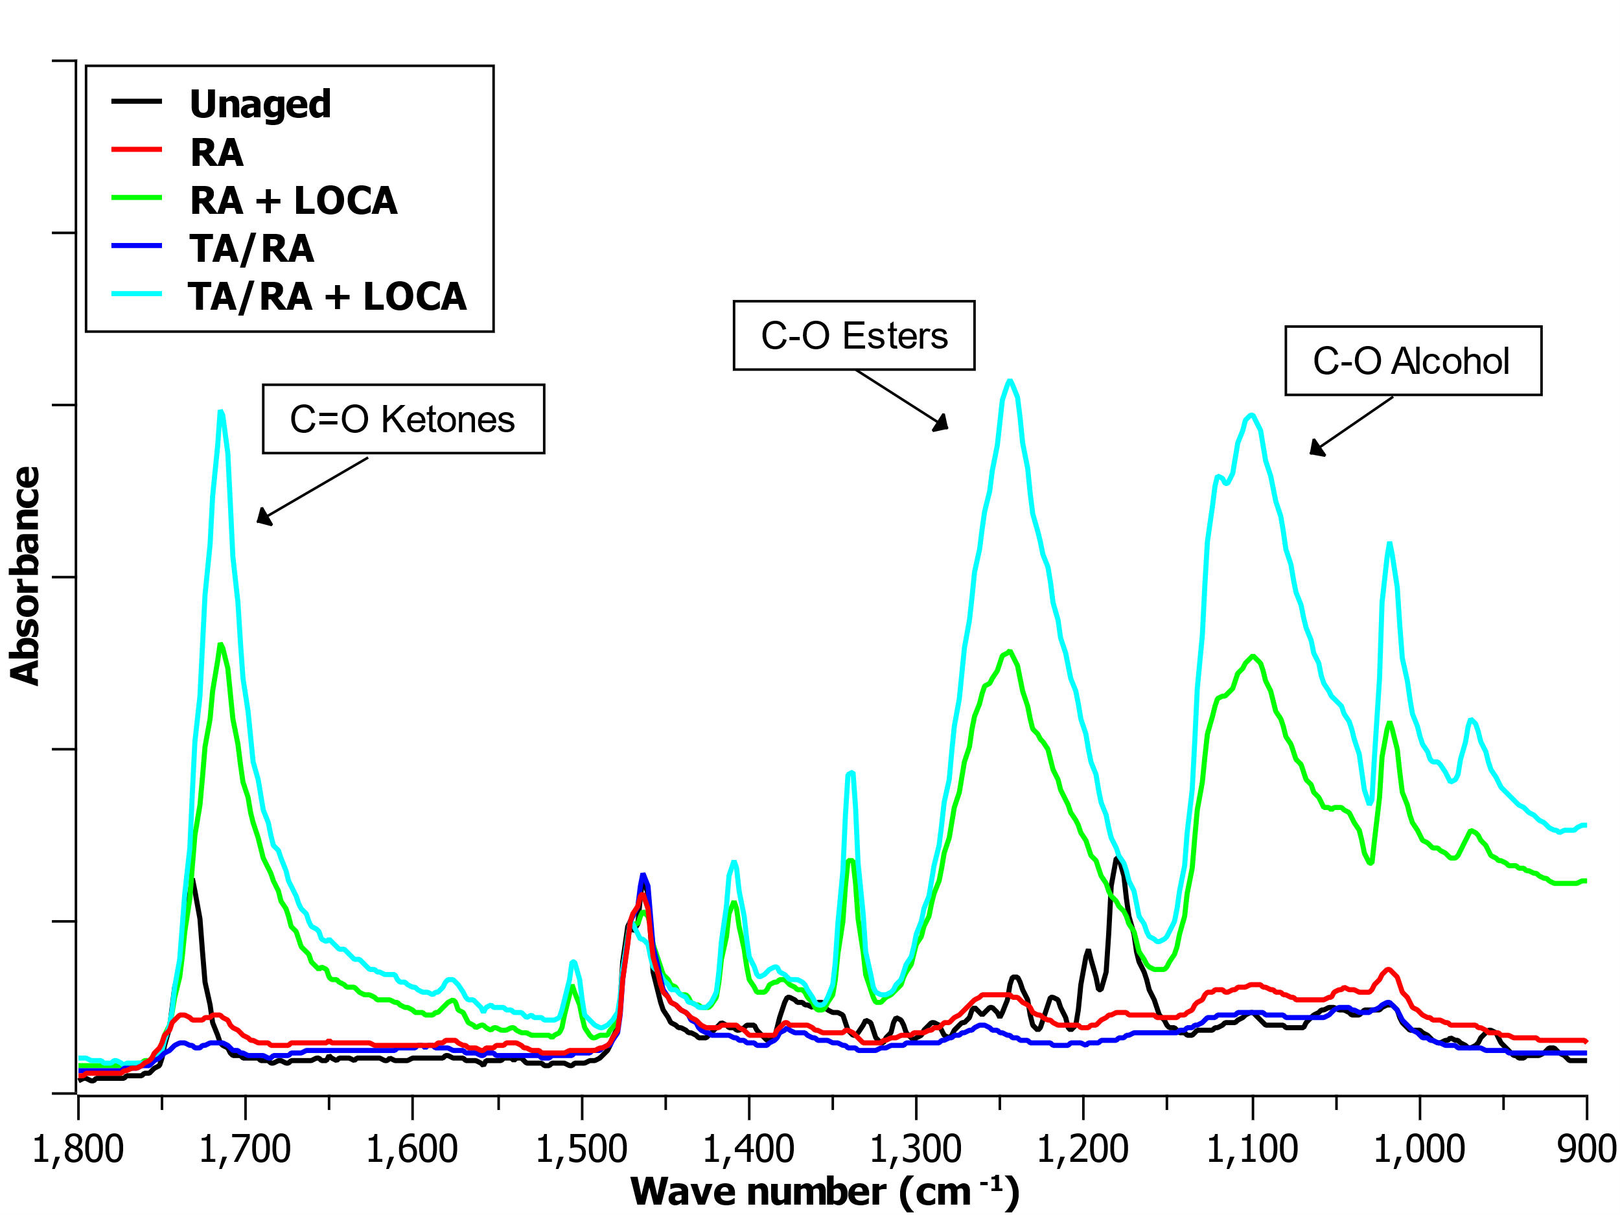
Figure 6 Normalized FTIR spectra related to Ketones, Esters and Alcohols groups for the different aging levels.

3.1.2 DSC results
Figure 7 reports the thermograms obtained through DSC tests as a function of the different aging conditions, for the first (Figure 7.a) and second (Figure 7.b) heating scans.
For the sake of this work, it has been chosen to provide more detailed analysis on the thermographs related to the first scan, which, as reported in the experimental setup section, refers to both permanent and nonpermanent modifications within the material. This reasoning stands as the aim of this article is to investigate the aging development of cable materials. Nonetheless, information arising from the second heating scan may highlight the contribution of permanent modifications due to aging. This is of particular interest in the case of radiation aging, as one of its main effects is crystal destruction due to the high transfer of energy.
From the figure related to the first heating, it is evident how the aging treatment deeply influences crystalline arrangement within the polymer matrix. As an example, for the unaged material, one can highlight the contribution of three main peaks occurring at ~50°C, 100°C and 120°C. This suggests that either the polymer matrix features a complex crystalline structure with crystallites of different sizes or the polymer underwent a dynamic reorganization effect during the first heating ramp. In the case of radiation-only (RA) aging, these peaks are then convoluted into a unique peak modifying the heat flow trend over temperatures. The combined effect of temperature and radiation (TA/RA) further modifies the trend over temperatures showing a different convolution of peaks with a sharper shape. This suggests that the distribution in size of crystallites is more homogenous.
The modification of the crystallite distribution is likely imputable to the chemi-crystallization [26]. Indeed this is one of the main phenomena to consider in the case of radiation aging, as microstructural modifications occurs more frequently than with thermo-oxidation [21], [27]. The reason for that is usually found in the low interaction time within the active particles and radicals which tend to quickly bond together rather than bond with environmental oxygen. During chemi-crystallization, the broken chains arising from the chain scission tend to accumulate close to crystallites which act as nucleating agents, resulting in an increase of crystal sizes. On a larger scale, this leads to a decline in the polymer's plastic properties and causes it to become mechanically brittle. As a result, a polymer which underwent radiation aging usually exhibits higher values of crystallinity than the value of the unaged material [28]. Normally, this would not impact on the thermal stability of the crystalline phase, keeping the melting point close to the unaged value. This reasoning perfectly fits with the results obtained by analyzing the thermograms (Table 2), where the crystalline ratio is increased (up to 45%) and the melting temperature is kept constant among the considered conditions.
It's noteworthy that at high radiation doses, this phenomenon is often masked by the destruction of crystals caused by radiolysis events, which are not observed in thermo-oxidation. Therefore, tracking the increase in crystal size during the aging process becomes challenging due to these concurrent effects.
Materials undergoing the DBE simulation exhibit opposite behavior, showing a significant decrease of the crystallinity ratio (-5%) and of the melting temperature (-10 °C), due to the possible crystal destruction during radiation aging. Moreover, the thermograms show a peak distribution closer to the one of the unaged polymers, with the reorganization of the crystalline phase resulting in three peaks. The reason for this may be possibly found into the diffusion phenomenon occurring during the post-LOCA treatment, where, thanks to the higher temperatures (65°C), the smaller crystallites are kept into their molten state, helping the diffusion and crystallization towards the initial stable polymer state.
Regarding the permanent crystalline structure after aging, which is related to the second heating scan, one can observe a homogenization of the shape of the melting peak. This is characterized by a unique peak at ~115°C with an extremely broad shape, implying a broad distribution of crystals of different sizes within the material (centered in the area ~100-120°C). In addition, the melting temperature is slightly modified with the radiation-only aging leading to the shifting towards higher temperatures. On the other hand, when thermal aging is present, a shift in the other direction is observable. Despite being little, these modifications suggest that thermal aging brings to the formation of smaller crystals, possibly due to the different chemical species formed during the initial aging treatment. This can be explained by the fact that radiation aging causes mainly chain scission not leading to chemically-modifies molecules. Smaller chains are more prone to agglomerate and increase crystal sizes. On the contrary, thermal aging causes the arising of oxidized species which do not concur with the increase in crystalline size, leading to smaller crystals and shifting of the peak towards lower temperatures.
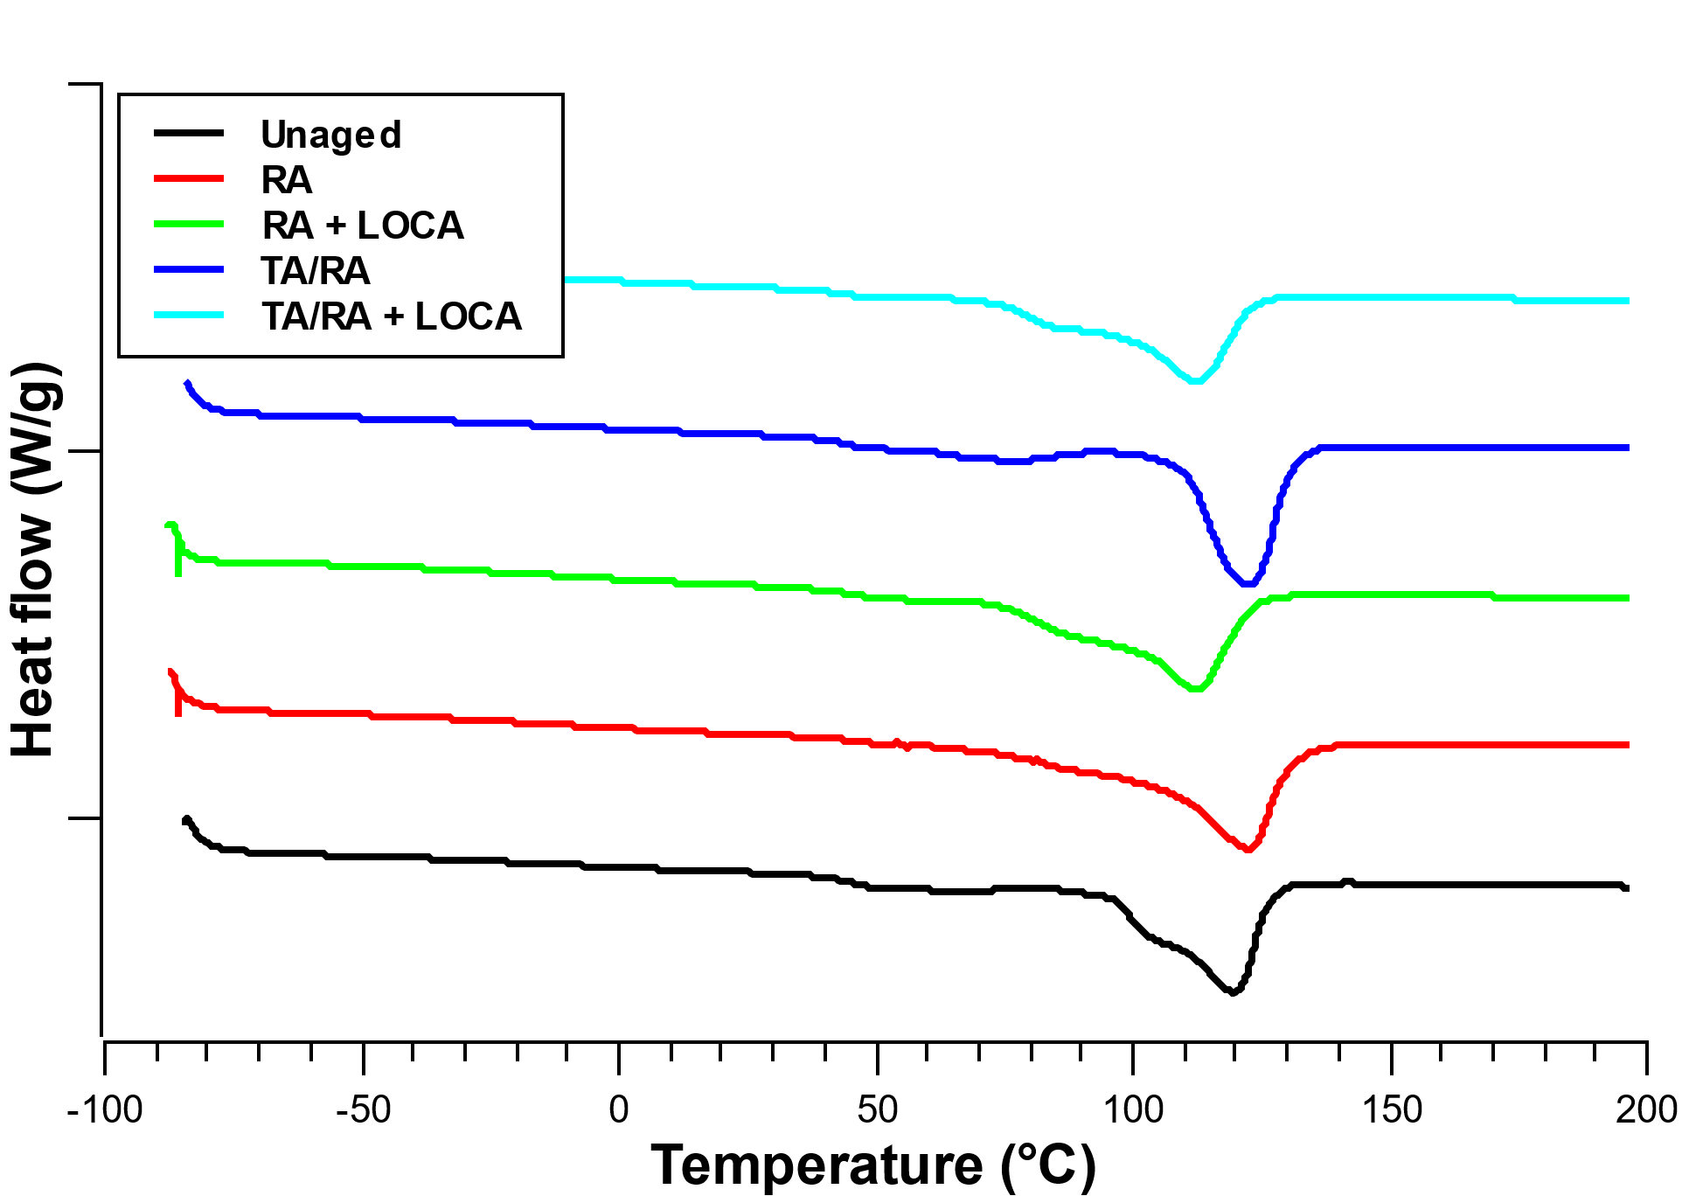 | 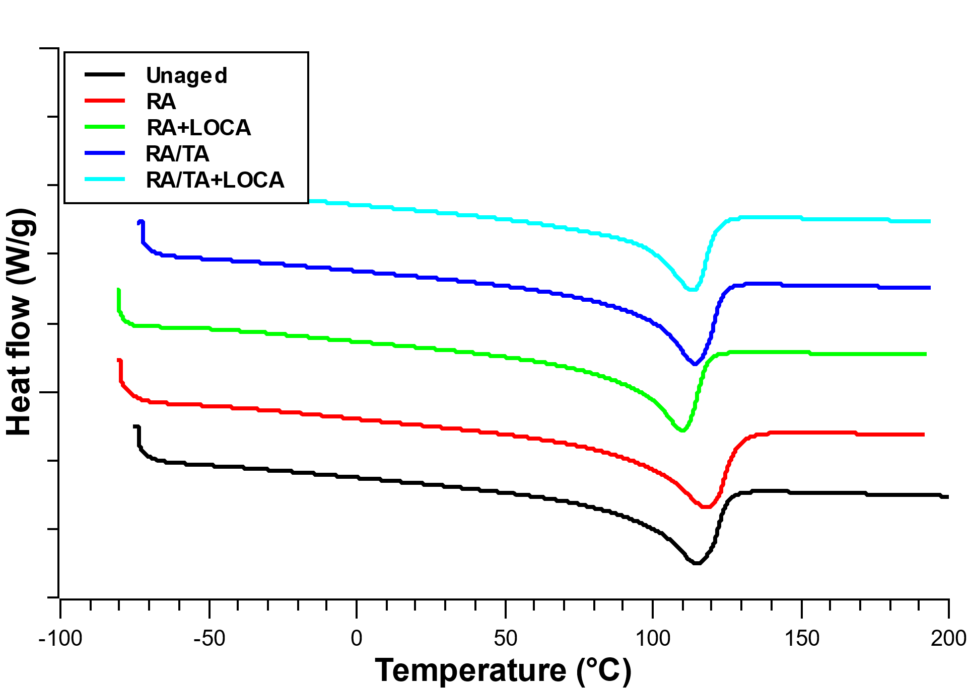
(a) | (b)
Figure 7 DSC thermograms for the different materials investigated. Exo up. (a) First heating scan, (b) Second heating scan.
Table 2 DSC properties for the different materials investigated
Material | Melting temperature (°C) | Crystallinity ratio (%)
Unaged | 120 | 42
RA | 122 | 43
RA + LOCA | 111 | 41
TA/RA | 122 | 45
TA/RA + LOCA | 112 | 37

3.1.3 TGA results
Figure 8 reports the thermograms obtained by the TGA under inert atmosphere (nitrogen) for the different analyzed materials. As expected, XLPE-based materials start their degradation at ~460°C, temperature beyond which more than 90% of the sample weight is lost. Interestingly, materials exposed to varying aging conditions exhibit notably distinct behaviors. Firstly, the unaged and TA/RA-aged samples do not reach 0% weight even at 700°C, suggesting that part of undegradable materials are present within the matrix, as in the case of unaged samples. This weight amount is brought to zero by means of an additional treatment into oxidizing atmosphere at 700°C.
This behavior can be attributed to the combined effects of temperature and radiation, potentially causing both increased chain scission and the formation of degradation species. Specifically, moderate temperatures (around 90°C in this case) may overcome any limitations related to diffusion-limited oxidation (DLO), leading to the formation of chemically stable degradation species. As a result, the polymer's stability is similar to that of the unaged material, which shows a residual mass of approximately 10%.
Following LOCA, the same material (TA/RA+LOCA) experiences severe radiation aging. In this scenario, the two degradation mechanisms are not concurrent; instead, radiation predominates, exceeding any potential stability arising from thermal degradation.
In order to better analyze the behavior with aging, it is also reported an insight (Figure 8.b) centered on 50% mass loss. This value is sometimes used as a reference value for the evaluation of the stability of the soft matters, as seen in [29].
Results indicate that all aged materials exhibit lower degradation temperatures compared to the unaged material. Notably, the temperature at which 50% degradation occurs (temperature-to-50%) is almost the same between the RA and TA/RA materials. Nonetheless, the weight loss trend appears to be different, with a faster degradation in the case of radiation-only (RA) aging.
Similar results can be observed when analyzing materials post-DBE event. As anticipated, the DBE simulation further diminishes polymer stability. Interestingly, materials aged under RA + LOCA conditions exhibit the lowest temperature-to-50%, indicating a more degraded and less stable material. Consequently, it can be concluded that thermal treatment enhances polymer stability, likely due to the formation of different species with aging.
These results are consistent with the degradation mechanisms occurring during radiation and combined aging. Indeed, the presence of shorter chains within the polymer matrix usually needs lower temperatures to degrade. This is in agreement with the reported results, being the chain scission the main mechanism in radiation aging. On the contrary, thermo-oxidation causes the formation of different products which are shown to be slightly more stable with temperature, leading to the need of higher temperature to achieve the same degradation level.
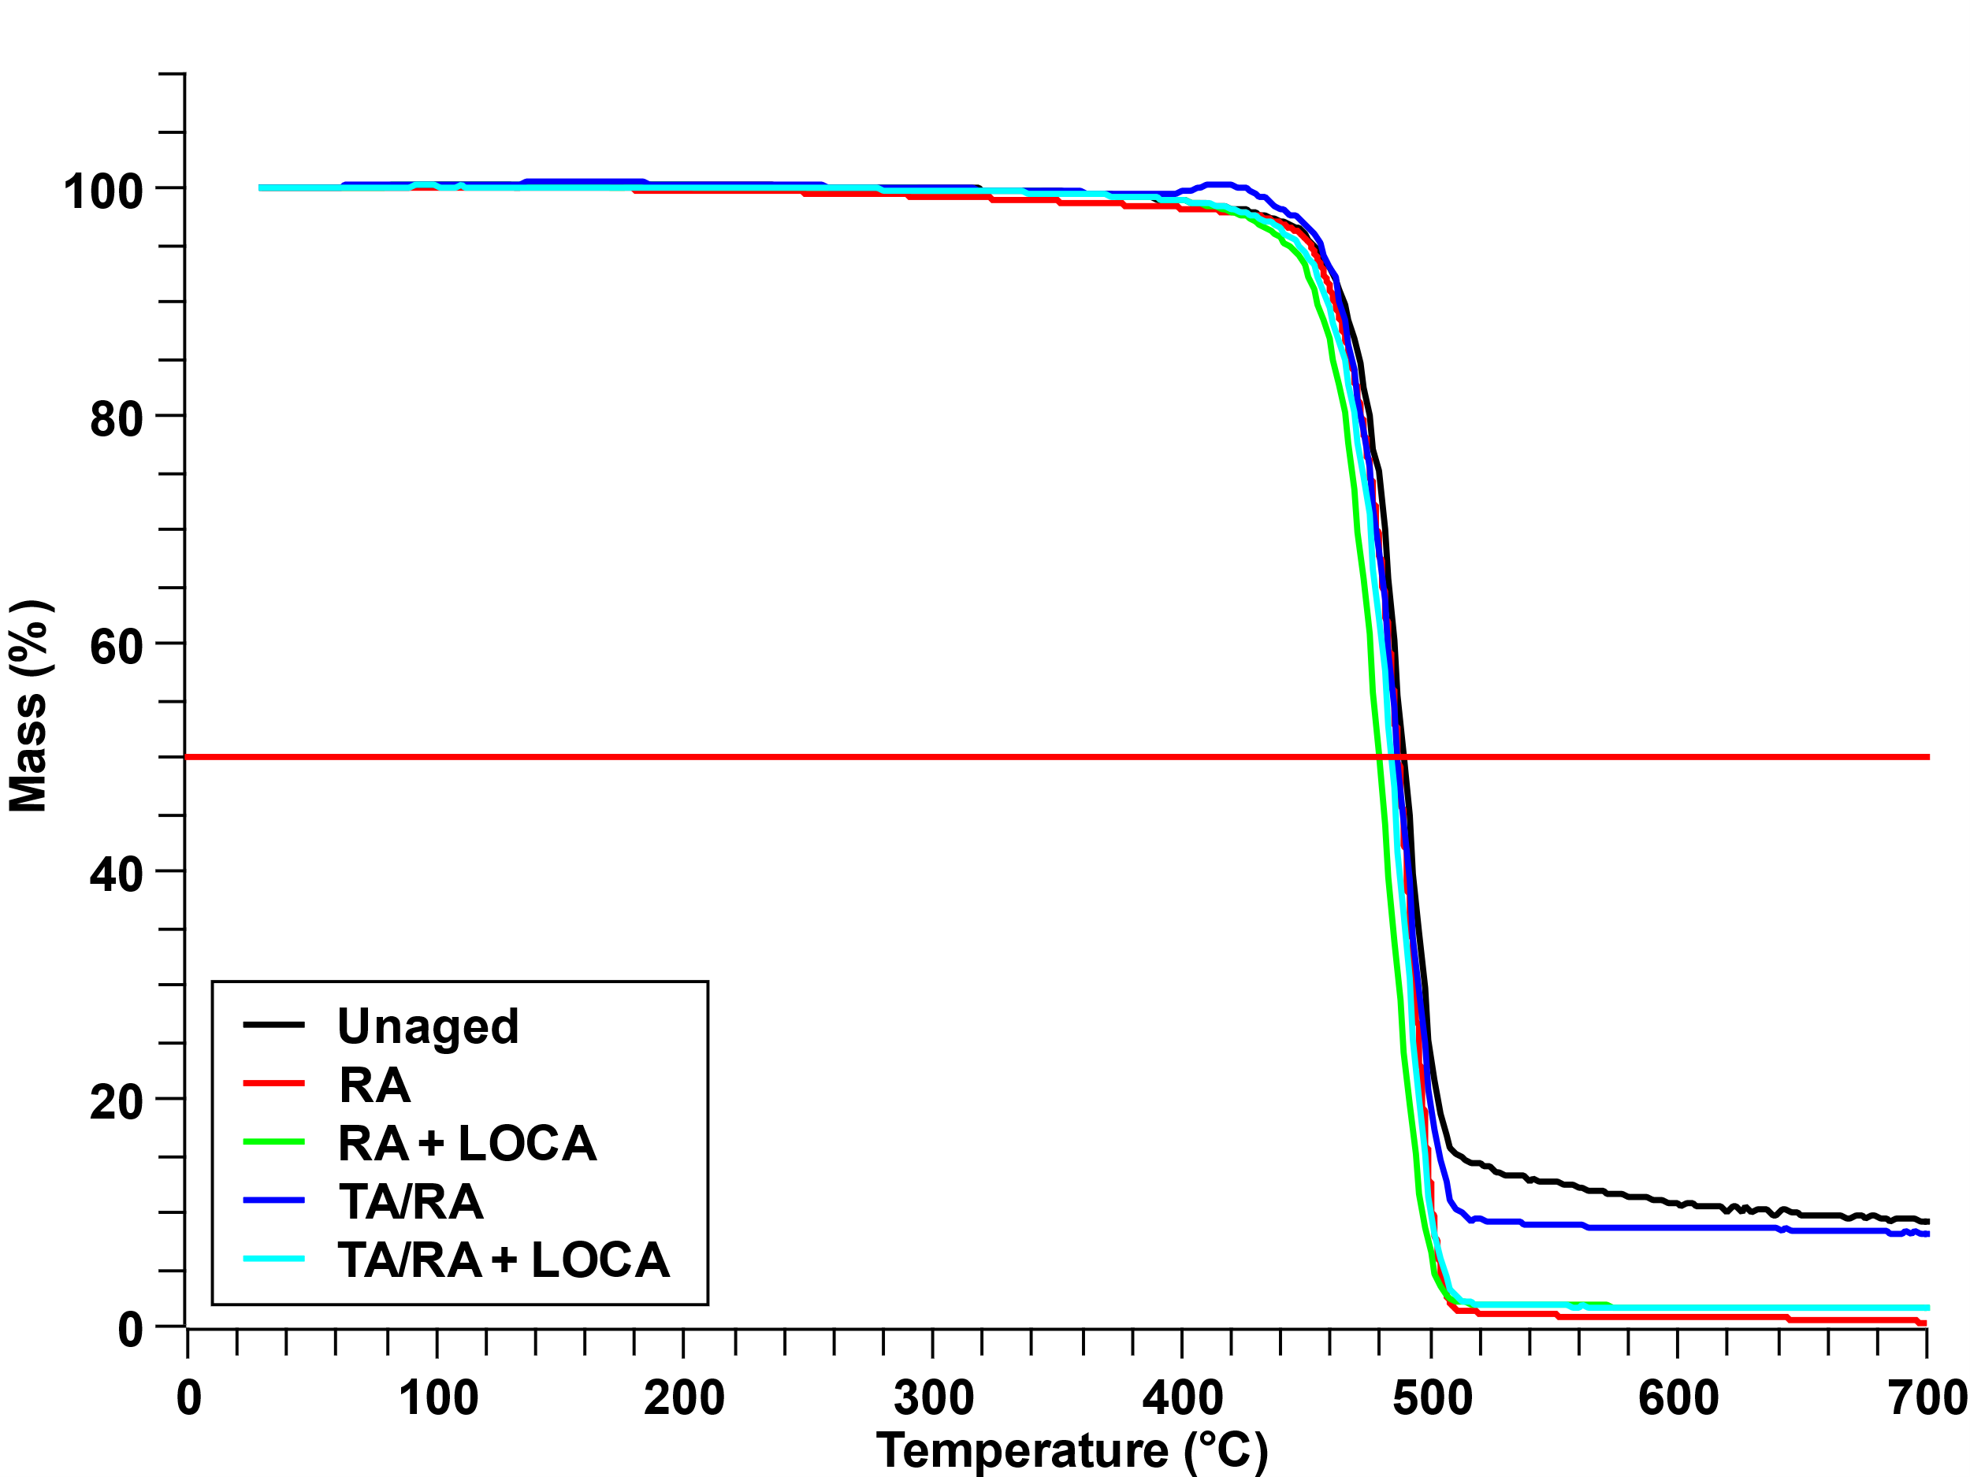 | 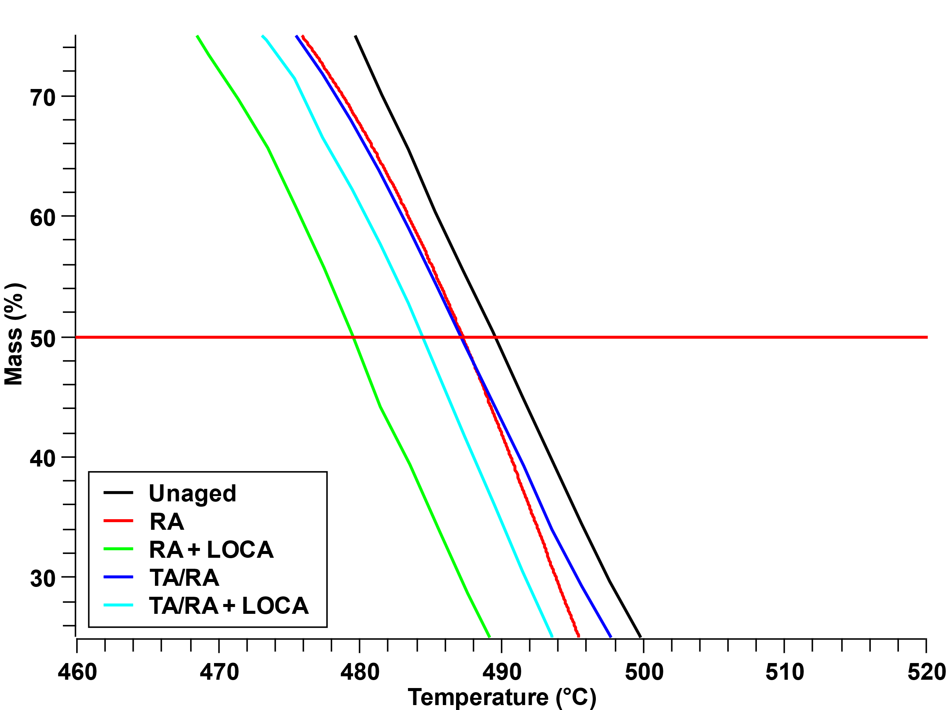
(a) | (b)
Figure 8 TGA thermograms for the different materials investigated. (a) Full scale, (b) Insight close to 50% weight loss.

3.2 Electrical characterization results

3.2.1 Dielectric spectroscopy results
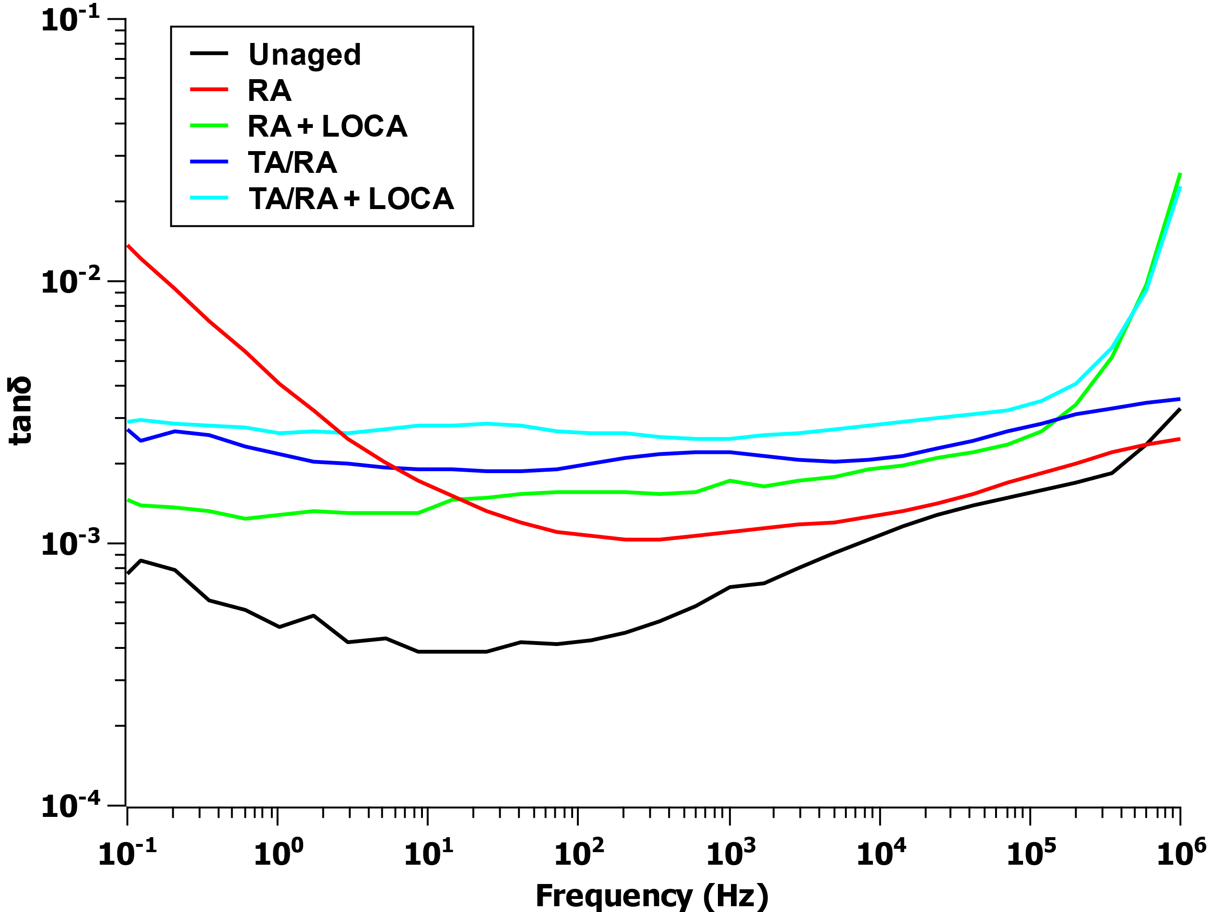 | 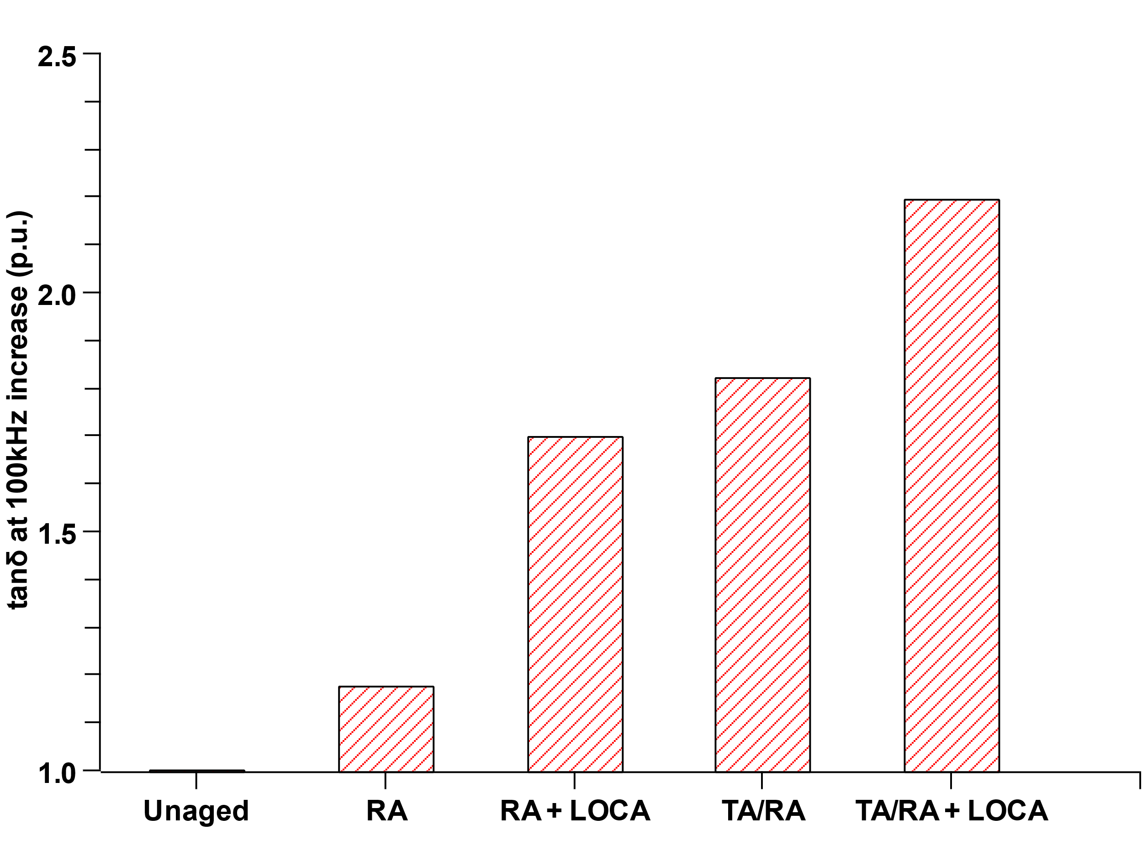
(a) | (b)
Figure 9 (a) Trend of tanδ as a function of frequency for the different cables. (b) Relative increase of tanδ at 100 kHz as a function of aging conditions
Figure 9.a shows the trend of the dissipation factor as a function of frequency for the different aging conditions considered. The unaged cable depicts the lowest dielectric losses of the bench, as expected, and a unique peak in the highest frequency region, related to the dipolar polarization. Most likely, this peak is associated with the antioxidants within the polymer matrix which are shown to have quite a high dipole moment, in our previous works [30].
Aged materials show higher values of dielectric losses, whose amplitude is somehow proportional to the aging severity with some peculiarities. In particular, radiation aging (RA) exhibits an increasing trend lowering the frequencies (interfacial polarization area), which is not present among the other materials. As a consequence, this trend is likely imputable to the species specifically formed during the radiation aging without the interaction with thermally induced phenomena. These being the formation of free radicals and charges, which are formed in high concentration during radiation aging and, due to the fast kinetics of radiation aging, are unable to recombine and de-activate themselves. The response of these free species to the alternating electric field causes the uncontrolled increase of the dissipation factor towards the lower frequency region due to the so-called Quasi-DC conduction (Q-DC) [31], possibly justifying the shown behavior.
Further confirmation of this reasoning may be found by considering the response of the same cables under radiation and higher temperatures (TA/RA). Here, the dielectric losses at high frequencies are higher than RA and no increasing trend is recorded at lower frequencies. Firstly, the higher values in the dipolar polarization area are expected due to the increase of dipolar species rising from oxidation mechanisms due to aging, which in this case, is catalyzed by synergistic effect of combined aging. Secondly, the effect of temperature may be twofold. On the one hand, it increases the energy of free charges which may, in this case, recombine, thus reducing the conductivity effect at low frequency. On the other hand, the presence of temperature leads most likely to thermo-oxidation, as presented, which causes the inactivation of radicals with the formation of different degradation species.
The subsequent DBE simulation aging on RA cables deeply modifies the trend over frequencies. Again, this is likely attributed to the effect of temperature present in the post-LOCA simulation phase, leading to the possible recombination of the free charges and the consequent disappearance of the low-frequency behavior. In general, the DBE simulation causes a further increase of the dielectric losses, as expected, due to the additional radio-thermal aging performed during the simulation. This is particularly evident in the highest frequency region (~100 kHz) where the values of dissipation factor follow the just described aging severity, depicting the highest recorded value for the TA/RA+LOCA sample, as expected.
For an easier comparison among cables, it was chosen to report the values of tanδ at 100 kHz, normalized by the initial value related to the unaged cable, in Figure 9.b. The choice of this particular frequency finds its basis in our previous works [10], [10], [11], where it was proved to be linked to the degradation state of the polymer.
In terms of amplitude, from Figure 9.b, it can be noticed that radiation aging causes a little increase of the property (~ +20% from the unaged value) while aging under higher temperatures cause a significant raise of tanδ value (>160%, reaching up to +220% in presence of the DBE simulation).

3.2.2 DC Current results
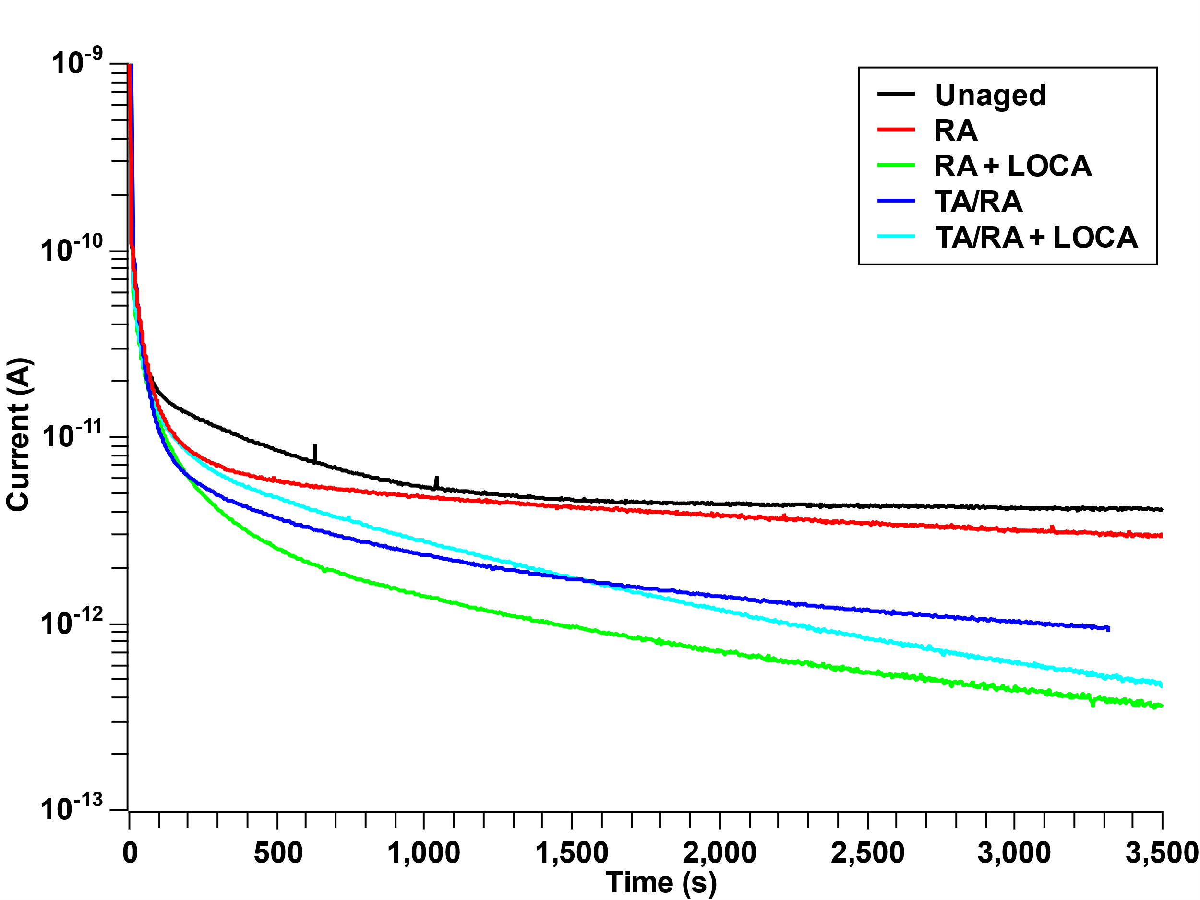 | 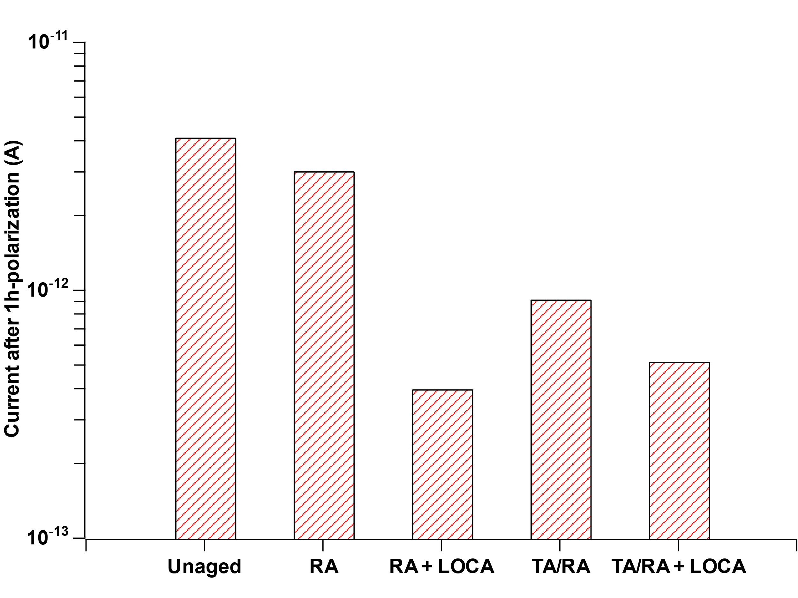
(a) | (b)
Figure 10 (a) Recorded current for the tested cables. (b) Current values after 1h of polarization.
Figure 10.a and b report the recorded value of conduction current across the primary insulation as a function of polarization time (a) and after 1h of polarization (b). From the trend of current with polarization time, it is evident how currents related to aged cables are lower than the one of the unaged specimens. The resulting current decreases by up to 1.5 orders of magnitude. This reduction could be attributed to two potential phenomena. Firstly, it may be due to the formation of less conductive species during aging. Secondly, it could be linked to the deepening of existing traps or the formation of new ones, which may hinder the conduction mechanisms and, consequently, result in a lower recorded current. More significant information may be derived from the trend shown in Figure 10.b. In particular, the current value of the RA specimen is, by far, the highest among the aged samples, with values similar to the unaged cable. This further confirms the reasoning done in the previous section with reference to the tanδ at low frequency. Indeed, the forecasted presence of free charges due to radiation aging enhances the conduction mechanisms within the material, leading to the increase of the recorded polarization current.
Following the same hypothesis, the presence of thermal treatment may decrease the concentration of the free charges leading to the reduction of conduction current. Further modifications may be recorded among the aging conditions due to the different degradation species possibly arising during the treatments.
As a result, the lowest value of current is recorded for the materials subjected to DBE simulation. This again can be attributed to the two aforementioned phenomena, along with the possible recombination of free species formed during the aging treatment.

Conclusions
This article presented some of the most significant electrical properties for the LV I&C cables during normal and accidental conditions. The characterization of the aged materials was performed considering both the physical-chemical and electrical properties of the insulating material. The investigated properties showed that the different treatments deeply modify the performance of the base polymer. Specifically, modifications in the microscale-related properties e.g., crystallinity and polar chemical species, also affected the macroscale electrical properties, modifying the conduction mechanisms and the dielectric losses of the insulation system.
It has been demonstrated that the main degradation mechanisms resulting from radiation aging involve the formation of highly reactive radicals and charged species which mainly alter the structure of the PE matrix, rather than generate new chemical degradation species. Due to the very fast reaction kinetics, these species have limited formation as broken chains, arising from radiation, tend not to bond with environmental oxygen. Consequently, microstructural modifications, such as chain scission and crosslinking, may be considered as the predominant ones in radiation aging. This was reflected in a mild increase of the oxidized species from FTIR, a more homogenous and unique melting peak in the DSC analyses and a lower temperature-to-50% degradation from the TGA. Electrically, the formation of charged species caused by RA lead to the appearance of Q-DC conduction phenomena and a remarkable increase in polarization currents.
The combination of high temperatures, like in the case of TA/RA aging, caused the inception of the thermo-oxidation degradation mechanism, characterized by lower kinetics, which caused the disappearance of Q-DC conduction phenomenon and lowered the values of conductivity, suggesting the abrupt decrease of the presence of charged species. Notably, negligible differences from radiation-only aging may be highlighted with reference to microstructural modifications. For example, the contribution of oxidation, valued through FTIR analyses, in the case of both RA and RA/TA aged cables is very limited. The reason for that was likely linked to the low concentration of oxygen inside the multilayer structure of the cables.
On the other hand, despite the possible DLO effect, cables aged after the DBE simulation show a significant presence of oxidized species which was linked to the easier permeation of oxygen within the cable by the presence of high pressure applied in the LOCA tests. This phenomenon, along with the high temperatures (up to 150°C) catalyzed the occurrence of oxidative reaction within the polymer. The DBE treatment significantly reduced the quantity of crystallites within the material, also leading to a significant decrease (-10°C) of the melting point of the polymer. From the electrical point of view, this caused the increase of the dielectric losses (+230% from the unaged value) and the decrease of conduction current, suggesting the arising of less-conducting species.
Focusing on the dielectric spectroscopy technique, it has been shown that this method effectively tracks aging development, with a consistent increase in dielectric losses as aging severity increases. Specifically, the high-frequency dielectric response, particularly around the frequency of ~100 kHz, mirrors the aging severity. This behavior is attributed to the chemical species formed during aging, mainly oxidized species, which are highly dipolar. Thanks to its strong correlation with insulation degradation, this technique is recommended as an effective nondestructive condition monitoring method for assessing cable condition in real environments.
Future works on this topic will include additional physical-chemical characterization of the cables subjected to the DBE i.e., oxidation induction time and tensile stress tests. These investigations will provide valuable insights into the long-term reliability and durability of the cables, enhancing the overall safety and efficiency of nuclear power plant operations.
ACKNOWLEDGMENTS
The authors are grateful to the UJV Research group for performing the DBE simulation and to Emanuele Maccaferri for the DSC and TGA analyses.

The project leading to this application has received funding from the Euratom research and training programme 2014-2018 under grant agreement No 755183 and from the National Recovery and Resilience Plan (NRRP), Mission 04 Component 2 Investment 1.5 – NextGenerationEU, Call for tender n. 3277 Award Number: 0001052.
This publication reflects only the authors’ view and the European Commission is not responsible for any use that may be made of the information it contains.
REFERENCES
[1] A. Watanabe, M. Ikeda, T. Minakawa, N. Hirai, e Y. Ohki, «Insulation Performance of Safety-Related Electrical Penetrations for Pressurized Water Reactors under Simulated Severe Accident Conditions», IEEJ Trans. Fundam. Mater., vol. 141, fasc. 10, pp. 552–559, 2021, doi: 10.1541/ieejfms.141.552.
[2] T. Seguchi, K. Arakawa, M. Ito, N. Hayakawa, e S. Machi, «Radiation induced oxidative degradation of polymers—III: Effect of radiation on mechanical properties», Radiat. Phys. Chem. 1977, vol. 21, fasc. 6, pp. 495–501, gen. 1983, doi: 10.1016/0146-5724(83)90004-3.
[3] M. Klauck et al., «Experimental investigation on the impact of cable fire products from flame-retardant cables on catalysts used in passive auto-catalytic recombiners», Prog. Nucl. Energy, vol. 152, p. 104365, ott. 2022, doi: 10.1016/j.pnucene.2022.104365.
[4] R. S. A. Afia, M. Ehtasham, e Z. Á. Tamus, «Electrical and Mechanical Condition Assessment of Low Voltage Unshielded Nuclear Power Cables Under Simultaneous Thermal and Mechanical Stresses: Application of Non-Destructive Test Techniques», IEEE Access, vol. 9, pp. 4531–4541, 2021, doi: 10.1109/ACCESS.2020.3048189.
[5] G. T. Andreou e D. P. Labridis, «Electrical Parameters of Low-Voltage Power Distribution Cables Used for Power-Line Communications», IEEE Trans. Power Deliv., vol. 22, fasc. 2, pp. 879–886, apr. 2007, doi: 10.1109/TPWRD.2006.881577.
[6] «IEEE Standard for Qualifying Electric Cables and Splices for Nuclear Facilities», IEEE Std 383-2015 Revis. IEEE Std 383-2003, pp. 1–27, ott. 2015, doi: 10.1109/IEEESTD.2015.7287711.
[7] Nuclear power plants. Instrumentation, control and electrical power systems important to safety. Categorization of functions and classification of systems. London: British Standards Institution, 2021.
[8] F. Yu, «A Review of Nondestructive Evaluation Technologies for Cable System Integrity», Electr. Power Res. Inst. EPRI, p. 82, 2013.
[9] Z. Šaršounová, P. Žák, e D. Dragoun, «Comparison of accelerated and non-accelerated post-LOCA simulation», Nucl. Eng. Des., vol. 418, p. 112903, mar. 2024, doi: 10.1016/j.nucengdes.2024.112903.
[10] S. V. Suraci, D. Fabiani, S. Roland, e X. Colin, «Multi scale aging assessment of low-voltage cables subjected to radio-chemical aging: Towards an electrical diagnostic technique», Polym. Test., p. 107352, ott. 2021, doi: 10.1016/j.polymertesting.2021.107352.
[11] S. V. Suraci e D. Fabiani, «Multiscale properties of polymeric insulating materials: from microscale polarizability to macroscale permittivity», in 2022 IEEE 4th International Conference on Dielectrics (ICD), lug. 2022, pp. 437–440. doi: 10.1109/ICD53806.2022.9863508.
[12] X. Colin, C. Monchy-Leroy, L. Audouin, e J. Verdu, «Lifetime prediction of polyethylene in nuclear plants», Nucl. Instrum. Methods Phys. Res. Sect. B Beam Interact. Mater. At., vol. 265, fasc. 1, pp. 251–255, dic. 2007, doi: 10.1016/j.nimb.2007.08.086.
[13] «TeaM Cables H2020 Euratom research project - Home», TeaM CABLES. Consultato: 3 maggio 2023. [Online]. Disponibile su: https://www.team-cables.eu/
[14] A. Charlesby e Al., «Comparison of alpha and gamma radiation effects in polyethylene», Proc. R. Soc. Lond. Ser. Math. Phys. Sci., vol. 277, fasc. 1370, pp. 348–364, feb. 1964, doi: 10.1098/rspa.1964.0027.
[15] Bruno Fayolle, E. Richaud, X. Colin, e J. Verdu, «Review: degradation-induced embrittlement in semi-crystalline polymers having their amorphous phase in rubbery state», J. Mater. Sci., vol. 43, fasc. 22, pp. 6999–7012, nov. 2008, doi: 10.1007/s10853-008-3005-3.
[16] J. Colombani, «A FTIR/chemometrics approach to characterize the gamma radiation effects on iodine/epoxy-paint interactions in Nuclear Power Plants», Anal. Chim. Acta, p. 10, 2017.
[17] J. V. Gulmine e L. Akcelrud, «FTIR characterization of aged XLPE», Polym. Test., vol. 25, fasc. 7, Art. fasc. 7, ott. 2006, doi: 10.1016/j.polymertesting.2006.05.014.
[18] N. Saidi-Amroun, S. Mouaci, A. Mezouar, M. Saidi, V. Griseri, e G. Teyssèdre, «Analysis of the Gamma Irradiation Effect on PTFE Films by FTIR and DSC», in 2018 IEEE Conference on Electrical Insulation and Dielectric Phenomena (CEIDP), ott. 2018, pp. 430–433. doi: 10.1109/CEIDP.2018.8544841.
[19] A. Xu, S. Roland, e X. Colin, «Thermal ageing of a silane-crosslinked polyethylene stabilised with a thiodipropionate antioxidant», Polym. Degrad. Stab., vol. 181, p. 109276, nov. 2020, doi: 10.1016/j.polymdegradstab.2020.109276.
[20] A. Xu, S. Roland, e X. Colin, «Thermal ageing of a silane-crosslinked polyethylene stabilised with an excess of Irganox 1076®», Polym. Degrad. Stab., p. 109597, apr. 2021, doi: 10.1016/j.polymdegradstab.2021.109597.
[21] M. Celina, E. Linde, D. Brunson, A. Quintana, e N. Giron, «Overview of accelerated aging and polymer degradation kinetics for combined radiation-thermal environments», Polym. Degrad. Stab., vol. 166, pp. 353–378, ago. 2019, doi: 10.1016/j.polymdegradstab.2019.06.007.
[22] A. Quintana e M. C. Celina, «Overview of DLO modeling and approaches to predict heterogeneous oxidative polymer degradation», Polym. Degrad. Stab., vol. 149, pp. 173–191, mar. 2018, doi: 10.1016/j.polymdegradstab.2017.11.014.
[23] E. Suljovrujic, «Post-irradiation effects in polyethylenes irradiated under various atmospheres», Radiat. Phys. Chem., vol. 89, pp. 43–50, ago. 2013, doi: 10.1016/j.radphyschem.2013.04.003.
[24] S. V. Suraci, D. Fabiani, e C. Li, «Post-irradiation effect analysis on XLPE-insulated LV cables used in nuclear power plants», in 2019 2nd International Conference on Electrical Materials and Power Equipment (ICEMPE), apr. 2019, pp. 53–56. doi: 10.1109/ICEMPE.2019.8727281.
[25] D. Fabiani e S. V. Suraci, «Broadband Dielectric Spectroscopy: A Viable Technique for Aging Assessment of Low-Voltage Cable Insulation Used in Nuclear Power Plants», Polymers, vol. 13, fasc. 4, Art. fasc. 4, gen. 2021, doi: 10.3390/polym13040494.
[26] I. H. Craig, J. R. White, e P. C. Kin, «Crystallization and chemi-crystallization of recycled photo-degraded polypropylene», Polymer, vol. 46, fasc. 2, pp. 505–512, gen. 2005, doi: 10.1016/j.polymer.2004.11.019.
[27] S. Liu, L. S. Fifield, e N. Bowler, «Aging Mechanisms of Filled Cross-linked Polyethylene (XLPE) Cable Insulation Material Exposed to Simultaneous Thermal and Gamma Radiation», Radiat. Phys. Chem., p. 109486, apr. 2021, doi: 10.1016/j.radphyschem.2021.109486.
[28] S. Hettal, S. Roland, K. Sipila, H. Joki, e X. Colin, «A new analytical model for predicting the radio-thermal oxidation kinetics and the lifetime of electric cable insulation in nuclear power plants. application to silane cross-linked polyethylene», Polym. Degrad. Stab., vol. 185, p. 109492, mar. 2021, doi: 10.1016/j.polymdegradstab.2021.109492.
[29] E. Kandare, H. Deng, D. Wang, e J. M. Hossenlopp, «Thermal stability and degradation kinetics of poly(methyl methacrylate)/layered copper hydroxy methacrylate composites», Polym. Adv. Technol., vol. 17, fasc. 4, pp. 312–319, 2006, doi: 10.1002/pat.681.
[30] S. V. Suraci, D. Mariani, e D. Fabiani, «Impact of Antioxidants on DC and AC Electrical Properties of XLPE-Based Insulation Systems», IEEE Access, vol. 11, pp. 76132–76141, 2023, doi: 10.1109/ACCESS.2023.3297495.
[31] A. Hascoat et al., «Study and analysis of conduction mechanisms and space charge accumulation phenomena under high applied DC electric field in XLPE for HVDC cable application», in 2014 IEEE Conference on Electrical Insulation and Dielectric Phenomena (CEIDP), ott. 2014, pp. 530–533. doi: 10.1109/CEIDP.2014.6995877.

BIOGRAPHIES


SIMONE VINCENZO SURACI is Assistant Professor at the Department of Electrical Electronics and Information Engineering of University of Bologna. He received his B. Sc. Degree in Civil and Environmental Engineering from the University of Reggio Calabria in 2015, M.Sc. degree in Energy and Nuclear Engineering from the University of Bologna in 2017 and PhD in Electrical Engineering and Polymer Science at the University of Bologna and at Arts et Métiers Institute of Technology (Paris) in 2020. His research interests include the investigation of polymer dielectrics in special environments such as nuclear plants and HVDC applications, focusing on their degradation due to aging. He also deals with nondestructive diagnostic techniques and modeling of insulation aging. To date, he has been acting as chairman of IEEE DEIS Italy Section and member of IEEE DEIS Education Committee since 2024.
In 2024 he was awarded with the 2024 IEEE DEIS Caixin Sun and Stan Grzybowski Award - Young-Professional Achievement Award for contributions to dielectric and electrical insulation technologies and their aging in severely damaging environments.


DAVIDE FABIANI received the M.Sc. and Ph.D. in Electrical Engineering with honors in 1997 and 2002, respectively. Since 2014, he is Associate Professor at the Department of Electrical Electronics and Information Engineering of University of Bologna where he teaches the courses of “Innovative Electrical Technologies” and “Insulation Systems Design and Diagnosis”. His fields of research are mainly related to: development and characterization of nanostructured materials for applications in electrical and electronic apparatus, investigation of HV apparatus diagnosis mainly through partial discharge measurements, evaluation of the effect of non-sinusoidal waveforms on reliability of components and insulation systems (in particular, induction motors fed by power electronic converters) and the study of electrical conduction mechanisms and aging processed in high voltage insulation systems.
He was involved in several projects financed by public and private companies. He is author or co-author of about 280 papers, most of them published on the major international journals and conference proceedings. He is Associate Editor of IET High Voltage Journal, IET Electrical Materials and Applications, as well as reviewer for several International Journals.
Currently he is President of IEEE DEIS from January 2024, re-elected for 2025. He has been member-at-large of DEIS AdCom and Chair of the Meetings Committee from 2016 to 2019, VP Technical for 2020 and 2021, VP Admin for 2022 and 2023.

