Supplementary Material

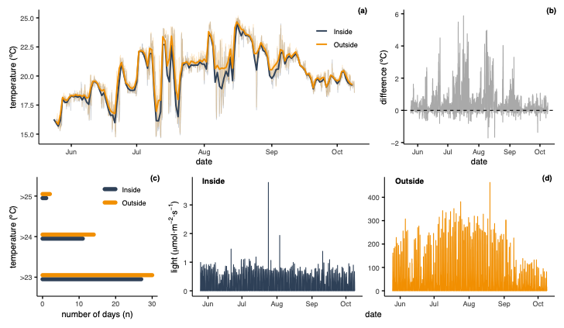
Supplementary Figure 1. Temperature and light inside and outside the cave Cova de la Vaca in 2024. (a) Temperature data over time inside (blue) and outside (orange) the cave, the bold line represents the daily mean temperature, and the light shading shows all temperature data recorded every 30 minutes. (b) Temperature differences between outside and inside the cave. (c) Number of days inside (blue) and outside (orange) the cave with temperature over 23, 24 and 25ºC. (d) Light data (μmol·m⁻²·s⁻¹) inside and outside the cave every 30 minutes over time.

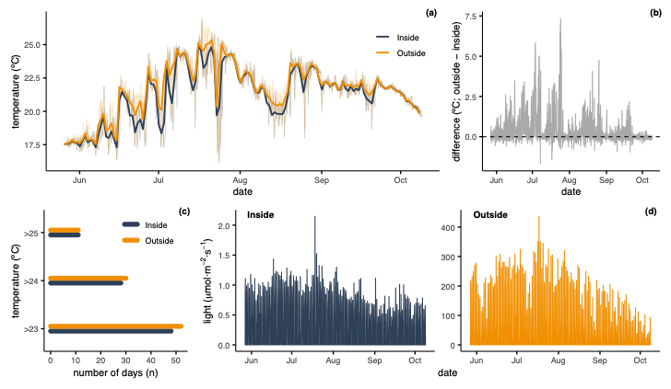
Supplementary Figure 2. Temperature and light inside and outside the cave Cova de la Vaca in 2025. (a) Temperature data over time inside (blue) and outside (orange) the cave, the bold line represents the daily mean temperature, and the light shading shows all temperature data recorded every 30 minutes. (b) Temperature differences between outside and inside the cave. (c) Number of days inside (blue) and outside (orange) the cave with temperature over 23, 24 and 25ºC. (d) Light data (μmol·m⁻²·s⁻¹) inside and outside the cave every 30 minutes over time.

Supplementary Table 1. Heat events recorded inside and outside the cave Cova de la Vaca from June to October in 2024 and 2025. Number of events (N), mean duration (days) and maximum duration (days) for three temperature thresholds (23, 24 and 25ºC) at each location.
Threshold | Location | N events | Mean duration (days) | Max duration (days)
> 23ºC | Inside | 13 | 5.8 | 17
> 23ºC | Outside | 14 | 5.9 | 29
> 24ºC | Inside | 12 | 3.2 | 15
> 24ºC | Outside | 12 | 3.7 | 16
> 25ºC | Inside | 4 | 3.0 | 8
> 25ºC | Outside | 3 | 4.3 | 10

