Distribution of endocannabinoid system receptors in the equine hoof: dysregulation as a potential therapeutic target for laminitis
Histochemistry and Cell Biology
Rodrigo Zamith Cunha^{1,2}*, Francesca Gobbo¹, Maria Morini¹, Augusta Zannoni¹, Carlo Mainardi¹, Lorenzo D’arpe¹, Alessandro Gramenzi², Roberto Chiocchetti¹
¹ Department of Veterinary Medical Sciences (UNI EN ISO 9001:2008), University of Bologna, Italy
² Department of Veterinary Medicine, University of Teramo, Teramo, Italy
* Corresponding author email: rodrigo.zamithcunha@studio.unibo.it

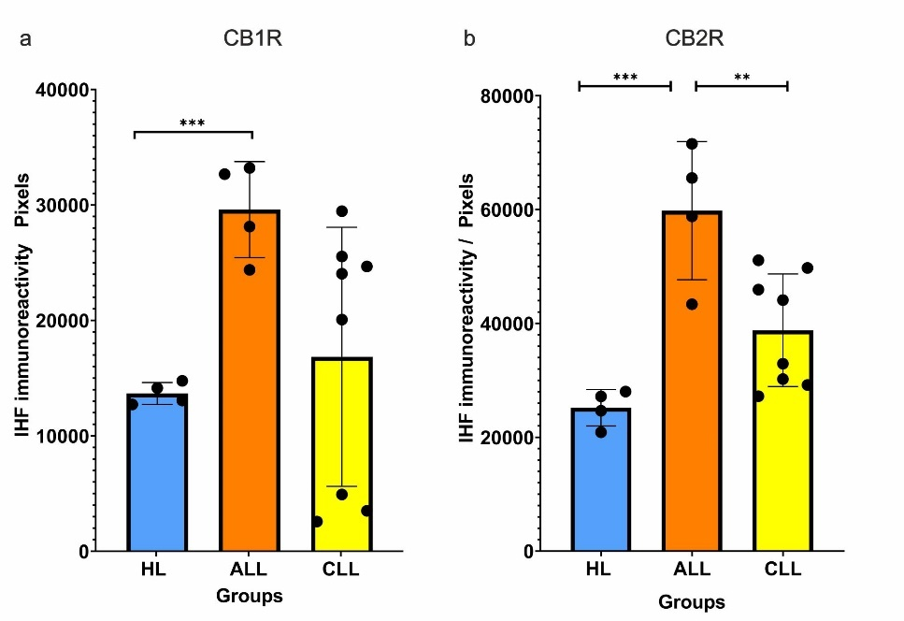
Supplementary item 2. a) Quantification of CB1 receptor (CB1R) immunofluorescence in healthy (HL) and laminitic (ALL, CLL) laminae. The graph displays the intensity of CB1R immunoreactivity (measured in pixels) across healthy laminae (HL), acute laminitic laminae (ALL), and chronic laminitic laminae (CLL). The CB1R expression is significantly upregulated in the ALL group as compared to the HL group (*p < 0.001, 95% CI). The CLL group shows a wide distribution of CB1R expression levels, indicating variable receptor activity. The data are presented as mean ± SD, with statistical significance determined using one-way ANOVA followed by a Tukey's post-hoc test. b) Quantification of CB2 receptor (CB2R) immunofluorescence in healthy (HL) and laminitic (ALL, CLL) laminae. The bar graph shows the intensity of CB2R immunoreactivity (measured in pixels) in healthy laminae (HL), acute laminitic laminae (ALL), and chronic laminitic laminae (CLL). A significant upregulation of CB2R expression is observed in the ALL group as compared to both the HL group (***p < 0.001, 95% CI) and the CLL group (**p < 0.01, 95% CI). The CLL group exhibits intermediate levels of CB2R expression with some variability among the samples. The data are represented as mean ± SD, with statistical analysis carried out using one-way ANOVA followed by a Tukey's post-hoc test.

