SUPPLEMENTARY MATERIALS
Appendix 1: Confirmatory Factor Analysis for the final measurement model
The final measurement model was estimated using confirmatory factor analysis (CFA) with robust maximum likelihood estimation (MLM; Satorra–Bentler correction) in lavaan. The model comprised four first-order latent factors—socially responsible HRM (12 items), green HRM (3 items), interpersonal workplace well-being (4 items), and intrapersonal workplace well-being (4 items)—as well as two second-order factors— perceived sustainable HRM indicated by socially responsible HRM and green HRM and eudaimonic workplace well-being indicated by interpersonal workplace well-being and intrapersonal workplace well-being. Work engagement was specified as a single first-order factor indicated by three UWES-3 items.
All three focal latent variables used in hypothesis testing were allowed to correlate. The model demonstrated good fit to the data: Satorra–Bentler scaled χ²(292) = 9320.33, RMSEA = .051, CFI = .953, TLI = .948, SRMR = .040 (N = 14,502). A graphical representation of the final measurement model with standardized loadings and latent correlations is provided in Figure S1. Full reliability and convergent validity indicators are reported in the Results section.
In addition, separate CFA models were estimated for each focal construct to obtain latent factor scores used in hypothesis testing. These models showed satisfactory fit and factor loadings comparable to those observed in the joint measurement model. Detailed results of these auxiliary CFA models are available from the authors on request.
Figure S1. The results of the CFA (standardized factor loadings) for the final measurement model used in the study (total sample).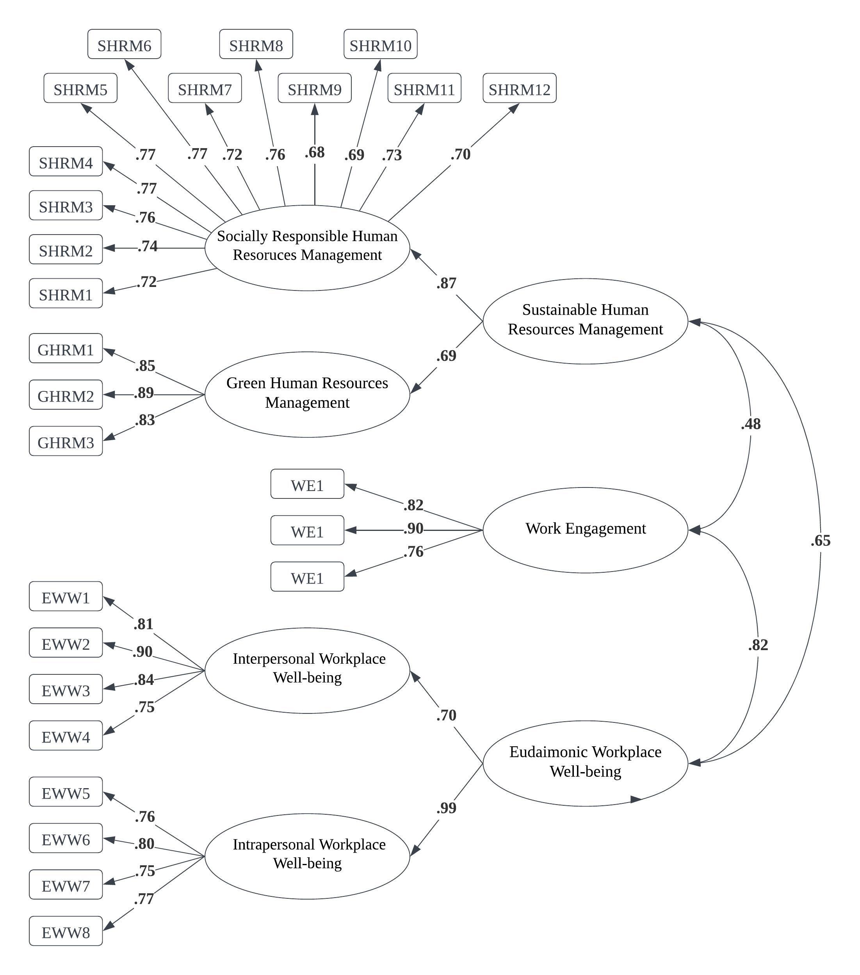
Note. All reported loadings were statistically significant (p < .001).
Appendix 2: Descriptive statistics of the 54 samples included in the analysis
Table S1. Descriptive statistics and reliability indices for measured variables (raw scores) in the study and CFA measurement model fit indices in 54 countries.
Country | Sample size (N) | Gender: % female | SHRM | WE | EWW | IND | CFA
Country | Sample size (N) | Gender: % female | M(SD); ɷ | M(SD); ɷ | M(SD); ɷ | M | CFI | RMSEA
Australia | 228 | 49 | 2.75(.85); .93 | 3.96(1.04); .91 | 3.41(.84); .89 | 90 | .95 | .049
Belgium | 203 | 58 | 2.67(.78); .90 | 4.12(.88); .77 | 3.40(.75); .86 | 75 | .88 | .071
Brazil | 213 | 52 | 3.05(1.01); .95 | 4.91(.93); .88 | 3.98(.71); .89 | 38 | .93 | .061
Bulgaria | 203 | 46 | 3.39(.98); .96 | 4.10(.93); .93 | 3.77(.86); .86 | 30 | .95 | .053
Canada | 453 | 48 | 3.13(.82); .92 | 4.34(.84); .82 | 3.63(.79); .90 | 80 | .90 | .068
Chile | 389 | 59 | 2.45(.81); .92 | 4.38(1.11); .90 | 3.46(.82); .92 | 23 | .93 | .059
China | 499 | 49 | 3.09(.77); .92 | 4.65(.90); .93 | 3.63(.65); .88 | 20 | .92 | .060
Colombia | 207 | 62 | 2.85(.90); .93 | 4.19(1.23); .83 | 3.82(.78); .91 | 13 | .94 | .059
Croatia | 195 | 78 | 2.91(1.05); .96 | 4.40(.86); .84 | 3.68(.76); .90 | 58 | .94 | .063
Czechia | 205 | 62 | 3.04(.85); .92 | 4.65(.72); .84 | 3.87(.76); .88 | 33 | .90 | .067
Denmark | 200 | 57 | 3.23(.41); .85 | 4.37(.59); .80 | 3.65(.43); .79 | 74 | .86 | .068
Ecuador | 200 | 53 | 3.74(.88); .95 | 5.09(.94); .89 | 4.09(.77); .92 | 8 | 98 | .037
Egypt | 436 | 45 | 3.65(.54); .75 | 3.70(1.01); .84 | 3.51(.93); .93 | 37 | .90 | .072
Estonia | 82 | 38 | 3.39(.87); .91 | 4.73(.88); .82 | 3.90(.73); .89 | 60 | .80 | .086
Finland | 255 | 78 | 2.91(.76); .91 | 4.36(.85); .86 | 3.63(.77); .87 | 63 | .90 | .065
France | 252 | 48 | 2.58(.79); 91 | 4.24(.99); .85 | 3.34(.79); .88 | 71 | .90 | .065
Georgia | 455 | 58 | 2.99(.89); .93 | 4.67(.93); .81 | 3.57(.93); .92 | 41 | .93 | .058
Germany | 450 | 46 | 2.99(.72); .88 | 4.27(.80); .81 | 3.41(.65); .81 | 67 | .90 | .053
Ghana | 201 | 44 | 3.28(.82); .93 | 4.58(.85); .71 | 3.82(.58); .82 | 15 | .92 | .053
Greece | 200 | 68 | 3.24(.86); .94 | 4.25(1.01); .89 | 3.60(.73); .83 | 35 | .92 | .062
India | 200 | 42 | 4.11(.54); .90 | 4.84(.79); .72 | 4.10(.60); .86 | 48 | .83 | .057
Indonesia | 253 | 68 | 3.31(.81); .94 | 4.64(.73); .80 | 3.90(.55); .86 | 14 | .91 | .057
Iran | 199 | 69 | 2.91(1); .95 | 4.60(.85); .82 | 3.67(.63); .84 | 41 | .94 | .055
Ireland | 224 | 58 | 3.17(.83); .92 | 4.26(.81); .86 | 3.61(.74); .89 | 70 | .92 | .059
Israel | 263 | 79 | 2.98(.67); .85 | 4.30(.81); .79 | 3.58(.70); .84 | 54 | .91 | .055
Italy | 891 | 55 | 2.59(.79); .91 | 4.46(.90); .81 | 3.53(.72); .87 | 76 | .96 | .040
Japan | 400 | 50 | 2.21(.82); .94 | 2.98(1.13); .91 | 2.76(.79); .88 | 46 | .95 | .055
Lithuania | 190 | 86 | 2.81(.87); .92 | 4.74(.80); .86 | 3.72(.69); .89 | 60 | .94 | .051
Malta | 163 | 71 | 2.48(.71); .91 | 4.30(1); .87 | 3.67(.81); .91 | 59 | .92 | .060
Mexico | 451 | 56 | 3.51(.93); .94 | 5.07(.87); .85 | 4.04(.81); .92 | 30 | .95 | .048
Nepal | 226 | 34 | 3.55(.81); .94 | 4.17(.93); .80 | 4.09(.67); .88 | 30 | .95 | .044
Netherlands | 97 | 58 | 2.76(.48); .84 | 4.70(.52); .83 | 3.69(.48); .80 | 80 | .74 | .078
New Zealand | 374 | 55 | 2.95(.89); .95 | 4.28(.91); 83 | 3.59(.76); .90 | 79 | .92 | .062
Nigeria | 141 | 53 | 3.33(.70); .88 | 4.52(1.16); .87 | 4.02(.56); .80 | 30 | .56 | .149
Norway | 119 | 51 | 2.95(.79); .91 | 4.55(.74); .82 | 3.79(.72); .86 | 69 | .72 | .124
Pakistan | 205 | 37 | 4.33(.50); .93 | 4.19(.94); .90 | 4.17(.52); .92 | 14 | .83 | .110
Peru | 200 | 36 | 3.05(.89); .94 | 4.21(1.06); .92 | 3.90(.73); .90 | 16 | .94 | .055
Philippines | 265 | 49 | 3.61(.80); .95 | 4.99(.83); .88 | 4.13(.63); .91 | 32 | .95 | .048
Poland | 283 | 58 | 2.94(.85); .91 | 4.36(.86); .83 | 3.31(.81); .86 | 60 | .94 | .048
Portugal | 213 | 64 | 2.69(.86); .94 | 4.55(1.20); .94 | 3.42(.84); .92 | 27 | .94 | .059
Serbia | 211 | 69 | 3.12(.96); .94 | 4.37(.84); .80 | 3.64(.75); .87 | 25 | .94 | .059
Slovak Republic | 258 | 47 | 2.94(.85); .93 | 4.34(1.14); .91 | 3.59(.84); .90 | 52 | .95 | .055
South Africa | 191 | 70 | 3.21(1.02); .96 | 4.63(.82); .75 | 3.79(.73); .87 | 65 | .93 | .061
Spain | 205 | 64 | 3.06(.82); .92 | 4.61(.98); .90 | 3.76(.76); .88 | 51 | .91 | .066
Sri Lanka | 288 | 67 | 3.84(.67); .92 | 4.40(.83); .80 | 4.03(.61); .89 | 35 | .96 | .040
Suriname | 238 | 55 | 2.67(.97); .95 | 4.86(.96); .86 | 3.63(.80); .88 | 47 | .95 | .051
Switzerland | 172 | 58 | 2.79(.89); .93 | 4.31(.93); .83 | 3.48(.76); .87 | 68 | .90 | .070
Thailand | 241 | 56 | 3.11(.70); .91 | 4.48(.87); .80 | 3.71(.60); .86 | 20 | .92 | .049
Turkey | 390 | 45 | 3.16(.93); .94 | 4.56(.99); .83 | 3.59(.74); .89 | 37 | .92 | .063
UK | 671 | 51 | 2.78(.80); .92 | 4.09(.99); .88 | 3.47(.81); .89 | 89 | .93 | .058
Ukraine | 186 | 62 | 3.43(.82); .93 | 3.96(1.43); .91 | 3.61(.85); .88 | 25 | .97 | .038
UAE | 205 | 69 | 3.34(.88); .94 | 4.56(1.01); .87 | 3.77(.89); .92 | 36 | .95 | .050
Uruguay | 111 | 54 | 2.38(.84); .91 | 4.23(.84); .88 | 3.63(.69); .87 | 36 | .87 | .072
USA | 252 | 46 | 2.97(.89); .93 | 4.23(.84); .94 | 3.34(1.02); .88 | 91 | .93 | .067
Notes: N = 14,502; Sustainable HRM – Sustainable Human Resources Management; WE – Work Engagement; EWW – Eudaimonic Workplace Well-being; IND – Hofstede’s Individualism-Collectivism; ɷ – McDonald’s omega; CFA – Confirmatory Factor Analysis; CFI – Comparative Fit Index; RMSEA – Root Mean Square Error of Approximation.
Appendix 3: Additional analyses
This supplementary material expands on the analyses reported in the main manuscript. These additional analyses were conducted to deepen our understanding of the relationships among sustainable HRM, work engagement, cultural dimensions, and employee eudaimonic well-being.
The initial model explored in our manuscript posits that sustainable HRM affects employee eudaimonic well-being through increased work engagement, and that the work engagement–employee eudaimonic well-being relationship could be moderated by cultural factors, specifically individualism-collectivism. To ensure the credibility of our analysis, however, we checked whether other dimensions of culture moderate the relationships that we tested. Moreover, questions were raised about the potential distinct effects on the interpersonal and intrapersonal components of well-being and the need to include control variables.
1. Disentangling the components of eudaimonic well-being
Following the assumption to differentiate the effects on the interpersonal and intrapersonal dimensions of well-being, we revised our models to treat these components as separate DVs. To this end, we reconfigured the models reported in the article (from Model 1 to Model 5) in a variant where the DV was the employee’s interpersonal workplace well-being (Models 1A to 5A) and for the employee’s intrapersonal workplace well-being (Models 1B to 5B). This approach allowed us to discern whether the effects of sustainable HRM through work engagement varied among these facets of eudaimonic well-being.
The reliability of measuring the interpersonal and intrapersonal dimensions of workplace well-being, as assessed by McDonald’s omega, was .90 and .85, respectively. The correlation between these two latent variables in the CFA model was .68, indicating a strong relationship between these two components of employee well-being. Tables S2 and S3 present the results of the multilevel models predicting interpersonal and intrapersonal employee workplace well-being, respectively.
As can be observed, the results for both components of employee workplace well-being are comparable, particularly in terms of the primary finding, which demonstrated the moderating role of a country’s individualism in the relationship between work engagement and workplace well-being. Some differences were noted in the intraclass correlation coefficients (ICC); a slightly higher index for employee’s intrapersonal workplace well-being suggests that working in a specific country explains a greater variance in intrapersonal compared to interpersonal workplace well-being. Another difference was the observed main effect of a country’s individualism on intrapersonal workplace well-being (see Model 4B, Table S3). It was shown that the more individualistic the country of employment, the lower the average intrapersonal workplace well-being. This effect was not significant for employees’ interpersonal workplace well-being but was significant when workplace well-being was measured as a single dimension (see Model 4, Table 3).
Table S2. Results of the multilevel models predicting employees’ interpersonal eudaimonic workplace well-being
Model type | Predictor | Model 1A | Model 2A | Model 3A | Model 4A | Model  5A
Fixed effects |  | B [95% CI] | B [95% CI] | B [95% CI] | B [95% CI] | B [95% CI]
Baseline | Intercept | .03 [–.03, .09] | .02 [–.02, .06] | .02 [–.02, .05] | .09 [.01, .16]* | .33 [.04, .63]*
Individual-level variables (L1) | Sustainable HRM | – | .46 [.45, .48]** | .30 [.28, .31]** | .32 [.29, .36]** | .32 [.28, .36]**
Individual-level variables (L1) | Work Engagement | – | – | .38 [.37, .40]** | .30 [.27, .34]** | .30 [.27, .34]**
Country-level variables (L2) | Individualism (IND) | – | – | – | –.001 [–.003, <.001] | –.000 [–.002, .002]
Country-level variables (L2) | Human Development Index | – | – | – | – | –.37 [–.80, .06]
Cross-levels interaction component | Sustainable HRM x IND | – | – | – | –.001 [–.001, <.001] | –.001 [–.001, <.001]
Cross-levels interaction component | Work Engagement x IND | – | – | – | .002 [.001, .002]** | .002 [.001, .002]**
Random effects | Residual | .63 | .51 | .43 | .43 | .43
Random effects | Intercept | .05 | .02 | .02 | .01 | .01
Multilevel Models’ Fit Indices | Δ −2LL | – | 2,955.62** | 2,536.01** | 32.15** | 2.77
Multilevel Models’ Fit Indices | AIC | 34,591.0 | 31,637.4 | 29,103.3 | 29,077.2 | 29,076.4
Multilevel Models’ Fit Indices | Marginal R² | .00 | .21 | .34 | .35 | .35
 | Conditional R² | .07 | .24 | .36 | .37 | .37
Note: N = 14,502; countries = 54. Unstandardized fixed-effect coefficients (B) are reported with 95% Wald confidence intervals in brackets. All individual-level predictors are standardized latent factor scores derived from CFA. ICC (Model 1A) = .07 (adjusted ICC = .072). * p < .05, ** p < .01.
Table S3. Results of the multilevel models predicting employees’ intrapersonal eudaimonic workplace well-being
Model type | Predictor | Model 1B | Model 2B | Model 3B | Model 4B | Model 5B
Fixed effects |  | B [95% CI] | B [95% CI] | B [95% CI] | B [95% CI] | B [95% CI]
Baseline | Intercept | .04 [–.03, .10] | .02 [–.02, .07] | .02 [–.02, .06] | .13 [.05, .20]** | .35 [.06, .63]*
Individual-level variables (L1) | Sustainable HRM | – | .46 [.45, 48]** | .23 [.22, .25]** | .25 [.22, .27]** | .24 [.22, .27]**
Individual-level variables (L1) | Work Engagement | – | – | .52 [.51, .53]** | .37 [.35, .39]** | .37 [.35, .39]**
Country-level variables (L2) | Individualism (IND) | – | – | – | –.002 [–.004,  –.001]** | –.001 [–.003, .001]
Country-level variables (L2) | Human Development Index | – | – | – | – | –.33 [–.74, .09]
Cross-levels interaction component | Sustainable HRM x IND | – | – | – | –.000 [–.001, <.001] | –.000 [–.001, <.001]
Cross-levels interaction component | Work Engagement x IND | – | – | – | .003 [.003, .004]** | .003 [.003, .004]**
Random effects | Residual | .48 | .36 | .21 | .21 | .21
Random effects | Intercept | .05 | .03 | .02 | .01 | .01
Multilevel Models’ Fit Indices | Δ −2LL | – | 3,974.46** | 7,768.97** | 251.36** | 2.37
Multilevel Models’ Fit Indices | AIC | 30,668.7 | 26,696.2 | 18,929.2 | 18,683.9 | 18,683.5
Multilevel Models’ Fit Indices | Marginal R² | .00 | .26 | .57 | .59 | .59
 | Conditional R² | .10 | .32 | .60 | .61 | .62
Note: N = 14,502; countries = 54. Unstandardized fixed-effect coefficients (B) are reported with 95% Wald confidence intervals in brackets. All individual-level predictors are standardized latent factor scores derived from CFA. ICC (Model 1B) = .10 (adjusted ICC = .099). * p < .05, ** p < .01.
2. Incorporation of control variables
To strengthen the robustness of our findings, we introduced key sociodemographic variables as controls in our models, including gender, tenure, job position (managerial vs. nonmanagerial), and company size. This adjustment helps ensure that the observed relationships are not confounded by these variables.
Table S4 presents the results of model fits that incorporate four sociodemographic variables. As indicated, neither gender nor company size was a significant predictor of employees’ eudaimonic workplace well-being in any model. The data suggest that managers typically reported higher levels of workplace well-being. Furthermore, total work tenure was significantly associated with workplace well-being—the longer the professional experience, the better the well-being reported. Most importantly, including sociodemographic variables in the models did not alter the main findings; sustainable HRM and work engagement positively correlated with employee well-being, and the country’s individualism moderated the relationship between work engagement and eudaimonic workplace well-being (see Model 12, Table S4).
Table S4. Results of multilevel models predicting employee’s eudaimonic workplace well-being, incorporating control variables and additional cultural dimensions.
Model type | Predictor | Model 9 | Model 10 | Model 11 | Model 12 | Model 13
Fixed effects |  | B [95% CI] | B [95% CI] | B [95% CI] | B [95% CI] | B [95% CI]
Baseline | Intercept | .00 [–.19, .19] | .03 [–.12, .17] | .05 [–.26, .37] | .03 [–.28, .34] | .05 [–.27, .37]
Individual-level variables (L1) | Gender (male) | .02 [–.01, .04] | .00 [–.02, .02] | –.01 [–.03, .02] | –.01 [–.03, .02] | –.01 [–.03, .02]
Individual-level variables (L1) | Seniority (1-5 years) | .04 [–.01, .08] | .06 [.03, .10]** | .06 [.02, .09]** | .06 [.02, .09]** | .06 [.02, .09]**
Individual-level variables (L1) | Seniority (6-10 years) | .03 [–.02, .08] | .09 [.05, .13]** | .08 [.04, .12]** | .08 [.04, .12]** | .08 [.04, .12]**
Individual-level variables (L1) | Seniority (over 10 years) | .07 [.02, .11]* | .09 [.05, .13]** | .03 [.01, .05]* | .03 [.01, .05]* | .03 [.01, .05]*
Individual-level variables (L1) | Job Position (managerial) | .16 [.13, .19]** | .03 [.01, .05]* | .04 [.01, .06]** | .04 [.01, .06]** | .04 [.01, .06]**
Individual-level variables (L1) | Company size (10-49 employees) | – .03 [–.21, .15] | – .04 [–.18, .10] | – .06 [–.21, .10] | – .05 [–.21, .10] | – .05 [–.21, .11]
Individual-level variables (L1) | Company size (50-250 employees) | – .10 [–.27, .08] | – .10 [–.25, .04] | – .11 [–.27, .04] | – .11 [–.27, .05] | – .11 [–.27, .05]
Individual-level variables (L1) | Company size (over 250 employees) | – .08 [–.26, .09] | – .10 [–.25, .04] | – .12 [–.28, .04] | – .12 [–.27, .04] | – .11 [–.27, .05]
Individual-level variables (L1) | SusHRM | – | .30 [.28, .31]** | .29 [.28, .31]** | .32 [.28, .36]** | .21 [.06, .36]**
Individual-level variables (L1) | Work Engagement | – | .41 [.40, .43]** | .42 [.40, .43]** | .32 [.28, .35]** | .24 [.11, .37]**
Country-level variables (L2) | Individualism (IND) | – | – | –.001 [–.004, .001] | –.001 [–.004, .001] | –.001 [–.003, .001]
Country-level variables (L2) | Power Distance (PD) | – | – | –.000 [–.003, .003] | .000 [–.002, .003] | .000 [–.002, .003]
Country-level variables (L2) | Masculinity (Ma) | – | – | –.001 [–.003, .001] | –.001 [–.003, .001] | –.001 [–.003, .001]
Country-level variables (L2) | Uncertainty Avoidance (UA) | – | – | .001 [–.001, .003] | .001 [–.001, .002] | .001 [–.001, .002]
Country-level variables (L2) | Long-term Orientation (LO) | – | – | –.000 [–.002, .002] | –.000 [–.002, .002] | –.000 [–.002, .001]
Country-level variables (L2) | Indulgence (In) | – | – | .001 [–.001, .003] | .001 [–.000, .003] | .001 [–.001, .003]
Cross-levels interaction component | Sustainable HRM x IND | – | – | – | –.001 [–.001, .001] | –.001 [–.002, .001]
Cross-levels interaction component | Work Engagement x IND | – | – | – | .002 [.001, .003]** | .003 [.002, .004]**
Cross-levels interaction component | Sustainable HRM x PD | – | – | – | – | .000 [–.001, .002]
Cross-levels interaction component | Work Engagement x PD | – | – | – | – | .002 [.001, .003]**
Cross-levels interaction component | Sustainable HRM x Ma | – | – | – | – | .000 [–.001, .002]
Cross-levels interaction component | Work Engagement x Ma | – | – | – | – | –.000 [–.001, <.001]
Cross-levels interaction component | SusHRM x UA | – | – | – | – | .001 [–.000, .001]
Cross-levels interaction component | Work Engagement x UA | – | – | – | – | –.001 [–.002, .000]
Cross-levels interaction component | SusHRM x LO | – | – | – | – | .000 [–.001, .001]
Cross-levels interaction component | Work Engagement x LO | – | – | – | – | –.001 [–.002, .000]
Cross-levels interaction component | Sustainable HRM x In | – | – | – | – | .001 [–.000, .002]
Cross-levels interaction component | Work Engagement x In | – | – | – | – | –.000 [–.001, .001]
Random effects | Residual | .60 | .39 | .39 | .39 | .39
Random effects | Intercept | .05 | .02 | .01 | .01 | .01
Multilevel Models’ Fit Indices | Δ −2LL | – | 6,297.6** | 2,310.8** | 43.2** | 32.7**
Multilevel Models’ Fit Indices | AIC | 33,535.5 | 27,241.9 | 24,943.1 | 24,903.9 | 24,891.2
Multilevel Models’ Fit Indices | Marginal R² | .01 | .39 | .40 | .40 | .40
 | Conditional R² | .09 | .41 | .42 | .42 | .42
Note: Models 9–10: N = 14,302; countries = 54. Models 11–13: N = 13,087; countries = 49 (variables available for 49 countries). Unstandardized fixed-effect coefficients (B) are reported with 95% Wald confidence intervals in brackets. Individual-level predictors include a binary indicator for gender (male vs. reference group), seniority, job position, and company size. * p < .05, ** p < .01.
3. Exploring additional cultural dimensions
To broaden the cultural framework beyond individualism-collectivism, we incorporated other cultural dimensions proposed by Hofstede, including power distance, masculinity, uncertainty avoidance, long-term orientation, and indulgence. These dimensions were examined to see if they could further elucidate variations in the relationships among sustainable HRM, work engagement, and eudaimonic well-being across different cultural contexts.
Table S4 presents the results from multilevel models predicting employee’s eudaimonic workplace well-being, incorporating additional cultural dimensions (Models 11-13). The findings indicate that no main effects were observed for any of the cultural dimensions proposed by Hofstede; however, it was again demonstrated that sustainable HRM and work engagement positively correlate with employee well-being, and the country’s individualism moderates the relationship between work engagement and eudaimonic workplace well-being. It is important to note that a significant interaction effect was observed in the case of the power distance dimension (see Model 13); the higher the country’s power distance, the lower the correlation between work engagement and employee well-being. This result is not surprising given the strong negative correlation between power distance and individualism in the studied group of 54 countries (r = –.71; p < .01).
4. Testing cultural dimensions in the Sustainable HRM and work engagement relationship
To address the confusion around the hypothesized cultural moderation, we expanded our analysis to include a test of the moderating effect of cultural dimensions on the sustainable HRM and work engagement relationship. This was intended to clarify whether cultural context influences the first part of our proposed model, and if so, how.
Table S5 presents the results of multilevel models predicting employee’s work engagement, incorporating control variables. The results indicate that the more employees experience sustainable HRM practices, the more they engage in their work (Models 14 and 15). Additionally, the average level of work engagement varies across countries depending on their cultural specifics; generally, higher work engagement is observed in countries with higher power distance, higher indulgence, and lower masculinity (see Model 16). Moreover, selected cultural dimensions moderate the relationship between sustainable HRM and work engagement; Figures S2 to S5 illustrate the direction of these interactions. It is important to note that while these effects are statistically significant, their magnitude is relatively marginal. Overall, the higher the individualism and masculinity at the country level, the weaker the relationship between sustainable HRM and work engagement, while conversely, the higher the country’s power distance and indulgence, the stronger the relationship between sustainable HRM and work engagement.
Table S5. Results of the multilevel models predicting employee’s work engagement.
Model type | Predictor | Model 14 | Model 15 | Model 16 | Model 17
Fixed effects |  | B [95% CI] | B [95% CI] | B [95% CI] | B [95% CI]
Baseline | Intercept | – .10 [–.18, –.01]* | – .14 [–.22, –.05]** | – .45 [–1.02, –.12] | – .39 [–.95, –.18]
Individual-level variables (L1) | Gender (male) | –.02 [–.05, .01] | –.05 [–.08, –.03]** | –.05 [–.08, –.03]** | –.06 [–.08, –.03]**
Individual-level variables (L1) | Seniority (1-5 years) | .02 [–.02, .07] | .07 [.04, .11]** | .08 [.03, .12]** | .08 [.03, .12]**
Individual-level variables (L1) | Seniority (6-10 years) | – .02 [–.07, .03] | .06 [.01, .10]* | .05 [.00, .10]* | .05 [.00, .10]*
Individual-level variables (L1) | Seniority (over 10 years) | .12 [.07, .16]** | .23 [.18, .27]** | .22 [.17, .27]** | .22 [.17, .27]**
Individual-level variables (L1) | Job Position (managerial) | .20 [.17, .23]** | .13 [.11, .16]** | .15 [.12, ,18]** | .15 [.12, .18]**
Individual-level variables (L1) | Sustainable HRM | – | .44 [.43, .46]** | .45 [.43, .46]** | .12 [–.05, .29]
Country-level variables (L2) | Individualism (IND) | – | – | .003 [–.001, .008] | .003 [–.001, .008]
Country-level variables (L2) | Power Distance (PD) | – | – | .006 [.000, .011]* | .006 [.000, .011]
Country-level variables (L2) | Masculinity (Ma) | – | – | –.006 [–.010, –.002]** | –.006 [–.010, –.002]**
Country-level variables (L2) | Uncertainty Avoidance (UA) | – | – | –.001 [–.005, .002] | –.001 [–.005, .002]
Country-level variables (L2) | Long-term Orientation (LO) | – | – | –.000 [–.004, .003] | –.001 [–.004, .003]
Country-level variables (L2) | Indulgence (In) | – | – | .005 [.001, .009]* | .004 [.000, .008]*
Cross-levels interaction component | Sustainable HRM x IND | – | – | – | .002 [.000, .003]*
Cross-levels interaction component | Sustainable HRM x PD | – | – | – | .003 [.001, .004]**
Cross-levels interaction component | Sustainable HRM x Ma | – | – | – | –.002 [–.003, –.001]**
Cross-levels interaction component | Sustainable HRM x UA | – | – | – | .000 [–.001, .001]
Cross-levels interaction component | Sustainable HRM x LO | – | – | – | .001 [.000, .002]**
Cross-levels interaction component | Sustainable HRM x In | – | – | – | .002 [.001, .003]**
Random effects | Residual | .65 | .55 | .55 | .55
Random effects | Intercept | .08 | .08 | .05 | .05
Multilevel Models’ Fit Indices | Δ −2LL | – | 2,471.0** | 2,719.3** | 24.2**
Multilevel Models’ Fit Indices | AIC | 34,570.8 | 32,104.9 | 29,392.9 | 29,381.2
Multilevel Models’ Fit Indices | Marginal R² | .02 | .19 | .22 | .22
 | Conditional R² | .13 | .29 | .29 | .29
Note: Models 14–15: N = 14,302; countries = 54. Models 16–17: N = 13,087; countries = 49 (indicators available for 49 countries). Unstandardized fixed-effect coefficients (B) are reported with 95% Wald confidence intervals in brackets. * p < .05, ** p < .01. ICC for Model 14 ≈ .11 (Adjusted ICC = .107).
Figure S2. Moderation of country’s individualism on the relationship between sustainable HRM and work engagement.
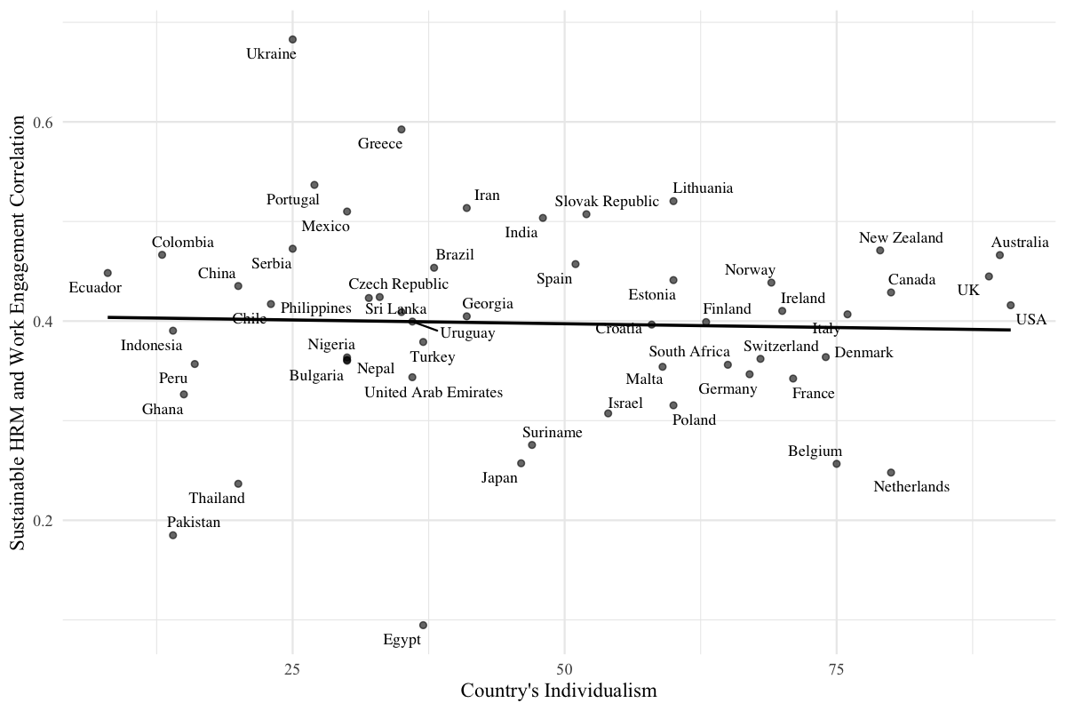
Figure S3. Moderation of country’s power distance on the relationship between sustainable HRM and work engagement.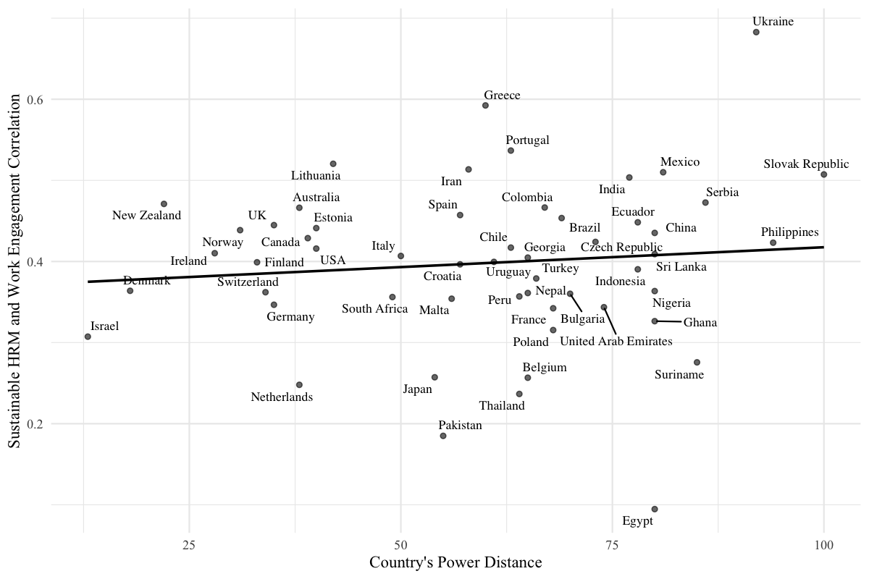Figure S4. Moderation of country’s masculinity on the relationship between sustainable HRM and work engagement.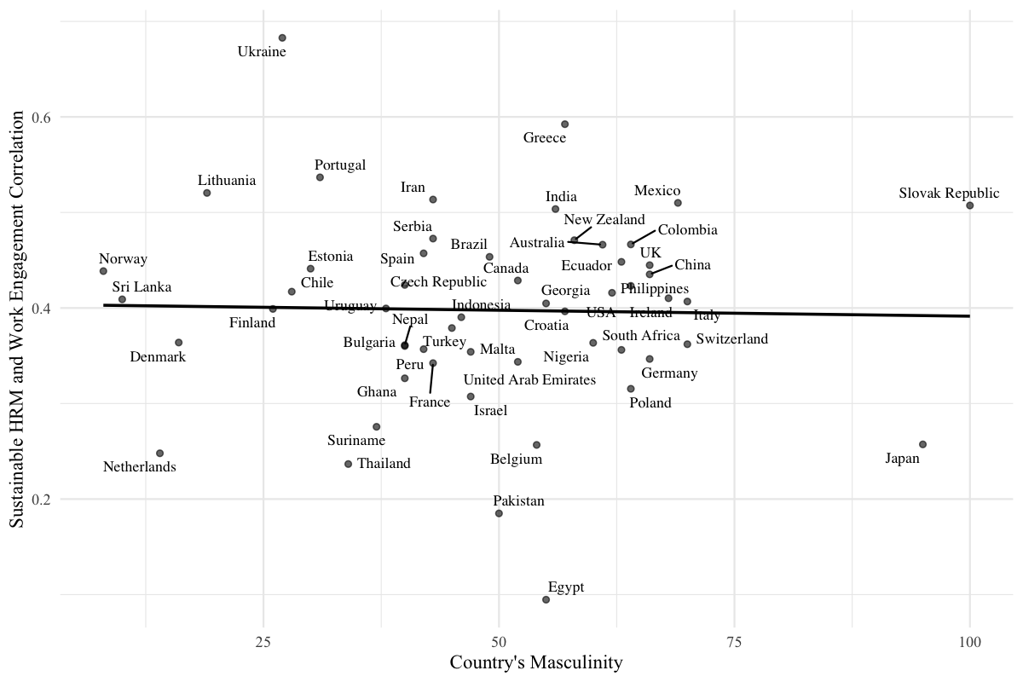
Figure S5. Moderation of country’s indulgence on the relationship between sustainable HRM and work engagement.
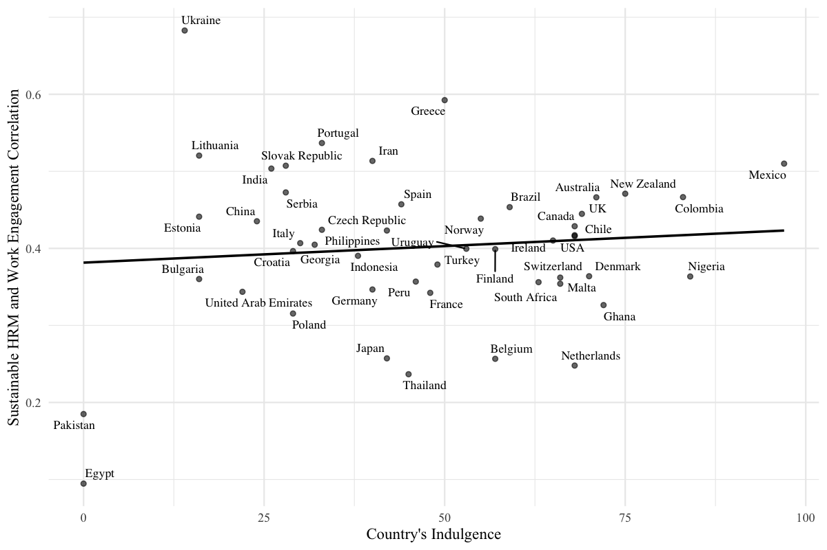
5. Addressing potential reverse causality between work engagement and eudaimonic well-being
A potential concern in interpreting the mediation results relates to the possibility of reverse causality between work engagement and eudaimonic workplace well-being. While our theoretical model is grounded in self-determination theory and assumes that work engagement functions as a motivational mechanism through which sustainable HRM enhances employee eudaimonic well-being, it is also plausible that employees who experience higher levels of eudaimonic well-being subsequently report greater work engagement.
Several considerations mitigate this concern. First, the proposed causal ordering is theoretically justified. Self-Determination Theory conceptualizes work engagement as a proximal motivational state reflecting the satisfaction of basic psychological needs at work, which in turn facilitates experiences of purpose, meaning, and optimal functioning (core elements of eudaimonic well-being). Thus, engagement is theorized as an antecedent rather than a consequence of eudaimonic well-being in the work context.
Second, our supplementary analyses demonstrate that the cultural moderation effects consistently operate on the engagement–well-being link rather than on the sustainable HRM–engagement link. This pattern supports the interpretation of work engagement as a mechanism translating organizational practices into well-being outcomes rather than merely a reflection of preexisting well-being.
Third, although the cross-sectional nature of the data does not allow for definitive causal inference, the robustness of the results across multiple model specifications (including alternative cultural dimensions, separate interpersonal and intrapersonal well-being outcomes, and extensive control variables) reduces the likelihood that the observed relationships are driven solely by reverse causality.
Nevertheless, we acknowledge that reciprocal relationships between work engagement and eudaimonic well-being are theoretically plausible. Future research would benefit from longitudinal or cross-lagged designs to explicitly test bidirectional effects and to further clarify the temporal dynamics between engagement and eudaimonic workplace well-being.
Summary
These supplementary analyses deepen our understanding of the relationship between sustainable HRM and employee job attitudes across diverse cultural backgrounds. Additionally, they strengthen the evidence supporting the robustness of our findings across various cultural dimensions and aspects of well-being.

