Supporting information: Control strategies for atmospheric pressure plasma polymerization of fluorinated silane thin films with antiadhesive properties

Giulia Laghi¹, Domenico Franco², Guglielmo Guido Condorelli^{3,4}, Riccardo Gallerani¹, Salvatore Guglielmino², Romolo Laurita^{1,5}, Dario Morganti⁶, Francesco Traina^{6,7}, Sabrina Conoci^{2,6,8,9,10}, Matteo Gherardi^{1,11*}

–––––––––
¹ Department of Industrial Engineering, Alma Mater Studiorum - University of Bologna, 40136 Bologna, Italy
² Department of Chemical, Biological, Pharmaceutical and Environmental Sciences, University of Messina, 98166 Messina, Italy
³ Department of Chemical Science, University of Catania, 95125 Catania, Italy
⁴ Consorzio Interuniversitario di Scienze e Tecnologie dei Materiali (INSTM) UdR of Catania, 95125 Catania, Italy
⁵ Interdepartmental Centre for Industrial Research Health Sciences and Technologies, Alma Mater Studiorum - University of Bologna, 40064 Ozzano dell’Emilia (BO), Italy
⁶ IBMTech s.r.l., 95127 Catania, Italy
⁷ Department of Biomedical and Neuromotor Sciences, Alma Mater Studiorum - University of Bologna, 40126 Bologna, Italy
⁸ Department of Chemistry ‘‘Giacomo Ciamician’’, Alma Mater Studiorum – University of Bologna, 40126 Bologna, Italy
⁹ LAB Sense Beyond Nano - URT Department of Sciences Physics and Technologies of Matter (DSFTM) CNR, 98166 Messina, Italy
¹⁰ Istituto per la Microelettronica e Microsistemi, Consiglio Nazionale delle Ricerche (CNR-IMM), 95121 Catania, Italy.
¹¹ Interdepartmental Centre for Industrial Research Advanced Mechanical Engineering Applications and Materials Technology, Alma Mater Studiorum - University of Bologna, 40136 Bologna, Italy

*Correspondence
Matteo Gherardi
Department of Industrial Engineering, Alma Mater Studiorum - University of Bologna, 40136 Bologna, Italy
Email: matteo.gherardi4@unibo.it
Materials and methods
The morphological characteristics of thin films deposited on propylene foils were investigated by means of Scanning Electron Microscopy (SEM). All the observations were carried out using a SEM (Phenom ProX, ThermoFisher Scientific) by applying an accelerating voltage of 10 kV. A sputter coater (SC7620, Quorum Technologies) was used to cover the coating surface with gold before SEM analysis.
The evolution of the substrate surface temperature during the deposition process was analysed using the infrared sensor Optris CT. Five positions along the diameter of the propylene samples (2 cm long), at a distance of 0.25 mm from each other.

Results
According to the SEM images reported in Figure 1, the surface of the uncoated PE substrate appears flat and smooth, while in coatings deposited in conditions A and C (conditions with the highest W/FM values), the presence of numerous fractures (black lines in the images) can be observed. As W/FM decreases, the fractures in the coating disappear, but the number of granular structures on the surface of the film progressively increases.
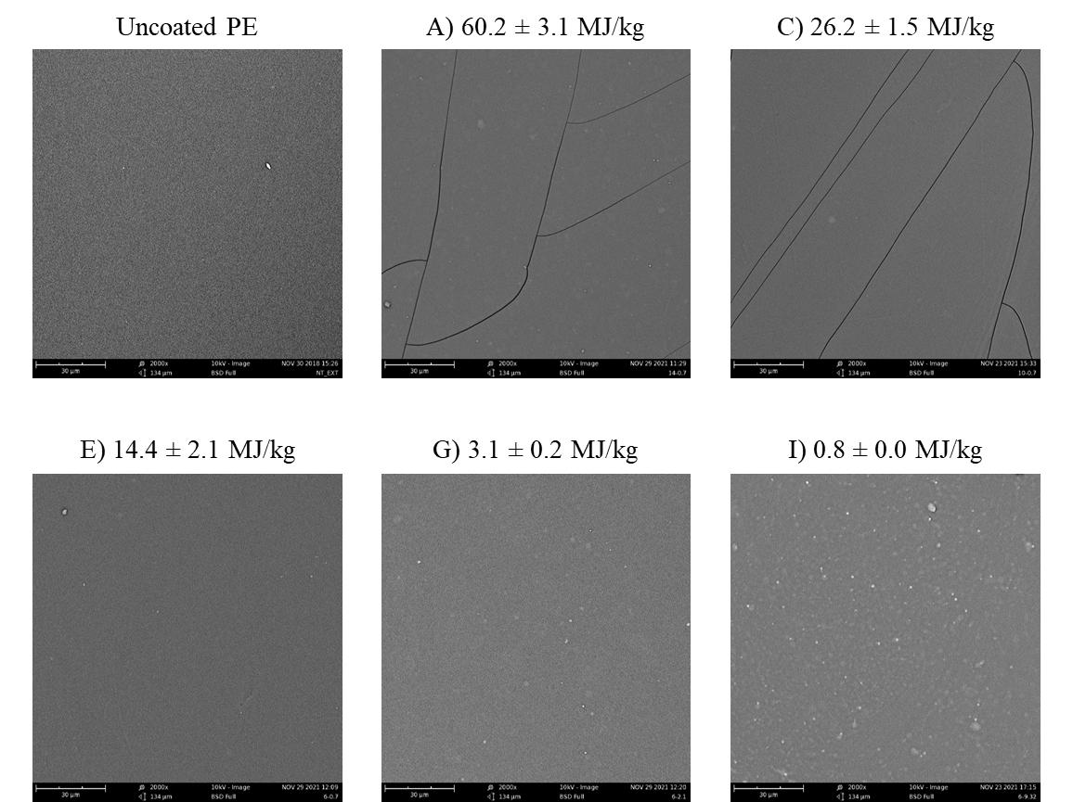
Figura 1: SEM images of uncoated and coated substrates
Discussion
Respect to other characterization techniques, the presence of two deposition regimes can be less obviously appreciated from SEM images, nonetheless through the analysis of several differences in the coating characteristics some reasonings can be performed. One of the features of the coatings deposited in conditions A and C is the presence of numerous fractures, which disappear decreasing the W/FM value. Despite few articles address this aspect of plasma deposition processes [1], [2], the possible mechanism proposed for the formation of fractures in Si-coatings on thermosensitive polymeric substrates is the different coefficient of thermal dilation between the substrate and the deposited coating. The deposition process, indeed, can induce a thermal stress on the polymeric substrate and consequently lead to its stretching: if the coating is sufficiently adherent to the substrate and has a different coefficient of thermal dilatation, fractures can be formed in the coating. According to ATR-FTIR and XPS analysis, the uncoated substrate exhibits a more “organic character” respect to coatings deposited in conditions from A to E, suggesting that in case of heating induced by the process, the thermal stretching of the substrate will be higher than that of the coating and may lead to fractures formation. Considering that the chemical composition of coatings deposited from condition A to condition E should be similar, the reason why fractures cannot be observed in condition E is probably related to the lower heating that is induced in that condition respect to condition A. The only aspect which makes different conditions A and E is the fact that in the first one a higher discharge power is used, and higher discharge powers usually lead to higher surface heating. To prove this hypothesis, the heating of the substrate during the deposition treatment is investigated. The substrate temperature profiles along the diameter of the polymeric substrate for deposition processes in conditions A and E are reported in Figure 2.

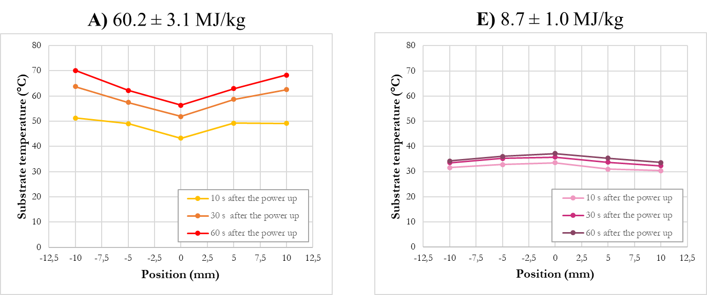
Figure 2: Substrate temperature profiles along the diameter of the sample in deposition conditions A and E
The temperature measurements confirm the higher heating of the substrate in condition A respect to condition E. Indeed, while the temperature remains slightly higher than the ambient temperature in condition E, the temperature reaches average values of 65°C (average value) in condition A. The two conditions exhibit also a different profile along the diameter: in condition A the surface temperature seems to be higher in correspondence of the edge of the sample (±10 mm) respect the central zone (0 mm) thus generating a “donut shape” behaviour, while in condition E the temperature seems to remain stable along all the central axis. This behaviour can be related to the more pronounced ambient air diffusion into the plasma discharge in condition A, which increases the gas temperature due to Penning ionization reactions between N₂ molecules and Ar metastable atoms [3] in the part where there is the maximum air penetration (at the edge of the samples). Nonetheless, a detailed discussion on the trend of the substrate temperature as a function of the position along the central line is beyond the purpose of this paper.
As W/FM further decreases from E to I, the number of granular structures on the surface of the film progressively increases: if in condition E a reduced and almost negligible number of particles can be observed, in conditions G and I their presence is pronounced and proportional to the amount of precursor feed rate (E, G and I are indeed characterized by an increased precursor feed rate). The formation of these structures is due to plasma produced radicals originating from the initial monomer which are recombined in the volume of the discharge and then deposited in form of particles on the substrate. The formation of such particles and their increase with the precursor feed rate has been previously reported in the literature related to atmospheric pressure plasma polymerization of organosilicon precursors.[4], [5] This difference in the surface morphology of the coatings indicates a change in the formation mechanism of the plasma polymers and thus again suggests the presence of two deposition regimes.

References

[1] P. Scopece, A. J. Viaro, R. Sulcis, I. Kulyk, A. Patelli, and M. Guglielmi, “SiOx-based gas barrier coatings for polymer substrates by atmospheric pressure plasma jet deposition,” Plasma Process. Polym., vol. 6, no. SUPPL. 1, pp. 705–710, 2009, doi: 10.1002/ppap.200931707.
[2] J. Petersen, J. Bardon, A. Dinia, D. Ruch, and N. Gherardi, “Organosilicon coatings deposited in atmospheric pressure townsend discharge for gas barrier purpose: Effect of substrate temperature on structure and properties,” ACS Appl. Mater. Interfaces, vol. 4, no. 11, pp. 5872–5882, 2012, doi: 10.1021/am3015229.
[3] X. Lu, G. V. Naidis, M. Laroussi, and K. Ostrikov, “Guided ionization waves: Theory and experiments,” Phys. Rep., vol. 540, no. 3, pp. 123–166, 2014, doi: 10.1016/j.physrep.2014.02.006.
[4] M. Rahman, R. Amsarani, D. A. Mooney, J. M. D. MacElroy, and D. P. Dowling, “Effect of process parameters on chemistry, growth rate and nano-sized particulate formation of atmospheric plasma deposited, nm thick siioxane coatings,” J. Nanosci. Nanotechnol., vol. 9, no. 6, pp. 3506–3513, 2009, doi: 10.1166/jnn.2009.NS24.
[5] A. Kakaroglou et al., “Evaluation of the Yasuda parameter for the atmospheric plasma deposition of allyl methacrylate,” RSC Adv., vol. 5, no. 35, pp. 27449–27457, 2015, doi: 10.1039/c5ra02684a.

