

Supplementary Material

Comparative flavonoid profile of orange (Citrus sinensis) peel extracted by conventional and emerging techniques using UPLC-IMS-MS, chemometrics and antioxidant effects

Sherif M. Afifi^{1,2}, Recep Gök³, Ingo Eikenberg⁴, Dennis Krygier¹, Eric Rottmann⁴, Anne- Sophie Stübler^{5,} Kemal Aganovic⁵, Silke Hillebrand⁴, Tuba Esatbeyoglu¹*
¹ Institute of Food Science and Human Nutrition, Gottfried Wilhelm Leibniz Universität Hannover, 30167 Hannover, Germany esatbeyoglu@lw.uni-hannover.de, d.krygier@aol.de
² Pharmacognosy Department, Faculty of Pharmacy, University of Sadat City, Sadat City 32897, Egypt; shshsh38@hotmail.com
³ Institute of Food Chemistry, Technische Universität Braunschweig, 38106 Braunschweig, Germany; r.goek@tu-braunschweig.de
⁴ Symrise AG, 37603 Holzminden, Germany; silke.hillebrand@symrise.com, eric.rottmann@symrise.com, ingo.eikenberg@symrise.com
⁵ German Institute of Food Technologies (DIL e.V.), 49610 Quakenbrück, Germany k.aganovic@dil- ev.de, annasophie.stuebler@gmail.com

* Correspondence:
Prof. Dr. Tuba Esatbeyoglu esatbeyoglu@lw.uni-hannover.de

1 Supplementary Figures

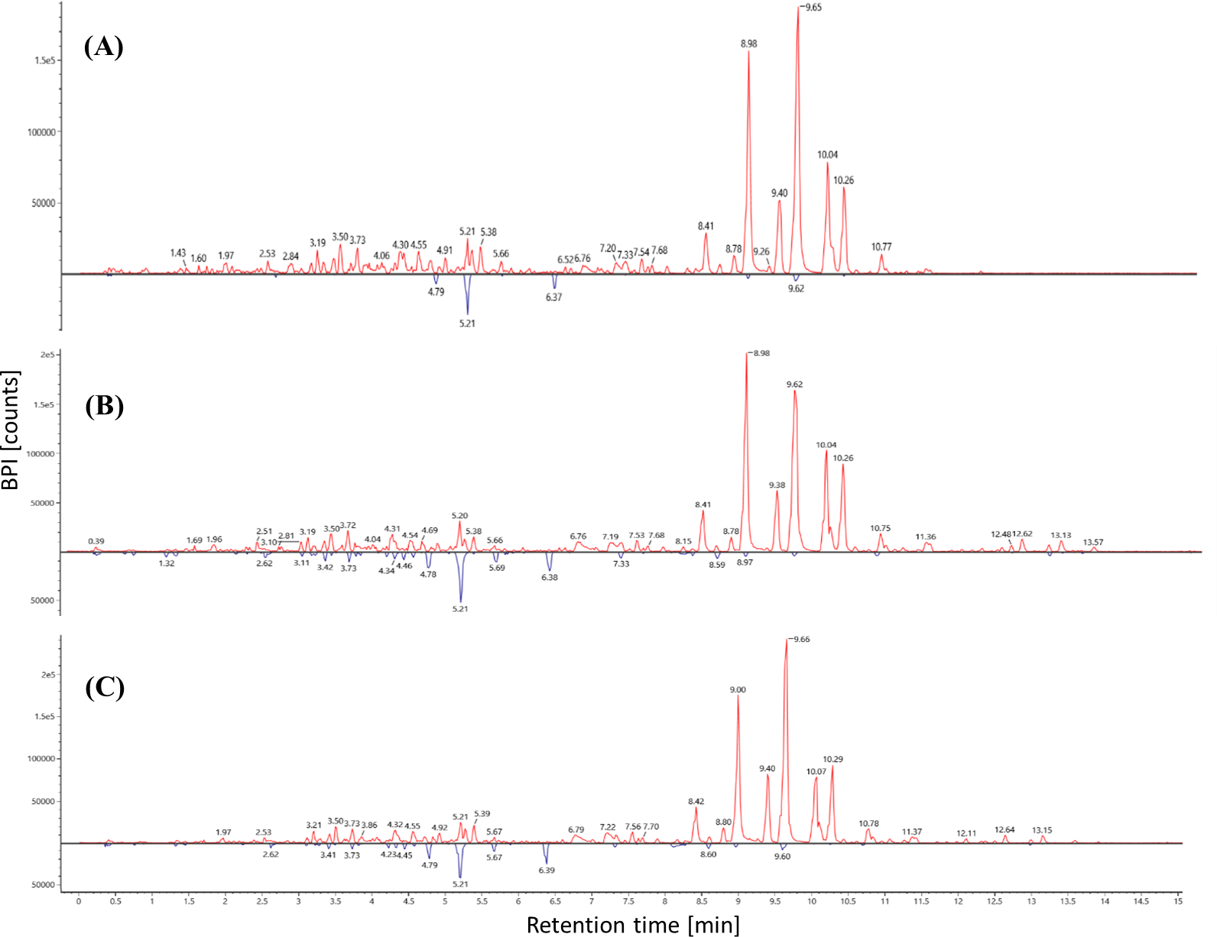

Supplementary Figure 1. Overlay of base peak intensity (BPI) chromatograms of flavedo (in red) and albedo (in blue) samples extracted via ultrasonic method by A: water, B: methanol, C: ethanol.

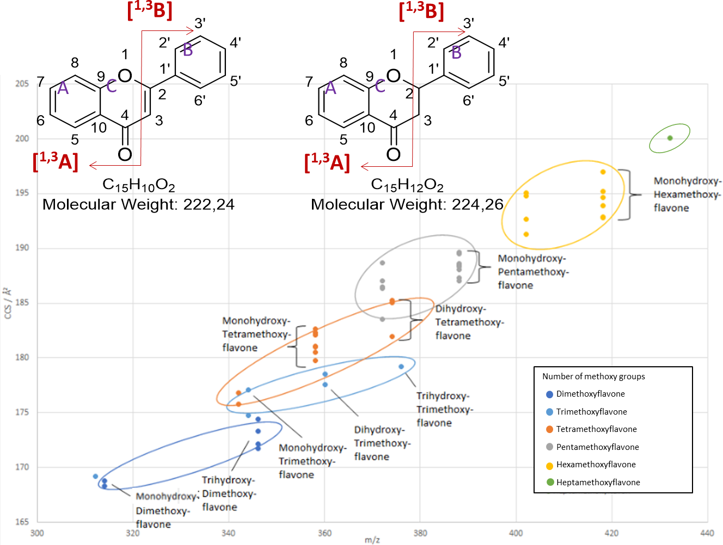
Supplementary Figure 2. Correlation between relative ion mobility-derived collision cross section (CCS) distribution and m/z of various methoxylated flavonoid isomers. In addition, basic flavone (on left) and flavanone (on right) ring configurations, with functional locations and highlighted Retro-Diels-Alder fragmentation processes.

Supplementary Material

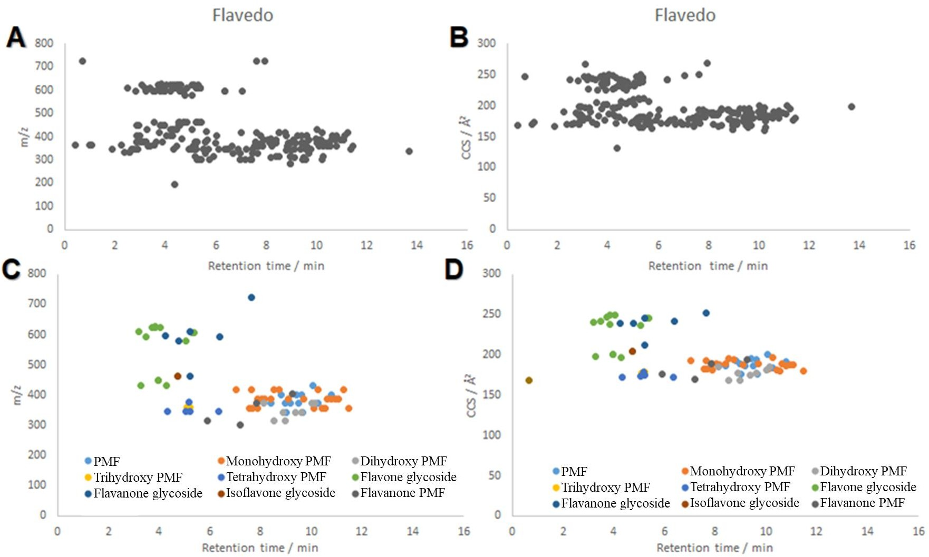
Supplementary Figure 3. Ion map for flavedo in terms of retention time and m/z (A) and retention time and CCS (B) for all flavonoid masses detected in positive mode. C and D highlight the flavonoid isomers. PMFs: polymethoxy flavones.

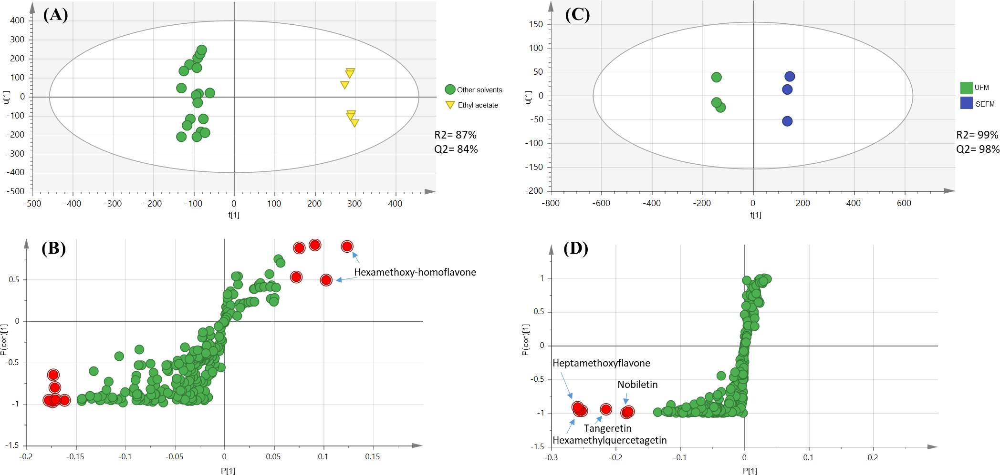

Supplementary Figure 4. Supervised multivariate data analysis based on the UHPLC-Q-TOF MS spectra of flavedo: OPLS-DA of ethyl acetate against all other solvents A: score plot, B: S-loading plot; and OPLS-DA of methanol extracted by ultrasonic against conventional method C: score plot, D: S-loading plot.

Supplementary Material

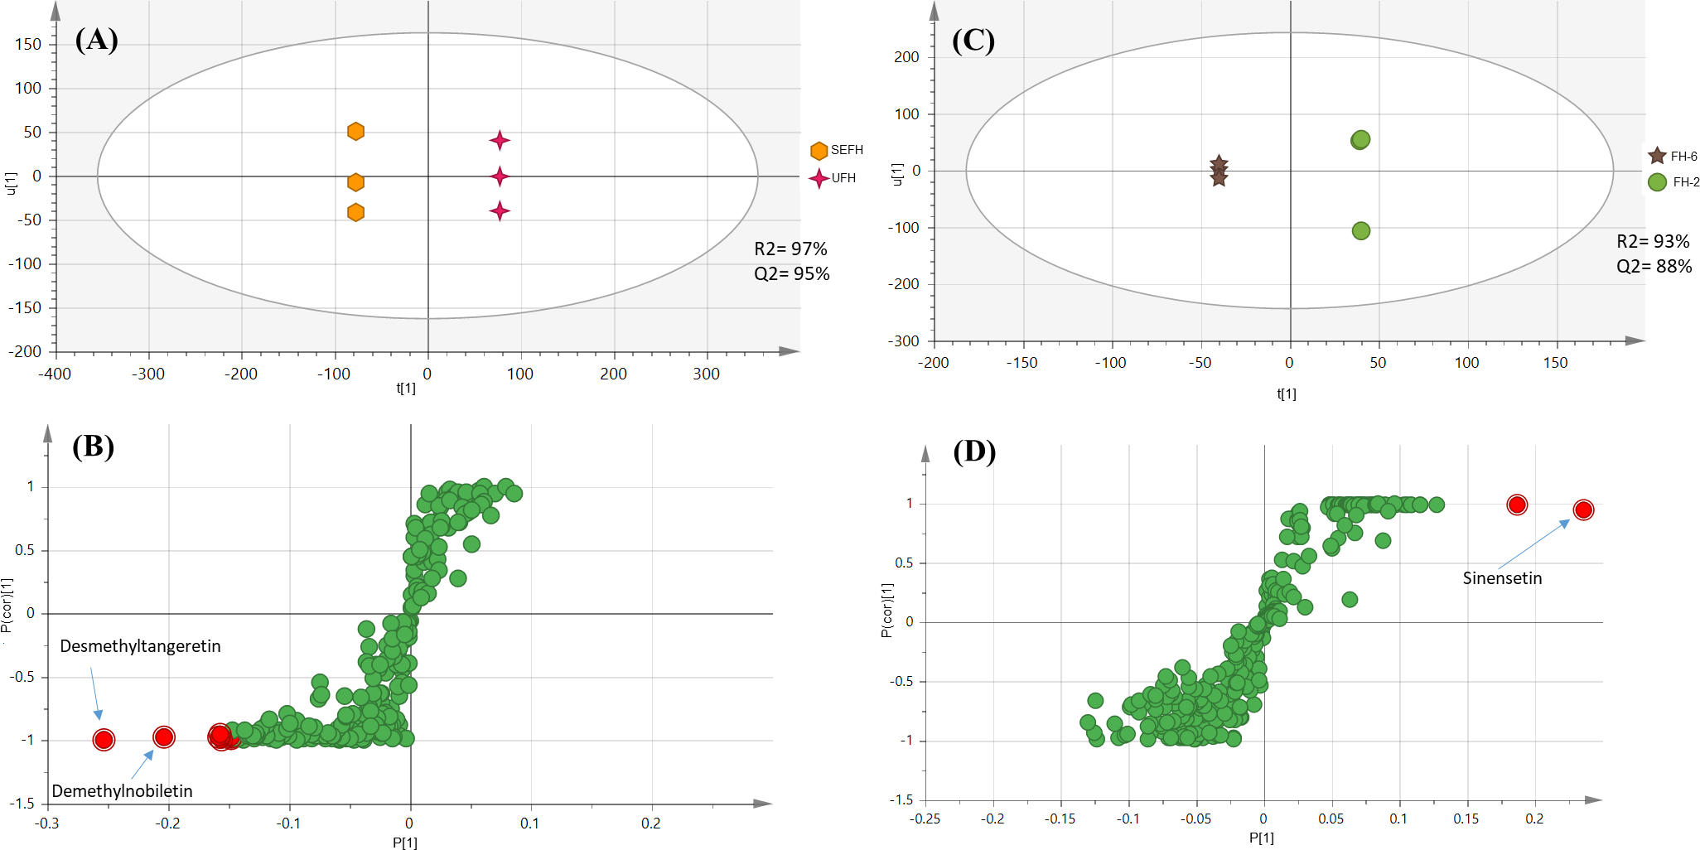

Supplementary Figure 5. Supervised multivariate data analysis based on the UHPLC-Q-TOF MS spectra of flavedo: OPLS-DA of aqueous samples extracted by conventional against ultrasonic method A: score plot, B: S-loading plot; and OPLS-DA of HHP samples extracted at 200 MPa against 600 MPa C: score plot, D: S-loading plot.

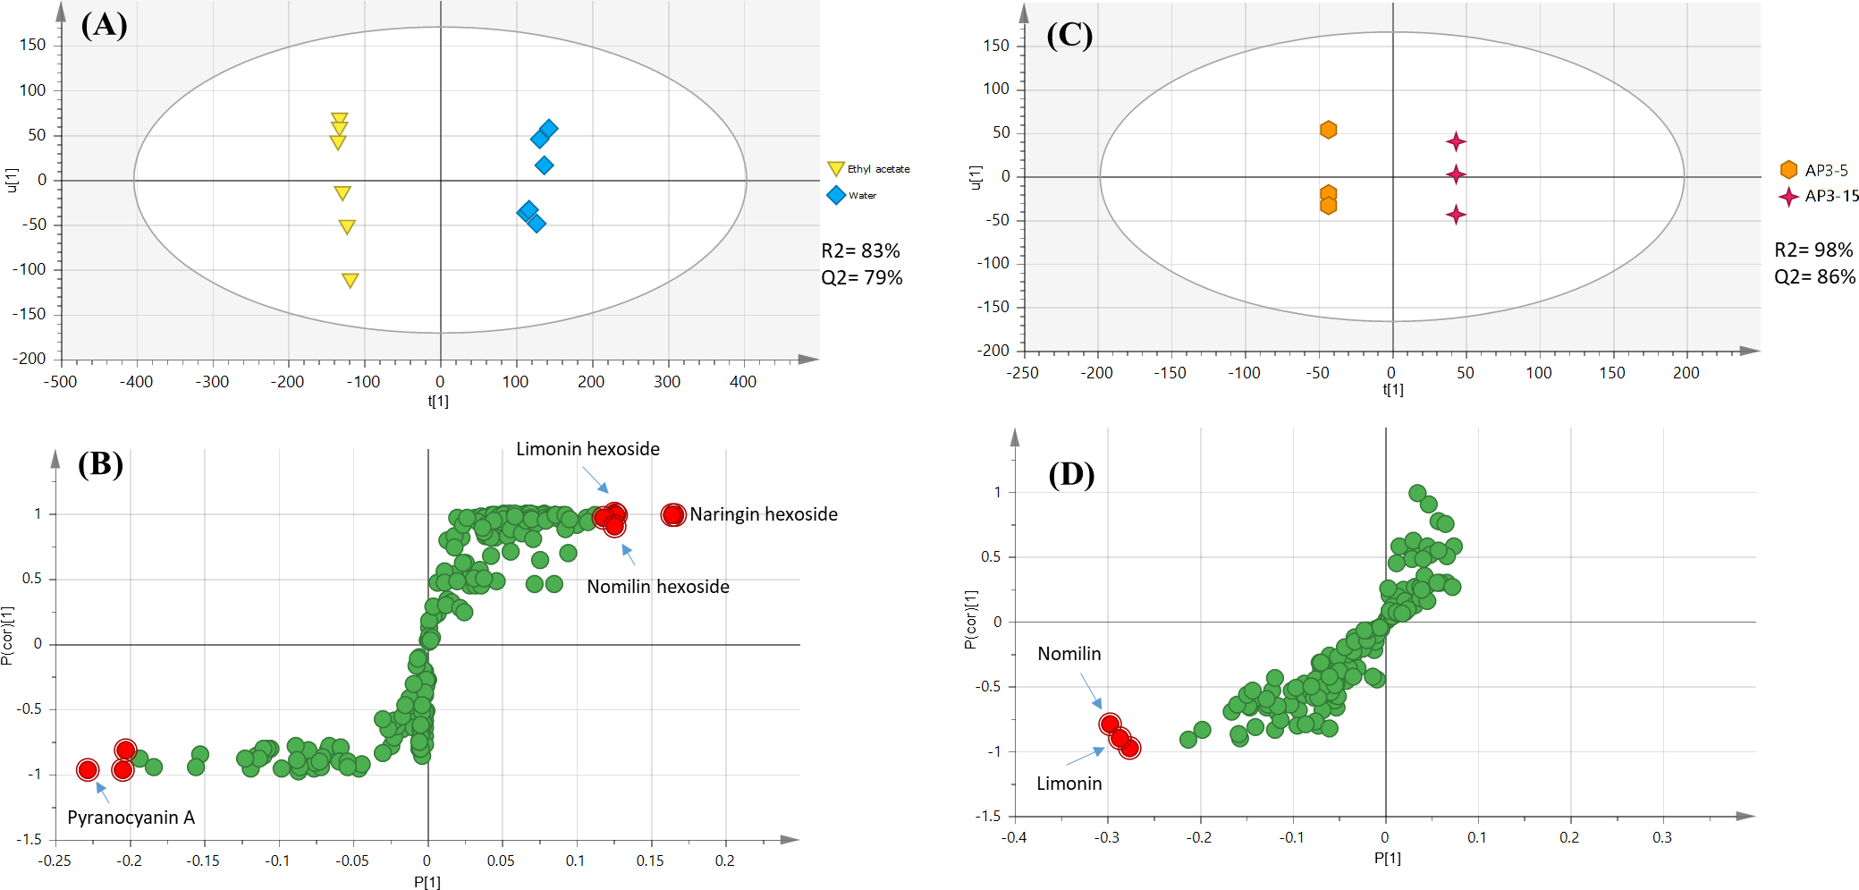

Supplementary Figure 6. Supervised multivariate data analysis based on the UHPLC-Q-TOF MS spectra of albedo: OPLS-DA of aqueous extracts against ethyl acetate extracts A: score plot, B: S-loading plot and OPLS-DA of PEF samples extracted at 15 kJ/kg / 3kV against 5 kJ/kg /3kV C: score plot, D: S-loading plot.

O-Hexosyldiosmetin

Homoeriodictyol chalcone Khayasin

(B)
Supplementary Material
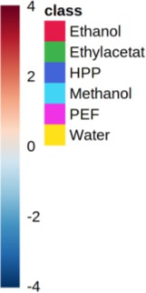
Nomilinic acid -O-hexoside Limonin hexoside
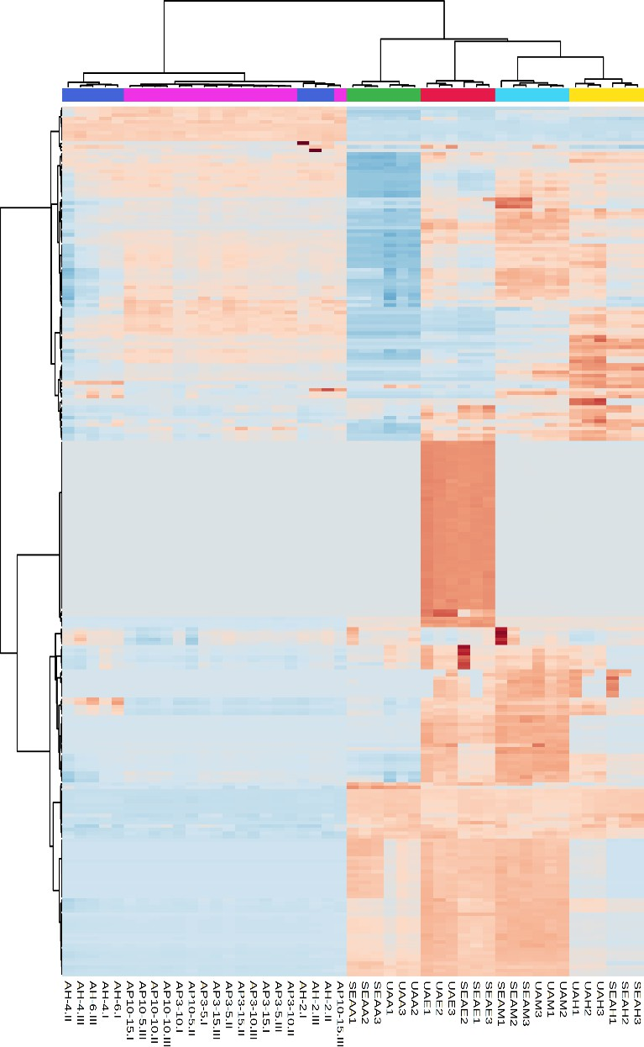
Nomilin

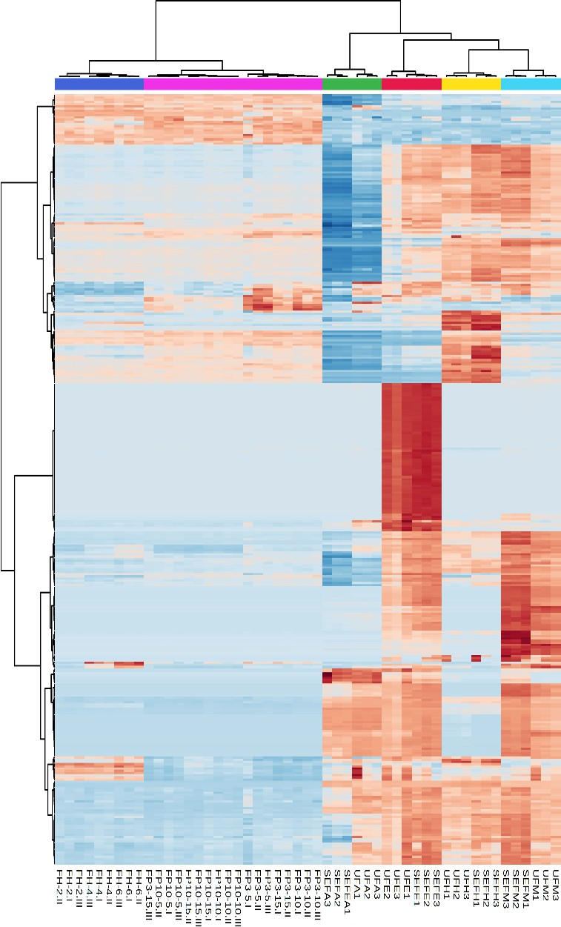
(A)

Tangeretin Heptamethoxyflavone

Acacetin (di-deoxyhexosyl)-hexoside

Methoxynaringenin

Supplementary Figure 7. Heat map demonstrating potential biomarker variations in levels in both flavedo (A) and albedo (B) samples. Columns representing various samples; rows representing biomarkers. The color key displays the ratio of the biomarker content (blue: lowest; red: highest). HHP: High Hydrostatic Pressure, PEF: Pulsed Electric Field. Sample codes: U = Ultrasonic, SE = Solvent extraction, P = PEF, H = HHP, A = Albedo, F = Flavedo, H = Water, M = Methanol E =Ethanol, A = Ethyl acetate or see Table 1.

