Supplementary Material

High levels of genetic diversity and population structure in the Mediterranean seagrass Posidonia oceanica at its easternmost distribution limit

Ozge Tutar*, Miriam Ruocco*, Emanuela Dattolo, Guglielmo Lacorata, Raffaele Corrado, Romain Watteaux, Daniele Iudicone, Bettina Fach and Gabriele Procaccini

Supplementary S1

Table S1. List of 18 microsatellites used in this analysis with related motif, concentration, label and sequences.

Primer Name | Primer Motif | Primer  concentration  added [pmol] | Label | Sequences
1st multiplex
Poc-45*** | (TCC)8 (TTC)4 | 5 | PET | F:AAATTGCCAGATTCTGGTGTCA  R:AACCACGTGAGTAAGGGAGGG
Po-5-10** | (GA)13 | 10 | PET | F:ATGAGACTCCCACAATAACA  R:CATGGGAAGGTATAGAAGC
Po-4-3** | (GA)10 | 10 | 6-FAM | F:ACAGAAACTACGAACCATCAG  R:TAAGGAGAAGGAGAAGGAAA
Pooc-361*** | (TC)17 | 3 | NED | F:GTGTTTTGGGCTTGACTAAGAGAT  R:AGGCAACAATTAAGATAGCCCAAAC
Po-5-39** | (GA)13 | 5 | VIC | F:CATTTGGCTGAGTCCCTTTC  R:GTCCAAGGCTTCCGTGATGG
Poc-35* | (TCC)11 | 2 | NED | F:TGGCAAAGTCAATGGCAATAGTAG  R:GTACGTCGTCTCGGATGGGAGA
Poc-42*** | (TGC)6 | 5 | 6-FAM | F:CTCCTTCCTGTACATTCCCCTC  R:TGGTCTCTCCCCTTCTCTCACT
Pooc-PC047G07*** | (AGG)4 | 6 | 6-FAM | F:GCCATCTTGGAAAGCCTAAG  R:CAGAATCCACTCCCCAACC
2nd multiplex
Po-15** | (GA)20 | 5 | NED | F:AAGCACGCCGCTTAAACCATA  R:CATGTTAGTAGGCAATATACTAGGC
Pooc-229*** | (ACG)10 | 5 | PET | F:CTCAGGGGAAGGTAGAAGAGATG  R:CTGCTTTGTTTCCTCAAAAAGTG
Po-5** | (GA)20 | 5 | VIC | F:CACAATGGCCCGGTAGCA  R:GTGGTTGCGTGCCTTCGGTTG
Poc-5* | (TGG)10 | 3 | NED | F:TCTTCGGCTTGTGCTCGTCCTTGA  R:GCCTCTCCTGCCCACCACCGCT
Pooc-PC045G11*** | (GA)18 | 10 | 6-FAM | F:CTCCACCATCCGCCCCCATTTG  R:CTTCGACAACCTTGCAGGCCCT
Pooc-153*** | (AG)16 | 10 | PET | F:TCCTCCCAATCTAATTTGCTG  R:AAGAACAGTGAGCGCCAGAC
Pooc-330*** | (GAT)4 | 8 | VIC | F:GGAAAACAGCAGCAATCAATC  R:ACGTCTACATCCTCGACCAC
Poc-26*** | (GCGAGGA)4 | 10 | PET | F:GTCACCTTAAATCATCGGAG  R:AACGAGGACATAGCGAGTAC
Pooc-044B02*** | (CA)5 | 5 | NED | F:GCTGCAACTAATACACCTCG  R:AGGGACGTGATATGCGAGAC
Pooc-333*** | (TCT)10 | 10 | VIC | F:AAAAGTGTTTGAGAGAAACAACTCG  R:ACCTTTGACTTCTCCTTCTGAATCT
*Procaccini and Waycott, 1998; **Alberto et al., 2003; ***Arranz et al., 2013

Table S2. Master Mix used for amplification of microsatellites.
Master Mix Multi-Plex
DNA | 0.5 µl
Q-mix | 7.5 µl
Primer Forward | 0.3 µl x X
Primer Reverse | 0.3 µl x X
Water | X
Total volume | 15 µl

Figure S1. LOSITAN analysis of the 16 P. oceanica sites. Three loci are under balancing selection (yellow background). Two loci are under positive selection.
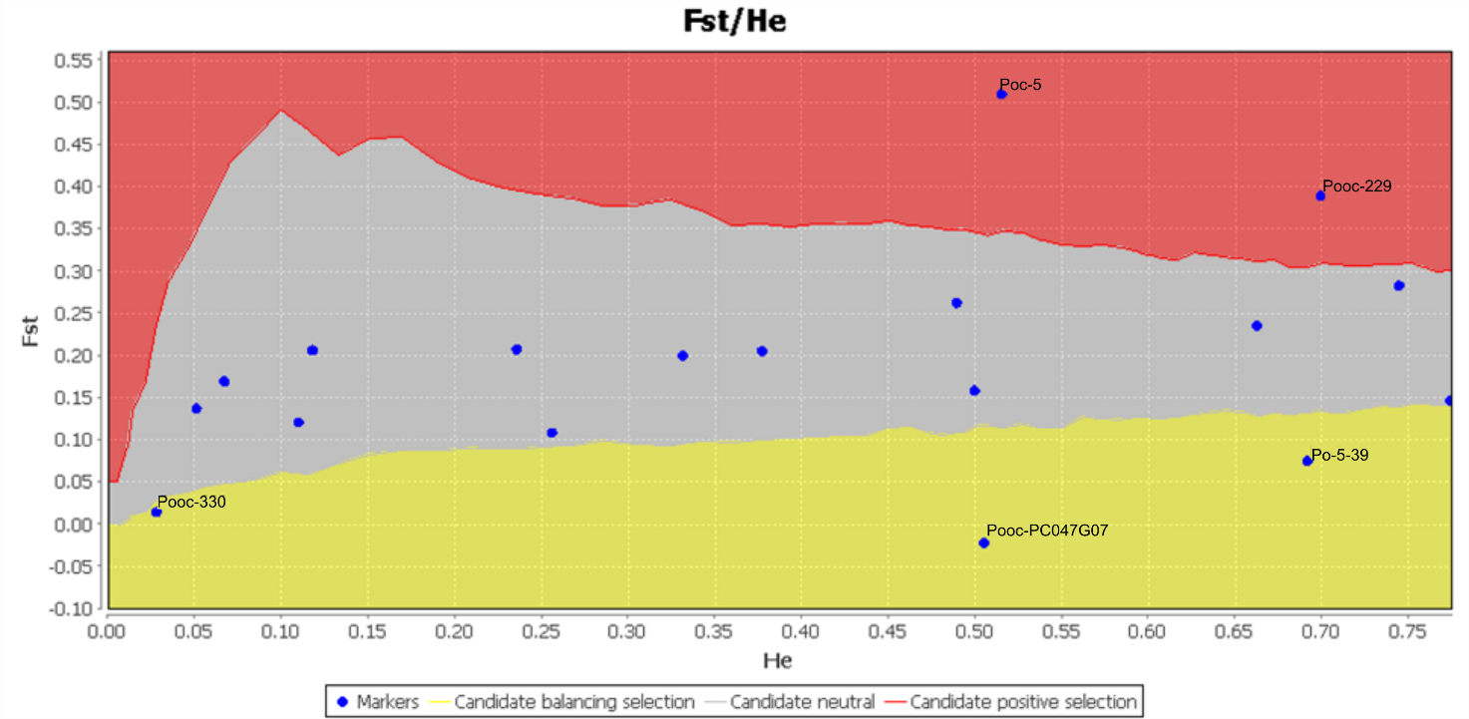

Figure S2. BayeScan analysis of the 16 P. oceanica sites. Two loci are under diversifying selection. Two loci are under balancing selection.

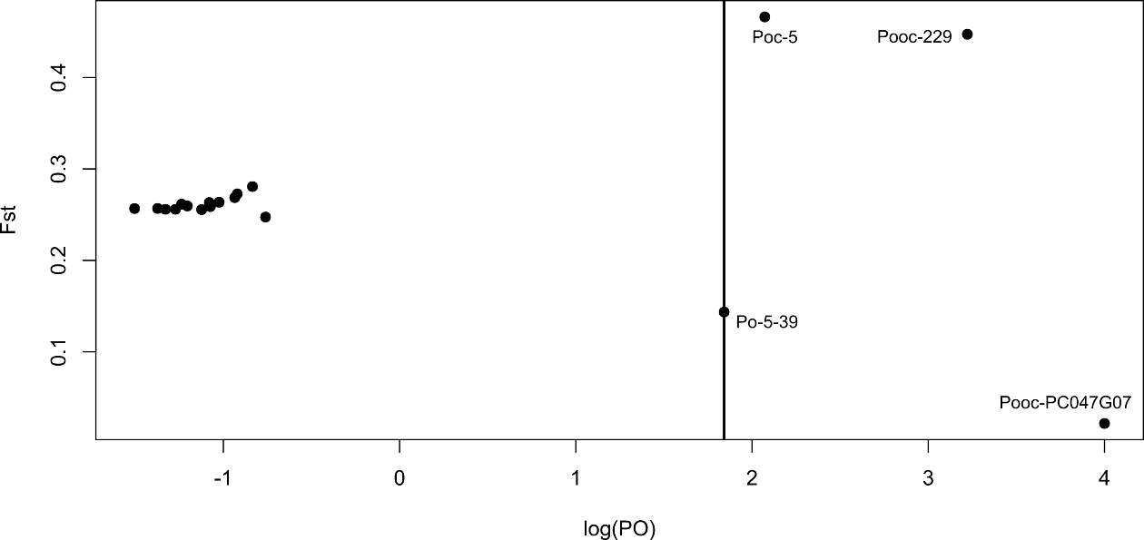
Table S3. Detailed output of BayeScan analysis for all 18 loci included in our study. Putative outlier loci (FDR ≤0.05) are highlighted in bold.

 |  | prob | log10(PO) | alpha | F_{ST}
Pooc-45 | 1 | 0.127626 | -0.834765 | 0.10632 | 0.28075
Po-15 | 2 | 0.030406 | -1.5036 | -0.00659 | 0.25673
Pooc-229 | 3 | 0.9994 | 3.2215 | 0.90494 | 0.44735
Po-5 | 4 | 0.070014 | -1.1233 | -0.02061 | 0.25555
Po-5-10 | 5 | 0.076815 | -1.0798 | 0.027993 | 0.26327
Po-4-3 | 6 | 0.040608 | -1.3734 | -0.00733 | 0.25684
Poc-5 | 7 | 0.9916 | 2.072 | 0.98576 | 0.4663
Po-5-39 | 8 | 0.9858 | 1.8414 | -0.78692 | 0.14353
Pooc-361 | 9 | 0.058812 | -1.2042 | 0.004315 | 0.25954
Poc-35 | 10 | 0.10402 | -0.93518 | 0.054089 | 0.26865
Poc-42 | 11 | 0.05081 | -1.2714 | -0.0132 | 0.25593
Pooc-153 | 12 | 0.077816 | -1.0738 | -0.00532 | 0.25886
Pooc-PC045G11 | 13 | 0.14783 | -0.76077 | -0.06182 | 0.24743
Pooc-PC047G07 | 14 | 1 | 1000 | -3.0009 | 0.021705
Pooc-330 | 15 | 0.086417 | -1.0241 | 0.018288 | 0.2636
Poc-26 | 16 | 0.044809 | -1.3287 | -0.01278 | 0.25594
Pooc-044B02 | 17 | 0.054811 | -1.2367 | 0.017893 | 0.26155
Pooc-333 | 18 | 0.10702 | -0.92137 | 0.071419 | 0.27273

Table S4. Pairwise F_{ST} matrix (below the diagonal) and significance level (above the diagonal) based on 1023 permutations between 16 sites of P. oceanica calculated in Arlequin 3.5.2.2 considering on all 18 loci. ** p <0.01; *** p <0.001.
 | GO-S | GO-D | FO-S | FO-D | CE-S | CE-D | KUS-S | BOD-S | BOD-D | KAS-D | KEM-S | KAL-S | KAL-D | TEK-S | TEK-D | TU-S
GO-S |  | *** | ** | *** | *** | *** | *** | *** | *** | *** | *** | *** | *** | *** | *** | ***
GO-D | 0.093 |  | *** | *** | *** | *** | *** | *** | *** | *** | *** | *** | *** | *** | *** | ***
FO-S | 0.061 | 0.095 |  | ** | *** | *** | ** | *** | *** | *** | *** | *** | *** | *** | *** | ***
FO-D | 0.115 | 0.128 | 0.044 |  | *** | ** | *** | *** | *** | *** | *** | *** | *** | *** | *** | ***
CE-S | 0.095 | 0.150 | 0.053 | 0.065 |  | *** | *** | *** | *** | *** | *** | *** | *** | *** | *** | ***
CE-D | 0.137 | 0.153 | 0.048 | 0.044 | 0.096 |  | *** | *** | *** | *** | *** | *** | *** | *** | *** | ***
KUS-S | 0.057 | 0.062 | 0.032 | 0.085 | 0.098 | 0.107 |  | *** | *** | *** | *** | *** | *** | *** | *** | ***
BOD-S | 0.120 | 0.078 | 0.084 | 0.109 | 0.141 | 0.151 | 0.060 |  | ** | *** | *** | *** | *** | *** | *** | ***
BOD-D | 0.146 | 0.155 | 0.100 | 0.103 | 0.106 | 0.133 | 0.099 | 0.060 |  | *** | *** | *** | *** | *** | *** | ***
KAS-D | 0.279 | 0.147 | 0.196 | 0.232 | 0.273 | 0.222 | 0.174 | 0.151 | 0.191 |  | *** | *** | *** | *** | *** | ***
KEM-S | 0.314 | 0.230 | 0.289 | 0.373 | 0.379 | 0.340 | 0.247 | 0.261 | 0.296 | 0.166 |  | *** | *** | *** | *** | ***
KAL-S | 0.283 | 0.222 | 0.192 | 0.248 | 0.280 | 0.214 | 0.209 | 0.182 | 0.191 | 0.167 | 0.172 |  | ** | *** | *** | ***
KAL-D | 0.277 | 0.249 | 0.212 | 0.280 | 0.296 | 0.225 | 0.234 | 0.198 | 0.223 | 0.228 | 0.222 | 0.034 |  | *** | *** | ***
TEK-S | 0.438 | 0.381 | 0.357 | 0.420 | 0.421 | 0.370 | 0.368 | 0.363 | 0.346 | 0.311 | 0.331 | 0.187 | 0.185 |  | *** | ***
TEK-D | 0.283 | 0.231 | 0.217 | 0.287 | 0.259 | 0.242 | 0.223 | 0.222 | 0.199 | 0.168 | 0.209 | 0.119 | 0.124 | 0.102 |  | ***
TU-S | 0.330 | 0.306 | 0.278 | 0.362 | 0.343 | 0.287 | 0.289 | 0.309 | 0.306 | 0.286 | 0.217 | 0.154 | 0.116 | 0.189 | 0.121

Table S5. Pairwise F_{ST} matrix (below the diagonal) and significance level (above the diagonal) based on 1023 permutations between 16 sites of P. oceanica calculated in Arlequin 3.5.2.2 and considering only 14 neutral loci. * p <0.05; ** p <0.01; *** p <0.001.

 | GO-S | GO-D | FO-S | FO-D | CE-S | CE-D | KUS-S | BOD-S | BOD-D | KAS-D | KEM-S | KAL-S | KAL-D | TEK-S | TEK-D | TU-S
GO-S |  | *** | *** | *** | *** | *** | ** | *** | *** | *** | *** | *** | *** | *** | *** | ***
GO-D | 0.122 |  | *** | *** | *** | *** | ** | ** | *** | *** | *** | *** | *** | *** | *** | ***
FO-S | 0.066 | 0.106 |  | ** | ** | ** | ** | *** | *** | *** | *** | *** | *** | *** | *** | ***
FO-D | 0.165 | 0.165 | 0.049 |  | *** | * | *** | *** | *** | *** | *** | *** | *** | *** | *** | ***
CE-S | 0.128 | 0.202 | 0.057 | 0.101 |  | *** | *** | *** | *** | *** | *** | *** | *** | *** | *** | ***
CE-D | 0.188 | 0.205 | 0.072 | 0.053 | 0.128 |  | *** | *** | *** | *** | *** | *** | *** | *** | *** | ***
KUS-S | 0.065 | 0.068 | 0.045 | 0.115 | 0.128 | 0.152 |  | *** | *** | *** | *** | *** | *** | *** | *** | ***
BOD-S | 0.097 | 0.058 | 0.076 | 0.110 | 0.168 | 0.173 | 0.066 |  | *** | *** | *** | *** | *** | *** | *** | ***
BOD-D | 0.174 | 0.198 | 0.119 | 0.128 | 0.136 | 0.175 | 0.139 | 0.088 |  | *** | *** | *** | *** | *** | *** | ***
KAS-D | 0.337 | 0.169 | 0.248 | 0.275 | 0.336 | 0.297 | 0.220 | 0.179 | 0.246 |  | *** | *** | *** | *** | *** | ***
KEM-S | 0.267 | 0.154 | 0.283 | 0.351 | 0.359 | 0.373 | 0.211 | 0.205 | 0.277 | 0.154 |  | *** | *** | *** | *** | ***
KAL-S | 0.181 | 0.107 | 0.109 | 0.103 | 0.160 | 0.159 | 0.135 | 0.059 | 0.094 | 0.141 | 0.219 |  | ** | *** | *** | ***
KAL-D | 0.156 | 0.153 | 0.128 | 0.154 | 0.180 | 0.163 | 0.172 | 0.091 | 0.145 | 0.226 | 0.277 | 0.047 |  | *** | *** | ***
TEK-S | 0.394 | 0.337 | 0.316 | 0.353 | 0.354 | 0.352 | 0.340 | 0.319 | 0.300 | 0.311 | 0.398 | 0.227 | 0.222 |  | *** | ***
TEK-D | 0.288 | 0.235 | 0.232 | 0.285 | 0.245 | 0.284 | 0.237 | 0.218 | 0.196 | 0.213 | 0.272 | 0.142 | 0.139 | 0.095 |  | ***
TU-S | 0.217 | 0.206 | 0.202 | 0.262 | 0.213 | 0.240 | 0.225 | 0.234 | 0.249 | 0.290 | 0.278 | 0.191 | 0.134 | 0.228 | 0.127

Table S6. Pairwise F_{ST} matrix (below the diagonal) and significance level (above the diagonal) based on 1023 permutations between 16 sites of P. oceanica calculated in Arlequin 3.5.2.2 and considering only the 4 outlier loci (Poc-5, Po-5-39, Pooc-229, Pooc-PC047G07) shared between LOSITAN and BayeScan. * p <0.05; ** p <0.01; *** p <0.001.

 | GO-S | GO-D | FO-S | FO-D | CE-S | CE-D | KUS-S | BOD-S | BOD-D | KAS-D | KEM-S | KAL-S | KAL-D | TEK-S | TEK-D | TU-S
GO-S |  | ** | ** | ns | * | * | ** | *** | *** | *** | *** | *** | *** | *** | *** | ***
GO-D | 0.038 |  | *** | *** | *** | ** | *** | *** | ** | *** | *** | *** | *** | *** | *** | ***
FO-S | 0.053 | 0.075 |  | ** | *** | ns | ns | *** | ** | *** | *** | *** | *** | *** | *** | ***
FO-D | 0.002 | 0.054 | 0.035 |  | ns | ** | ** | *** | ** | *** | *** | *** | *** | *** | *** | ***
CE-S | 0.028 | 0.040 | 0.043 | -0.011 |  | ** | *** | *** | ** | *** | *** | *** | *** | *** | *** | ***
CE-D | 0.029 | 0.048 | 0.002 | 0.029 | 0.035 |  | * | *** | * | ** | *** | *** | *** | *** | *** | ***
KUS-S | 0.042 | 0.053 | 0.006 | 0.025 | 0.041 | 0.017 |  | *** | ns | *** | *** | *** | *** | *** | *** | ***
BOD-S | 0.159 | 0.110 | 0.100 | 0.107 | 0.091 | 0.109 | 0.048 |  | ns | *** | *** | *** | *** | *** | *** | ***
BOD-D | 0.087 | 0.064 | 0.061 | 0.049 | 0.044 | 0.043 | 0.014 | 0.004 |  | ** | *** | *** | *** | *** | *** | ***
KAS-D | 0.135 | 0.104 | 0.067 | 0.133 | 0.117 | 0.036 | 0.076 | 0.093 | 0.060 |  | *** | *** | *** | *** | *** | ***
KEM-S | 0.390 | 0.340 | 0.301 | 0.414 | 0.414 | 0.271 | 0.307 | 0.350 | 0.331 | 0.188 |  | * | *** | *** | *** | ns
KAL-S | 0.443 | 0.391 | 0.337 | 0.457 | 0.455 | 0.312 | 0.332 | 0.367 | 0.353 | 0.219 | 0.034 |  | ns | *** | *** | *
KAL-D | 0.449 | 0.392 | 0.353 | 0.462 | 0.459 | 0.330 | 0.336 | 0.360 | 0.355 | 0.234 | 0.062 | 0.001 |  | *** | *** | **
TEK-S | 0.527 | 0.467 | 0.443 | 0.548 | 0.541 | 0.409 | 0.426 | 0.451 | 0.443 | 0.312 | 0.052 | 0.041 | 0.054 |  | *** | *
TEK-D | 0.272 | 0.223 | 0.183 | 0.290 | 0.284 | 0.146 | 0.195 | 0.230 | 0.204 | 0.059 | 0.034 | 0.060 | 0.087 | 0.119 |  | **
TU-S | 0.494 | 0.450 | 0.408 | 0.516 | 0.516 | 0.369 | 0.393 | 0.430 | 0.409 | 0.278 | 0.029 | 0.036 | 0.064 | 0.031 | 0.106

Table S7. Pairwise differentiation index (D_{est}) (below the diagonal) and probability based on 999 permutations (above the diagonal) between 16 sites of P. oceanica calculated in GenAlex 6.5 based on all 18 loci. ** p <0.01.

 | GO-S | GO-D | FO-S | FO-D | CE-S | CE-D | KUS-S | BOD-S | BOD-D | KAS-D | KEM-S | KAL-S | KAL-D | TEK-S | TEK-D | TU-S
GO-S |  | ** | ** | ** | ** | ** | ** | ** | ** | ** | ** | ** | ** | ** | ** | **
GO-D | 0.039 |  | ** | ** | ** | ** | ** | ** | ** | ** | ** | ** | ** | ** | ** | **
FO-S | 0.027 | 0.047 |  | ** | ** | ** | ** | ** | ** | ** | ** | ** | ** | ** | ** | **
FO-D | 0.048 | 0.059 | 0.020 |  | ** | ** | ** | ** | ** | ** | ** | ** | ** | ** | ** | **
CE-S | 0.037 | 0.067 | 0.023 | 0.026 |  | ** | ** | ** | ** | ** | ** | ** | ** | ** | ** | **
CE-D | 0.064 | 0.078 | 0.023 | 0.020 | 0.043 |  | ** | ** | ** | ** | ** | ** | ** | ** | ** | **
KUS-S | 0.025 | 0.030 | 0.016 | 0.042 | 0.046 | 0.057 |  | ** | ** | ** | ** | ** | ** | ** | ** | **
BOD-S | 0.057 | 0.037 | 0.044 | 0.054 | 0.068 | 0.083 | 0.031 |  | ** | ** | ** | ** | ** | ** | ** | **
BOD-D | 0.076 | 0.088 | 0.057 | 0.054 | 0.052 | 0.077 | 0.057 | 0.033 |  | ** | ** | ** | ** | ** | ** | **
KAS-D | 0.173 | 0.082 | 0.126 | 0.141 | 0.165 | 0.142 | 0.110 | 0.093 | 0.132 |  | ** | ** | ** | ** | ** | **
KEM-S | 0.178 | 0.124 | 0.185 | 0.240 | 0.234 | 0.225 | 0.151 | 0.161 | 0.205 | 0.096 |  | ** | ** | ** | ** | **
KAL-S | 0.168 | 0.128 | 0.116 | 0.146 | 0.163 | 0.129 | 0.131 | 0.109 | 0.123 | 0.103 | 0.095 |  | ** | ** | ** | **
KAL-D | 0.160 | 0.147 | 0.130 | 0.169 | 0.174 | 0.135 | 0.149 | 0.119 | 0.148 | 0.150 | 0.128 | 0.017 |  | ** | ** | **
TEK-S | 0.304 | 0.257 | 0.253 | 0.293 | 0.280 | 0.257 | 0.269 | 0.259 | 0.258 | 0.218 | 0.209 | 0.106 | 0.102 |  | ** | **
TEK-D | 0.170 | 0.139 | 0.140 | 0.182 | 0.149 | 0.154 | 0.146 | 0.145 | 0.135 | 0.108 | 0.124 | 0.069 | 0.071 | 0.054 |  | **
TU-S | 0.187 | 0.180 | 0.173 | 0.223 | 0.195 | 0.174 | 0.185 | 0.201 | 0.214 | 0.192 | 0.115 | 0.082 | 0.058 | 0.097 | 0.064

Table S8. Pairwise differentiation index (D_{est}) (below the diagonal) and probability based on 999 permutations (above the diagonal) between 16 sites of P. oceanica calculated in GenAlex 6.5 based on 14 neutral loci. * p <0.05; ** p <0.01.

 | GO-S | GO-D | FO-S | FO-D | CE-S | CE-D | KUS-S | BOD-S | BOD-D | KAS-D | KEM-S | KAL-S | KAL-D | TEK-S | TEK-D | TU-S
GO-S |  | ** | ** | ** | ** | ** | ** | ** | ** | ** | ** | ** | ** | ** | ** | **
GO-D | 0.039 |  | ** | ** | ** | ** | ** | ** | ** | ** | ** | ** | ** | ** | ** | **
FO-S | 0.022 | 0.040 |  | * | ** | ** | * | ** | ** | ** | ** | ** | ** | ** | ** | **
FO-D | 0.057 | 0.059 | 0.017 |  | ** | * | ** | ** | ** | ** | ** | ** | ** | ** | ** | **
CE-S | 0.039 | 0.072 | 0.019 | 0.031 |  | ** | ** | ** | ** | ** | ** | ** | ** | ** | ** | **
CE-D | 0.070 | 0.082 | 0.026 | 0.017 | 0.043 |  | ** | ** | ** | ** | ** | ** | ** | ** | ** | **
KUS-S | 0.021 | 0.023 | 0.016 | 0.043 | 0.046 | 0.062 |  | ** | ** | ** | ** | ** | ** | ** | ** | **
BOD-S | 0.033 | 0.018 | 0.029 | 0.040 | 0.062 | 0.072 | 0.024 |  | ** | ** | ** | ** | ** | ** | ** | **
BOD-D | 0.073 | 0.090 | 0.054 | 0.053 | 0.053 | 0.081 | 0.064 | 0.037 |  | ** | ** | ** | ** | ** | ** | **
KAS-D | 0.178 | 0.073 | 0.134 | 0.139 | 0.173 | 0.160 | 0.111 | 0.086 | 0.141 |  | ** | ** | ** | ** | ** | **
KEM-S | 0.113 | 0.058 | 0.144 | 0.176 | 0.170 | 0.202 | 0.094 | 0.091 | 0.149 | 0.069 |  | ** | ** | ** | ** | **
KAL-S | 0.079 | 0.044 | 0.050 | 0.043 | 0.067 | 0.073 | 0.062 | 0.024 | 0.044 | 0.071 | 0.110 |  | ** | ** | ** | **
KAL-D | 0.064 | 0.064 | 0.058 | 0.066 | 0.074 | 0.072 | 0.080 | 0.038 | 0.071 | 0.122 | 0.145 | 0.019 |  | ** | ** | **
TEK-S | 0.229 | 0.185 | 0.189 | 0.201 | 0.188 | 0.206 | 0.204 | 0.186 | 0.186 | 0.192 | 0.253 | 0.127 | 0.119 |  | ** | **
TEK-D | 0.140 | 0.110 | 0.123 | 0.145 | 0.109 | 0.149 | 0.121 | 0.110 | 0.105 | 0.115 | 0.142 | 0.071 | 0.067 | 0.045 |  | **
TU-S | 0.089 | 0.087 | 0.097 | 0.120 | 0.085 | 0.112 | 0.108 | 0.113 | 0.136 | 0.164 | 0.138 | 0.097 | 0.061 | 0.119 | 0.058

Table S9. Pairwise differentiation index (D_{est}) (below the diagonal) and probability based on 999 permutations (above the diagonal) between 16 sites of P. oceanica calculated in GenAlex 6.5 based on the 4 outlier loci (Poc-5, Po-5-39, Pooc-229, Pooc-PC047G07) shared between LOSITAN and BayeScan. ** p < 0.01.

 | GO-S | GO-D | FO-S | FO-D | CE-S | CE-D | KUS-S | BOD-S | BOD-D | KAS-D | KEM-S | KAL-S | KAL-D | TEK-S | TEK-D | TU-S
GO-S |  | ** | ** | ns | * | * | ** | ** | ** | ** | ** | ** | ** | ** | ** | **
GO-D | 0.037 |  | ** | ** | ** | ** | ** | ** | ** | ** | ** | ** | ** | ** | ** | **
FO-S | 0.050 | 0.083 |  | ** | ** | ns | ns | ** | ** | ** | ** | ** | ** | ** | ** | **
FO-D | 0.009 | 0.056 | 0.038 |  | ns | ** | ** | ** | ** | ** | ** | ** | ** | ** | ** | **
CE-S | 0.027 | 0.042 | 0.043 | 0.002 |  | ** | ** | ** | ** | ** | ** | ** | ** | ** | ** | **
CE-D | 0.030 | 0.057 | 0.006 | 0.034 | 0.039 |  | * | ** | * | ** | ** | ** | ** | ** | ** | **
KUS-S | 0.047 | 0.068 | 0.013 | 0.035 | 0.048 | 0.027 |  | ** | ns | ** | ** | ** | ** | ** | ** | **
BOD-S | 0.177 | 0.138 | 0.123 | 0.121 | 0.100 | 0.145 | 0.071 |  | ns | ** | ** | ** | ** | ** | ** | **
BOD-D | 0.091 | 0.077 | 0.072 | 0.056 | 0.047 | 0.055 | 0.022 | 0.012 |  | ** | ** | ** | ** | ** | ** | **
KAS-D | 0.149 | 0.131 | 0.082 | 0.152 | 0.129 | 0.048 | 0.106 | 0.130 | 0.082 |  | ** | ** | ** | ** | ** | **
KEM-S | 0.480 | 0.449 | 0.376 | 0.535 | 0.532 | 0.344 | 0.439 | 0.509 | 0.484 | 0.227 |  | ** | ** | ** | ** | ns
KAL-S | 0.553 | 0.516 | 0.410 | 0.587 | 0.584 | 0.388 | 0.455 | 0.505 | 0.489 | 0.253 | 0.029 |  | ns | ** | ** | *
KAL-D | 0.588 | 0.537 | 0.455 | 0.622 | 0.617 | 0.435 | 0.480 | 0.507 | 0.512 | 0.285 | 0.054 | 0.005 |  | ** | ** | **
TEK-S | 0.606 | 0.557 | 0.509 | 0.653 | 0.650 | 0.471 | 0.548 | 0.565 | 0.562 | 0.327 | 0.037 | 0.028 | 0.038 |  | ** | *
TEK-D | 0.316 | 0.282 | 0.222 | 0.350 | 0.336 | 0.182 | 0.273 | 0.323 | 0.284 | 0.076 | 0.038 | 0.058 | 0.087 | 0.093 |  | **
TU-S | 0.601 | 0.592 | 0.502 | 0.655 | 0.665 | 0.454 | 0.544 | 0.596 | 0.563 | 0.315 | 0.021 | 0.023 | 0.045 | 0.017 | 0.090

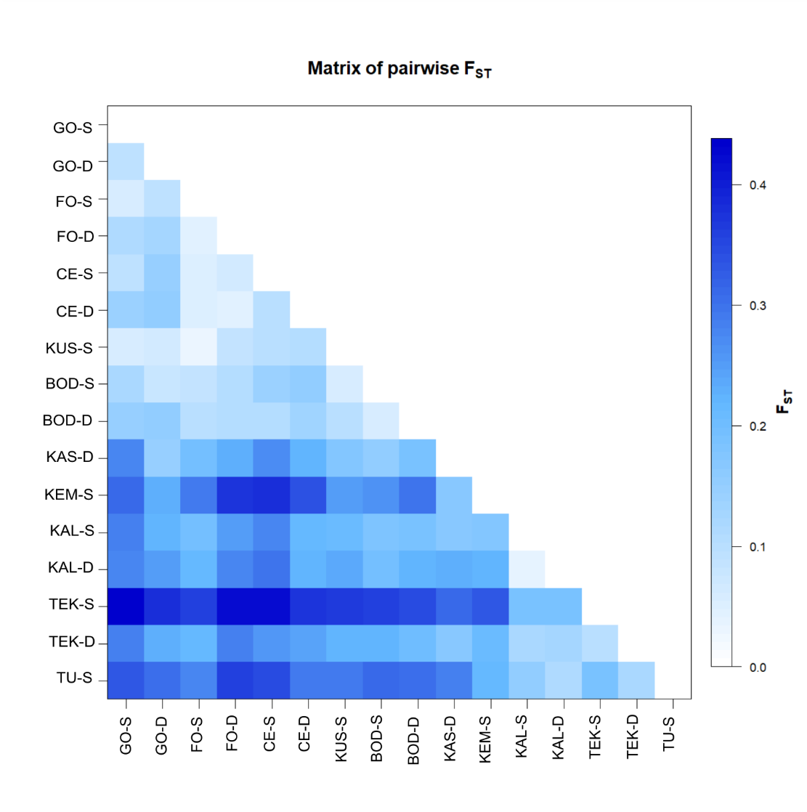
Figure S3. Pairwise F_{ST} distance matrix for all 16 P. oceanica sites considering all 18 loci obtained with Arlequin v.3.5.2.

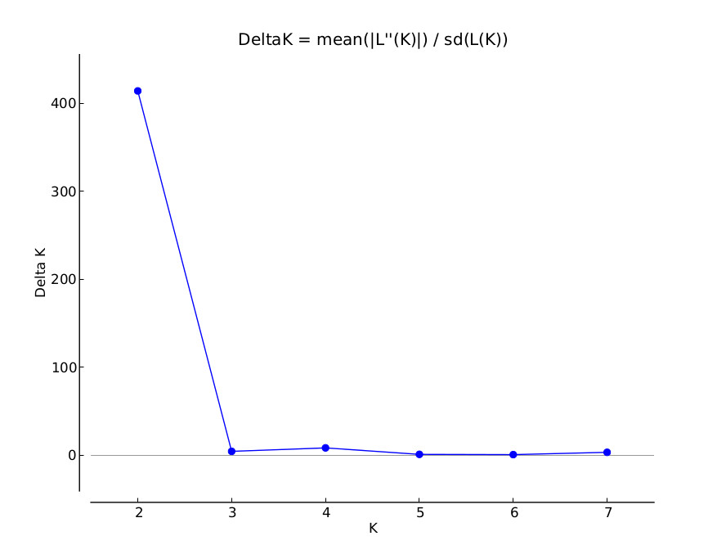
Figure S4. ΔK analysis according to the Evanno method and performed in STRUCTURE HARVESTER of the Structure clustering analysis for the 16 P. oceanica sites considering all 18 loci. K = 2 is the most likely number of clusters.

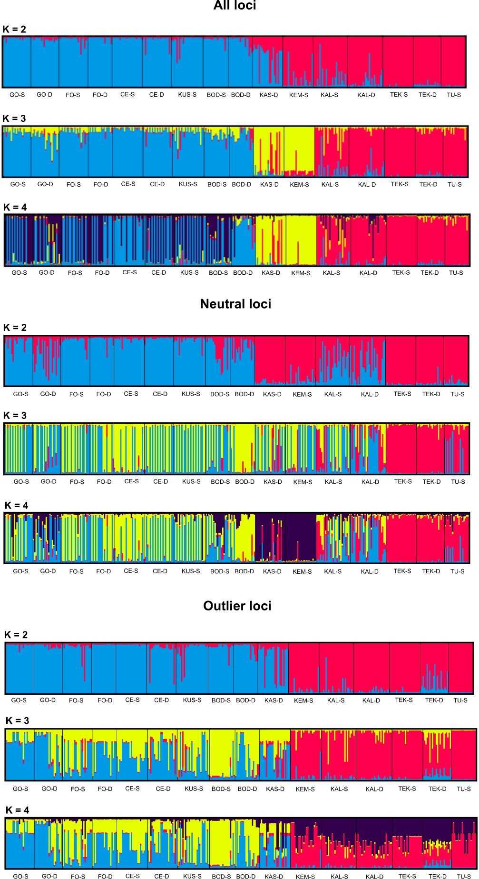
Figure S5. Spatial population structure performed in STRUCTURE among 16 sites of P. oceanica (K = 2 to K = 4) considering all 18 loci, neutral loci and only outlier loci. Each individual sampled is represented on the x-axis, while the y-axis denotes the probability of identity to each genetic cluster.

Table S10. Results of LOSITAN and BayeScan analysis for the “Aegean vs Levantine” grouping. Putative outliers shared between both methods are highlighted in bold.

 | BayeScan |  |  |  | LOSITAN
Locus | prob | log10(PO) | alpha | F_{ST} | Het | F_{ST} | P (Simul Fst<sample Fst)
Pooc-PC045G11 | 0.98360 | 1.7779 | -1.5608 | 0.067613 | 0.787807 | 0.045677 | 0.00004
Po-15 | 0.83197 | 0.69471 | -1.0037 | 0.11138 | 0.789899 | 0.129649 | 0.275046
Po-5-39 | 0.70654 | 0.38159 | -1.0123 | 0.12063 | 0.699752 | 0.031985 | 0.0
Pooc-333 | 0.23325 | -0.51684 | 0.25842 | 0.29404 | 0.295262 | 0.281034 | 0.863721
Pooc-45 | 0.175235 | -0.672709 | 0.17924 | 0.27675 | 0.058376 | 0.039053 | 0.527515
Poc-26 | 0.11242 | -0.89735 | -0.093582 | 0.2274 | 0.500347 | 0.033388 | 0.268559
Pooc-361 | 0.10762 | -0.91865 | 0.069474 | 0.25271 | 0.129683 | 0.054949 | 0.347587
Po-5-10 | 0.10662 | -0.92319 | -0.078004 | 0.22668 | 0.664363 | 0.034885 | 0.007176
Poc-5 | 0.091018 | -0.99943 | 0.052878 | 0.2487 | 0.709187 | 0.544799 | 0.879426
Poc-42 | 0.089418 | -1.0079 | -0.046789 | 0.23308 | 0.265364 | 0.013444 | 0.106593
Pooc-PC047G07 | 0.087618 | -1.0176 | -0.042694 | 0.23346 | 0.505499 | -0.002691 | 0.03105
Pooc-153 | 0.086017 | -1.0264 | 0.017515 | 0.2435 | 0.053405 | 0.014389 | 0.176429
Pooc-330 | 0.084617 | -1.0341 | 0.031955 | 0.24512 | 0.027783 | -0.000861 | 0.026704
Po-5 | 0.078816 | -1.0677 | 0.0055094 | 0.24065 | 0.112159 | 0.050938 | 0.365569
Pooc-229 | 0.075815 | -1.086 | 0.035098 | 0.24453 | 0.862687 | 0.482496 | 0.857847
Pooc-044B02 | 0.072214 | -1.1088 | 0.019296 | 0.24254 | 0.411749 | 0.279611 | 0.742241
Poc-35 | 0.069614 | -1.126 | -0.027729 | 0.23407 | 0.524829 | 0.105338 | 0.425842
Po-4-3 | 0.063613 | -1.1679 | -0.0037029 | 0.23814 | 0.358699 | 0.115412 | 0.457268

Figure S6. EDENetworks genetic relationship network for the 16 P. oceanica sites along the Turkish coastline using allele-sharing distance and an automatic thresholding of 0.28. Shallow and deep sites of the same location are shown with the same color. The node size represents the number of connections to that individual within the network. The thickness, length, and color of links indicate their weight. Longer, thinner and blue links = weak relationships; thicker, green and shorter links = strong relationships. Population acronyms as in Table 1.

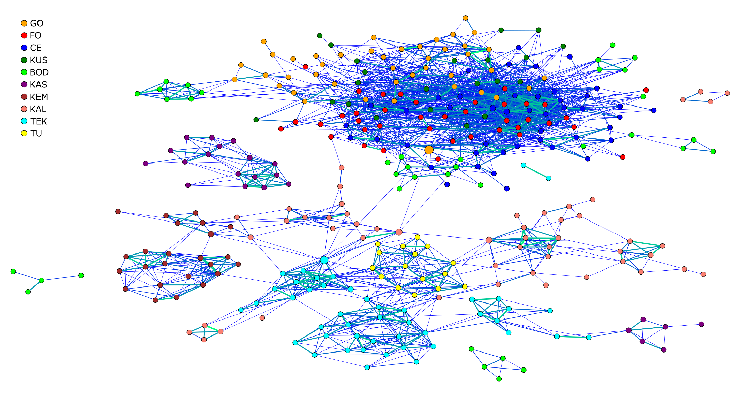

Figure S7. Non-significant relative migration levels (P > 0.05) based on D_{est} genetic differentiation for all 16 sites of P. oceanica obtained with the function ‘DivMigrate’ in the R package diveRsity. Darker connections represent higher relative migration value between locations. Only neutral loci are considered in the analysis.

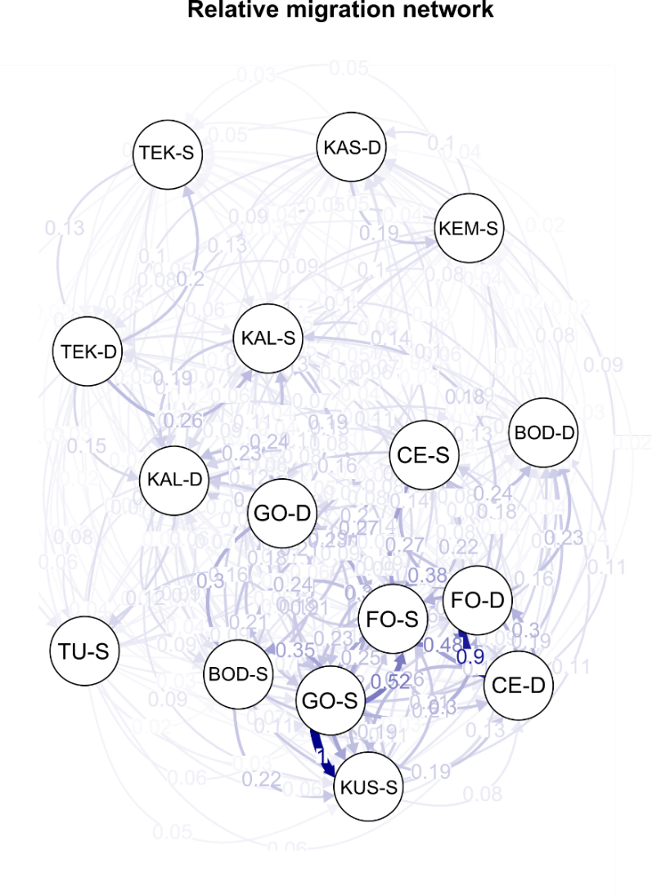

Figure S8. Oceanographic connectivity of P. oceanica. (A-I) Mean Lagrangian Probability Density Functions (PDFs) of particles after an advection time of 10 days for 9 locations along the Turkish coastline considering all the years; (J) Matrix showing potential connectivity between locations estimated via Lagrangian simulations. Site acronyms as in Fig. 1.

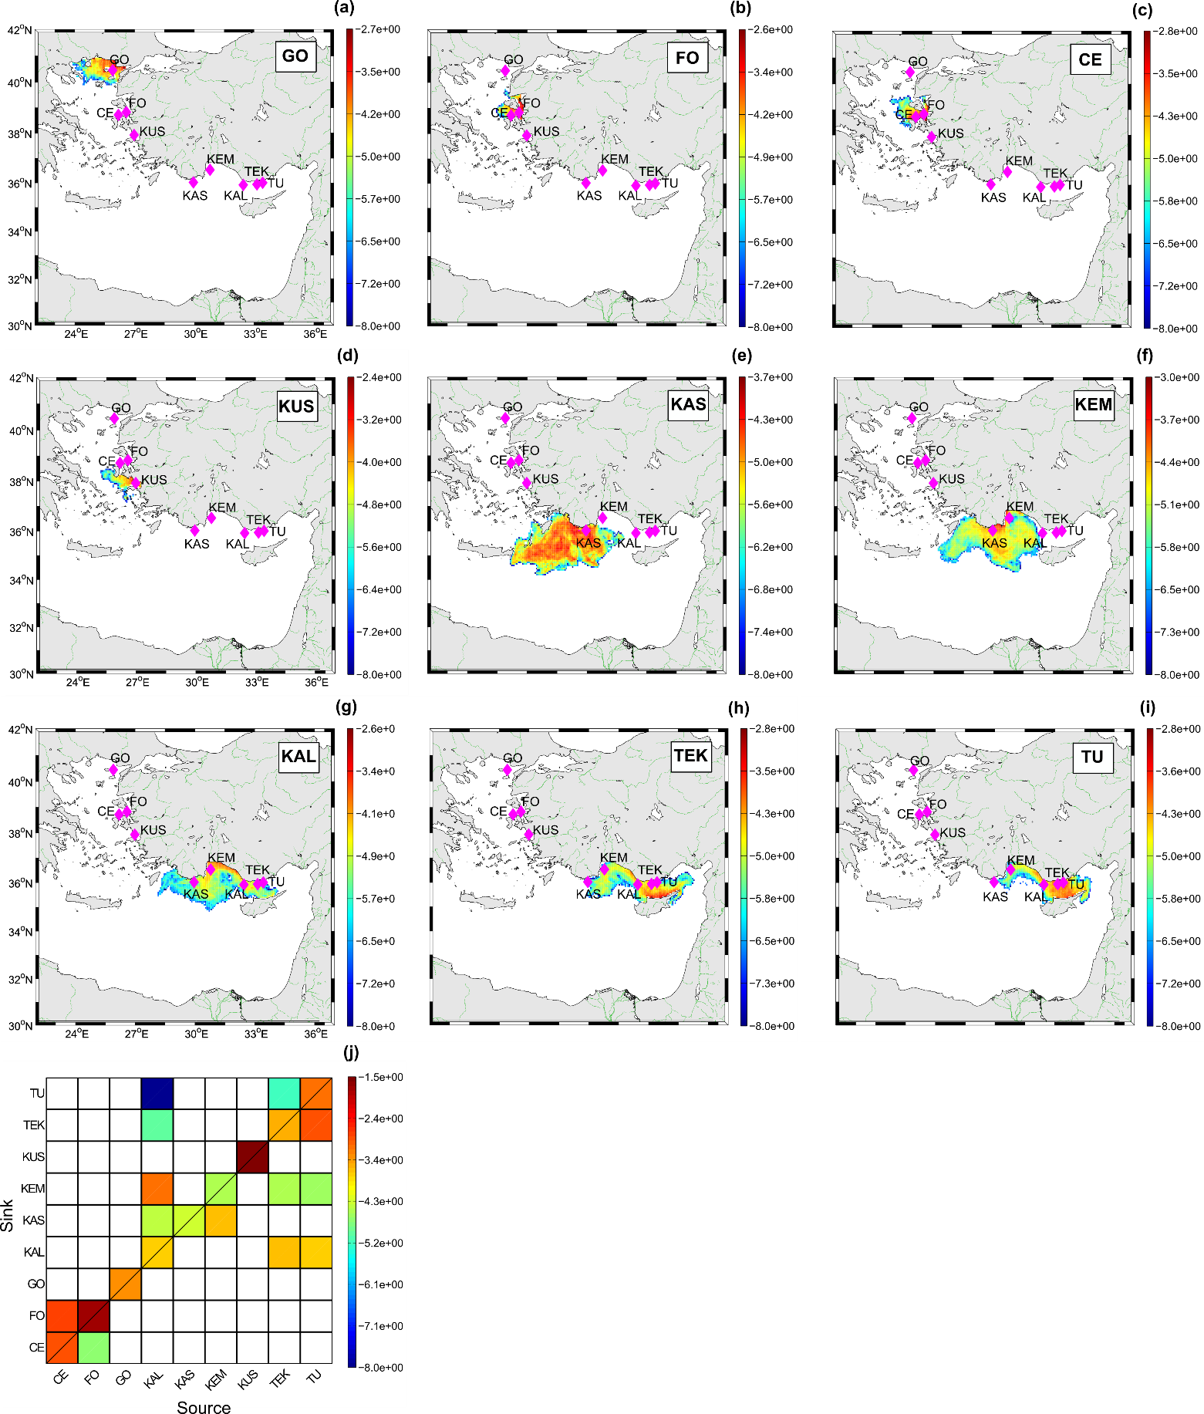
Figure S9. Oceanographic connectivity of P. oceanica. (A-I) Mean Lagrangian Probability Density Functions (PDFs) of particles after an advection time of 14 days for 9 locations along the Turkish coastline considering all the years; (J) Matrix showing potential connectivity between locations estimated via Lagrangian simulations. Site acronyms as in Fig. 1.

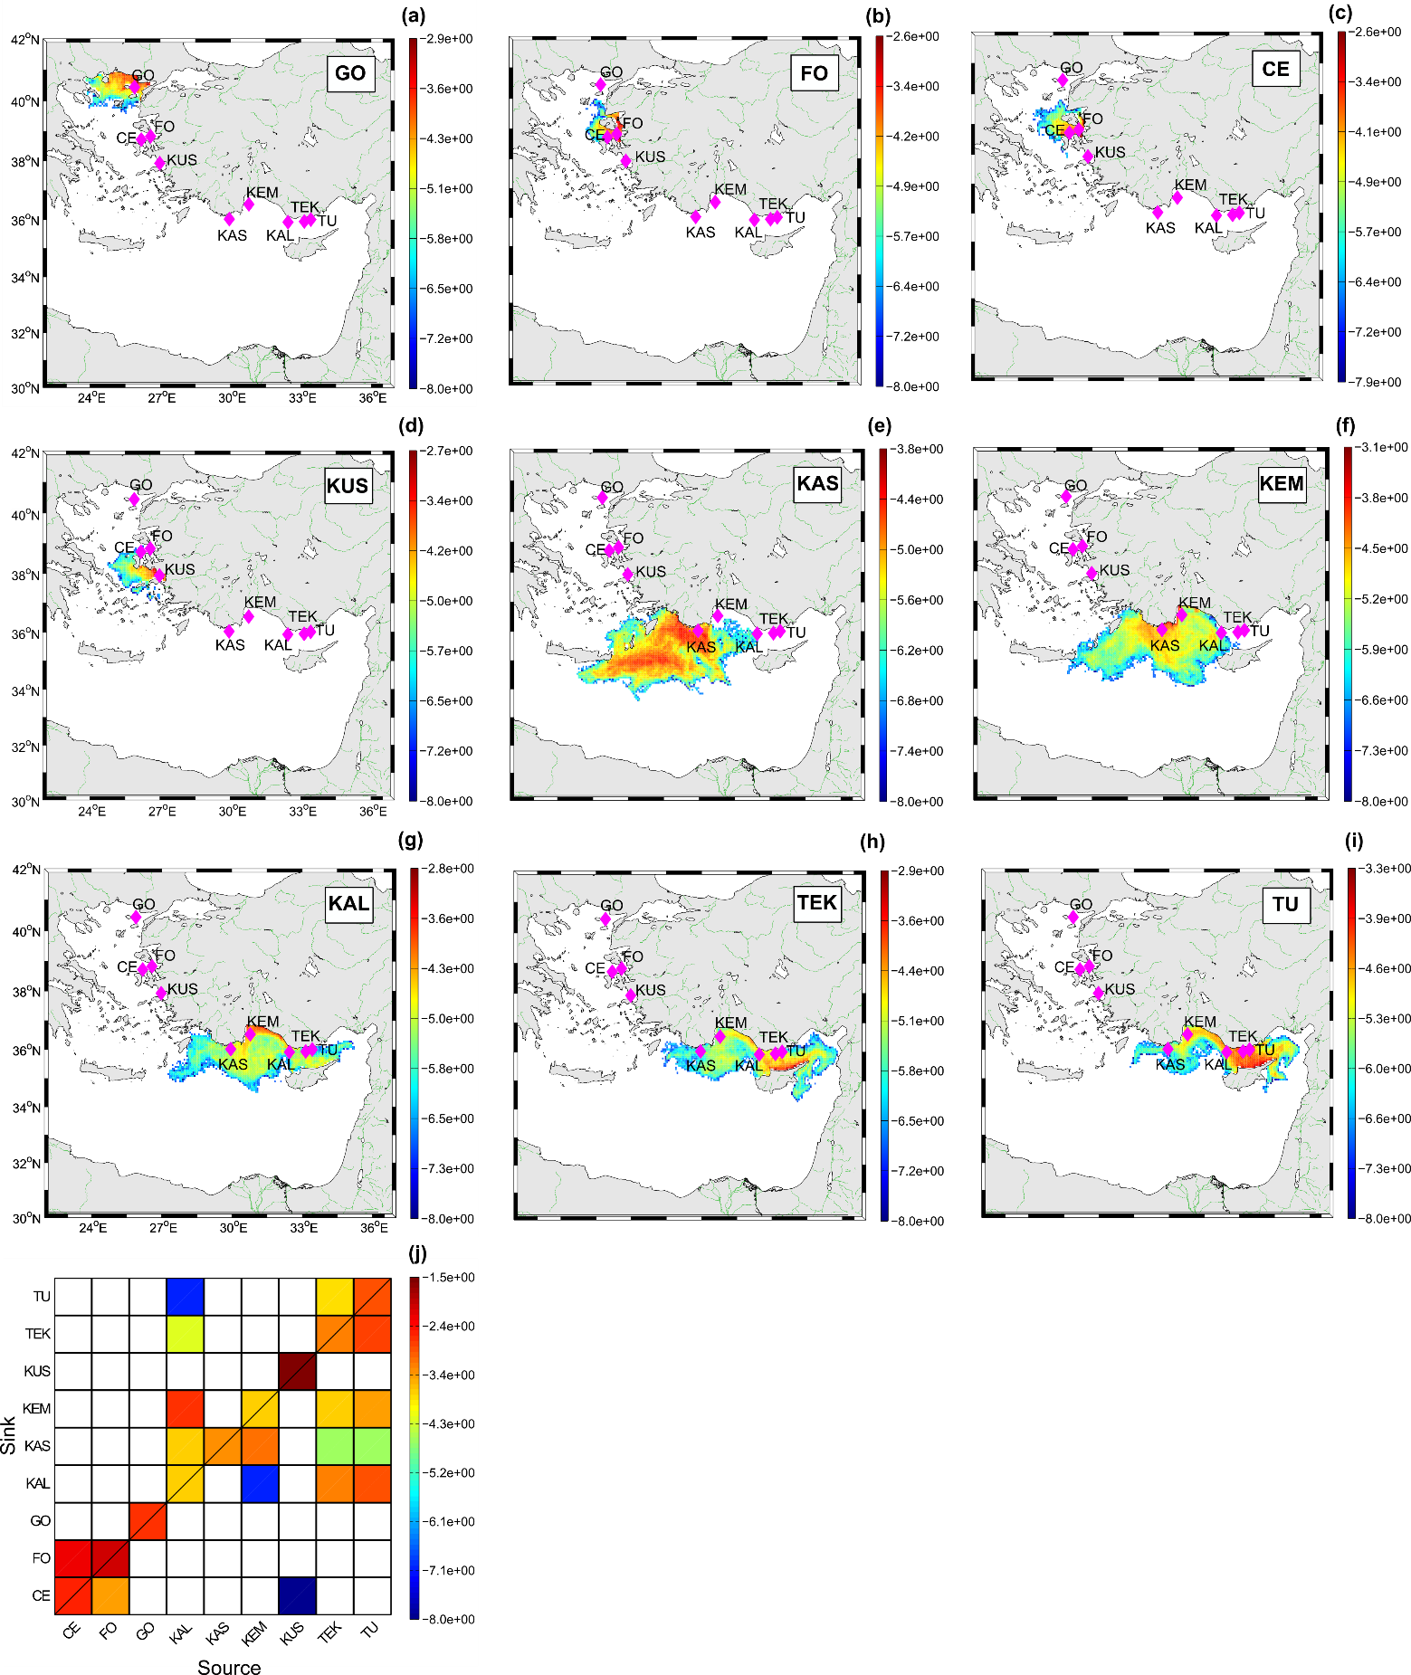
Figure S10. Oceanographic connectivity of P. oceanica. (A-I) Mean Lagrangian Probability Density Functions (PDFs) of particles after an advection time of 20 days for 9 locations along the Turkish coastline considering all the years; (J) Matrix showing potential connectivity between locations estimated via Lagrangian simulations. Site acronyms as in Fig. 1.

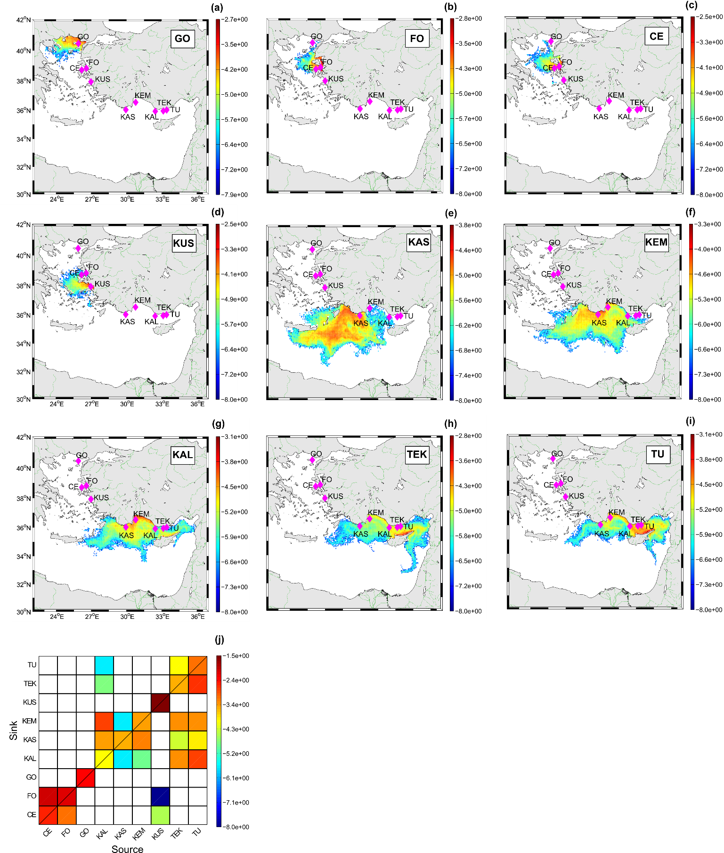
Figure S11. Histograms showing source, retention and destination strengths of each site (9 locations) along the Turkish coastline at 10, 14, 20 and 28 days of passive dispersal, calculated over all years of releases. Site acronyms as in Fig. 1.

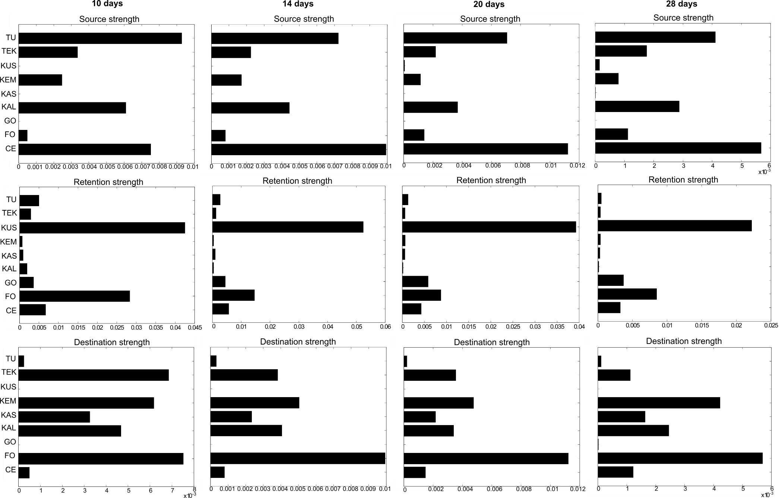
Figure S12. Monthly long-term mean of Sea Surface Temperature (SST) in the study area for the years 1991-2020 in winter months (Dec-Feb). Image provided by Physical Sciences Laboratory, NOAA, Boulder, Colorado, from their Web site at https://psl.noaa.gov/.
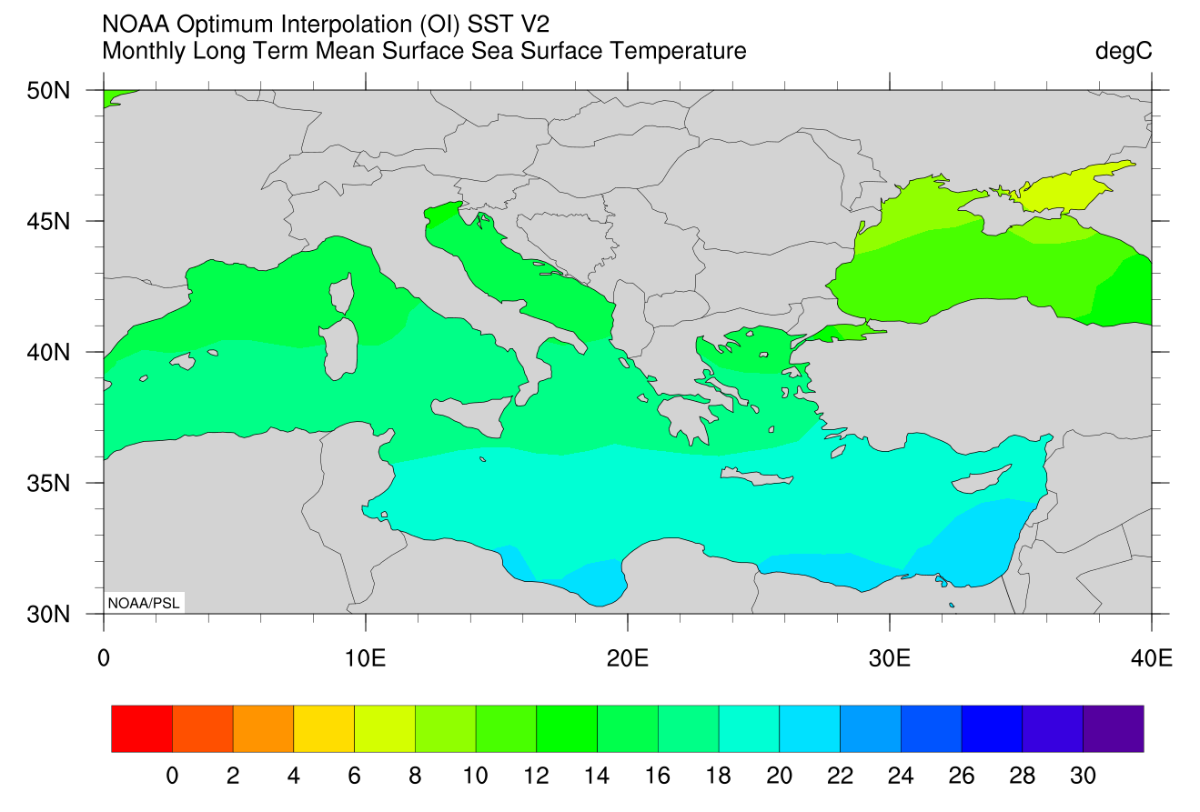

Supplementary S2

Material and Methods

Potential connectivity (oceanographic)

Lagrangian simulations were computed using the Mediterranean Forecasting System (MFS) analysis fields for the years from 2010 to 2013. MFS output consists of daily velocity fields on a regular grid with horizontal 1/16° x 1/16° spatial resolution and 72 unevenly spaced vertical levels (Dobricic et al., 2007; Tonani et al., 2008; Oddo et al., 2009). MFS is a hydrodynamic eddy-permitting model with a variational data assimilation scheme for temperature and salinity vertical profiles, and satellite Sea Level Anomaly along track data. The hydrodynamics is forced by momentum, water, and heat fluxes interactively computed by ERAInterim reanalysis fields from the European Centre for Medium-Range Weather Forecasts (ECMWF) and model predicted surface temperatures (Tonani et al., 2009). MFS assimilates satellite (sea level anomaly, SST) and in situ (ship or drifter temperature and salinity profiles) data with the 3DVar scheme (Dobricic and Pinardi, 2008). The great advantage of using MFS products for applied research studies in the Mediterranean Sea is that they are publicly available, with a wide range of temporal coverage. It has to be pointed out that near the coastline, the model velocity fields are not expected to reproduce the coastal dynamics with great accuracy, especially where the roughness of the coastline has a characteristic scale smaller than the spatial resolution of the model. Despite these limitations, in the present context, the most important contribution of the numerical simulations was to provide a statistical description of the site-to-site transport across the Mediterranean region under study, rather than a detailed trajectory evolution next to the coastline. At this regard, we recall here a Lagrangian validation and optimization methodology that was recently developed for the MFS model currents, in terms of dynamical systems techniques and multi-scale chaotic models (Lacorata et al., 2014), and later extended to observational (satellite-derived) current fields in other ocean regions (Lacorata et al., 2019). Since part of the mesoscale energy spectrum is filtered out by the finite resolution of the large-scale ocean model, the relative dispersion rates of numerical Lagrangian trajectories, computed by integration of MFS velocity fields, can significantly underestimate the dispersion of actual ocean tracers. The amount of this discrepancy is evaluated by computing the Finite-Scale Lyapunov Exponent, i.e., the optimal scale-dependent indicator of relative dispersion, for both numerical and real ocean drifter trajectories (Lacorata et al., 2014). This issue can be overtaken by introducing an additional “sub-grid” model, which restores, in a statistical sense, the missing velocity modes into the large-scale circulation model. This sub-grid model, called Kinematic Lagrangian Model (KLM), was devised in the framework of the chaotic systems theory (Lacorata et al., 2014, Lacorata & Vulpiani, 2017) and applied to several studies of Lagrangian transport in the ocean (Palatella et al., 2014; Maffucci et al., 2016; Torri et al., 2018; Lacorata et al., 2019; Falcini et al., 2020). In order to simulate small-scale turbulent fluctuations, consistently with observation, the parameter representing the turbulent dissipation rate in KLM has the same order of magnitude, ε ⁓ O (10⁻⁹) m²/s³, of the mean turbulent dissipation rate measured from Mediterranean surface drifter data (Lacorata et al., 2014). Furthermore, the kinematic sub-grid modelling, depending on the case study, can be possibly extended to simulate also chaotic/turbulent vertical motions in the mixed layer. In our case, we only considered fixed-depth 2D Lagrangian trajectories. The operating procedure for the implementation of the numerical simulations consists of the following basic steps: MFS model velocity data are retrieved for period and area of interest; a fixed depth (-3 m) is selected; an interpolation scheme involving bi-cubic splines in space, and linear interpolation in time, is applied to compute the large-scale fields outside the grid points and at fractions of day; a suitably parameterized sub-grid kinematic field is added to the trajectory evolution equations; the numerical integration time step is set to 120 s while particle positions are printed out every hour; the increment due to the kinematic term is integrated by means of a 4th order Runge-Kutta algorithm while the contribution due to MFS velocity term is computed by linear integration; reflective boundary conditions are imposed along the coastlines where a “mask” is used to distinguish the land from the sea; a (large) number of numerical trajectories are released from a given site and analysed after a given time interval in terms of final positions and density distribution (as described in the main text). It can happen that for initial conditions too close to the land, and/or surrounded almost completely by coastline and islands, the Lagrangian simulation is not feasible.

References

Dobricic, S., & Pinardi, N. 2008. An oceanographic three-dimensional variational data assimilation scheme. Ocean Modeling, 22: 89–105.
Dobricic, S., Pinardi, N., Adani, M., Tonani, M., Fratianni, C., Bonazzi, A. & Fernandez, V. 2007. Daily oceanographic analyses by Mediterranean Forecasting System at the basin scale. Ocean Science, 3: 149-157.
Falcini, F., Corrado, R., Torri, M., Mangano, M.C., Zarrad, R., Di Cintio, A., Palatella, L., Jarboui, O., Missaoui, H. & Cuttitta, A. 2020. Seascape connectivity of European anchovy in the Central Mediterranean Sea revealed by weighted Lagrangian backtracking and bio-energetic modelling. Scientific reports, 10: 1-13.
Lacorata, G., Corrado, R., Falcini, F. & Santoleri, R. 2019. FSLE analysis and validation of Lagrangian simulations based on satellite-derived GlobCurrent velocity data. Remote sensing of environment, 221: 136-143.
Lacorata, G., Palatella, L. & Santoleri, R. 2014. Lagrangian predictability characteristics of an Ocean Model. Journal of Geophysical Research: Oceans, 119: 8029-8038.
Lacorata, G. & Vulpiani, A. 2017. Chaotic Lagrangian models for turbulent relative dispersion. Physical Review E, 95: 043106.
Maffucci, F., Corrado, R., Palatella, L., Borra, M., Marullo, S., Hochscheid, S., Lacorata, G. & Iudicone, D. 2016. Seasonal heterogeneity of ocean warming: a mortality sink for ectotherm colonizers. Scientific reports, 6: 1-9.
Oddo, P., Adani, M., Pinardi, N., Fratianni, C., Tonani, M. & Pettenuzzo, D. 2009. A nested Atlantic-Mediterranean Sea general circulation model for operational forecasting. Ocean science, 5: 461-473.
Palatella, L., Bignami, F., Falcini, F., Lacorata, G., Lanotte, A.S. & Santoleri, R. 2014. Lagrangian simulations and interannual variability of anchovy egg and larva dispersal in the Sicily Channel. Journal of Geophysical Research: Oceans, 119: 1306-1323.
Tonani, M., Pinardi, N., Dobricic, S., Pujol, I. & Fratianni, C. 2008. A high-resolution free-surface model of the Mediterranean Sea. Ocean Science, 4: 1-14.
Tonani, M., Pinardi, N., Pistoia, J., Dobricic, S., Pensieri, S., de Alfonso, M. & Nittis, K. 2009. Mediterranean forecasting system: Forecast and analysis assessment through skill scores. Ocean Science, 5: 649–660.
Torri, M., Corrado, R., Falcini, F., Cuttitta, A., Palatella, L., Lacorata, G., Patti, B., Arculeo, M., Mifsud, R. & Mazzola, S. 2018. Planktonic stages of small pelagic fishes (Sardinella aurita and Engraulis encrasicolus) in the central Mediterranean Sea: The key role of physical forcings and implications for fisheries management. Progress in Oceanography, 162: 25-39.

