ChemCatChem
Supporting Information

Ammonia Borane Hydrolysis towards H₂ Production: Integrating Experimental Studies, Computational Fluid Dynamics and Statistical Analysis for Predicting and Optimising Process Conditions for Reactor Design
Panayiota Adamou, Eleana Harkou, Silvio Bellomi, Ilaria Barlocco, Dimitris Mintis, Antreas Afantitis, Juan J. Delgado, Xiaowei Chen, George Manos, Nikolaos Dimitratos, Alberto Villa*, Achilleas Constantinou*

^{Supporting Information for}
Ammonia Borane Hydrolysis towards H₂ Production: Integrating Experimental Studies, Computational Fluid Dynamics and Statistical Analysis for Predicting and Optimising Process Conditions for Reactor Design
Panayiota Adamou^{[a]}, Eleana Harkou^{[a]}, Silvio Bellomi^{[b]}, Ilaria Barlocco^{[b]}, Dimitris Mintis^{[c,d]}, Antreas Afantitis^{[c,d]}, Juan J. Delgado^{[e]}, Xiaowei Chen^{[e]}, George Manos^{[f]}, Nikolaos Dimitratos^{[g,h]}, Alberto Villa^{[b,*]}, Achilleas Constantinou^{[a,*]}
[a] P. Adamou, E. Harkou, A. Constantinou
Department of Chemical Engineering, Cyprus University of Technology, 57 Corner of Athinon and Anexartisias, 3036 Limassol, Cyprus
E-mail: a.konstantinou@cut.ac.cy
[b] S Bellomi, I. Barlocco, A. Villa
Dipartimento di Chimica, Università degli Studi di Milano, via Golgi 19, I-20133, Milano, Italy
Email: alberto.villa@unimi.it
[c] D. Minits, A. Afantitis
NovaMechanics Ltd, Nicosia 1070, Cyprus
[d] D. Minits, A. Afantitis
Entelos Institute, Larnaca 6059, Cyprus
[e] J.J. Delgado, X. Chen
Departamento de Ciencia de los Materiales, Ingeniería Metalúrgica y Química Inorgánica, Facultad de Ciencias, Universidad de Cádiz, Campus Río San Pedro, Puerto Real (Cádiz) E-11510, Spain
[f] G. Manos
Department of Chemical Engineering, University College London, London WCIE 7JE, UK
[g] N. Dimitratos
Department of Industrial Chemistry “Toso Montanari”, Alma Mater Studiorum University of Bologna, Viale Risorgimento 4, 40136 Bologna, Italy
[h] N. Dimitratos

Center for Chemical Catalysis-C3, Alma Mater Studiorum University of Bologna, Viale Risorgimento 4, 40136 Bologna, Italy

Ir/Ni₁₀Ce catalyst development
NiCeO_{x} composite oxides were developed by a rate-controlled co-precipitation method with a Na₂CO₃ solution (1M). The nitrate precursors, Ni(NO₃)₂·6H₂O and Ce(NO₃)₃·6H₂O, were added to the desired volume of milliQ water (50 mL/g catalyst) to achieve a Ni/(Ni+Ce) loading of 10 wt%. The solution was aged for 30 min under 800 rpm stirring. Using a peristaltic pump, Na₂CO₃ was added at 2 mL/min, until a pH of 8.5 was reached, monitored with an online pH electrode. The resulted precipitate was aged at room temperature for 3 h, then washed three times with hot distilled water and then was dried at 100 ºC overnight and calcined in static air at 650 ºC for 5 h. The desired amount of Ir (IrCl₃) was deposited by incipient wetness impregnation to achieve a metal loading of 1 wt%. Both bare and Ir-doped supports were thermally treated in a vertical tubular furnace in N₂ at 400 ºC for 2 h and in 10 % H₂ at 200 ºC for 2 h.
Characterisation techniques
Talos F200X instrument (FEI) was utilised for high-angle annular dark field scanning transmission electron microscopy (HAADF-STEM) characterisation. Energy-dispersive X-ray spectroscopy (EDX) was carried out for the elemental distribution of the samples, with a beam current of 200 picoamperes and a dwell time of 128 microseconds per pixel to ensure precise resolution. Ir nanoparticles were randomly selected and measured using ImageJ software. The average particle size (d) was also calculated using the expression: d = ∑n_{i}d_{i}/∑n_{i}, where n_{i}​ ≥150. The corresponding metal particle size distributions were also determined. XRD patterns were collected using a D8ADVANCE diffractometer (Bruker) with Cu Kα₁ radiation (λ=1.5406 Å). Data were recorded from 20° to 70° 2θ at a step size of 0.02°/s.
Table S1. Comparison of noble metal catalysts on experimental conditions, activation energy, and TOF value.
Catalyst | Temperature (ºC) | Reaction time (min) | Catalyst amount/Cat:Sub Ratio | Activation energy (kJ/mol) | TOF (min ⁻¹) | Ref.
Ru/C | 25 | 16 | 15.2 mg | 76.0 | - | ^{[1]}
Ru⁰/X-NW | 25 | 30 | 0.00271 | 77 | 135 | ^{[2]}
Ru/γ-Al₂O₃ | 65 | ∼11 | 10 wt% | 67 |  | ^{[3]}
Ru/graphene | 25 | 6 | 0.01 | 11.7 | 100 | ^{[4]}
Ru/TiO₂(P25) | 25 | ∼20 | 0.001 | 37.7 | 604 | ^{[5]}
Ru NPs | 25 | 6 | 0.0025 | 27.5 | 21.8 | ^{[6]}
Ru/C | 25 | 1.66 | 0.00425 | 34.81 | 429.5 | ^{[7]}
Rh⁰/CeO₂ | 25 | - | 0.0008 | 42.6 | 2010 | ^{[8]}
Pd-Rh@PVP | 25 | 0.83 | 0.003 | 46.1 | 1333 | ^{[9]}
SNP-Pt₆₅Ti₃₅ | 25 | ∼10 | 0.01 | 39.4 | 51.4 | ^{[10]}
Rh³⁺-Y | 25 | ∼8 | 0.002 | 66.9 | 92 | ^{[11]}
[Cp*Ir(6,6’-(OH)₂-bpy)(OH₂)]SO₄ | 65 | 60 | 1 μmol | ∼100 | - | ^{[12]}
Ir/Ni₁₀Ce | 40 | 10 min | 0.0003 | 65.9 | 400 | This study

Figure S1. Particle size distribution of the Ir/Ni₁₀Ce catalyst.

Figure S2. XRD patterns of IrNi₁₀Ce.
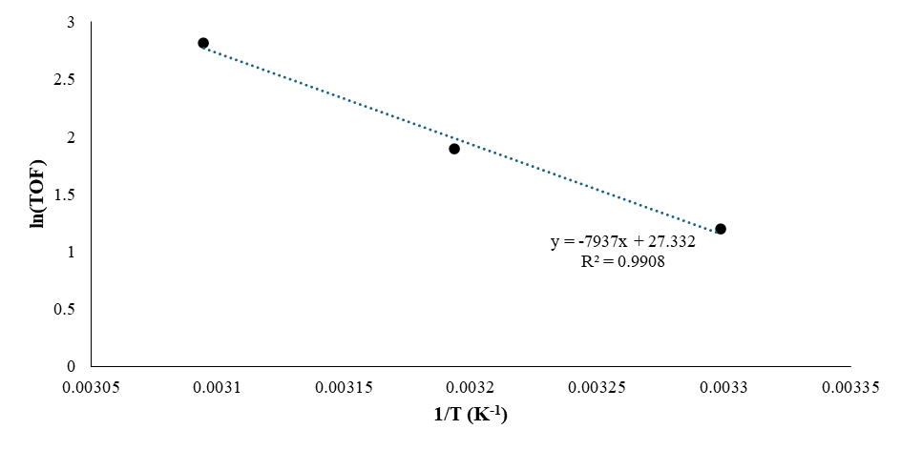
Figure S3. Arrhenius plot (30-50 ºC).
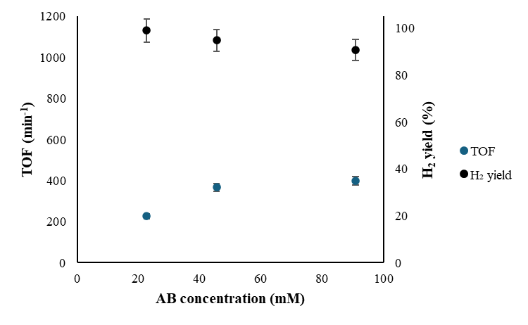

Figure S4. TOF values (left y-axis) and H₂ yield (right y-axis) at AB concentrations of 22.7-90.9 mM.

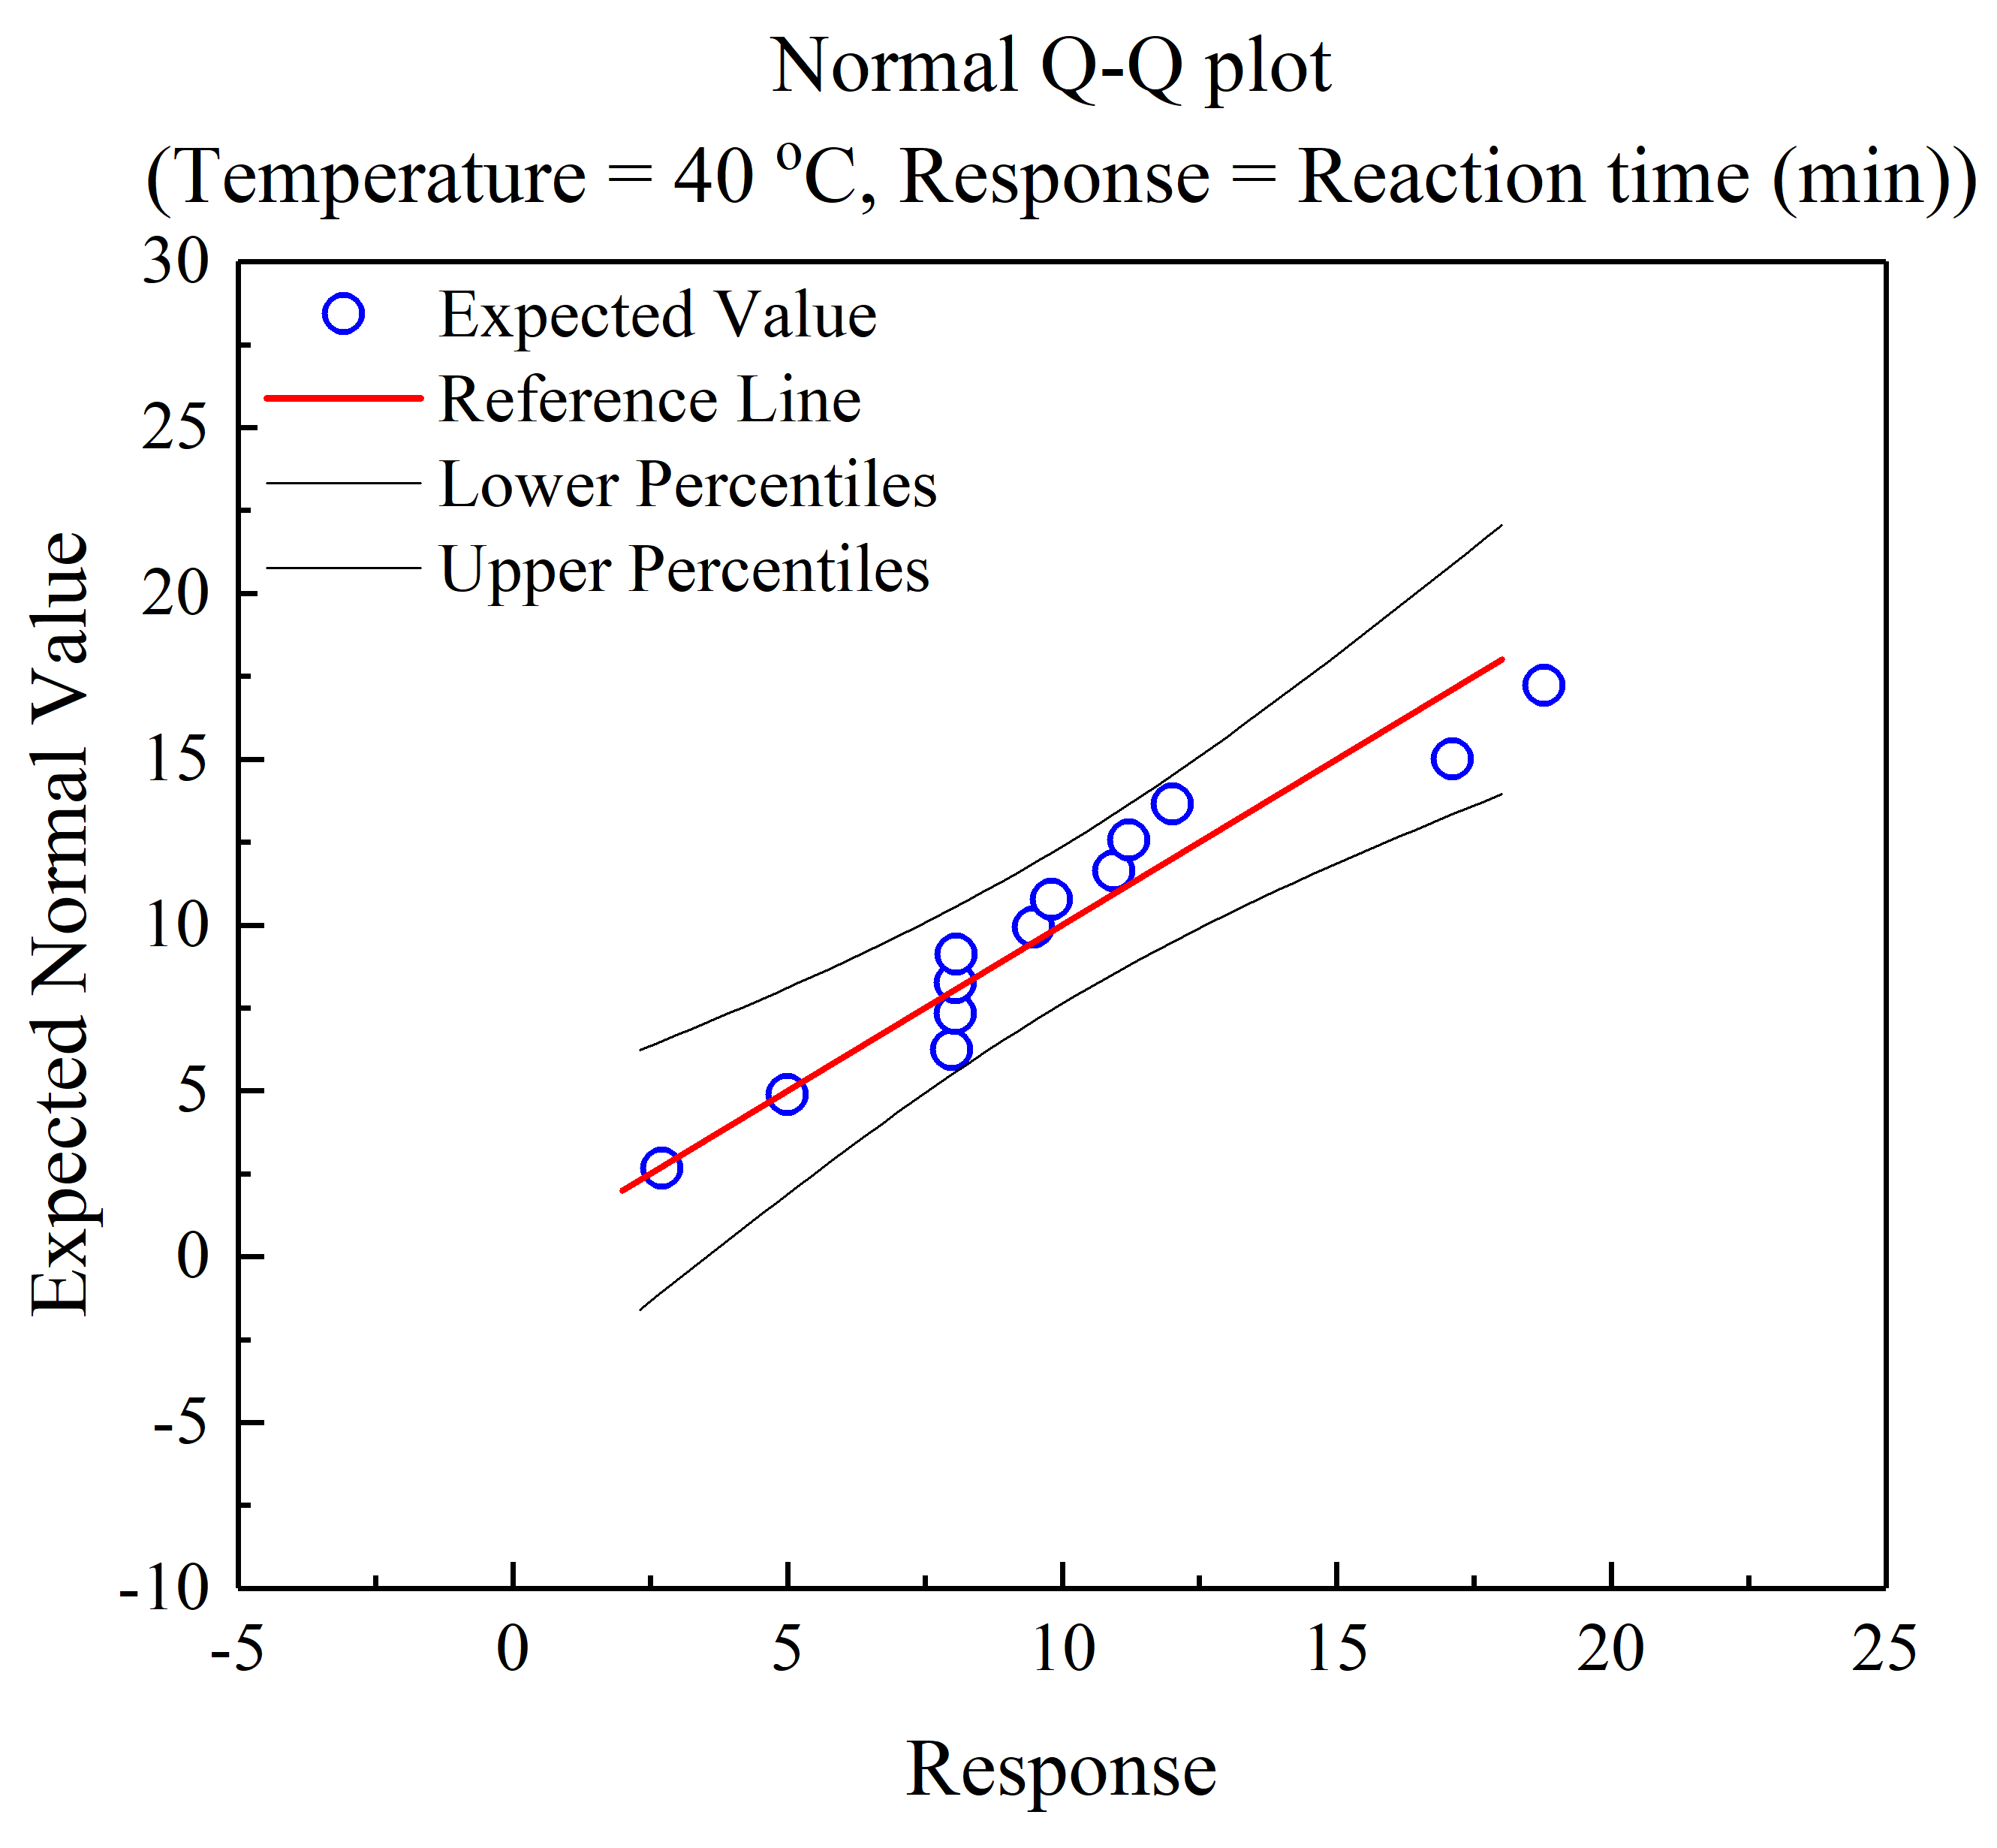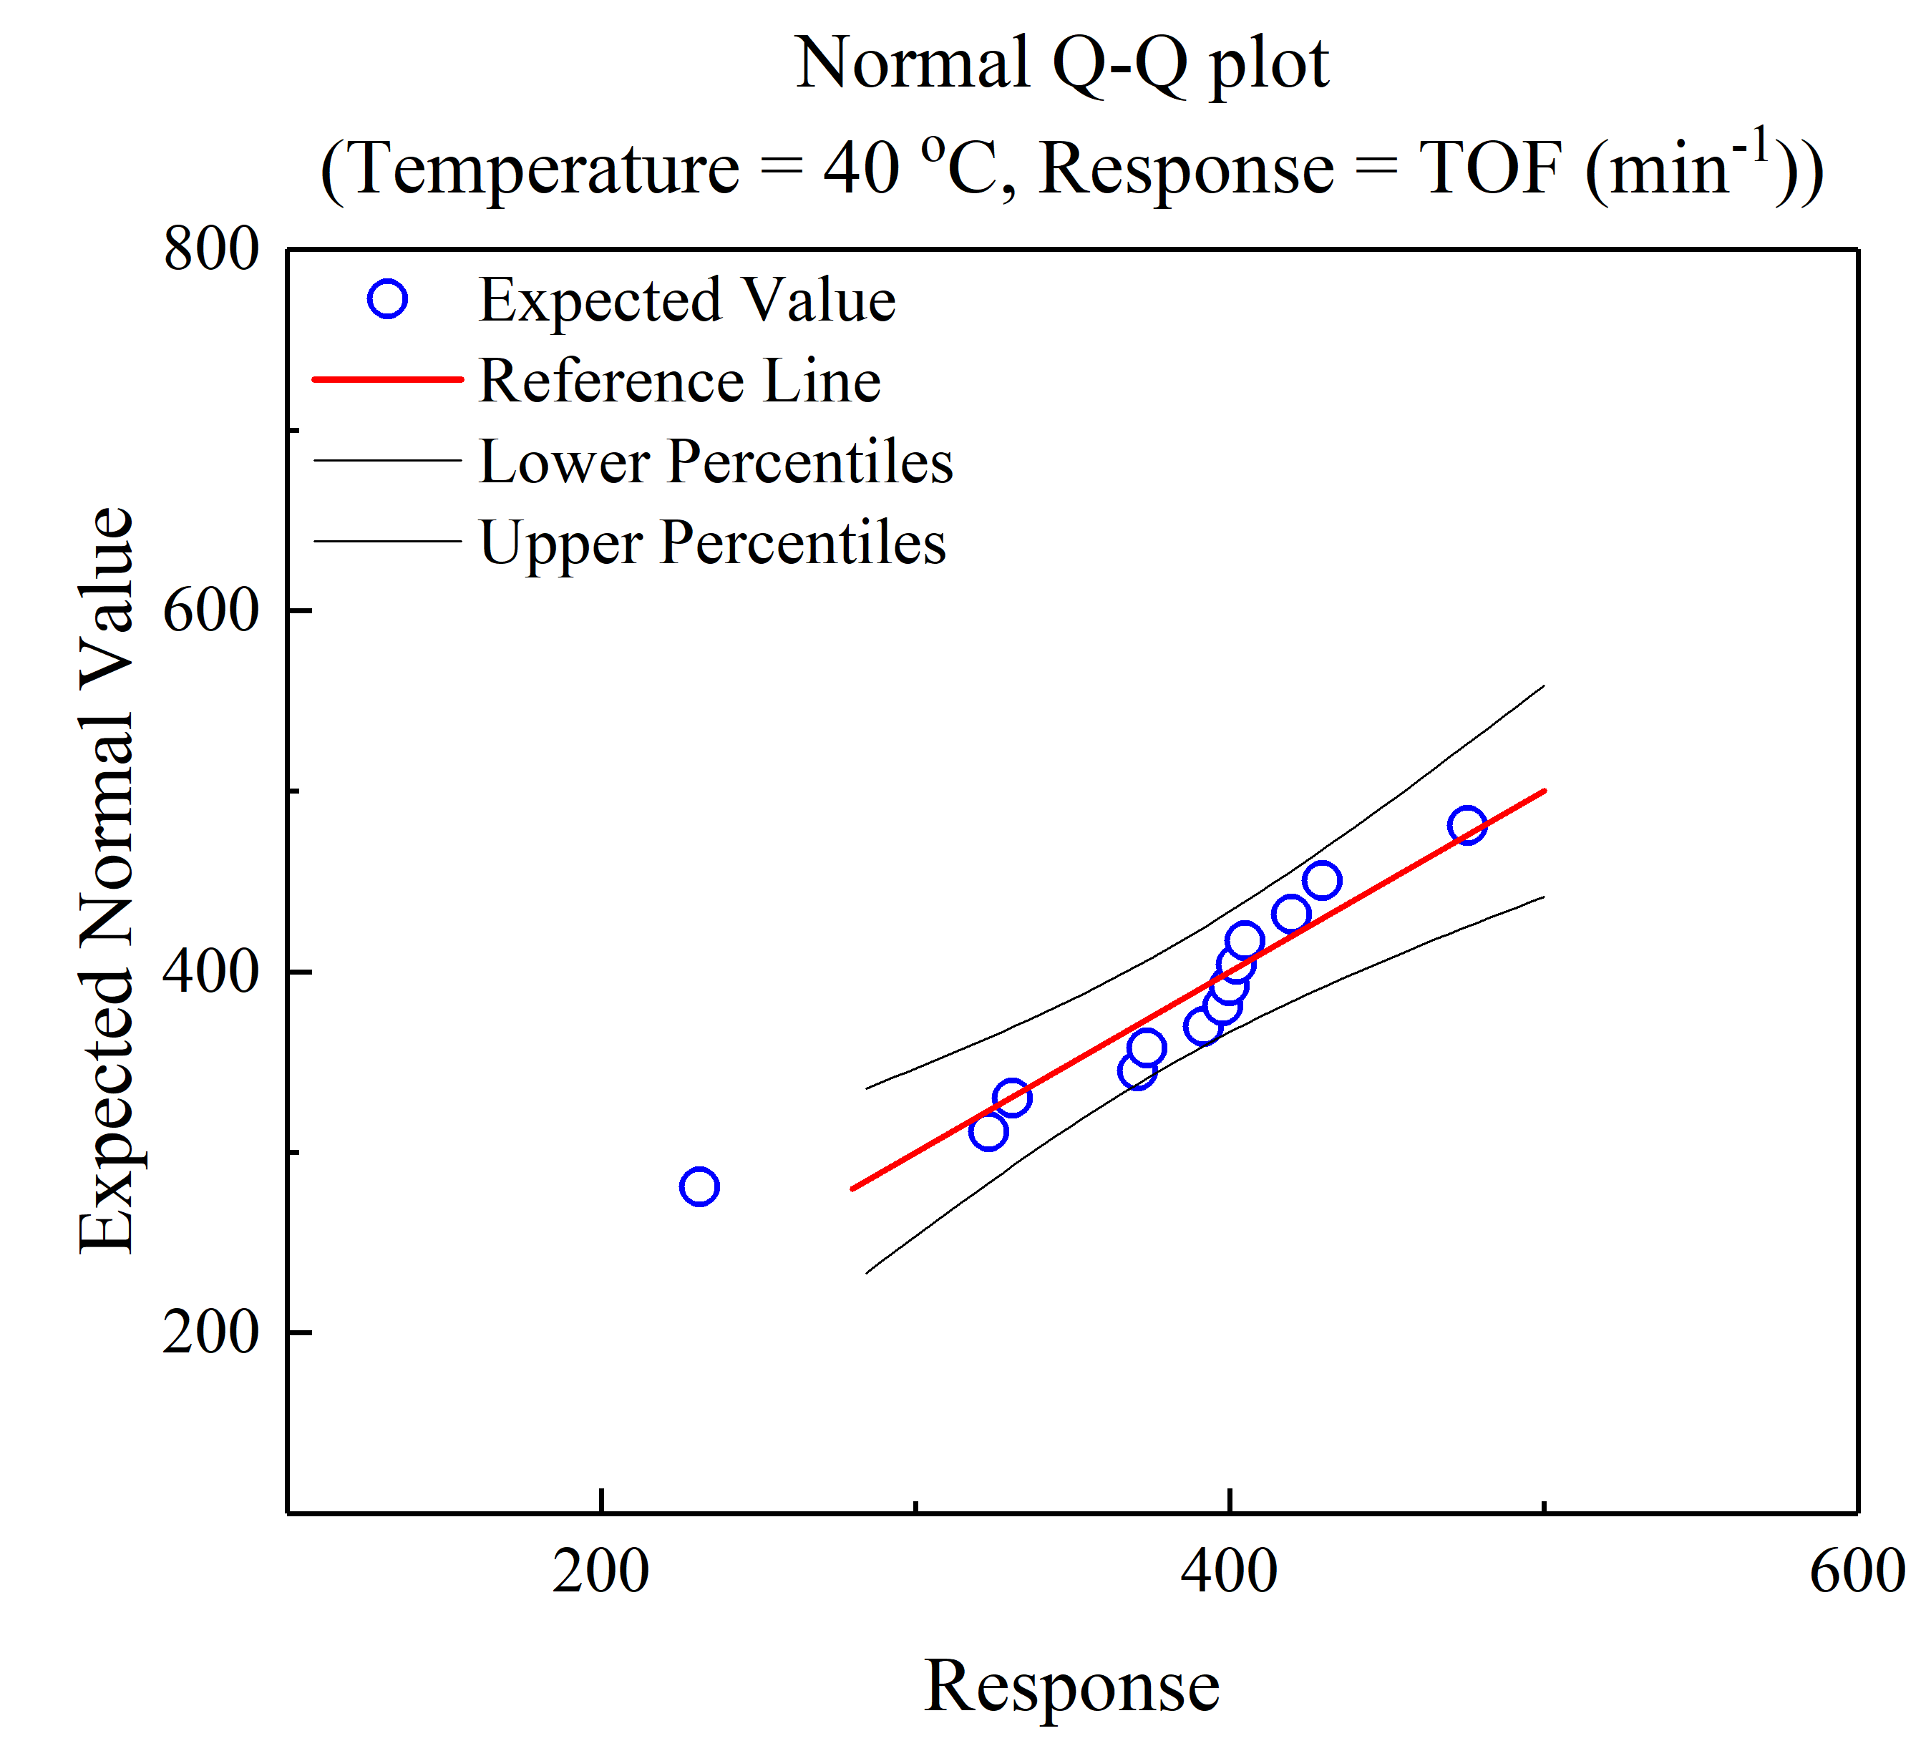
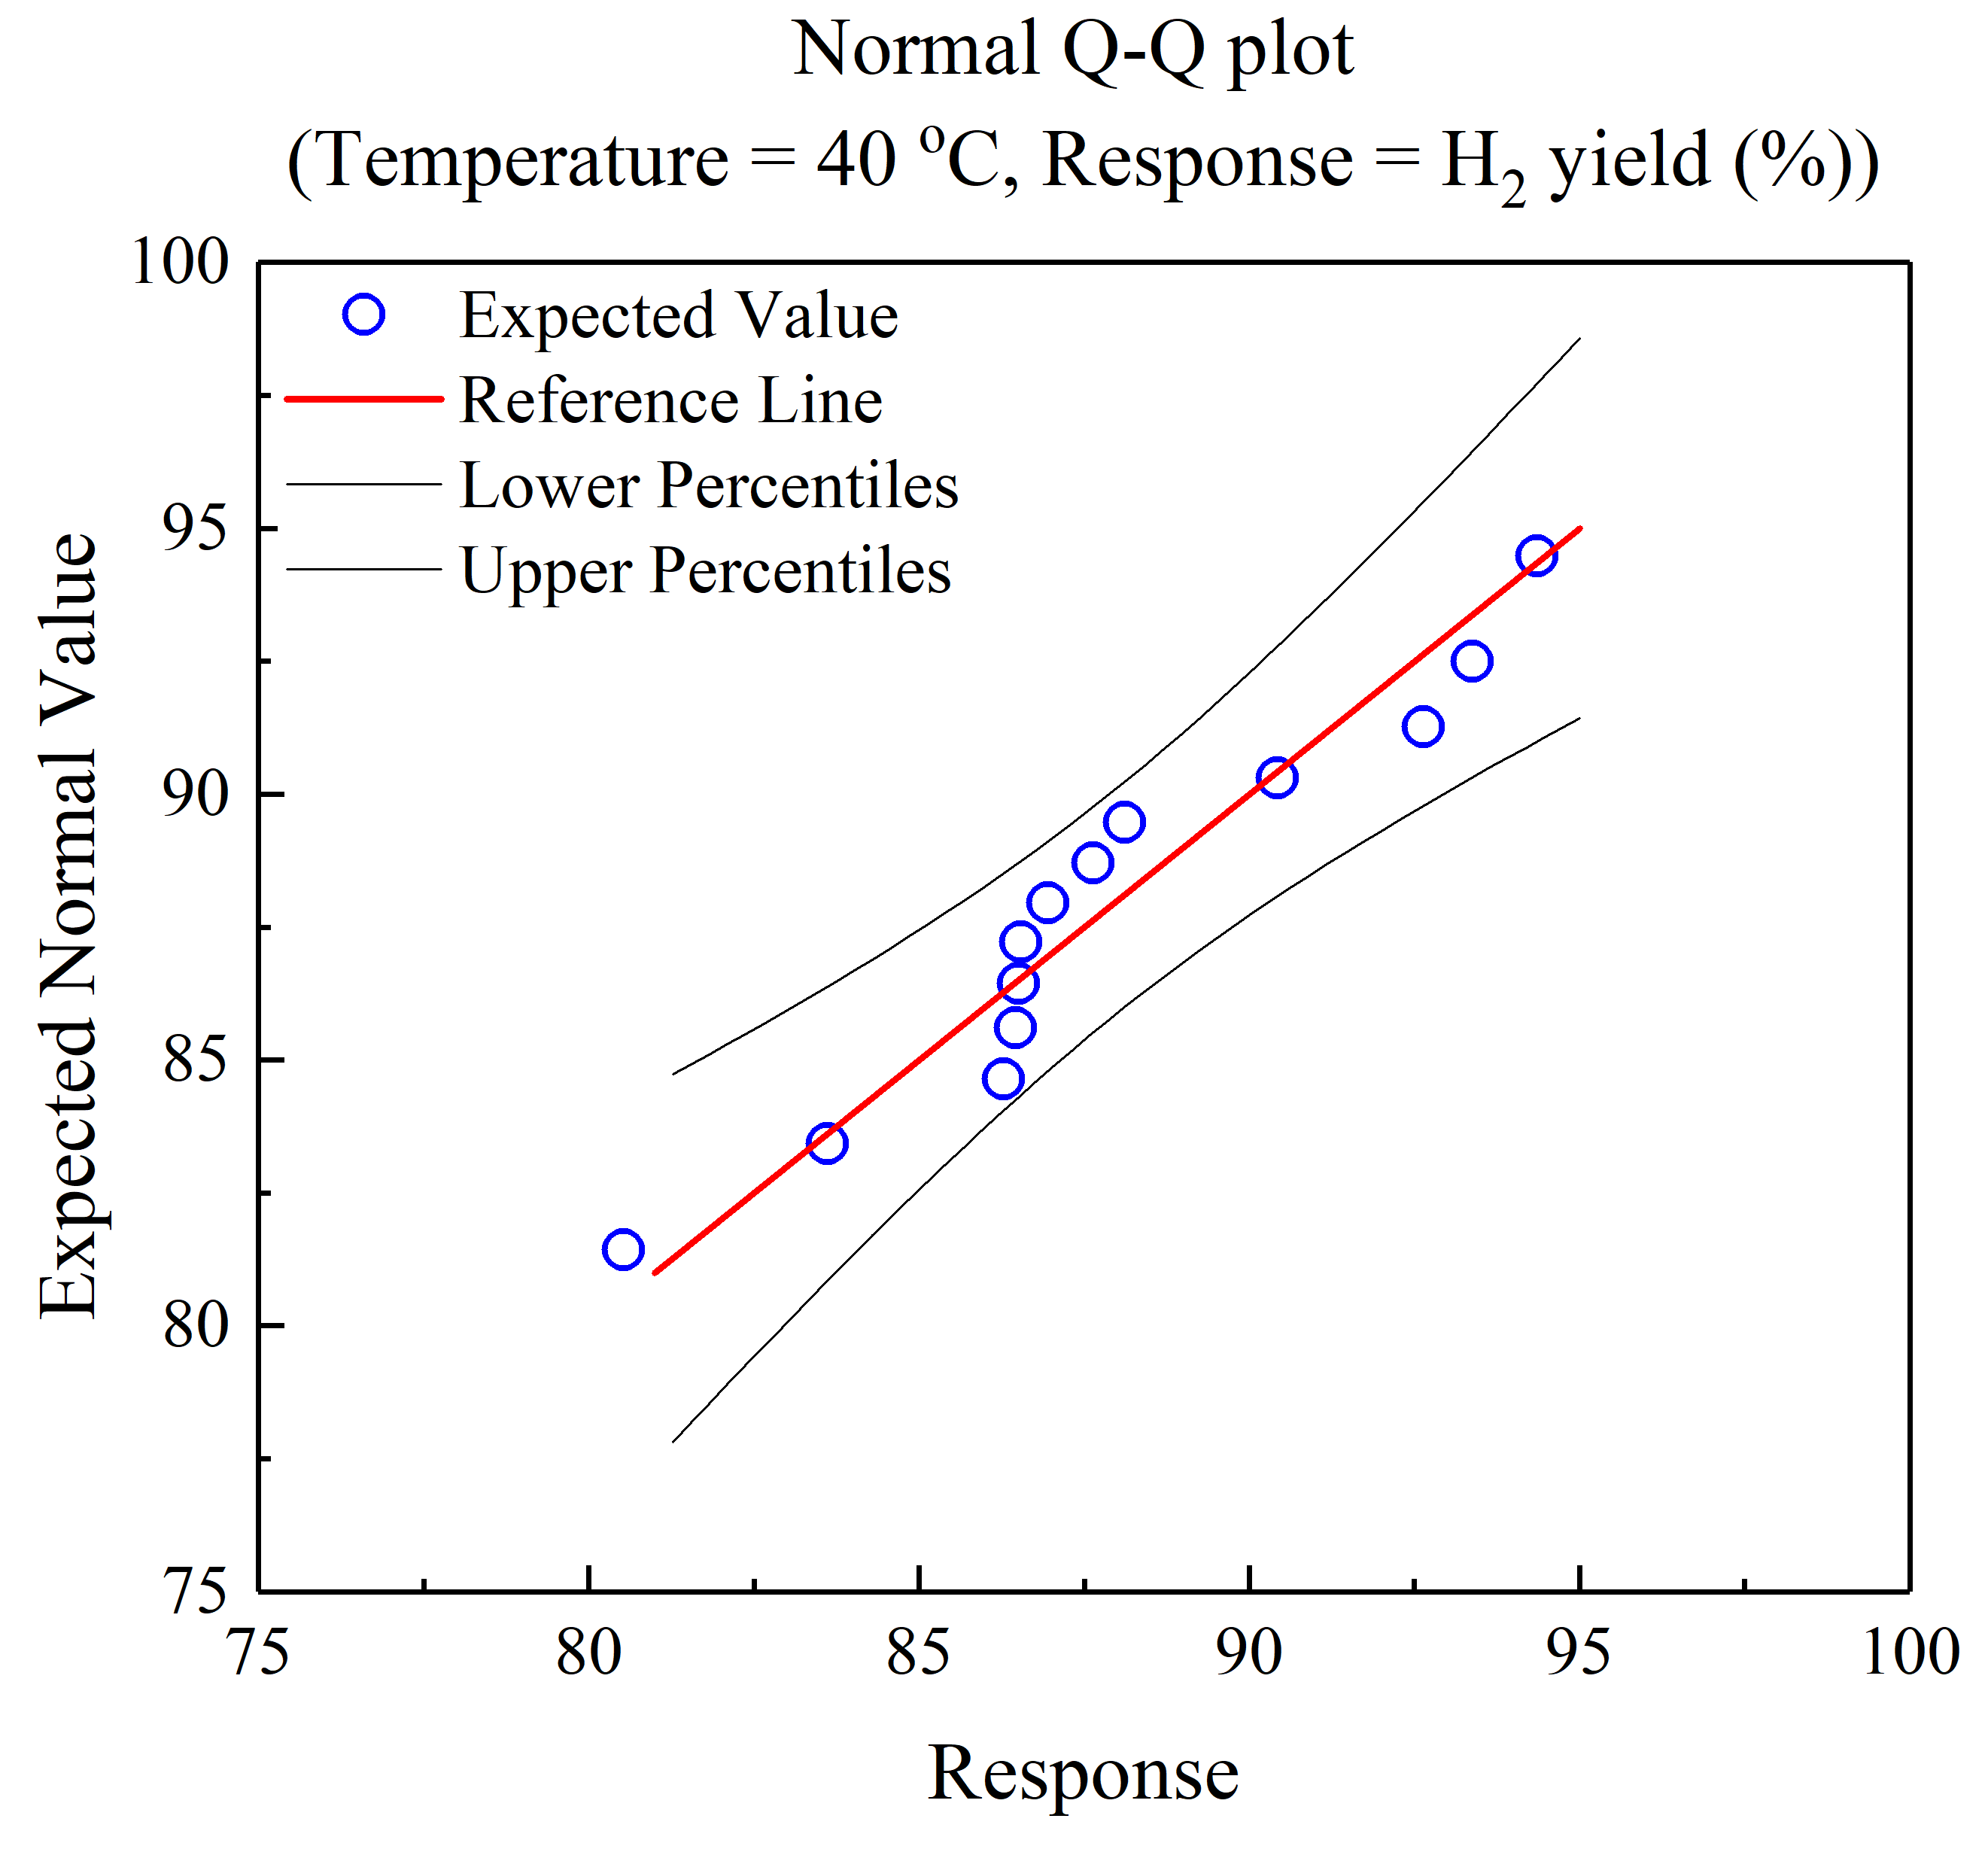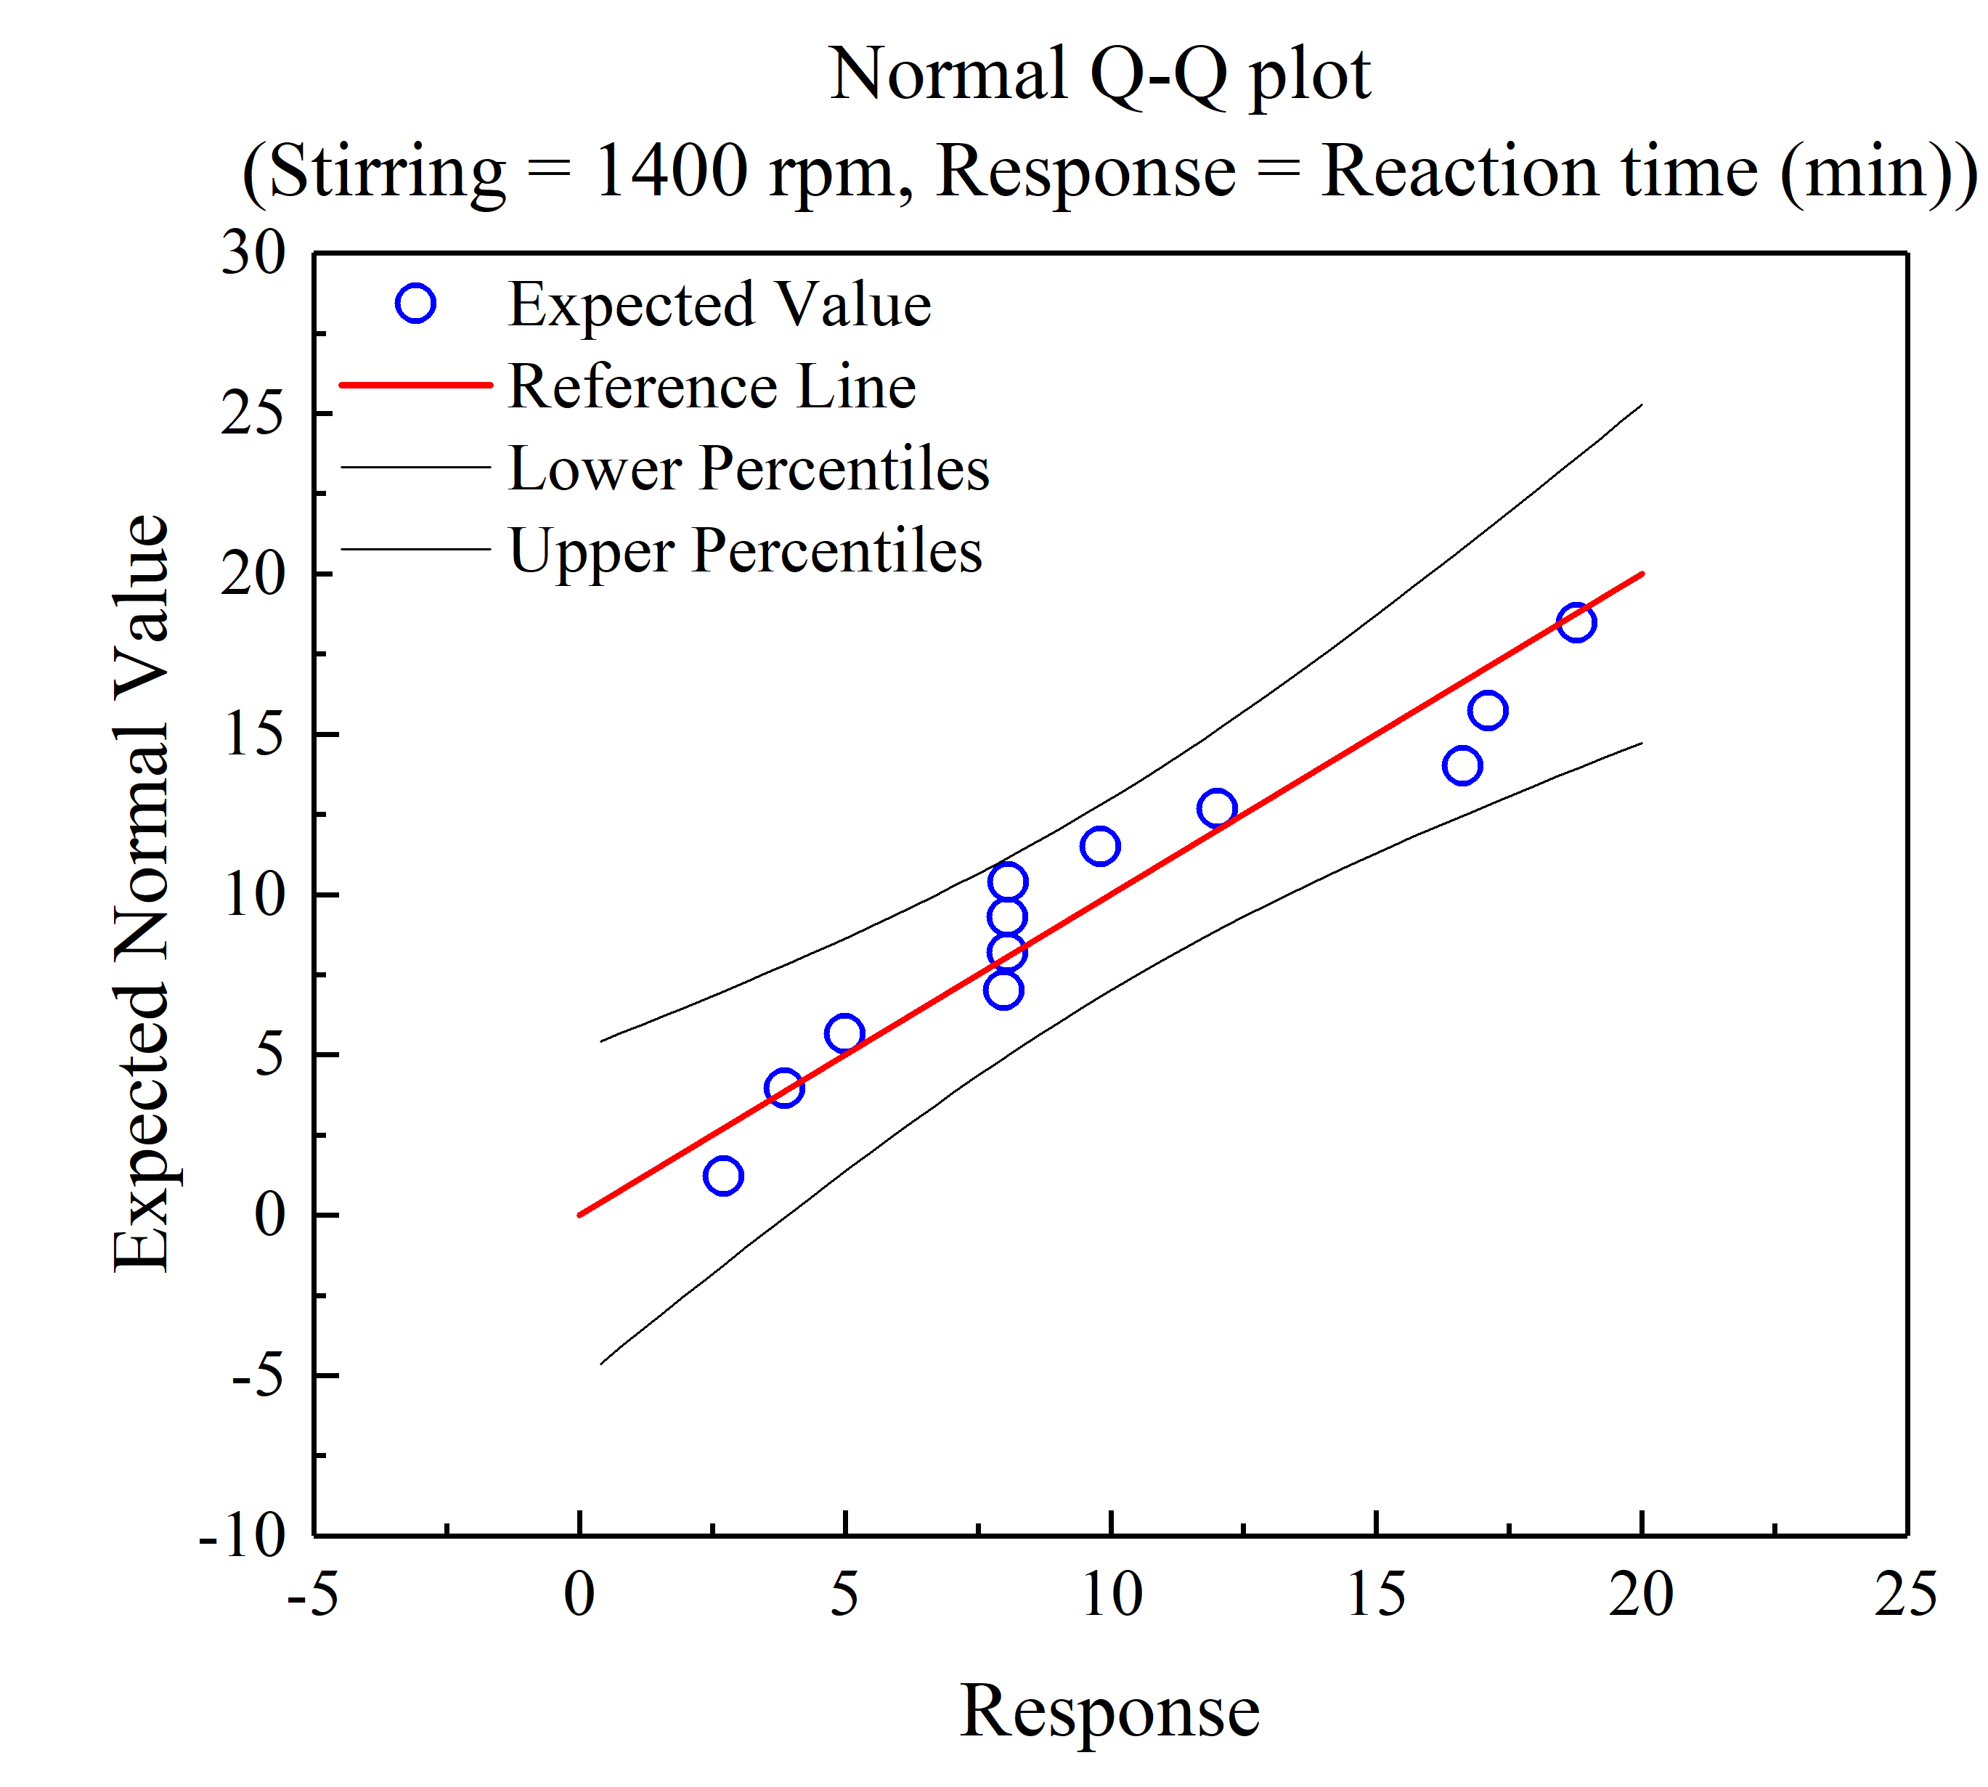
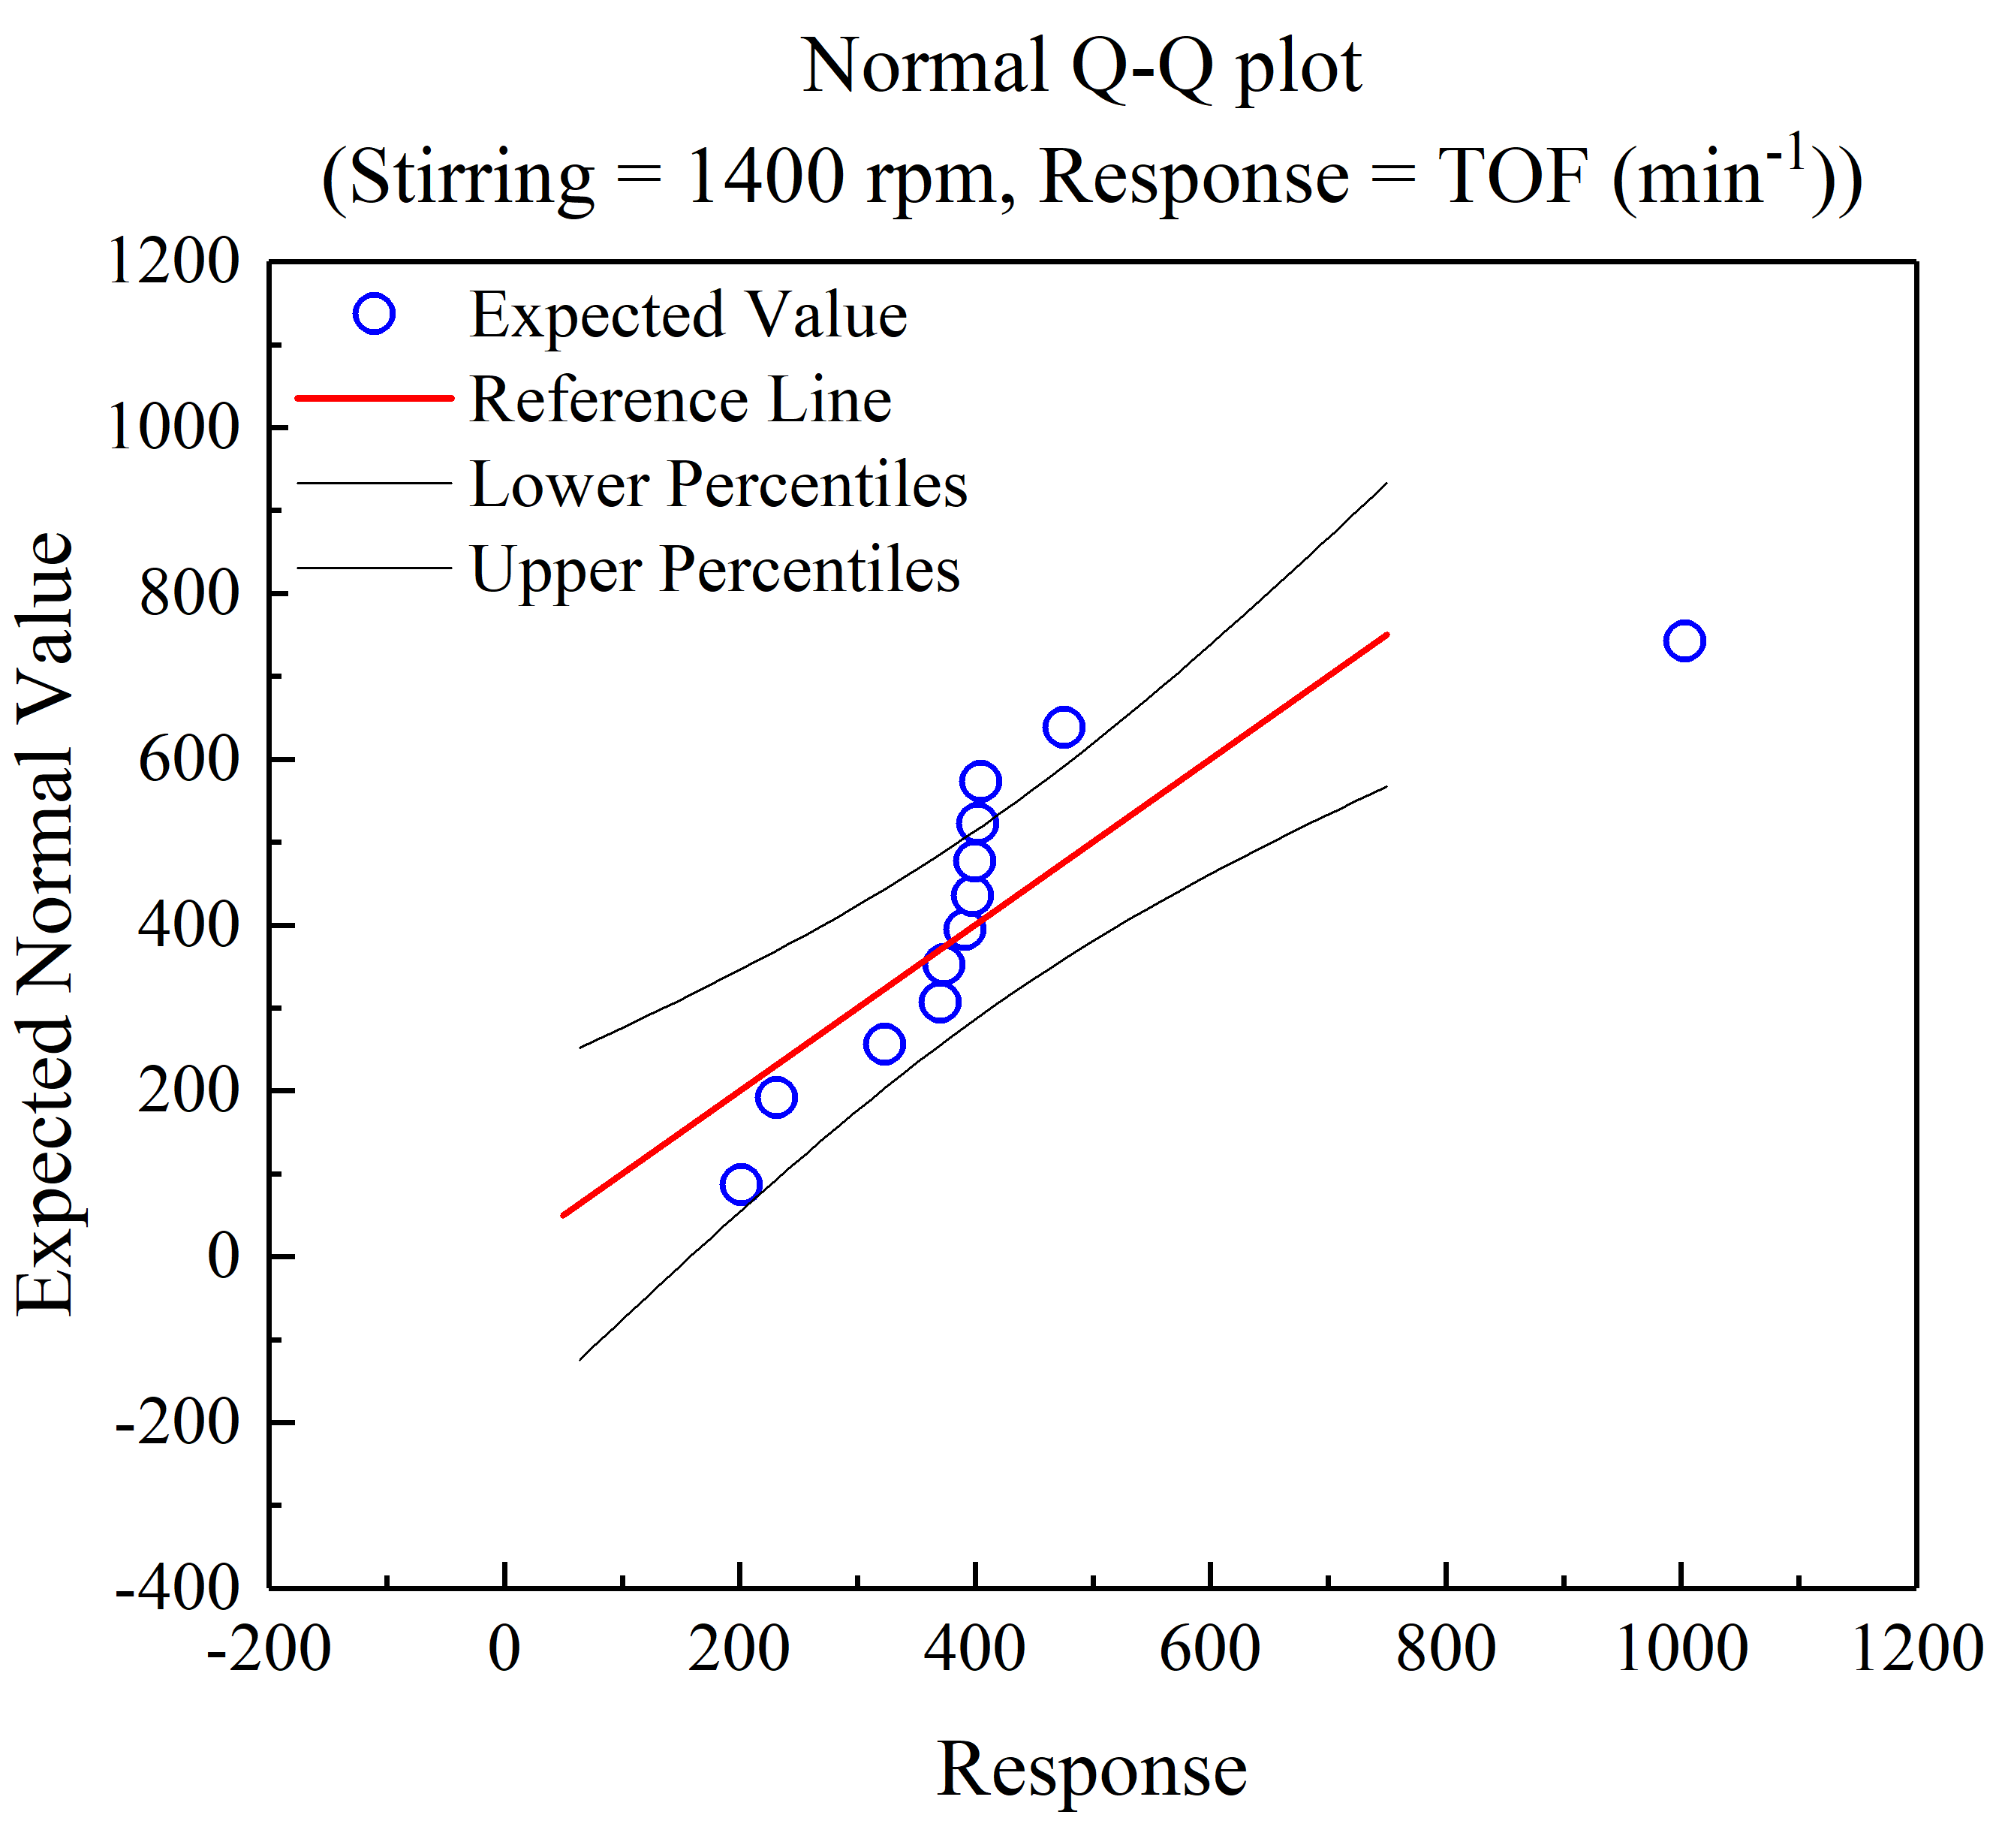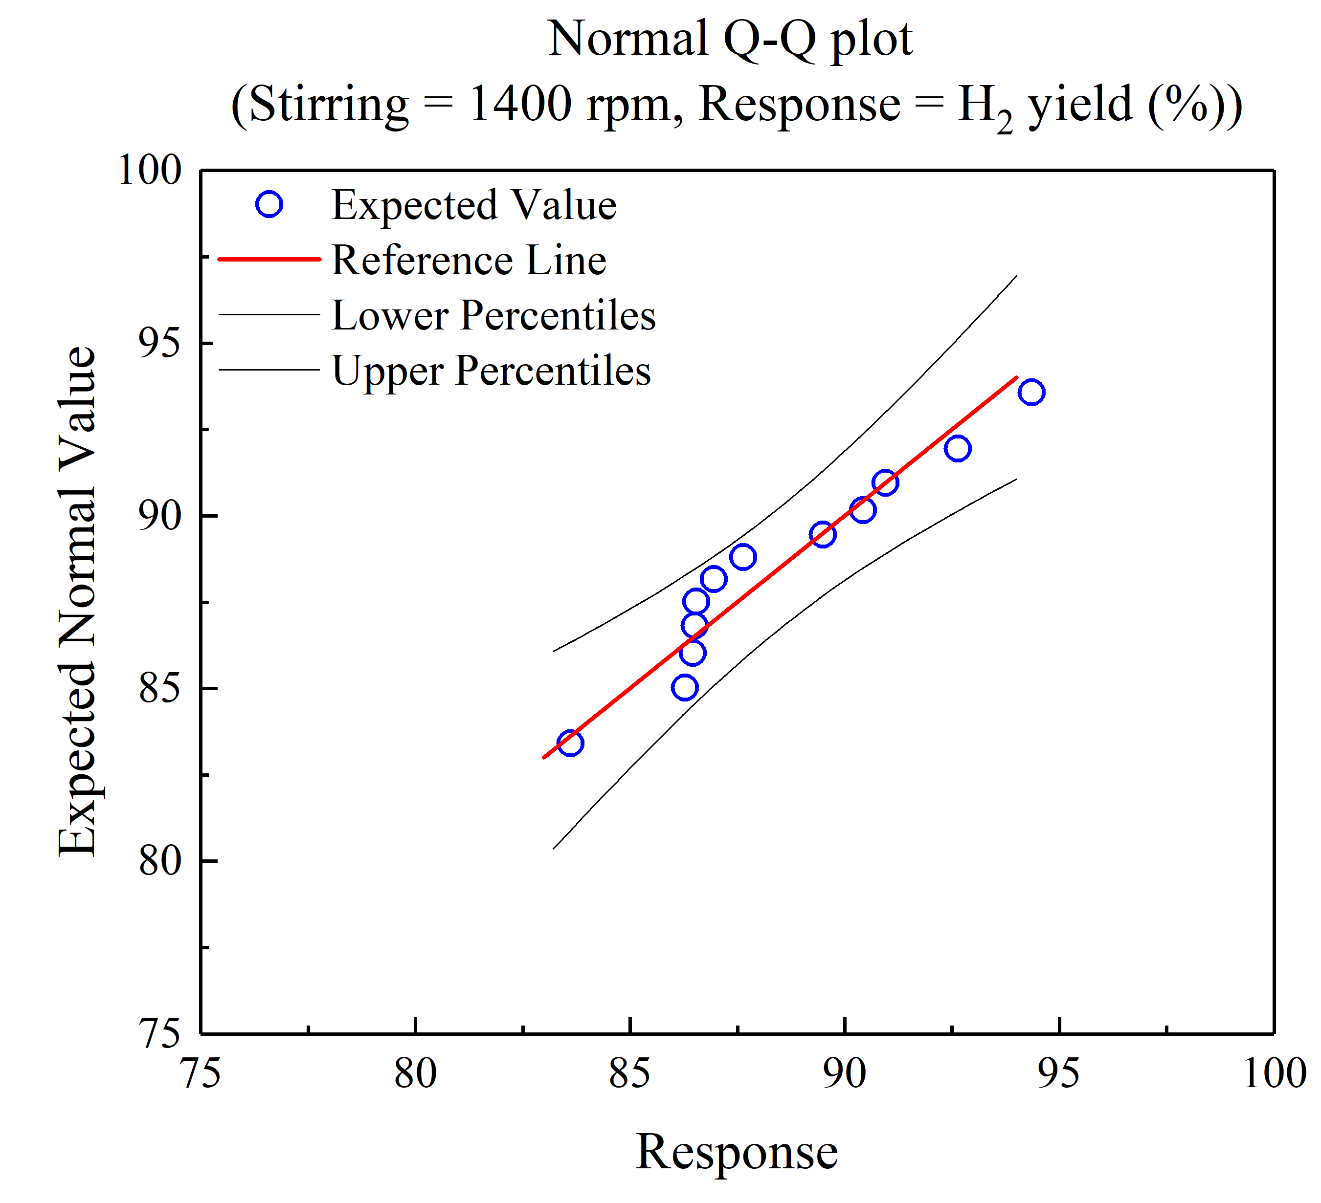
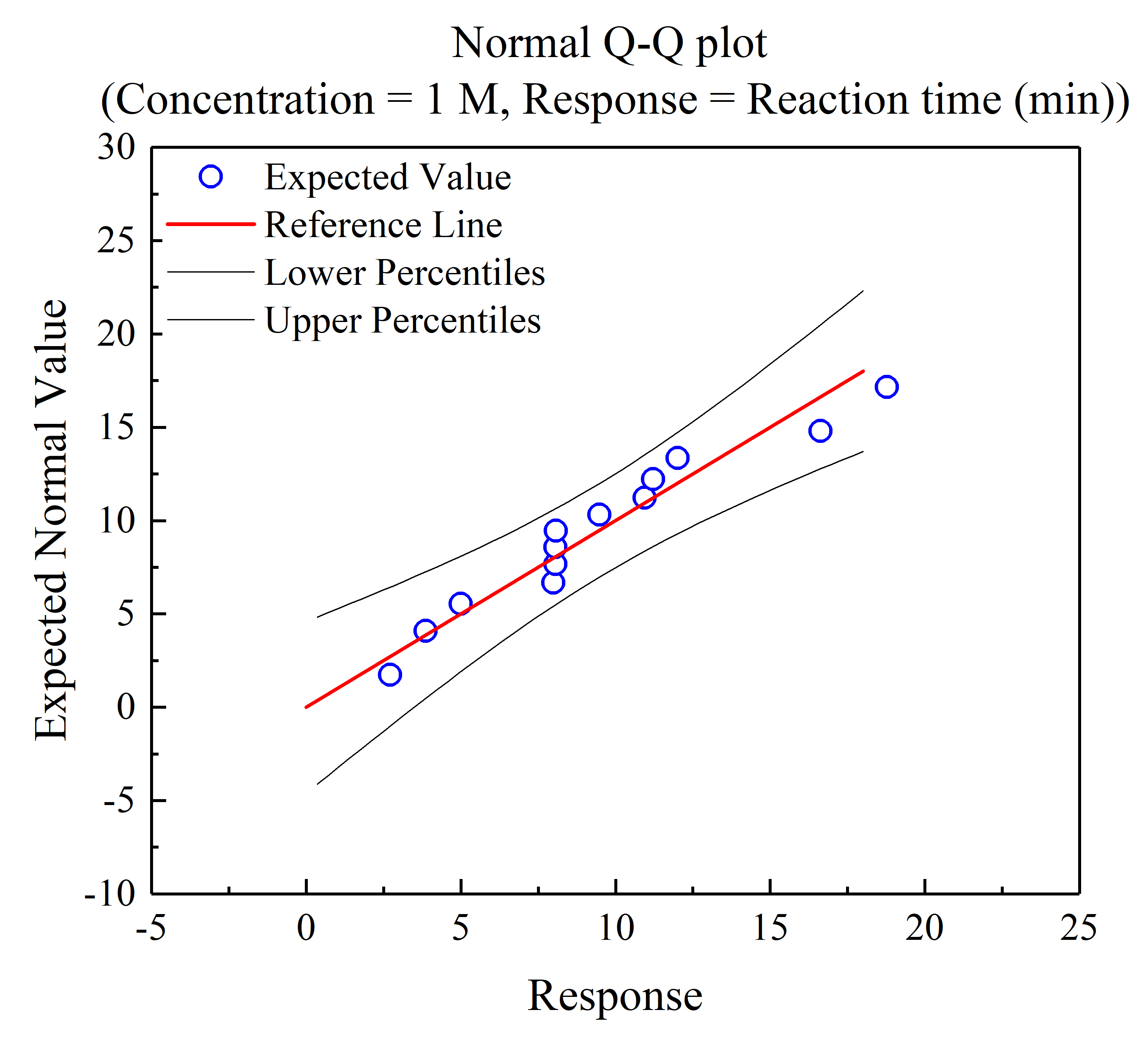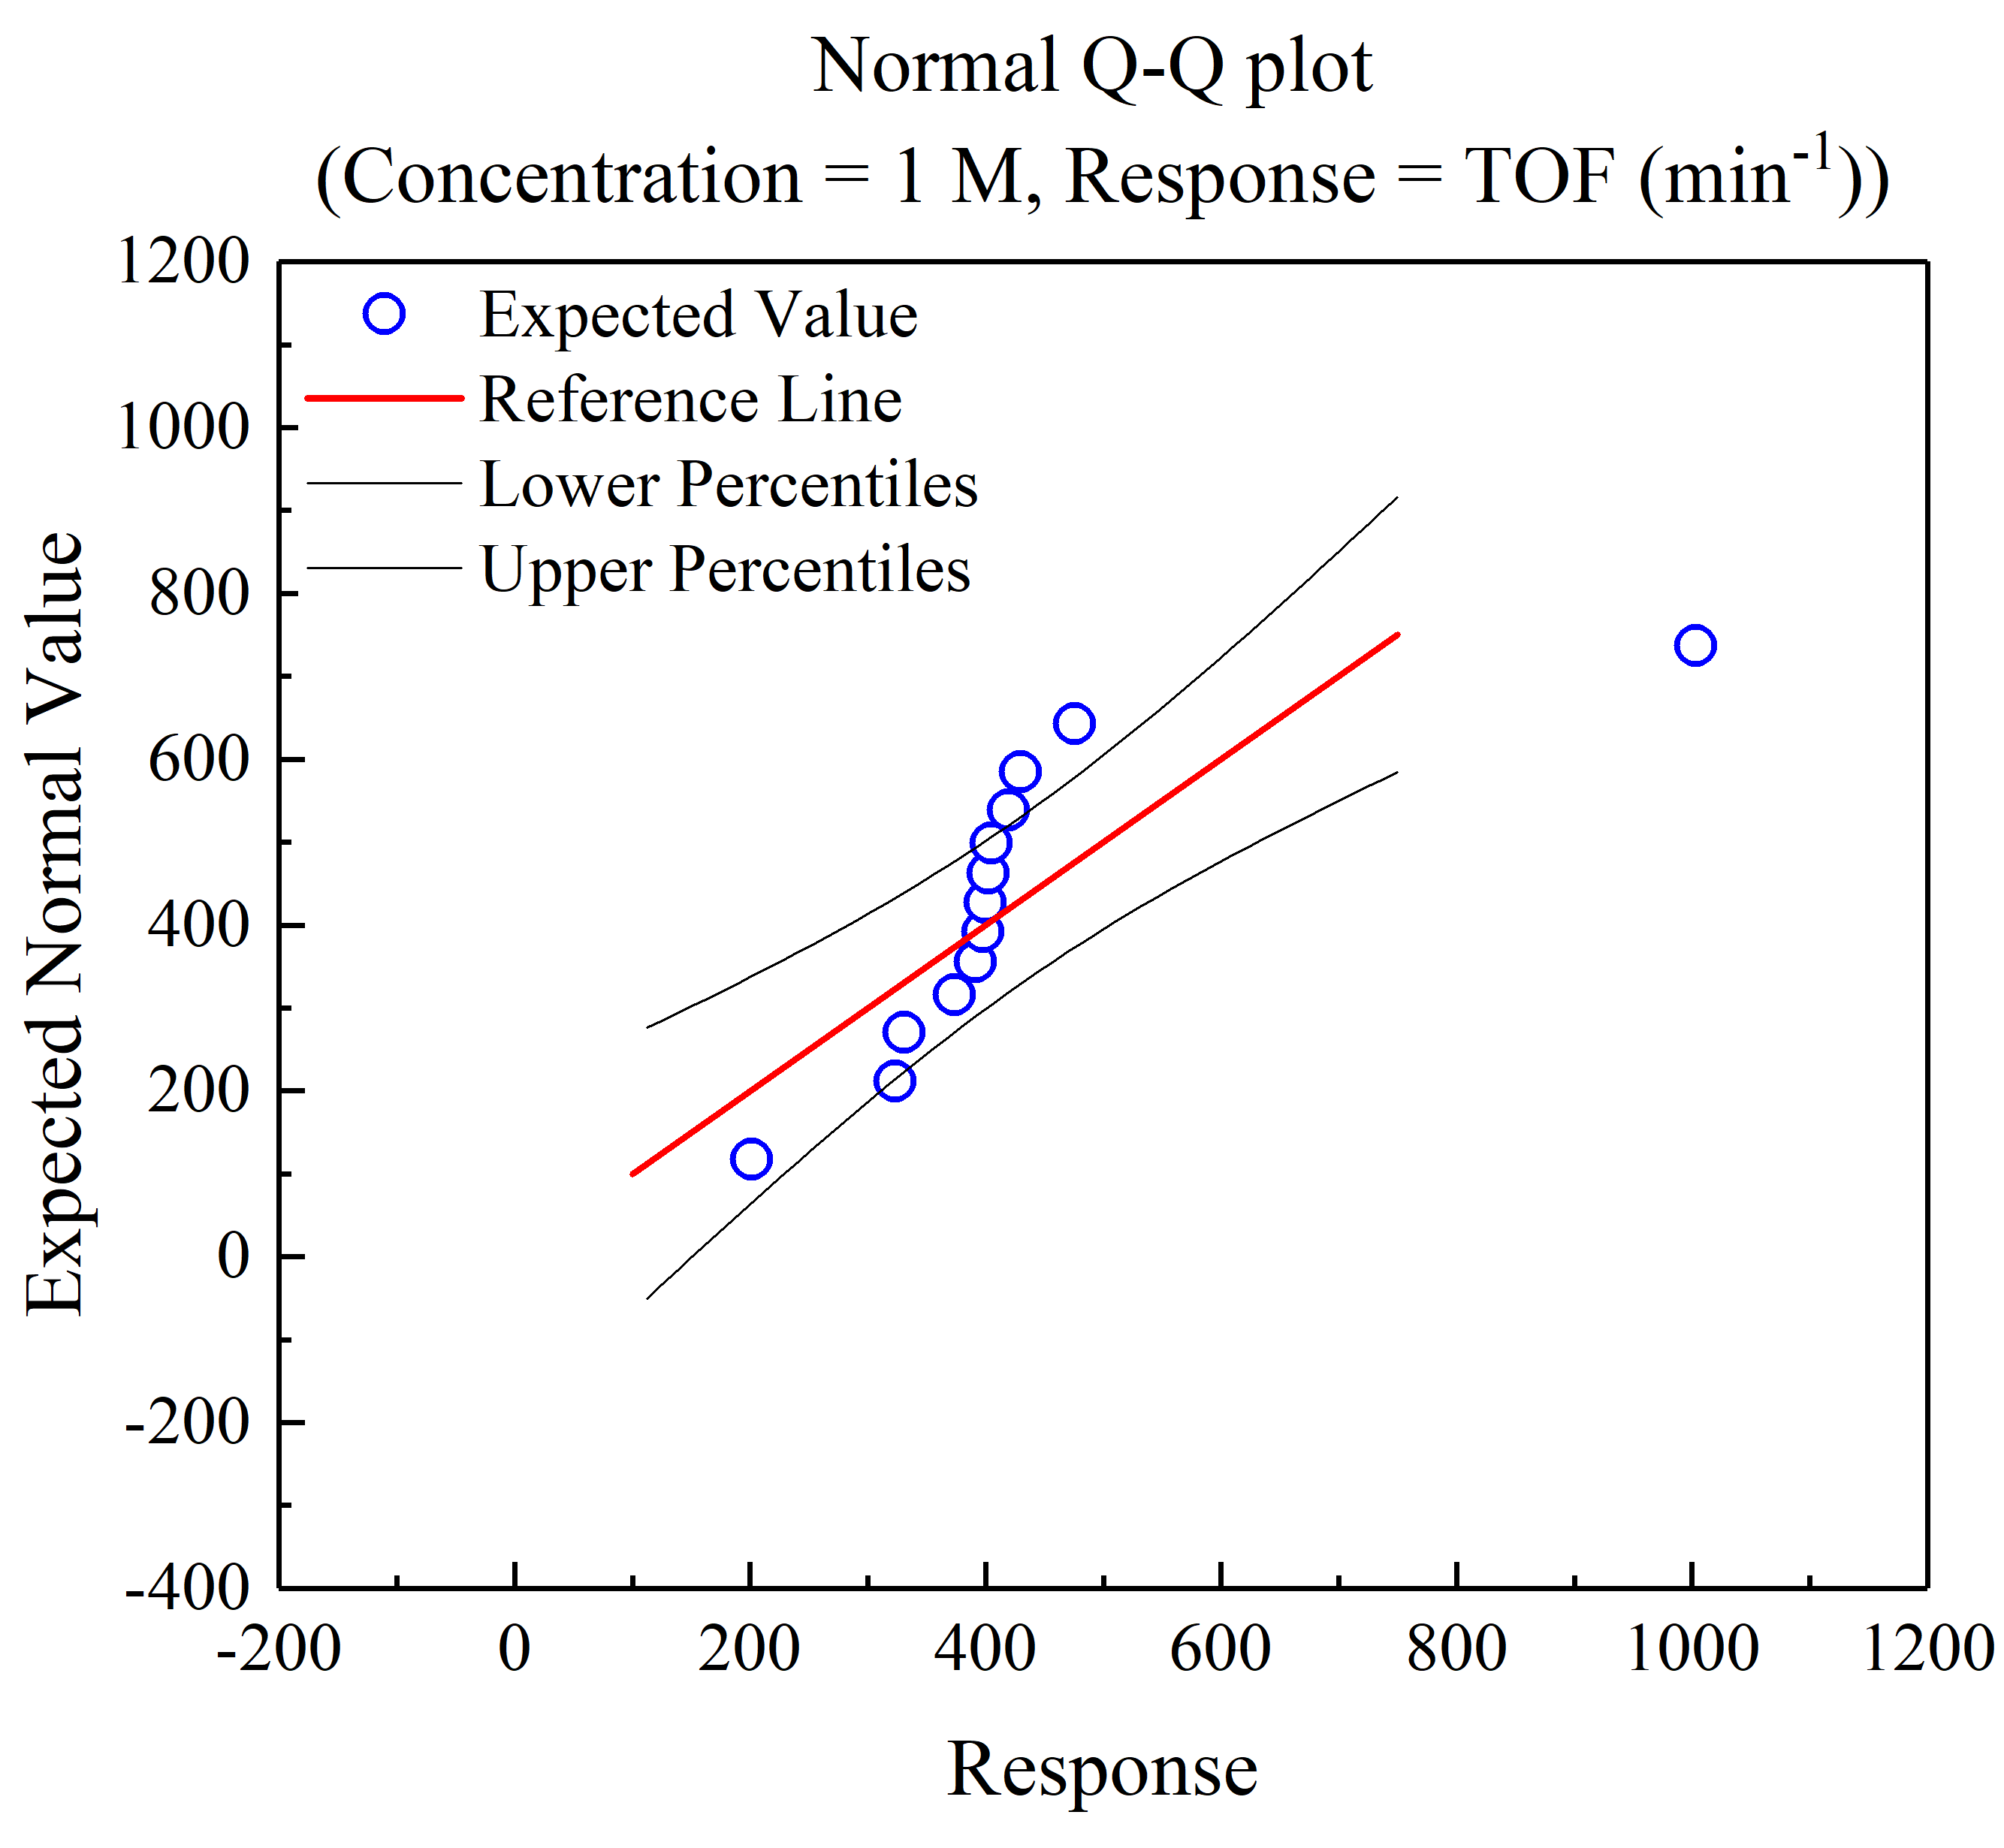
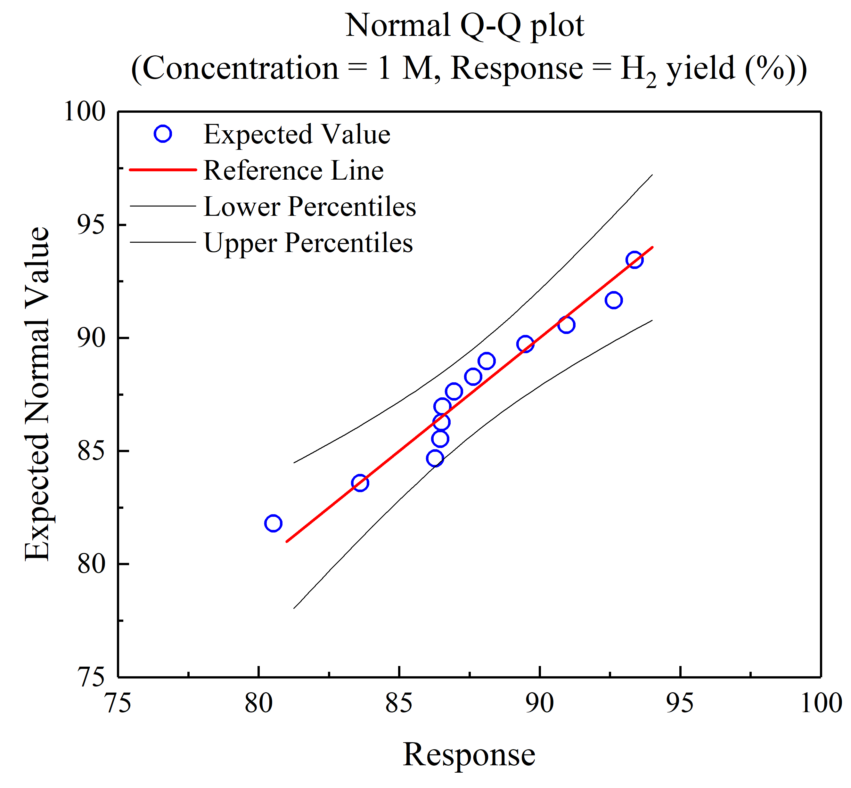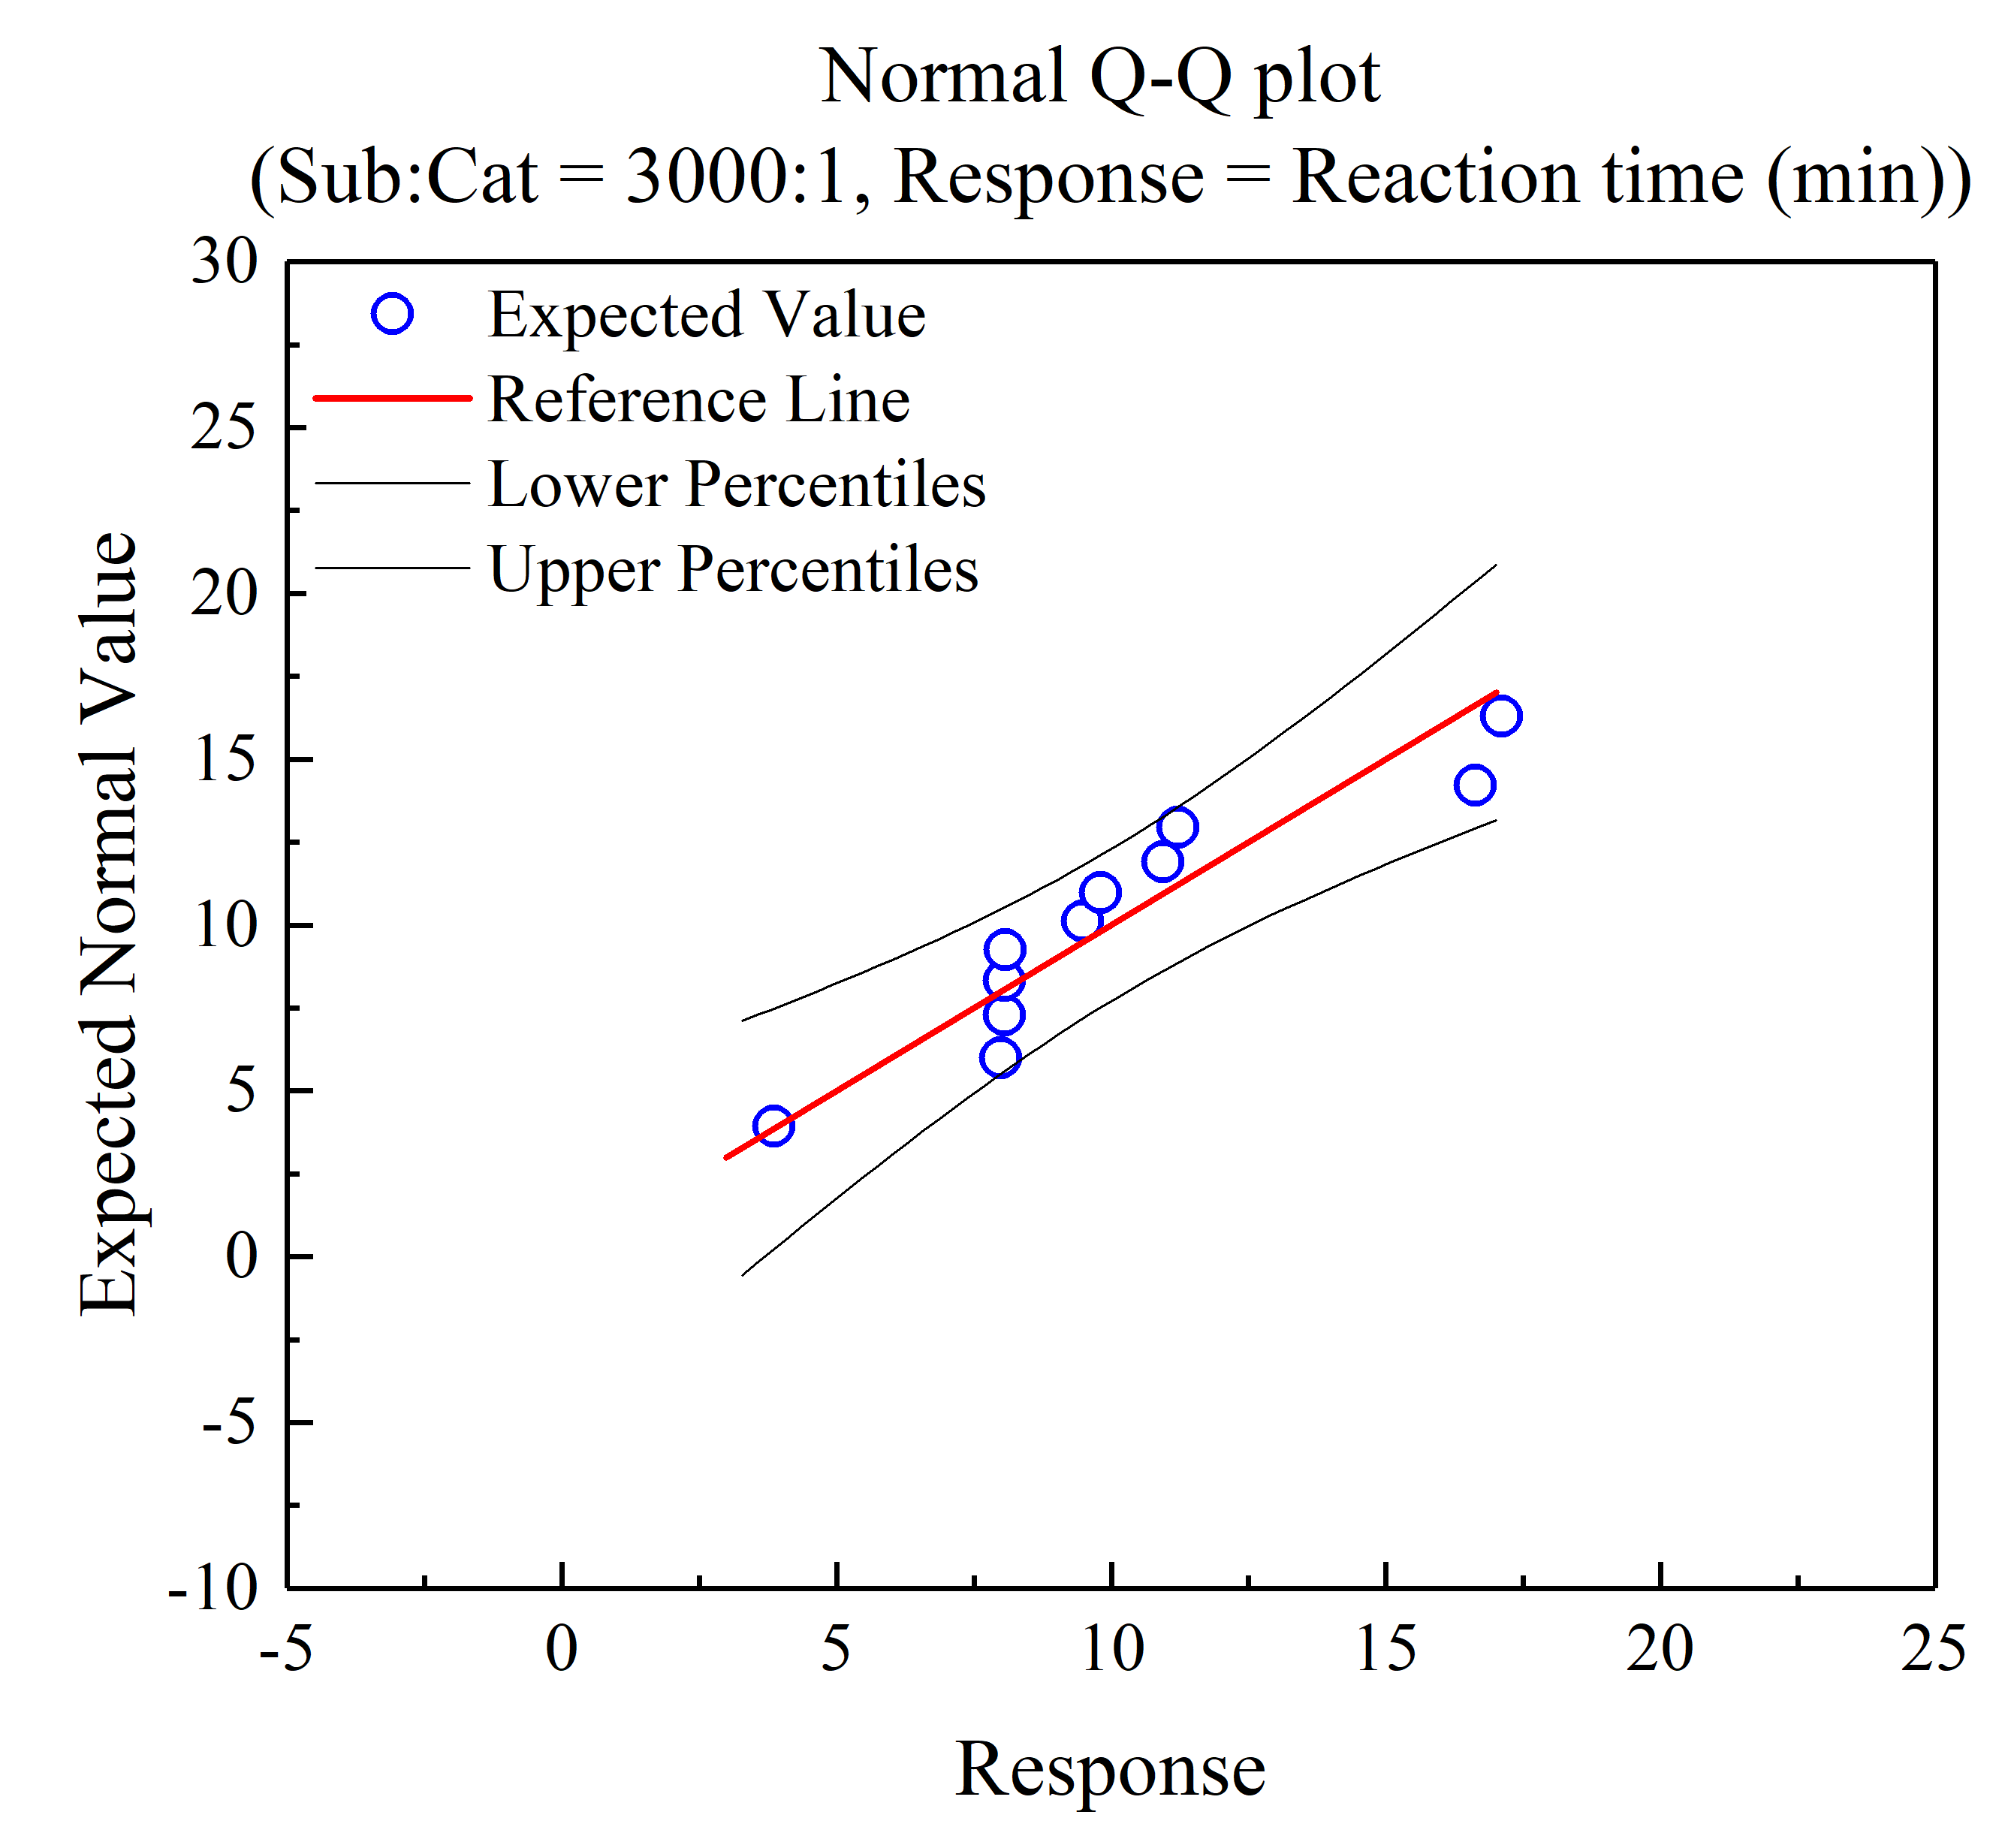
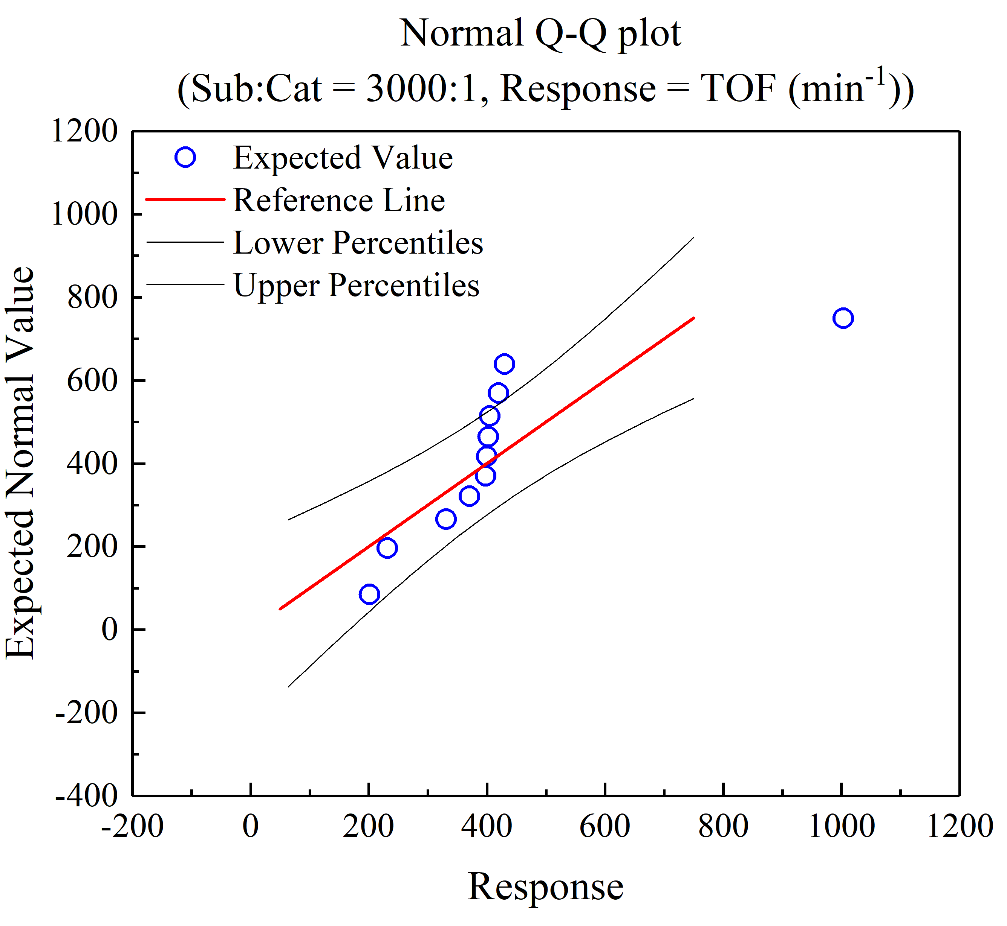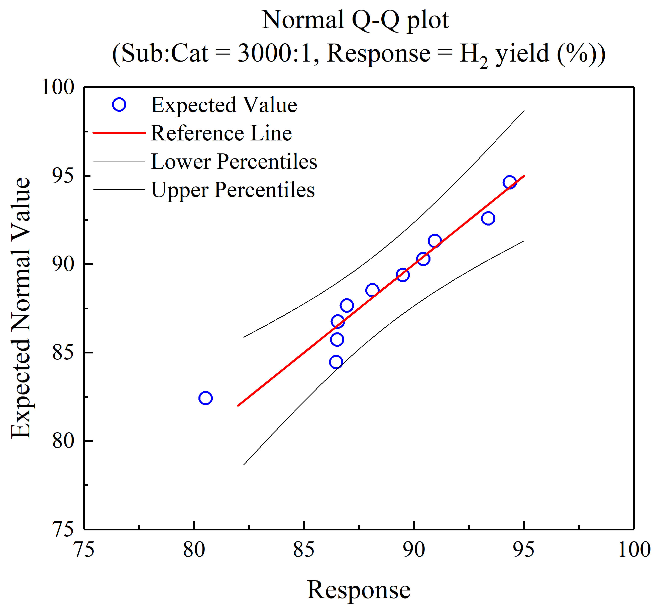
Figure S5. Quantile-Quantile (QQ) plots assessing the normality of residuals for each factor-response pair.
* The concentration of 1 M AB (initial concentration) corresponds to the final concentration of 90.9 mM AB in the reactor.

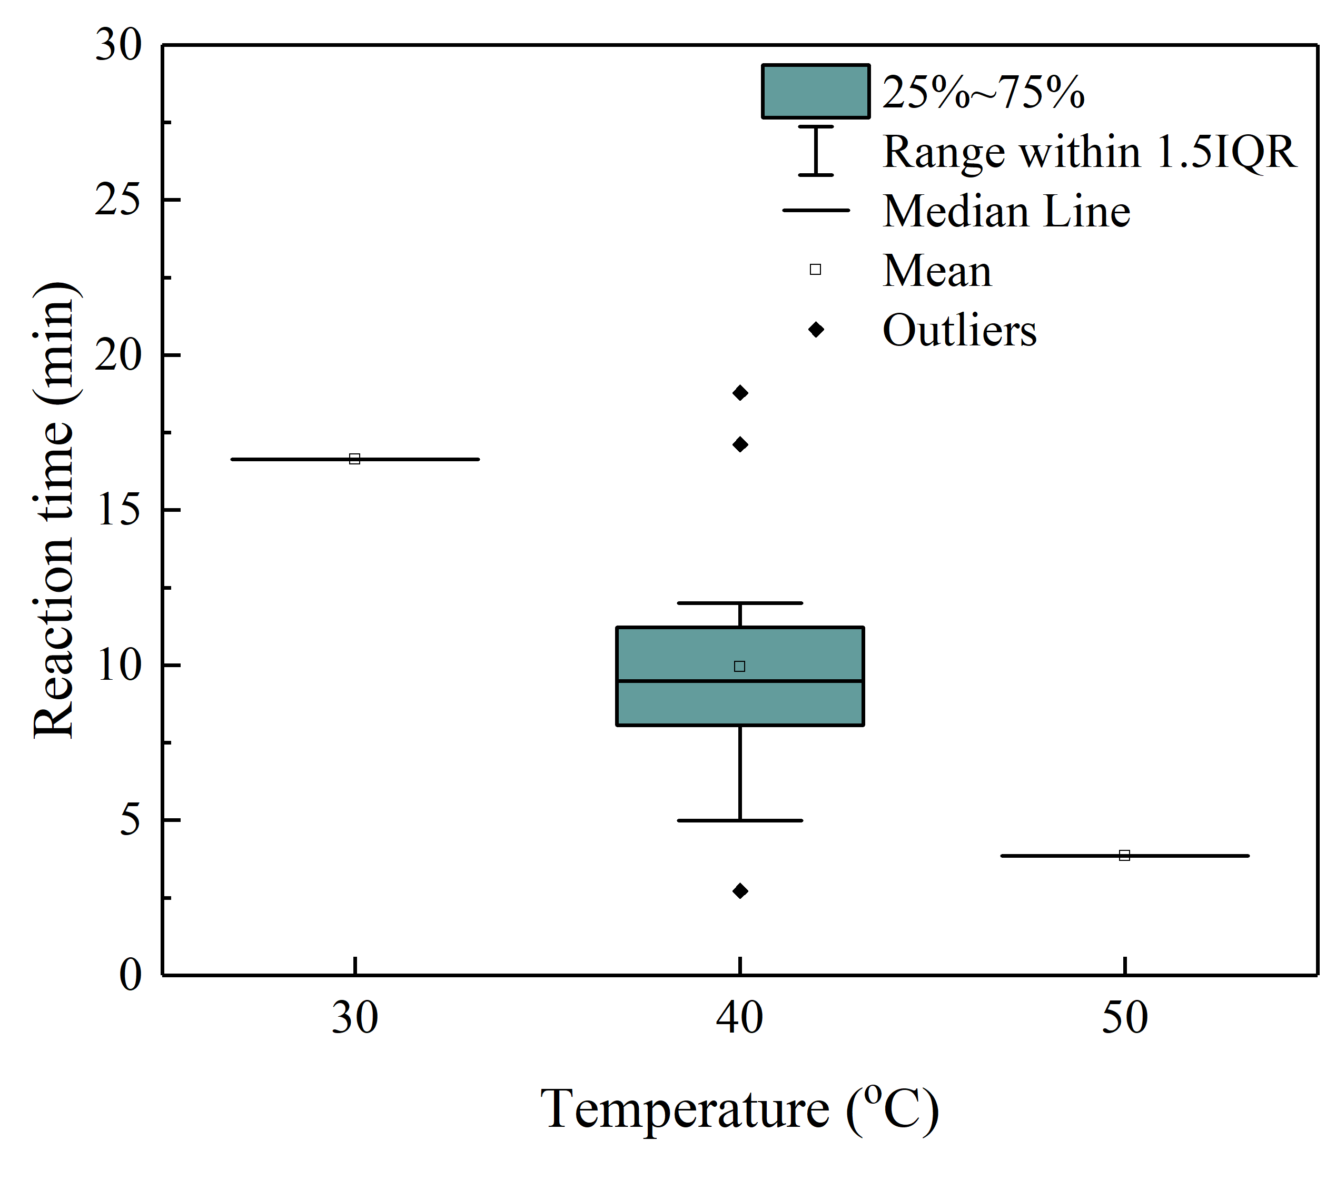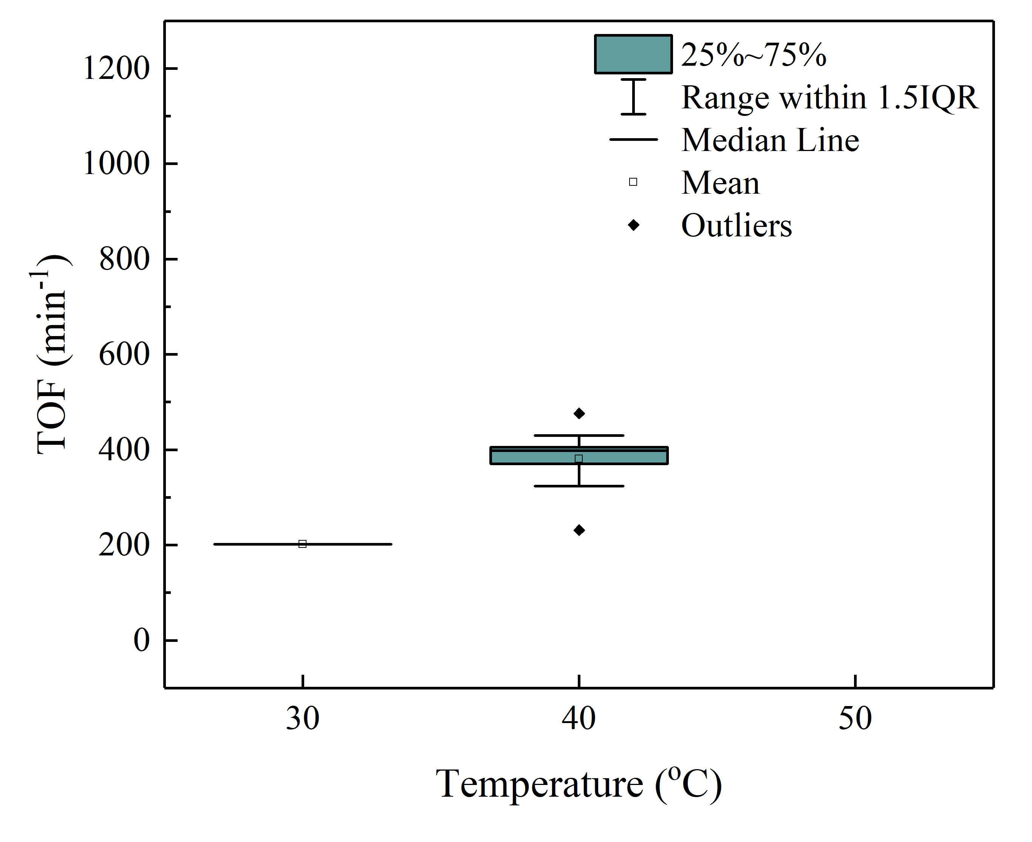
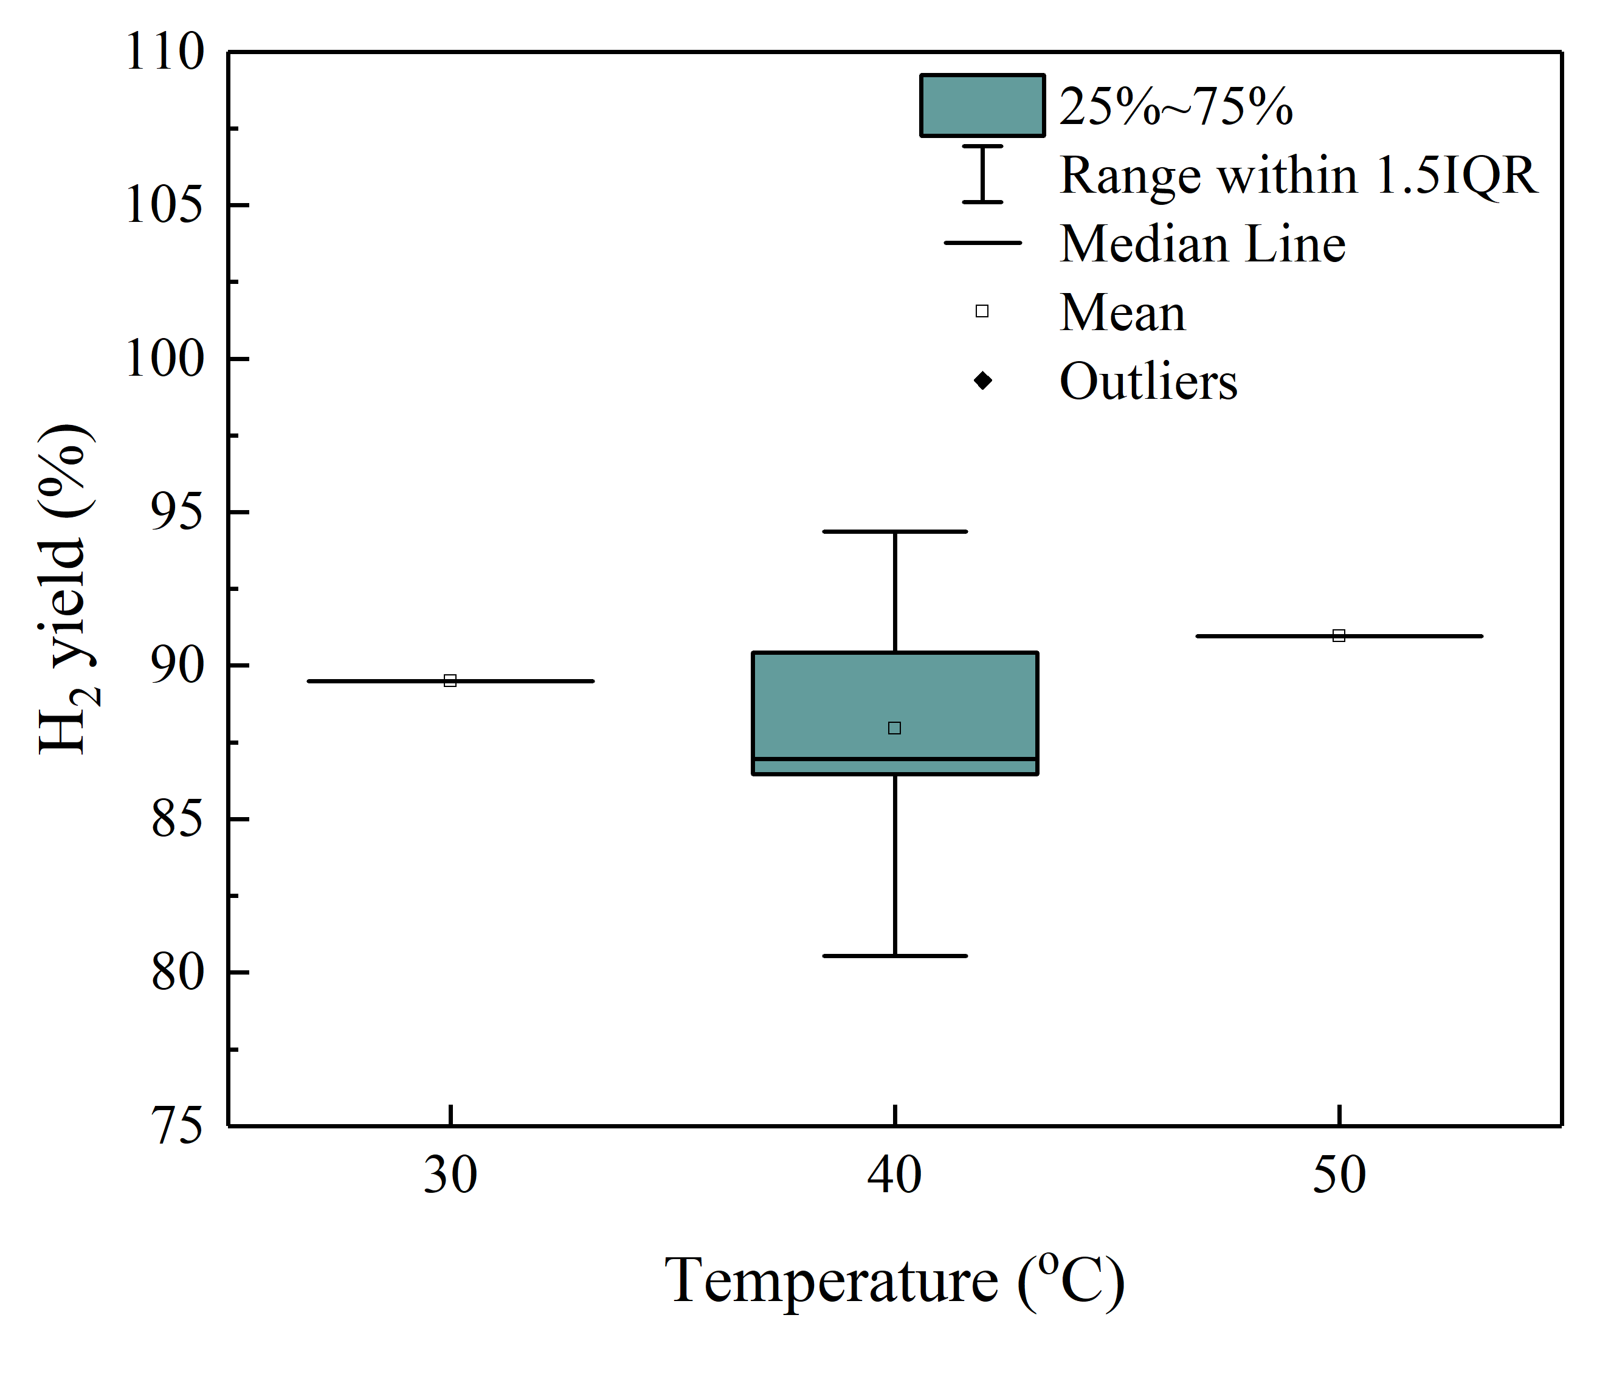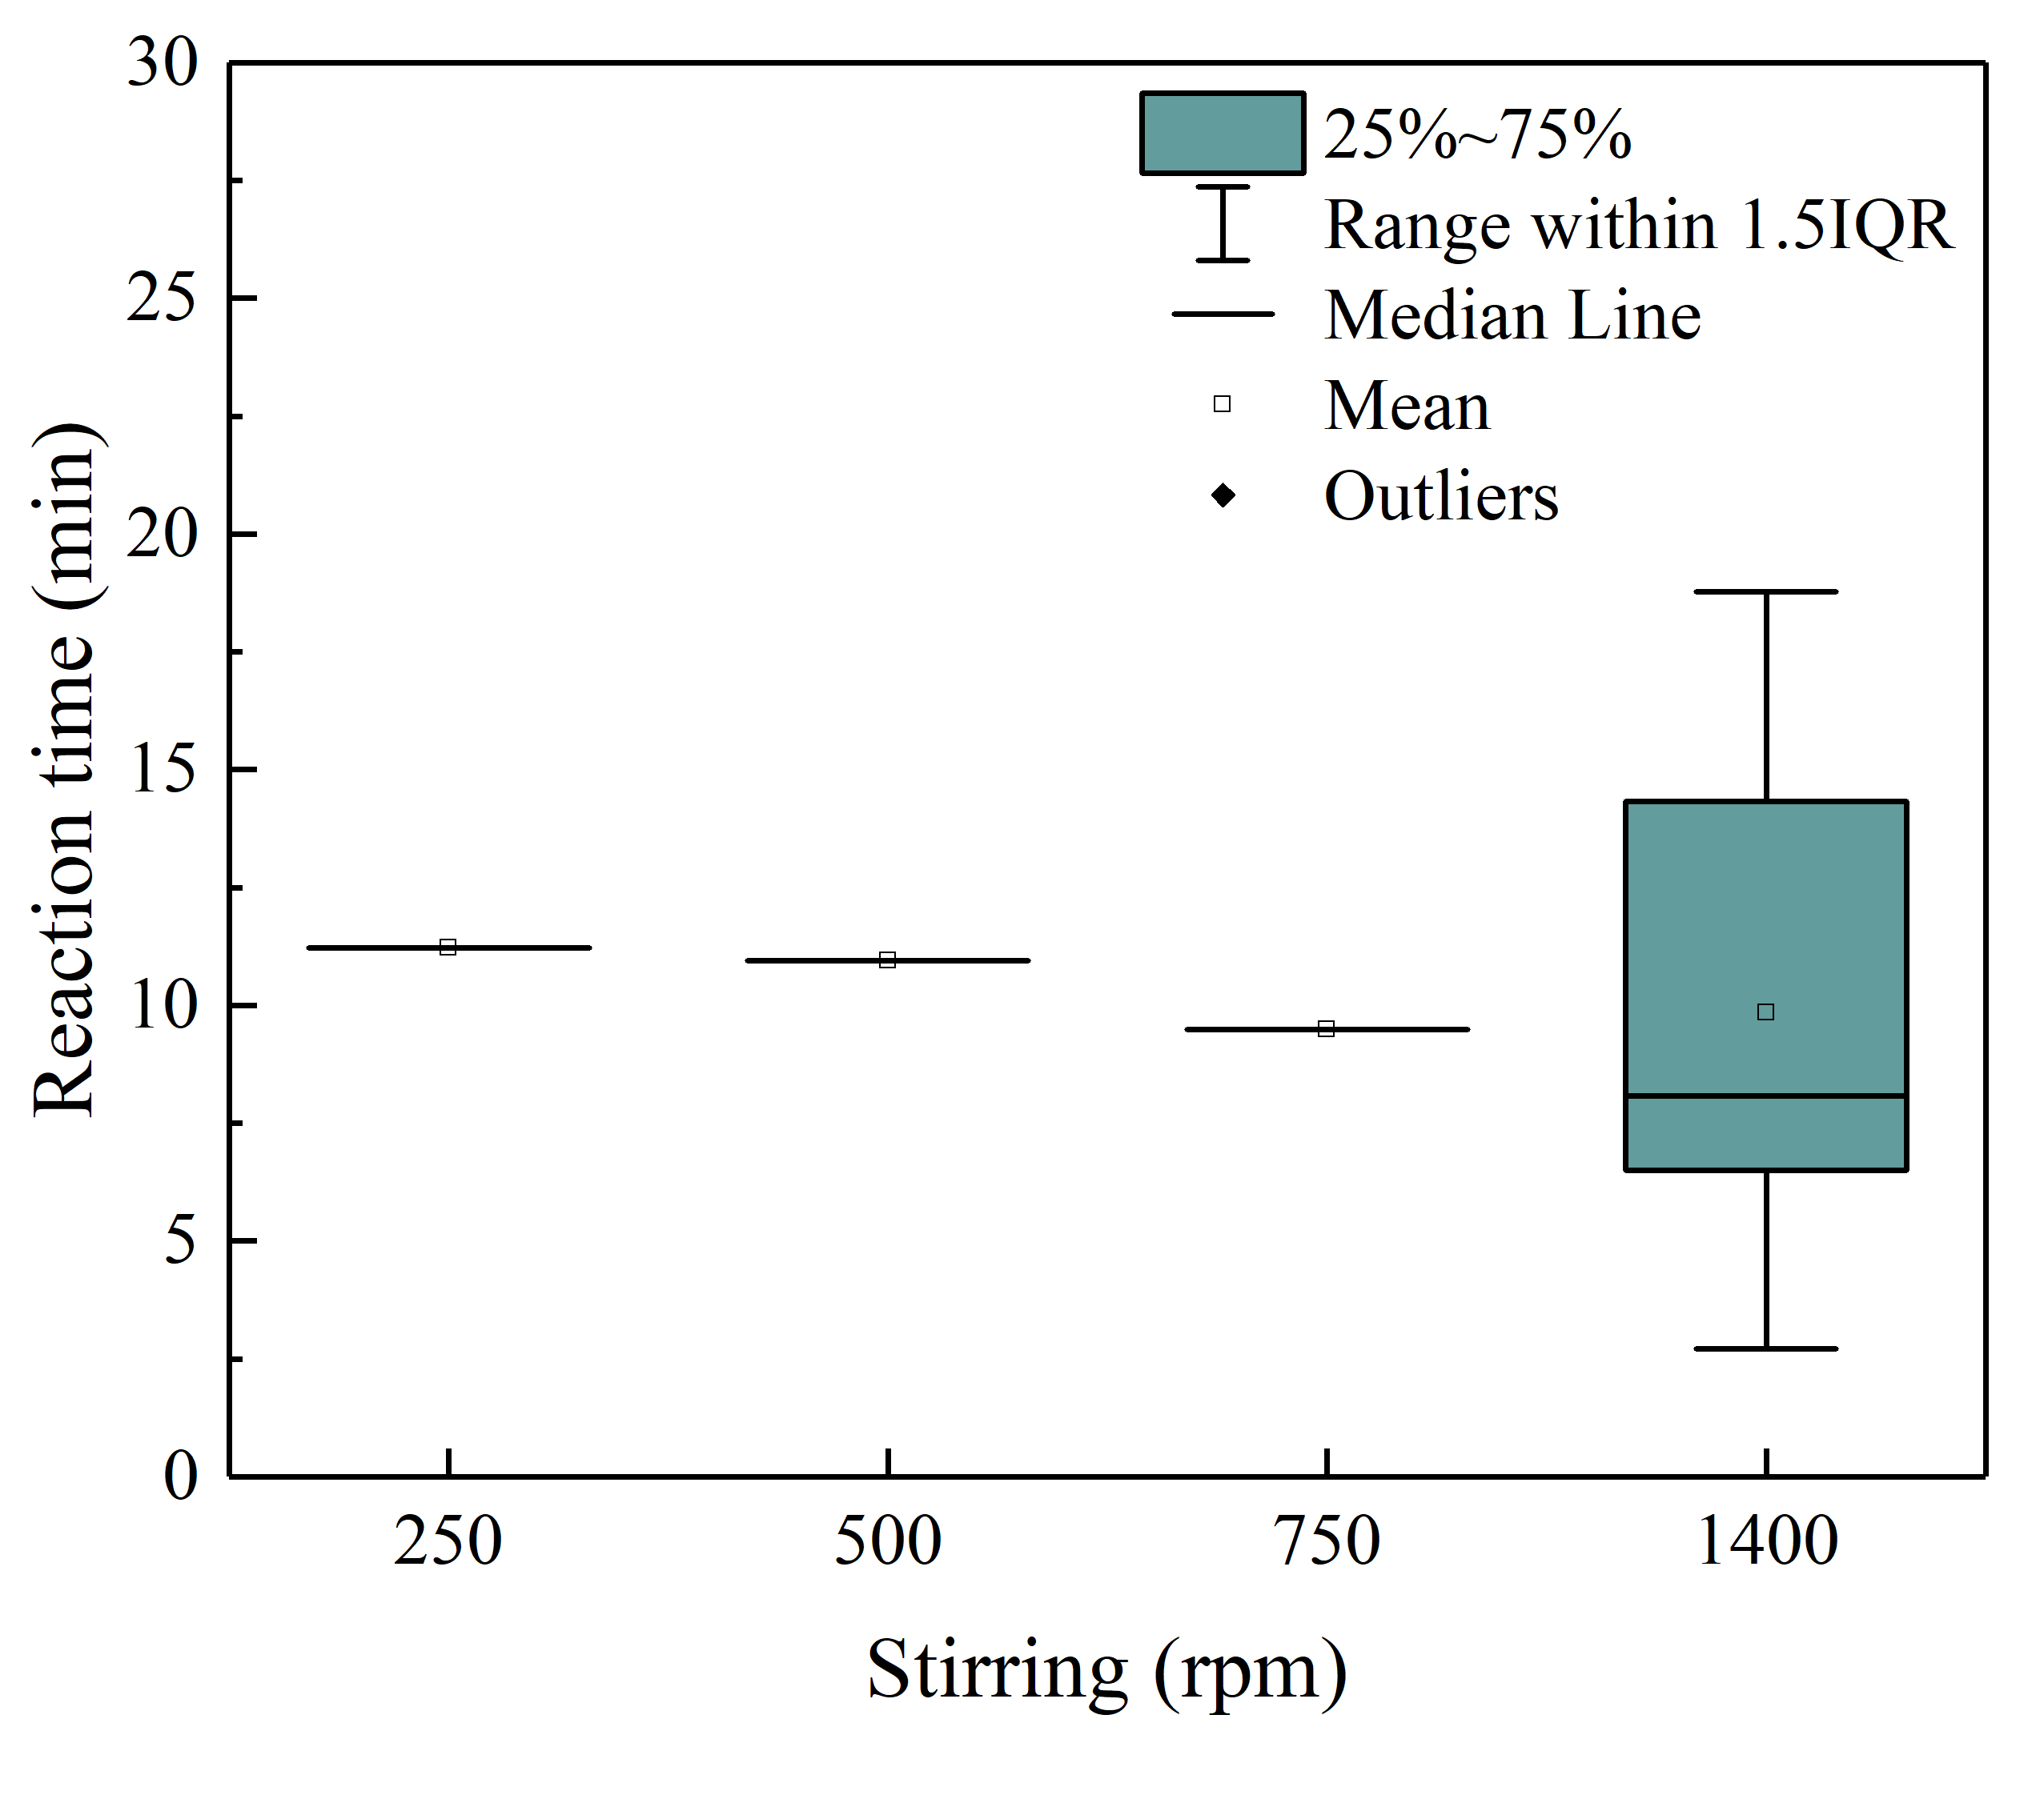

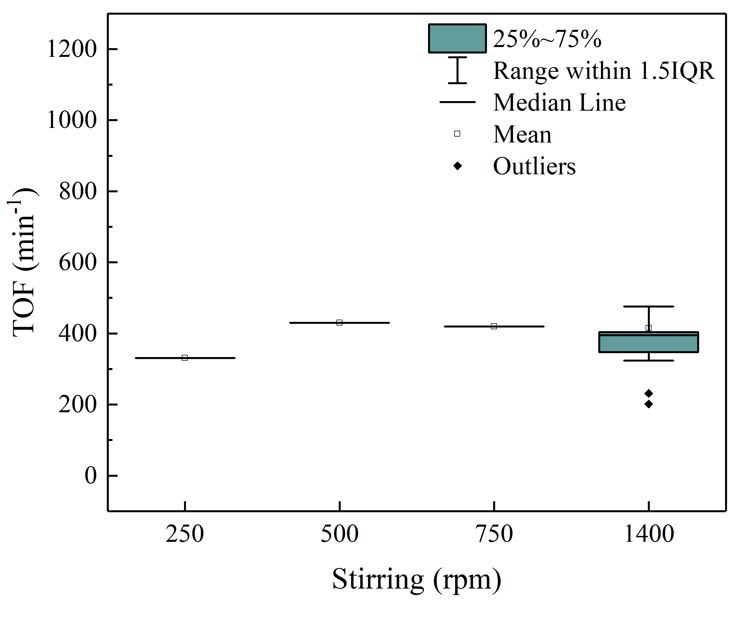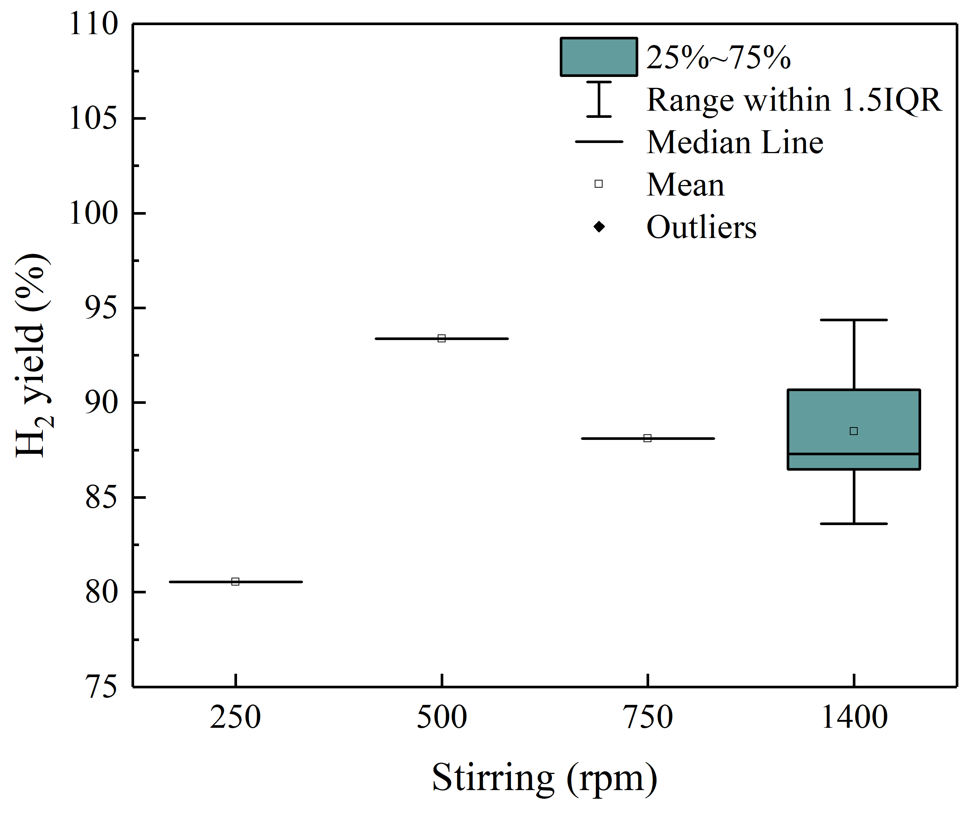
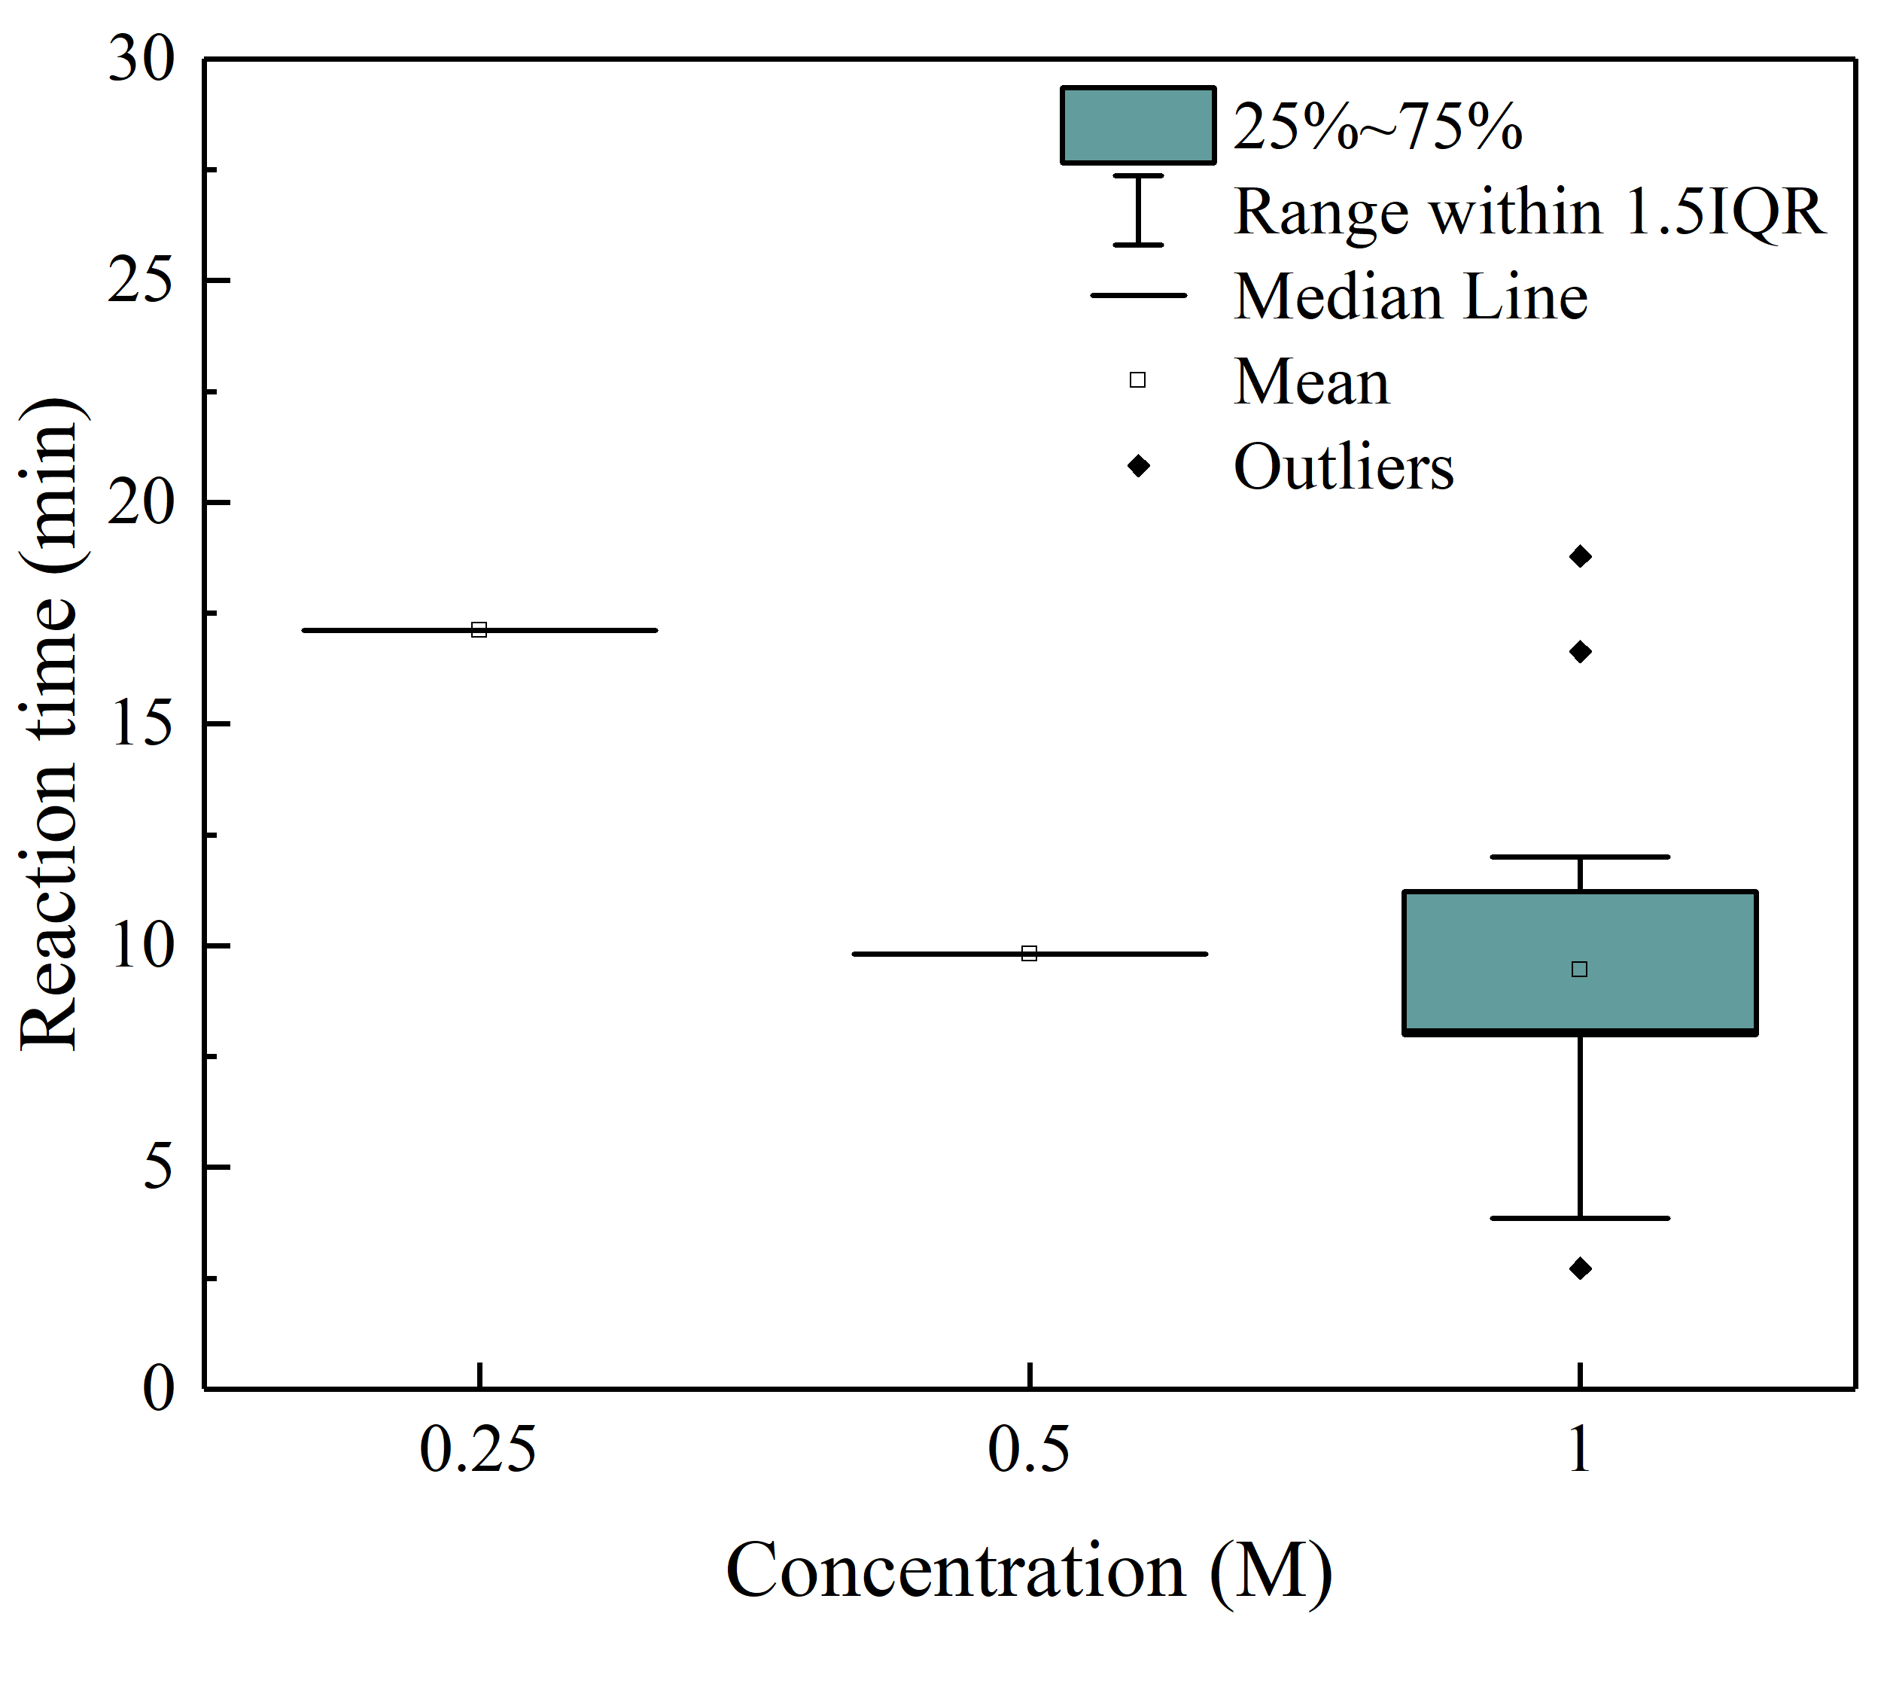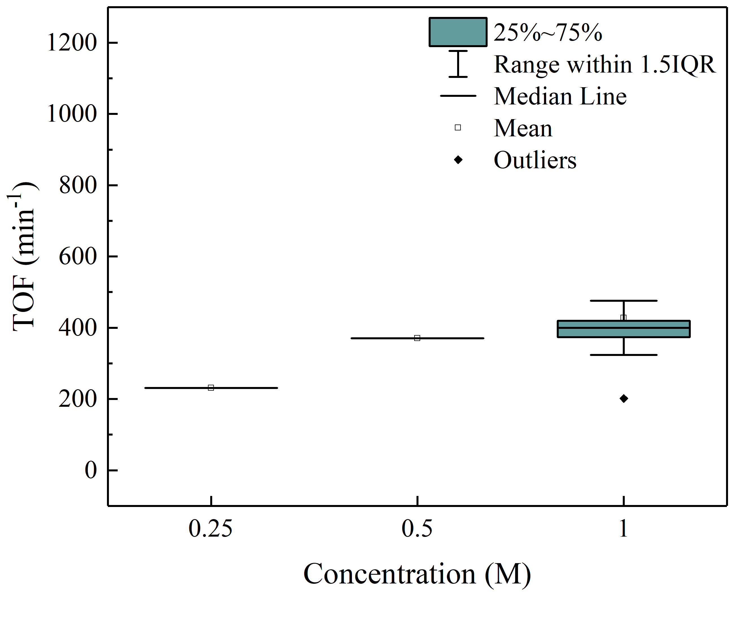
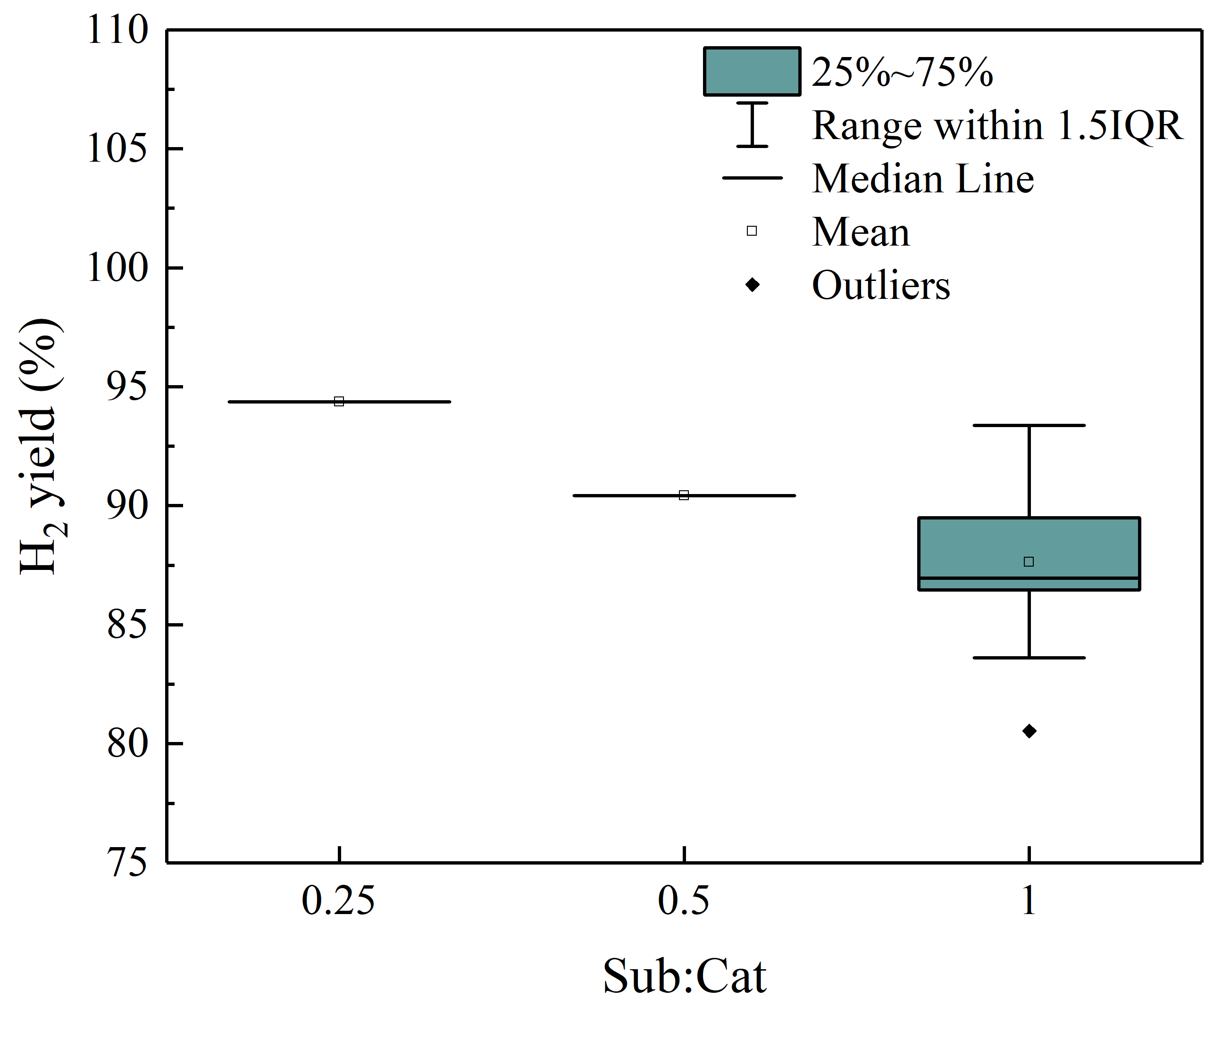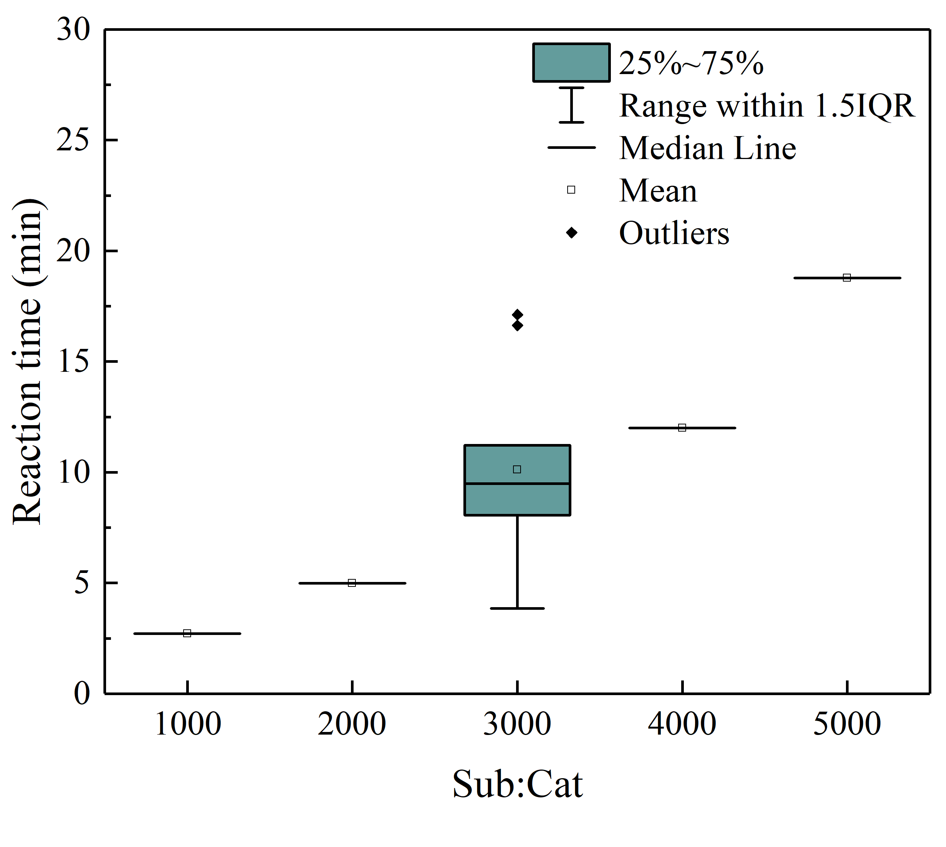

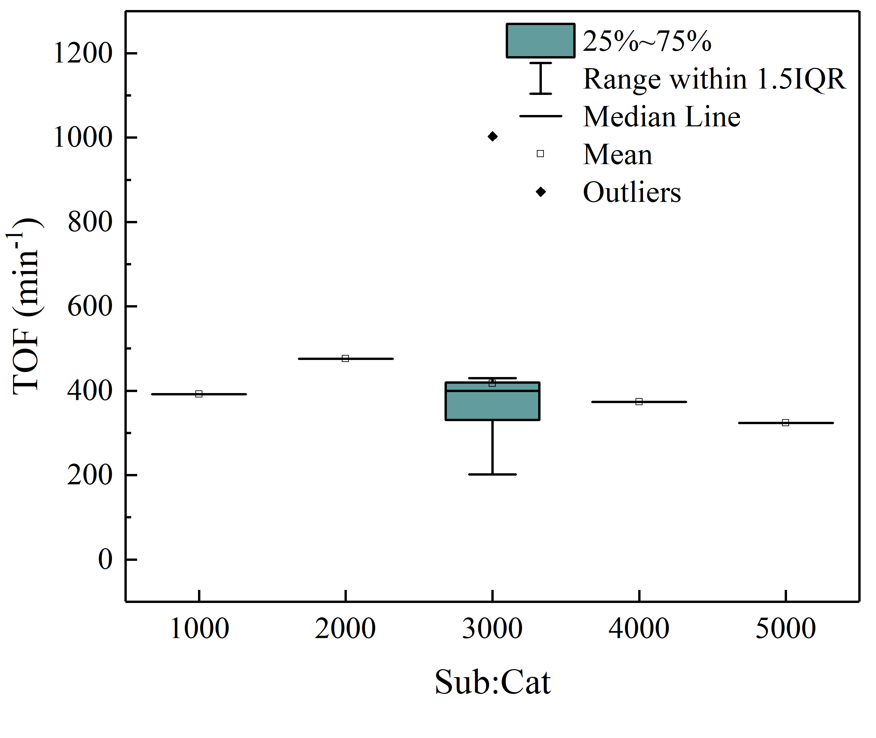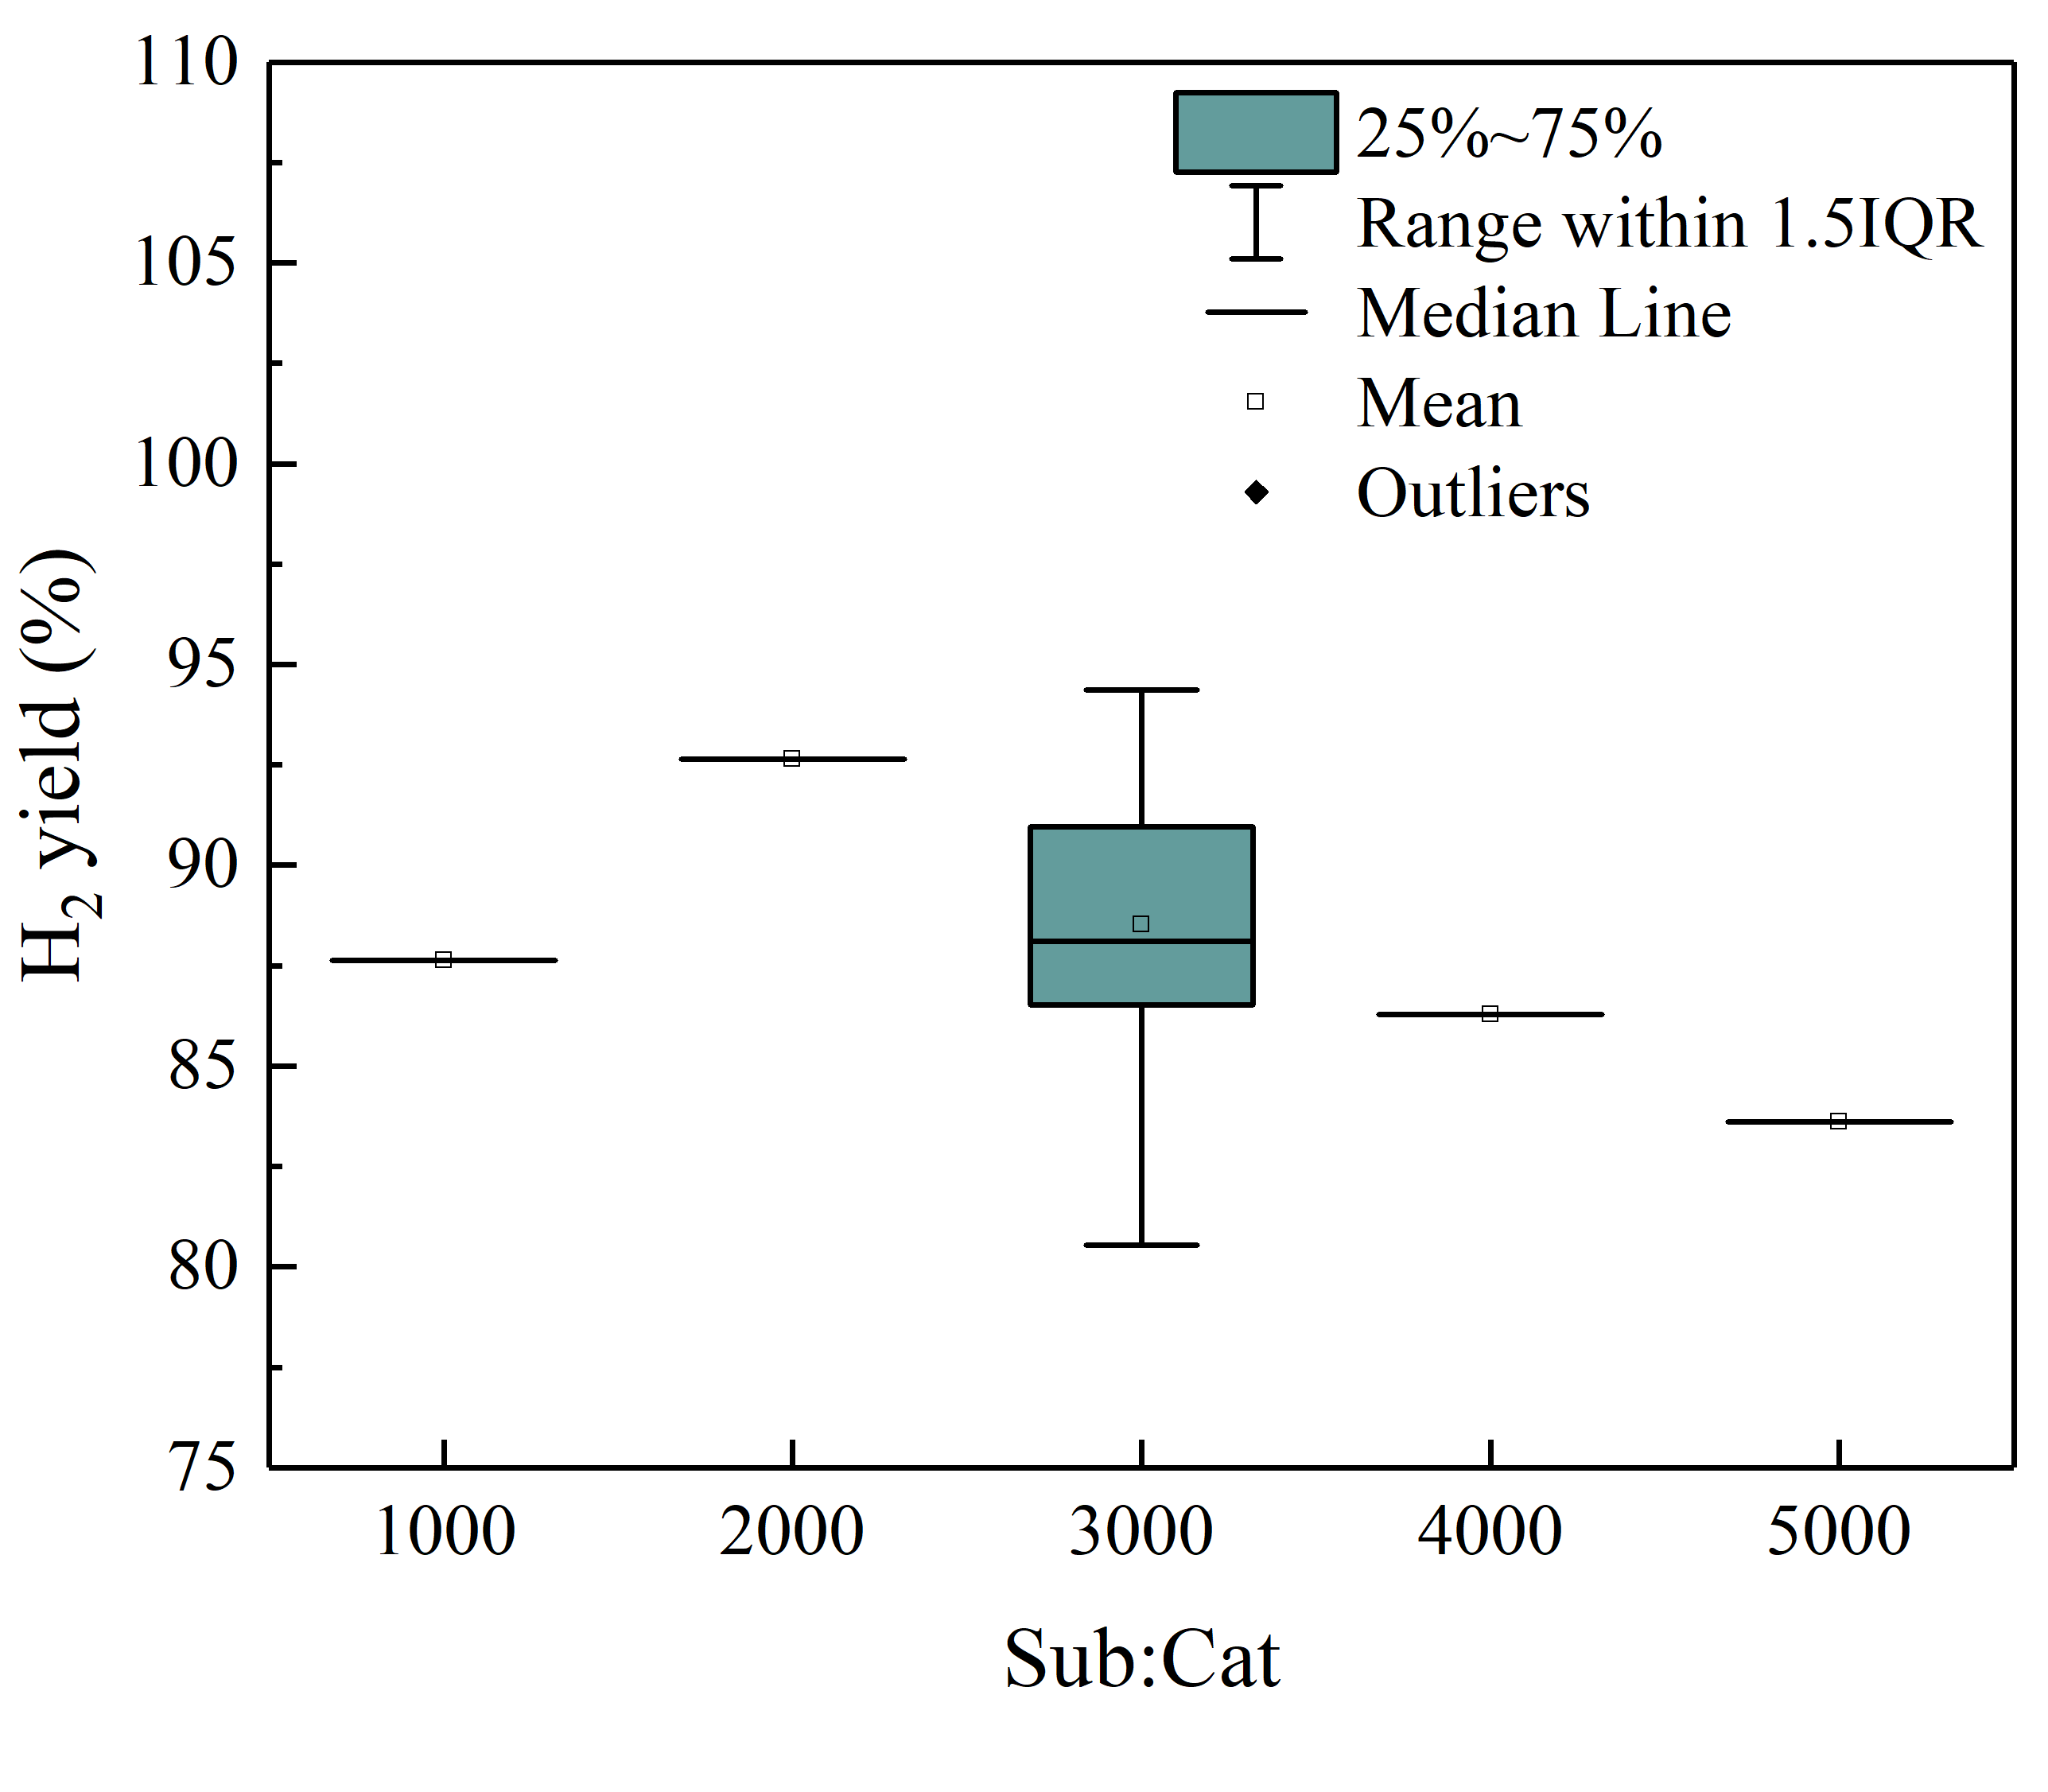
Figure S6. Box plots illustrating the distribution of response values across the levels of each factor.
** The concentrations of 0.25, 0.5 and 1 M AB (initial concentrations) correspond to the final concentrations of 22.7, 45.5 and 90.9 mM AB in the reactor, respectively.

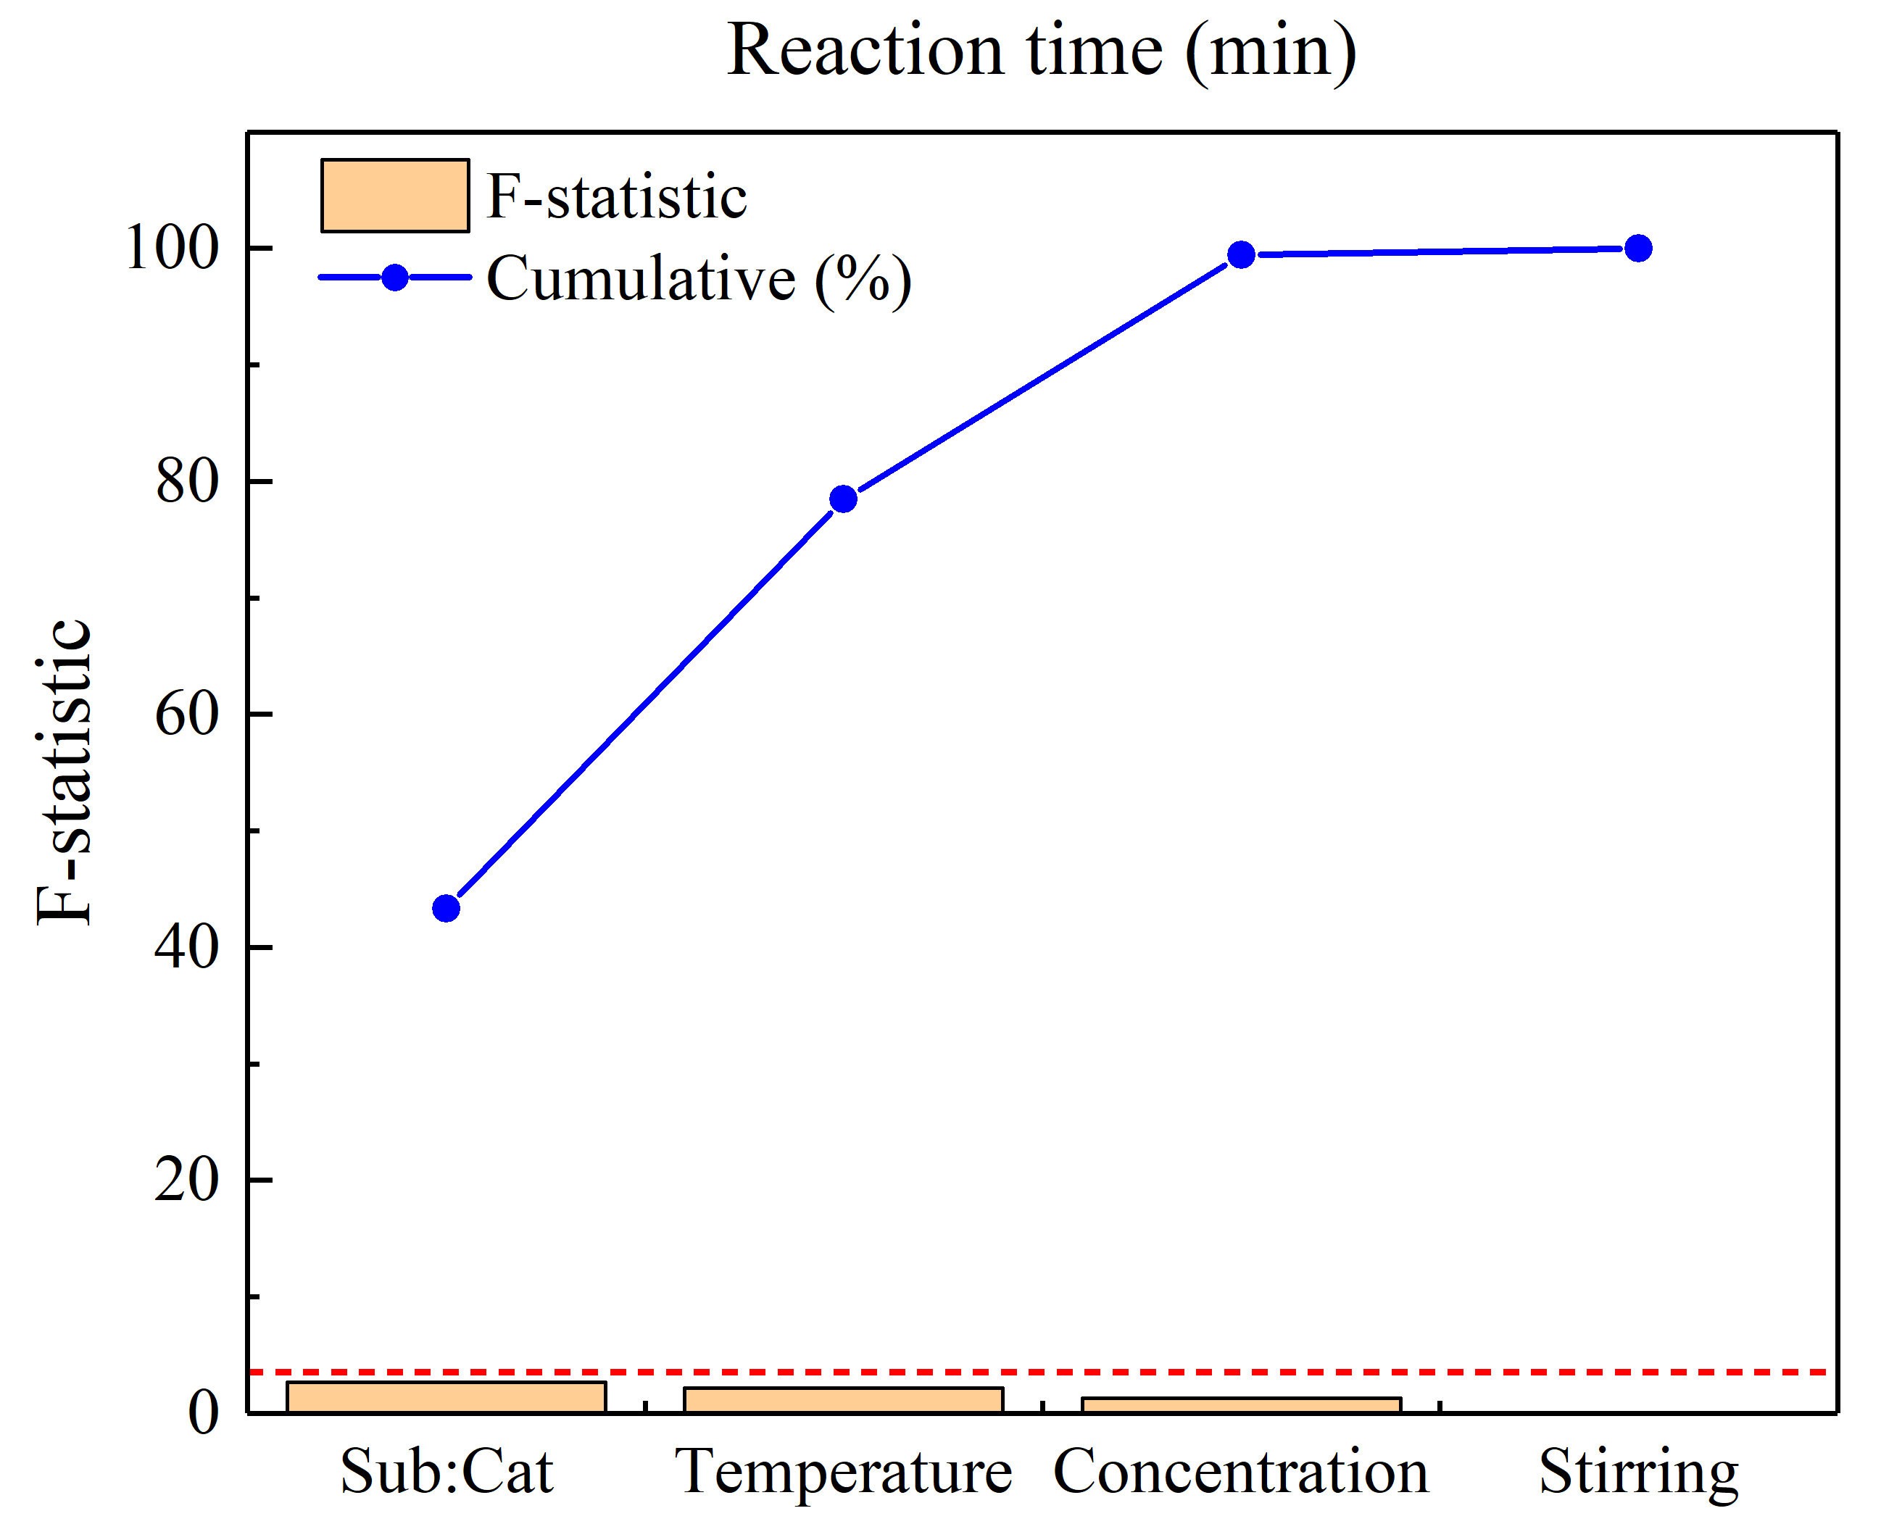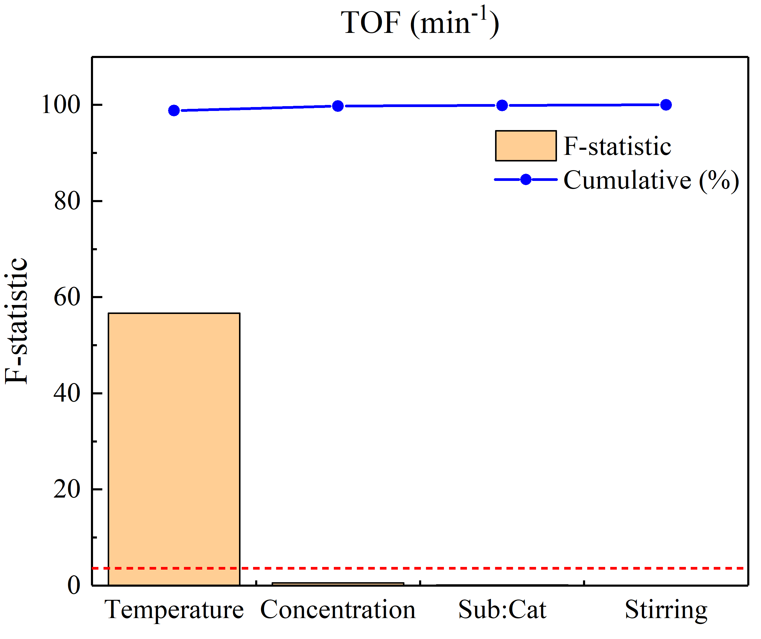
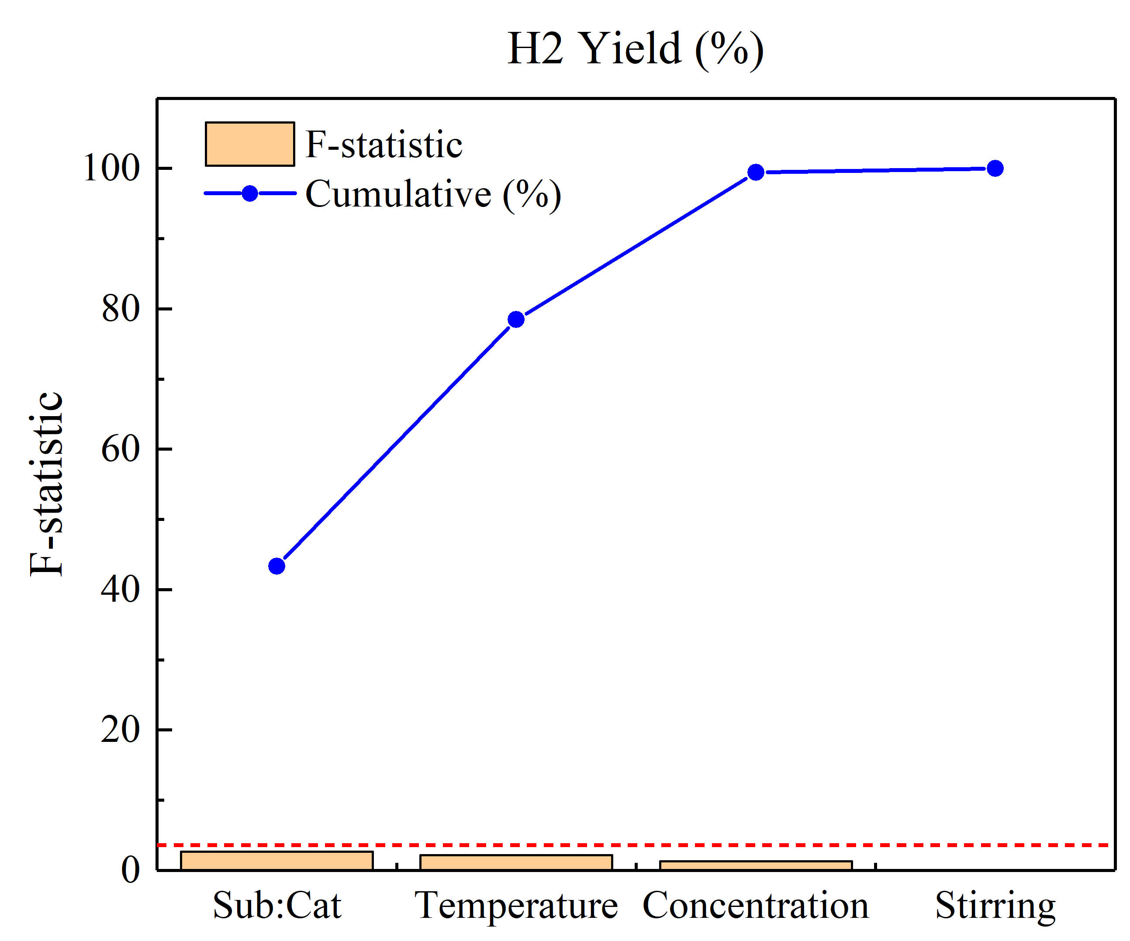
Figure S7. Bar charts showing the F-statistics for each factor’s effect on the responses from one-way ANOVA analysis.

Table S2. Kinetic properties of AB hydrolysis used in the model.
Kinetic parameter
$E_{a}$ (kJ/mol) |  | 65.9
$A$ (mol/m³.s) |  | 7.45$×$10¹¹
$K_{ads}$ (m³/mol) |  | 0.07
Kinetic constants at different temperatures
$k$ at 30 ºC (mol/m³.s) |  | 3.16
$k$ at 40 ºC (mol/m³.s) |  | 7.29
$k$ at 50 ºC (mol/m³.s) |  | 15.97

[1] S. Basu, A. Brockman, P. Gagare, Y. Zheng, P. V. Ramachandran, W. N. Delgass, J. P. Gore, J. Power Sources 2009, 188, 238–243.
[2] S. Akbayrak, S. Özkar, Dalton Trans. 2014, 43, 1797–1805.
[3] G. P. Rachiero, U. B. Demirci, P. Miele, Catal. Today 2011, 170, 85–92.
[4] N. Cao, W. Luo, G. Cheng, Int. J. Hydrog. Energy 2013, 38, 11964–11972.
[5] K. Mori, K. Miyawaki, H. Yamashita, ACS Catal. 2016, 6, 3128–3135.
[6] E. K. Abo-Hamed, T. Pennycook, Y. Vaynzof, C. Toprakcioglu, A. Koutsioubas, O. A. Scherman, Small 2014, 10, 3145–3152.
[7] H. Liang, G. Chen, S. Desinan, R. Rosei, F. Rosei, D. Ma, Int. J. Hydrog. Energy 2012, 37, 17921–17927.
[8] S. Akbayrak, Y. Tonbul, S. Özkar, Appl. Catal. B Environ. 2016, 198, 162–170.
[9] M. Rakap, Appl. Catal. B Environ. 2015, 163, 129–134.
[10] Q. Zhou, C. Xu, J. Colloid Interface Sci. 2017, 496, 235–242.
[11] M. Zahmakıran, S. Özkar, Appl. Catal. B Environ. 2009, 89, 104–110.
[12] W.-H. Wang, H.-P. Tang, W.-D. Lu, Y. Li, M. Bao, Y. Himeda, ChemCatChem 2017, 9, 3191–3196.

