Supplementary Materials
Title:
Probability Estimation of Narcolepsy Type 1 in DTA mice using Unlabeled EEG and EMG Data

Authors:
Laura Rose¹, Alexander Neergaard Zahid², Louise Piilgaard¹, Christine Egebjerg¹, Frederikke Lynge Sørensen³, Mie Andersen³, Tessa Radovanovic³, Anastasia Tsopanidou³, Stefano Bastianini⁴, Chiara Berteotti⁴, Viviana Lo Martire⁴, Micaela Borsa^{5,6}, Ryan K. Tisdale^{7,11}, Yu Sun⁷, Maiken Nedergaard³, Alessandro Silvani⁴, Giovanna Zoccoli⁴, Antoine Adamantidis^{5,6}, Thomas S. Kilduff⁷, Noriaki Sakai⁸, Seiji Nishino⁸, Sébastien Arthaud⁹, Christelle Peyron⁹, Patrice Fort⁹, Morten Mørup², Emmanuel Mignot^{10,¥}, Birgitte Rahbek Kornum^{1,*, ¥}

¹ Department of Neuroscience, Faculty of Health and Medical Sciences, University of Copenhagen, Copenhagen, Denmark
² Department of Applied Mathematics and Computer Science, Technical University of Denmark, Kgs. Lyngby, Denmark
³ Division of Glial Disease and Therapeutics, Center for Translational Neuromedicine, University of Copenhagen, Copenhagen, Denmark
⁴ Department of Biomedical and Neuromotor Sciences, University of Bologna, Bologna, Italy
⁵ Zentrum für Experimentelle Neurologie, Department of Neurology, University Hospital Bern, Bern, Switzerland
⁶ Department of Biomedical Research, University of Bern, Bern, Switzerland
⁷ Center for Neuroscience, Biosciences Division, SRI International, Menlo Park, CA, USA
⁸ Department of Psychiatry and Behavioral Sciences, Stanford University School of Medicine, Stanford, CA, USA
⁹ Center for Neuroscience Research in Lyon (CRNL), SLEEP Team, Université de Lyon, Lyon, France
¹⁰ Center for Narcolepsy, Department of Psychiatry, Stanford University School of Medicine, Stanford, CA, USA
¥ The authors contributed equally to this manuscript.
* Corresponding author: kornum@sund.ku.dk
¹¹ RKT is a current employee of F. Hoffmann-La Roche Ltd

Figure S1. Confusion matrix of Usleep_{EEG} with column-wise normalization (precision) tested in a held-out test set of (A) 11 WT mice (B) 19 DTA Confusion matrix of Usleep_{EMG} with column-wise normalization (precision) tested in a held-out test set of (C) 11 WT mice (D) 19 DTA mice
Figure S2. Confusion matrix of Usleep_{EEG} with row-wise normalization (recall) tested in a held-out test set of (A) 11 WT mice (B) 19 DTA Confusion matrix of Usleep_{EMG} with row-wise normalization (recall) tested in a held-out test set of (C) 11 WT mice (D) 19 DTA mice
Figure S3. Learning curve of usleep_{EEG.} Red color indicates validation loss, blue color training loss, grey dashed line indicates the model that is used (epoch = 938).
Figure S4. Learning curve of Usleep_{EMG.} Red color indicates validation loss, blue color training loss, grey dashed line indicates the model that is used (epoch = 569).
Figure S5. Learning curve of Usleep_{EEG,EMG.} Red color indicates validation loss, blue color training loss, grey dashed line indicates the model that is used (epoch = 984).

Table S1. The log-odds ratio (LOR) for each mis(classification) from Figure 2C is highlighted in bold, with the corresponding confidence intervals presented in parentheses. A LOR is considered significant if its confidence interval does not include zero.
Table S2. The log-odds ratio (LOR) for each mis(classification) from Figure 2D is highlighted in bold, with the corresponding confidence intervals presented in parentheses. A LOR is considered significant if its confidence interval does not include zero.
Table S3. List of hypothesis tests that were performed with the corresponding p-value. Pipeline A and pipeline B are tested against each other with a McNemar test, and none of the hypothesis tests yield significant outcomes.
Table S4. An overview of our automatic sleep stage classifiers (Usleep_{EEG} and Usleep_{EMG}) and how they compare to the literature in SPINDLE¹⁹ and in the model from Grieger et al²³. Notice the numbers from SPINDLE is calculated based on including the artefact epochs (SPINDLE Figure 6 – Cohort A).
Data S1: Environment.txt file
Data S2: Requirements.txt file
Data S3: Odds ratio and statistics

Figure S1. Confusion matrix of Usleep_{EEG} with column-wise normalization (precision) tested in a held-out test set of (A) 11 WT mice (B) 19 DTA Confusion matrix of Usleep_{EMG} with column-wise normalization (precision) tested in a held-out test set of (C) 11 WT mice (D) 19 DTA mice
Figure S2. Confusion matrix of Usleep_{EEG} with row-wise normalization (recall) tested in a held-out test set of (A) 11 WT mice (B) 19 DTA Confusion matrix of Usleep_{EMG} with row-wise normalization (recall) tested in a held-out test set of (C) 11 WT mice (D) 19 DTA mice

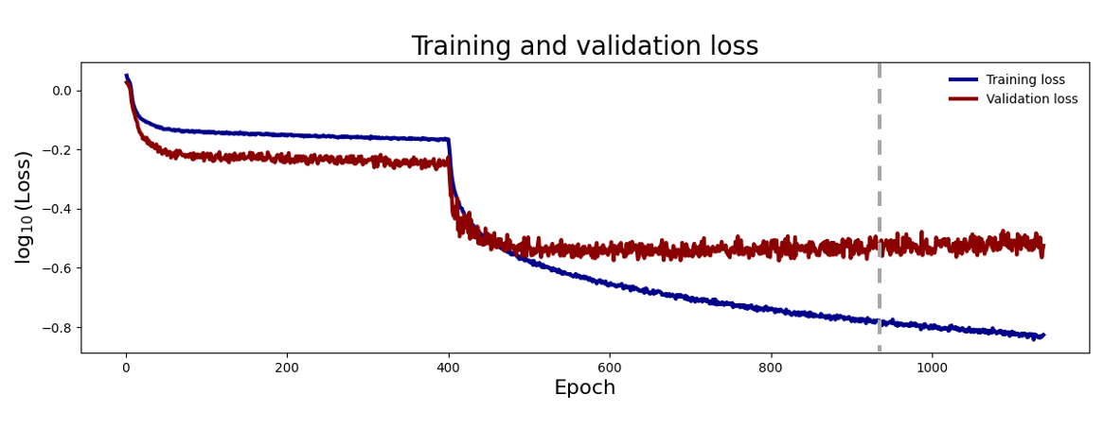
Figure S3. Learning curve of usleep_{EEG.} Red color indicates validation loss, blue color training loss, grey dashed line indicates the model that is used (epoch = 938).

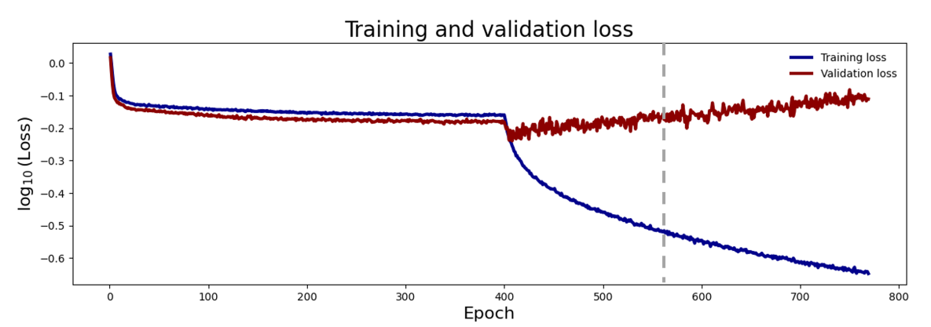
Figure S4. Learning curve of Usleep_{EMG.} Red color indicates validation loss, blue color training loss, grey dashed line indicates the model that is used (epoch = 569).
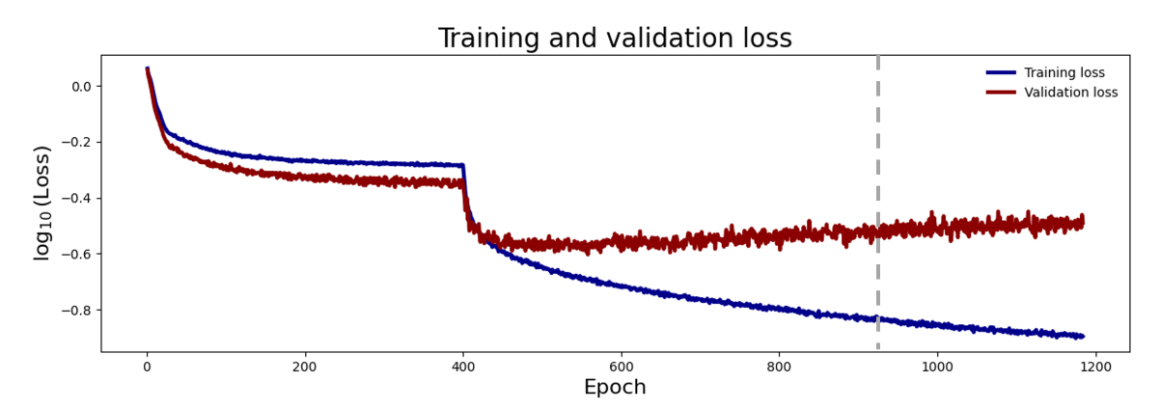
Figure S5. Learning curve of Usleep_{EEG,EMG.} Red color indicates validation loss, blue color training loss, grey dashed line indicates the model that is used (epoch = 984).

EMG
-0.901* (-0.931, -0.872) | 0.818* (0.787, 0.849) | 1.390* (1.300, 1.480)
0.127* (0.087, 0.166) | -0.074* (-0.100, -0.048) | 0.032 (0.000, 0.064)
0.050 (-0.045, 0.145) | -0.209* (-0.254, -0.164) | 0.207* (0.161, 0.253)

Table S1. The log-odds ratio (LOR) for each mis(classification) from Figure 2C is highlighted in bold, with the corresponding confidence intervals presented in parentheses. A LOR is considered significant if its confidence interval does not include zero.

EEG
-1.009* (-1.034, -0.985) | 0.850* (0.821, 0.878) | 1.285* (1.237, 1.334)
0.610* (0.565, 0.655) | -0.786* (-0.823, -0.750)', | 1.012* (0.952, 1.072)
0.603* (0.537, 0.668) | -0.308* (-0.383, -0.234) | -0.228* (-0.280, -0.176)

Table S2. The log-odds ratio (LOR) for each mis(classification) from Figure 2D is highlighted in bold, with the corresponding confidence intervals presented in parentheses. A LOR is considered significant if its confidence interval does not include zero.

Table S3. List of hypothesis tests that were performed with the corresponding p-value. Pipeline A and pipeline B are tested against each other with a McNemar test, and none of the hypothesis tests yield significant outcomes.
Table S4. An overview of our automatic sleep stage classifiers (Usleep_{EEG} and Usleep_{EMG}) and how they compare to the literature in SPINDLE¹⁹ and in the model from Grieger et al²³. Notice the numbers from SPINDLE is calculated based on including the artefact epochs (SPINDLE Figure 6 – Cohort A).

Data S1: Environment.txt file
name: u-sleep_v3
channels:
- defaults
- conda-forge
dependencies:
- conda>=4.10.3
- python=3.7*
- pip>=21.2.4
- setuptools>=52.0.0
- tk>=8.6.10
- wheel>=0.37.0
- numpy>=1.21.5
- tensorflow=2.8
- protobuf=3.20

Data S2: Requirements.txt file
numpy>=1.21.5
h5py>=3.6.0
matplotlib>=3.4.3
pandas>=1.3.5
psutil>=5.9.0
scipy>=1.7.3
mne>=0.24.1
tables>=3.7.0
tabulate>=0.8.9
wfdb>=3.4.1
ruamel.yaml>=0.17.21
scikit-learn>=1.0.2
requests>=2.27.1
carbontracker>=1.1.6
psg_utils>=0.1.6
tensorflow>=2.8.0
tensorflow-addons>=0.16.1
yamlhparams>=0.2.0

Data S3: Odds ratio and statistics
The odds ratio is obtained by first making a contingency table based on the information from the 3 x 3 matrix. As an example, if we want to calculate the odds ratio of the Wakefulness – REM sleep misclassification based on the 3 x 3 matrix from both the NT1 and WT cohort (see below) the contingency table will look like this.

NT1:
w – w | w – n | w – r
n – w | n – n | n – r
r – w | r – n | r - r

WT:
w – w | w – n | w – r
n – w | n – n | n – r
r – w | r – n | r - r

Contingency table
 | W – R | (W – W) + (W – N)
NT1 | X1 | X2
WT | X3 | X4

Based on elements in the contingency table the odds ratio and the confidence interval can be calculated as explained in (method section “Statistics”).

