Supporting Informations
- Figures and Tables
- Spectral Copies of ¹H, ¹³C NMR
- HPLC Data
- References

- Figures and Table

Figure S1. (A) CHMFL-EGFR-202 (orange colour) effect on the EGFR L858R structure (PDB ID 5GNK). The αC-helix is highlighted in forest green while the residues K745 and E762 are shown as spheres. (B) CHMFL-EGFR-202 (orange colour) binding pose in the ATP binding pocket in which the residues in the αC‐β4 loop are showed as spheres and coloured in light brown. (C) Comparison of binding modes of amide-flavone analogues (FL31 in pink, FL32 in dark red and FL33 in yellow) with FL30 (light sea green). (D) Comparison of binding modes of amide-flavone analogue FL34 in dark magenta with FL30 (light sea green).
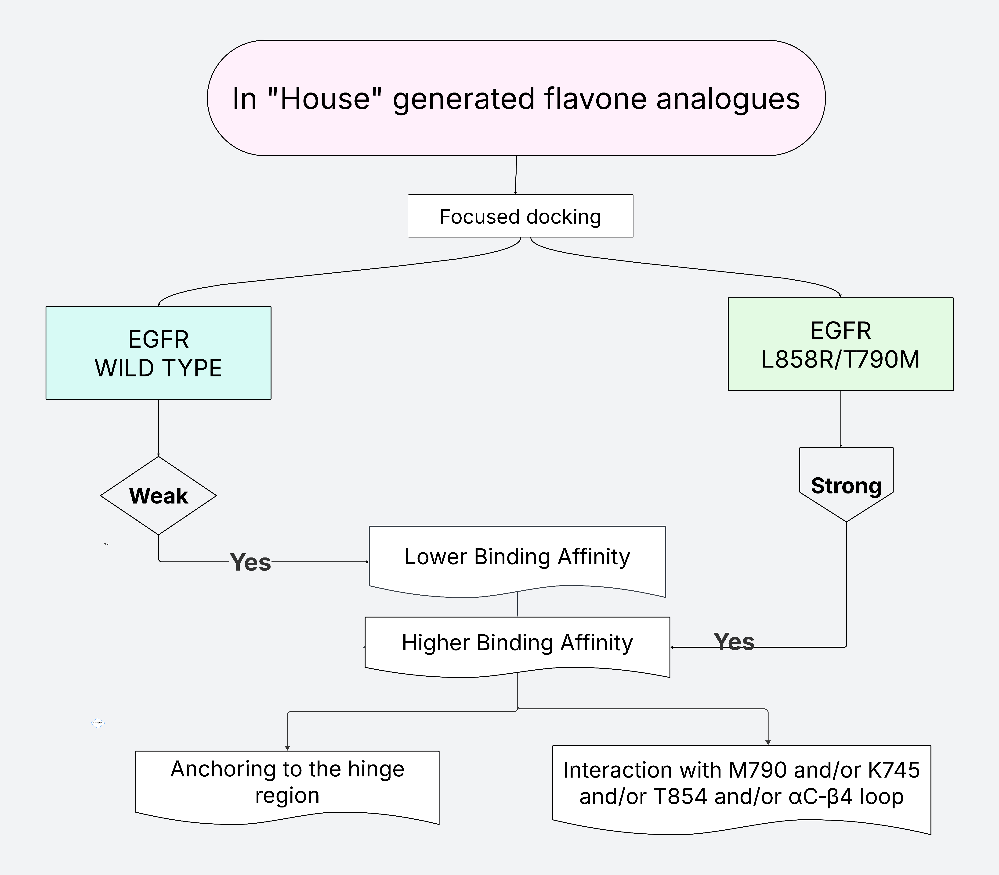
Figure S2. Flowchart for the discovery of mutant-selective EGFR inhibitors using the three-track virtual screening.
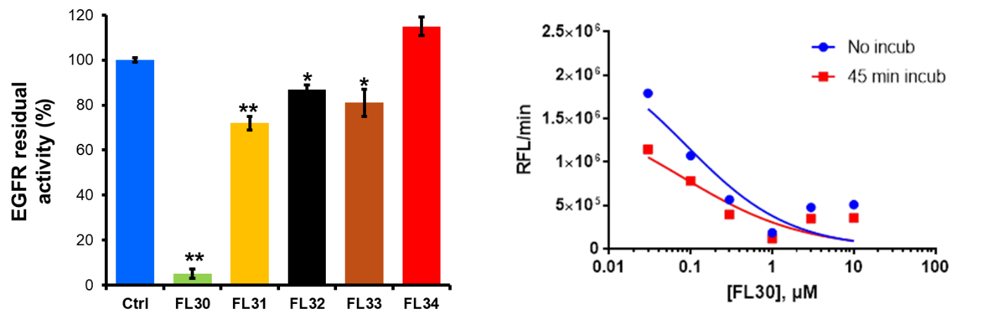
Figure S3. Left: Histograms of the residual EGFR kinase activity in the presence of 1 µM concentration of the tested compound. The data represent the mean ± SD of three independent experiments. Right: Dose and time-dependent inhibition of EGFR-LT activity by FL30. The partial release of inhibition at higher concentration (≥3 µM) is likely due to the formation of aggregates or precipitates, reducing its effective concentration in solution. **P<0.001; *P<0.05 vs. control.

Table S1. Cytotoxicity of TKIs on cell lines.
 | IC₅₀, µM
Cell Lines | MCF7 [a] | A549 [b] | H1975 [c] | HDF | [d] Selective Index^{d}
FL4 | >100 | >100 | 72 ± 4 | >100 | >1.4
FL30 | 65 ± 8 | 54 ± 2 | 1.7 ± 0.5 | 45 ± 3 | 31
Lapatinib | 55 | 9 | 20 | - | -
Osimertinib | 18 | 7.5 | 0.5 | ND | 32
Erlotinib | 4 ± 3 | 2.5 ± 0.4 | 62 ± 4 | - | -
[a] Low-expressing Wt-EGFR
[b] High-expressing Wt-EGFR
[c] High-expressing EGFR-L858R/T790M
[d] SI, determined as the ratio between IC₅₀ values measured in A549 and IC₅₀ calculated in H1975.
IC₅₀, half maximal inhibitory concentration.

Table S2. Data obtained from flow cytometry analyses in H1975 NSCLC cells after elaboration with FCS-7 Express Software.
 |  | % of Events |  | % of gated cells  (from plot) |  | Geometric Mean  (GRN-HLog) |  | Median
 |  | EGFR | pEGFR | EGFR | pEGFR | EGFR | pEGFR | EGFR | pEGFR
H1975 NSCLC | Untreated cells | 1967 | 1952 | 100 | 100 | 49.56 | 35.74 | 91.65 | 40.37
H1975 NSCLC | [FL30], 1 µM | 1938 | 1936 | 100 | 100 | 40.29 | 15.00 | 79.23 | 18.72
H1975 NSCLC | [FL30], 5 µM | 1970 | 1962 | 100 | 100 | 55.30 | 10.87 | 89.72 | 15.42
H1975 NSCLC | [FL4], 60 µM | 1947 | 1943 | 100 | 100 | 48.91 | 42.82 | 87.16 | 44.22
A549 NSCLC | Untreated cells | 1835 | 1948 | 100 | 100 | 92.25 | 24.48 | 107.87 | 25.11
A549 NSCLC | [FL30], 1 µM | 1850 | 1506 | 100 | 100 | 95.92 | 21.44 | 116.35 | 23.29
A549 NSCLC | [FL30], 5 µM | 1873 | 1876 | 100 | 100 | 86.31 | 20.77 | 105.27 | 22.69
A549 NSCLC | [FL4], 60 µM | 1759 | 1914 | 100 | 100 | 100.64 | 18.63 | 112.84 | 19.93

Figure S4. Average 2nd Derivative spectra of Wt EGFR in black and EGFR-LT in red. The shading areas represent the calculated standard deviation between the different experiments.

Figure S5. (A-C) Line plot of the loadings of the PCA: in black PC2 and in red PC3. (D-F) Same plots for the EGFR-L858R/T790M (LT) experiments. *** P≤0.001 vs EGFR-LT CTRL.

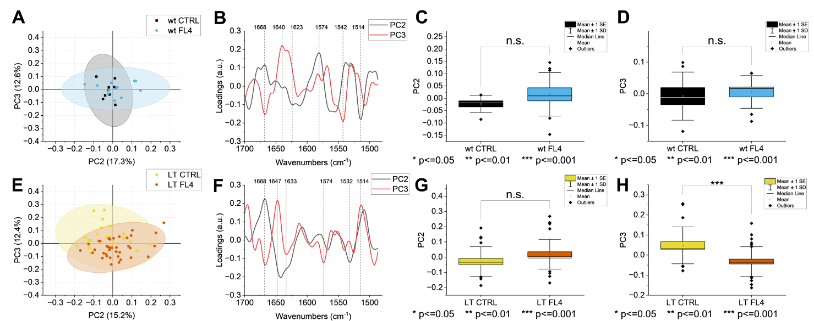
Figure S6. (A) Scatterplot representing the PCA score values of all the experimental points of the Wt+FL4, the ellipses represent the C.I of 95%. (E) The same for EGFR-LT+FL4, the ellipses represent the C.I of 95%. (B) Line plot of the loadings of the PCA: in black PC2 and in red PC3. (F) Same plots for the EGFR-L858R/T790M (LT) experiments. (C-D) Box plot of the paired comparison with Tukey test of the score values of EGFR Wt alone and treated with FL4 for PC2 and PC3, respectively. (G-H) Same plots for the EGFR (LT) experiments. *P≤0.05; **P≤0.01; *** P≤0.001 vs EGFR-LT CTRL.

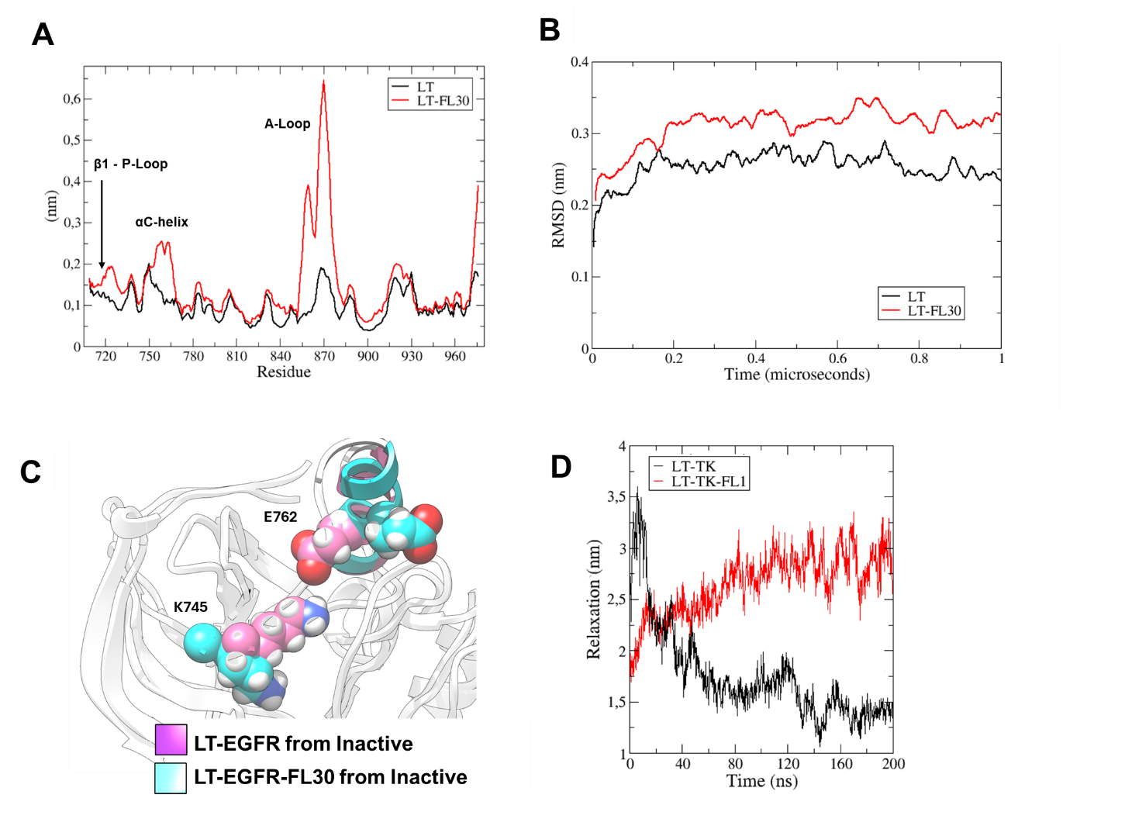
Figure S7. (A) Root-mean square fluctuations (RMSF) and (B) root-mean square deviation (RMSD) analyses for the EGFR-LT in isolation and in complex with FL30. (C) Representative structures and (D) radius of gyration (relaxation) of EGFR-LT in both its isolated form and complexed with FL30, derived from molecular dynamics (MD) simulations. It is important to note that the initial structure used was the inactive form of EGFR-LT, and the comparison is based on the two structures generated at the conclusion of the 200 ns MD simulation.

- Spectral Copies of ¹H, ¹³C NMR

NMR spectra of compound 1b (¹H, 600 MHz, DMSO-d6)

NMR spectra of compound 1b (¹³C, 151 MHz, DMSO-d6)

NMR spectra of compound 3a (¹H, 400 MHz, DMSO-d6)

NMR spectra of compound 3a (¹³C, 101 MHz, DMSO-d6)

NMR spectra of compound 3b (¹H, 600 MHz, DMSO-d6)

NMR spectra of compound 3b (¹³C, 151 MHz, DMSO-d6)

NMR spectra of compound 4a (¹H, 400 MHz, CDCl₃)

NMR spectra of compound 4a (¹³C, 151 MHz, CDCl₃)

NMR spectra of compound 4b (¹H, 600 MHz, DMSO-d6)

NMR spectra of compound 4b (¹³C, 151 MHz, DMSO-d6)

NMR spectra of compound 5a (¹H, 400 MHz, DMSO-d6)

NMR spectra of compound 5a (¹³C, 100 MHz, DMSO-d6)

NMR spectra of compound 5b (¹H, 600 MHz, DMSO-d6)

NMR spectra of compound 5b (¹³C, 151 MHz, DMSO-d6)

NMR spectra of compound 6a (FL30) (¹H, 500 MHz, DMSO-d6)

NMR spectra of compound 6a (FL30) (¹³C, 126 MHz, DMSO-d6)

NMR spectra of compound 6b (FL31) (¹H, 600 MHz, DMSO-d6)

NMR spectra of compound 6b (FL31) (¹³C, 151 MHz, DMSO-d6)

NMR spectra of compound 6c (FL32) (¹H, 400 MHz, DMSO-d6)

NMR spectra of compound 6c (FL32) (¹³C, 101 MHz, DMSO-d6)

NMR spectra of compound 6d (FL33) (¹H, 600 MHz, DMSO-d6)

NMR spectra of compound 6d (FL33) (¹³C, 151 MHz, DMSO-d6)

NMR spectra of compound 6e (FL34) (¹H, 600 MHz, DMSO-d6)

NMR spectra of compound 6e (FL34) (¹³C, 151 MHz, DMSO-d6)

- HRMS and HPLC-MS Data
HRMS spectra for compound 1b (Calcd. Neutral mass: 211.04807 Da).

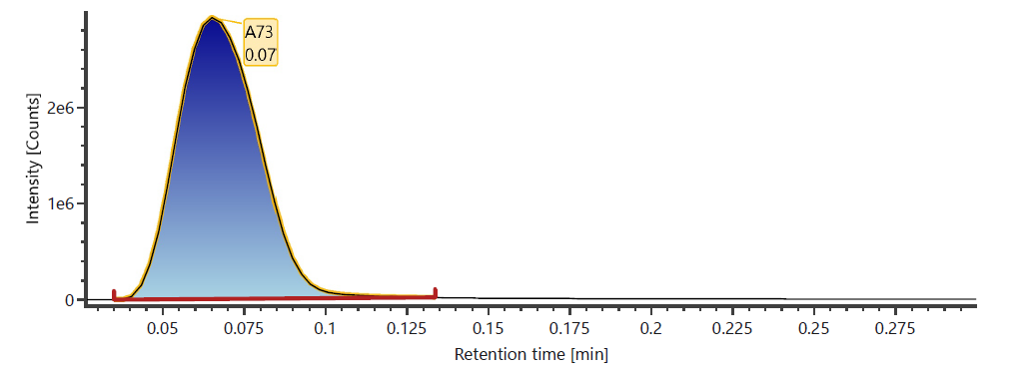
1b

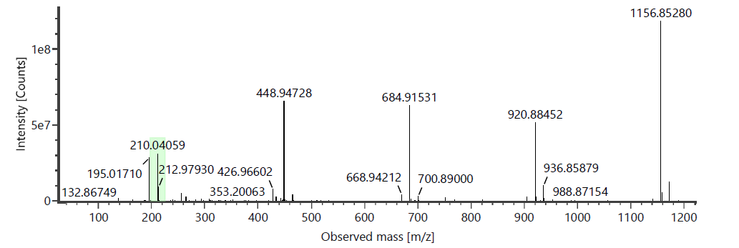

HRMS spectra of compound 3a (Calcd. Neutral mass: 375.11067 Da, Calcd. mass for C₂₂H₁₇NO₅ +Na⁺ = 398,36330).
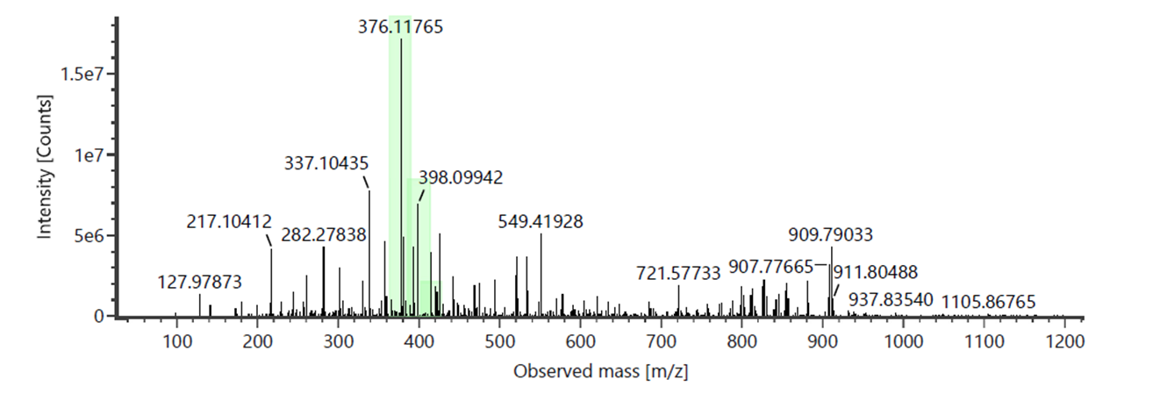

HRMS spectra of compound 3b (Calcd. Neutral mass: 391.10559 Da).
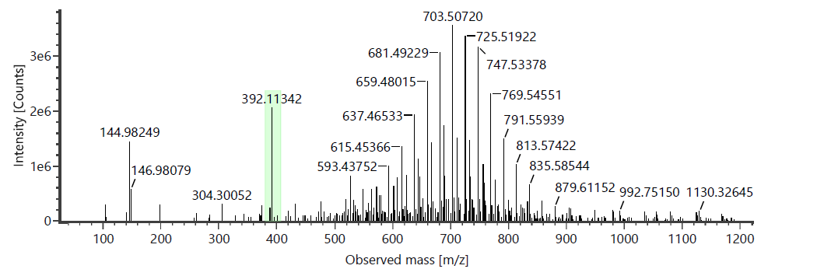

HRMS spectra of compound 4a (Calcd. Neutral mass: 373.09502 Da).
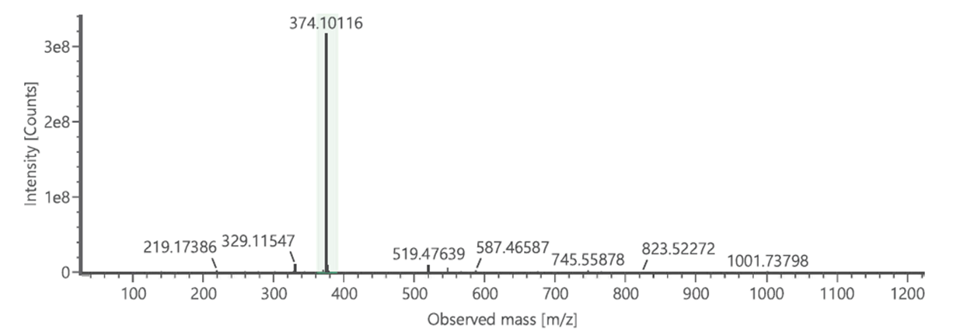

HRMS spectra for compound 4b (Calcd. Neutral Mass: 389.08994 Da).
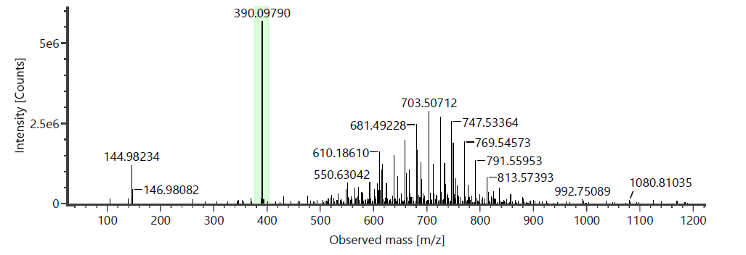

HRMS spectra of compound 5a (Calcd. Neutral mass: 343.12084 Da).
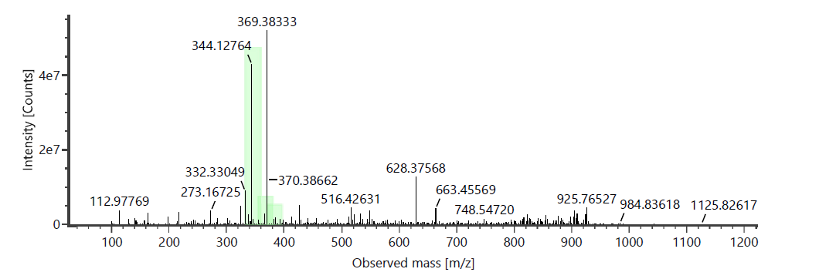

HRMS spectra for compound 5b (Calcd. Neutral Mass 359.11576 Da).
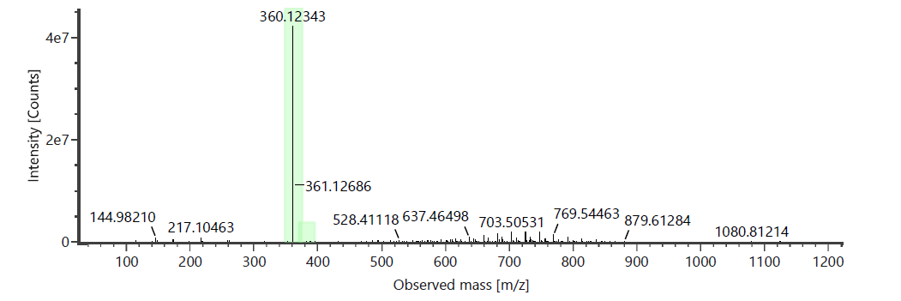

HPLC-MS spectra of compound 6a, FL30 (Calcd. Neutral mass: 397.13141 Da).
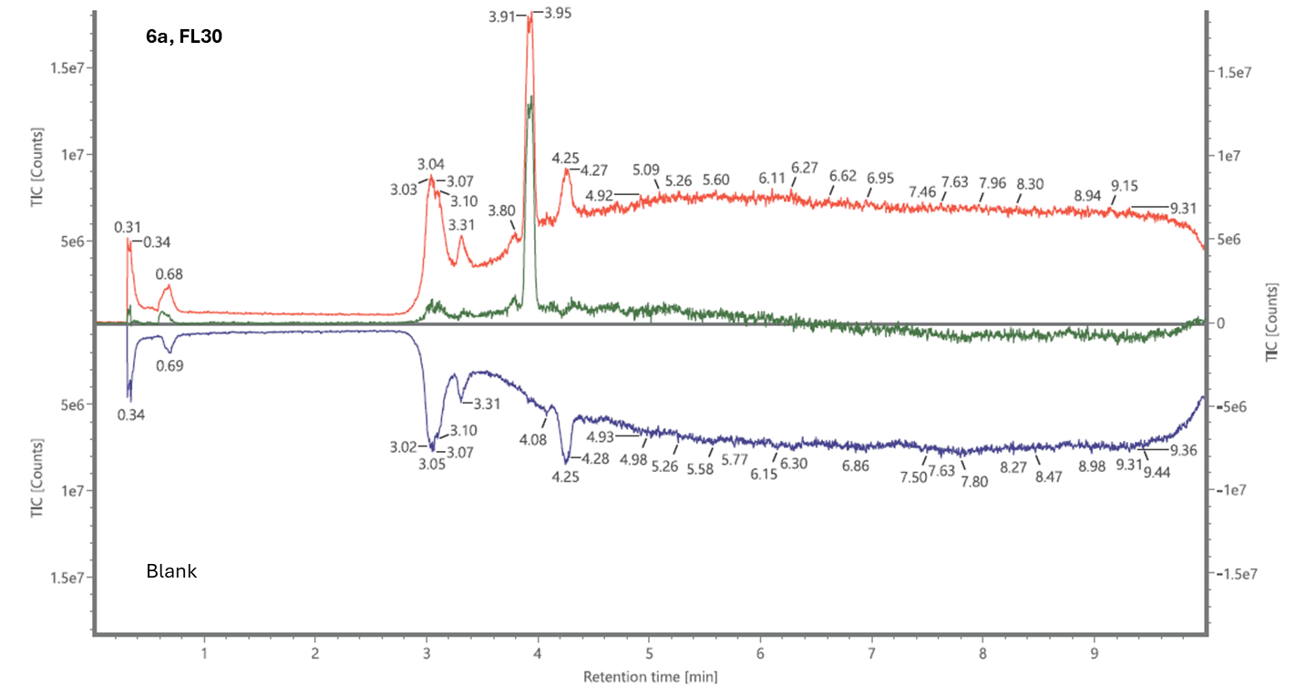
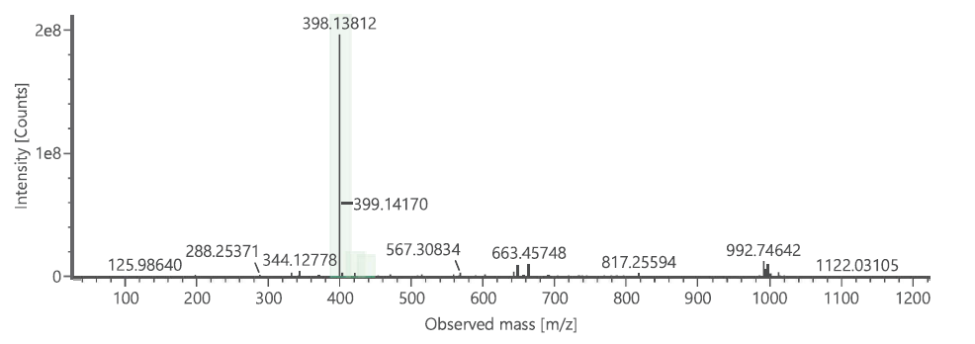

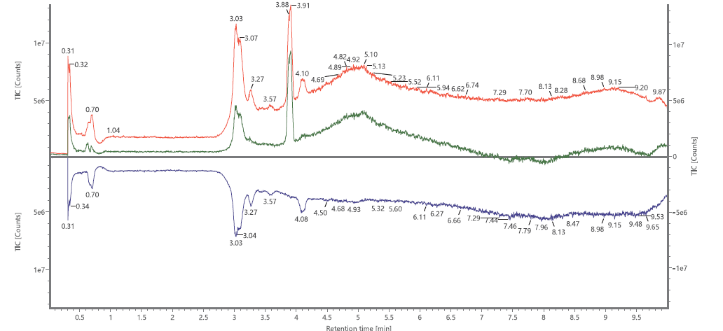
HPLC-MS spectra of compound 6b, FL31 (Calcd. Neutral mass: 413.12632 Da).
6b, FL31
Blank

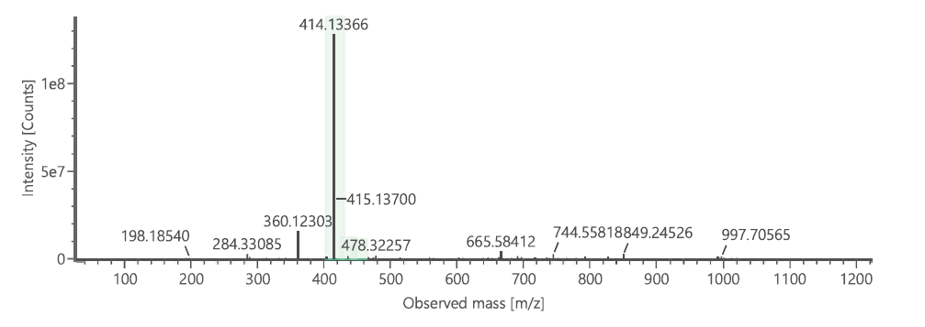

HPLC-MS spectra of compound 6c, FL32 (Calcd. Neutral mass: 447.14706 Da). Calcd. mass for C₂₉H₂₁NO₄ +Na⁺: 470,13628 Da
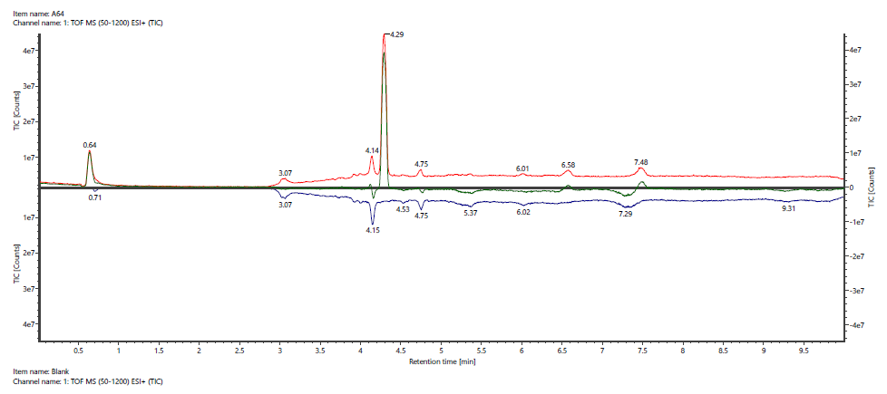
6c, FL32
Blank

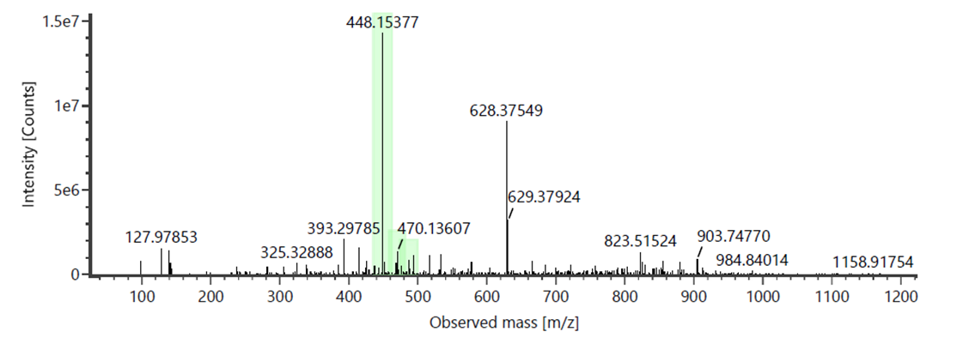

HRMS spectra of compound 6d, FL33 (Calcd. Neutral mass: 427.17836 Da, Calcd mass for C₂₇H₂₅NO₄ +Na⁺: 450,16758 Da).

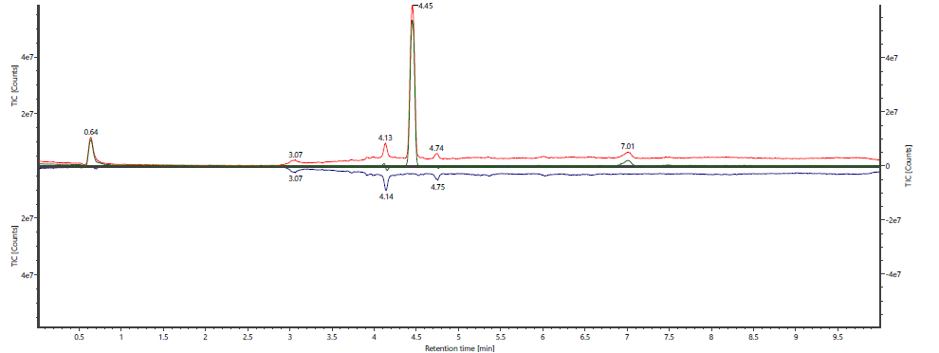
6d, FL33
Blank

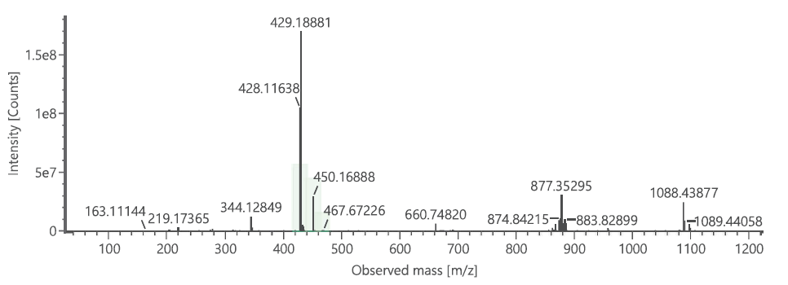

HPLC-MS spectra of compound 6e, FL34 (Calcd. Neutral mass: 399,14706 Da).
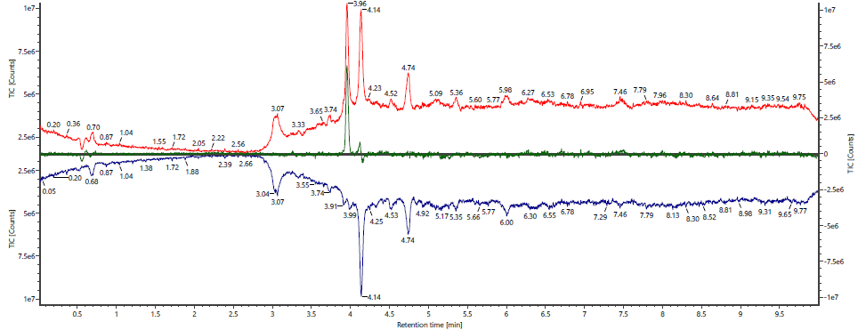
Blank
6e, FL34)

