Suppl. Table S1 Quantum yield of photosystem II (PSII) (Fv/Fm) detected upon UV and thermal stress treatments in anemone Entacmaea quadricolor.
 |  | Day1 |  |  | Day2 |  |  | Day3 |  |  | Day4
Control
Anemone Tank |  | F-Value | Fv/Fm |  | F-Value | Fv/Fm |  | F-Value | Fv/Fm |  | F-Value | Fv/Fm
 | 1 | 258 | 658 |  | 237 | 610 |  | 278 | 648 |  | 259 | 575
 |  | 268 | 622 |  | 224 | 592 |  | 205 | 618 |  | 223 | 469
 |  | 243 | 592 |  | 276 | 657 |  | 227 | 641 |  | 212 | 406
Average |  | 256.33 | 624 |  | 245.66 | 619.66 |  | 236.66 | 635.66 |  | 231.33 | 483.33
 | 2 | 284 | 570 |  | 285 | 791 |  | 194 | 648 |  | 264 | 488
 |  | 278 | 616 |  | 233 | 695 |  | 228 | 580 |  | 256 | 544
 |  | 259 | 645 |  | 198 | 617 |  | 302 | 639 |  | 246 | 566
Average |  | 273.66 | 610.33 |  | 238.66 | 701 |  | 241.33 | 622.33 |  | 255.33 | 532.66
 | 3 | 228 | 518 |  | 265 | 648 |  | 209 | 556 |  | 241 | 644
 |  | 302 | 627 |  | 233 | 570 |  | 202 | 556 |  | 241 | 467
 |  | 270 | 659 |  | 229 | 671 |  | 244 | 515 |  | 259 | 511
Average |  | 266.66 | 601.33 |  | 242.33 | 629.66 |  | 218.33 | 542.33 |  | 247 | 540.66
 | 4 | 272 | 595 |  | 249 | 668 |  | 226 | 594 |  | 256 | 401
 |  | 281 | 553 |  | 198 | 579 |  | 245 | 482 |  | 210 | 587
 |  | 300 | 617 |  | 279 | 678 |  | 307 | 604 |  | 192 | 469
Average |  | 284.33 | 588.33 |  | 242 | 641.66 |  | 259.33 | 560 |  | 219.33 | 485.66
Average of Total |  | 270.25 | 606 |  | 242.16 | 648 |  | 238.9167 | 590.08 |  | 238.25 | 510.58
Temperature
Anemone Tank |  | F-Value | Fv/Fm |  | F-Value | Fv/Fm |  | F-Value | Fv/Fm |  | F-Value | Fv/Fm
 | 1 | 290 | 678 |  | 206 | 764 |  | 247 | 621 |  | 318 | 587
 |  | 321 | 626 |  | 308 | 632 |  | 196 | 678 |  | 181 | 639
 |  | 276 | 674 |  | 250 | 654 |  | 248 | 604 |  | 308 | 613
Average |  | 295.66 | 659.33 |  | 254.66 | 683.33 |  | 230.33 | 634.33 |  | 269 | 613
 | 2 | 226 | 613 |  | 285 | 540 |  | 264 | 648 |  | 234 | 767
 |  | 259 | 671 |  | 295 | 561 |  | 254 | 649 |  | 280 | 636
 |  | 265 | 684 |  | 270 | 553 |  | 203 | 655 |  | 312 | 754
Average |  | 250 | 656 |  | 283.33 | 551.33 |  | 240.33 | 650.66 |  | 275.33 | 719
 | 3 | 238 | 636 |  | 227 | 655 |  | 263 | 660 |  | 246 | 336
 |  | 288 | 636 |  | 292 | 659 |  | 237 | 629 |  | 274 | 406
 |  | 289 | 505 |  | 266 | 661 |  | 227 | 642 |  | 268 | 473
Average |  | 271.66 | 592.33 |  | 261.66 | 658.33 |  | 242.33 | 643.66 |  | 262.66 | 405
 | 4 | 293 | 657 |  | 252 | 687 |  | 249 | 644 |  | 315 | 272
 |  | 273 | 635 |  | 273 | 693 |  | 196 | 562 |  | 281 | 344
 |  | 279 | 614 |  | 304 | 693 |  | 209 | 595 |  | 218 | 31
Average |  | 281.66 | 635.33 |  | 276.33 | 691 |  | 218 | 600.33 |  | 271.33 | 215.66
Average of Total |  | 274.75 | 635.75 |  | 269 | 646 |  | 232.75 | 632.25 |  | 269.58 | 488.16
UV
Anemone Tank |  | F-Value | Fv/Fm |  | F-Value | Fv/Fm |  | F-Value | Fv/Fm |  | F-Value | Fv/Fm
 | 1 | 235 | 573 |  | 192 | 682 |  | 259 | 671 |  | 233 | 591
 |  | 308 | 656 |  | 283 | 621 |  | 302 | 532 |  | 216 | 494
 |  | 275 | 583 |  | 267 | 578 |  | 300 | 665 |  | 266 | 641
Average |  | 272.66 | 604 |  | 247.33 | 627 |  | 287 | 622.66 |  | 238.33 | 575.33
 | 2 | 252 | 612 |  | 253 | 680 |  | 261 | 676 |  | 270 | 607
 |  | 256 | 617 |  | 214 | 720 |  | 284 | 600 |  | 225 | 630
 |  | 251 | 617 |  | 274 | 629 |  | 227 | 556 |  | 220 | 772
Average |  | 253 | 615.33 |  | 247 | 676.33 |  | 257.33 | 610.66 |  | 238.3333 | 669.66
 | 3 | 285 | 638 |  | 287 | 686 |  | 299 | 548 |  | 305 | 640
 |  | 294 | 676 |  | 293 | 620 |  | 223 | 607 |  | 291 | 665
 |  | 250 | 641 |  | 233 | 677 |  | 258 | 410 |  | 205 | 668
Average |  | 276.33 | 651.66 |  | 271 | 661 |  | 260 | 521.66 |  | 267 | 657.66
 | 4 | 224 | 571 |  | 315 | 670 |  | 277 | 654 |  | 269 | 570
 |  | 307 | 554 |  | 314 | 647 |  | 281 | 610 |  | 231 | 601
 |  | 281 | 632 |  | 267 | 555 |  | 218 | 593 |  | 182 | 696
Average |  | 270.66 | 585.66 |  | 298.66 | 624 |  | 258.66 | 619 |  | 227.33 | 622.33
Average of Total |  | 268.16 | 614.16 |  | 266 | 647.08 |  | 265.75 | 593.5 |  | 242.75 | 631.25

Suppl. Table S2 Quantum yield of photosystem II (PSII) (Fv/Fm) and number of bell pulsations per minute detected upon UV and thermal stress treatments in jellyfish Cassiopea andromeda.
 |  | Day1 |  |  | Day2 |  |  |  | Day3 |  |  |  | Day4
Control
Jellyfish Tank |  | F-Value | Fv/Fm |  | F-Value | Fv/Fm | Pulsing |  | F-Value | Fv/Fm | Pulsing |  | F-Value | Fv/Fm | Pulsing
 | 1 | 221 | 620 |  | 206 | 553 |  |  | 204 | 583 |  |  | 263 | 490
 |  | 204 | 616 |  | 239 | 587 |  |  | 235 | 620 |  |  | 231 | 587
 |  | 245 | 590 |  | 205 | 571 |  |  | 204 | 595 |  |  | 190 | 581
Average |  | 223.33 | 608.66 |  | 216.66 | 570.33 | 12 |  | 214.33 | 599.33 | 18 |  | 228 | 552.66 | 12
 | 2 | 241 | 642 |  | 209 | 571 |  |  | 236 | 566 |  |  | 215 | 605
 |  | 231 | 663 |  | 252 | 600 |  |  | 187 | 591 |  |  | 176 | 614
 |  | 225 | 563 |  | 205 | 601 |  |  | 171 | 589 |  |  | 172 | 578
Average |  | 232.33 | 622.66 |  | 222 | 590.66 | 42 |  | 198 | 582 | 48 |  | 187.66 | 599 | 24
 | 3 | 232 | 581 |  | 214 | 673 |  |  | 261 | 611 |  |  | 218 | 552
 |  | 231 | 604 |  | 219 | 656 |  |  | 258 | 623 |  |  | 208 | 541
 |  | 218 | 597 |  | 233 | 701 |  |  | 212 | 631 |  |  | 240 | 546
Average |  | 227 | 594 |  | 222 | 676.66 | 24 |  | 243.66 | 621.66 | 18 |  | 222 | 546.33 | 24
 | 4 | 226 | 633 |  | 195 | 586 |  |  | 193 | 620 |  |  | 282 | 638
 |  | 221 | 465 |  | 302 | 589 |  |  | 203 | 599 |  |  | 208 | 571
 |  | 202 | 588 |  | 205 | 616 |  |  | 206 | 571 |  |  | 266 | 619
Average |  | 216.33 | 562 |  | 234 | 597 | 30 |  | 200.66 | 596.66 | 48 |  | 252 | 609.33 | 54
Average of Total |  | 224.75 | 596.83 |  | 223.66 | 608.66 | 27 |  | 214.16 | 599.91 | 33 |  | 222.4167 | 576.83 | 28.5
Temperature
Jellyfish Tank |  | F-Value | Fv/Fm |  | F-Value | Fv/Fm | Pulsing |  | F-Value | Fv/Fm | Pulsing |  | F-Value | Fv/Fm | Pulsing
 | 1 | 206 | 669 |  | 263 | 661 |  |  | 220 | 621 |  |  | 218 | 652
 |  | 199 | 650 |  | 219 | 663 |  |  | 236 | 678 |  |  | 295 | 722
 |  | 234 | 647 |  | 226 | 638 |  |  | 254 | 604 |  |  | 282 | 675
Average |  | 213 | 655.33 |  | 236 | 654 | 24 |  | 236.66 | 634.33 | 18 |  | 265 | 683 | 42
 | 2 | 254 | 584 |  | 232 | 573 |  |  | 264 | 648 |  |  | 247 | 598
 |  | 245 | 652 |  | 226 | 586 |  |  | 254 | 649 |  |  | 199 | 552
 |  | 223 | 643 |  | 196 | 594 |  |  | 201 | 655 |  |  | 284 | 601
Average |  | 240.66 | 626.33 |  | 218 | 584.33 | 18 |  | 239.66 | 650.66 | 30 |  | 243.33 | 583.66 | 30
 | 3 | 212 | 653 |  | 250 | 651 |  |  | 263 | 660 |  |  | 263 | 570
 |  | 266 | 693 |  | 296 | 678 |  |  | 237 | 629 |  |  | 221 | 558
 |  | 299 | 651 |  | 256 | 627 |  |  | 227 | 642 |  |  | 231 | 586
Average |  | 259 | 665.66 |  | 267.33 | 652 | 18 |  | 242.33 | 643.66 | 18 |  | 238.33 | 571.33 | 12
 | 4 | 213 | 629 |  | 234 | 673 |  |  | 249 | 644 |  |  | 259 | 523
 |  | 244 | 641 |  | 232 | 655 |  |  | 196 | 562 |  |  | 251 | 609
 |  | 232 | 633 |  | 203 | 589 |  |  | 209 | 595 |  |  | 271 | 628
Average |  | 229.66 | 634.33 |  | 223 | 639 | 18 |  | 218 | 600.33 | 30 |  | 260.33 | 586.66 | 60
Average of Total |  | 235.58 | 645.41 |  | 236.08 | 632.33 | 19.5 |  | 234.16 | 632.25 | 24 |  | 251.75 | 606.16 | 36
UV
Jellyfish Tank |  | F-Value | Fv/Fm |  | F-Value | Fv/Fm | Pulsing |  | F-Value | Fv/Fm | Pulsing |  | F-Value | Fv/Fm | Pulsing
 | 1 | 226 | 560 |  | 221 | 583 |  |  | 253 | 561 |  |  | 231 | 559
 |  | 226 | 613 |  | 237 | 603 |  |  | 214 | 586 |  |  | 311 | 498
 |  | 221 | 645 |  | 241 | 597 |  |  | 239 | 557 |  |  | 299 | 613
Average |  | 224.33 | 606 |  | 233 | 594.33 | 24 |  | 235.33 | 568 | 12 |  | 280.33 | 556.66 | 12
 | 2 | 223 | 604 |  | 238 | 690 |  |  | 217 | 594 |  |  | 264 | 604
 |  | 241 | 621 |  | 270 | 617 |  |  | 291 | 608 |  |  | 268 | 537
 |  | 276 | 603 |  | 306 | 600 |  |  | 272 | 622 |  |  | 277 | 632
Average |  | 246.66 | 609.33 |  | 271.33 | 635.66 | 30 |  | 260 | 608 | 6 |  | 269.66 | 591 | 12
 | 3 | 226 | 616 |  | 241 | 684 |  |  | 241 | 661 |  |  | 225 | 553
 |  | 207 | 626 |  | 230 | 604 |  |  | 233 | 608 |  |  | 254 | 532
 |  | 223 | 613 |  | 220 | 648 |  |  | 255 | 622 |  |  | 271 | 577
Average |  | 218.66 | 618.33 |  | 230.33 | 645.33 | 30 |  | 243 | 630.33 | 18 |  | 250 | 554 | 12
 | 4 | 210 | 604 |  | 193 | 654 |  |  | 247 | 607 |  |  | 222 | 656
 |  | 201 | 703 |  | 211 | 556 |  |  | 270 | 609 |  |  | 245 | 672
 |  | 237 | 586 |  | 242 | 657 |  |  | 266 | 644 |  |  | 250 | 673
Average |  | 216 | 631 |  | 215.33 | 622.33 | 24 |  | 261 | 620 | 18 |  | 239 | 667 | 0
Average of Total |  | 226.41 | 616.16 |  | 237.5 | 624.41 | 27 |  | 249.83 | 606.58 | 13.5 |  | 259.75 | 592.16 | 9

Suppl. Table S3 Differential metabolite classes detected upon UV and thermal stress treatments in anemone Entacmaea quadricolor.

Peak no. | RT (min) | Parent ion (Error in ppm) | Compound Name | Formula | Fragments
Fatty acid
A1 | 9.84 | 189.11 (1.67) | Dihydroxynonanoic acid | C₉H₁₇O₄⁻ | 171, 129, 127, 59
A2 | 10.46 | 218.21 (2.4) | Lauric acid [M+NH₄]⁺ | C₁₂H₂₈NO₂⁺ | 201, 174, 106, 88
A3 | 11.81 | 246.24 (0.91) | Myristic acid [M+NH₄]⁺ | C₁₄H₃₂NO₂⁺ | 228, 202, 106, 88
A46 | 17.02 | 415.31 (-0.9) | Hydroxy fatty acid ascaroside | C₂₃H₄₄O₆⁻
Glycolipid
A6 | 13.48 | 673.34 (-3.2) | Sarcoglycoside A | C₃₃H₅₄O₁₄⁻
A51 | 17.78 | 950.58 (-0.1) | DGDG (36:8) | C₅₁H₈₄NO₁₅⁺ | 753, 609, 333
A54 | 18.07 | 976.6 (-0.76) | DGDG (38:9) | C₅₃H₈₆NO₁₅⁺ | 779, 635, 333
A61 | 18.86 | 814.55 (1.45) | MGDG (38:9) | C₄₇H₇₆NO₁₀⁺ | 797, 635, 333
Polyketide
A5 | 13.47 | 719.34 (8.8) | Salarin B | C₃₆H₅₂N₂O₁₃⁻ | 673, 415, 397
A12 | 14.38 | 509.38 (2.07) | Levantilide A | C₃₀H₅₂O₆⁺
A25 | 15.15 | 507.37 (3.36) | Levantilide B | C₃₀H₅₀O₆⁺
A30 | 15.35 | 538.35 (-6.1) | Halichomycin | C₃₃H₄₉NO₅⁻
A56 | 18.29 | 979.56 (-3.09) | Spirastrellolide B | C₅₂H₈₃O₁₇⁻ | 933, 655, 397, 379
A63 | 19.64 | 727.56 (-1.72) | Vitroprocine E dimer [2M+H]⁺ | 2(C₂₂H₃₇NO₃)⁺ | 364
Nitrogenous lipid
A18 | 14.85 | 526.35 (1) | Unknown | C₂₇H₄₉N₃O₇⁻ | 466
A59 | 18.74 | 338.34 (-0.86) | Docosenamide | C₂₂H₄₄NO⁺ | 321, 303
Peptide
A48 | 17.08 | 582.41 (4.6) | Tuftsin-hexylamide (threonyl-lysyl-prolyl-N-hexyl-argininamide) | C₂₇H₅₃N₉O₅⁻ | 549, 522, 433
A52 | 17.80 | 977.55 (-0.95) | Phe-Ala-Leu-Pro-Gln-Tyr-Leu-Lys | C₄₉H₇₃N₁₀O₁₁⁻ | 931, 673, 655, 397, 379
A53 | 18.06 | 1003.56 (8.8) | Seongsanamide A | C₅₂H₇₆N₈O₁₂⁻ | 681, 655, 415, 397, 379
A68 | 24.09 | 748.53 (4.02) | Cavinafungin B | C₄₀H₇₁N₅O₈⁻
Phospholipid
A7 | 13.83 | 498.26 (-2.2) | PE (O-20:5/0:0) | C₂₅H₄₁NO₇P⁻ | 438
A8 | 13.97 | 454.33 (1.7) | LPC (O-14:0) | C₂₂H₄₉NO₆P⁺ | 436, 393, 184
A11 | 14.27 | 500.28 (-0.23) | LPE (20:4) | C₂₅H₄₃NO₇P⁻ | 303, 259
A13 | 14.51 | 496.34 (0.4) | LPC (16:0) | C₂₄H₅₁NO₇P⁺ | 478, 184
A15 | 14.63 | 540.33 (-0.82) | PC (16:0/0:0) | C₂₅H₅₁NO₉P⁻ | 480, 255
A17 | 14.82 | 466.33 (-2.3) | PE (O-18:0/0:0) | C₂₃H₅₀NO₆P⁻ | 395, 378, 224, 168
A21 | 14.91 | 436.28 (0.69) | PE (P-16:0) | C₂₁H₄₃NO₆P⁻ | 393, 239, 196, 140
A24 | 15.09 | 482.35 (0.06) | LPC (O-16:0) | C₂₄H₅₃NO₆P⁺ | 482, 464, 405, 184
A29 | 15.30 | 478.33 (-2.7) | PC (O-16:1/0:0) | C₂₄H₅₀NO₆P⁻
A31 | 15.48 | 526.31 (-0.94) | PS (18:0/0:0) | C₂₄H₄₉NO₉P⁺ | 508, 421, 341
A32 | 15.52 | 524.3 (-0.08) | PS (18:0/0:0) | C₂₄H₄₇NO₉P⁻ | 437, 152
A33 | 15.54 | 599.32 (-2.3) | PI (18:0/0:0) | C₂₇H₅₃O₁₂P⁻ | 437, 419, 315, 283, 241
A34 | 15.57 | 480.31 (-0.66) | LPE (18:0) | C₂₃H₄₇NO₇P⁻ | 283, 214, 196
A35 | 15.63 | 568.36 (2.03) | LPC (18:0) | C₂₇H₅₅NO₉P⁻ | 508, 283
A36 | 15.64 | 524.37 (-1.17) | PC (18:0) | C₂₆H₅₅NO₇P⁺ | 506, 184
A39 | 15.89 | 464.3 (-2.2) | PE (O-18:1/0:0) | C₂₃H₄₈NO₆P⁻ | 421, 267, 196, 152, 140
A40 | 15.90 | 494.36 (-2.4) | PE (O-20:0/0:0) | C₂₅H₅₄NO₆P⁻ | 423, 406, 224, 168
A43 | 16.03 | 510.39 (-1.5) | LPC (O-18:0) | C₂₆H₅₇NO₆P⁺ | 492, 433, 184
A47 | 17.06 | 522.39 (-2.6) | PC (O-18:0/O-1:0) | C₂₇H₅₈NO₆P⁻
A70 | 24.96 | 796.62 (-0.02) | PC (O-38:4) | C₄₆H₈₇NO₇P⁺ | 737, 655
A71 | 24.98 | 750.54 (-1.42) | PE (P-18:0/20:4) | C₄₃H₇₇NO₇P⁻ | 464, 446, 303, 259
Phosphorous compound
A19 | 14.88 | 1007.7 (-8.2) | Hexcosyl-phosphoundecaprenol | C₆₁H₁₀₁O₉P⁻ | 909, 791, 606, 588, 526
A28 | 15.25 | 450.3 (-1.9) | Ammonioethyl (hexadecyl-dioxolanyl) methyl phosphate | C₂₂H₄₆NO₆P⁻
Sphingolipid/ ceramide
A16 | 14.77 | 490.37 (-0.77) | N,N-Dimethyl psychosine | C₂₆H₅₂NO₇⁺ | 472, 413, 313, 252
A27 | 15.20 | 643.52 (0.18) | Ceramide aminoethylphosphonate (CEAP d18:2/16:0) | C₃₆H₇₂N₂O₅P⁺ | 625, 518, 500
A55 | 18.16 | 774.59 (-0.2) | Termitomycesphin F | C₄₃H₈₄NO₁₀⁺ | 730, 518, 472
A60 | 18.76 | 800.6 (-0.05) | Glucosyl ceramide (14:1/28:6) | C₄₈H₈₂NO₈⁺ | 756, 544, 472
A62 | 19.30 | 424.28 (-4.28) | 1,2-Diacetylsphingosine [M+K]⁺ | C₂₂H₄₃NO₄+K⁺ | 386
A65 | 21.45 | 518.49 (-0.08) | Cer (34:3;O) | C₃₄H₆₄NO₂⁺ | 500, 488, 262
A66 | 21.46 | 580.49 (-7.06) | Cer (d15:2/20:0) | C₃₅H₆₆NO₅⁻ | 534
A67 | 22.04 | 554.51 (-4.28) | Cer (t18:0/h16:0) | C₃₄H₆₉NO₄⁻ | 494
Steroid
A20 | 14.89 | 483.36 (-7.92) | Methylcholestane-hexaol | C₂₈H₅₀O₆⁺
A22 | 14.97 | 572.29 (-7.7) | Echinoclasterol sulfate | C₂₉H₄₉O₉S⁻
A23 | 15.00 | 487.34 (-2) | Methyl cholestadiene-tetrol acetate | C₃₀H₄₈O₅⁻ | 395, 377, 168
A26 | 15.18 | 475.34 (-2.3) | Cholest-ene-tetrol acetate | C₂₉H₄₈O₅⁻ | 457, 431, 371, 317
A37 | 15.74 | 523.36 (3.42) | Penicisteroid F | C₃₀H₅₀O₇⁺
A38 | 15.87 | 465.32 (7.42) | Chloroergostenetriol | C₂₈H₄₇ClO₃⁻
A42 | 15.92 | 511.4 (-8.07) | Propyl-cholesta-hexaol | C₃₀H₅₄O₆⁺
A64 | 20.91 | 381.35 (-0.33) | Campestriene | C₂₈H₄₅⁺ | 311, 203, 161
Terpenoid
A4 | 11.98 | 541.32 (3.21) | Ethyl ganoderenate D | C₃₂H₄₄O₇⁺
A14 | 14.58 | 569.35 (4.29) | Fomitopsin B | C₃₄H₄₈O₇⁺
A44 | 16.59 | 517.35 (0.17) | Unknown | C₃₁H₄₉O₆⁻ | 457, 439, 413, 339
A45 | 16.64 | 327.23 (-2.3) | Brassicolene | C₂₂H₃₂O₂⁻ | 309, 283, 229, 191
A49 | 17.56 | 587.23 (1.52) | Unknown | C₃₄H₃₅O₉⁺ | 543, 527, 511, 483, 455
Miscellaneous
A9 | 14.09 | 557.29 (-0.34) | Unknown | C₂₈H₄₅O₁₁⁻ | 511, 496, 275, 253
A10 | 14.23 | 408.22 (5.8) | Unknown | C₂₅H₃₁NO₄⁻
A41 | 15.90 | 973.7 (-1.4) | Unknown | C₅₇H₉₈O₁₂⁻
A50 | 17.57 | 381.17 (5.9) | Monascorubrin [Azaphilone] | C₂₃H₂₆O₅⁻ | 363, 345, 337, 319
A57 | 18.40 | 813.48 (1.35) | Unknown | C₄₆H₆₉O₁₂⁻ | 753, 711, 275
A58 | 18.68 | 815.49 (-1.9) | Unknown | C₄₆H₇₁O₁₂⁻ | 796, 755, 711, 275
A69 | 24.73 | 765.48 (1.43) | Unknown | C₄₂H₆₉O₁₂⁻ | 537, 509, 255, 225

Suppl. Table S4 Differential metabolites detected upon UV and thermal stress treatments in jellyfish Cassiopea andromeda.
Peak no. | RT (min) | Parent ion (Error in ppm) | Compound Name | Formula | Fragments
Peptide
J1 | 0.75 | 515.16 (-0.29) | Cyclic tetraglutamate (cnidarin) | C₂₀H₂₇N₄O₁₂⁻ | 497, 479, 461, 453, 435, 386, 368, 350, 262, 257, 306, 238, 195
J5 | 12.84 | 419.26 (2.55) | Cyclo(isoleucylprolylleucylprolyl) | C₂₂H₃₅N₄O₄⁻ | 376, 358, 181, 140
J6 | 13.05 | 433.28 (2.81) | Unknown | C₂₃H₃₇N₄O₄⁻ | 415, 390, 372, 181, 140
J42 | 17.80 | 977.54 (-0.95) | Phe-Ala-Leu-Pro-Gln-Tyr-Leu-Lys | C₄₉H₇₃N₁₀O₁₁⁻ | 931, 673, 655, 397, 379
Ceramide
J17 | 14.77 | 490.37 (-0.77) | N,N-Dimethylpsychosine | C₂₆H₅₂NO₇⁺ | 472, 413, 313, 252
J23 | 15.20 | 643.51 (0.18) | Ceramide aminoethylphosphonate (CEAP d18:2/16:0) | C₃₆H₇₂N₂O₅P⁺ | 625, 518, 500
J38 | 17.08 | 643.51 (0.18) | Ceramide aminoethylphosphonate (CEAP d18:2/16:0) | C₃₆H₇₂N₂O₅P⁺ | 625, 518, 500
J43 | 18.07 | 872.60 (0.08) | GlcCer (20:1;O3/23:1;O2) | C₄₉H₉₃NO₁₁⁺ | 828, 562, 544,
J47 | 18.16 | 774.58 (-0.2) | GlcCer (37:1;O4) | C₄₃H₈₄NO₁₀⁺ | 730, 518, 472
J53 | 18.86 | 800.60 (-0.05) | GlcCer (d14:1/28:6) | C₄₈H₈₂NO₈⁺ | 756, 544, 480, 472, 300
J58 | 21.45 | 518.49 (-0.08) | Cer (34:3;O) | C₃₄H₆₄NO₂⁺ | 500, 488, 262
J59 | 21.46 | 580.49 (-7.06) | Cer (d15:2/20:0) | C₃₅H₆₆NO₅⁻ | 534
Fatty acid
J2 | 9.82 | 189.11 (1.67) | Dihydroxynonanoic acid (omega-1) | C₉H₁₇O₄⁻ | 171, 129, 127, 59
J3 | 10.47 | 218.21 (3.1) | Lauric acid [NH₄]⁺ adduct | C₁₂H₂₈NO₂⁺ | 201, 174, 106, 88
J4 | 11.81 | 246.24 (0.91) | Myristic acid (FA 14:0) [NH₄]⁺ adduct | C₁₄H₃₂NO₂⁺ | 228, 202, 106, 88
J7 | 13.24 | 311.19 (0.2) | FA (17:3;O3) | C₁₇H₂₇O₅⁻ | 293, 267
J8 | 13.39 | 311.20 (0.2) | FA (17:3;O3) | C₁₇H₂₇O₅⁻ | 293, 267
Glycolipid
J40 | 17.78 | 948.56 (-0.05) | DGDG (36:9) [M+NH₄]⁺ adduct | C₅₁H₈₂NO₁₅⁺ | 751, 607, 333
J41 | 17.80 | 950.58 (-0.1) | DGDG (36:8) [M+NH₄]⁺ adduct | C₅₁H₈₄NO₁₅⁺ | 753, 609, 333
J44 | 18.09 | 976.59 (-0.76) | DGDG (38:9) [M+NH₄]⁺ adduct | C₅₃H₈₆NO₁₅⁺ | 779, 635, 333
J48 | 18.29 | 952.59 (-0.78) | DGDG (36:7) [M+NH₄]⁺ adduct | C₅₁H₈₆NO₁₅⁺ | 755, 611, 333
J51 | 18.68 | 788.53 (-0.22) | MGDG (36:8) [M+NH₄]⁺ adduct | C₄₅H₇₄NO₁₀⁺ | 771, 609, 333
J54 | 18.89 | 814.54 (1.45) | MGDG (38:9) [M+NH₄]⁺ adduct | C₄₇H₇₆NO₁₀⁺ | 797, 635, 333
J55 | 19.15 | 790.54 (1.36) | MGDG (36:7) [M+NH₄]⁺ adduct | C₄₅H₇₆NO₁₀⁺ | 773, 611, 333
Phospholipid
J9 | 13.98 | 518.32 (0.65) | PC (18:3) | C₂₆H₄₉NO₇P⁺ | 500, 184
J11 | 14.03 | 454.32 (1.67) | LPC (O-14:0) | C₂₂H₄₉NO₆P⁺ | 436, 393, 184
J12 | 14.25 | 502.29 (-0.73) | LPE (20:4) | C₂₅H₄₅NO₇P⁺ | 484, 361, 269
J13 | 14.37 | 500.27 (-0.23) | LPE (20:4) | C₂₅H₄₃NO₇P⁻ | 303, 259
J14 | 14.38 | 520.34 (-0.61) | PC (18:2/0:0) | C₂₆H₅₁NO₇P⁺
J15 | 14.62 | 496.34 (-0.15) | LPC (16:0) | C₂₄H₅₁NO₇P⁺ | 478, 184
J16 | 14.63 | 540.33 (-0.82) | PC (16:0/0:0) | C₂₅H₅₁NO₉P⁻ | 480, 255
J18 | 14.94 | 466.33 (0.54) | LPC (O-15:0) | C₂₃H₄₉NO₆P⁻ | 395, 378, 224, 168
J20 | 15.00 | 436.28 (0.69) | PE (P-16:0) | C₂₁H₄₃NO₆P⁻ | 393, 239, 196, 140
J21 | 15.09 | 482.35 (0.06) | LPC (O-16:0) | C₂₄H₅₃NO₆P⁺ | 482, 464, 405, 184
J24 | 15.27 | 524.3 (-0.08) | PS(18:0/0:0) | C₂₄H₄₇NO₉P⁻ | 437, 152
J25 | 15.37 | 496.37 (-0.15) | LPC (16:0) | C₂₄H₅₁NO₇P⁺ | 478, 184
J26 | 15.46 | 526.31 (-0.94) | PS (18:0/0:0) | C₂₄H₄₉NO₉P⁺ | 508, 421, 341
J27 | 15.51 | 599.31 (-0.23) | LPI (18:0) | C₂₇H₅₂O₁₂P⁻ | 437, 419, 315, 283, 241
J28 | 15.56 | 482.32 (4.72) | LPC (O-16:0) | C₂₄H₅₃NO₆P⁺ | 482, 464, 405, 184
J29 | 15.57 | 480.30 (-0.66) | LPE (18:0) | C₂₃H₄₇NO₇P⁻ | 283, 214, 196
J30 | 15.63 | 568.36 (2.03) | LPC (18:0) | C₂₇H₅₅NO₉P⁻ | 508, 283
J31 | 15.65 | 524.37 (-1.17) | PC (18:0) | C₂₆H₅₅NO₇P⁺ | 506, 184
J32 | 15.93 | 466.32 (-2.54) | LPC (O-18:1) | C₂₃H₄₉NO₆P⁺ | 448, 312, 294
J33 | 15.99 | 464.31 (-0.65) | PE (O-18:0) | C₂₃H₄₇NO₆P⁻ | 421, 267, 196, 152, 140
J34 | 16.09 | 510.39 (2.98) | LPC (O-18:0) | C₂₆H₅₇NO₆P⁺ | 492, 433, 184
J35 | 16.12 | 494.36 (-2.12) | LPC (O-17:0) | C₂₅H₅₃NO₆P⁻ | 423, 406, 224, 168
J46 | 18.14 | 500.27 (-0.23) | LPE (20:4) | C₂₅H₄₃NO₇P⁻ | 303, 259
J60 | 21.68 | 750.54 (-1.42) | PE (P-18:0/20:4) | C₄₃H₇₇NO₇P⁻ | 464, 446, 303, 259
J63 | 24.98 | 796.62 (-0.02) | PC (O-38:4) | C₄₆H₈₇NO₇P⁺ | 737, 655
Polyketide
J49 | 18.40 | 979.56 (-3.09) | Spirastrellolide B | C₅₂H₈₃O₁₇⁻ | 933, 655, 397, 379
J56 | 20.91 | 817.50 (-2.69) | Homooligomycin B | C₄₆H₇₃O₁₂⁻ | 755, 711, 275
Steroid/ terpenoid
J22 | 15.19 | 475.34 (-0.74) | Dihydroxy-acetoxy-cholestanone | C₂₉H₄₇O₅⁻ | 457, 432, 431, 371, 317
J57 | 21.45 | 381.35 (-0.33) | Campestriene | C₂₈H₄₅⁺ | 311, 203, 161
J61 | 22.45 | 369.35 (-0.34) | Cholestadiene | C₂₇H₄₅⁺ | 287, 259, 243, 161, 147, 135
J62 | 24.73 | 383.36 (0.58) | Campestadiene | C₂₈H₄₇⁺ | 301, 243, 161, 147, 135
J10 | 14.01 | 498.31 (-4.71) | Zooxanthellamine | C₃₀H₄₄NO₅⁻ | 438
J19 | 14.99 | 203.18 (0.12) | Bisabolatetraene | C₁₅H₂₃⁺ | 175, 161, 147, 133
J36 | 16.59 | 553.33 (-1.93) | Unknown | C₃₇H₄₅O₄⁺ | 535, 517, 385, 225
J37 | 17.04 | 517.35 (0.17) | Acetyloxy dihydroxy tetramethyl tetradecahydrocyclopenta-phenanthrenyl methylheptenoic acid | C₃₁H₄₉O₆⁻ | 457, 439, 413, 339
J39 | 17.57 | 587.22 (1.52) | Unknown | C₃₄H₃₅O₉⁺ | 543, 527, 511, 483, 455
J45 | 18.10 | 1003.56 (-3.02) | Okadaic acid, dihydroxy-methylene heptyl ester | C₅₄H₈₃O₁₇⁻ | 681, 655, 415, 397, 379
J50 | 18.60 | 813.47 (1.35) | Acetic acid-tetraacetyl-galactopyranosyloxy-lupaeneyl ester | C₄₆H₆₉O₁₂⁻ | 753, 711, 275
Nitrogenous lipid
J52 | 18.76 | 338.34 (-0.86) | Docosenamide | C₂₂H₄₄NO⁺ | 321, 303

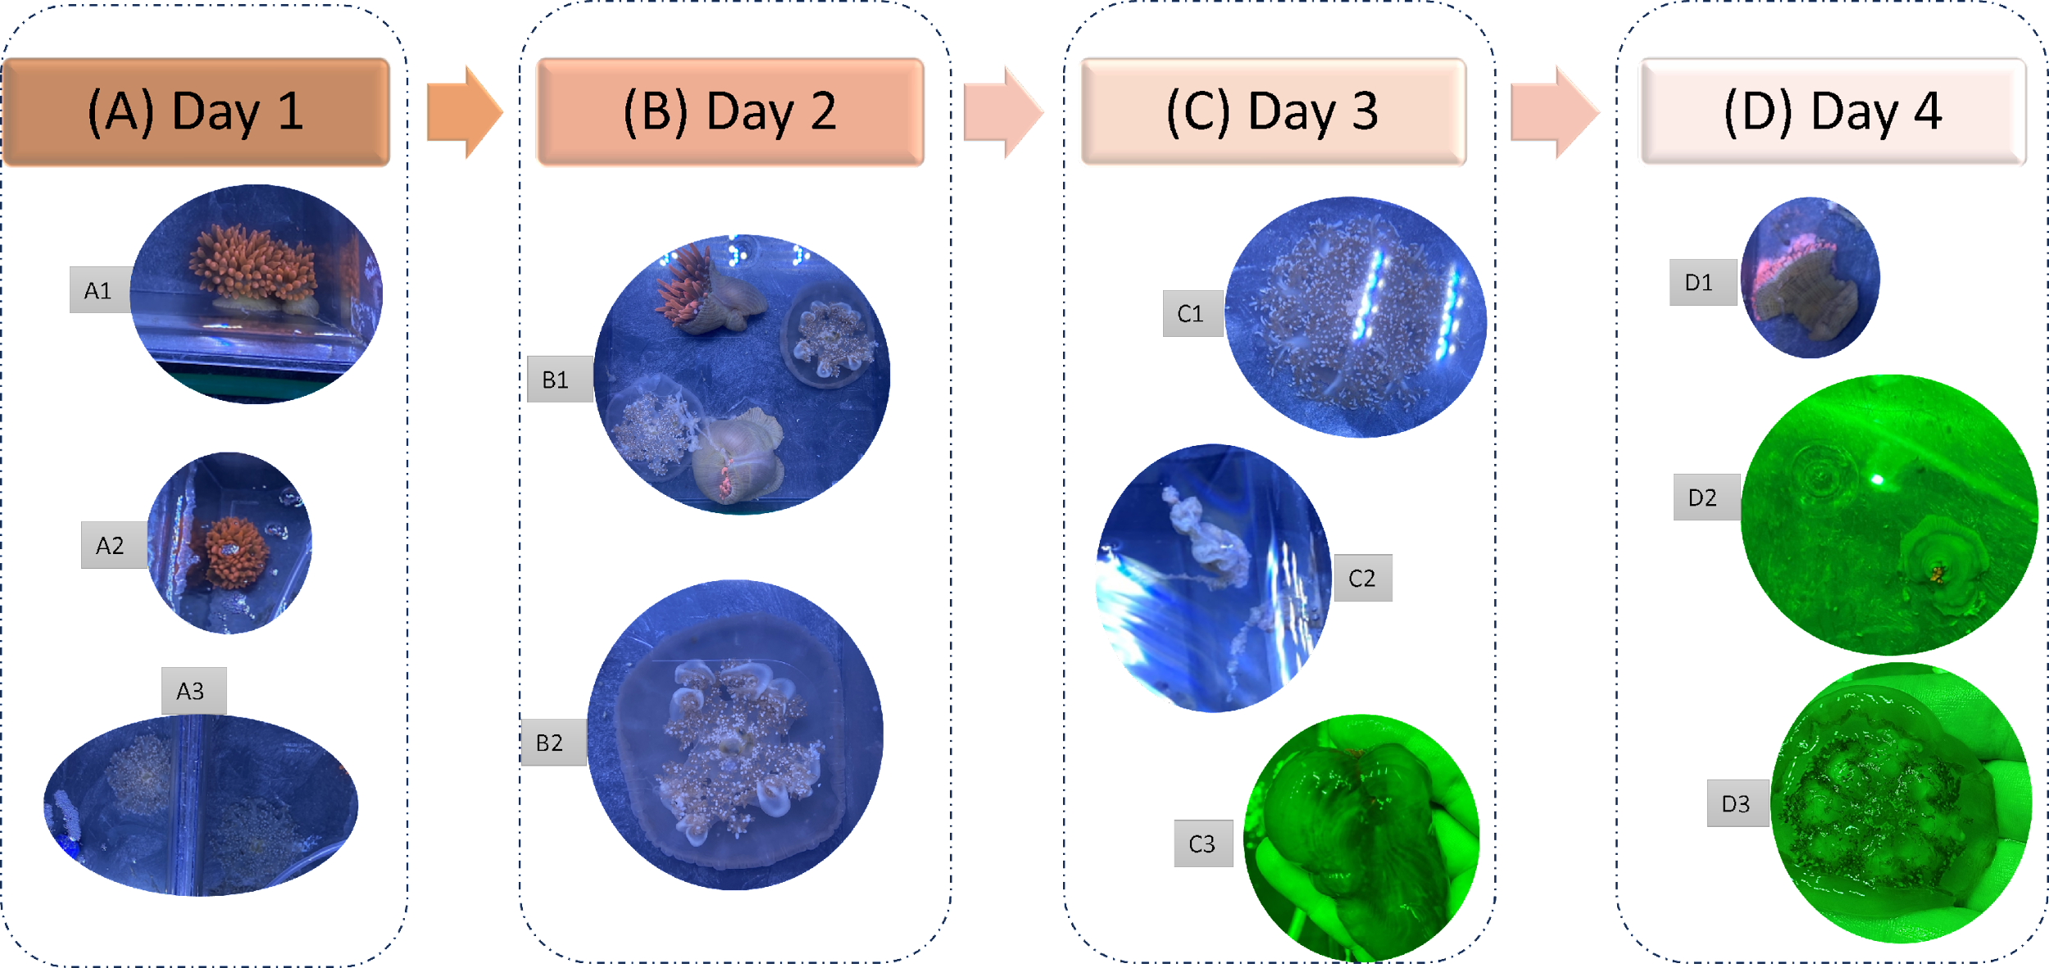
Suppl. Figure S1 Diagrammatic sketch showing the control specimens versus abnormalities that were observed in both the anemone E. quadricolor, and the jellyfish C. andromeda upon exposure to UV radiation or elevated temperature. (A) Specimens of Day 1 without UV exposure, and 28˚C at the start of the experiment. A1, A2: normal anemones under control conditions. A3: normal jellyfish. (B) Day 2; exposure to 30˚C or 1 dose of UV light. B1: anemone showing closed tentacles in response to UV. B2: jellyfish tentacles were centered and retracted under UV light. (C) Day 3; exposure to 32˚C or two doses of UV light. C1: jellyfish flips over down with slime discharge [UV]., and, C2: tentacles were lost [UV]. C3: The anemone turned transparent and appeared swollen with water [UV]. (D) Day 4; exposure to 34˚C or three doses of UV light. D1: dead anemone [temp.]. D2: anemone lost most of its water content [UV]. D3: jellyfish lost control over directions [UV].

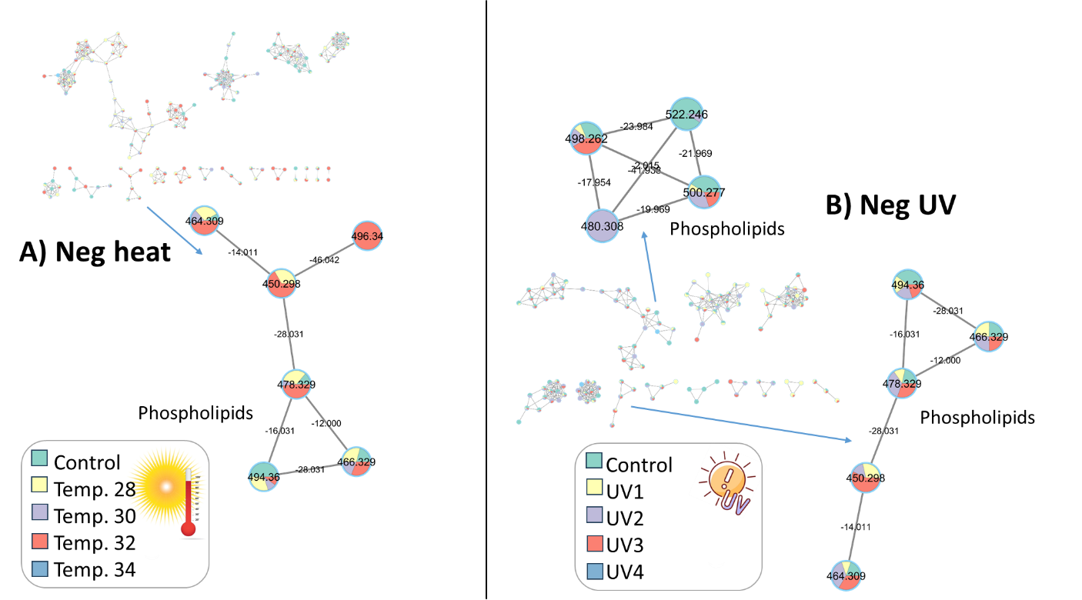
Suppl. Figure S2 Molecular networks generated from UHPLC-MS dataset of anemone E. quadricolor showing phosphlipids clusters in negative ioniziation mode, (A) heat stress, and (B) UV stress.

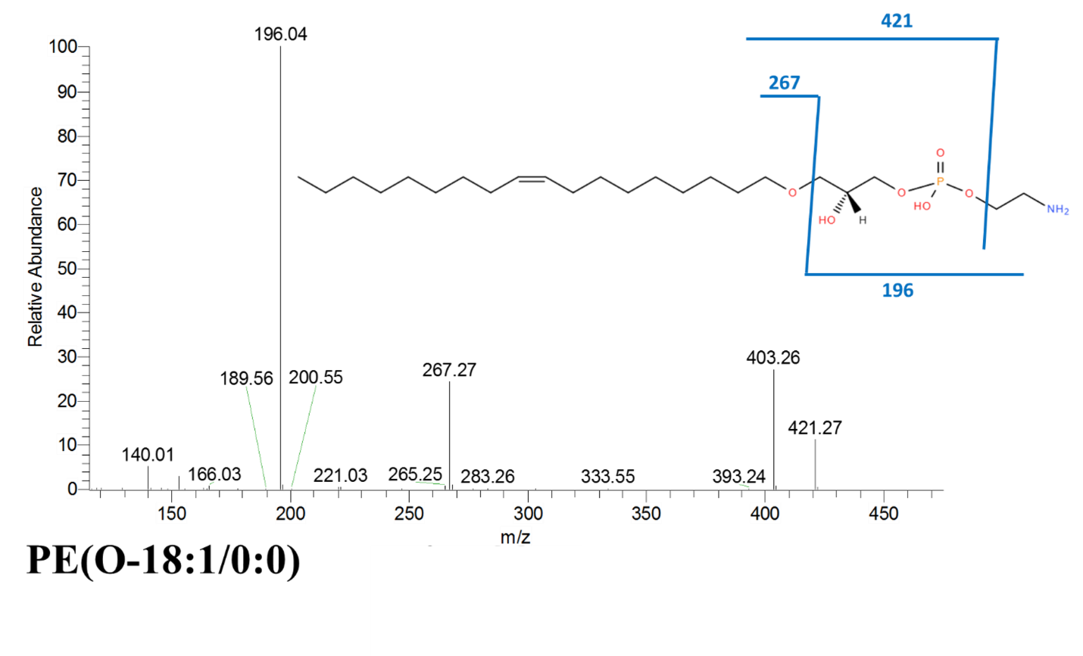Suppl. Figure S3 MS/MS spectrum of peak (A39) in negative ionization mode

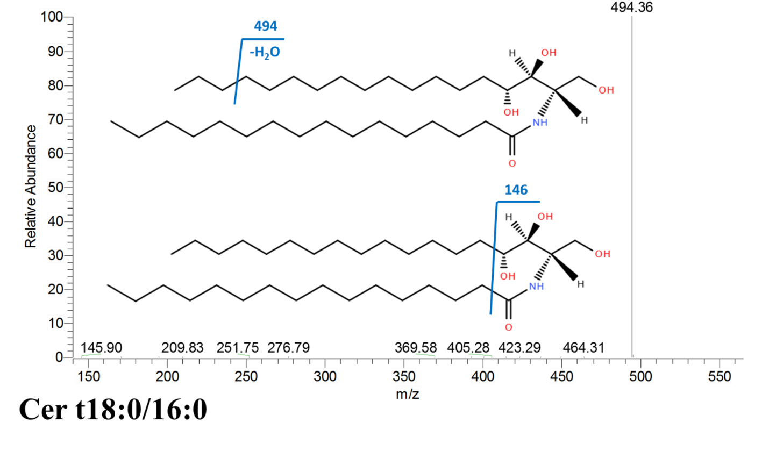
Suppl. Figure S4 MS/MS spectrum of peak (A67) in negative ionization mode

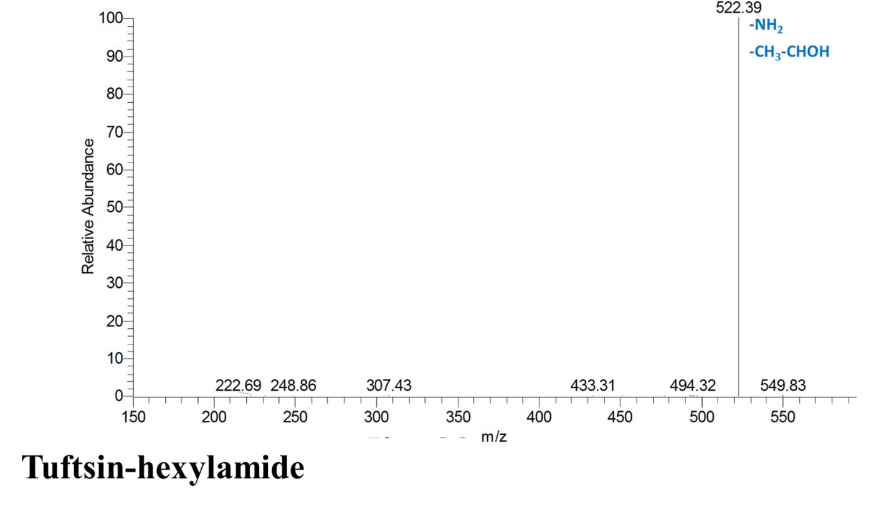
Suppl. Figure S5 MS/MS spectrum of peak (A48) in negative ionization mode
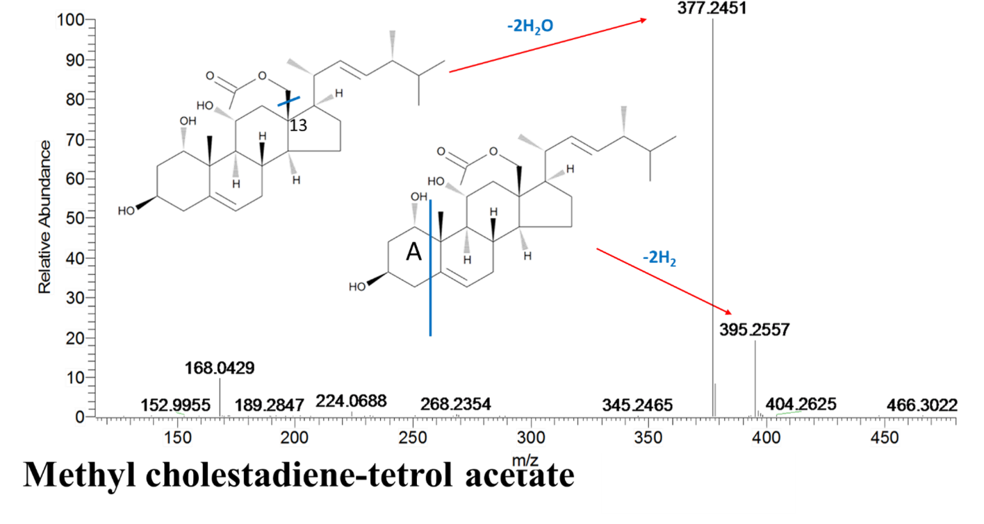
Suppl. Figure S6 MS/MS spectrum of peak (A23) in negative ionization mode

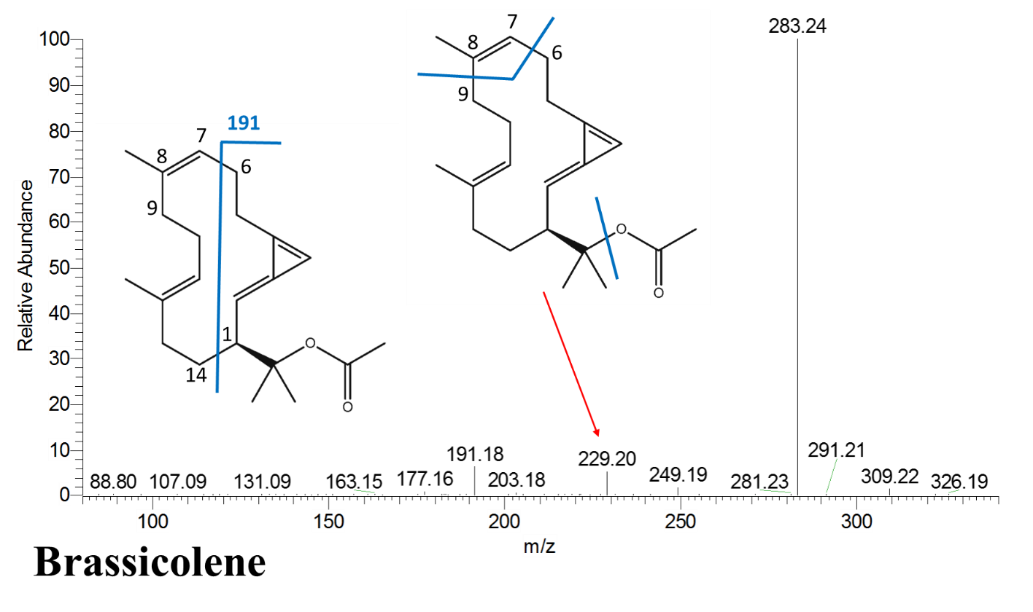
Suppl. Figure S7 MS/MS spectrum of peak (A45) in negative ionization mode
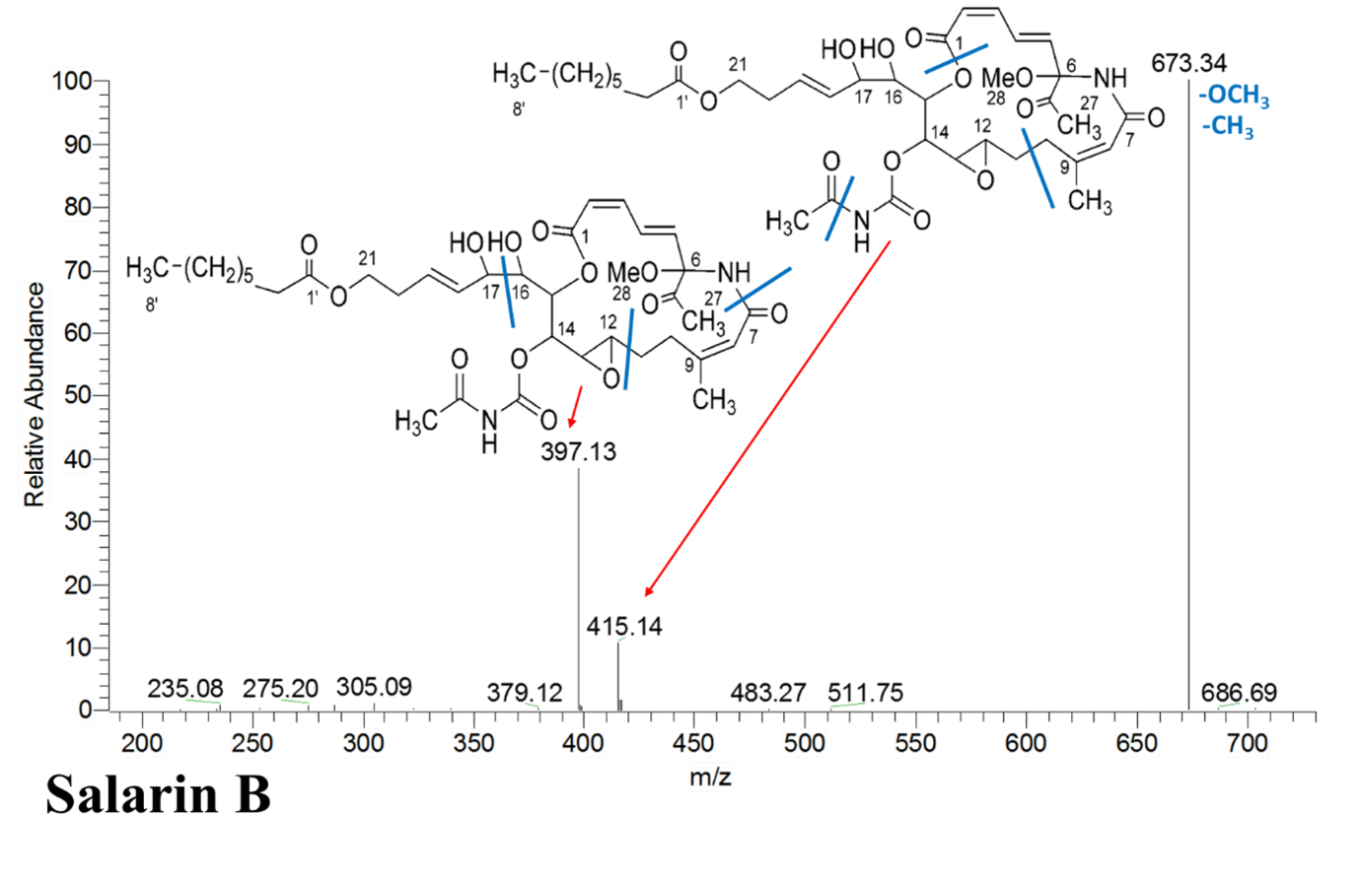
Suppl. Figure S8 MS/MS spectrum of peak (A5) in negative ionization mode

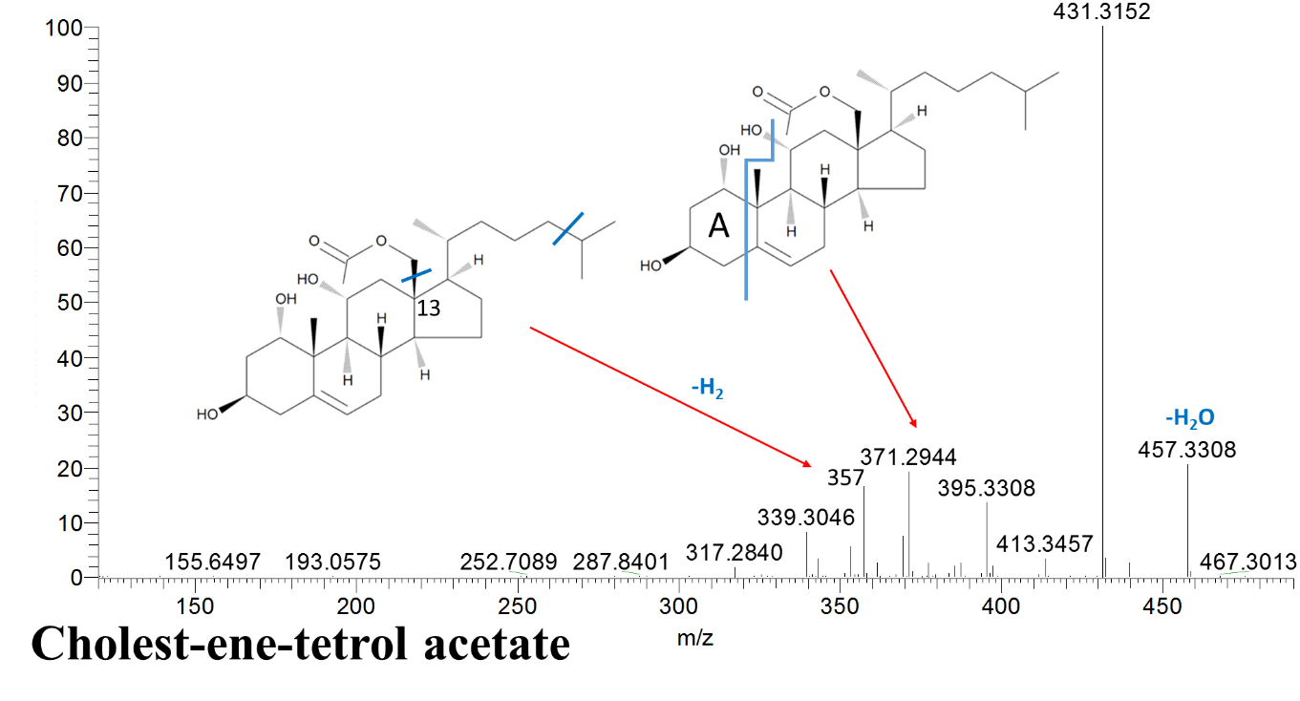
Suppl. Figure S9 MS/MS spectrum of peak (A26) in negative ionization mode
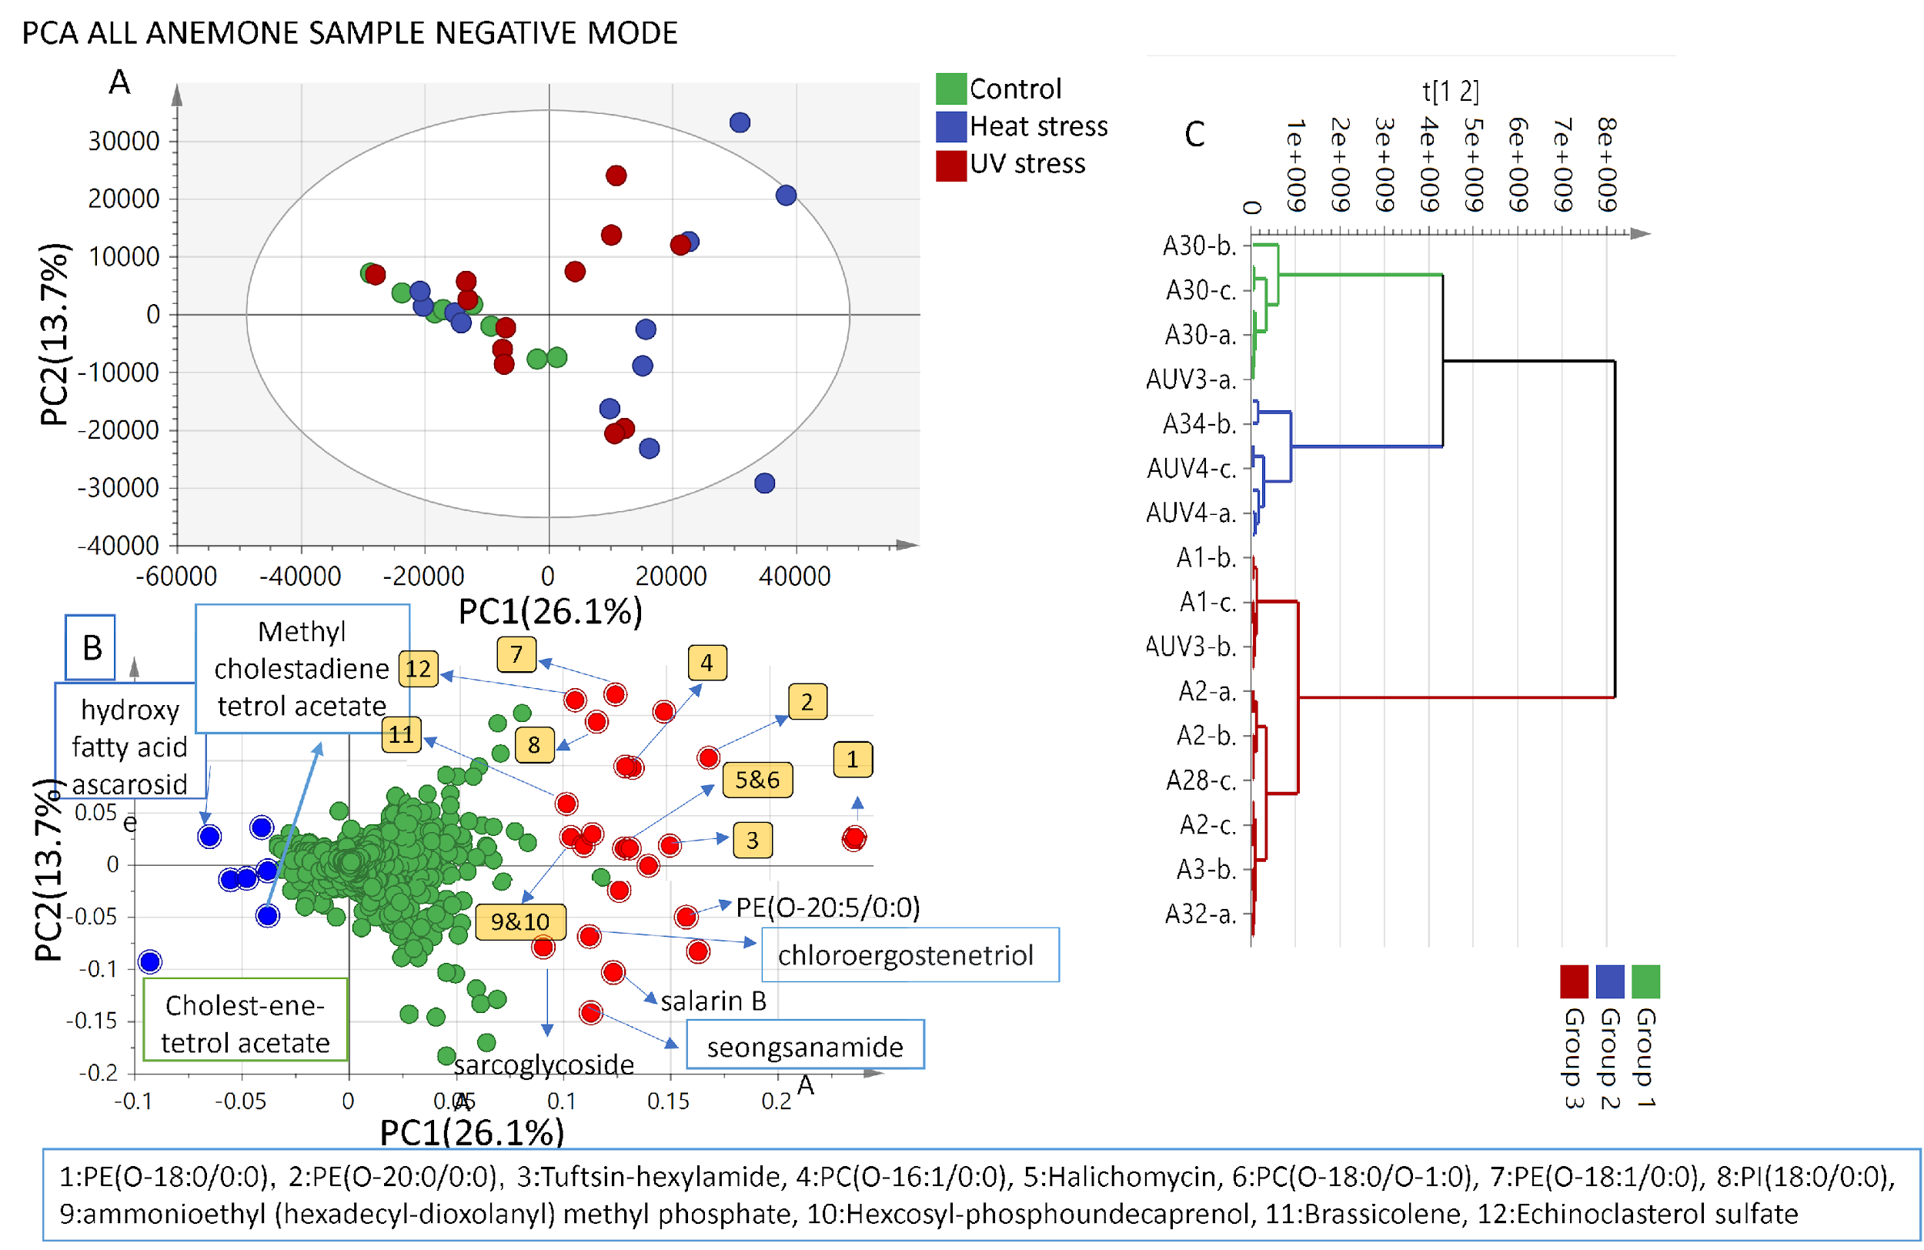
Suppl. Figure S10 (A) UHPLC-MS all dataset of negative ion mode based PCA score plot model of anemone E. quadricolor prescribed by PC1 & PC2. (B) Loading plot for PC1 & PC2 contributing metabolites and their identifications. (C) Hierarchical cluster analysis HCA revealing 3 main divisions.

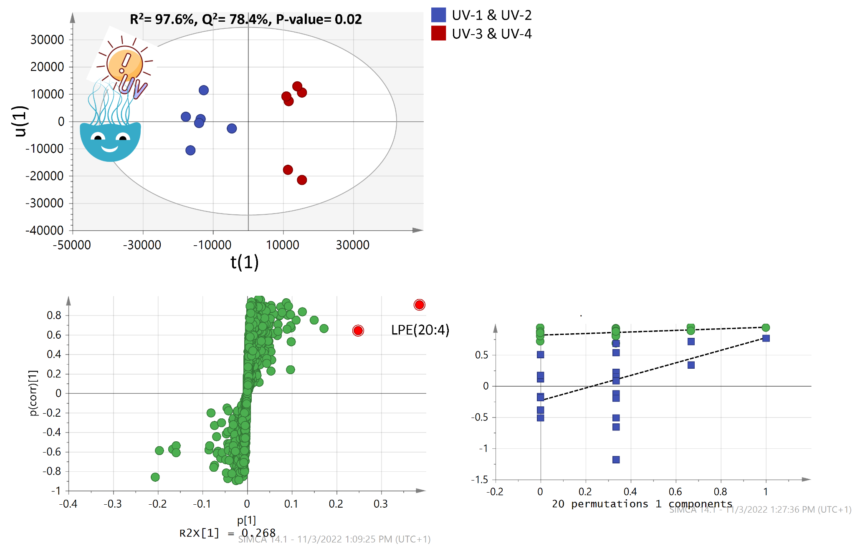
Suppl. Figure S11 (A)UHPLC-MS based OPLS-DA score plot model of jellyfish C. andromeda metabolites analyzed of dataset resulted upon UV treatment in negative ionization mode. (B) S-curve for contributing metabolites and their identifications in negative ionization mode. (C) Permutation chart for OPLS-DA model in negative ionization mode.

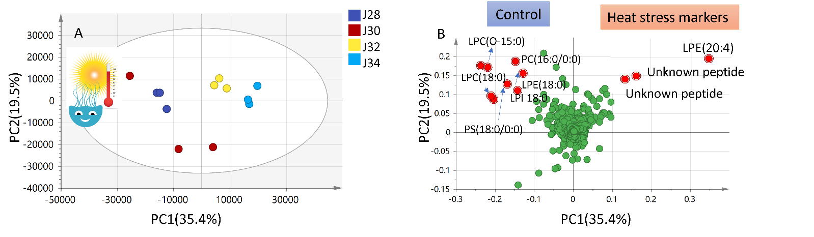
Figure 11 (A) UPLC-MS based PCA score plot model of jellyfish C. andromeda metabolites analyzed in PC1 against PC2 of dataset resulted upon thermal treatment in -ve ionization mode. (B) Loading plot for PC1 & PC2 contributing metabolites and heat stress markers and their identifications in -ve ionization mode.

Suppl. Figure S12 UHPLC-MS based PCA score plot model of jellyfish C. andromeda metabolites analyzed in PC1 against PC2 of dataset resulted upon thermal treatment in (A) negative ionization mode. (B) Loading plot for PC1 & PC2 contributing metabolites and their identifications in negative ionization mode.

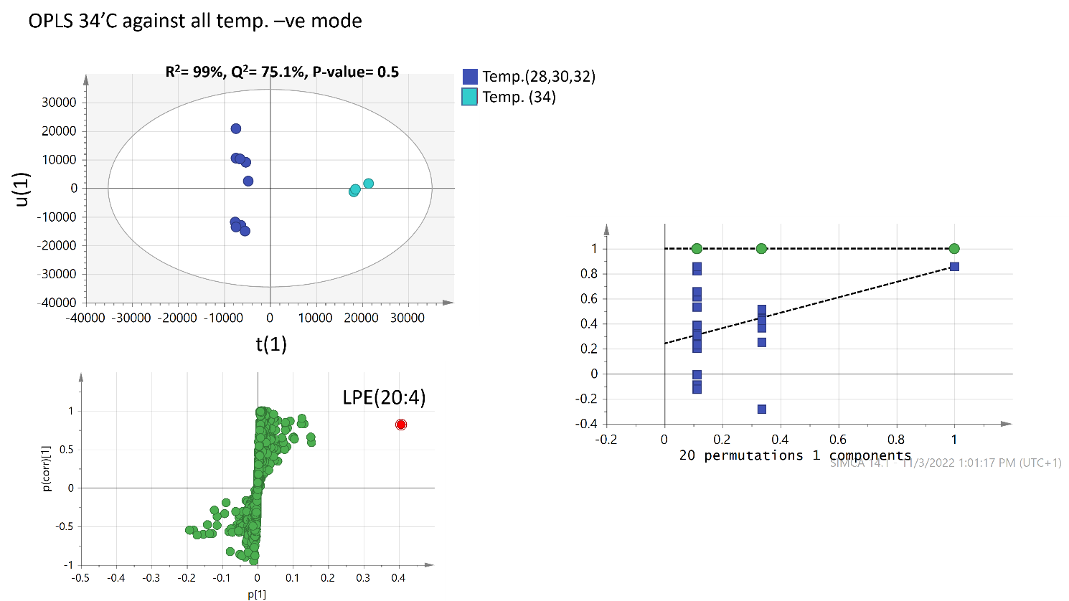
A
B
CA

Suppl. Figure S13 (A) UHPLC-MS based OPLS-DA score plot model of jellyfish C. andromeda dataset resulted upon thermal treatment in -ve ionization mode. (B) S-chart for contributing metabolites and their identifications in -ve ionization mode. (C) Permutation chart for OPLS-DA model in -ve ionization mode.

