SUPPLEMENTARY MATERIAL
- hBM-MSCs isolation and characterization by flow cytometry

Briefly, whole BM aspirate was directly seeded at a concentration of 50,000 total nucleated cells/cm2 in a T75 plastic flask containing minimum essential medium alpha (α-MEM; Gibco, Thermo Fisher Scientific, Waltham, Massachusetts, United States) supplemented with 1% GlutagroTM (Corning, Corning, New York, United States), 10% Fetal Bovine Serum (FBS) and 1% penicillin/streptomycin and incubated at 37°C in an atmosphere of 5% CO2 and 95% relative humidity. After 48h, non-adherent cells were removed, and medium replaced twice a week. Cells were detached when 70-80% confluent, using 0.05% trypsin-0.53mM ethylenediaminetetraacetic acid (EDTA), washed with PBS (Corning), and counted using Trypan Blue (Sigma-Aldrich, Milan, Italy).

Cells were incubated at room temperature (RT) for 20 min in the dark with the following directly conjugated mouse-anti human antibodies: 2.5 μL of fluorescein isothiocyanate (FITC) - conjugated anti-CD90 or 10 μL of FITC - conjugated anti-HLA-DR; 5 μL of allophycocyanin (APC) - conjugated anti-CD73; 10 μL of phycoerythrin (PE) - conjugated anti-CD105 or 10 μL of PE - conjugated anti-CD34; and 10 μL of phycoerythrin cyanin 7 (PC7) – conjugated anti-CD45 or 10 μL of PC7 – conjugated anti-CD14 (all antibodies were from Beckman Coulter, Fullerton, CA, USA). All isotype controls were immunoglobulin G type 1 (IgG1) conjugated to FITC, PE, APC, or PC7 (all from Beckman Coulter), and were used as negative controls. After incubation, cells were washed with 3 mL of PBS and resuspended in 300 µL of the same buffer for acquisition.

For confirming MSC phenotype, a minimum of 1x105 cells, at the third passage, were stained with surface markers for MSC immunophenotyping by flow cytometry according to the International Society of Cellular Therapy guidelines. Sample acquisition was performed using a BD FACSVerse flow cytometer (Becton Dickinson, BD, NJ, USA) equipped with blue (488 nm) and red lasers (628 nm) and BD FACSuite software (BD Biosciences). Compensation was calculated utilizing single-color controls for each fluorochrome and an unstained sample as negative control for setting PMT voltages.

All samples were run using the same PMT voltages. A minimum of 30,000 events were recorded. FlowJo software (v.10.7.1, LLC, BD Biosciences) was employed for post-acquisition compensation and flow cytometric analysis. In details, BM-MSCs were first identified using linear parameters (forward scatter area (FSC-A) vs side scatter area (SSC-A), double cells were excluded (area vs height, FSC-A vs FSC-H), and CD90 and CD45 expression was first investigated. Subsequently, CD105 and CD73 expression was further studied on CD45-CD90+ cells. Similarly, HLA-DR and CD34 expression was first investigated on single cells, and CD14 was further analysed on CD34-HLA-DR- cells. Expression of each marker on single cells was also reported using histograms and using unstained samples as negative controls (see Figure S1).

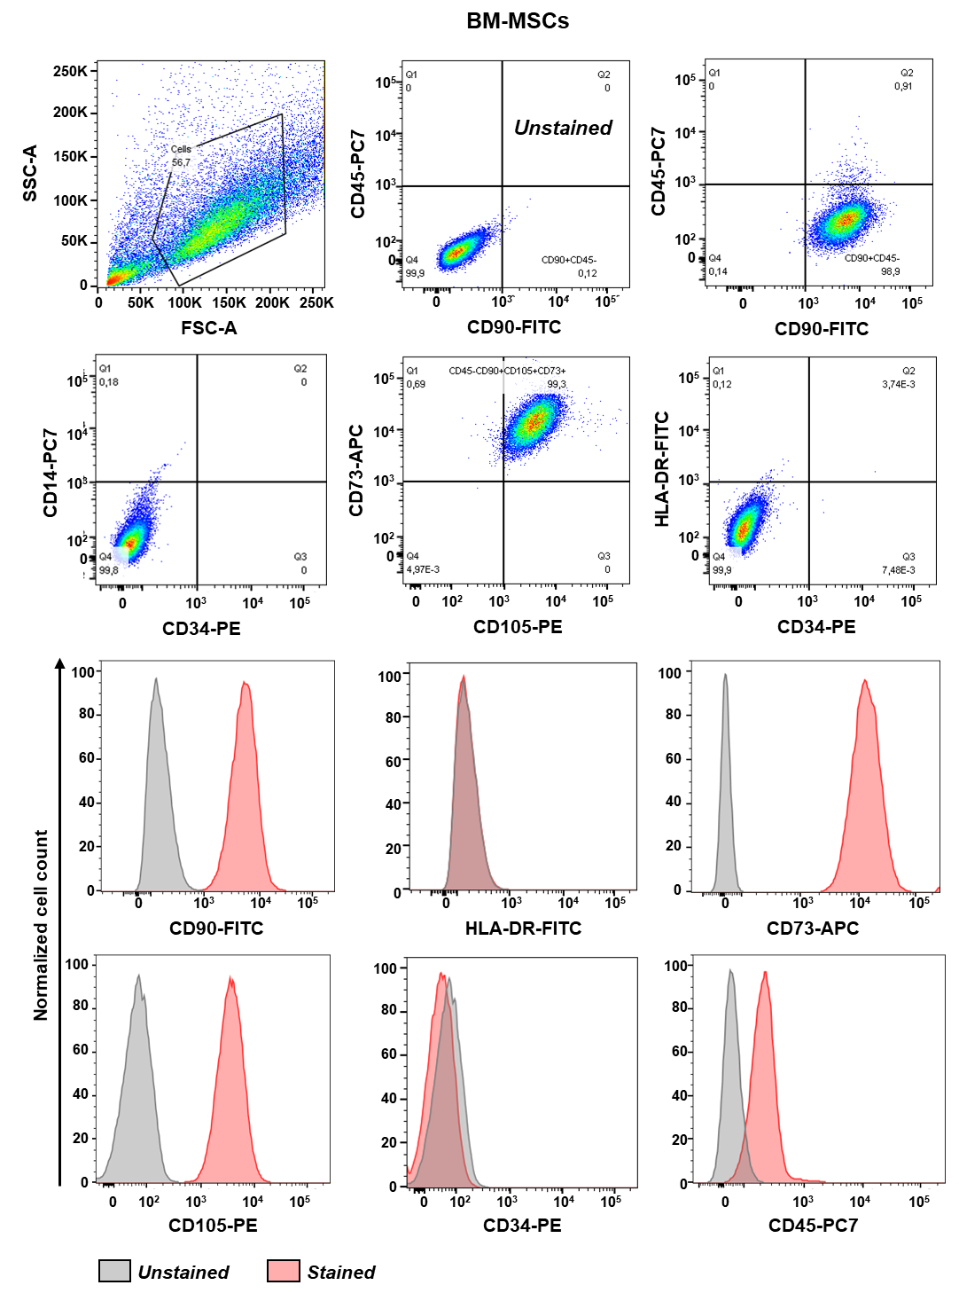

Figure S1. Flow cytometry and gating strategy of hBM-MSCs.
The panel shows a representative cytofluorimetric FSC vs SSC (cell size vs granularity index) cells scatter of hBM-MSCs. Cells were first identified using linear parameters (forward scatter area [FSC-A] vs side scatter area [SSC-A], and double cells were excluded (FSC-A vs FSC-H). For antibody mix 1, CD90 and CD45 expression was investigated on single cells, and CD105 and CD73 expression was further studied on CD45-CD90+ cells. For antibody mix 2, HLA-DR and CD34 expression was first investigated on single cells, and CD14 was further studied on CD34-HLA-DR- cells. Expression of each marker on single cells was also reported using histograms and using unstained samples as negative controls.

