Article title: A pan-European citizen science study shows population size, climate and land use are related to biased morph ratios in the heterostylous plant Primula veris

Authors: Tsipe Aavik, Triin Reitalu, Marianne Kivastik, Iris Reinula, Sabrina Träger, Evelyn Uuemaa, Marta Barberis, Arjen Biere, Sílvia Castro, Sara A. O. Cousins, Anikó Csecserits, Eleftherios Dariotis, Živa Fišer, Grzegorz Grzejszczak, Cuong Nguyen Huu, Kertu Hool, Hans Jacquemyn, Margaux Julien, Marcin Klisz, Alexander Kmoch, Nikos Krigas, Attila Lengyel, Michael Lenhard, Desalew M. Moges, Zuzana Münzbergová, Ülo Niinemets, Baudewijn Odé, Hana Pánková, Meelis Pärtel, Ricarda Pätsch, Theodora Petanidou, Jan Plue, Radosław Puchałka, Froukje Rienks, Ioulietta Samartza, Julie K. Sheard, Bojana Stojanova, Joachim P. Töpper, Georgios Tsoktouridis, Spas Uzunov & Martin Zobel

This file includes the following Supporting Information:
Fig. S1 The distribution of sampled study populations of Primula veris along with the deviation of morph frequencies from isoplethy.
Fig. S2 The results of the genotyping of CYP734A50 of the samples of Primula veris
Fig. S3 Relationships between the proportion of S-morphs and land use and climatic variables with model prediction and raw data points.
Fig. S4 Relationships between morph deviation from equal frequency and land use and climatic variables with model prediction and raw data points.
Methods S1 The list of questions asked from the citizen scientists on the data uploading platform of the citizen science campaign “Looking for Cowslips”.
Methods S2 The list of the main communication channels and tools with corresponding web links used in spreading the information
Methods S3 Data filtering criteria and the corresponding number of excluded observations of the Primula veris heterostyly observations
Methods S4 Laboratory protocol for the determination of mutations at S-locus of Primula veris

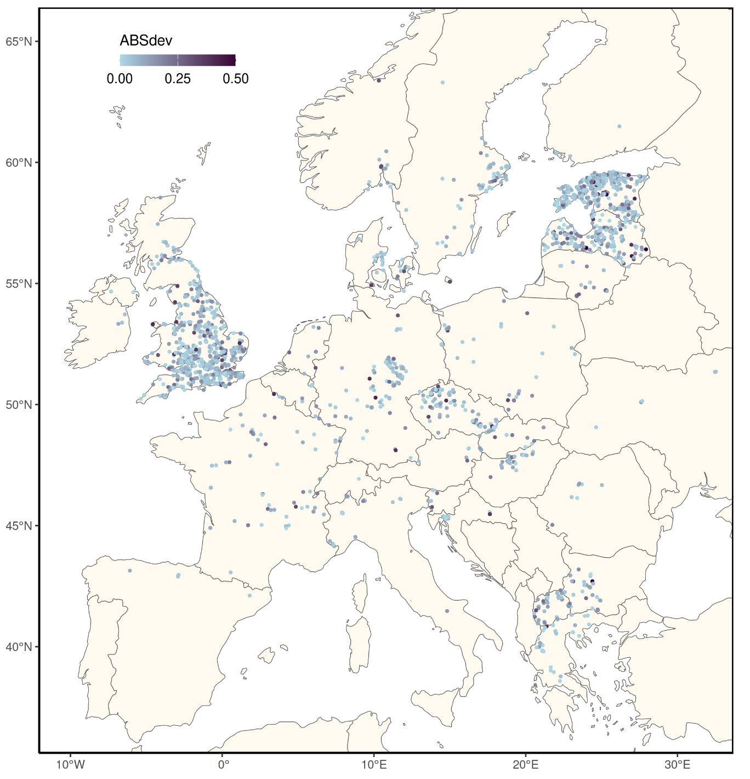
Fig. S1. Overview of the observed populations of Primula veris within the frames of the citizen science campaign "Looking for Cowslips" in 2021 and 2022. Only populations associated with geographic coordinates retained after quality filtering are depicted (Methods S3). "ABSdev" denotes the deviation of morphs from isoplethy (i.e., expected equal frequency of morphs) with light blue values depicting populations with low deviation and darker colours populations with higher deviation from isoplethy. WGS84 was the coordinate system used for creating the map, respective coordinates are expressed in degrees.

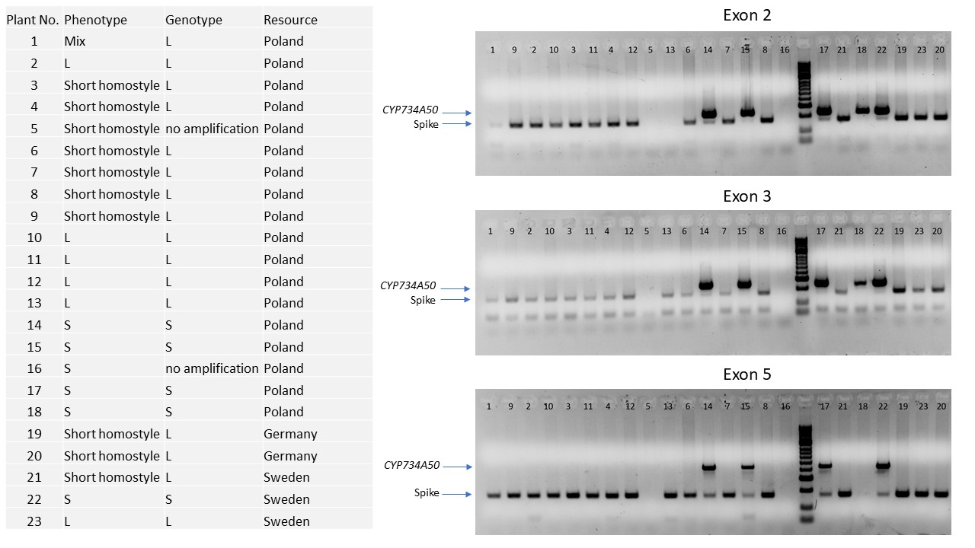
Fig. S2 The results of the genotyping of CYP734A50 of the samples of Primula veris collected from Poland (18 samples: 5 L-morphs, 5 S-morphs and 7 specimens with a phenotype of short homostyle), Germany (2 samples with short homostylous phenotype) and Sweden (1 S-morph, 1 L-morph and one short homostyle). The presence of the "Spike" refers to the success of PCR amplification. The presence of the band at "CYP734A50" indicates that the specimen is genetically an S-morph. The lack of the band in the plants that were phenotypically short homostyles suggests that the phenotype has not arisen as a result of a mutation in the S-locus.

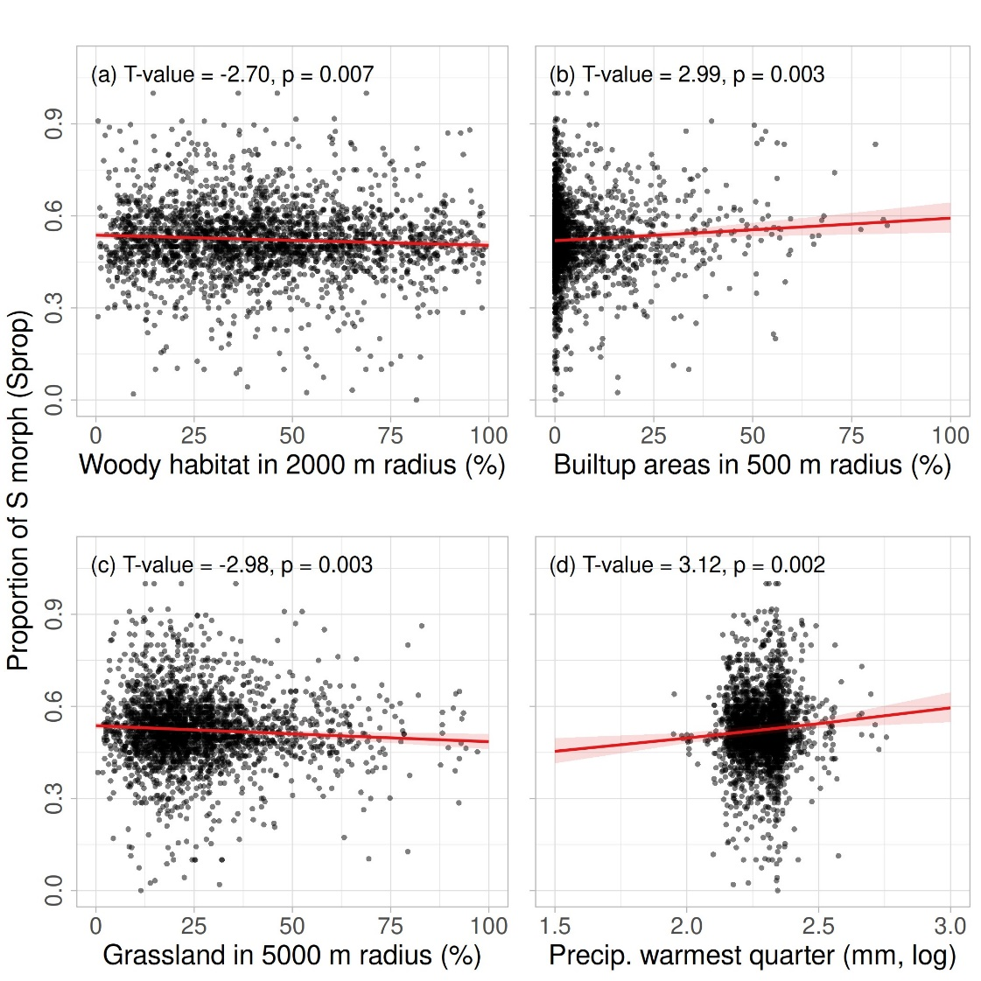

Fig. S3. Relationship between the proportion of woody habitats (a), built-up areas (b), grasslands (c), precipitation of the warmest quarter of the year (d) and the proportion of S-morphs (Sprop) of Primula veris populations in the pan-European citizen science campaign "Looking for Cowslips". The graph with data points represents the effect of variables with p-value < 0.01 in GLMM model on effects of climate, land use and environment on the proportion of S-morphs (Table 2). T- and p-values originate from the final GLMM model. Red lines depict the partial predicted marginal effects for each explanatory variable from the mixed model (Table 2) and light red areas indicate the 95% confidence intervals.

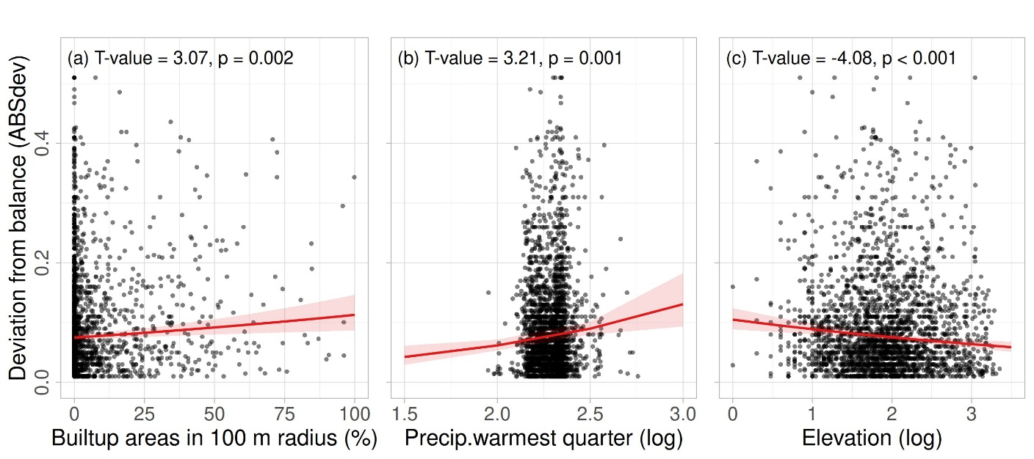

Fig. S4. Relationship between the proportion of built-up areas (a), precipitation the during the warmest quarter of the year (b) and elevation (c) on the deviation of morphs from equal frequencies/balance (ABSdev) in the populations of Primula veris populations observed in the pan-European citizen science campaign "Looking for Cowslips". The graphs with observed data points represents the effects of variables with p-value < 0.01 in GLMM model on the effects of climate, land use and environment on the deviation from morph balance (ABSdev). T- and p-values originate from the final GLMM model (Table 2). Red lines depict the partial predicted marginal effects for each explanatory variable from the mixed model (Table 2) linear model fit and light red areas indicate the 95% confidence intervals.

Methods S1 The list of questions asked from the citizen scientists on the data uploading platform of the citizen science campaign “Looking for Cowslips”.
(1) ID assigned to each observed population (automatic),
(2) The date of observation (automatic),
(3) Location (automatic/manually written coordinates/no coordinates),
(4) Cowslip occurrence at the study location (Yes/No),
(5) Cowslips flowering (Yes/No),
(6) The approximate number of cowslip individuals (Few: some plants, up to 100 individuals; Average: about 100-200 individuals; Large: more than 200 up to thousands),
(7) The identification of morphs of about 100 cowslip individuals wherever possible. Observers were also welcome to submit data on a smaller/higher number of individuals depending on the number of cowslip individuals (e.g., fewer than 100 flowering individuals occurring at the observation location) or the willingness and possibility to spend time for a more extensive sampling effort. This question was provided with a short description of S- and L-morphs along with illustrative photos. Observers were asked to step at least one step (i.e., about 0.5 -1 m) further after each identified morph to avoid sampling the same individual,
(8) Upload of up to three photos
(9) Additional comments,
(10) Personal details for receiving feedback in future (the name of the observer and e-mail address for further correspondence),
(11) Information on whether (a) they would like to receive feedback about the study, (b) they agree to the use of their photos for introducing and promoting the campaign, and (c) they agree to the terms and conditions of the observation.
Methods S2 The list of the main communication channels and tools with corresponding web links used in spreading the information within the frames of the citizen science campaign “Looking for Cowslips”.
(1) Website
https://cowslip.science/ in the following languages:
- Bulgarian: https://cowslip.science/nablyudenie
- Croatian: https://cowslip.science/promatranje
- Czech: https://cowslip.science/pozorujte
- Danish: https://cowslip.science/observere
- Dutch: https://cowslip.science/observatie
- English: https://cowslip.science/observation
- Estonian: https://cowslip.science/vaatlus
- Finnish: https://cowslip.science/havainto
- French: https://cowslip.science/observation-1
- German: https://cowslip.science/beobachtung
- Greek: https://cowslip.science/parathrhsh
- Hungarian: https://cowslip.science/megfigyeles
- Italian: https://cowslip.science/osservazione
- Latvian: https://cowslip.science/noverosana
- Lithuanian: https://cowslip.science/apziura
- Macedonian: https://cowslip.science/nabuduvanje
- Norwegian: https://cowslip.science/observasjon
- Polish: https://cowslip.science/obserwacja
- Russian: https://cowslip.science/provedi-osmotr
- Slovakian: https://cowslip.science/pozorovanie
- Slovenian: https://cowslip.science/opazovanje
- Spanish: https://cowslip.science/observacion
- Swedish: https://cowslip.science/observera
- Ukrainian: https://cowslip.science/sposterezhennya
(2) Facebook
- Looking for Cowslips (in English): https://www.facebook.com/LookingForCowslips
- Honba za petrklíči (in Czech): https://www.facebook.com/honbazapetrklici
- Αναζητάμε πρίμουλες (In Greek): https://www.facebook.com/greeceprimula/
- Alla ricerca delle Primule odorose (in Italian): https://www.facebook.com/AllaricercadellePrimuleodorose
- Барање пролетни јаглики (in Macedonian): https://www.facebook.com/jagliki
(3) Instagram
- @lookingforcowslips (in English): https://www.instagram.com/lookingforcowslips/
- @greeceprimula (in Greek): https://www.instagram.com/greeceprimula/
(4) Twitter
- @LookForCowslips (in English): https://twitter.com/LookforCowslips
(5) Youtube
(a) The channel "Looking for Cowslips": https://www,youtube,com/@lookingforcowslips3627
- Animation „Europe is looking for cowslips!“ (in English; also available in Dutch, Estonian, German, Greek, Italian, Latvian, Bulgarian, Croatian, Czech, Danish, Finnish, French, Hungarian, Lithuanian, Macedonian, Norwegian, Russian, Serbian, Slovakian, Slovenian, Spanish, Swedish and Ukrainian): https://www,youtube,com/watch?v=6IL9Pv2RlF8
- Invitation to participate (in English) „Invitation from Europe“: https://www,youtube,com/watch?v=3b7XfChevvI
- Instruction video (in English; subtitles also available in Macedonian) „How to make a cowslip observation?“: https://www,youtube,com/watch?v=wwdiQ9le-Ok&t=3s
- Instruction video (in Russian) „Европа ищет первоцвет весенний“: https://www,youtube,com/watch?v=cfFu4aPbbNU
- Instruction video (in German): „Findet die Schlüsselblume Beobachtungsanleitung“ - https://www,youtube,com/watch?v=-CqIunXYMn4
- Darwin und die Heterostylie (in German): https://www,youtube,com/watch?v=V71YFJFmUm0
- Scientific journey from Estonia to Europe (in English; also available in Estonian): https://www,youtube,com/watch?v=vz-1ybrfidM
- Animation „Scientific Research from Start to Finish“ (in English; also available in Estonian and Russian; subtitles also available in Italian, Greek, German, Slovakian): https://www,youtube,com/watch?v=tw-GdKu2xtw
(b) The channel of Estonian Fund for Nature
- Campaign invitation (in Estonian): https://www.youtube.com/watch?v=5SM0JOpvW14
- Campaign invitation (in Estonian): https://www.youtube.com/watch?v=wENggSb__Uo
- Campaign invitation (in Estonian with English subtitles): https://www.youtube.com/watch?v=KVAS0CZER2s
- Guidelines for observations (in Estonian): https://www.youtube.com/watch?v=SuTe_HWomqE
- Guidelines for observations (in Russian): https://www.youtube.com/watch?v=pltLQxK_G0w
- About the history of heterostyly research (in Estonian): https://www.youtube.com/watch?v=33xtTBYqSUs
- Cowslips in folklore (in Estonian): https://www.youtube.com/watch?v=hbBglcIXUzk
- Cowslip research and biodiversity studies (in Estonian): https://www.youtube.com/watch?v=z5ropwqjJZU
(c) Наука за деца
- Пролетни јаглики и хетеростилност (in Macedonian) https://www.youtube.com/watch?v=RoU4Q-1xll0
Methods S3 Data filtering steps and criteria, and the corresponding number of excluded observations of the Primula veris heterostyly observations from the pan-European citizen science campaign "Looking for Cowslips" in 2021-2022. 16 observations were excluded from the final list of observations due to the termination of collaboration with Russia during the campaign.
- Observations of the wrong species, filtered out by pictures sent by the observers (n = 554; corresponding numbers for 2021 and 2022 separately can be found in the Table below). These included observations of other Primula species, mostly P. elatior and P. vulgaris, and different Primula hybrids or species from home gardens.
- Double observations with the same observation ID (exactly the same geographic coordinates and heterostyly data) (201). Double observations happened most likely due to occasional time lags during data uploading. If this was the case, people repeated the procedure, which resulted in a double record from the exact location.
- Observations with less than ten individuals with S-morphs and L-morphs combined (1227). These included 0 observations (observations with 0 S-morphs and 0 L-morphs), which happened most likely because of info-technological problems during uploading, perhaps because of the intense data upload during the peak of flowering. Some observations did not contain any data because P. veris was not yet flowering at the location, but participants still aimed at reporting the location.
- Unrealistic observations (273), e.g., reporting 10000 S-morphs and 0 L-morphs. Expert opinion was also used to filter out less obvious but still unrealistic observations, such as 100 S- and 1 L-morphs.
After step (4), we were able to perform an interim analysis regarding the overall morph bias (location data not necessary). Next steps are for landscape analyses, which required location data.
- Observations without geographic coordinates or described location information (283).
- Among observations recorded closer than 100 meters to each other, one of the two observations was omitted as potentially representing the same population. The choice of the excluded population was random. Although we asked participants to record morph deviation across the whole population of P. veris, it is still possible that several observations were recorded from the same population. We aimed to avoid double observations leading to potential pseudo-replication by filtering out observations close to each other.
- Observations without population size indication (39).
- Observations with inaccurate location data and populations which did not occur on the land but in the sea instead, most likely because of GPS positioning problems (28).

 | 2021 | 2022 | All
Total number of observations | 3475 | 1794 | 5269
Filtering criteria step:
(1) Wrongly identified species | 3076 | 1639 | 4715
(2) Double observations | 2949 | 1565 | 4514
(3) Observations with very few individuals | 2066 | 1221 | 3287
(4) Unrealistic observations | 1880 | 1134 | 3014
Interim analyses about morph bias (observations with and without coordinates included) | 1880 | 1134 | 3014
(5) Without geographic coordinates | 1747 | 984 | 2731
(6) Spatially neighbouring observations | 1549 | 937 | 2486
(7) No population size indication | 1519 | 928 | 2447
(8) Very inaccurate location data | 1500 | 919 | 2419
(9) The same location in two consecutive years
Final analyses with landscape data (only observations with coordinates) | 1500 | 919 | 2419
* Numbers indicate how many observations were left after a specific filtering step.

Methods S4 Laboratory protocol for the determination of mutations at S-locus of Primula veris.
We followed the protocol developed by Huu et al. (2016). Multiplex polymerase chain reactions (PCRs) were used to amplify exon 3 of the CYP734A50 gene (CYPT) and the internal transcribed spacer (ITS) region as an internal control. For PCR, a 10 μl master mix was prepared using 5.42 μl H₂O, 2.00 μl Buffer 5x (GoTaq G2 Promega), 0.8 μl MgCl (25mM), 0.20 μl dNTPs (10 μM), 0.20 μl CYP06-F (10 μM), 0.20 μl CYP06-R (10 μM), 0.04 μl ITS.LEU (10 μM), 0.04 ITS4 (10 μM), and 0.10 μl Taq (GoTaq G2 Promega). PCR reactions were performed with the following conditions: 95°C for 2 min, 35 cycles of 95°C for 30 sec, 52°C for 1 min, 72°C for 1 min 45 sec, then 72°C for 10 min and cooling down to 10°C. PCR products were separated on agarose gels (1.5%) and visualised under ultraviolet (UV) light to determine whether the samples were S-morphs or L-morphs.

Reference
Huu, C.N., Kappel, C., Keller, B., Sicard, A., Takebayashi, Y., Breuninger, H., Nowak, M.D., Bäurle, I., Himmelbach, A., Burkart, M., Ebbing-Lohaus, T., Sakakibara, H., Altschmied, L., Conti, E. & Lenhard, M. (2016) Presence versus absence of CYP734A50 underlies the style-length dimorphism in primroses. eLife, 5, e17956.

