Supplementary Material

Table S1. Baseline soil physical and chemical properties.

Property | Mean ± SD | Method
Clay (%) | 11.27 ± 1.06 | Particle-size distribution determined by laser diffraction (Pieri et al., 2006)
Silt (%) | 45.66 ± 2.43
Sand (%) | 44.33 ± 2.43
Soil Texture | Loam | Classified according to USDA textural classes based on particle size distribution
Soil pH (1:2.5) | 7.5 ± 0.46 | Measured potentiometrically in a 1:2.5 soil-to-deionised water suspension following standard soil pH determination procedures
Electrical Conductivity (dS m⁻¹; 1:5) | 0.10 ± 0.05 | Measured conductometrically in a 1:5 soil-to-water extract
Total Carbon (g kg⁻¹) | 9.7 ± 0.56 | Determined by dry combustion using an elemental analyser following ASA–CSSA–SSSA soil analysis procedures
CEC (meq 100 g⁻¹) | 24.03 ± 2.5 | Determined by ammonium acetate extraction at pH 7.0 followed by quantification of exchangeable cations

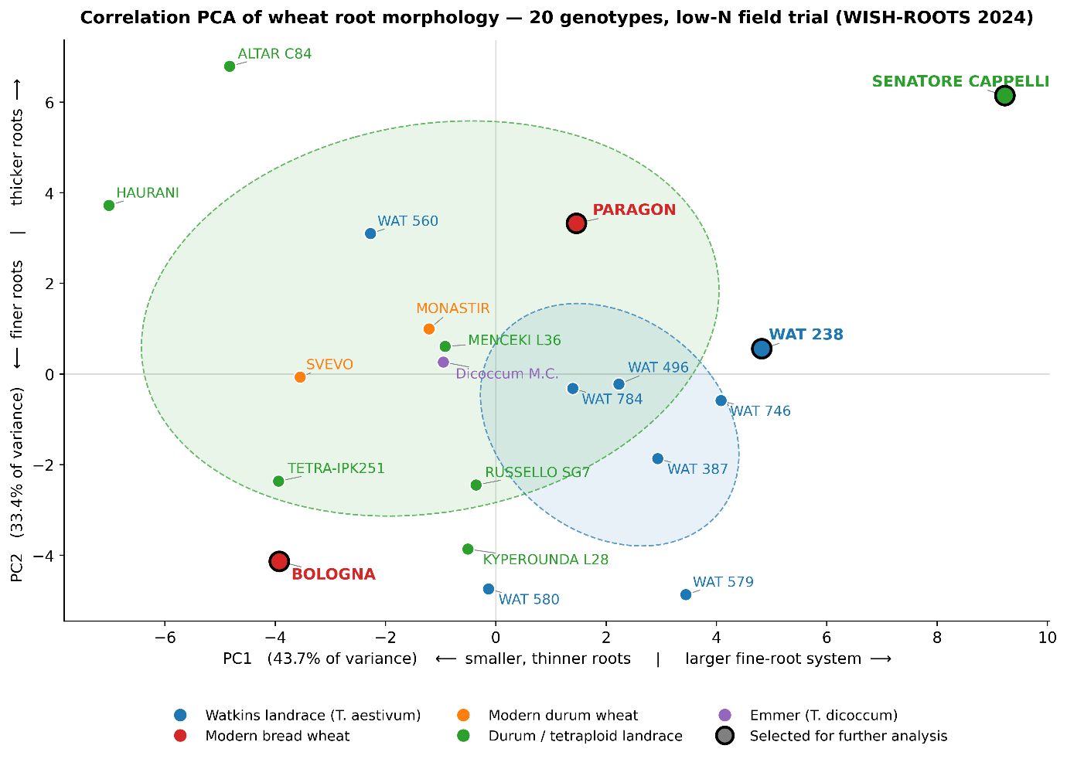
Figure S1. Principal component analysis of root morphological variation across 20 wheat genotypes grown under low nitrogen fertilisation (48 kg N ha⁻¹) in a field trial. PCA was performed on 32 root architectural and topological traits extracted from root crown imaging and RhizoVision Explorer analysis, using genotype-level means across nine replicate plants per genotype (three plants sampled from each of three field plots). Variables were centred to zero mean and scaled to unit variance prior to eigendecomposition (i.e. PCA was performed on the correlation matrix), so that each trait contributed equally to the analysis irrespective of its measurement unit or numerical range. PC1 explained 43.7% of the total variance and primarily separated genotypes by overall root system size and fine-root development (left = smaller, thinner root systems; right = larger fine-root systems), with the strongest positive loadings on total root length, perimeter, number of holes (a proxy for branching), and the surface area, length and volume of fine-diameter roots. PC2 explained 33.4% of total variance and reflected an orthogonal axis of root thickness (lower values = finer roots; higher values = thicker roots), with the strongest positive loadings on mean, median and maximum root diameter and on the surface area and projected area of coarse-diameter roots. Together, PC1 and PC2 captured 77.1% of the trait variance among genotypes. Coloured points represent genotype groups according to germplasm class: Watkins bread-wheat landraces (Triticum aestivum, blue), modern bread-wheat cultivars (Paragon, Bologna; red), modern durum-wheat cultivars (Monastir, Svevo; orange), durum and other tetraploid landraces (green), and emmer (T. dicoccum; purple). Dashed ellipses indicate the one-standard-deviation dispersion of each genotype group containing three or more members. Genotypes highlighted with black outlines (Paragon, Bologna, Senatore Cappelli and Watkins 238) were selected for subsequent rhizosphere hydraulic characterisation to represent contrasting root phenotypes across the PCA space, jointly spanning 81% of the observed PC1 range and 88% of the PC2 range across four distinct quadrants of root-trait space. The two modern bread-wheat cultivars (Paragon, Bologna) provide a within-class contrast between a large, thicker-rooted (Paragon) and a compact, fine-rooted (Bologna) phenotype, complemented by a Watkins bread-wheat landrace at the high-extent end of PC1 (Watkins 238) and a heritage durum landrace at the extreme of large, thick-rooted phenotypes (Senatore Cappelli).

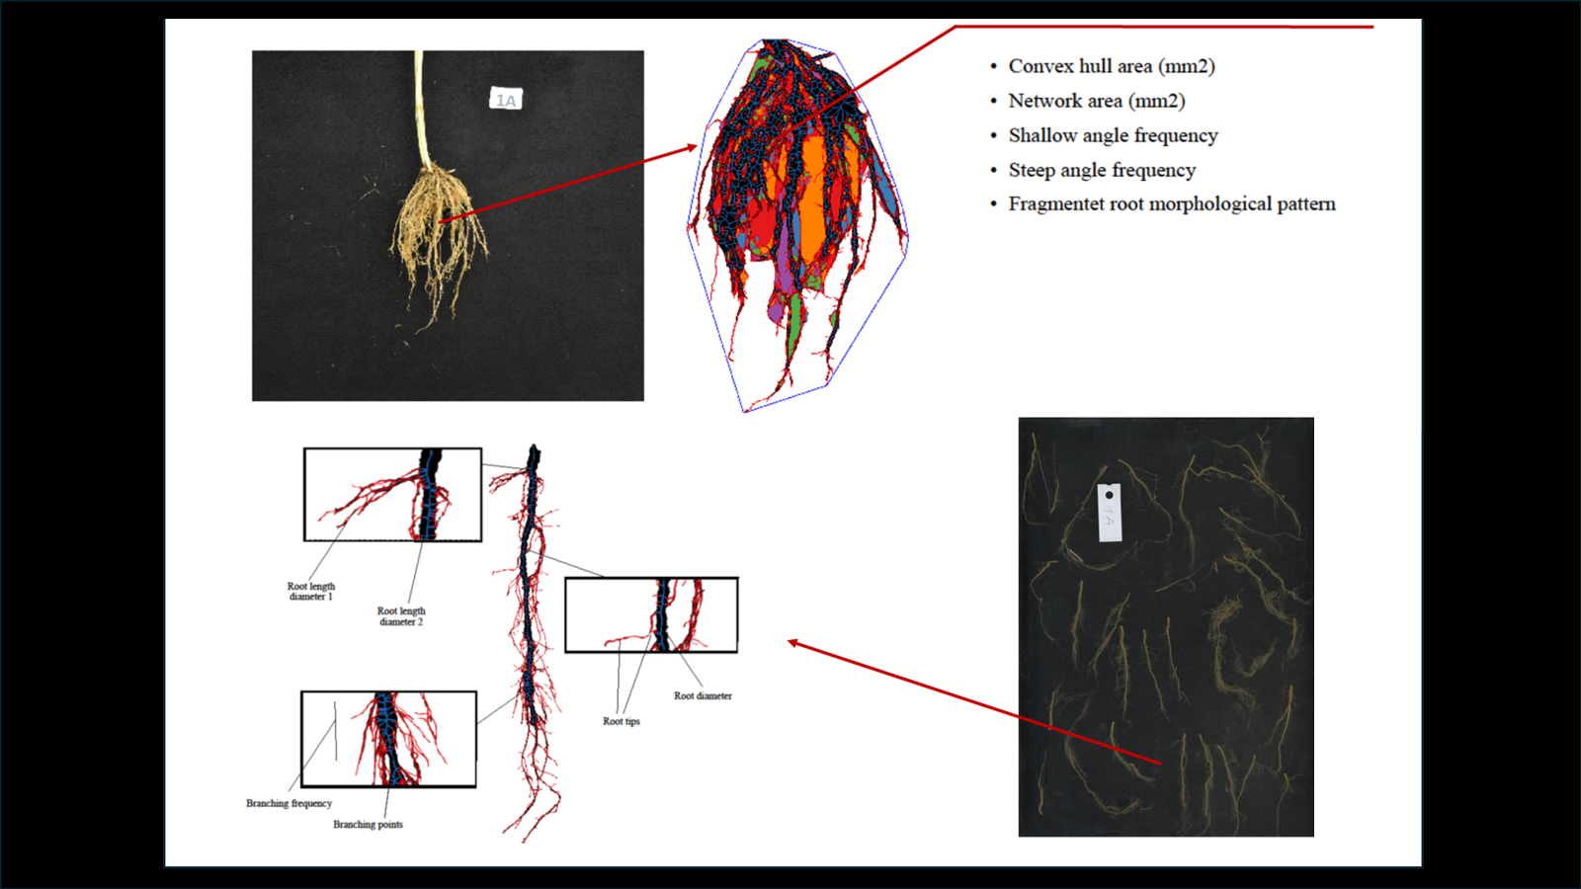

Figure S2. Image analysis workflow using RhizoVision Explorer: extraction of root system architecture traits from whole root images (top) and detailed morphometric data from broken root samples (bottom). Root crowns of the four wheat genotypes with insets showing representative subsamples used for broken-root analysis. Lower panels show RhizoVision Explorer outputs with root segments colour-coded by diameter (red = fine roots; blue = thicker roots). Coloured polygons indicate fragmented root components, and the outer blue contour represents the convex hull of each root system.

Plant material and root phenotyping

The genotype panel comprised 20 lines spanning a broad spectrum of wheat genetic diversity and breeding history. Ten hexaploid bread wheats (Triticum aestivum) were included: eight landraces from the A. E. Watkins collection held at the John Innes Centre — a globally sourced germplasm resource assembled in the 1930s and recently characterised as a foundational platform for systematic gene discovery in bread wheat (Wingen et al., 2014) — together with two modern elite cultivars, the UK reference Paragon and the Italian cultivar Bologna. The tetraploid component of the panel comprised two modern durum wheat cultivars (T. turgidum ssp. durum: Monastir, Svevo), seven durum and other tetraploid landraces (Altar C84, Haurani, Kyperounda L28, Menceki L36, Russello SG7, Senatore Cappelli, Tetra-IPK251) representing Mediterranean and Near-Eastern breeding histories, and one accession of cultivated emmer (T. turgidum ssp. dicoccum: Dicoccum Molise Colli). Together these genotypes capture key axes of variation explored in the durum wheat pan-genome and domestication studies of Maccaferri et al. (2019), spanning the transition from emmer through landraces to modern elite cultivars across both ploidy levels.
Root crown images acquired from field-excavated plants were analysed using RhizoVision Explorer (Seethepalli et al., 2021), an open-source platform for standardised extraction of root architectural and topological traits from 2D root images.

Maccaferri, M., Harris, N.S., Twardziok, S.O., Pasam, R.K., Gundlach, H., Spannagl, M., Ormanbekova, D., Lux, T., Prade, V.M., Milner, S.G., Himmelbach, A., Mascher, M., Bagnaresi, P., Faccioli, P., Cozzi, P., Lauria, M., Lazzari, B., Stella, A., Manconi, A., Gnocchi, M., Moscatelli, M., Avni, R., Deek, J., Biyiklioglu, S., Frascaroli, E., Corneti, S., Salvi, S., Sonnante, G., Desiderio, F., Marè, C., Crosatti, C., Mica, E., Özkan, H., Kilian, B., De Vita, P., Marone, D., Joukhadar, R., Mazzucotelli, E., Nigro, D., Gadaleta, A., Chao, S., Faris, J.D., Melo, A.T.O., Pumphrey, M., Pecchioni, N., Milanesi, L., Wiebe, K., Ens, J., MacLachlan, R.P., Clarke, J.M., Sharpe, A.G., Koh, C.S., Liang, K.Y.H., Taylor, G.J., Knox, R., Budak, H., Mastrangelo, A.M., Xu, S.S., Stein, N., Hale, I., Distelfeld, A., Hayden, M.J., Tuberosa, R., Walkowiak, S., Mayer, K.F.X., Ceriotti, A., Pozniak, C.J., Cattivelli, L., 2019. Durum wheat genome highlights past domestication signatures and future improvement targets. Nat. Genet. 51, 885–895.
Seethepalli, A., Dhakal, K., Griffiths, M., Guo, H., Freschet, G. T., & York, L. M., 2021. RhizoVision Explorer: open-source software for root image analysis and measurement standardization. AoB plants, 13(6), plab056.
Wingen, L.U., Orford, S., Goram, R., Leverington-Waite, M., Bilham, L., Patsiou, T.S., Ambrose, M., Dicks, J., Griffiths, S., 2014. Establishing the A. E. Watkins landrace cultivar collection as a resource for systematic gene discovery in bread wheat. Züchter Genet. Breed. Res. 127, 1831–1842.

