Supplementary Table 1. Sensitivity analysis of different models for rule-in CSPH
Model |  | CSPH misdiagnosed | Rule-in CSPH | Specificity | PPV
HBV cohort  n = 53 | LSM ≥25 kPa | 0 (0) | 2 (3.8%) | 100.0% | 100.0%
HBV cohort  n = 53 | SSM > 50 kPa | 0 (0) | 11 (20.8%) | 100.0% | 100.0%
HBV cohort  n = 53 | SSM >50 kPa OR LSM ≥25 kPa | 0 (0) | 11 (20.8%) | 100.0% | 100.0%
Non-HBV cohort  n = 57 | LSM ≥25 kPa | 1 (5.0%) | 20 (35.1%) | 96.4% | 95.0%
Non-HBV cohort  n = 57 | SSM >50 kPa | 1 (10.0%) | 10 (17.5%) | 96.4% | 90.0%
Non-HBV cohort  n = 57 | SSM >50 kPa OR LSM ≥25 kPa | 2 (8.3%) | 24 (42.1%) | 92.9% | 91.7%
Note: Date were presented as n (%).
Abbreviation: CSPH, clinically significant portal hypertension; HBV, hepatitis B virus; LSM, liver stiffness measurement; PPV, positive predictive value; SSM, spleen stiffness measurement.

Supplementary Table 2. Sensitivity analysis of different models for rule-out CSPH
Model |  | CSPH missed | Rule-out CSPH | Sensitivity | NPV
HBV cohort  n = 53 | LSM ≤15 kPa AND PLT ≥15010⁹/L | 2 (11.1%) | 18 (34.0%) | 93.1% | 88.9%
HBV cohort  n = 53 | SSM <21 kPa | 0 (0.0%) | 2 (3.8%) | 100.0% | 100.0%
HBV cohort  n = 53 | SSM <21 kPa OR  (LSM ≤15 kPa AND PLT ≥15010⁹/L) | 2 (10.5%) | 19 (35.8%) | 93.1% | 89.5%
Non-HBV cohort  n = 57 | LSM ≤15 kPa AND PLT ≥15010⁹/L | 0 (0.0%) | 16 (28.1%) | 100.0% | 100.0%
Non-HBV cohort  n = 57 | SSM <21 kPa | 0 (0.0%) | 8 (14.0%) | 100.0% | 100.0%
Non-HBV cohort  n = 57 | SSM <21 kPa OR  (LSM ≤15 kPa AND PLT ≥15010⁹/L) | 0 (0.0%) | 20 (35.1%) | 100.0% | 100.0%
Note: Date were presented as n (%).
Abbreviation: CSPH, clinically significant portal hypertension; HBV, hepatitis B virus; LSM, liver stiffness measurement; NPV, negative predictive value; PLT, platelet count; SSM, spleen stiffness measurement.
Supplementary Figure 1. The success rate of spleen stiffness was measured by spleen-dedicated 100 Hz and conventional 50 Hz.
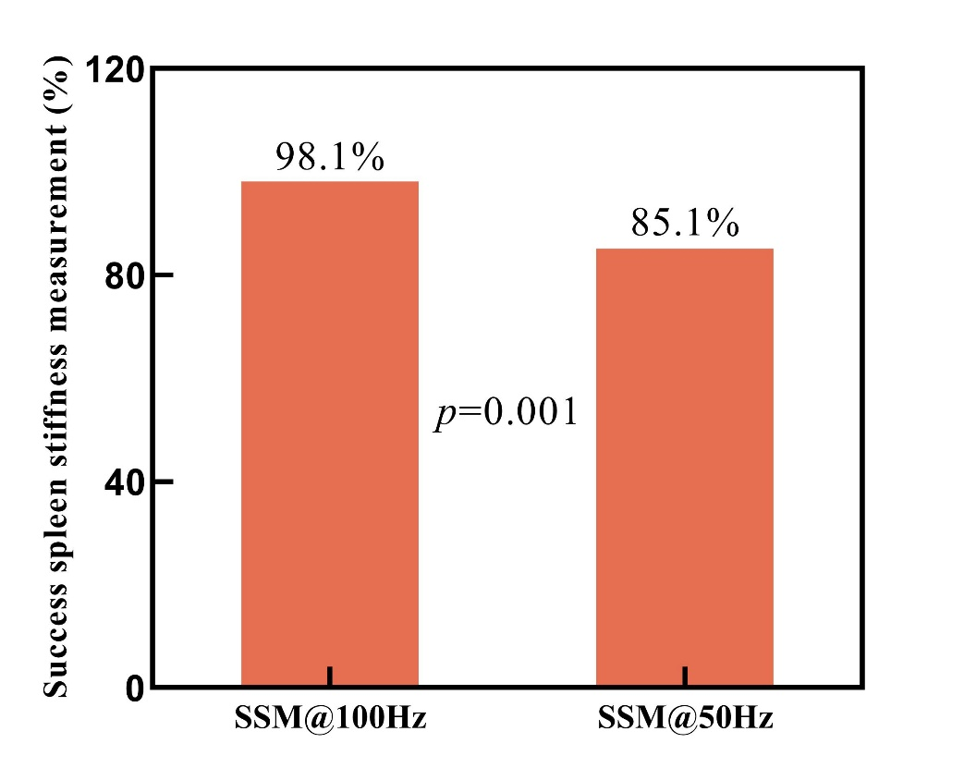

Supplementary Figure 2. Performance of different models for minimising patients in the grey zone. (A) HBV cohort, (B) non-HBV cohort.
