Appendix A
Of the 64 stimulus videos, 15 angry and 22 happy stimuli movies were analyzed for their kinematics characteristics by tracking in MATLAB the object that was moved by the actor. (The MATLAB script did not succeed in tracking the objects in the other videos accurately). The script yielded a measure of the movement velocity, acceleration, and jerk in each stimulus video. An independent-samples t-test with velocity as dependent variable and emotion (angry, happy) as independent variable showed a significant effect (t(15.97)=−3.61, p=.002, Cohen’s d =−1.42). Angry movements had a significantly higher velocity (M = 34.09, SD = 12.83) compared to happy movements (M = 34.09, SD = 4.11). Independent-samples t-tests showed no significant effect of emotion (angry, happy) on acceleration (t(35)=0.45, p=.650) or jerk (t(35)=−1.02, p=.313).
Furthermore, the mean standard deviation of the three measures – velocity, acceleration and jerk – was calculated for each movie. The variability in velocity was significantly larger in angry videos (M = 1.15, SD = 0.58) than in happy videos (M = 0.85, SD = 0.27; t(18.20)=0.4.21, p=.001, Cohens’ d =1.60). Moreover, the variability in acceleration was significantly larger in angry videos (M = 1.12, SD = 0.68) than in happy videos (M = 0.39, SD = 0.41; t(21.06)=0.3.69, p=.001, Cohens’ d =1.35). The variability in jerk was larger in angry videos (M = 1.68, SD = 1.14) than in happy videos (M = 0.59, SD = 0.76; t(22.46)=0.3.26, p=.004, Cohens’ d =1.18).
Appendix B
A validation study of the video stimuli was performed. Twenty Dutch adults (M = 34.45 years, SD = 28.5 years, range = 21–68 years, 16 females) participated in this study. Participants watched each video once and were then asked to indicate through a button press whether the actor was angry, happy, sad, surprised, fearful, or disgusted. Participants were asked to identify the emotion of the person acting and were also instructed that some emotions might never or rarely occur, while others might occur often. One participant did not finish the rating study and was excluded.
The results showed that all angry actions were rated most frequently as angry (M = 82.0%, SD = 8.0%, range: 68.4–100%, f1Fig. A1). Happy actions were most often identified as happy (M = 58.4%, SD = 21.6%, range = 5.3–94.7%, f2Fig. A2). Only for 3 of the 32 happy stimulus videos, participants chose another emotion as frequently or more frequently (H39: 31.6% sadness vs. 21.1% happy; H41: 31.6% happy vs. 31.6% fear; H48: 57.9% disgust vs. 10.5% happy). None of the angry actions was identified as a different emotion more frequently.
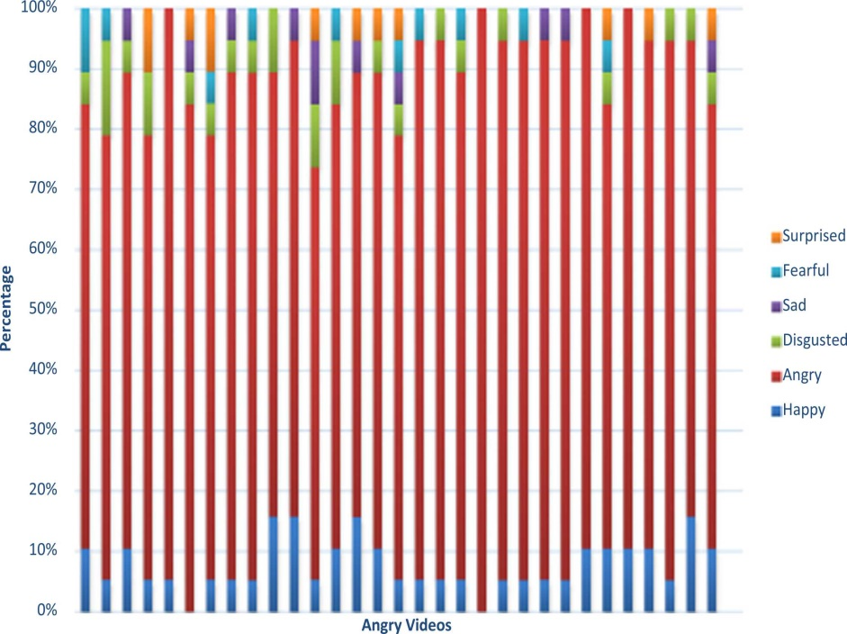
Fig. A1 . The percentage of participants that rated the angry stimulus videos as surprised, fearful, sad, disgusted, angry, or happy (separate for each angry stimulus video).Fig. A1
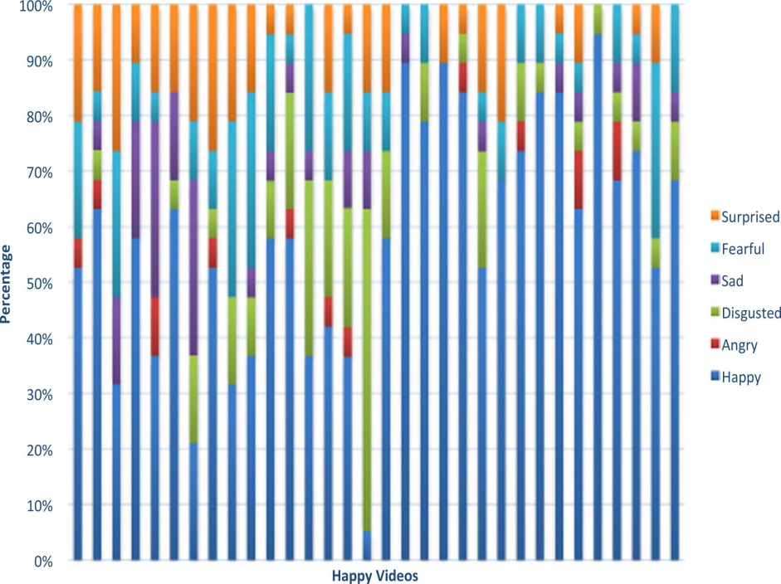
Fig. A2 . The percentage of participants that rated the happy stimulus videos as surprised, fearful, sad, disgusted, angry, or happy (separate for each happy stimulus video).Fig. A2

