Supplementary Material
Supplementary Figure 1. Graphic representation of the experimental treatments. Note the 16 h photoperiod from 06:00 to 22:00, and the hourly red and blue adjustments maintaining 200 μmol m⁻² s⁻¹ as total photosynthetic photon flux density.
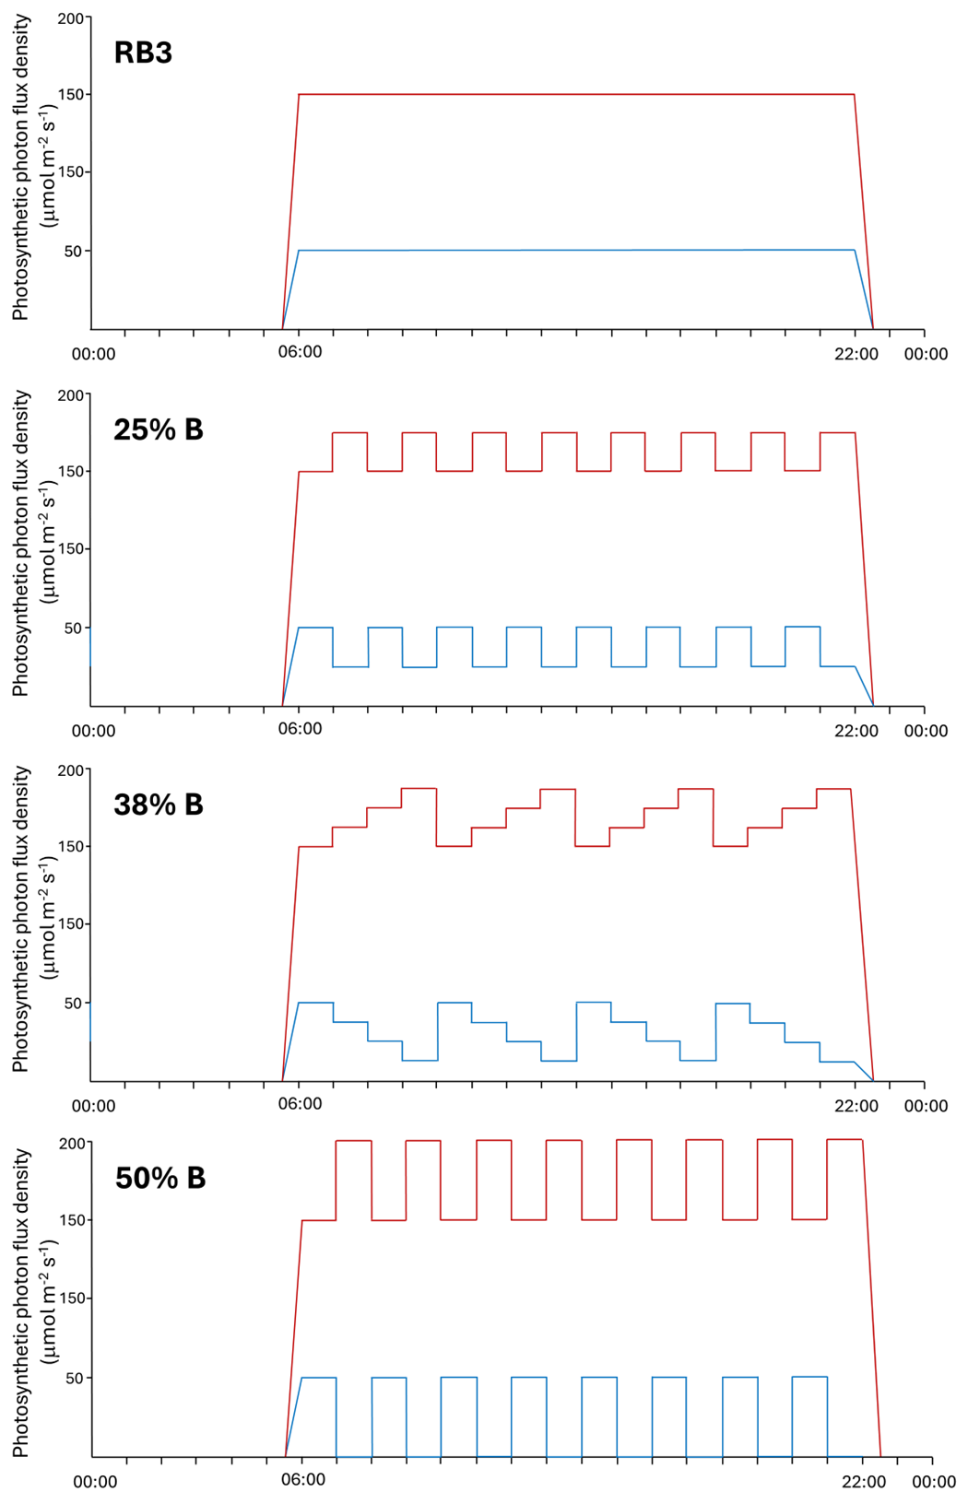

Supplementary Figure 2. Schematic layout of the experimental design, arranged as a completely randomized design, conducted within Nära Sverige AB vertical farm, Stockholm, Sweden. The experiment composed with four lighting treatments with each of three replications. Twelve light-insulated compartments, each measuring 0.5 m², were constructed for this study.
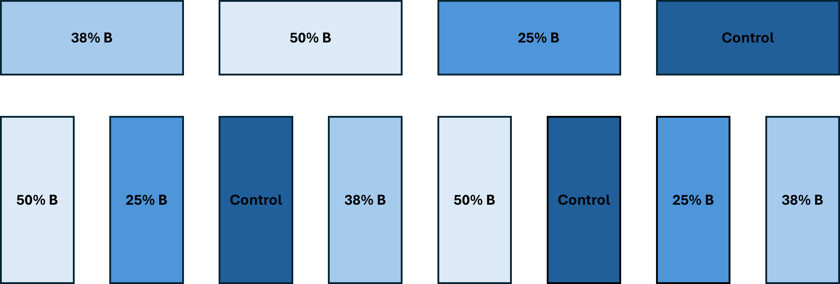

Supplementary Table 1. Effect of dynamic versus constant lighting treatments on agronomic parameters at different harvest time (7, 14, and 21 days after transplanting, DAT).
Treatments | Parameters
Treatments | Fresh weight (g FW plant⁻¹) | Dry weight (g DW plant⁻¹)
7 days after transplanting (DAT)
Control | 0.98 a | 0.091 a
B 25% | 0.94 a | 0.089 a
B 38% | 1.04 a | 0.099 a
B 50% | 1.08 a | 0.094 a
14 days after transplanting (DAT)
Control | 3.76 a | 0.382 a
B 25% | 4.15 a | 0.399 a
B 38% | 4.08 a | 0.423 a
B 50% | 3.89 a | 0.398 a
21 days after transplanting (DAT)
Control | 8.39 c | 0.798 a
B 25% | 13.44 a | 0.831 a
B 38% | 12.58 ab | 0.846 a
B 50% | 10.58 bc | 0.776 a

