APPENDIX

Section A

The search in the V Edition of “The Theories of the Policy Process” of
the recurrence of the main concept/words that usually are considered to capture the processual dimension of policymaking (together with policy instruments)

The research was carried out as follows.
- All occurrences of specific words in the text were searched, excluding those in the title page, acknowledgements page, dedication, table of contents, list of figures and tables, contributors' biographies, preface and index.
- At this point, recurrences in the references were also excluded.
- The remaining words have been screened to exclude those used in a sense other than that for which they were searched. For example. Concerning:
- Process, those uses that were not directly related to the policy process were excluded;
- Formulation, the exclusion mainly considered the use of the word as "formulation of theory";
- Agenda, the exclusion considered the use of the word when used as "research agenda";
- Change, the exclusion was based on those uses that were not strictly related to policy/process change (like "words change meaning");
- Design, all expressions such as "research design" were excluded.
- Evaluation, uses such as "evaluation criteria in theories" were excluded.
- Administration, the word was excluded when used in expressions such as Bush administration, public administration, administration staff.
- Management, the exclusion has considered expressions like New Public Management.

The following words did not require any kind of exclusion
- Policy-making
- Dynamics
- Decision-making
- Implementation
- Instruments
- Enforcement
- Stability

All data from the selection process are presented in Table 1.

Table 1. The selection process of the recurrence of the main concept/words that usually are considered to capture the processual dimension of policymaking (together with policy instruments)

 | Initial selection (*) | In the references | other use | Final selection
Process | 559 | 121 | 29 | 409
Policymaking | 162 | 33 | 0 | 129
Dynamics | 102 | 34 | 0 | 68
Agenda | 232 | 79 | 9 | 144
Formulation | 14 | 0 | 7 | 7
Design | 72 | 23 | 12 | 37
Decision-making | 245 | 38 | 0 | 207
Implementation | 88 | 16 | 0 | 72
Evaluation | 13 | 4 | 7 | 2
Policy Instruments | 37 | 6 | 0 | 31
Change | 500 | 133 | 5 | 362
Stability | 54 | 11 | 0 | 43
Administration | 100 | 81 | 14 | 5
Governance | 210 | 121 | 0 | 89
Enforcement | 4 | 3 | 0 | 1
Management | 83 | 37 | 4 | 42
(*)excluding those on the title page, acknowledgements page, dedication, table of contents, list of figures and tables, contributors' biographies, preface, and index.

Section B
The keyword search

The period of time considered for the analysis is from 1984 to July 2024. 1984 was chosen because it was the year of publication of the first of the seminal works of the four frameworks analysed (Kingdon's book Agenda, Alternatives and Public Policies).

The keyword search was based on:
- pairing the name of the framework with implementation and instruments/tools;
- pairing the acronym of the framework with the word policy and with either implementation or instruments /tools.

The decision to add the word policy when searching the acronym is because the acronym itself could be very misleading and would have been conducted to select an incredibly high number of publications. The choice to use both the instrument and/or tools option is justified because these two terms are often used as synonyms in the literature.

Finally, for the Multiple Stream Framework, we doubled the search by also using the label Multiple Stream Approach because the word approach or framework is commonly used in the literature to name this framework.

Table A. The Keywords of the systematic review
Framework | Implementation | Policy instruments
Advocacy Coalition Framework | - Advocacy Coalition Framework + implementation  - ACF+Policy+implementation | - Advocacy Coalition Framework + instrument/tools  - ACF+Policy+instruments/ tools
Multiple Stream Framework | - Multiple Stream Framework+implementation  - MSF +policy+Implementation  - Multiple Stream Approach+implementation  - MSA+policy+implementation | - Multiple Stream Framework+instruments/tools  - MSF +policy+instruments/tools  - Multiple Stream Approach +instruments/tools  - MSA+policy+ instruments/tools
Narrative Policy Framework | - Narrative Policy Framework+ implementation  - NPF+Policy+implementation | - Narrative Policy Framework+ instruments/tools  - NPF+Policy+ instruments/tools
Punctuated Equilibrium Theory | - Punctuated Equilibrium Theory +implementation  - PET +Policy+implementation | - Punctuated Equilibrium Theory + instruments/tools  - PET +Policy+ instruments/tools

Table B. Results of the keyword search on Implementation

 | Name of the framework + Implementation | Acronymous + policy+ implementation | Total
ACF | 78 | 40 | 118
MSF | 77 | 21 | 98 | 171
MSA | 59 | 14 | 73
NPF | 213 | 15 | 228
PET | 12 | 14 | 26

Table C. Results of the keyword search on Instruments/tools

 | Name of the framework * instruments/tools | Acronymous + policy+ instruments/tools | Total
ACF | 64 | 21 | 85
MSF | 60 | 10 | 70 | 161
MSA | 85 | 6 | 91
NPF | 213 | 11 | 224
PET | 11 | 15 | 26

Section C

The selection trees

After removing duplicate records, we merged the two subsamples to obtain a final working sample (“records merged after removing duplicates”).
By successively screening the content of the abstracts, we were able to further reduce our sample by removing all articles that, although citing one (or combinations) of our keywords, did not directly refer to implementation or policy instruments/tools (“fully screened articles”).
We assessed the eligibility of each of the fully screened articles by analysing the whole text and deciding whether it really focused on implementation and/or policy instruments or whether these terms were used in a general way. Very often, even if the terms implementation or policy instruments/tolls are present in the abstract, the content of the paper is not focused on any relevant dimension of these two objects.
This step made it possible to select the final set of articles for an "in-depth analysis" based on a qualitative analysis of their content in terms of treatment implementation and instruments/tools. The small number of articles finally selected and the incredible variety of ways in which they dealt with implementation, together with the widespread lack of a clear definition and operationalisation of policy instruments, led us to avoid a specific classification of content (also due to the very different characteristics of the four frameworks) and to move towards a descriptive categorisation, which is presented in Table 2 in the paper

Advocacy Coalition Framework

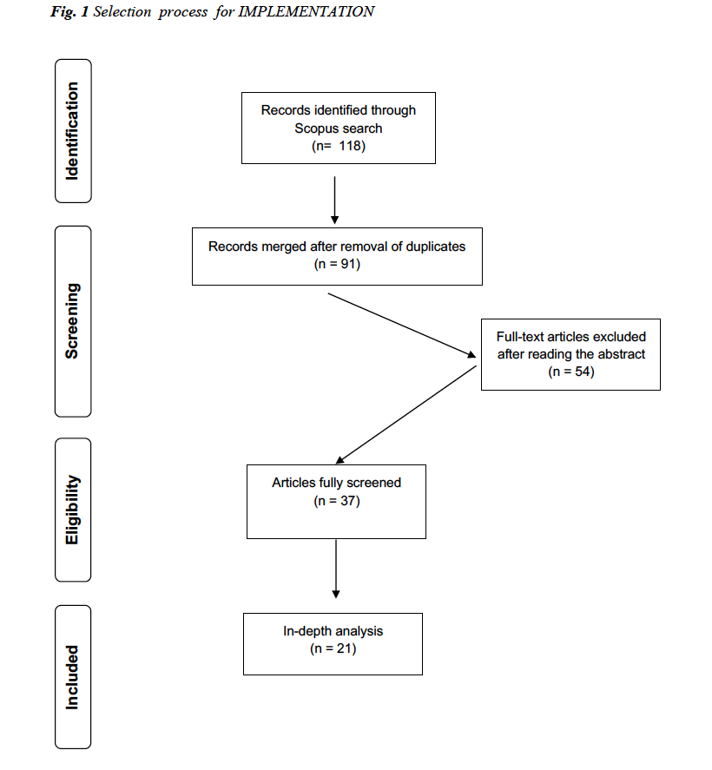

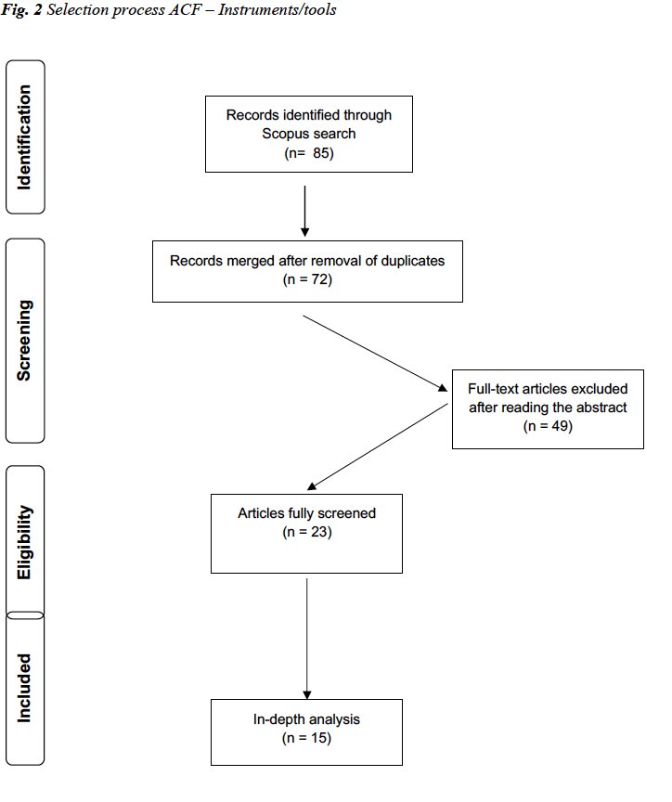

MULTIPLE STREAM APPROACH

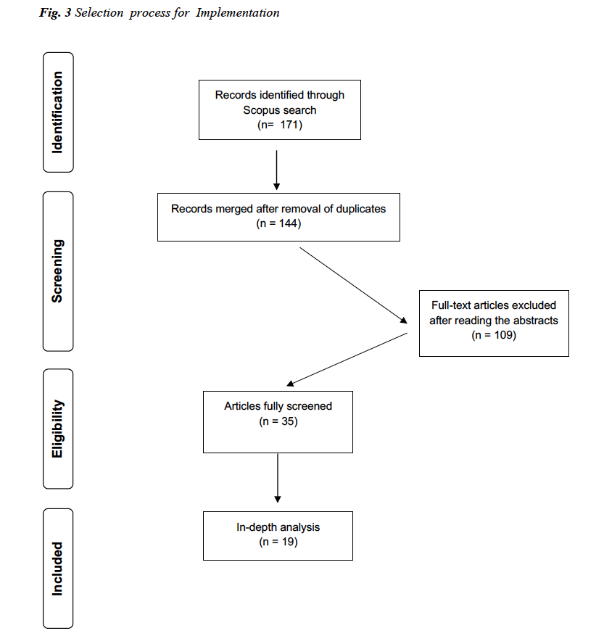

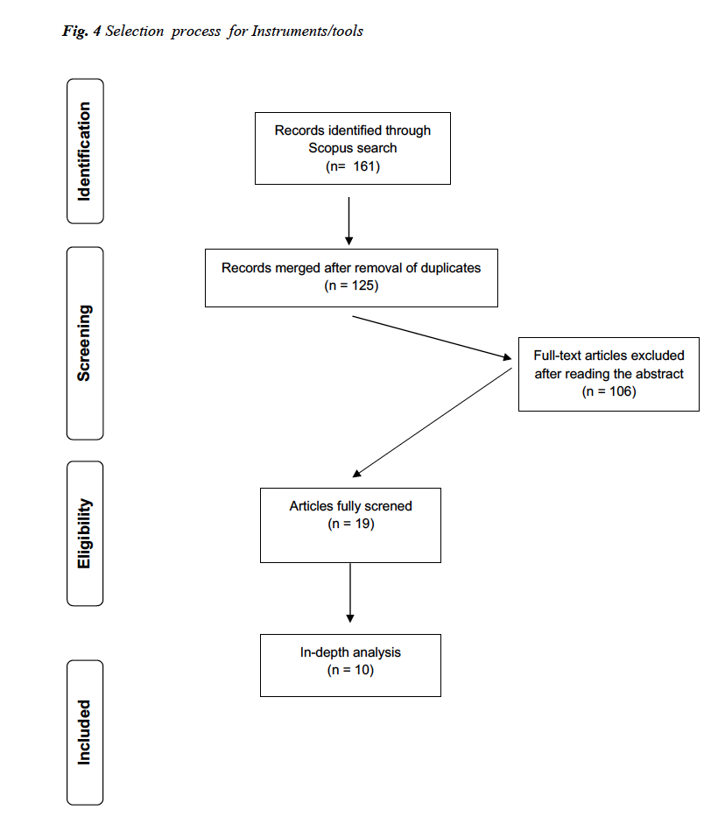

Narrative Policy Framework
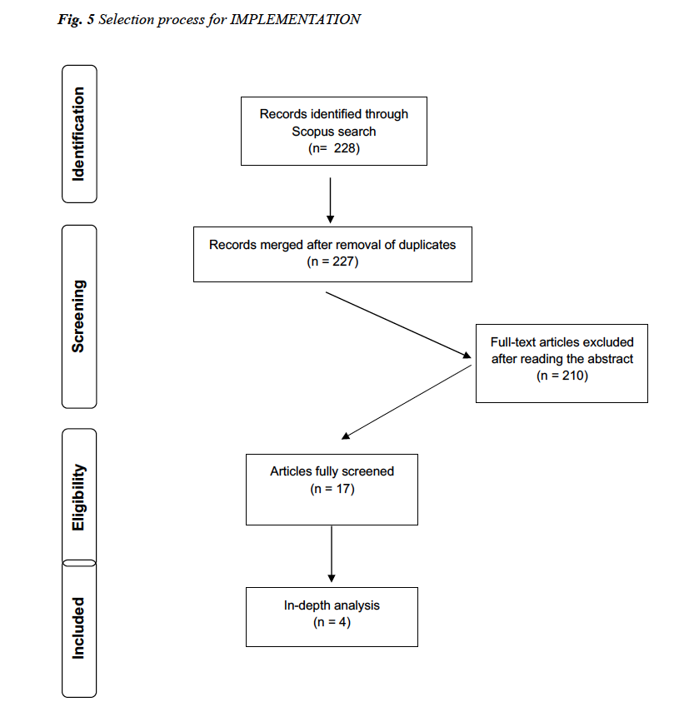
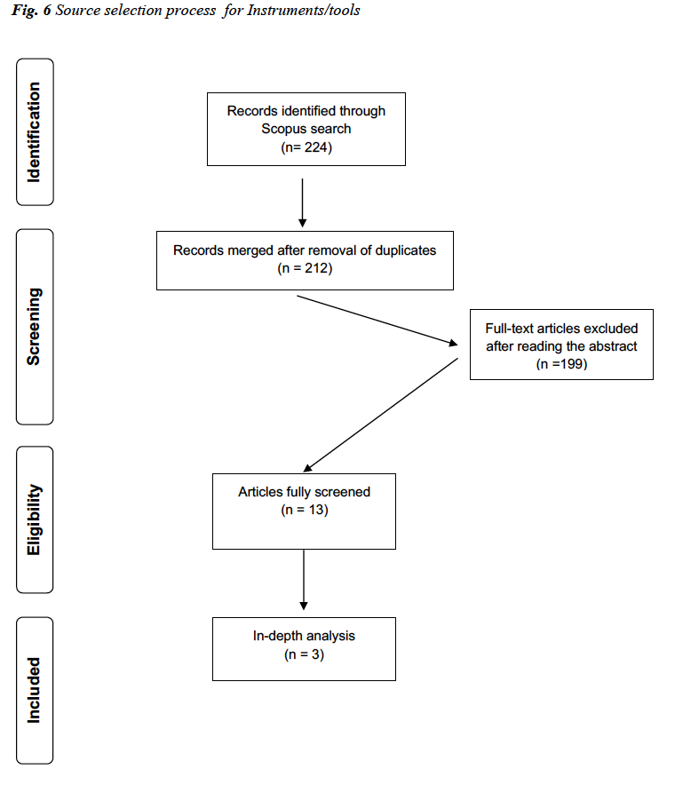

Punctuated Equilibrium Theory

