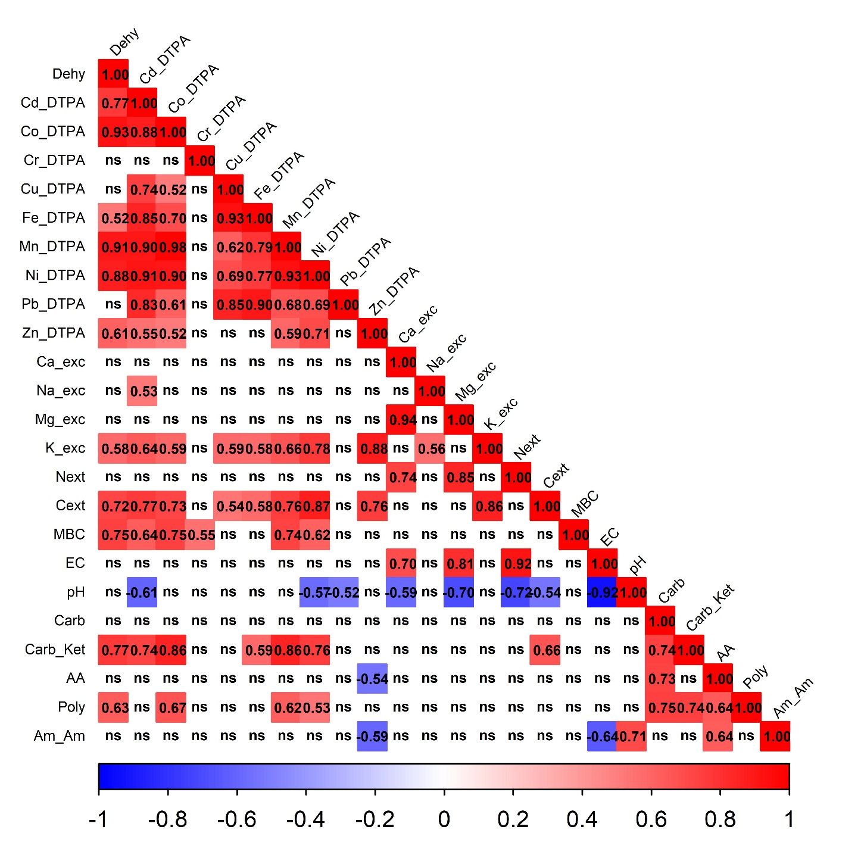
Figure S1. Corrplot diagram of 24 variables analysed after the soil incubation: chemical, biochemical indicators and substrate degradation after CLPP. Pearson’s coefficients are reported as number (-1, 1) only when p-value > 0.05.

Table S1. List of the principal organic contaminants analysed.
 |  | WW | WB | Methods
Polycyclic aromatic hydrocarbons (PAHs)
Benzene | mg kg⁻¹ dw | < 0.005 | < 0.005 | EPA 5021A 2014 + EPA 8260D 2018
Ethylbenzene (A) | mg kg⁻¹ dw | < 0.005 | < 0.005 | EPA 5021A 2014 + EPA 8260D 2018
Styrene (B) | mg kg⁻¹ dw | < 0.005 | < 0.005 | EPA 5021A 2014 + EPA 8260D 2018
Toluene (C) | mg kg⁻¹ dw | < 0.005 | 0.006 | EPA 5021A 2014 + EPA 8260D 2018
Xylene (D) | mg kg⁻¹ dw | < 0.005 | < 0.005 | EPA 5021A 2014 + EPA 8260D 2018
Polycyclic Hydrocarbons
Naphthalene | mg kg⁻¹ dw | < 0.01 | 0.05 | EPA 3550C 2007 + EPA 8270E 2018
Acenaphthylene | mg kg⁻¹ dw | < 0.01 | < 0.01 | EPA 3550C 2007 + EPA 8270E 2018
Acenaphthene | mg kg⁻¹ dw | < 0.01 | 0.06 | EPA 3550C 2007 + EPA 8270E 2018
Fluorene | mg kg⁻¹ dw | < 0.01 | < 0.01 | EPA 3550C 2007 + EPA 8270E 2018
Phenanthrene | mg kg⁻¹ dw | < 0.01 | < 0.01 | EPA 3550C 2007 + EPA 8270E 2018
Anthracene | mg kg⁻¹ dw | < 0.01 | < 0.01 | EPA 3550C 2007 + EPA 8270E 2018
Fluoranthene | mg kg⁻¹ dw | < 0.01 | < 0.01 | EPA 3550C 2007 + EPA 8270E 2018
Pyrene (A) | mg kg⁻¹ dw | < 0.01 | < 0.01 | EPA 3550C 2007 + EPA 8270E 2018
Benzo(a)anthracene (B) | mg kg⁻¹ dw | < 0.01 | < 0.01 | EPA 3550C 2007 + EPA 8270E 2018
Chrysene (C) | mg kg⁻¹ dw | < 0.01 | < 0.01 | EPA 3550C 2007 + EPA 8270E 2018
Benzo(b)fluoranthene (E) | mg kg⁻¹ dw | < 0.01 | < 0.01 | EPA 3550C 2007 + EPA 8270E 2018
Benzo(k)fluoranthene (E) | mg kg⁻¹ dw | < 0.01 | < 0.01 | EPA 3550C 2007 + EPA 8270E 2018
Benzo(a)pyrene (F) | mg kg⁻¹ dw | < 0.01 | < 0.01 | EPA 3550C 2007 + EPA 8270E 2018
Indeno(1,2,3-cd)pyrene (G) | mg kg⁻¹ dw | < 0.01 | < 0.01 | EPA 3550C 2007 + EPA 8270E 2018
Dibenzo(a,h)anthracene (H) | mg kg⁻¹ dw | < 0.01 | < 0.01 | EPA 3550C 2007 + EPA 8270E 2018
Benzo(ghi)perylene (I) | mg kg⁻¹ dw | < 0.01 | < 0.01 | EPA 3550C 2007 + EPA 8270E 2018
Dibenzo(a,e)pyrene (L) | mg kg⁻¹ dw | < 0.01 | < 0.01 | EPA 3550C 2007 + EPA 8270E 2018
Dibenzo(a,h)pyrene (M) | mg kg⁻¹ dw | < 0.01 | < 0.01 | EPA 3550C 2007 + EPA 8270E 2018
Dibenzo(a,i)pyrene (N) | mg kg⁻¹ dw | < 0.01 | < 0.01 | EPA 3550C 2007 + EPA 8270E 2018
Dibenzo(a,l)pyrene (N) | mg kg⁻¹ dw | < 0.01 | < 0.01 | EPA 3550C 2007 + EPA 8270E 2018
Non-Chlorinated Phenols
Methylphenol (o-, m-, p-) | mg kg⁻¹ dw | 0.03 | 0.12 | EPA 3550C 2007 + EPA 8270E 2018
Phenol | mg kg⁻¹ dw | < 0.1 | 1 | EPA 3550C 2007 + EPA 8270E 2018
Chlorinated Phenols
2-Chlorophenol | mg kg⁻¹ dw | < 0.01 | < 0.01 | EPA 3550C 2007 + EPA 8270E 2018
2,4-Dichlorophenol | mg kg⁻¹ dw | < 0.01 | < 0.01 | EPA 3550C 2007 + EPA 8270E 2018
2,4,6-Trichlorophenol | mg kg⁻¹ dw | < 0.01 | < 0.01 | EPA 3550C 2007 + EPA 8270E 2018
Pentachlorophenol | mg kg⁻¹ dw | < 0.01 | < 0.01 | EPA 3550C 2007 + EPA 8270E 2018
Other Substances
Formaldehyde | mg kg⁻¹ dw | 1.1 | 1.1 | EPA 8315A 1996
Acetaldehyde | mg kg⁻¹ dw | 1.5 | 1.6 | EPA 8315A 1996
Butyraldehyde | mg kg⁻¹ dw | 0.5 | nd | EPA 8315A 1996
Benzaldehyde | mg kg⁻¹ dw | < 0.1 | < 0.1 | EPA 8315A 1996
Valeraldehyde | mg kg⁻¹ dw | < 0.1 | nd | EPA 8315A 1996
Butyraldehyde (butanal) | mg kg⁻¹ dw | nd | < 0.1 | EPA 8315A 1996
Valeraldehyde (pentanal) | mg kg⁻¹ dw | nd | < 0.1 | EPA 8315A 1996
Glutaraldehyde | mg kg⁻¹ dw | <5 | <5 | ISO 17226-1:2021

Table S2. Principal characteristics of the soil used in the in the soil incubation and Rhizotest.
Characteristics | Unit | CC
Classification (WRB) | - | Clay-Loam Cambisol
Texture (USDA) | - | Loam
Sand | % dw | 37
Silt | % dw | 46
Clay | % dw | 17
Reaction (H₂O) | pH-unit | 7.9
Total carbonates | % CaCO₃ | 36
Total organic C | % dw | 1.19
Total N | % dw | 0.12
C/N ratio | - | 10
Cation exchange capacity | cmol₊ kg⁻¹ dw | 19.1
Available P | mg kg⁻¹ dw | 5
Full water holding capacity | % dw | 47.3
Oxidising Capacity for Cr(VI) | µmol_{Cr(VI)} | 0.024

Table S3. Parameters of mineral N-release fitting for WW and WB non-linear models.
Treatment | p-value(N₀) | RSE | Psudo R² | N₀ | k
WW | 1.3e-5 | 6.03 | 0.899 | 44.63 ± 3.4 | 0.15 ± 0.05
WB | 1.1e-4 | 6.31 | 0.869 | 39.74 ± 4.5 | 0.11 ± 0.04

Table S4. Results of one-way ANOVA performed on the first three principal components (PC1, PC2 and PC3) after Principal Component Analysis (PCA). Different letters indicate significant differences at post-hoc Tukey’s test (p<0.05).
 | Treatment | adj. Mean | SD | Tukey
 | CK | 3.70 | 1.78 | a
 | MF | 0.63 | 0.09 | b
 | OF | -0.46 | 0.40 | c
 | WW | -0.62 | 0.41 | b
 | WB | -3.25 | 0.20 | b
 |  | F_{4, 10} | p-value | Explained variance (%)
 | PC1 | 26.7 | <0.001 | 36.9
 | Treatment | adj. Mean | SD | Tukey
 | CK | 2.88 | 0.53 | a
 | MF | -2.96 | 0.34 | d
 | OF | 1.21 | 0.54 | ab
 | WW | -0.89 | 0.57 | b
 | WB | -0.23 | 0.34 | c
 |  | F_{4, 10} | p-value | Explained variance (%)
PC2 |  | 79.9 | <0.001 | 24.9
Treatment |  | adj. Mean | SD | Tukey
CK |  | 2.88 | 0.53 | bc
MF |  | -2.96 | 0.34 | bc
OF |  | 1.21 | 0.54 | c
WW |  | -0.89 | 0.57 | a
WB |  | -0.23 | 0.34 | b
 |  | F_{4, 10} | p-value | Explained variance (%)
PC3 |  | 23.2 | <0.001 | 14.3

Table S5. PCA loadings i.e. correlation of the variables in the dataset with the principal components PC1, PC2 and PC3. Dehy: dehydrogenase; X_DTPA: extractable elements in DTPA; X_exch: exchangeable cations; Next: extractable N; Cext: extractable C; MBC: microbial biomass C; EC: electric conductivity; Carb: carbohydrates substrate; Carb_Ket: carboxylic and ketonic acids substrates; AA: amino acids substrates; Poly: polymers substrates; Am_Am: amines and amides substrates.
Variable | PC1 | PC2 | PC3
Dehy | -0.34 | 0.18 | 0.01
Cr_DTPA | -0.06 | -0.03 | 0.12
Cu_DTPA | -0.29 | 0.00 | -0.02
Pb_DTPA | -0.30 | -0.03 | 0.17
Zn_DTPA | -0.29 | 0.03 | -0.42
Mg_exch | -0.10 | -0.43 | 0.08
K_exch | -0.30 | 0.11 | -0.37
Next | -0.07 | -0.45 | 0.25
Cext | -0.35 | 0.09 | -0.12
MBC | -0.25 | 0.17 | -0.09
EC | -0.22 | -0.39 | 0.22
pH | 0.31 | 0.28 | -0.17
Carb | -0.09 | 0.28 | 0.46
Carb_Ket | -0.28 | 0.26 | 0.24
Poly | -0.17 | 0.28 | 0.38
Am_Am | 0.26 | 0.29 | 0.23

