Supplementary materials
Table S1: List of Other indications for LT waitlisting

Rendu-Osler Weber
Hepatoblastoma
Hemangioma with kasaback merit syndrome
Familial amyloid polineuropathy
Hepato-pulmonary syndrome
Porto-pulmonary hypertension
Refractory Hydrothorax
Refractory ascites
Hepato-renal syndrome
Polycistic disease
Wilson’s disease
Neuroendocrine tumour metastases
Hemangioendotheliomas
Complicated adenoma
Fibrolamellar HCC
Hilar cholangiocarcinoma
Colorectal cancer metastases
Budd-Chiari syndrome
Cystic fibrosis

Table S2: Demographic Characteristics of the Study Cohort (n=12,749)
Variable | Overall | Era 1 | Era 2 | Era 3
Median (Q1-Q3) or % (n) |  | Median (Q1-Q3) or % (n) | Median (Q1-Q3) or % (n) | Median (Q1-Q3) or % (n)
Waiting list | 12,749 | 3,161 | 4,652 | 4,936
Age (years) | 57 (51-62) | 55 (49-61) | 56 (51-62) | 59 (52-64)
Gender (male) | 75.7% (9,651) | 75.9% (2,400) | 78.2% (3,637) | 73.2 (3,614)
Blood Group  O  A  AB  B | 41.1% (5,243)  40.1% (5,112)  5.0% (642)  13.8% (1,752) | 41.2% (1,303)  40.4% (1,275)  4.8% (152)  13.6% (431) | 41.0% (1,906)  40.3% (1,876)  5.4% (253)  13.3% (617) | 41.2% (2,034)  39.7% (1,961)  4.8% (237)  14.3% (704)
MELD | 14 (10-18) | 15 (10-19) | 14 (10-18) | 13 (9-18)
Height | 170 (165-176) | 170 (165-176) | 170 (165-177) | 170 (165-176)
Indications  HCC  Cirrhosis  Other | 44.8% (5,716)  50.3% (6,416)  4.9% (617) | 42.8% (1,352)  53.6% (1,696)  3.6% (113) | 50.5% (2,347)  45.7% (2,127)  3.8% (178) | 40.9% (2,017)  52.5% (2,593)  6.6% (326)
Etiology  Alcoholic  HBV  HCV  Metabolic  Other | 20.1% (2,424)  18.5% (2,236)  38.5% (4,638)  10.7% (1,291)  12.2% (1,473) | 15.6% (477)  18.6% (569)  48.4% (1,475)  8.2% (249)  9.2% (282) | 19.7% (875)  18.4% (818)  40.7% (1,809)  10.8% (480)  10.4% (461) | 23.5% (1,072)  18.6% (849)  29.6% (1,354)  12.3% (562)  16.0% (730)

MELD: model for end-stage liver disease; HCC: hepatocellular carcinoma; HBV: hepatitis B Virus; HCV: Hepatitis C virus

Table S3. Multivariable analysis of factors predicting the drop-out from the waiting list due to clinical improvement in patient waitlisted for liver transplantation in Italy between January 2012 and December 2022 (number of observations used 12,029)

Variable | Contrast | Hazard Ratio | 95% Confidence Interval | Wald statistic | p-value
Etiology |  |  |  | 10.65 | 0.0308
Gender |  |  |  | 3.92 | 0.0477
Etiology*Gender |  |  |  | 17.98 | 0.0012
 | HCV vs HBV at gender=male | 1.51 | (0.94, 2.42)
 | Alcoholic cirrhosis vs HBV at gender=male | 2.04 | (1.25, 3.32)
 | Metabolic cirrhosis vs HBV at gender=male | 1.06 | (0.53, 2.14)
 | Other vs HBV at gender=male | 1.33 | (0.68, 2.63)
 | Female vs male at alcoholic cirrhosis | 3.16 | (2.10, 4.76)
 | Female vs male at metabolic cirrhosis | 2.24 | (1.00, 5.02)
 | Female vs male at HCV | 1.54 | (1.00, 2.37)
 | Female vs male at HBV | 0.53 | (0.21, 1.32)
Era |  |  |  | 23.46 | <0.0001
MELD |  |  |  | 52.69 | <0.0001
Era*MELD |  |  |  | 6.39 | 0.0409
 | Era 2 vs Era 1 at median MELD 14 | 0.74 | (0.58, 0.96)
 | Era 3 vs Era 1 at median MELD 14 | 0.25 | (0.18, 0.35)
 | x 5 MELD units in Era 1 | 0.49 | (0.41, 0.60)
 | x 5 MELD units in Era 2 | 0.57 | (0.49, 0.67)
 | x 5 MELD units in Era 3 | 0.78 | (0.57, 1.07)
Indication |  |  |  | 85.98 | <0.0001
 | HCC vs Cirrhosis | 0.19 | (0.14, 0.27)
 | HCC vs Other | 0.21 | (0.11, 0.40)
Nationality | Foreigner vs Italian | 1.70 | (1.23, 2.35) | 10.32 | 0.0013

Figure S1: Cumulative incidence functions for liver transplantation rate (A) and waiting list failure (B) according to Era.

Figure S2: Cumulative incidence functions for liver transplantation rate according to underlying aetiology in patients with cirrhosis as indication

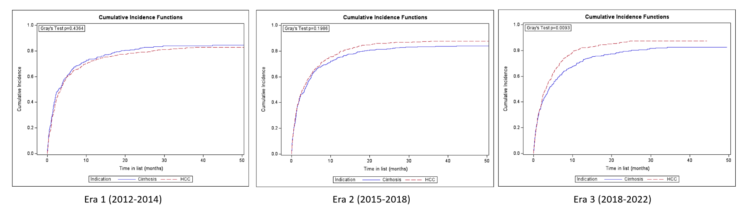
Figure S3: Cumulative incidence functions for liver transplantation rate according to indication in HBV patients [Era-1(A), Era-2(B), Era-3 (C)]
C
B
A

Figure S4: Cumulative incidence functions for liver transplantation rate according to indication and Era in HBV patients

Figure S5: Cumulative incidence functions for liver transplantation rate according to stature in Era-1 (A), Era-2(B) and Era-3 (C)

Figure S6: Cumulative incidence functions for liver transplantation rate according to blood group in Era-1 (A), Era-2(B) and Era-3 (C)

Figure S7: Cumulative incidence functions for liver transplantation rate according to MELD in Era 1 (A), Era 2 (B) and Era 3 (C)

