Stochastic modelling of muscle control during shoulder abduction
Supplementary file
Alex Bersani¹, Saulo Martelli^{2,3}, Maxence Lavaill^{2,3}, Giorgio Davico¹
¹ Department of Industrial Engineering, Alma Mater Studiorum - University of Bologna, Bologna, Italy
² School of Mechanical, Medical and Process Engineering, Queensland University of Technology, Brisbane, Australia
³ Centre for Biomedical Technologies, Queensland University of Technology, Brisbane, Australia
Muscle forces solution spaces analysis – Material and Methods
As explained in the main document, the experimental data were collected on a 64-year-old man implanted with an instrumented right shoulder prosthesis, which was part of a publicly available dataset. The data is composed of three consecutive shoulder slow abductions while holding a 2.4 kg weight. Stochastic simulations were performed with Myobolica sampling 10⁵ solutions every 30 timeframes of the simulation. In particular, in the EMG-informed stochastic simulations the initial tentative solution – for the muscles informed with EMG – was the EMG-derived force with a 50 % error. Table 1 reports the updated the gamma values for the muscles that were modelled with multiple actuators (e.g., the deltoids muscle is modelled with 15 actuators), by normalising the experimentally determined gamma value to the number of actuators.
To assess the impact of the EMG-based constraint on the muscle force solution spaces, the reduction of the solution space was estimated as the difference between the average bandwidth in the initial simulation (labelled Default, not EMG-informed with experimentally derived – non-muscle-specific – gamma values) and each subsequent one.
Muscle forces solution spaces analysis – Results and Discussion
The width of the muscle force solution spaces tended to decrease when the EMG-based constraint was introduced (Figure 1). The largest variation (compared to the Default simulation) was observed when the EMG data from the deltoids, biceps, triceps and trapezius muscles were provided altogether (All EMGs simulation)(Figure 1). However, while in the All EMGs simulations the width of the muscle force solution spaces was substantially reduced (by approximately 60-70 %) for the muscle more involved in the analysed task (i.e., deltoid, biceps, triceps), it increased (by up to ~140-220%) for other muscles, such as pectoralis and latissimus dorsi, which are marginally involved in a shoulder abduction task (i.e., they generate little force in absolute terms) and for which no experimental data were provided; this should not mislead the reader, since the few muscles significantly increasing the width showed a very close to zero activation level both in the Default simulation (which led to a high percentage variation) and in the optimal solution. A notable exception is represented by the trapezius muscle: the width of its solution space increased by ~180 % when informed by experimental EMG data (All EMGs simulation)(Figure 1). As shown in the figures below, the new constraint influenced also the solution space predicted for muscles not informed with EMG data (e.g., the supraspinatus and the subscapularis muscles).

Table 1. Summary of the number of muscle-tendon actuators modelling each muscle and the muscle-specific gamma parameter adopted for all actuators of each muscle. Trapezius and deltoid muscles are listed with the names they are more often described for clarity.
Muscle name | Number of actuators | Specific gamma value
Trapezius clavicularis (descending) | 2 | 0.2250
Trapezius scapularis (transverse) | 8 | 0.0562
Trapezius scapularis (ascending) | 3 | 0.1500
Deltoid scapularis (posterior) | 3 | 0.1500
Deltoid scapularis (medial) | 8 | 0.0562
Deltoid clavicularis (anterior) | 4 | 0.1125
Coracobrachialis | 3 | 0.1500
Infraspinatus | 6 | 0.0750
Teres minor | 3 | 0.1500
Teres major | 4 | 0.1125
Supraspinatus | 4 | 0.1125
Subscapularis | 11 | 0.0409
Biceps long head | 1 | 0.4500
Biceps short head | 2 | 0.2250
Triceps long head | 4 | 0.1125
Latissimus dorsi | 6 | 0.0750
Pectoralis major toracic | 6 | 0.0750
Pectoralis major clavicularis | 2 | 0.2250
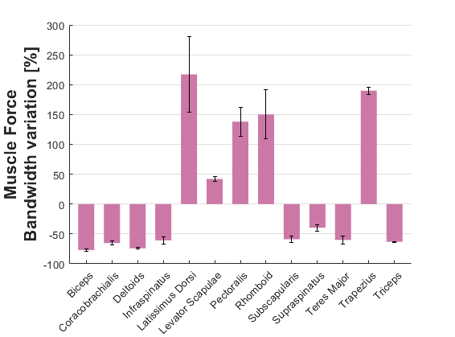
Figure 1. Mean and standard deviation across the three trials of each muscle group solution space variation between the Default simulation and the All EMGs simulation.

Results from all analysed trials
Glossary
Default: Myobolica simulation obtained without applying the muscle-specific gamma parameter and the EMG-based constraint.
MS gamma parameter: Myobolica simulation obtained by applying the muscle-specific gamma parameter but not the EMG-based constraint.
Delt. EMG: Myobolica simulation obtained by applying the muscle-specific gamma parameter and the EMG-based constraint with the deltoid muscle EMG data.
Bic. EMG: Myobolica simulation obtained by applying the muscle-specific gamma parameter and the EMG-based constraint with the biceps muscle EMG data.
Tric. EMG: Myobolica simulation obtained by applying the muscle-specific gamma parameter and the EMG-based constraint with the triceps muscle EMG data.
Trap. EMG: Myobolica simulation obtained by applying the muscle-specific gamma parameter and the EMG-based constraint with the trapezius muscle EMG data.
All EMGs: Myobolica simulation obtained by applying the muscle-specific gamma parameter and the EMG-based constraint with the deltoid, biceps, triceps and trapezius muscle EMG data.
Optimal solution: Solution obtained by using OpenSim tools (Static Optimization tool and Analyze tool).
Experimental data: Glenohumeral (GH) joint contact force measured with the instrumented shoulder prosthesis.

Glenohumeral joint contact force
Comparison of the glenohumeral (GH) joint contact force – normalised to the subject’s body weight – predicted with the distinct Myobolica simulations, the optimal solution, and the experimental data for the three trials (named trial 1, trial 2, and trial 3). The R² and RMSE between the experimental data and the median solution of each Myobolica bandwidth are reported.

Trial 1
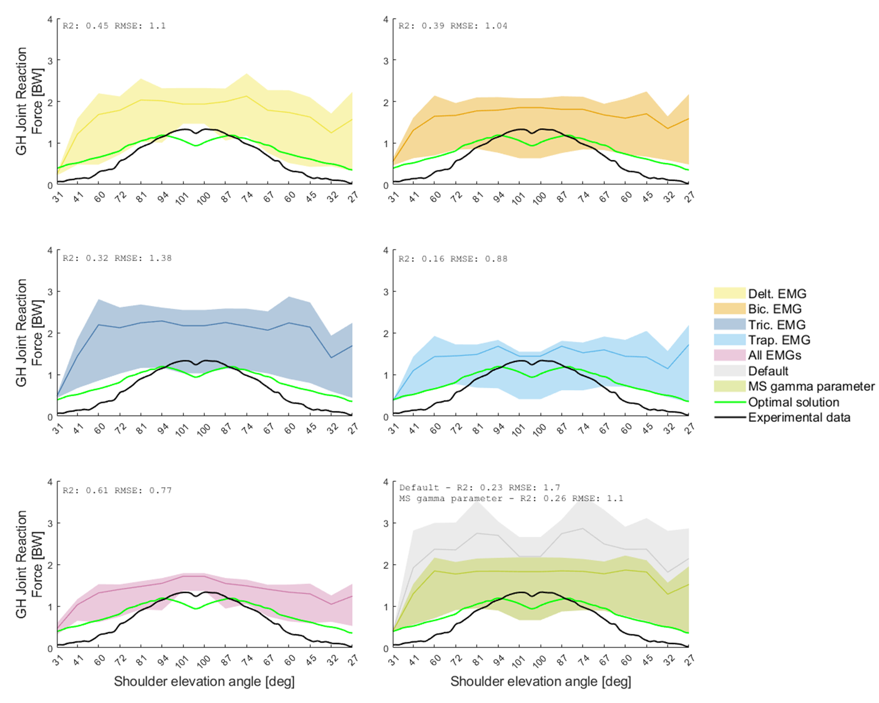

Trial 2
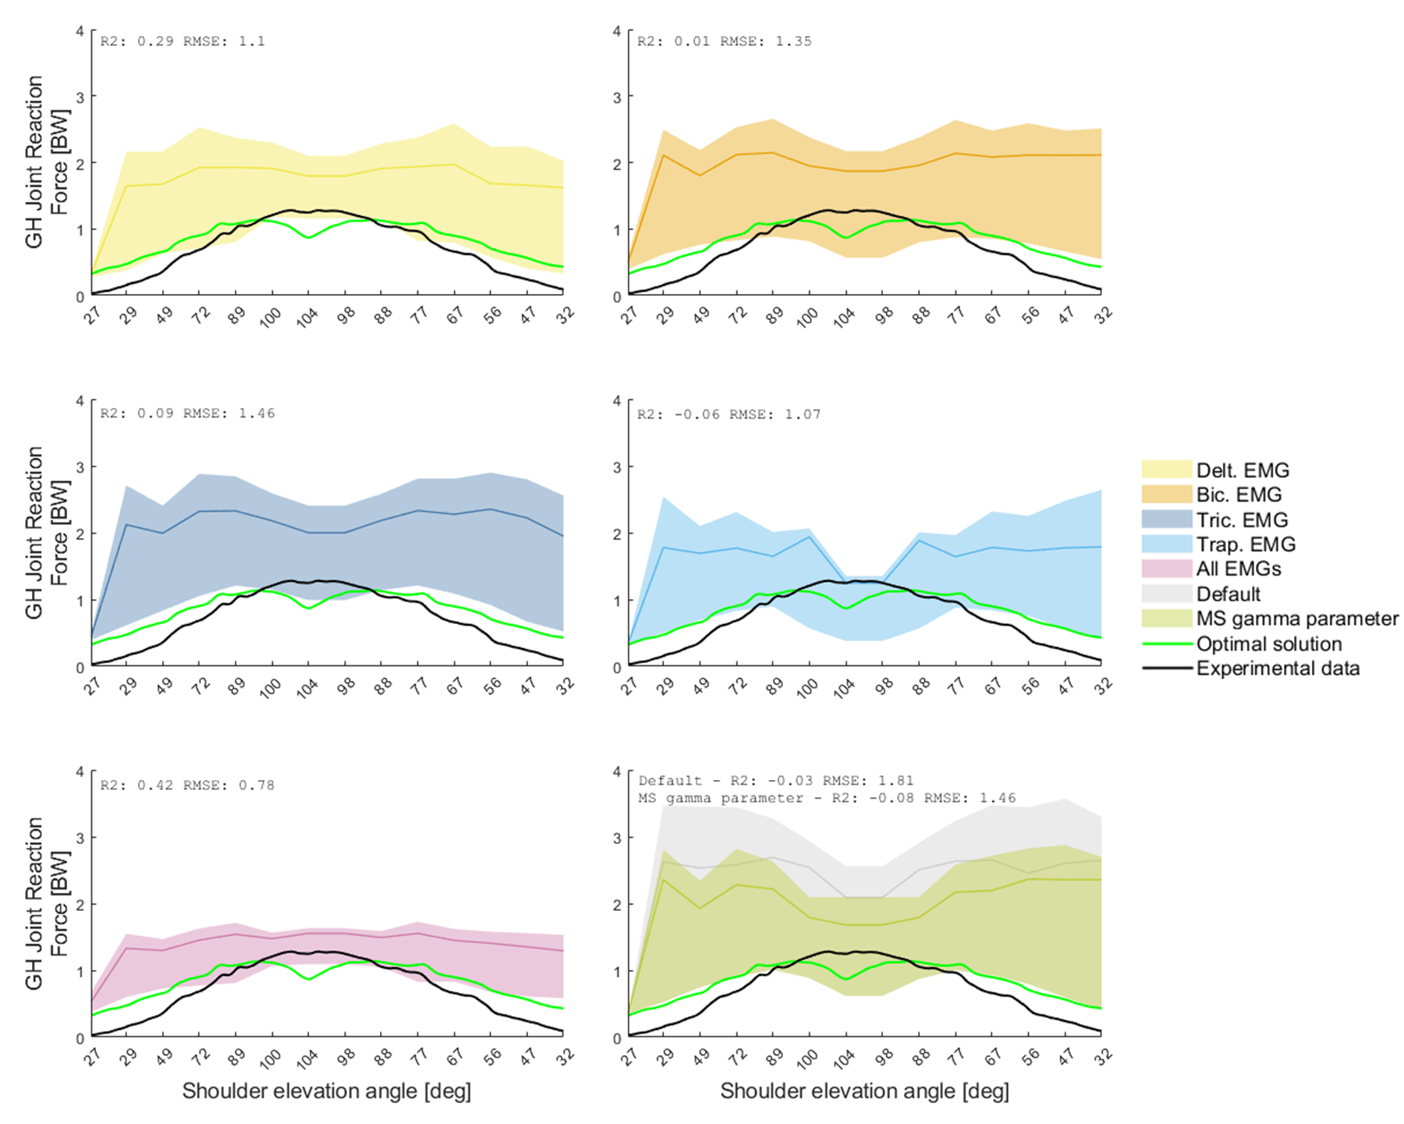

Trial 3
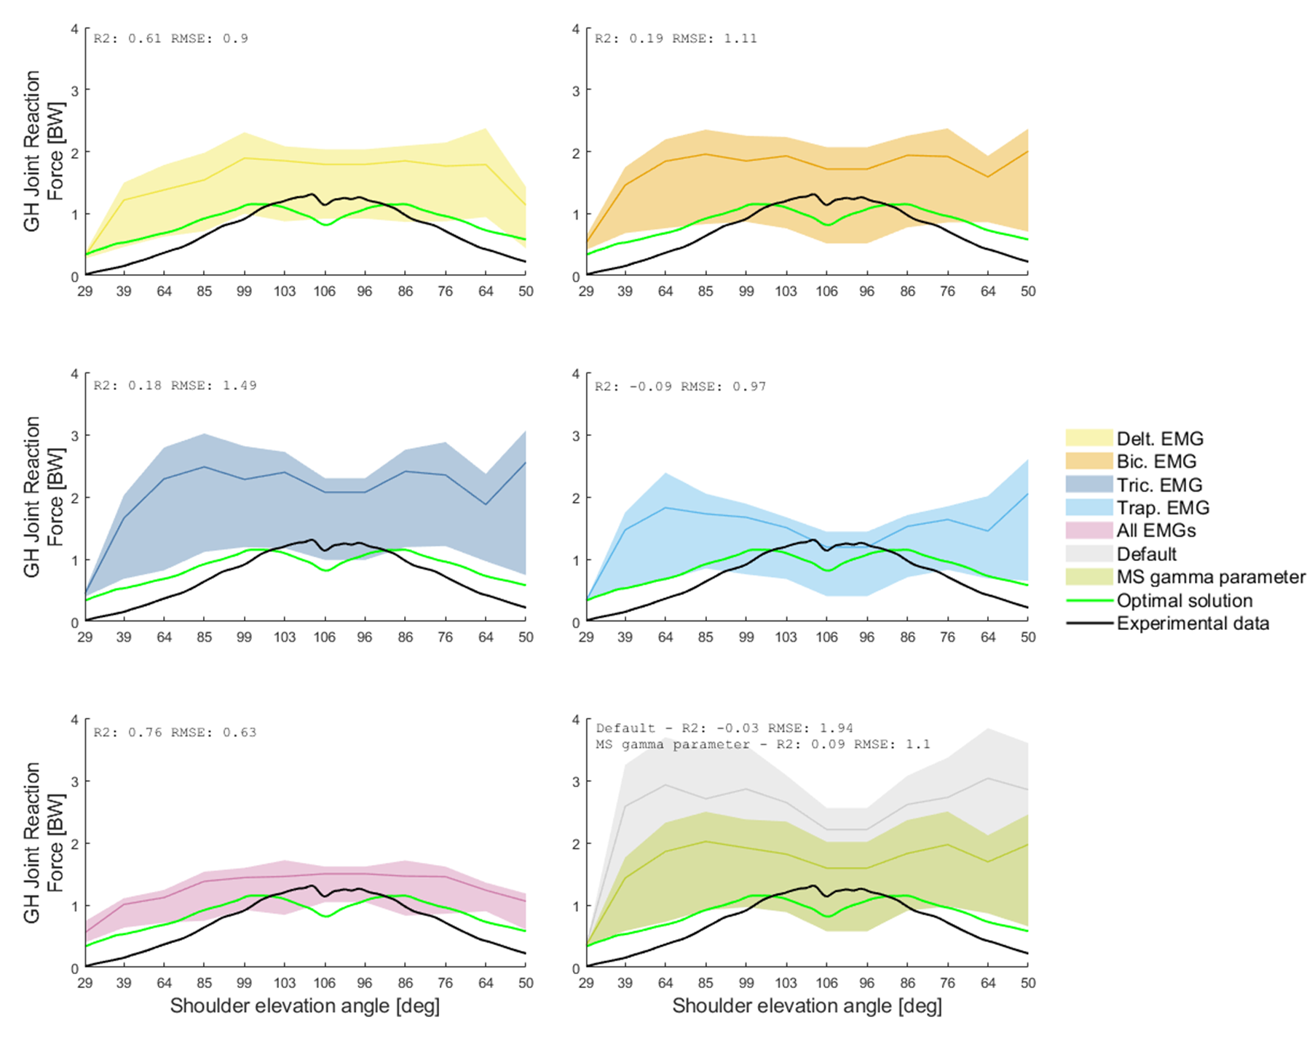

Table 2. R² and RMSE between Myobolica median solutions and the optimal solution estimated with OpenSim for the GH joint contact force of the three trials. In the last row, the R² and RMSE values between the experimental data and the optimal solution are shown.
Simulation | R² |  |  | RMSE [BW]
 | Trial 1 | Trial 2 | Trial 3 | Trial 1 | Trial 2 | Trial 3
Default | 0.44 | 0.91 | 0.15 | 2.31 | 2.43 | 2.57
MS gamma parameter | 0.39 | -0.05 | 0.34 | 1.68 | 2.03 | 1.72
Delt. EMG | 0.59 | 0.45 | 0.74 | 1.72 | 1.74 | 1.59
Bic. EMG | 0.47 | 0.11 | 0.41 | 1.63 | 1.96 | 1.75
Tric. EMG | 0.48 | 0.25 | 0.39 | 1.99 | 2.1 | 2.14
Trap. EMG | 0.26 | 0.05 | 0.03 | 1.43 | 1.64 | 1.52
All EMGs | 0.61 | 0.50 | 0.81 | 1.37 | 1.40 | 1.29
Experimental data | 0.88 | 0.86 | 0.76 | 0.78 | 0.80 | 0.78

Muscle force solution spaces
Comparison of muscle force solution spaces for ten muscles of interest predicted with the distinct Myobolica simulations, the optimal solution, and the normalised EMG for the three trials (named trial 1, trial 2, and trial 3). The chosen muscles are biceps short head, deltoid clavicularis, deltoid scapularis, subscapularis, supraspinatus, trapezius clavicularis, trapezius scapularis, triceps long head. The term “head (number)” stands for the selected muscle actuator chosen among the actuators modelling the single muscle.

Trial 1
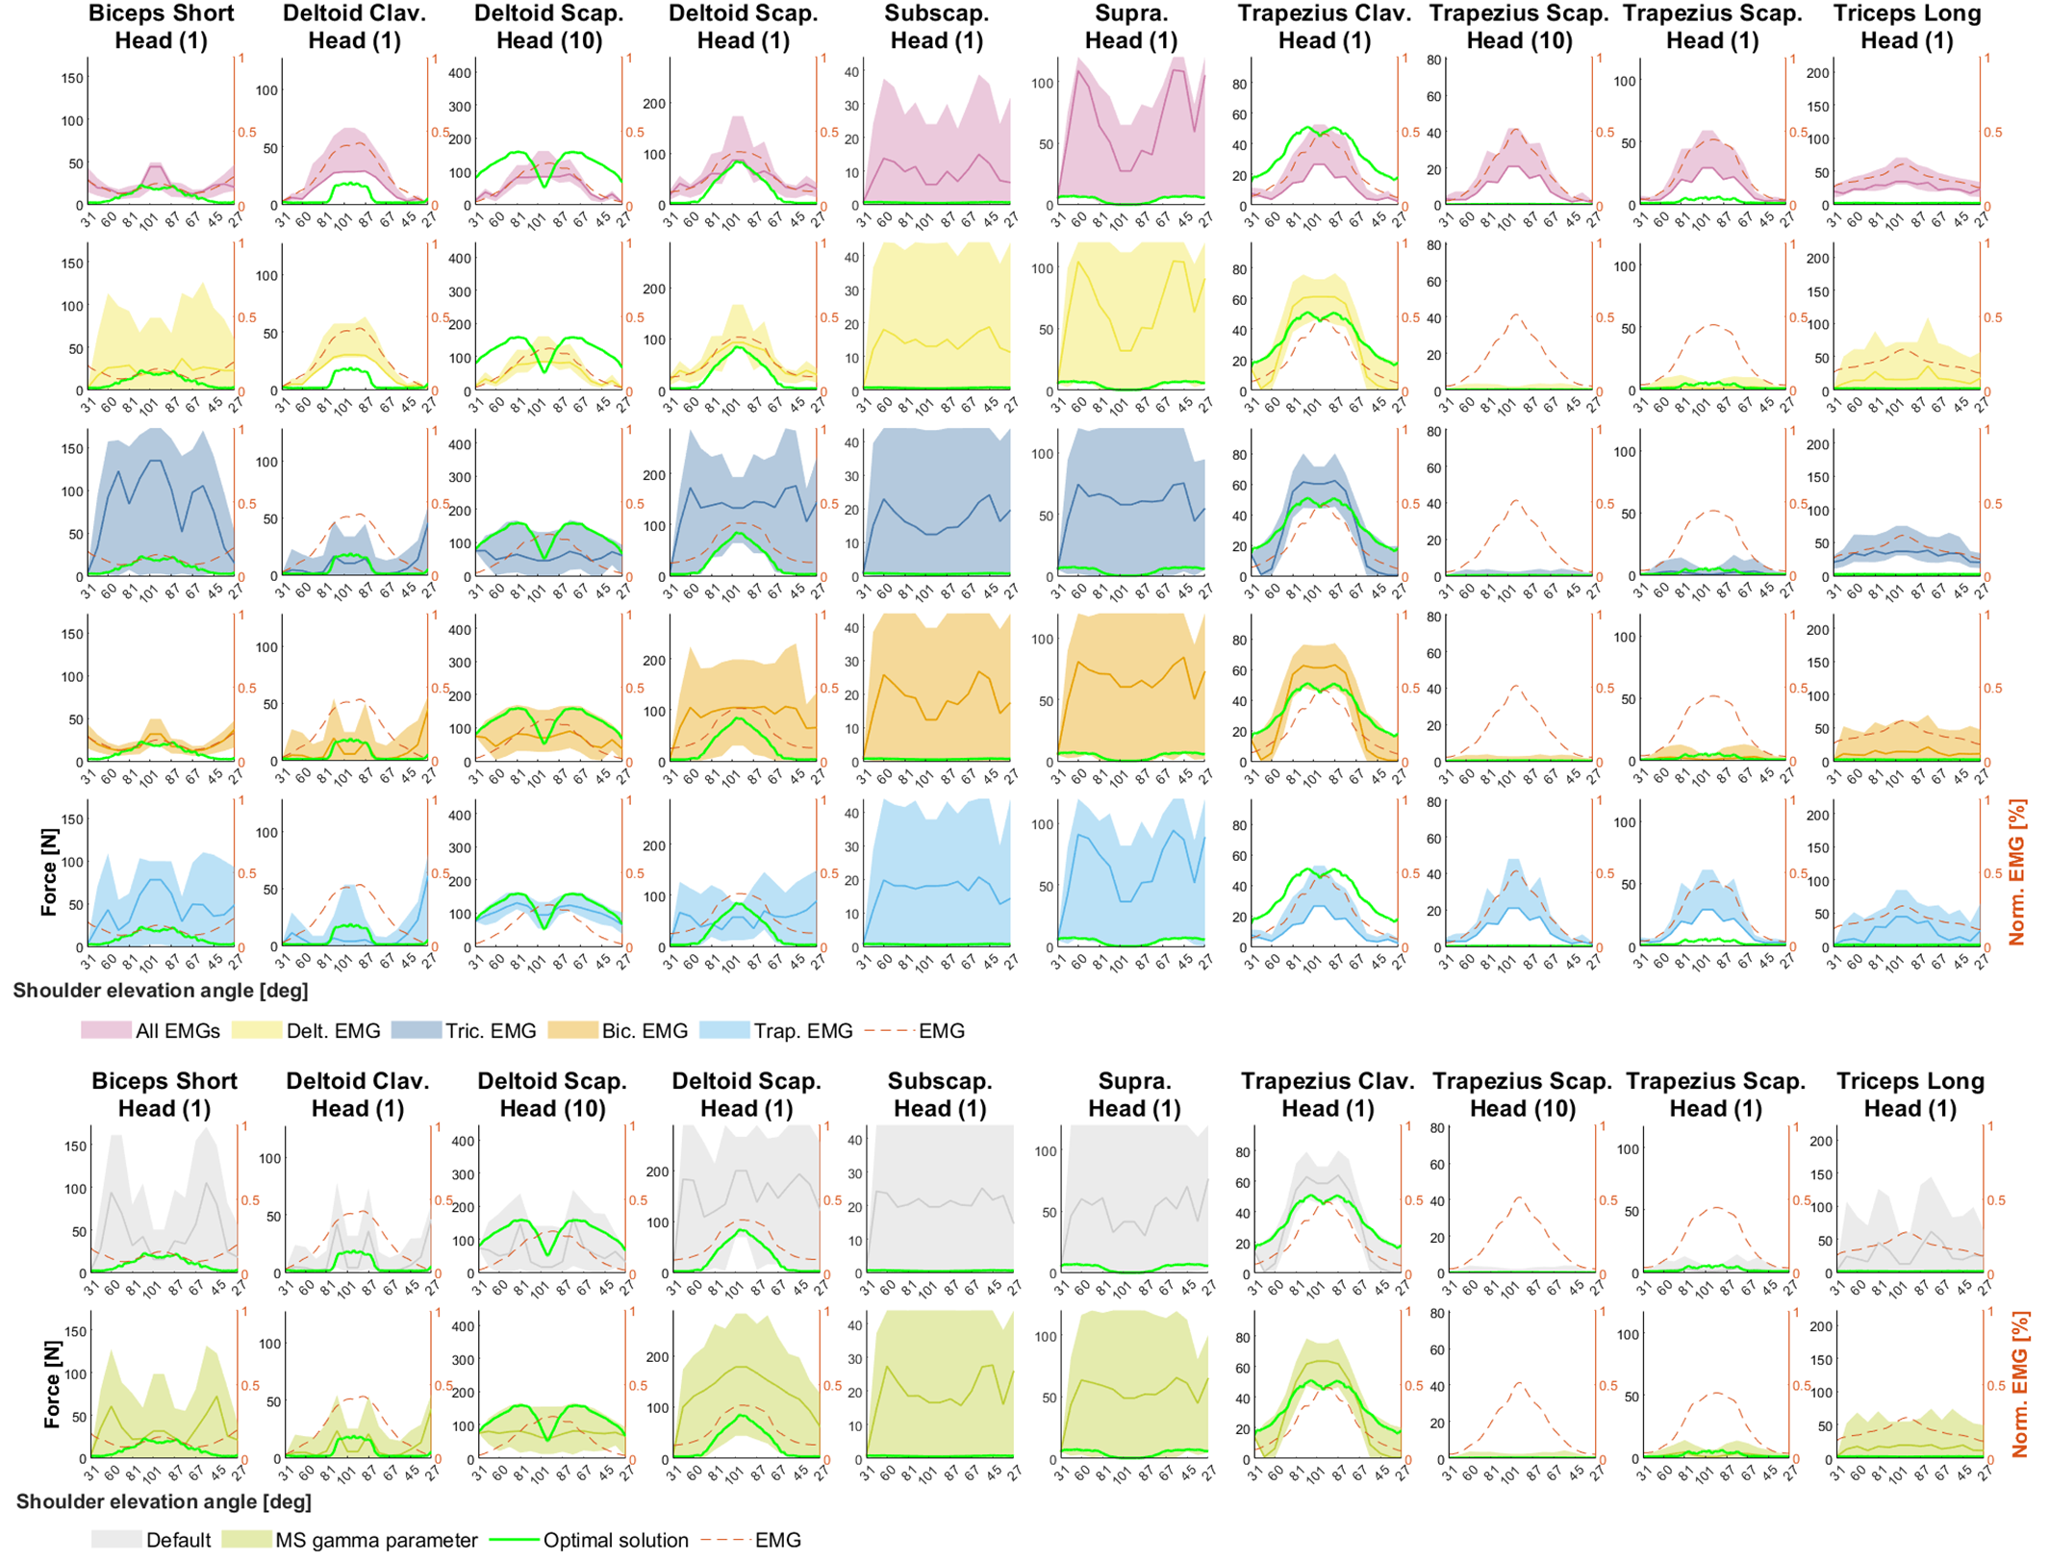

Trial 2
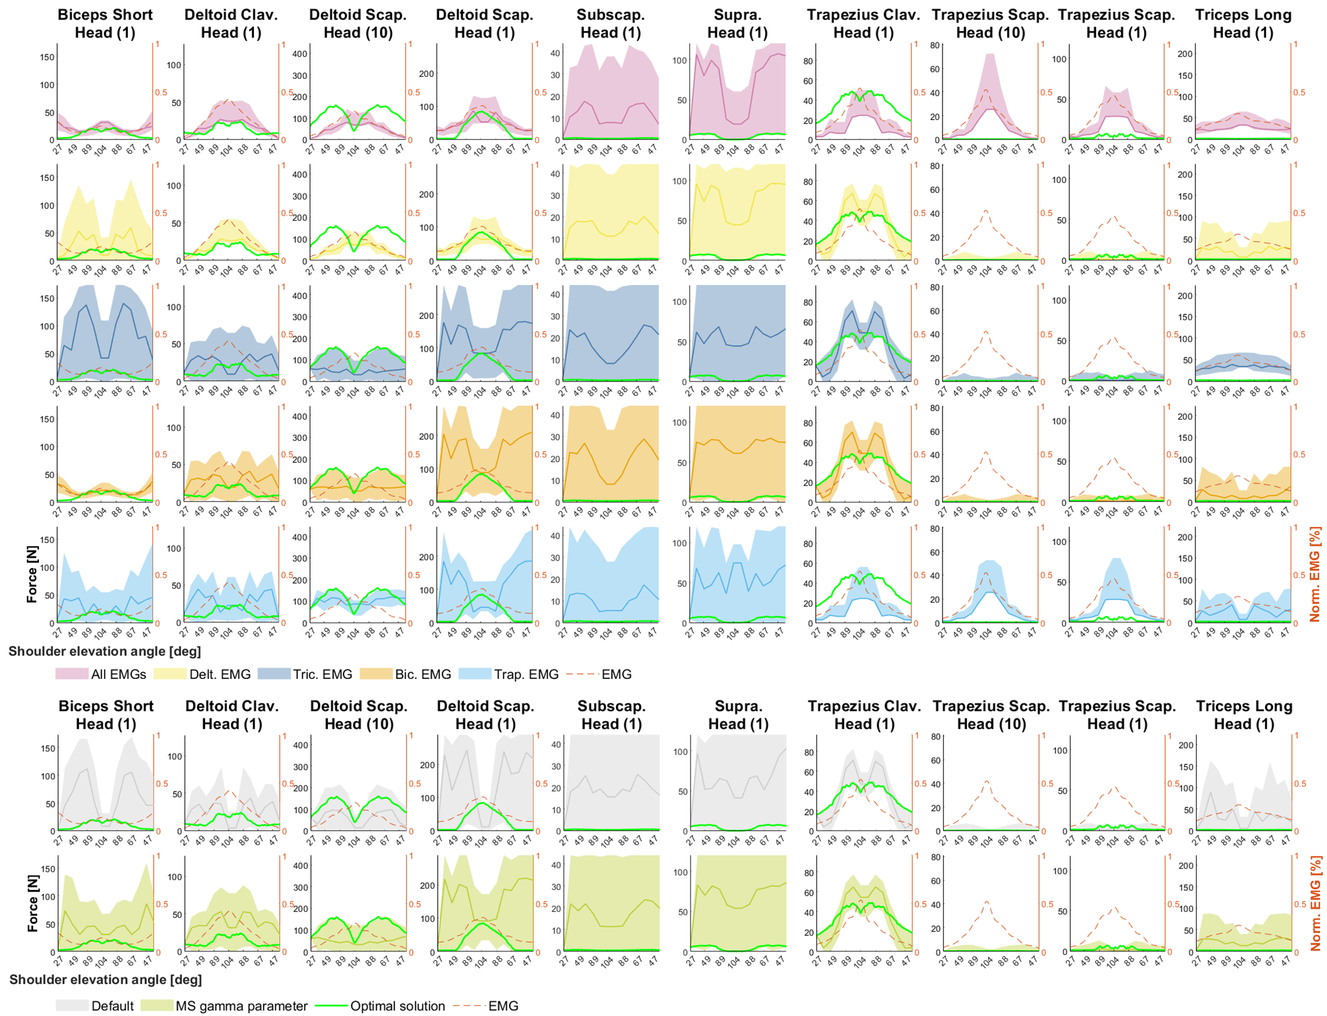

Trial 3
