Appendix S3

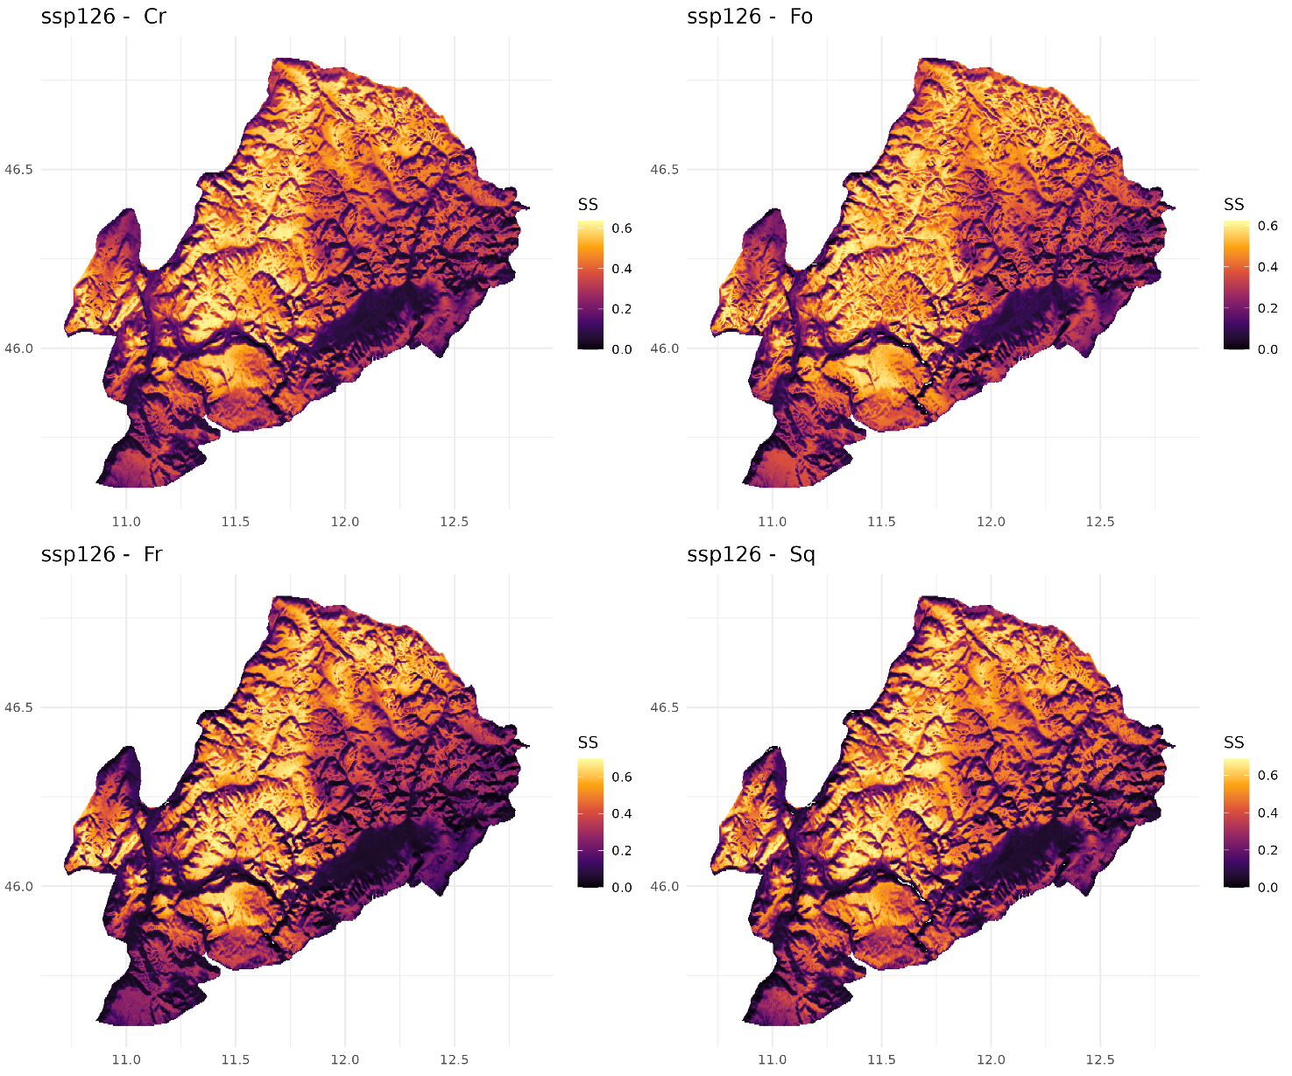
Fig. S3-1. Maps of predicted climatic refugia for the AOA in the mitigation scenario, illustrate as the areas where the greatest sum of "high suitability score stability" index (scaled 0 to 1) for the species aggregated by growth form. Areas outside the AOA are shown in white.

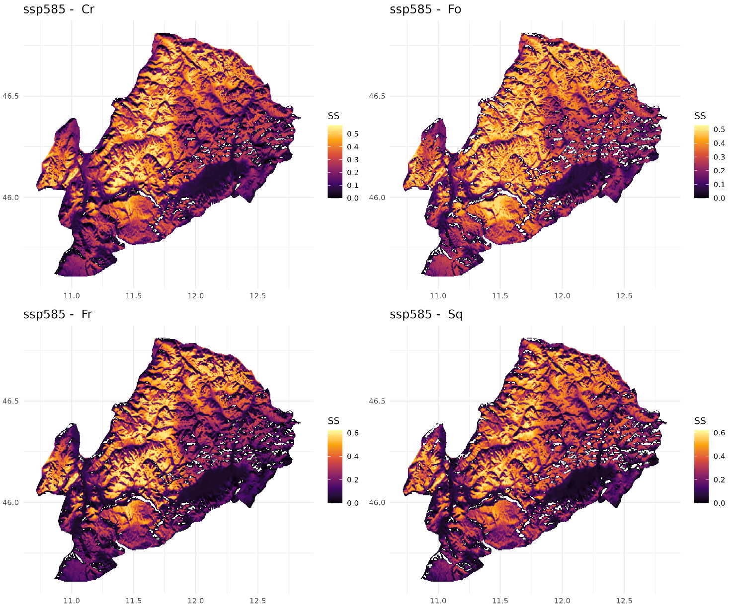
Fig. S3-2. Maps of predicted climatic refugia for the AOA in the high-emission scenario, illustrate as the areas where greatest sum of "high suitability score stability" index (scaled 0 to 1) for the species aggregated by growth form. Areas outside the AOA are shown in white.

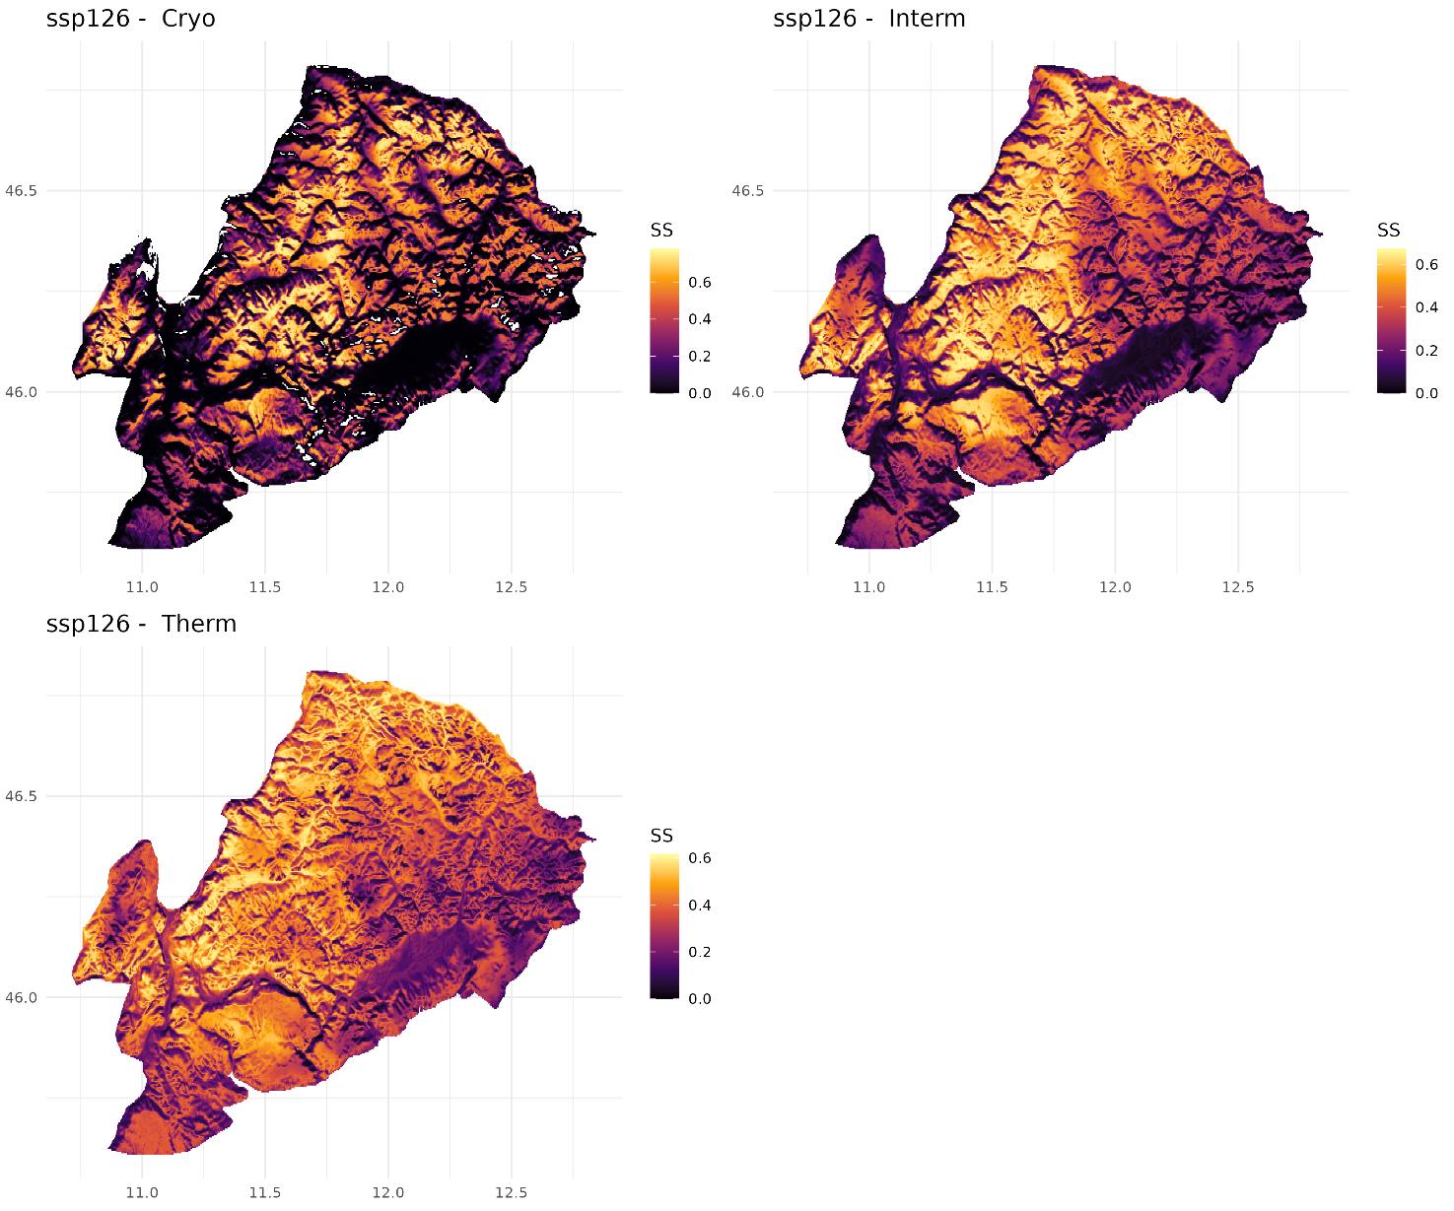Fig. S3-3. Maps of predicted climatic refugia for the AOA in the mitigation scenario, illustrate as the areas where greatest sum of "high suitability score stability" index (scaled 0 to 1) for the species aggregated by temperature affinity. Areas outside the AOA are shown in white.

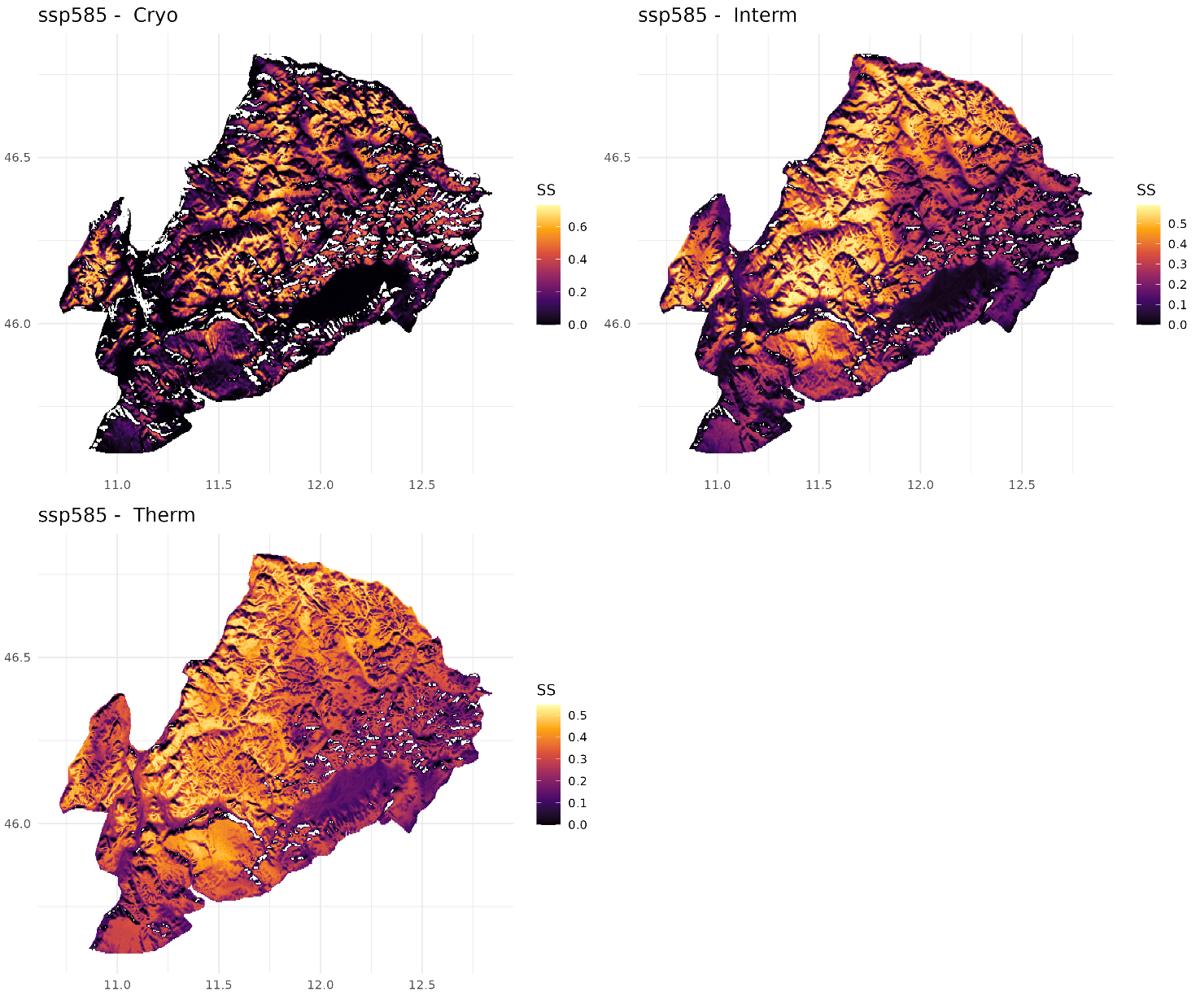
Fig. S3-4. Maps of predicted climatic refugia for the AOA in the high-emission scenario, illustrate as the areas where greatest sum of "high suitability score stability" index (scaled 0 to 1) for the species aggregated by temperature affinity. Areas outside the AOA are shown in white.

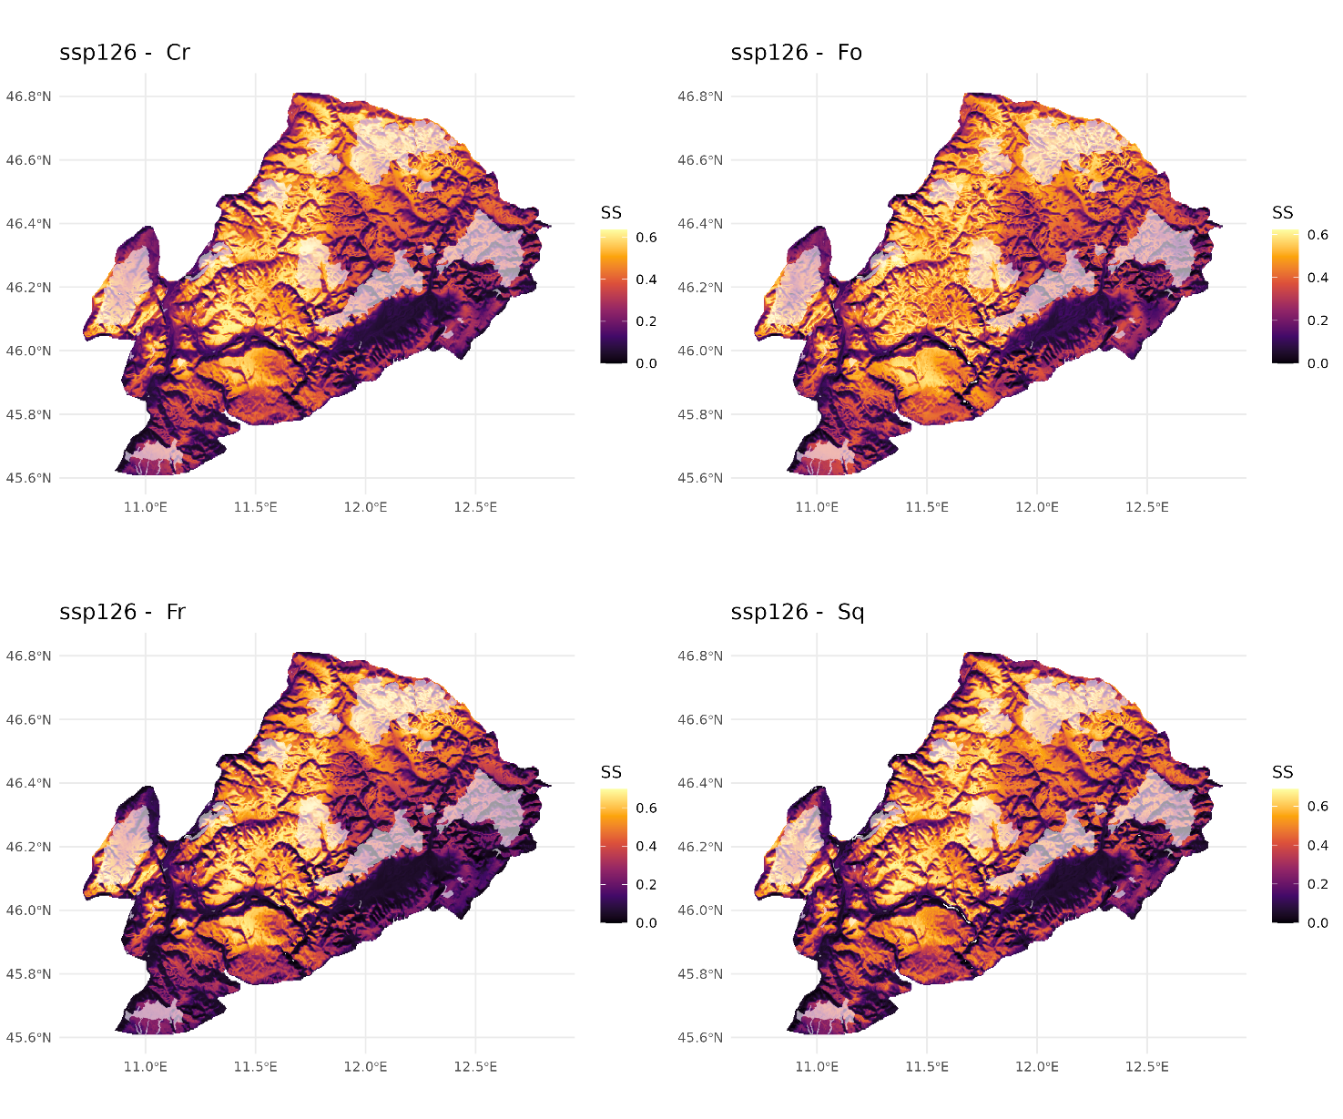
Fig. S3-5. Maps of predicted climatic refugia for the AOA in the mitigation scenario, illustrate as the areas where the greatest sum of "high suitability score stability" index (scaled 0 to 1) for the species aggregated by growth form. Areas outside the AOA are shown in white. Semi-transparent polygons represent protected areas in the study area.

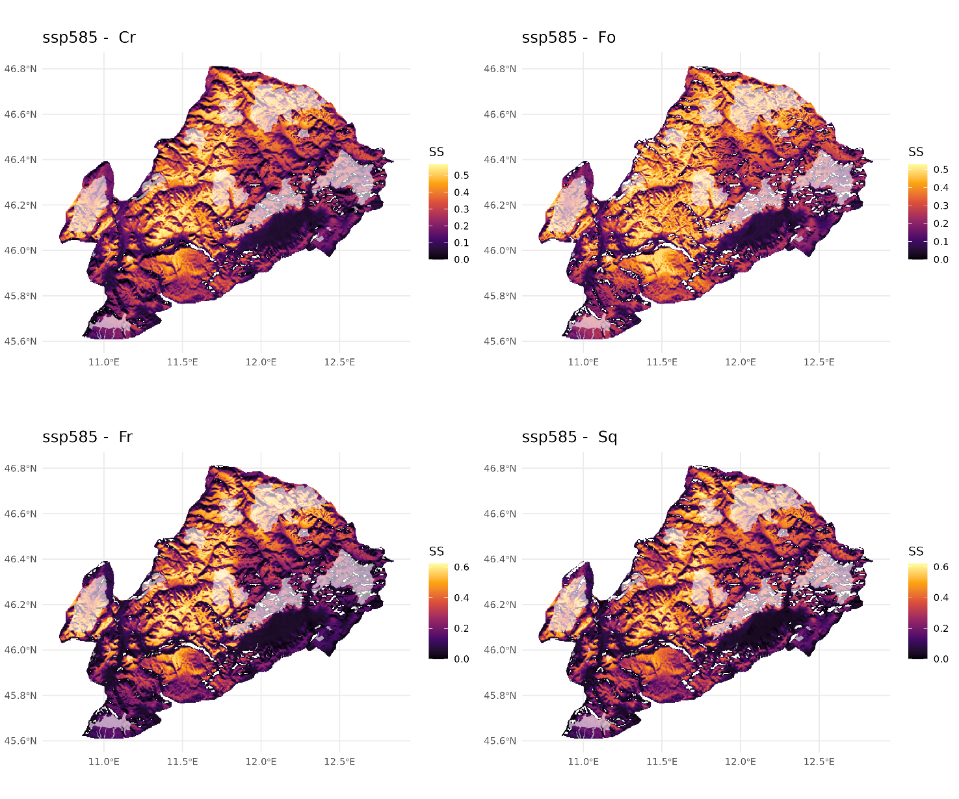
Fig. S3-6. Maps of predicted climatic refugia for the AOA in the high-emission scenario, illustrate as the areas where greatest sum of "high suitability score stability" index (scaled 0 to 1) for the species aggregated by growth form. Areas outside the AOA are shown in white. Semi-transparent polygons represent protected areas in the study area.

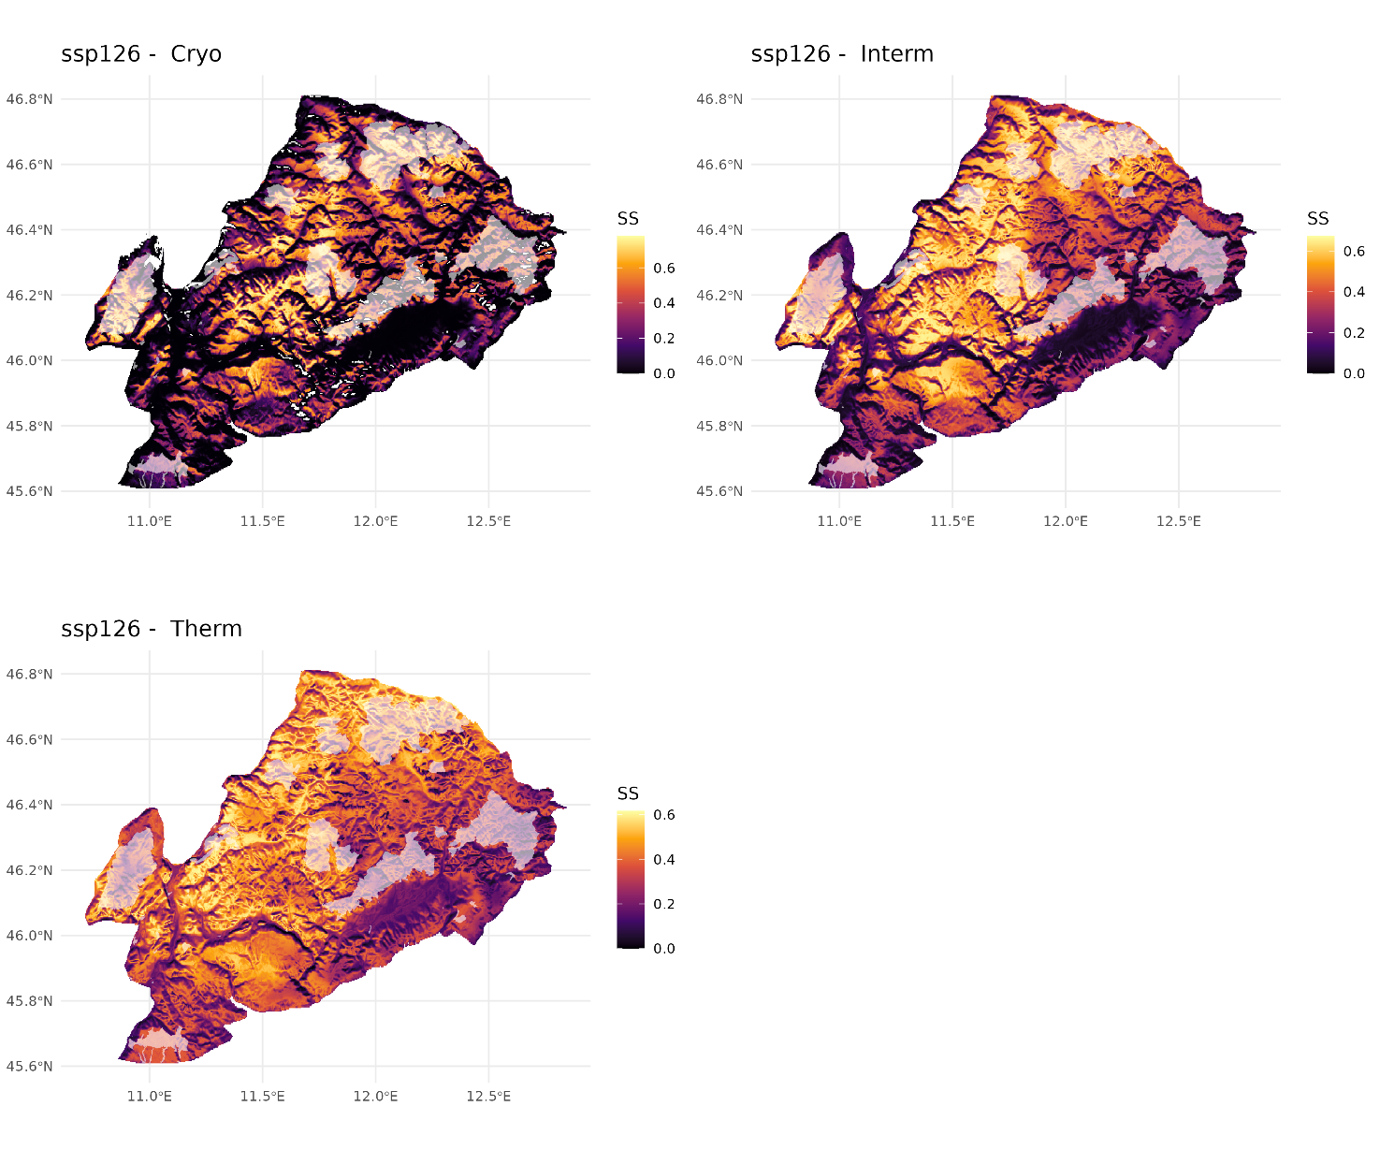Fig. S3-7. Maps of predicted climatic refugia for the AOA in the mitigation scenario, illustrate as the areas where greatest sum of "high suitability score stability" index (scaled 0 to 1) for the species aggregated by temperature affinity. Areas outside the AOA are shown in white. Semi-transparent polygons represent protected areas in the study area.

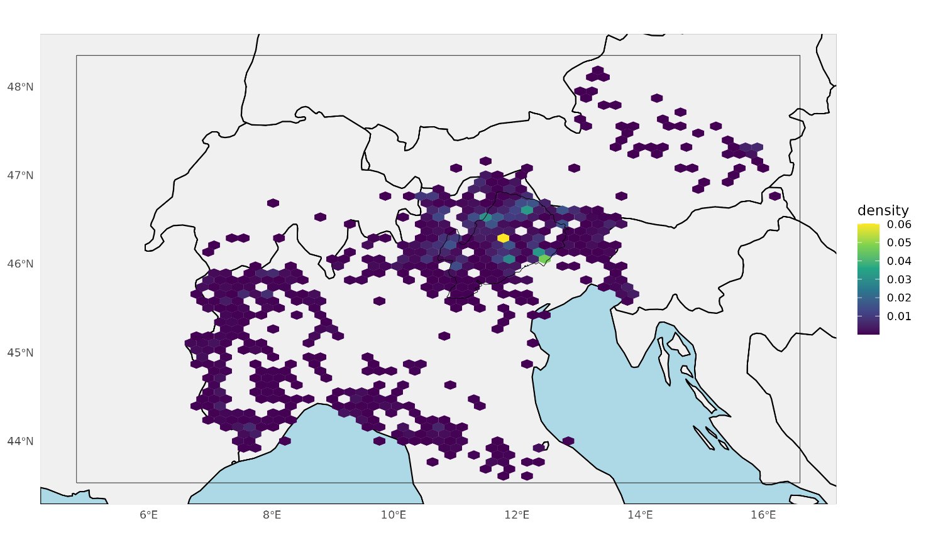
Fig. S3-8. Heatmap of all the occurrences in the calibration area.

