Supplementary Information:
Effect of gamma irradiation on chemico/physical properties and enzymatic hydrolysis of poly(butylene 2,5-furanoate) based films

Bettina Semler¹*, Felice Quartinello¹, Alessandro Coatti², Michelina Soccio², Maddalena Negrin³, Elena Macerata^{3,4}, Mario Mariani^{3,4}, Andrea Soldini⁵, Ignacio Solaberrieta⁶, María Carmen Garrigós⁶, Debora Puglia⁷, Sara Filippi⁸, Patrizia Cinelli⁸, Alfonso Jiménez⁶, Nadia Lotti^{2,} Georg M. Guebitz¹

¹ BOKU-University, Institute of Environmental Biotechnology, Department of Agricultural Sciences, Konrad-Lorenz-Strasse 20, 3430 Tulln an der Donau, Austria.
² Department of Civil, Chemical, Environmental and Materials Engineering, University of Bologna, Via Terracini 28, Bologna, 40131, Italy.
³ Department of Energy, Politecnico di Milano, Piazza L. da Vinci 32, 20133 Milano, Italy
⁴ National Interuniversity Consortium of Materials Science and Technology, via G. Giusti 9, 50121 Firenze, Italy
⁵ Gammatom Srl, via XXIV Maggio 14, 22070 Guanzate, Italy
⁶ Department of Analytical Chemistry, Nutrition & Food Sciences, University of Alicante, San Vicente del Raspeig, ES-03690, Spain.
⁷ Department of Civil and Environmental Engineering, Università degli Studi di Perugia, Strada di Pentima 4, 05100, Terni, Italy
⁸University of Pisa, Department of Civil and Industrial Engineering, Largo Lucio Lazzarino 1, 56122, Pisa, Italy

*Correspondence to Bettina Semler (bettina.semler@boku.ac.at)

Number of pages: 5
Number of figures: 6
Number of tables: 1

Table S1. Number-average molecular weights (Mn), Weight-average molecular weights (Mw), dispersity (Ð), and tensile test results as a function of irradiation dose.
 | GPC |  |  | WCA | Tensile test
PBF sample: | M_{n} (g/mol) | M_{w} (g/mol) | D | (°) | E. Modulus (MPa) | σ_{b} (MPa) | ε_{b} (%)
Neat | 52570 | 105800 | 2.01 | 79 ± 3 | 1503 ± 104 | 55 ± 17 | 414 ± 80
10 kGy cold spot | 53380 | 106810 | 2.00 | 81 ± 2 | 1514 ± 165 | 61 ± 8 | 461 ± 57
25 kGy hot spot | 48650 | 98970 | 2.03 | 79 ± 2 | 1440 ± 50 | 58 ± 2 | 369 ± 10
25 kGy cold spot | 48980 | 98810 | 2.02 | 79 ± 3 | 1671 ± 68 | 57 ± 3 | 456 ± 31
50 kGy cold spot | 45850 | 93170 | 2.03 | 78 ± 3 | 1573 ± 155 | 58 ± 5 | 432 ± 40
75 kGy cold spot | 44150 | 88100 | 2.00 | 81 ± 2 | 1449 ± 67 | 58 ± 9 | 395 ± 23
100 kGy cold spot | 42490 | 84370 | 1.99 | 82 ± 3 | 1447 ± 84 | 62 ± 8 | 420 ± 48
200 kGy cold spot | 38010 | 70270 | 1.85 | 75 ± 2 | 2200 ± 74 | 43 ± 9 | 190 ± 146
300 kGy cold spot | 24060 | 34700 | 1.44 | 73 ± 2 | 2676 ± 53 | 67 ± 1 | 3.03 ± 0.08

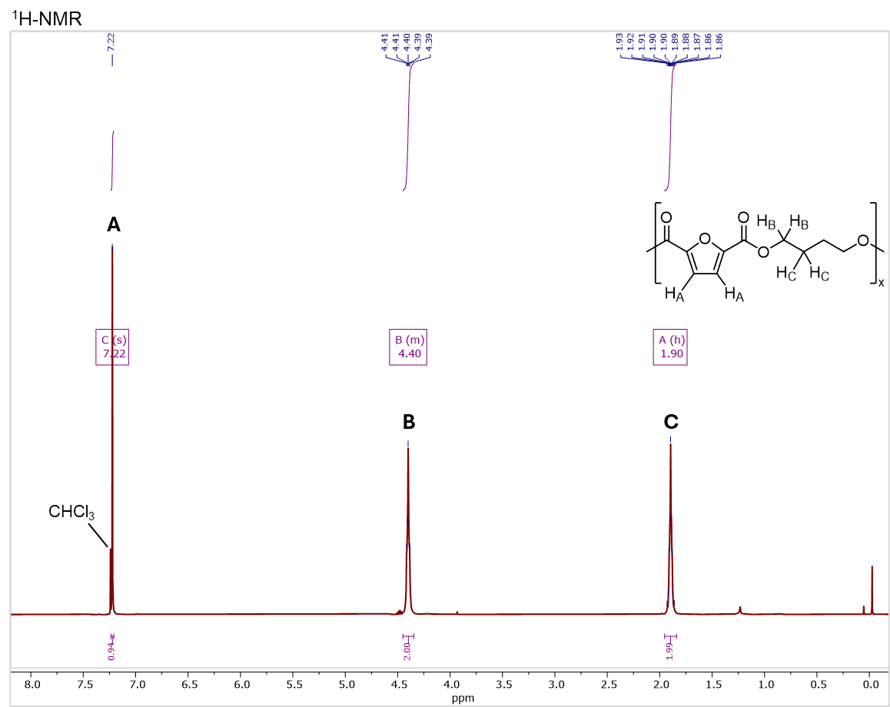
Figure S1. ¹H-NMR spectrum of PBF with peak assignment

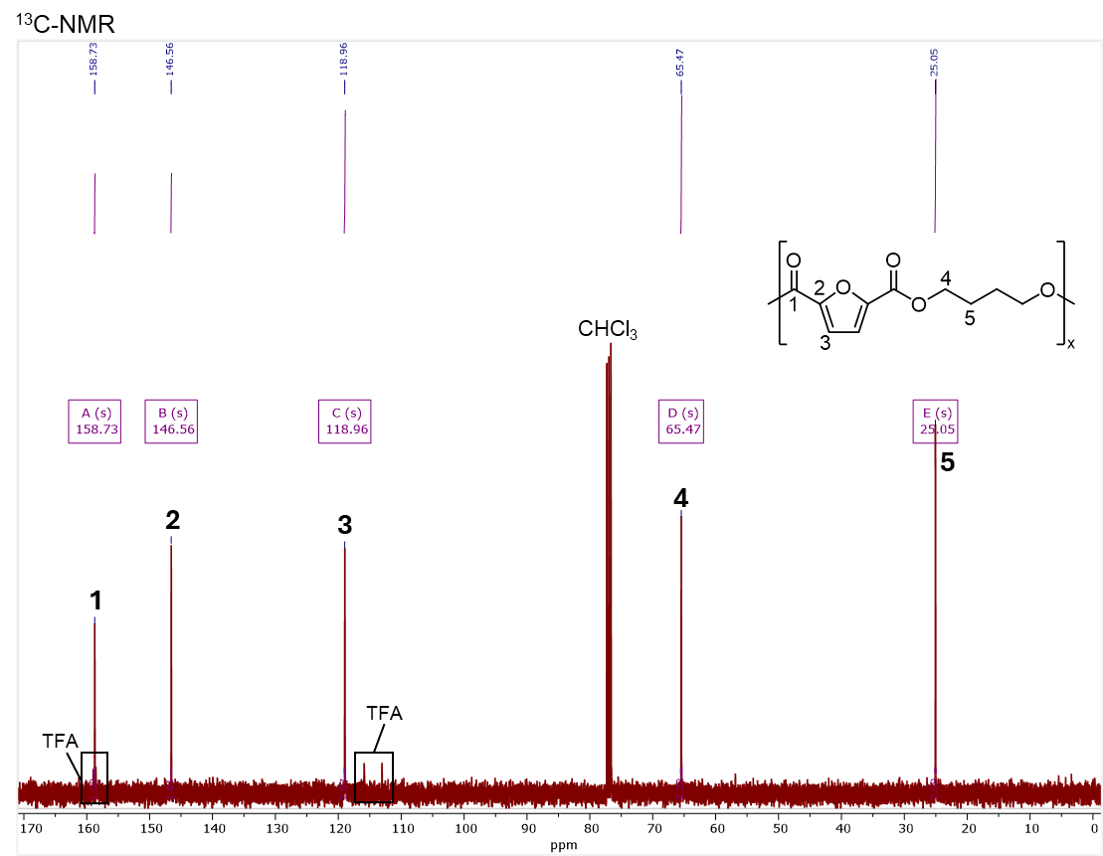
Figure S2. ¹³C-NMR spectrum of PBF with peak assignment.
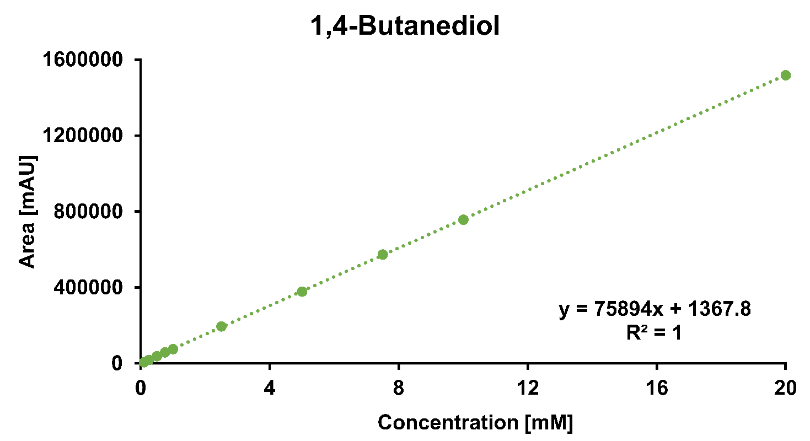
Figure S3. Calibration curve for 1,4-Butanediol concentration determination.

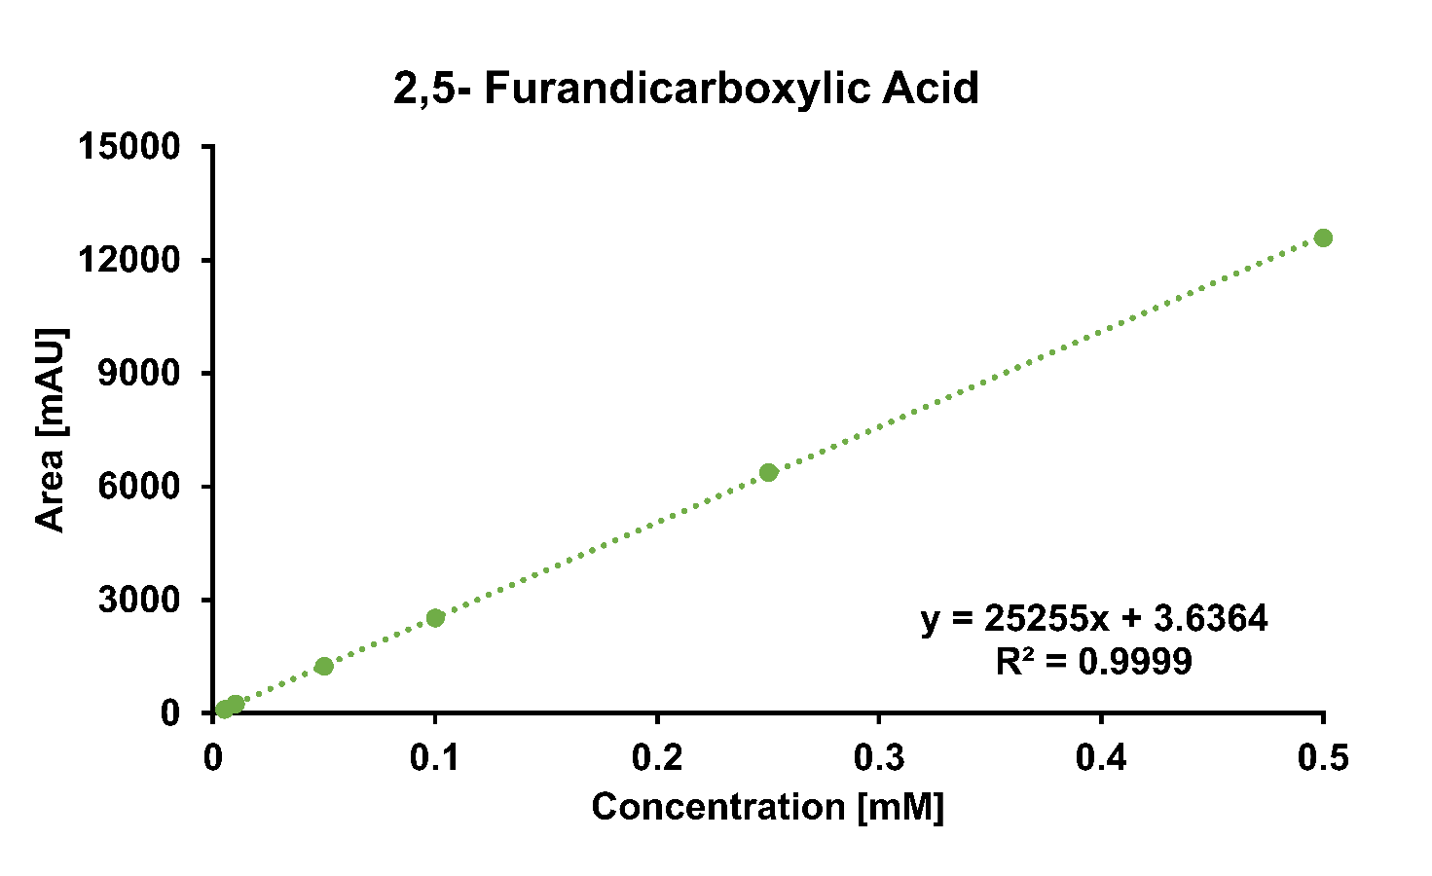
Figure S4. Calibration curve for 2,5-Furandicarboxylic Acid (FDCA) concentration determination.

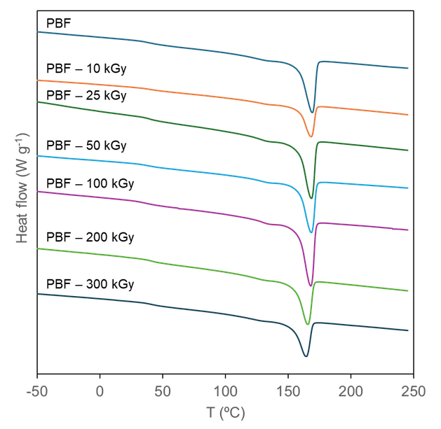
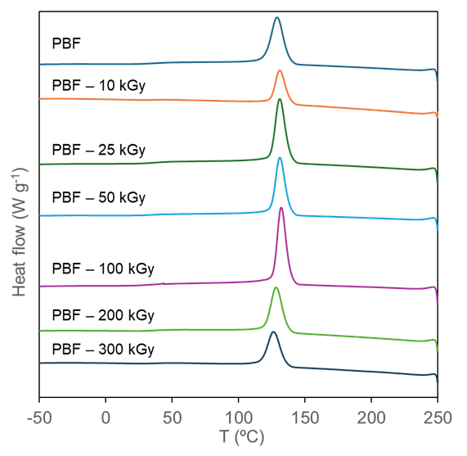
A.
B.

Figure S5. DSC thermograms A. second heating and B. cooling. Exo up.

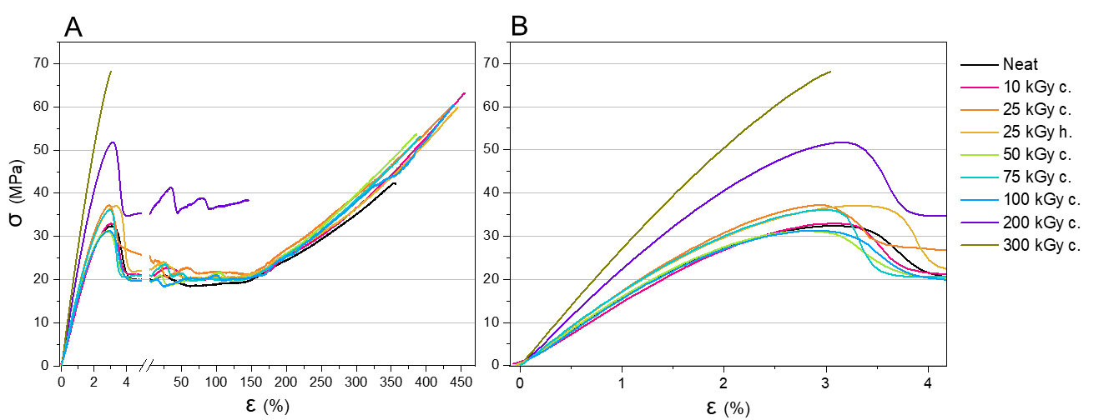
Figure S6. Stress–strain curves of the PBF samples at different irradiation doses (A), and a magnified view of the curves at low strain values (B).

