Supplementary Materials
Table a
Data sources, original format and pre-processing operations.
Data | Source | Original data format | Pre-processing operations
Freshwater sources | Kindly provided by ARPA Emilia-Romagna | Points | Reprojection, format conversion
Sea | Coastline shapefile | Lines | Reprojection, clipping
Brackish underground water sources | Water quality census of the Emilia-Romagna region | Points | Format conversion, selection by attribute, proximity analysis
Average annual temperature | Dext3r Emilia-Romagna | Points | Reprojection, interpolation
Elevation | https://tinitaly.pi.ingv.it/ | Points | Reprojection
Slope | Own elaboration starting from DEM data | Own elaboration | Computation starting from DEM
Electricity network | https://overpass-turbo.eu/ | Lines | Reprojection, format conversion, clipping, proximity analysis
Road network | Extraction from Emilia-Romagna land use map | Lines | Selection by attributes and format conversion, proximity analysis
Sewage network | https://geoportale.regione.emilia-romagna.it/ | Polygons | Reprojection, format conversion, proximity analysis
Fish hatcheries / fishfarms | https://overpass-turbo.eu/ | Polygons | Reprojection, format conversion, clipping
Gas network | https://overpass-turbo.eu/ | Lines | Reprojection, format conversion, clipping, proximity analysis
Plant nurseries | https://overpass-turbo.eu/ | Polygons | Reprojection, format conversion, clipping
Industrial activities | https://overpass-turbo.eu/ | Polygons | Reprojection, format conversion, clipping
Income | 2011 Italian census (last available) | Polygons | Format conversion
Proximity to settlements and urban areas | https://geoportale.regione.emilia-romagna.it/ | Polygons | Format conversion
Unemployment rate | 2011 Italian census (last available) | Polygons | Format conversion
Consumers (proxy: density of inhabitants) | 2011 Italian census (last available) | Polygons | Format conversion
Logistic platforms (harbour, etc.) | https://overpass-turbo.eu/ | Polygons | Reprojection, format conversion, clipping
Organic products consumers (percentage of people aged 25-40 and percentage of graduates) | 2011 Italian census (last available) | Polygons | Format conversion
Land use | CORINE landcover 2018 (last available) | Polygons | Format conversion

Table b
Reclassification for the majority of submodels.
Submodels | Class 8 | Class 7 | Class 6 | Class 5 | Class 4 | Class 3 | Class 2 | Class 1
Most appropriate elevation (metres) | 3 – 79.29 | 79.29 – 155.57 | 155.57 – 231.86 | 231.86 – 308.14 | 308.14 – 384.43 | 384.43 – 460.71 | 460.71 – 537 | 537 – Max
Most appropriate slope (percentage) | 0.1 – 1.24 | 1.24 – 2.39 | 2.39 – 3.53 | 3.53 – 4.67 | 4.67 – 5.81 | 5.81 – 6.96 | 6.96 – 8.1 | 8.1 – Max
Proximity to electricity network (metres) | 208 – 425 | 425 – 642 | 642 – 859 | 859 – 1076 | 1076 – 1293 | 1293 – 1510 | 1510 – 1727 | 1727 – Max
Proximity to road network (metres) | 6 – 238.71 | 238.71 – 471.43 | 471.43 – 704.14 | 704.14 – 936.86 | 936.86 – 1169.57 | 1169.57 – 1402.29 | 1402.29 – 1635 | 1635 – Max
Proximity to sewage network (metres) | 4.5 – 164.57 | 164.57 – 324.64 | 324.64 – 484.71 | 484.71 – 644.79 | 644.79 – 804.86 | 804.86 – 964.93 | 964.93 – 1125 | 1125 – Max
Proximity to fish hatcheries/fish farms | 1250 – 63471.43 | 63471.43 – 125692.86 | 125692.86 – 187914.29 | 187914.29 – 250135.71 | 250135.71 – 312357.14 | 312357.14 – 374578.57 | 374578.57 – 436800 | 436800 – Max
Proximity to gas network (metres) | 20 – 166.43 | 166.43 – 312.86 | 312.86 – 459.29 | 459.29 – 605.71 | 605.71 – 752.14 | 752.14 – 898.57 | 898.57 – 1045 | 1045 – Max
Proximity to plant nurseries (metres) | 107 – 25507.86 | 25507.86 – 50908.71 | 50908.71 – 76309.57 | 76309.57 – 101710.43 | 101710.43 – 127111.29 | 127111.29 – 152512.14 | 152512.14 – 177913 | 177913 – Max
Proximity to industrial activities (metres) | 124 – 15041.29 | 15041.29 – 29958.57 | 29958.57 – 44875.86 | 44875.86 – 59793.14 | 59793.14 – 74710.43 | 74710.43 – 89627.71 | 89627.71 – 104545 | 104545 – Max
Average income | 12360 – 14289 | 14289 – 16218 | 16218 – 18147 | 18147 – 20076 | 20076 – 22005 | 22005 – 23934 | 23934 – 25863 | 25863 – Max
Proximity to settlements and urban areas (metres) | 1555 – 4275.71 | 4275.71 – 6996.43 | 6996.43 – 9717.14 | 9717.14 – 12437.86 | 12437.86 – 15158.57 | 15158.57 – 17879.29 | 17879.29 – 20600 | 20600 – Max
Unemployment rate (percentage) | 0 – 2.25 | 2.25 – 4.5 | 4.5 – 6.75 | 6.75 – 9 | 9 – 11.25 | 11.25 – 13.5 | 13.5 – 15.75 | 15.75 – Max
Potential consumers (population density, inhabitants/km²) | 3675 – 3175.43 | 3175.43 – 2675.86 | 2675.86 - 2176.29 | 2176.29 - 1676.71 | 1676.71 - 1177.14 | 1177.14 - 677.57 | 677.57 - 178 | 178 - Max
Proximity to logistic platforms (metres) | 720 - 5731.43 | 5731.43 - 10742.86 | 10742.86 - 15754.29 | 15754.29 - 20765.71 | 20765.71 - 25777.14 | 25777.14 - 30788.57 | 30788.57 - 35800 | 35800 - Max
Organic products consumers (proxy: age groups 25-40; percentage) | 87.5 - 100 | 75 - 87.5 | 62.5 - 75 | 50 - 62.5 | 37.5 - 50 | 25 - 37.5 | 12.5 - 25 | 0 - 12.5
Organic products consumers (proxy: inhabitants with a degree; percentage) | 87.5 – 100 | 75 – 87.5 | 62.5 – 75 | 50 – 62.5 | 37.5 – 50 | 25 – 37.5 | 12.5 – 25 | 0 – 12.5

Table c
Reclassification of CORINE land cover.
CORINE land use | Relative importance | Normalised values | Reclassification
Road and rail networks and associated land | 0.078534 | 1 | 8
Industrial or commercial units | 0.07199 | 0.916667 | 7
Salines | 0.070681 | 0.9 | 7
Salt marshes | 0.069372 | 0.883333 | 7
Continuous urban fabric | 0.068063 | 0.866667 | 6
Port areas | 0.068063 | 0.866667 | 6
Non-irrigated arable land | 0.065445 | 0.833333 | 6
Discontinuous urban fabric | 0.062827 | 0.8 | 6
Dump sites | 0.062827 | 0.8 | 6
Construction sites | 0.060209 | 0.766667 | 6
Land principally occupied by agriculture, with significant areas of natural vegetation | 0.058901 | 0.75 | 6
Annual crops associated with permanent crops | 0.056283 | 0.716667 | 5
Rice fields | 0.053665 | 0.683333 | 5
Complex cultivation patterns | 0.053665 | 0.683333 | 5
Permanently irrigated land | 0.049738 | 0.633333 | 5
Pastures | 0.049738 | 0.633333 | 5

Table d
Organic products consumers
 | 0 (constraints) | 1 | 2 | 3 | 4 | 5 | 6 | 7 | 8
0% | 4561188 | 0 | 0 | 2007 | 51479 | 559595 | 1769441 | 2031432 | 2626
1% | 4561188 | 0 | 0 | 2019 | 54092 | 577944 | 1839343 | 1941601 | 1581
2% | 4561188 | 0 | 0 | 2058 | 57123 | 597818 | 1914017 | 1844454 | 1110
3% | 4561188 | 0 | 0 | 2083 | 60088 | 619632 | 1992043 | 1741923 | 811
4% | 4561188 | 0 | 1 | 2109 | 63409 | 641212 | 2074522 | 1634665 | 662
5% | 4561188 | 0 | 1 | 2147 | 67059 | 663521 | 2157474 | 1525867 | 511
6% | 4561188 | 0 | 1 | 2192 | 70901 | 686440 | 2239316 | 1417302 | 428
7% | 4561188 | 0 | 1 | 2218 | 75572 | 710155 | 2322082 | 1306185 | 367
8% | 4561188 | 0 | 1 | 2273 | 80984 | 733852 | 2402927 | 1196212 | 331
9% | 4561188 | 0 | 1 | 2338 | 86505 | 758776 | 2480348 | 1088344 | 268
10% | 4561188 | 0 | 1 | 2402 | 92099 | 785907 | 2550289 | 985673 | 209
11% | 4561188 | 0 | 1 | 2475 | 98607 | 812734 | 2613877 | 888727 | 159
12% | 4561188 | 0 | 1 | 2520 | 105243 | 841465 | 2668829 | 798380 | 142
13% | 4561188 | 0 | 2 | 2598 | 112267 | 873328 | 2711415 | 716834 | 136
14% | 4561188 | 0 | 2 | 2677 | 120551 | 904715 | 2746153 | 642341 | 141
15% | 4561188 | 0 | 2 | 2821 | 129089 | 940697 | 2769167 | 574659 | 145
16% | 4561188 | 0 | 4 | 2938 | 137620 | 978049 | 2782695 | 515126 | 148
17% | 4561188 | 0 | 6 | 3084 | 146492 | 1017400 | 2784660 | 464790 | 148
18% | 4561188 | 0 | 6 | 3360 | 155084 | 1061841 | 2774809 | 421330 | 150
19% | 4561188 | 0 | 8 | 3600 | 165082 | 1109560 | 2756480 | 381701 | 149
20% | 4561188 | 0 | 10 | 3908 | 175526 | 1159732 | 2730917 | 346332 | 155

Table e
Potential consumers
 | 0 (constraints) | 1 | 2 | 3 | 4 | 5 | 6 | 7 | 8
0% | 4561188 | 0 | 0 | 2007 | 51479 | 559595 | 1769441 | 2031432 | 2626
1% | 4561188 | 0 | 0 | 2136 | 57797 | 595380 | 1887647 | 1872601 | 1019
2% | 4561188 | 0 | 0 | 2236 | 64611 | 634039 | 2015494 | 1699714 | 486
3% | 4561188 | 0 | 0 | 2368 | 71654 | 674971 | 2152201 | 1515181 | 205
4% | 4561188 | 0 | 1 | 2530 | 80225 | 717565 | 2288574 | 1327664 | 21
5% | 4561188 | 0 | 2 | 2681 | 89762 | 763091 | 2423364 | 1137678 | 2
6% | 4561188 | 0 | 2 | 2909 | 100333 | 809193 | 2557436 | 946705 | 2
7% | 4561188 | 0 | 2 | 3049 | 112532 | 857148 | 2684622 | 759225 | 2
8% | 4561188 | 0 | 2 | 3245 | 125910 | 908381 | 2788033 | 591007 | 2
9% | 4561188 | 0 | 2 | 3438 | 140211 | 961141 | 2876277 | 435509 | 2
10% | 4561188 | 0 | 2 | 3669 | 155594 | 1020443 | 2934042 | 302828 | 2
11% | 4561188 | 0 | 2 | 3896 | 172325 | 1082284 | 2960112 | 197959 | 2
12% | 4561188 | 0 | 2 | 4113 | 190693 | 1148696 | 2953148 | 119924 | 4
13% | 4561188 | 0 | 4 | 4390 | 210319 | 1222175 | 2914764 | 64923 | 5
14% | 4561188 | 0 | 4 | 4782 | 232367 | 1302347 | 2844173 | 32902 | 5
15% | 4561188 | 0 | 5 | 5116 | 255459 | 1392356 | 2746903 | 16736 | 5
16% | 4561188 | 0 | 6 | 5477 | 280579 | 1492507 | 2629144 | 8861 | 6
17% | 4561188 | 0 | 10 | 5985 | 307418 | 1603258 | 2494087 | 5815 | 7
18% | 4561188 | 0 | 12 | 6592 | 335816 | 1728005 | 2341564 | 4584 | 7
19% | 4561188 | 0 | 15 | 7264 | 367847 | 1867119 | 2170545 | 3781 | 9
20% | 4561188 | 0 | 21 | 8170 | 402331 | 2021464 | 1981279 | 3306 | 9

Table f
Proximity to electricity network
 | 0 (constraints) | 1 | 2 | 3 | 4 | 5 | 6 | 7 | 8
0% | 4561188 | 0 | 0 | 2007 | 51479 | 559595 | 1769441 | 2031432 | 2626
1% | 4561188 | 0 | 0 | 1996 | 53675 | 569969 | 1825015 | 1963182 | 2743
2% | 4561188 | 0 | 0 | 1970 | 56422 | 581288 | 1885519 | 1888233 | 3148
3% | 4561188 | 0 | 0 | 1971 | 59277 | 594905 | 1947804 | 1809046 | 3577
4% | 4561188 | 0 | 1 | 1997 | 62953 | 608644 | 2009269 | 1729617 | 4099
5% | 4561188 | 0 | 1 | 2010 | 67265 | 623861 | 2064295 | 1654572 | 4576
6% | 4561188 | 0 | 1 | 2048 | 72293 | 638467 | 2118680 | 1579893 | 5198
7% | 4561188 | 0 | 1 | 2055 | 78108 | 654033 | 2166436 | 1510095 | 5852
8% | 4561188 | 0 | 1 | 2132 | 84522 | 672595 | 2197150 | 1453570 | 6610
9% | 4561188 | 0 | 1 | 2198 | 91194 | 692829 | 2216418 | 1406404 | 7536
10% | 4561188 | 0 | 1 | 2294 | 98727 | 714937 | 2222969 | 1368776 | 8876
11% | 4561188 | 0 | 1 | 2390 | 106575 | 739280 | 2212158 | 1345931 | 10245
12% | 4561188 | 0 | 1 | 2491 | 114976 | 766195 | 2185596 | 1335196 | 12125
13% | 4561188 | 0 | 3 | 2613 | 124238 | 798419 | 2148393 | 1329061 | 13853
14% | 4561188 | 0 | 3 | 2844 | 134337 | 831689 | 2103817 | 1327536 | 16354
15% | 4561188 | 0 | 4 | 3009 | 145518 | 869681 | 2051749 | 1327727 | 18892
16% | 4561188 | 0 | 7 | 3215 | 157675 | 915619 | 1988677 | 1329179 | 22208
17% | 4561188 | 0 | 9 | 3523 | 170568 | 968287 | 1917477 | 1330833 | 25883
18% | 4561188 | 0 | 11 | 3937 | 184272 | 1025936 | 1839487 | 1332613 | 30324
19% | 4561188 | 0 | 14 | 4311 | 199410 | 1091800 | 1752453 | 1333329 | 35263
20% | 4561188 | 0 | 15 | 4994 | 216627 | 1163771 | 1656321 | 1333785 | 41067

Table g
Elevation
 | 0 (constraints) | 1 | 2 | 3 | 4 | 5 | 6 | 7 | 8
0% | 4561188 | 0 | 0 | 2007 | 51479 | 559595 | 1769441 | 2031432 | 2626
1% | 4561188 | 0 | 0 | 1997 | 53718 | 554879 | 1716932 | 2086020 | 3034
2% | 4561188 | 0 | 0 | 1988 | 56236 | 551216 | 1663491 | 2139987 | 3662
3% | 4561188 | 0 | 0 | 1985 | 58923 | 549393 | 1607635 | 2194185 | 4459
4% | 4561188 | 0 | 1 | 2031 | 61854 | 548539 | 1550909 | 2248014 | 5232
5% | 4561188 | 0 | 2 | 2064 | 65412 | 548451 | 1493072 | 2301381 | 6198
6% | 4561188 | 0 | 2 | 2108 | 69904 | 548113 | 1436553 | 2352599 | 7301
7% | 4561188 | 0 | 2 | 2148 | 75456 | 548466 | 1378935 | 2402858 | 8715
8% | 4561188 | 0 | 2 | 2230 | 80905 | 550431 | 1320843 | 2452090 | 10079
9% | 4561188 | 0 | 2 | 2311 | 86439 | 553784 | 1262389 | 2499712 | 11943
10% | 4561188 | 0 | 2 | 2333 | 93425 | 557028 | 1203256 | 2546363 | 14173
11% | 4561188 | 0 | 2 | 2391 | 100736 | 559217 | 1146553 | 2590839 | 16842
12% | 4561188 | 0 | 2 | 2472 | 108849 | 561575 | 1091282 | 2631954 | 20446
13% | 4561188 | 0 | 4 | 2648 | 117807 | 563122 | 1038043 | 2670864 | 24092
14% | 4561188 | 0 | 4 | 2859 | 127391 | 564621 | 984546 | 2708490 | 28669
15% | 4561188 | 0 | 5 | 3066 | 136734 | 565104 | 934451 | 2743505 | 33715
16% | 4561188 | 0 | 7 | 3292 | 147059 | 561761 | 888431 | 2775462 | 40568
17% | 4561188 | 0 | 7 | 3680 | 157555 | 556541 | 844969 | 2805958 | 47870
18% | 4561188 | 0 | 11 | 4027 | 168048 | 549930 | 805371 | 2831687 | 57506
19% | 4561188 | 0 | 18 | 4624 | 179062 | 541061 | 767939 | 2855701 | 68175
20% | 4561188 | 0 | 20 | 5282 | 191679 | 528445 | 733523 | 2876599 | 81032

Table h
Proximity to fish hatcheries
 | 0 (constraints) | 1 | 2 | 3 | 4 | 5 | 6 | 7 | 8
0% | 4561188 | 0 | 0 | 2007 | 51479 | 559595 | 1769441 | 2031432 | 2626
1% | 4561188 | 0 | 0 | 1816 | 46459 | 544711 | 1757977 | 2062991 | 2626
2% | 4561188 | 0 | 0 | 1613 | 41751 | 529396 | 1747689 | 2093504 | 2627
3% | 4561188 | 0 | 0 | 1398 | 37311 | 514813 | 1735749 | 2124667 | 2642
4% | 4561188 | 0 | 0 | 1177 | 33533 | 499613 | 1723168 | 2156447 | 2642
5% | 4561188 | 0 | 0 | 1011 | 29706 | 483990 | 1711343 | 2187870 | 2660
6% | 4561188 | 0 | 0 | 835 | 26393 | 468486 | 1697614 | 2220577 | 2675
7% | 4561188 | 0 | 0 | 681 | 23150 | 452777 | 1684789 | 2252509 | 2674
8% | 4561188 | 0 | 0 | 548 | 20369 | 436922 | 1670757 | 2285270 | 2714
9% | 4561188 | 0 | 0 | 430 | 17596 | 421545 | 1655653 | 2318633 | 2723
10% | 4561188 | 0 | 0 | 336 | 15471 | 405036 | 1641688 | 2351266 | 2783
11% | 4561188 | 0 | 0 | 225 | 13658 | 387901 | 1628166 | 2383808 | 2822
12% | 4561188 | 0 | 0 | 157 | 11962 | 371418 | 1613336 | 2416841 | 2866
13% | 4561188 | 0 | 0 | 122 | 10403 | 355231 | 1598749 | 2449169 | 2906
14% | 4561188 | 0 | 0 | 81 | 9091 | 338694 | 1583031 | 2482732 | 2951
15% | 4561188 | 0 | 0 | 39 | 8080 | 321772 | 1568785 | 2514909 | 2995
16% | 4561188 | 0 | 0 | 27 | 7159 | 305374 | 1552756 | 2548180 | 3084
17% | 4561188 | 0 | 0 | 19 | 6426 | 288505 | 1537086 | 2581408 | 3136
18% | 4561188 | 0 | 0 | 14 | 5814 | 272185 | 1519773 | 2615560 | 3234
19% | 4561188 | 0 | 0 | 11 | 5252 | 255858 | 1503101 | 2649037 | 3321
20% | 4561188 | 0 | 0 | 6 | 4701 | 239657 | 1486164 | 2682580 | 3472

Table i
Proximity to gas network
 | 0 (constraints) | 1 | 2 | 3 | 4 | 5 | 6 | 7 | 8
0% | 4561188 | 0 | 0 | 2007 | 51479 | 559595 | 1769441 | 2031432 | 2626
1% | 4561188 | 0 | 0 | 2137 | 57672 | 592632 | 1878802 | 1883550 | 1787
2% | 4561188 | 0 | 0 | 2237 | 64444 | 628277 | 1995974 | 1724073 | 1575
3% | 4561188 | 0 | 0 | 2370 | 71434 | 665809 | 2120712 | 1554691 | 1564
4% | 4561188 | 0 | 1 | 2530 | 79923 | 704339 | 2246184 | 1382019 | 1584
5% | 4561188 | 0 | 2 | 2680 | 89364 | 745854 | 2368596 | 1208366 | 1718
6% | 4561188 | 0 | 2 | 2907 | 99909 | 788177 | 2489090 | 1034709 | 1786
7% | 4561188 | 0 | 2 | 3042 | 111902 | 831255 | 2602784 | 865679 | 1916
8% | 4561188 | 0 | 2 | 3241 | 125141 | 877675 | 2692496 | 715977 | 2048
9% | 4561188 | 0 | 2 | 3440 | 138942 | 926008 | 2767742 | 578275 | 2171
10% | 4561188 | 0 | 2 | 3669 | 154134 | 979935 | 2815291 | 461188 | 2361
11% | 4561188 | 0 | 2 | 3887 | 170690 | 1036237 | 2833723 | 369498 | 2543
12% | 4561188 | 0 | 2 | 4111 | 188523 | 1096806 | 2820621 | 303764 | 2753
13% | 4561188 | 0 | 4 | 4397 | 207633 | 1163578 | 2780814 | 257155 | 2999
14% | 4561188 | 0 | 4 | 4767 | 229069 | 1236762 | 2712809 | 229935 | 3234
15% | 4561188 | 0 | 5 | 5078 | 251861 | 1318578 | 2621761 | 215719 | 3578
16% | 4561188 | 0 | 6 | 5454 | 276426 | 1410920 | 2511797 | 208146 | 3831
17% | 4561188 | 0 | 10 | 5938 | 302403 | 1513076 | 2387327 | 203643 | 4183
18% | 4561188 | 0 | 12 | 6532 | 330031 | 1626582 | 2248670 | 200111 | 4642
19% | 4561188 | 0 | 15 | 7163 | 361109 | 1754230 | 2091920 | 196971 | 5172
20% | 4561188 | 0 | 21 | 8041 | 394842 | 1897727 | 1916184 | 194117 | 5648

Table j
Proximity to industrial activities
 | 0 (constraints) | 1 | 2 | 3 | 4 | 5 | 6 | 7 | 8
0% | 4561188 | 0 | 0 | 2007 | 51479 | 559595 | 1769441 | 2031432 | 2626
1% | 4561188 | 0 | 0 | 1817 | 46873 | 548118 | 1757921 | 2059222 | 2629
2% | 4561188 | 0 | 0 | 1630 | 42401 | 536830 | 1746505 | 2086585 | 2629
3% | 4561188 | 0 | 0 | 1416 | 38445 | 525235 | 1734751 | 2114095 | 2638
4% | 4561188 | 0 | 0 | 1231 | 34469 | 513728 | 1722103 | 2142411 | 2638
5% | 4561188 | 0 | 0 | 1036 | 30910 | 502211 | 1710111 | 2169674 | 2638
6% | 4561188 | 0 | 0 | 866 | 27854 | 490504 | 1696979 | 2197734 | 2643
7% | 4561188 | 0 | 0 | 731 | 24801 | 478666 | 1683976 | 2225762 | 2644
8% | 4561188 | 0 | 0 | 581 | 22108 | 467548 | 1670392 | 2253301 | 2650
9% | 4561188 | 0 | 0 | 458 | 19229 | 456547 | 1655827 | 2281864 | 2655
10% | 4561188 | 0 | 0 | 362 | 16744 | 444774 | 1641738 | 2310289 | 2673
11% | 4561188 | 0 | 0 | 263 | 14810 | 432257 | 1628694 | 2337867 | 2689
12% | 4561188 | 0 | 0 | 170 | 12963 | 420617 | 1613835 | 2366299 | 2696
13% | 4561188 | 0 | 0 | 137 | 11287 | 408391 | 1600152 | 2393882 | 2731
14% | 4561188 | 0 | 0 | 94 | 9970 | 396150 | 1584792 | 2422798 | 2776
15% | 4561188 | 0 | 0 | 61 | 8932 | 384018 | 1569712 | 2451054 | 2803
16% | 4561188 | 0 | 0 | 45 | 7944 | 371831 | 1553544 | 2480387 | 2829
17% | 4561188 | 0 | 0 | 33 | 7115 | 359311 | 1538624 | 2508621 | 2876
18% | 4561188 | 0 | 0 | 20 | 6381 | 347596 | 1521761 | 2537919 | 2903
19% | 4561188 | 0 | 0 | 13 | 5708 | 335782 | 1505763 | 2566351 | 2963
20% | 4561188 | 0 | 0 | 5 | 5167 | 323833 | 1488397 | 2596173 | 3005

Table k
Current land use type
 | 0 (constraints) | 1 | 2 | 3 | 4 | 5 | 6 | 7 | 8
0% | 4561188 | 0 | 0 | 2007 | 51479 | 559595 | 1769441 | 2031432 | 2626
1% | 4561188 | 0 | 0 | 2197 | 46997 | 545692 | 1771076 | 2047978 | 2640
2% | 4561188 | 0 | 2 | 2416 | 42820 | 531919 | 1773656 | 2063105 | 2662
3% | 4561188 | 0 | 2 | 2678 | 38892 | 517445 | 1775691 | 2079199 | 2673
4% | 4561188 | 0 | 2 | 2934 | 35044 | 503675 | 1777477 | 2094760 | 2688
5% | 4561188 | 0 | 2 | 3165 | 31725 | 489954 | 1779587 | 2109442 | 2705
6% | 4561188 | 0 | 4 | 3409 | 28648 | 476336 | 1780579 | 2124856 | 2748
7% | 4561188 | 0 | 5 | 3678 | 25852 | 463335 | 1782605 | 2138345 | 2760
8% | 4561188 | 0 | 10 | 3943 | 23355 | 449714 | 1784373 | 2152366 | 2819
9% | 4561188 | 0 | 15 | 4209 | 21080 | 435465 | 1787042 | 2165923 | 2846
10% | 4561188 | 0 | 26 | 4502 | 18928 | 422369 | 1787478 | 2180392 | 2885
11% | 4561188 | 0 | 42 | 4758 | 16736 | 409222 | 1788988 | 2193910 | 2924
12% | 4561188 | 0 | 48 | 5043 | 15133 | 396107 | 1788444 | 2208867 | 2938
13% | 4561188 | 0 | 73 | 5341 | 13666 | 383201 | 1787589 | 2223750 | 2960
14% | 4561188 | 0 | 87 | 5692 | 12275 | 370116 | 1785599 | 2239791 | 3020
15% | 4561188 | 0 | 112 | 6051 | 11071 | 356813 | 1782943 | 2256526 | 3064
16% | 4561188 | 0 | 157 | 6397 | 10078 | 342247 | 1780967 | 2273610 | 3124
17% | 4561188 | 0 | 235 | 6680 | 9188 | 328891 | 1777574 | 2290816 | 3196
18% | 4561188 | 0 | 314 | 6944 | 8634 | 314971 | 1772150 | 2310266 | 3301
19% | 4561188 | 0 | 401 | 7234 | 8113 | 301913 | 1767407 | 2328055 | 3457
20% | 4561188 | 0 | 510 | 7547 | 7532 | 289021 | 1761150 | 2347257 | 3563

Table l
Proximity to plant nurseries
 | 0 (constraints) | 1 | 2 | 3 | 4 | 5 | 6 | 7 | 8
0% | 4561188 | 0 | 0 | 2007 | 51479 | 559595 | 1769441 | 2031432 | 2626
1% | 4561188 | 0 | 0 | 1805 | 46259 | 544215 | 1757660 | 2064010 | 2631
2% | 4561188 | 0 | 0 | 1597 | 41231 | 528338 | 1746887 | 2095881 | 2646
3% | 4561188 | 0 | 0 | 1366 | 36679 | 512844 | 1734959 | 2128071 | 2661
4% | 4561188 | 0 | 0 | 1159 | 32454 | 496951 | 1722645 | 2160691 | 2680
5% | 4561188 | 0 | 0 | 977 | 28449 | 480728 | 1710384 | 2193345 | 2697
6% | 4561188 | 0 | 0 | 794 | 25151 | 464303 | 1697367 | 2226253 | 2712
7% | 4561188 | 0 | 0 | 644 | 21924 | 447875 | 1683820 | 2259606 | 2711
8% | 4561188 | 0 | 0 | 511 | 19242 | 431375 | 1669915 | 2292792 | 2745
9% | 4561188 | 0 | 0 | 389 | 16418 | 415348 | 1654894 | 2326773 | 2758
10% | 4561188 | 0 | 0 | 296 | 14016 | 398184 | 1640997 | 2360302 | 2785
11% | 4561188 | 0 | 0 | 178 | 12172 | 379943 | 1627753 | 2393723 | 2811
12% | 4561188 | 0 | 0 | 108 | 10285 | 362769 | 1612431 | 2428146 | 2841
13% | 4561188 | 0 | 0 | 76 | 8769 | 345805 | 1598176 | 2460858 | 2896
14% | 4561188 | 0 | 0 | 46 | 7575 | 328374 | 1581231 | 2496425 | 2929
15% | 4561188 | 0 | 0 | 26 | 6620 | 311112 | 1566001 | 2529839 | 2982
16% | 4561188 | 0 | 0 | 10 | 5824 | 293652 | 1549359 | 2564696 | 3039
17% | 4561188 | 0 | 0 | 4 | 5174 | 276075 | 1532596 | 2599617 | 3114
18% | 4561188 | 0 | 0 | 2 | 4584 | 258874 | 1514717 | 2635241 | 3162
19% | 4561188 | 0 | 0 | 0 | 4077 | 241825 | 1496902 | 2670541 | 3235
20% | 4561188 | 0 | 0 | 0 | 3676 | 224637 | 1479320 | 2705594 | 3353

Table m
Proximity to logistic platforms
 | 0 (constraints) | 1 | 2 | 3 | 4 | 5 | 6 | 7 | 8
0% | 4561188 | 0 | 0 | 2007 | 51479 | 559595 | 1769441 | 2031432 | 2626
1% | 4561188 | 0 | 0 | 1981 | 51946 | 553948 | 1758605 | 2047289 | 2811
2% | 4561188 | 0 | 0 | 1967 | 52499 | 548049 | 1749178 | 2061824 | 3063
3% | 4561188 | 0 | 0 | 1950 | 53207 | 542730 | 1740464 | 2074825 | 3404
4% | 4561188 | 0 | 1 | 1943 | 54239 | 537506 | 1731429 | 2087685 | 3777
5% | 4561188 | 0 | 2 | 1959 | 55060 | 533136 | 1722775 | 2099372 | 4276
6% | 4561188 | 0 | 2 | 1981 | 55977 | 528774 | 1714510 | 2110563 | 4773
7% | 4561188 | 0 | 2 | 1966 | 57182 | 524698 | 1706890 | 2120492 | 5350
8% | 4561188 | 0 | 2 | 2028 | 58336 | 520901 | 1697034 | 2132285 | 5994
9% | 4561188 | 0 | 2 | 2065 | 59900 | 517021 | 1685630 | 2145252 | 6710
10% | 4561188 | 0 | 2 | 2141 | 61408 | 513483 | 1674028 | 2157451 | 8067
11% | 4561188 | 0 | 2 | 2199 | 62905 | 510086 | 1663289 | 2168909 | 9190
12% | 4561188 | 0 | 2 | 2233 | 64336 | 507390 | 1652721 | 2178945 | 10953
13% | 4561188 | 0 | 4 | 2334 | 65871 | 505398 | 1640685 | 2189555 | 12733
14% | 4561188 | 0 | 4 | 2531 | 67591 | 503703 | 1627277 | 2200611 | 14863
15% | 4561188 | 0 | 5 | 2696 | 69238 | 502156 | 1614913 | 2210249 | 17323
16% | 4561188 | 0 | 6 | 2825 | 70778 | 501696 | 1600683 | 2219749 | 20843
17% | 4561188 | 0 | 10 | 3034 | 72297 | 501596 | 1585851 | 2229752 | 24040
18% | 4561188 | 0 | 12 | 3322 | 73956 | 502739 | 1569922 | 2238153 | 28476
19% | 4561188 | 0 | 14 | 3593 | 75988 | 503438 | 1553702 | 2246700 | 33145
20% | 4561188 | 0 | 19 | 3937 | 77441 | 505830 | 1537705 | 2253415 | 38233

Table n
Proximity to road network
 | 0 (constraints) | 1 | 2 | 3 | 4 | 5 | 6 | 7 | 8
0% | 4561188 | 0 | 0 | 2007 | 51479 | 559595 | 1769441 | 2031432 | 2626
1% | 4561188 | 0 | 0 | 1936 | 50270 | 557946 | 1778530 | 2024995 | 2903
2% | 4561188 | 0 | 0 | 1826 | 49246 | 556464 | 1789493 | 2016134 | 3417
3% | 4561188 | 0 | 0 | 1749 | 48887 | 555813 | 1798586 | 2007625 | 3920
4% | 4561188 | 0 | 0 | 1661 | 49038 | 554862 | 1807526 | 1999013 | 4480
5% | 4561188 | 0 | 0 | 1607 | 49321 | 555241 | 1812784 | 1992514 | 5113
6% | 4561188 | 0 | 0 | 1545 | 49854 | 555926 | 1817348 | 1986189 | 5718
7% | 4561188 | 0 | 0 | 1535 | 51273 | 555441 | 1819548 | 1982309 | 6474
8% | 4561188 | 0 | 0 | 1485 | 53017 | 557396 | 1814388 | 1982994 | 7300
9% | 4561188 | 0 | 0 | 1431 | 54822 | 559198 | 1806756 | 1986110 | 8263
10% | 4561188 | 0 | 0 | 1449 | 57390 | 562119 | 1795969 | 1989797 | 9856
11% | 4561188 | 0 | 0 | 1429 | 59801 | 566279 | 1782239 | 1995552 | 11280
12% | 4561188 | 0 | 0 | 1424 | 62585 | 571488 | 1767578 | 2000042 | 13463
13% | 4561188 | 0 | 0 | 1432 | 65867 | 577488 | 1752304 | 2004198 | 15291
14% | 4561188 | 0 | 0 | 1475 | 69517 | 584440 | 1733600 | 2009573 | 17975
15% | 4561188 | 0 | 0 | 1493 | 74415 | 591965 | 1712207 | 2015726 | 20774
16% | 4561188 | 0 | 0 | 1561 | 78890 | 602583 | 1686372 | 2022944 | 24230
17% | 4561188 | 0 | 0 | 1711 | 83381 | 614175 | 1658939 | 2030240 | 28134
18% | 4561188 | 0 | 0 | 1813 | 88667 | 628412 | 1628738 | 2035378 | 33572
19% | 4561188 | 0 | 1 | 1959 | 94453 | 643561 | 1597544 | 2039727 | 39335
20% | 4561188 | 0 | 1 | 2172 | 100669 | 659122 | 1565045 | 2043407 | 46164

Table o
Income
 | 0 (constraints) | 1 | 2 | 3 | 4 | 5 | 6 | 7 | 8
0% | 4561188 | 0 | 0 | 2007 | 51479 | 559595 | 1769441 | 2031432 | 2626
1% | 4561188 | 0 | 0 | 1955 | 52309 | 563992 | 1774677 | 2021081 | 2566
2% | 4561188 | 0 | 0 | 1940 | 53686 | 569870 | 1776711 | 2011671 | 2702
3% | 4561188 | 0 | 0 | 1886 | 55476 | 575872 | 1780804 | 1999639 | 2903
4% | 4561188 | 0 | 0 | 1851 | 57278 | 581934 | 1785506 | 1986872 | 3139
5% | 4561188 | 0 | 0 | 1873 | 59097 | 588463 | 1790176 | 1973469 | 3502
6% | 4561188 | 0 | 0 | 1866 | 61936 | 594047 | 1793633 | 1961293 | 3805
7% | 4561188 | 0 | 0 | 1837 | 64987 | 600629 | 1795183 | 1949711 | 4233
8% | 4561188 | 0 | 0 | 1847 | 68246 | 606691 | 1796081 | 1939032 | 4683
9% | 4561188 | 0 | 0 | 1851 | 72275 | 613999 | 1794707 | 1928646 | 5102
10% | 4561188 | 0 | 0 | 1830 | 76915 | 622072 | 1791820 | 1917850 | 6093
11% | 4561188 | 0 | 0 | 1838 | 82079 | 630103 | 1788148 | 1907729 | 6683
12% | 4561188 | 0 | 0 | 1854 | 87666 | 636964 | 1783436 | 1898796 | 7864
13% | 4561188 | 0 | 2 | 1895 | 92839 | 643372 | 1777488 | 1892134 | 8850
14% | 4561188 | 0 | 2 | 1967 | 98832 | 649136 | 1771686 | 1884596 | 10361
15% | 4561188 | 0 | 3 | 2078 | 105584 | 655993 | 1763671 | 1877520 | 11731
16% | 4561188 | 0 | 6 | 2180 | 111406 | 664460 | 1752662 | 1872274 | 13592
17% | 4561188 | 0 | 8 | 2322 | 117965 | 671649 | 1741891 | 1867019 | 15726
18% | 4561188 | 0 | 10 | 2471 | 125160 | 678424 | 1729510 | 1862901 | 18104
19% | 4561188 | 0 | 12 | 2629 | 133434 | 683732 | 1717582 | 1858790 | 20401
20% | 4561188 | 0 | 12 | 2733 | 141744 | 689003 | 1704825 | 1855124 | 23139

Table p
Proximity to settlements and urban areas
 | 0 (constraints) | 1 | 2 | 3 | 4 | 5 | 6 | 7 | 8
0% | 4561188 | 0 | 0 | 2007 | 51479 | 559595 | 1769441 | 2031432 | 2626
1% | 4561188 | 0 | 0 | 1909 | 51016 | 576255 | 1872404 | 1912805 | 2191
2% | 4561188 | 0 | 0 | 1820 | 51080 | 594332 | 1985852 | 1781249 | 2247
3% | 4561188 | 0 | 0 | 1688 | 51691 | 614285 | 2105124 | 1641277 | 2515
4% | 4561188 | 0 | 0 | 1599 | 53070 | 635603 | 2225004 | 1498481 | 2823
5% | 4561188 | 0 | 1 | 1540 | 55415 | 659365 | 2342598 | 1354263 | 3398
6% | 4561188 | 0 | 1 | 1504 | 58358 | 683820 | 2459089 | 1209801 | 4007
7% | 4561188 | 0 | 1 | 1470 | 62008 | 710079 | 2568160 | 1070215 | 4647
8% | 4561188 | 0 | 1 | 1469 | 66808 | 738977 | 2655794 | 948089 | 5442
9% | 4561188 | 0 | 1 | 1486 | 72056 | 770537 | 2729896 | 836368 | 6236
10% | 4561188 | 0 | 1 | 1530 | 78132 | 806744 | 2776217 | 746627 | 7329
11% | 4561188 | 0 | 1 | 1592 | 84936 | 846651 | 2792103 | 682898 | 8399
12% | 4561188 | 0 | 1 | 1670 | 92902 | 890000 | 2781584 | 640521 | 9902
13% | 4561188 | 0 | 1 | 1784 | 102155 | 941905 | 2742559 | 616912 | 11264
14% | 4561188 | 0 | 1 | 1938 | 112481 | 998155 | 2679905 | 611053 | 13047
15% | 4561188 | 0 | 1 | 2021 | 124232 | 1062950 | 2596156 | 616127 | 15093
16% | 4561188 | 0 | 1 | 2163 | 137543 | 1139085 | 2495087 | 625333 | 17368
17% | 4561188 | 0 | 3 | 2294 | 152155 | 1226526 | 2380278 | 635381 | 19943
18% | 4561188 | 0 | 3 | 2517 | 168450 | 1325995 | 2250163 | 646346 | 23106
19% | 4561188 | 0 | 3 | 2772 | 186785 | 1441587 | 2101795 | 657058 | 26580
20% | 4561188 | 0 | 9 | 3071 | 207775 | 1572176 | 1935748 | 667701 | 30100

Table q
Proximity to sewage networks
 | 0 (constraints) | 1 | 2 | 3 | 4 | 5 | 6 | 7 | 8
0% | 4561188 | 0 | 0 | 2007 | 51479 | 559595 | 1769441 | 2031432 | 2626
1% | 4561188 | 0 | 0 | 2018 | 53792 | 574221 | 1822248 | 1961595 | 2706
2% | 4561188 | 0 | 0 | 2017 | 56062 | 590467 | 1875817 | 1889287 | 2930
3% | 4561188 | 0 | 0 | 2026 | 58464 | 607581 | 1930733 | 1814505 | 3271
4% | 4561188 | 0 | 1 | 2056 | 61577 | 625372 | 1984411 | 1739522 | 3641
5% | 4561188 | 0 | 2 | 2074 | 65366 | 645037 | 2035558 | 1664583 | 3960
6% | 4561188 | 0 | 2 | 2153 | 69725 | 665032 | 2084333 | 1590985 | 4350
7% | 4561188 | 0 | 2 | 2198 | 75280 | 684207 | 2129003 | 1521037 | 4853
8% | 4561188 | 0 | 2 | 2258 | 81943 | 705829 | 2160361 | 1460838 | 5349
9% | 4561188 | 0 | 2 | 2295 | 88812 | 728344 | 2185260 | 1406050 | 5817
10% | 4561188 | 0 | 2 | 2404 | 96440 | 753958 | 2197222 | 1359539 | 7015
11% | 4561188 | 0 | 2 | 2474 | 104815 | 780087 | 2198990 | 1322362 | 7850
12% | 4561188 | 0 | 2 | 2550 | 113907 | 809978 | 2185828 | 1295176 | 9139
13% | 4561188 | 0 | 3 | 2658 | 122936 | 842683 | 2162618 | 1275053 | 10629
14% | 4561188 | 0 | 3 | 2886 | 134083 | 878546 | 2128409 | 1260665 | 11988
15% | 4561188 | 0 | 4 | 3029 | 145699 | 917346 | 2086944 | 1249700 | 13858
16% | 4561188 | 0 | 5 | 3186 | 157955 | 961770 | 2038089 | 1239355 | 16220
17% | 4561188 | 0 | 7 | 3401 | 170357 | 1008825 | 1986164 | 1229044 | 18782
18% | 4561188 | 0 | 7 | 3657 | 183519 | 1059946 | 1927527 | 1219785 | 22139
19% | 4561188 | 0 | 8 | 3906 | 198708 | 1115969 | 1861118 | 1211181 | 25690
20% | 4561188 | 0 | 11 | 4436 | 214433 | 1179364 | 1785408 | 1202973 | 29955

Table r
Slope
 | 0 (constraints) | 1 | 2 | 3 | 4 | 5 | 6 | 7 | 8
0% | 4561188 | 0 | 0 | 2007 | 51479 | 559595 | 1769441 | 2031432 | 2626
1% | 4561188 | 0 | 0 | 2121 | 55663 | 547431 | 1719496 | 2088825 | 3044
2% | 4561188 | 0 | 0 | 2207 | 60502 | 535553 | 1669609 | 2145031 | 3678
3% | 4561188 | 0 | 0 | 2332 | 65911 | 524087 | 1618854 | 2200892 | 4504
4% | 4561188 | 0 | 0 | 2478 | 72083 | 512601 | 1567716 | 2256437 | 5265
5% | 4561188 | 0 | 0 | 2654 | 78969 | 501141 | 1516530 | 2311013 | 6273
6% | 4561188 | 0 | 0 | 2837 | 86147 | 490808 | 1465114 | 2364294 | 7380
7% | 4561188 | 0 | 0 | 2995 | 94397 | 478334 | 1415922 | 2416178 | 8754
8% | 4561188 | 0 | 0 | 3167 | 103049 | 467571 | 1366209 | 2466382 | 10202
9% | 4561188 | 0 | 0 | 3368 | 112227 | 457001 | 1315171 | 2516712 | 12101
10% | 4561188 | 0 | 0 | 3538 | 121309 | 446913 | 1264304 | 2566191 | 14325
11% | 4561188 | 0 | 0 | 3743 | 130901 | 436572 | 1214274 | 2614114 | 16976
12% | 4561188 | 0 | 0 | 3963 | 141205 | 426159 | 1166104 | 2658814 | 20335
13% | 4561188 | 0 | 2 | 4244 | 152255 | 414645 | 1118482 | 2702883 | 24069
14% | 4561188 | 0 | 2 | 4611 | 163654 | 403370 | 1071587 | 2744641 | 28715
15% | 4561188 | 0 | 4 | 4964 | 175101 | 391106 | 1026351 | 2785348 | 33706
16% | 4561188 | 0 | 8 | 5320 | 186958 | 378509 | 983894 | 2821347 | 40544
17% | 4561188 | 0 | 8 | 5861 | 198613 | 365811 | 939947 | 2858132 | 48208
18% | 4561188 | 0 | 12 | 6422 | 210748 | 353001 | 898316 | 2889641 | 58440
19% | 4561188 | 0 | 15 | 7128 | 223103 | 339337 | 857367 | 2920412 | 69218
20% | 4561188 | 0 | 21 | 8057 | 235832 | 324396 | 818462 | 2947198 | 82614

Table s
Average annual temperature
 | 0 (constraints) | 1 | 2 | 3 | 4 | 5 | 6 | 7 | 8
0% | 4561188 | 0 | 0 | 2007 | 51479 | 559595 | 1769441 | 2031432 | 2626
1% | 4561188 | 0 | 0 | 1826 | 47316 | 542346 | 1754492 | 2067881 | 2719
2% | 4561188 | 0 | 0 | 1674 | 43449 | 524933 | 1739809 | 2103786 | 2929
3% | 4561188 | 0 | 0 | 1479 | 40098 | 507355 | 1724564 | 2139934 | 3150
4% | 4561188 | 0 | 0 | 1304 | 36957 | 490093 | 1709442 | 2175333 | 3451
5% | 4561188 | 0 | 0 | 1147 | 34037 | 472572 | 1693002 | 2212123 | 3699
6% | 4561188 | 0 | 0 | 1011 | 31396 | 455057 | 1676545 | 2248491 | 4080
7% | 4561188 | 0 | 0 | 860 | 29195 | 437770 | 1659374 | 2284940 | 4441
8% | 4561188 | 0 | 0 | 733 | 26788 | 421222 | 1641317 | 2321733 | 4787
9% | 4561188 | 0 | 0 | 605 | 24694 | 403669 | 1623699 | 2358674 | 5239
10% | 4561188 | 0 | 0 | 509 | 22650 | 387210 | 1604989 | 2395513 | 5709
11% | 4561188 | 0 | 0 | 427 | 21004 | 370704 | 1587160 | 2431092 | 6193
12% | 4561188 | 0 | 0 | 354 | 19213 | 354300 | 1567884 | 2468040 | 6789
13% | 4561188 | 0 | 0 | 286 | 17632 | 338724 | 1548569 | 2503862 | 7507
14% | 4561188 | 0 | 0 | 246 | 16228 | 322675 | 1528164 | 2541095 | 8172
15% | 4561188 | 0 | 0 | 205 | 15049 | 306909 | 1507814 | 2577546 | 9057
16% | 4561188 | 0 | 0 | 179 | 13978 | 291294 | 1486063 | 2615135 | 9931
17% | 4561188 | 0 | 0 | 133 | 12896 | 275857 | 1463898 | 2652697 | 11099
18% | 4561188 | 0 | 0 | 102 | 12105 | 260579 | 1441779 | 2689627 | 12388
19% | 4561188 | 0 | 0 | 88 | 11188 | 245814 | 1420089 | 2725309 | 14092
20% | 4561188 | 0 | 0 | 79 | 10231 | 231856 | 1396951 | 2761598 | 15865

Table t
Unemployment rate
 | 0 (constraints) | 1 | 2 | 3 | 4 | 5 | 6 | 7 | 8
0% | 4561188 | 0 | 0 | 2007 | 51479 | 559595 | 1769441 | 2031432 | 2626
1% | 4561188 | 0 | 0 | 1896 | 49922 | 569217 | 1812281 | 1980981 | 2283
2% | 4561188 | 0 | 0 | 1782 | 48623 | 578941 | 1857454 | 1927753 | 2027
3% | 4561188 | 0 | 0 | 1650 | 47594 | 589668 | 1906315 | 1869457 | 1896
4% | 4561188 | 0 | 0 | 1516 | 46549 | 601858 | 1955498 | 1809217 | 1942
5% | 4561188 | 0 | 0 | 1405 | 45687 | 613703 | 2005223 | 1748505 | 2057
6% | 4561188 | 0 | 0 | 1317 | 45015 | 624415 | 2057629 | 1686061 | 2143
7% | 4561188 | 0 | 0 | 1209 | 44627 | 636298 | 2110840 | 1621277 | 2329
8% | 4561188 | 0 | 0 | 1109 | 44450 | 648715 | 2163181 | 1556647 | 2478
9% | 4561188 | 0 | 0 | 1002 | 44456 | 662267 | 2212276 | 1493903 | 2676
10% | 4561188 | 0 | 0 | 912 | 45035 | 677147 | 2256435 | 1434132 | 2919
11% | 4561188 | 0 | 0 | 851 | 45946 | 691462 | 2299103 | 1375998 | 3220
12% | 4561188 | 0 | 0 | 796 | 47140 | 707093 | 2336425 | 1321548 | 3578
13% | 4561188 | 0 | 0 | 761 | 49166 | 721363 | 2372466 | 1268891 | 3933
14% | 4561188 | 0 | 0 | 729 | 50914 | 736799 | 2405820 | 1218082 | 4236
15% | 4561188 | 0 | 0 | 692 | 53263 | 753701 | 2433467 | 1170796 | 4661
16% | 4561188 | 0 | 0 | 668 | 55408 | 771624 | 2453704 | 1130031 | 5145
17% | 4561188 | 0 | 0 | 650 | 58146 | 789547 | 2469850 | 1092745 | 5642
18% | 4561188 | 0 | 0 | 638 | 60873 | 809157 | 2482899 | 1056679 | 6334
19% | 4561188 | 0 | 0 | 621 | 64106 | 831026 | 2490707 | 1023007 | 7113
20% | 4561188 | 0 | 0 | 597 | 67529 | 854154 | 2494350 | 991974 | 7976

Fig. a. Graph showing the changes in quantity of 8-class pixels for the potential consumers criterion.

Fig. b. Graph showing the changes in quantity of 8-class pixels for the proximity to electricity network criterion.

Fig. c. Graph showing the changes in quantity of 8-class pixels for the elevation criterion.

Fig. d. Graph showing the changes in quantity of 8-class pixels for the proximity to fish hatcheries criterion.

Fig. e. Graph showing the changes in quantity of 8-class pixels for the proximity to industrial activities criterion.

Fig. f. Graph showing the changes in quantity of 8-class pixels for the current land use type criterion.

Fig. g. Graph showing the changes in quantity of 8-class pixels for the proximity to plant nurseries criterion.

Fig. h. Graph showing the changes in quantity of 8-class pixels for the proximity to proximity to logistic platforms criterion.

Fig. i. Graph showing the changes in quantity of 8-class pixels for the proximity to road network criterion.

Fig. j. Graph showing the changes in quantity of 8-class pixels for the income criterion.

Fig. k. Graph showing the changes in quantity of 8-class pixels for the proximity to settlements and urban areas criterion.

Fig. l. Graph showing the changes in quantity of 8-class pixels for the proximity to sewage network criterion.

Fig. m. Graph showing the changes in quantity of 8-class pixels for the slope criterion.

Fig. n. Graph showing the changes in quantity of 8-class pixels for the average annual temperature criterion.

Fig. o. Graph showing the changes in quantity of 8-class pixels for the unemployment rate criterion.
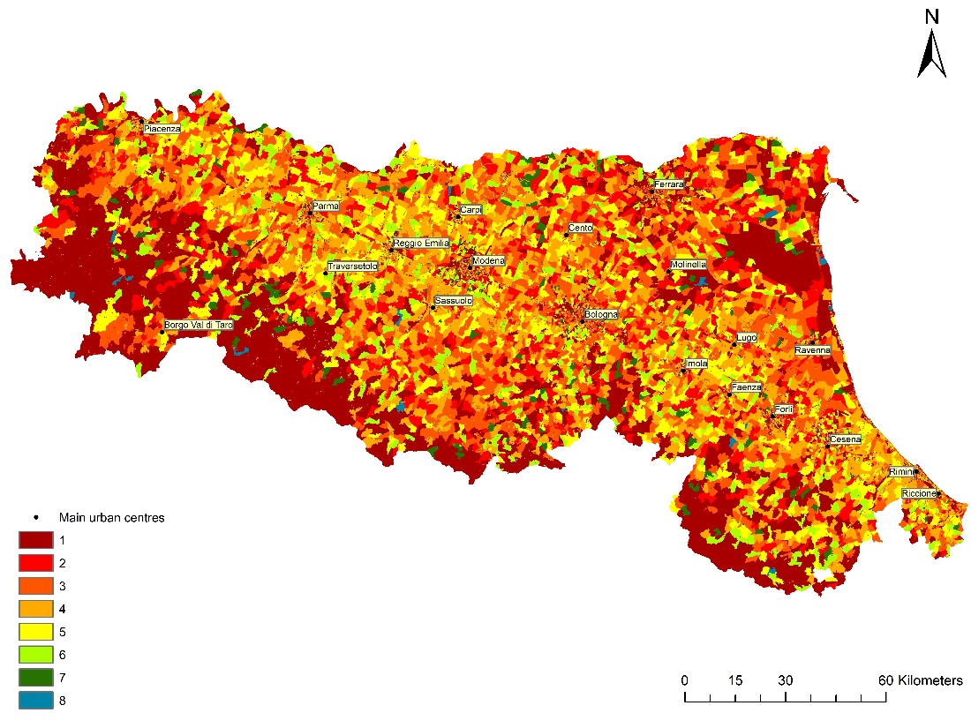
Fig. 16. Submodel map of the potential organic products consumers (proxy: age groups).
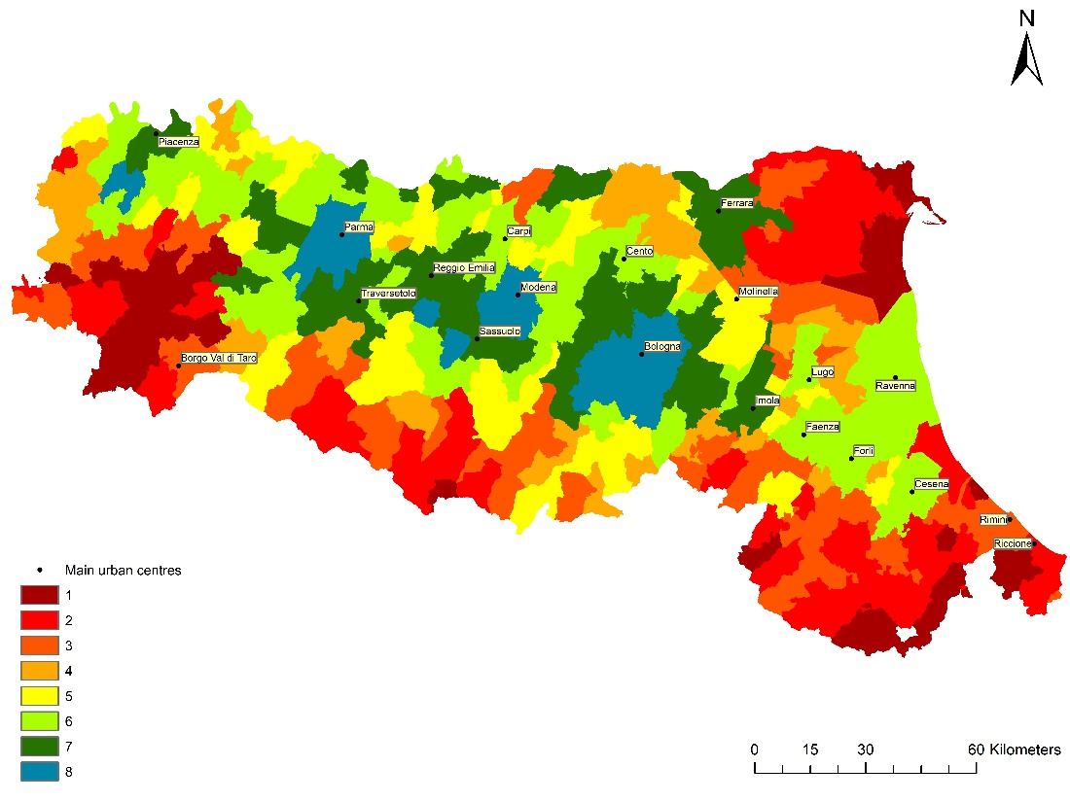
Fig. 17. Submodel map of the average income.
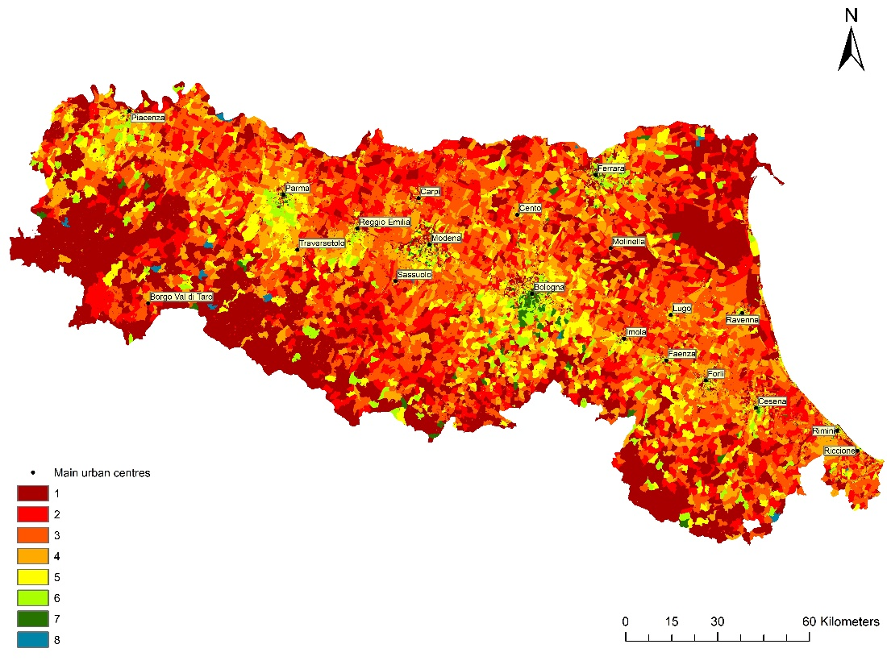
Fig. 18. Submodel map of the potential organic products consumers (proxy: education level).
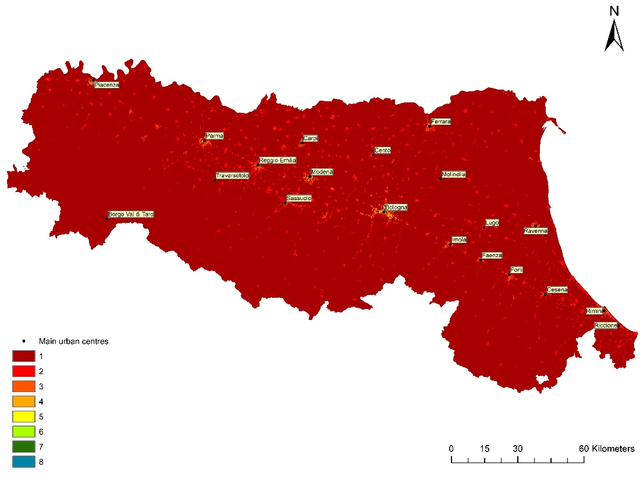
Fig. 19. Submodel map of the potential consumers (proxy: population density).
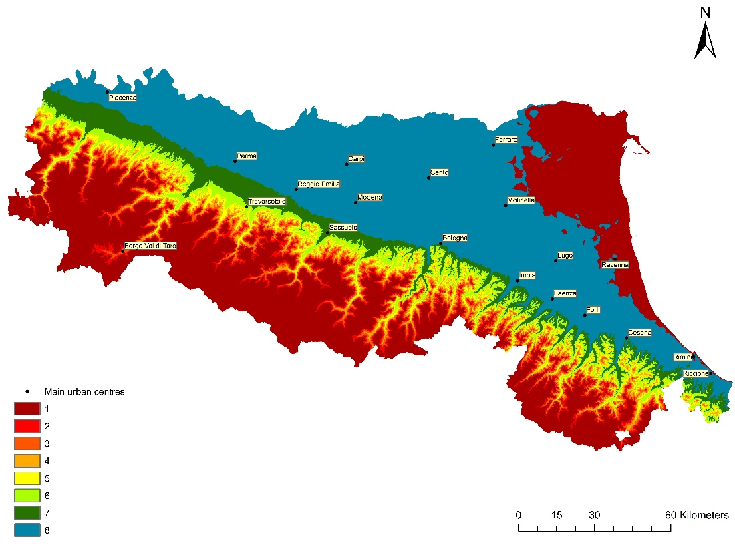
Fig. 20. Submodel map of the elevation.
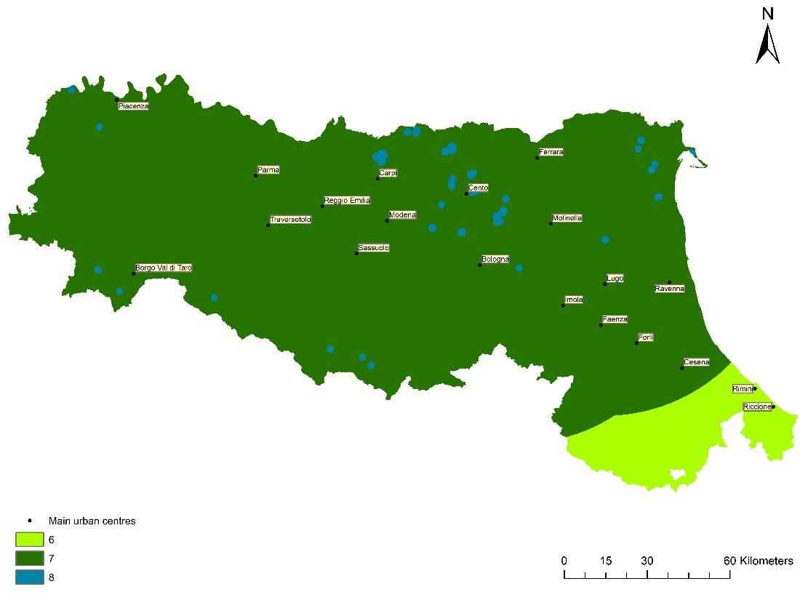
Fig. 21. Submodel map of the proximity to fish hatcheries / fishfarms.
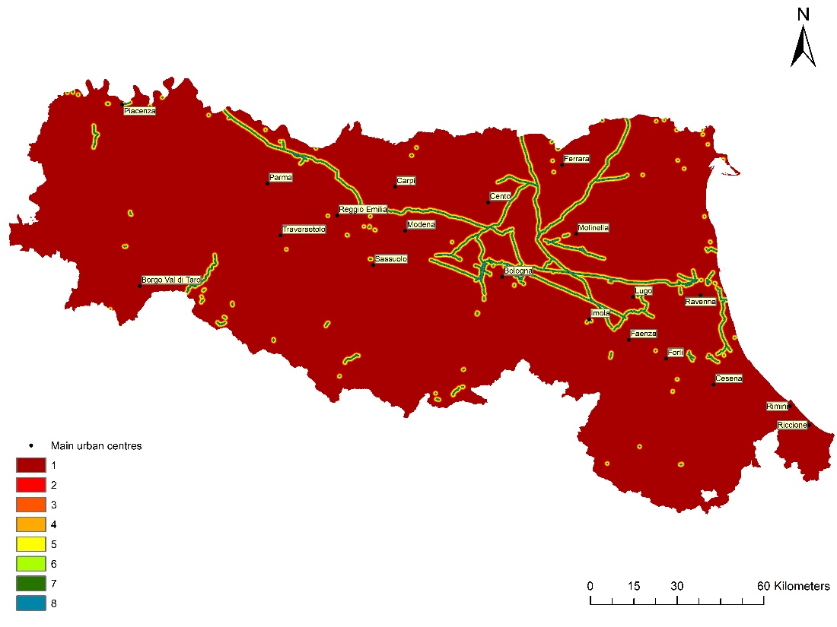
Fig. 22. Submodel map of the proximity to gas network.
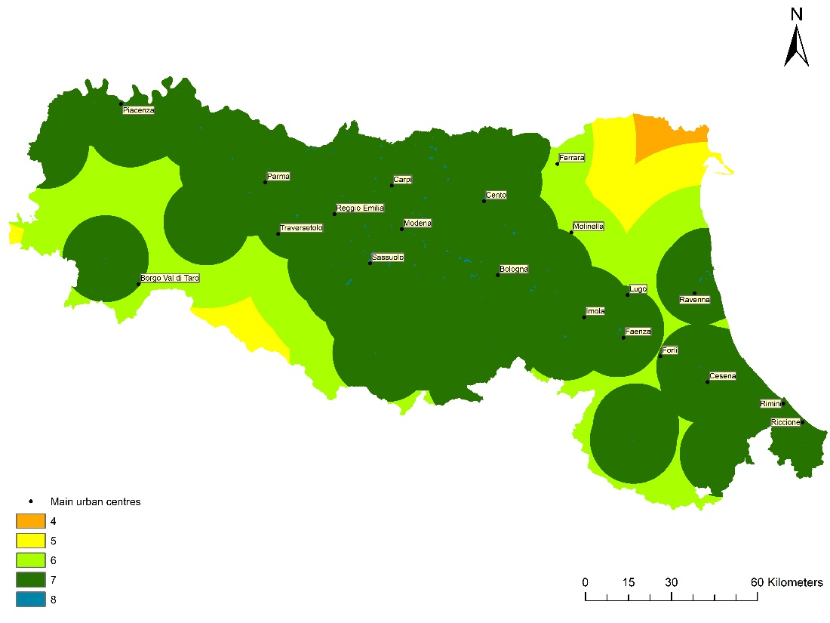
Fig. 23. Submodel map of the proximity to industrial activities.
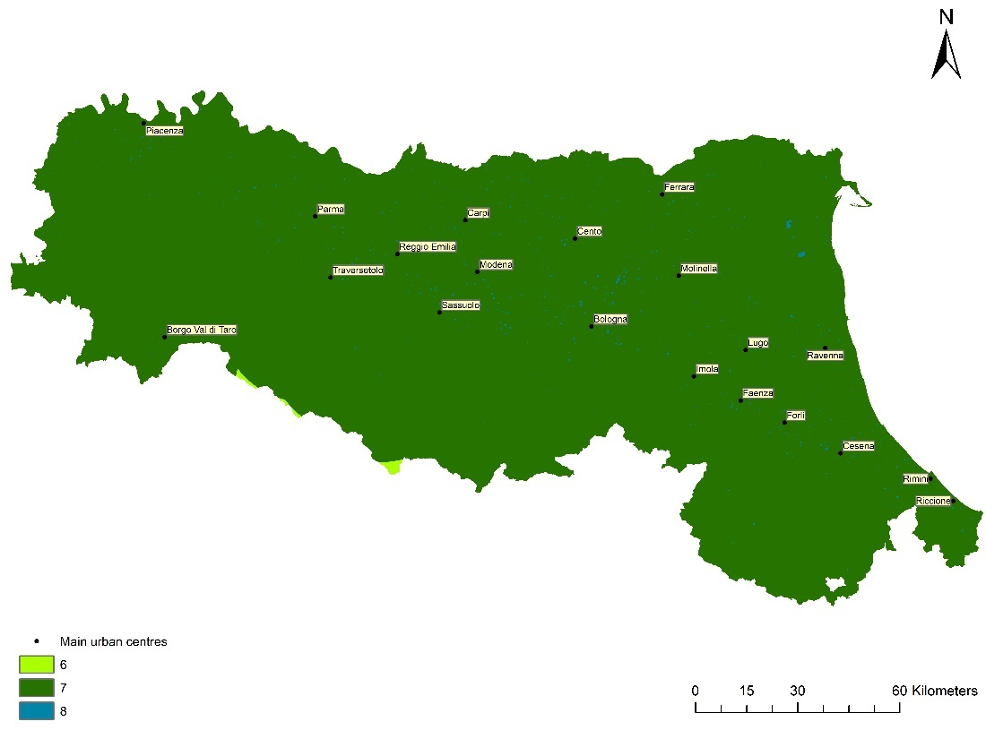
Fig. 24. Submodel map of the proximity to plant nurseries.
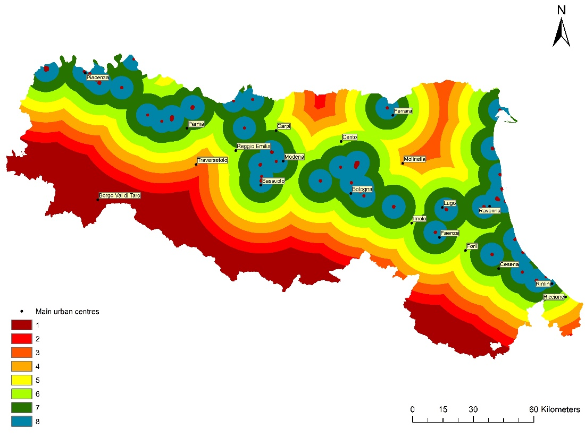
Fig. 25. Submodel map of the proximity to logistic platforms.
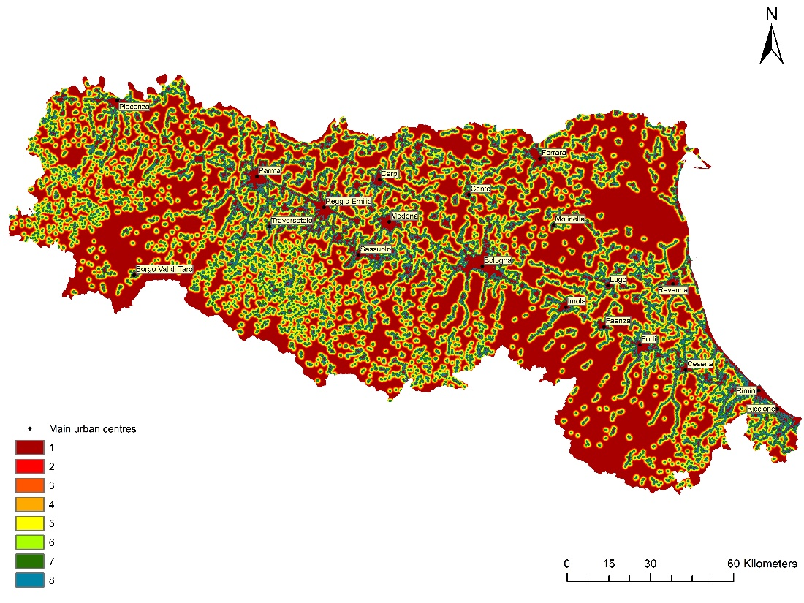
Fig. 26. Submodel map of the proximity to sewage network.
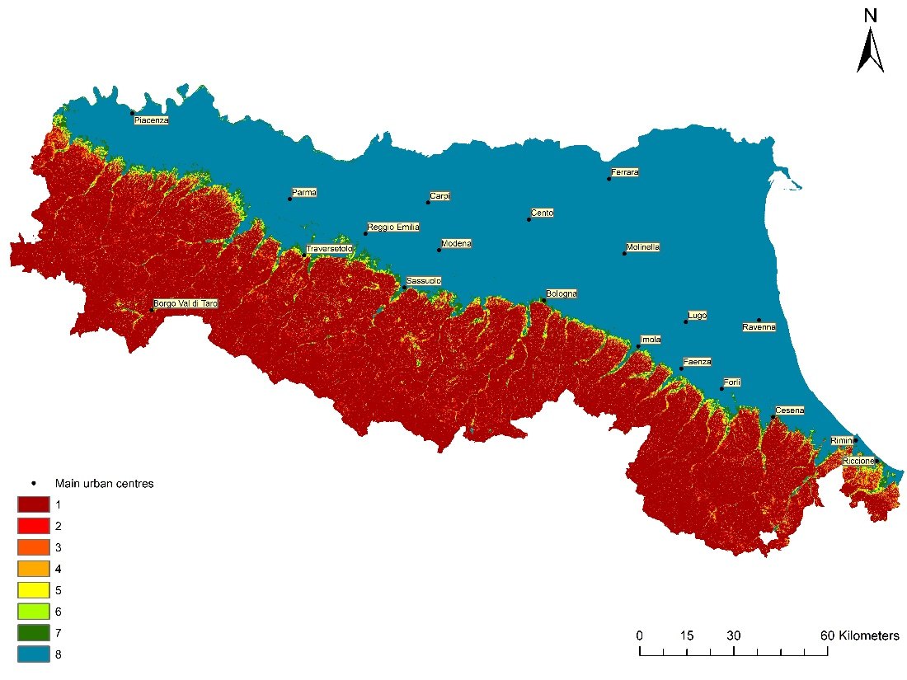
Fig. 27. Submodel map of the slope.
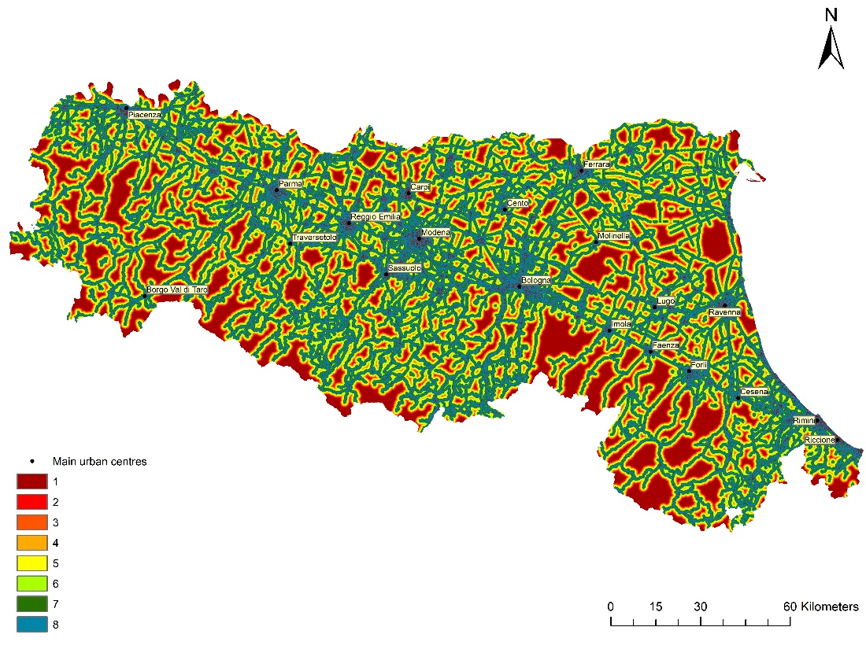
Fig. 28. Submodel map of the proximity to road network.
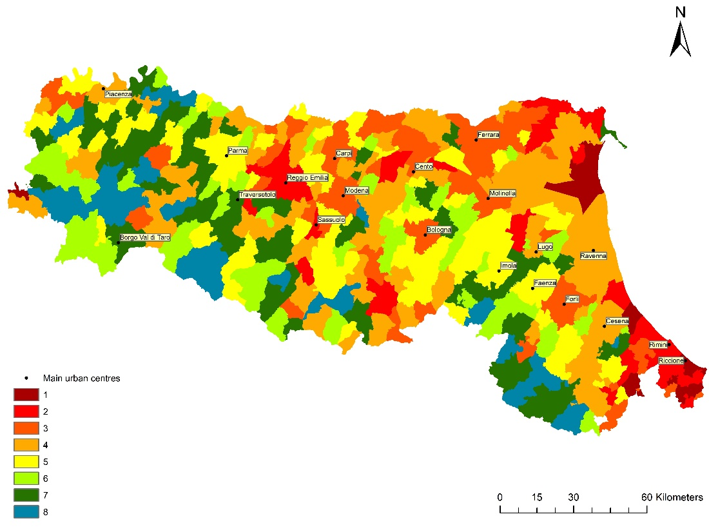
Fig. 29. Submodel map of the unemployment rate.
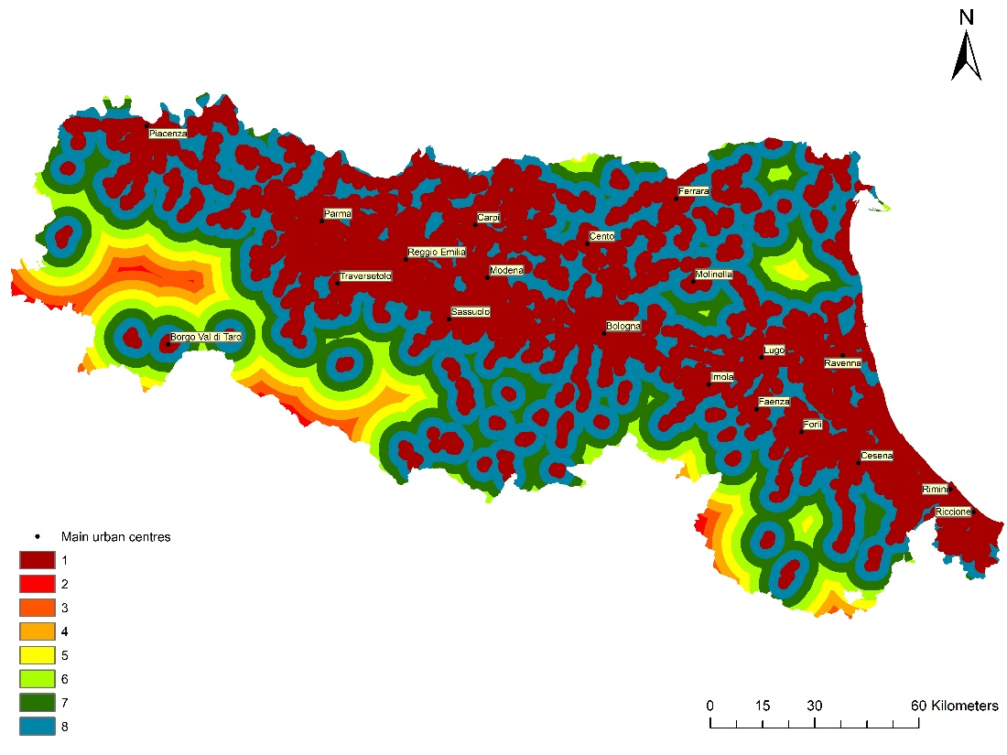
Fig. 30. Submodel map of the potential consumers (proxy: population density).

