SUPPORTING INFORMATION

Graphene-Based Pressure Sensor Application in Non-invasive Pulse Wave Velocity Continuous Estimation

Irene Buraioli, Stefania Vitale, Andrea Valerio, Alessandro Sanginario, Dario Leone, Sabrina Conoci, Artur Ciesielski, Alberto Milan, Danilo Demarchi, Paolo Samorì

S1. Sensor Materials
Graphene oxide (GO) in aqueous dispersion (4 mg mL⁻¹) was purchased from Graphenea (Spain). Ethanol (EtOH), isopropyl alcohol (IPA) and hydrazine mono-hydrate (N₂H₄·H₂O) were purchased from
Sigma-Aldrich Merck (France) and used as supplied. Triethylene glycol amine has been synthesized following a literature procedure^{[1,2]}.
ITO-covered PET substrates (ITO-PET, surface resistivity 60 Ω, thickness of ITO coating: 130 nm) were purchased from Sigma-Aldrich Merck (France). Copper wire (0.35 mm diameter), polyimide (PI) tape (0.08 mm thickness) and silver paste were purchased from RS Components (France).

S2. frGO active material preparation and characterisation
Graphene-based piezoresistive active material (frGO) was prepared as previously reported^{[3]}. Briefly, 50 mL of aqueous GO dispersion (4 mg mL⁻¹) was diluted with 120 mL ethanol in a 250 mL round-bottom flask and sonicated for 30 minutes. Triethylene glycol amine (200 mg) was dissolved in 5 mL of ethanol and the resulting solution was then added into the GO dispersion. The reaction mixture was then kept stirring overnight under reflux at 90 °C, under N₂ atmosphere. After cooling down the solution to room temperature, the dispersion was centrifuged for ten minutes at 2000 rpm. Then the supernatant was removed, and 200 mL of ethanol were added to the black sludge. This sonication-centrifugation process was repeated three times. After the last centrifugation step the black sludge was dispersed in 200 mL ethanol and the reduction of GO was carried out by adding 2 mL of N₂H₄·H₂O, followed by stirring overnight under reflux at 90 °C, under N₂ atmosphere. The purification of the final product (frGO) was performed through sonication-centrifugation cycles as described above. The resulting product was suspended in ethanol in order to have a working dispersion of (0.5 mg mL⁻¹). Ordered films of frGO were deposited from the working dispersion to carry out SEM and Raman characterisation. These analyses were executed to verify the morphology and structure of the films and their conformity with the desired characteristics, required for the subsequent preparation of the pressure sensing devices. frGO films were deposited on SiO₂ substrates (1 cm² area) by spray coating 1 mL of working dispersion at 80°C. For comparison, films of neat, i.e. non-functionalised, rGO were prepared in the same conditions from a dispersion of rGO, which was obtained by reduction of GO using the same reduction protocol adopted for the functionalised GO. SEM images were recorded with a FEI Quanta FEG 250 instrument S3. Raman spectra were collected with a Renishaw InVia RE04 combined with a MS20 Encoded stage and a 532 nm laser (power excitation below 1 mW); the measurements were carried out in ambient conditions with a 100x lens and a resulting beam spot of 800 nm.
SEM images (Figure S2.1 a) and b)) show that frGO is distributed in a uniform film of stacked layers, although the surface appears slightly smoother compared to that of the pure rGO film; since the reduction protocol adopted for reduction is the same for both functionalised and non functionalised graphene oxide, the different roughness shown on SEM images can be ascribed to a decreased presence of defects on frGO due to the prior functionalisation with triethylene glycol amine. Raman spectra (Figure S2.1 c)) support this conclusion, as shown by the smaller I_{D}/I_{G} ratio recorded for frGO compared to rGO, which is indication of a more ordered structure ^{[4,5]}.
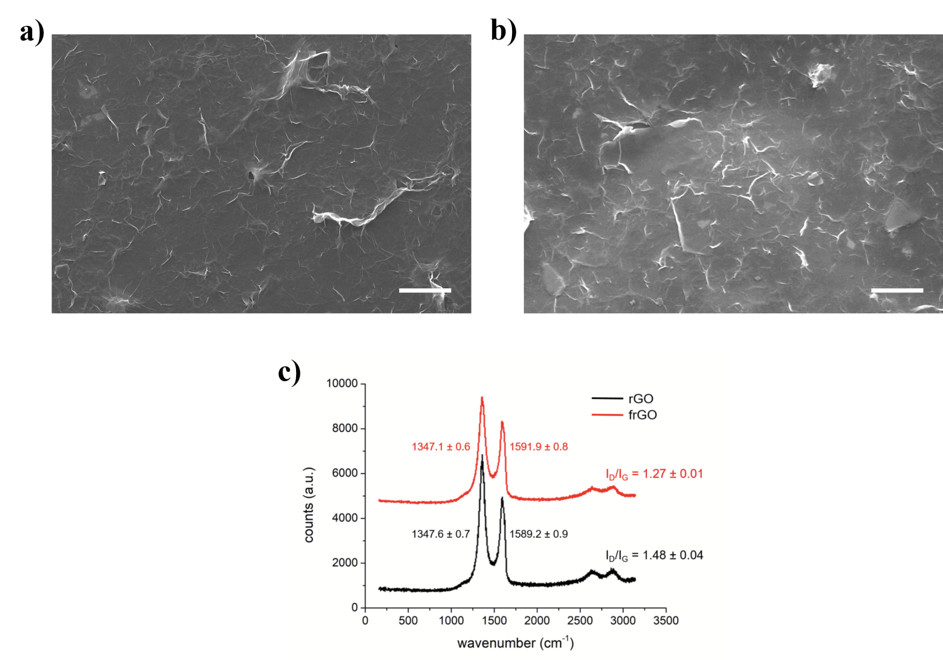
Figure S2.1: Representative SEM images of a) frGO and b) rGO blank (scalebars correspond to 5µm); c) representative Raman spectra of rGO and frGO.

S3. Pressure sensors fabrication
The graphene-based pressure sensing devices were prepared adopting previously reported procedures^{[3,6]} and using frGO active material and ITO-covered PET as conductive substrate were prepared. Briefly, frGO active material was spray coated at 80 °C onto rectangular chips of ITO-PET (13 mm × 20 mm). A shadow mask (13 mm × 5 mm) was applied prior to the spray coating, to have an rGO-free surface to place electrical contacts onto. The deposition of frGO was monitored through UV-Vis spectroscopy until a transmittance of 20% at 500 nm was achieved; such transmittance value was obtained after spraying 2 mL of dispersion per ITO-PET chip. After frGO deposition, the shadow mask was removed and two of the obtained electrodes were placed in a face-to-face configuration, to have a layer of active material sandwiched between two ITO-PET substrates. PI tape was used to fix together the two electrodes in the desired configuration, and at the same time to seal the device, thus preventing any interference of humid air. Finally, electrical contacts were obtained by fixing copper wires with silver paste.
S4. Piezoresistive behavior characterization
The devices’ performance was evaluated in terms of pressure sensitivity and device durability upon application of cyclic stress. Such tests were carried out using a Mark-10 M7-025E digital force gauge mounted on a Mark-10 ESM-303E motorised test stand. The test setup was equipped with a round com- pression plate of 1.15 cm diameter. The sensitivity was assessed through static pressure tests, consisting in the measurement of the device electrical resistivity when a static force was applied in the range 0.005 N to 0.2 N (corresponding to a pressure range between 0.05 kPa to 2 kPa. The resistivity was measured by means of a Keithley 2635B source meter. Durability of the devices was tested by cyclically applying a 0.1 kPa load, and monitoring overtime the change in electrical resistance using Labtracer. The performance tests were carried out in laboratories where temperature and humidity were equivalent to those expected in the environments intended for the device final application (i.e. hospital). In the present work, the static pressure tests and the durability tests carried out on the prepared devices confirmed high sensitivity (namely 0.77 kPa⁻¹ in the low pressure regime up to 0.6 kPa), fast response time (25 ms) and good stability upon cyclic (only 10% performance loss after 1000 load-unload cycles). The relative resistance plot as a function of applied pressure and the fatigue test results are presented in Figure S1.
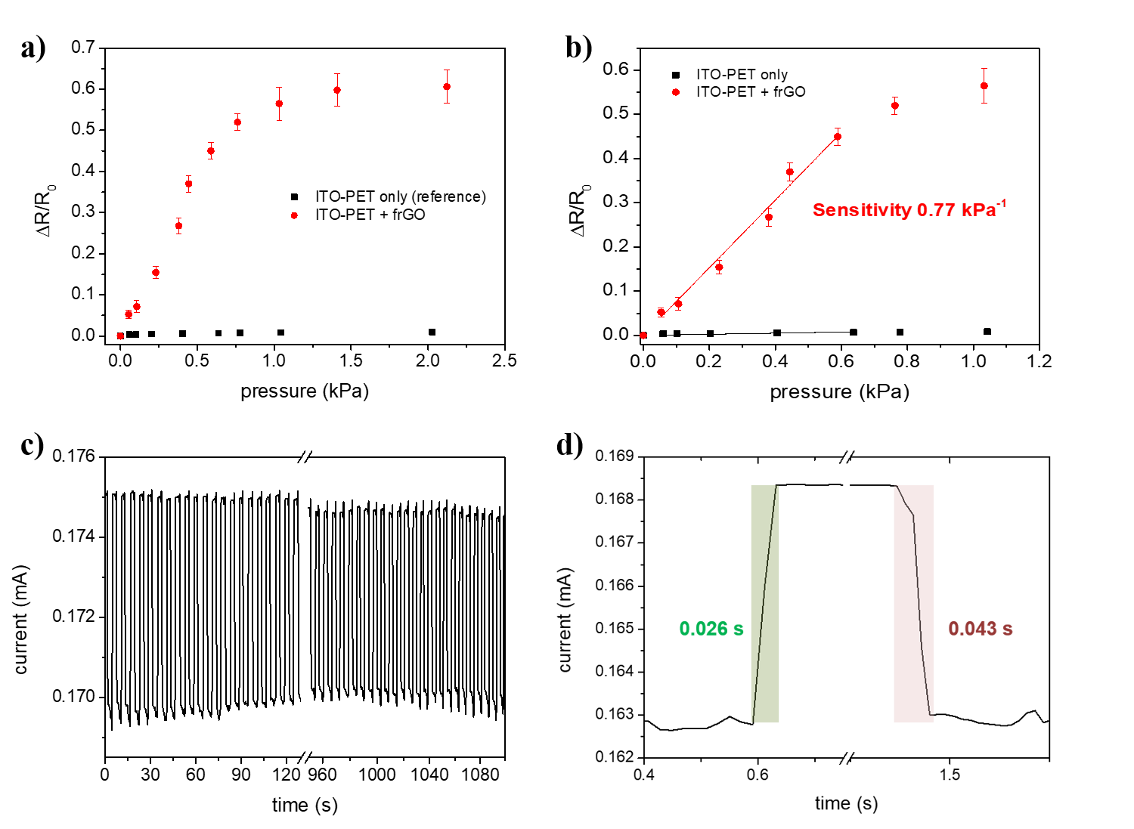
Figure S4.1: Performance characterization for ITO-PET-frGO pressure sensors: a) relative resistance as a function of the applied pressure, b) sensitivity in the low-pressure range regime, c) fatigue tests, with the graph showing the current variation caused by the cycling application of 0.1 kPa load overtime, d) response time.

S5. Sensor engineering and electronics read-out
The graphene sensor changes its resistance value proportionally to the variation in applied transverse pressure. As such, appropriate working conditions must be adopted to perform correct pulse detection, firstly by ensuring the correct positioning of the sensor on the skin in proximity of the artery.
In the first attempt, the graphene sensor was placed on a tape (Patch configuration, in Figure S2). Nevertheless, due to the “sandwich configuration” with wires connections on both sides of the device, the signal was affected by tape-sensor contact and the rubbing of the latter on the skin. Moreover, since the vessels are located deeper than the epidermis, with other layers in between (such as muscles and fat), the propagation of the heartbeat is rather dampened.
Thus, to achieve a more stable vital signal, the graphene sensor has been suitably engineered with a 3D-printed support (Flat Holder in Figure S2) that embeds the sensor and fastens it to a band, thus improving wearability and preventing it from rubbing.
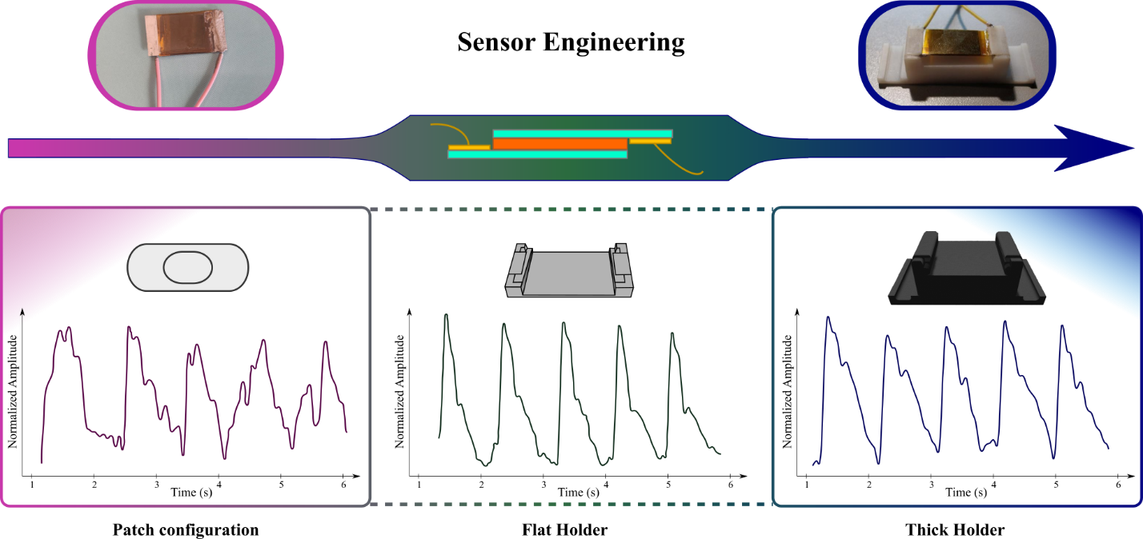

Figure S5.1: Sensor engineering strategies with enhanced complexity and reliability (from left to right). The first simple Patch configuration displays noisy and unreliable signal collection, whereas the more advanced Thick Holder enables to precisely position the sensor on the best acquisition site, yielding reproducible and noise-free signal collection.

S6. Clinical Trial and Signal Processing

Ten volunteer healthy subjects were recruited in a trial held at the “Città della Salute e della Scienza” hospital of Turin (Italy) and approved by the “University of Turin Bioethical Committee” (protocol number 155412). The subjects’ physiological parameters are reported in Table S1. The average age was 30.1 years, 60% male and 40% female. After the anamnesis, each subject was allowed to rest for fifteen minutes in a quiet room, with the appropriate ambient temperature (25°C), humidity level (50%) and ventilation (0,1 m/s), to allow the cardiovascular system to relax, in compliance with the Artery guidelines^{[7]}.
Table s6.1: Physiological Parameters of the Subjects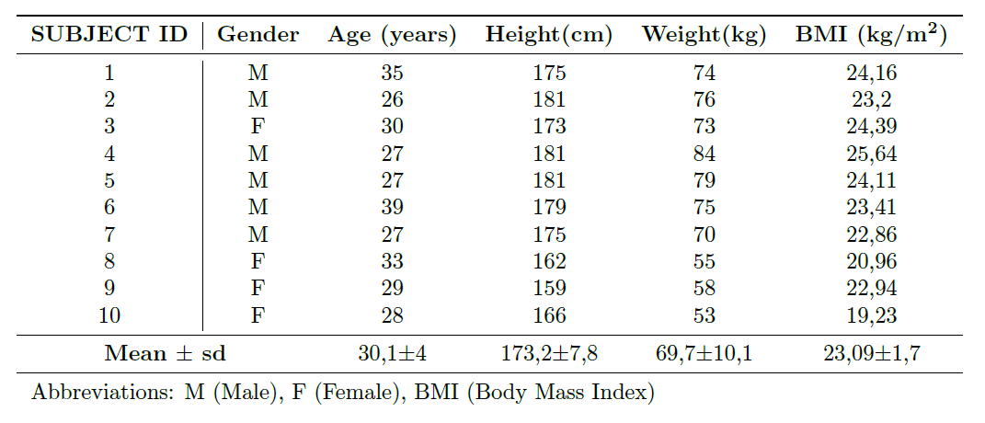
The offline algorithm has been employed to extract the PTT from the recorded signals and their implementation in Matlab environment. This approach was already adopted by Buraioli et al. in^{[8]}.
- To consider signals with the same duration as in Sphygmocor measurements, only the last ten seconds are taken into account out of the stored thirty seconds signals. Carotid and Femoral are separately processed up to the next ninth step.
- A 4th-order high-pass filter (HPF) with a cut-off frequency of 0.5 Hz is employed to eliminate the DC offset.
- A 4th-order low pass filter (LPF) with a cut-off frequency of 0.5 Hz is employed to detect the periodicity of the subject’s cardiac activity under test and divide the entire signal in single pulses.
- Each minimum point identified in the low-pass filtered signal is marked as an event starter. Each detected minimum indicates the beginning of the cardiac cycle, and the time duration between two consecutive event starters represents the cardiac period T of the subject. In the context of this application, the duration of T is expressed in terms of samples.
- The signal is divided into windows, each one going from one event starter to another and lasting the entire heartbeat. In each, the next steps are performed.
- By selecting a fraction of T equal to 50 %, all the minima are identified and subsequently filtered according to their amplitude and position with respect to the rising edge of the pulse along the abscissa.
- A threshold equivalent to 20 % of the amplitude of the lowest minimum is applied to filter out those that can be attributed to the presence of noise or fluctuations in the signal.
- The next step consists in the extraction of the Intersecting Tangent Point (ITP). This is done by considering a window of duration corresponding to T samples starting from each event starter. Thus, the first derivative of the signal is computed and the latter’s maximum is detected on the original pulse. Subsequently, the line passing through the maximum is built together with its tangent to the rising edge.
- Among the minima retrieved in the previous step, the closest one to the systolic upstroke is selected to trace the horizontal line needed to identify the intersecting tangent point along the abscissa. The foot of the wave is obtained by projecting the ITP on the original pulse.
- All the ITPs in the signal are detected. A set of three particular conditions is established to guarantee the accurate timing of the identified ITPs on the carotid and femoral signals:
  - ITP_{car}(i + 1) ITP_{car}(i) < T : The first condition checks that the time interval between two consecutive ITP on the carotid signal is coherent with the cardiac period T of the subject.
−
  - ITP_{fem}(i) > ITP_{car}(i): This second one ensures that the detected ITPs are consistent with the arrival sequence of the pressure wave at the two acquisition sites. This means that every femoral intersecting tangent point is temporally positioned after its corresponding point on the carotid signal
  - ITP_{car}(i + 1) > ITP_{fem}(i): The last one guarantees no multiple ITPs in the time interval under consideration.
Combining these criteria prevents PWV assessment errors arising from incorrect detection of the feature of interest. Furthermore, they ensure that each ITP detected on the carotid signal has a corresponding and singular ITP on the femoral signal. Those ITPs which do not respect any of the three conditions are discarded.
- If the analysis of both the carotid and femoral pulse waves results in a correct feature detection, the Pulse Transit Time (PTT) is then assessed according to the following:
$$PTT=\frac{{ITP}_{fem}-{ITP}_{car}}{f_{s}}$$
where fs represents the sampling frequency of the system, 2 kHz. In order to be again aligned as closely as possible with the gold standard, the same PTT filtering approach employed by the SphygmoCor is adopted. Particularly, all PTT values falling outside the range of σ ± 0.9 ∗ σ are discarded.
- Finally, the PWV is computed according to:
$$PWV=\frac{{distance}_{car-fem}}{PTT}$$
Where distance_{car−fem} is the distance between the two sites multiplied by a correction factor equal to 0.8 (as suggested by [64]) and PTT is the average value computed after applying the discarding criterion based on the standard deviation.
References
[1] K. D. Park, R. Liu, H. Kohn, Chem. Biol. 2009, 16, 763.
[2] H. Kim, Y. J. Kang, E. S. Jeong, S. Kang, K. T. Kim, ACS Macro Lett. 2012, 1, 1194.
[3] C.-B. Huang, S. Witomska, A. Aliprandi, M.-A. Stoeckel, M. Bonini, A. Ciesielski, P. Samorì, Adv. Mater. 2019, 31, 1804600.
[4] J.-B. Wu, M.-L. Lin, X. Cong, H.-N. Liu, P.-H. Tan, Chem. Soc. Rev. 2018, 47, 1822.
[5] M. M. Lucchese, F. Stavale, E. H. M. Ferreira, C. Vilani, M. V. O. Moutinho, R. B. Capaz, C. A. Achete, A. Jorio, Carbon 2010, 48, 1592.
[6] S. Vitale, H. Puozzo, S. Saiev, L. Bonnaud, A. G. Ricciardulli, A. Ciesielski, D. Beljonne, P. Samorì, Chem. Mater. 2023, 35, 6909.
[7] P. Mao, H. Li, Z. Yu, Sensors 2023, 23, 3673.
[8] I. Buraioli, D. Lena, A. Sanginario, D. Leone, G. Mingrone, A. Milan, D. Demarchi, IEEE Trans. Biomed. Circuits Syst. 2021, 15, 133.

