Supplementary Material:
Table S1 – Clinical data collection: for each patient we considered the following data.
Category of variables | Variables considered
Demographic Data | - Sex  - Age in months  - Weight  - Ethnicity
Known risk factors for the development of bronchiolitis | - Previous episodes of apnea  - Wheezing  - Chronic pulmonary disease  - Congenital heart disease  - Immunodeficiency  - Severe neurological or muscle disease  - Prematurity
Type of feeding | - Breastfeeding  - Mixed feeding  - Formula feeding
Vital signs at PED arrival | - Heart rate  - Respiratory rate  - Body temperature  - Oxygen saturation
Discharge modality | - Home  - SSOU  - Admission to the pediatric ward
Complications | - Pneumonia  - Sepsis  - Pneumothorax  - Pleural effusion
PED: Pediatric Emergency Department; SSOU: short‐stay observation unit.
Table S2 – Correlation (Spearman’s ρ) between monthly pollutants mobile averages and daily visits
Centre | NO₂ |  | PM₁₀ |  | PM_{2.5} |  | OC |  | EC |  | BC
 | ρ | p-value | ρ | p-value | ρ | p-value | ρ | p-value | ρ | p-value | ρ | p-value
Bologna | 0.390 | <0.001 | 0.349 | <0.001 | 0.383 | <0.001 | 0.439 | <0.001 | 0.406 | <0.001 | 0.431 | <0.001
Biella | 0.284 | <0.001 | 0.185 | <0.001 | 0.183 | <0.001 |  | <0.001 |  | <0.001 |  | <0.001
Belluno | 0.189 | <0.001 | 0.172 | <0.001 | 0.166 | <0.001 |  | <0.001 |  | <0.001 |  | <0.001
Overall | 0.291 | <0.001 | 0.396 | <0.001 | 0.440 | <0.001 | 0.439 | <0.001 | 0.406 | <0.001 | 0.431 | <0.001

Table S3 – Correlation (Spearman’s ρ) between weekly pollutants mobile averages and visits
Centre | NO₂ |  | PM₁₀ |  | PM_{2.5} |  | OC |  | EC |  | BC
 | ρ | p-value | ρ | p-value | ρ | p-value | ρ | p-value | ρ | p-value | ρ | p-value
Bologna weekly visits | 0.523 | <0.001 | 0.403 | <0.001 | 0.497 | <0.001 | 0.571 | <0.001 | 0.538 | <0.001 | 0.603 | <0.001
Bologna daily visits | 0.334 | <0.001 | 0.284 | <0.001 | 0.340 | <0.001 | 0.377 | <0.001 | 0.373 | <0.001 | 0.398 | <0.001

Table S4 - Main studies on the relationship between air pollutants and bronchiolitis.
Study | Years conducted | Country | Time lag | Pollutants | Significant findings
Karr et al.  (2004)¹ | 1995–2000 | USA | 1-2 and 3-5 days | PM_{2.5}, NO₂, CO | No effects of PM_{2.5}, NO₂, CO on bronchiolitis
Karr et al.  (2006) ² | 1995–2000 | USA | 1–2 and 3–5 days for PM_{2.5}, 1 and  4 days for NO₂, CO | PM_{2.5}, NO₂, CO | No association between PM_{2.5}, NO₂ and CO and bronchiolitis
Karr et al. (2007) ³ | 1995–2000 | USA | Chronic (lifetime) and sub-chronic (mean of previous 30 days) | PM₁₀, NO₂, CO, O₃ | Association between sub-chronic and chronic exposure to PM_{2.5} and increased risk of hospitalization for bronchiolitis
Ségala et al. (2008) ⁴ | 1997–2001 | France | 0-1 days, 0-4 days | PM₁₀,  NO₂, SO₂ | Association between PM₁₀,  NO₂, SO₂ and visits and hospitalization for bronchiolitis
Karr et al. (2009a)⁵ | 1999–2002 | Canada | Lifetime and first month | PM_{2.5}, PM₁₀, BC  NO₂, NO, SO₂,  CO, O₃ | Association between lifetime exposure to NO₂, NO, SO₂,  CO and increased risk of bronchiolitis. No association between exposure to PM_{2.5}, PM₁₀ e BC. Negative correlation between bronchiolitis and O₃
Karr et al. (2009b)⁶ | 1997–2003 | USA | Lifetime and mean of previous 30, 60 days, mean of 7 days (only for PM_{2.5}) | PM_{2.5}, NO₂ | No association between PM_{2.5} and NO₂ and bronchiolitis
Sheffield et al. (2011) ⁷ | 1999 - 2007 | USA | Lifetime | PM_{2.5}, PM₁₀,  NO₂, SO₂,  CO, O₃ | Association between chronic exposure to PM_{2.5} and hospitalization for bronchiolitis
Vandini et al. (2013)⁸ | 2007 - 2010 | Italy | Weekly mean of the previous week | PM_{2.5}, PM₁₀ | Correlation between RSV bronchiolitis and mean PM₁₀ concentration of the previous week. No correlation with PM_{2.5}
Darrow et al. (2014) ⁹ | 1993 - 2004 | USA | 0-3 days | PM_{2.}5, PM10,  NO₂, O₃ | No association between PM_{2.5}, PM₁₀, NO₂, O₃ and bronchiolis
Evangelisti et al. (2015) ¹⁰ | 2004 -2014 | Italy | Not defined | PM_{2.5}, PM₁₀,  NO₂, NO, SO₂,  CO, O₃, C₆H₆ | Correlation between RSV bronchiolitis and PM_{2.5}, PM₁₀,  NO₂, NO, C₆H₆ and negative correlation with O₃
Pablo-Romero et al. (2015)¹¹ | 2007 - 2011 | Spain | Not defined | PM_{2.5} | Association between PM_{2.5} increase and bronchiolitis
Mohammed et al. (2016)¹² | 2011 - 2012 | UK | Various short-term time lag | NO | Association between RSV bronchiolitis and NO exposure
Yitshak-sade et al. (2017) ¹³ | 2003 - 2013 | Israel | 0–1, 0–4, e  0–7 days | PM_{2.5}, PM₁₀, SO₂, NO₂ | Association between high PM_{2.5}, PM₁₀ and NO₂ level and bronchiolitis
Girguis  et al.  (2017) ¹⁴ | 2001–2009 | USA | Lifetime | PM_{2.5} | No association between chronic exposure to PM_{2.5} and bronchiolitis
Abdul  Rahman  et al.  (2017) ¹⁵ | 2006–2010 | Malesia | Lifetime | PM₁₀, NO₂, CO, O₃ | Association between PM₁₀ and bronchiolitis
Nenna et al. (2017) ¹⁶ | 2004 -2014 | Italy | 1 week | PM_{2.5}, PM₁₀,  NO₂, SO₂,  CO, O₃, C₆H₆ | Correlation between RSV bronchiolitis and PM_{2.5}, PM₁₀,  NO₂, SO₂, CO, C₆H₆; negative correlation with O₃; association between C₆H₆ and hospitalization for bronchiolitis
Carugno et al. (2018) ¹⁷ | 2012–2013 | Italy | Daily mean 0-30 days, mean 0-30 days, previous 4 weeks | PM₁₀ | Association between short- and medium-term exposure to PM₁₀ and risk of hospitalization for RSV bronchiolitis
Girguis  et al.  (2018) ¹⁸ | 2001 –2008 | USA | 1, 4, 7 days | PM_{2.5} | Increased risk of bronchiolitis for PM_{2.5} exposure for lag 1 and 4 day, but not for 7 days
Horne et al. (2018) ¹⁹ | 1999 - 2016 | USA | 0–6, 7–13, 14–20 and 21–27 previous days | PM_{2.5} | Association between short-term exposure to PM_{2.5} and bronchiolitis
Kennedy et al. (2018) ²⁰ | 2000 - 2010 | USA | First year of life | PM_{2.5}, NO_{x}, CO | Modest positive association between bronchiolitis and traffic emissions
Martín Martín et al. (2018) ²¹ | 2013 - 2015 | Spain | Not defined | NO₂, SO₂, CO, NO_{x}, C₆H₆, PM_{2.5}, PM₁₀, O₃, | Association between NO₂ and bronchiolitis
Terrazas et al. (2019) ²² | 2001 - 2014 | Chile | Not defined | PM_{2.5} | Direct correlation between PM_{2.5} and hospitalization for bronchiolitis
Matus et al. (2019) ²³ | 2001 - 2005 | Chile | 2 days | PM_{2.5}, PM₁₀, O₃, | Association between short-term exposure and hospitalization for bronchiolitis
Cheng et al. (2020) ²⁴ | 2013 - 2015 | Australia | 1 day | PM_{2.5}, PM₁₀, NO₂, O₃ | Association between short-term exposure and bronchiolitis
Kim et al. (2020) ²⁵ | 2013 - 2015 | Korea | Short-term | PM_{2.5} | Association between increased PM_{2.5} levels and bronchiolitis
Esteban et al. (2020) ²⁶ | 2011 - 2016 | Spain | 10 days | PM_{2.5}, PM₁₀, NO₂, SO₂ | No association between pollutants and hospitalization for bronchiolitis
Ortega-García et al. (2020) ²⁷ | 2015 | Spain | Not defined | PM₁₀, NO₂, O₃, SO₂ | Air pollution increases hospitalization for bronchiolitis
Cordova et al. (2020) ²⁸ | 2011 - 2015 | Peru | Varius time lag | PM_{2.5} | Association between PM_{2.5} and bronchiolitis
Luong et al. (2020) ²⁹ | 2016 - 2017 | Vietnam | 0-3 days | PM_{2.5} | Association between PM_{2.5} and bronchiolitis
Leung et al. (2021) ³⁰ | 2008 - 2017 | China | Varius time lag | SO₂, O₃, NO₂, PM₁₀ | Correlation between hospitalization for bronchiolitis and NO₂ and PM₁₀ exposure
Liang et al. (2021) ³¹ | 2013 - 2019 | China | 0-5 days | PM_{2.5}, PM₁₀, coarse particulate matter, NO₂, SO₂,  O₃ | Association between PM_{2.5}, PM₁₀, coarse particulate matter and bronchiolitis
Wrotek et al. (2021) ³² | 2010 - 2019 | Poland | Not defined | PM_{2.5}, PM₁₀,  NO₂ | Association between PM_{2.5}, PM₁₀, NO₂ and hospitalization for bronchiolitis
Milani et al. (2022) ³³ | 2019 - 2020 | Italy | Daily mean of the previous 29 days | PM_{2.5}, PM₁₀ | Direct association between PM_{2.5} and PM₁₀ levels and bronchiolitis severity
Chen et al. (2022) ³⁴ | 2006 - 2016 | Taiwan | Varius time lag | PM_{2.5} | Association between PM_{2.5} and bronchiolitis
Gallo et al. (2022) ³⁵ | 2007 - 2018 | Italy | 0-14 days | PM_{2.5}, PM₁₀,  NO₂ | Association between PM_{2.5}, PM₁₀,  NO₂ and visits and hospitalization for bronchiolitis
Xiao et al. (2022) ³⁶ | 2013 - 2019 | China | 0-5 days | PM_{2.5}, PM₁₀,  NO₂, SO₂,  O₃ | Association between PM_{2.5} and bronchiolitis
Liang et al. (2022) ³⁷ | 2014 - 2016 | China | 0-5 days | PM_{2.5}, PM₁₀, coarse particulate matter, NO₂, SO₂,  O₃ | Association between PM_{2.5}, PM₁₀, coarse particulate matter and bronchiolitis
Dondi et al. (2023)³⁸ | 2011 - 2020 | Italy | Mean of the previous week and 4 weeks | PM_{2.5}, PM₁₀,  NO₂,  C₆H₆ | PM_{2,5} exposure in the previous 4 weeks is the main factor increasing significantly the risk of hospitalization for bronchiolitis
Wang et al. (2023) ³⁹ | 2019 - 2022 | China | Various time lag | PM_{2.5}, PM₁₀, SO₂, NO₂, CO, O₃ | Association between PM_{2.5}, PM₁₀, SO₂, NO₂, CO and bronchiolitis
Zhang et al. (2023) ⁴⁰ | 2014 - 2020 | China | Short-term | PM_{2.5}, PM₁₀, SO₂, NO₂ | Association between PM_{2.5}, PM₁₀, SO₂, NO₂ and bronchiolitis
Villamil-Osorio et al. (2023) ⁴¹ | 2019 - 2021 | Colombia | Not defined | NO₂, CO PM_{2.5}, PM₁₀, SO₂, O₃ | Negative correlation between NO₂ and CO and bronchiolitis
Lei et al. (2023) ⁴² | 2013 - 2020 | China | 0-4 days | NO₂, CO PM_{2.5}, PM₁₀, SO₂, O₃ | Association between PM_{2.5} and PM₁₀ and bronchiolitis
Brusselen et al. (2024) ⁴³ | 2020 - 2021 | Belgium | Short-term (1-5 days) and medium-term (31 days) | PM_{2.5}, PM₁₀,  BC, NO₂ | Association between medium-term exposure to PM₁₀ and NO₂ and severe bronchiolitis

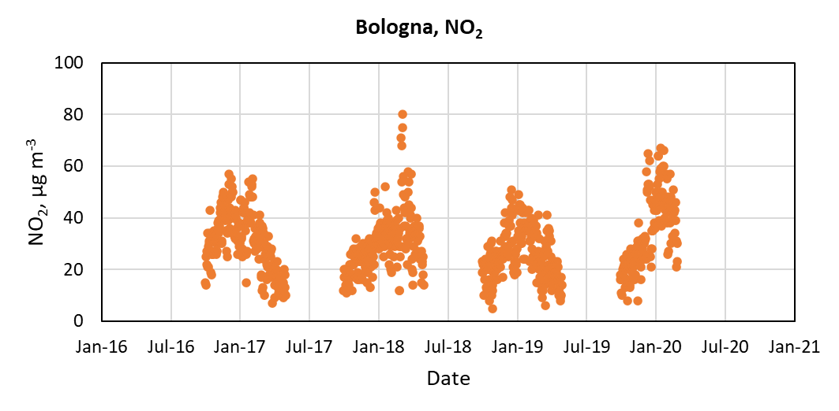
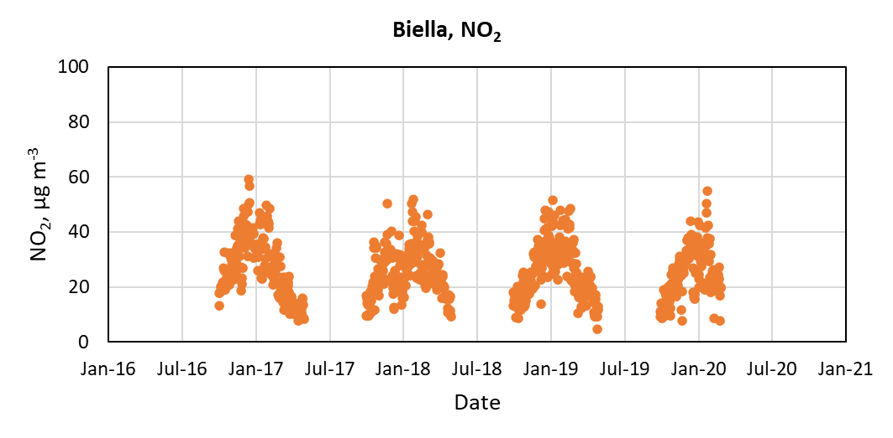
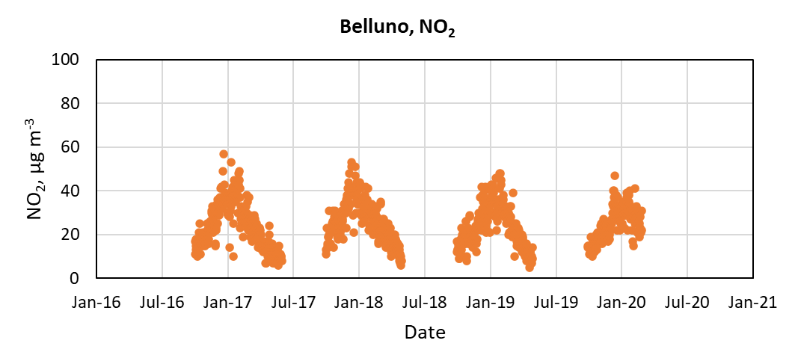
Figure S1. Daily concentrations of NO₂ in the cities of Bologna, Biella and Belluno. Only days within the epidemiological season (October-March) have been considered.

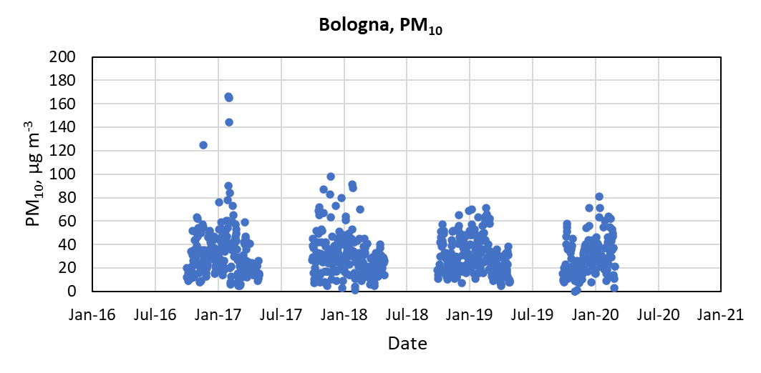
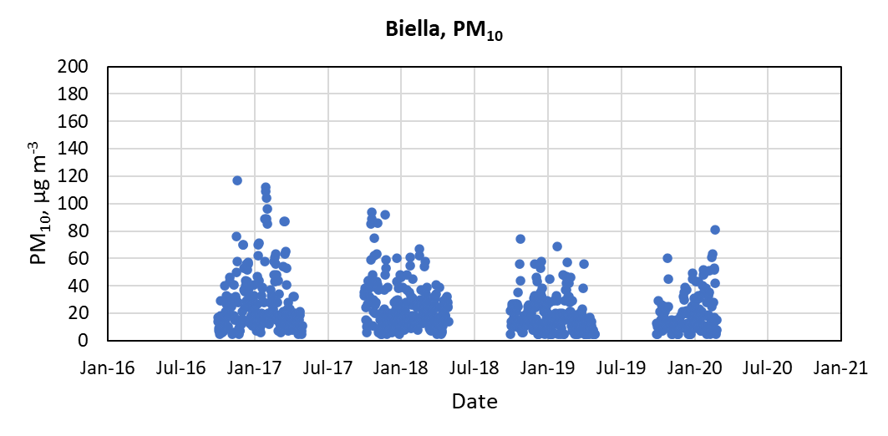
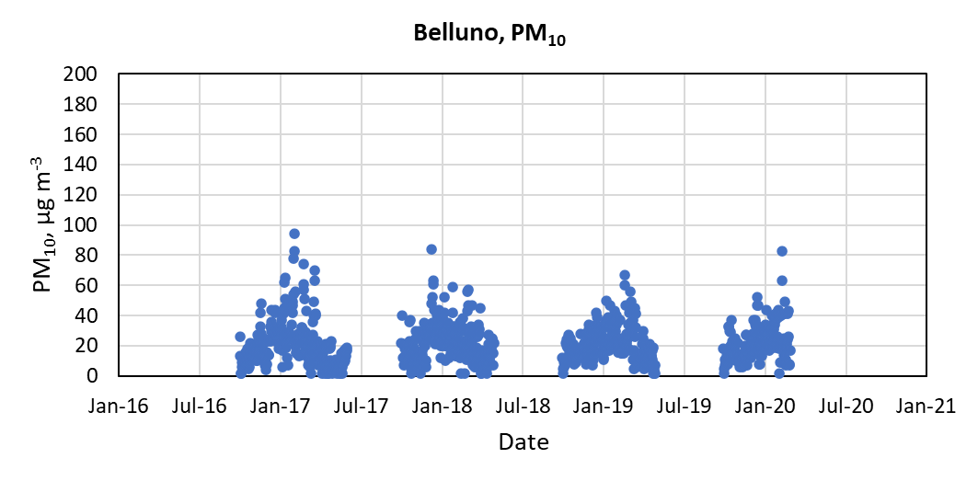
Figure S2. Daily concentrations of PM₁₀ in the cities of Bologna, Biella and Belluno. Only days within the epidemiological season (October-March) have been considered.

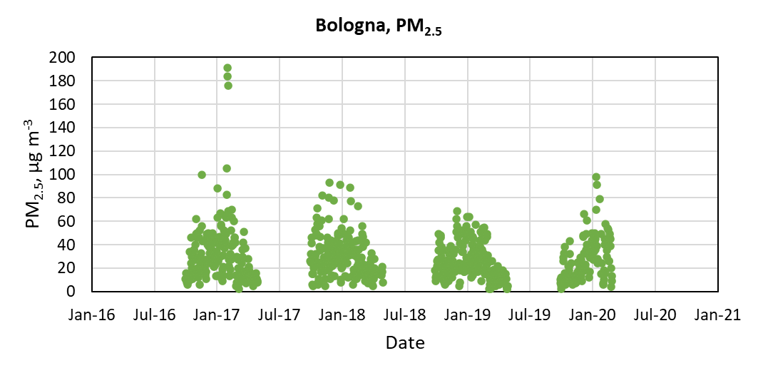
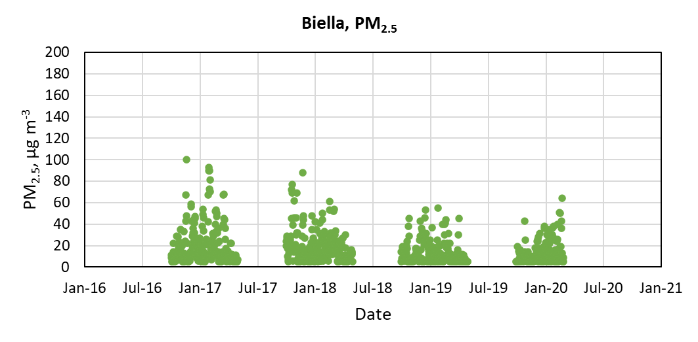
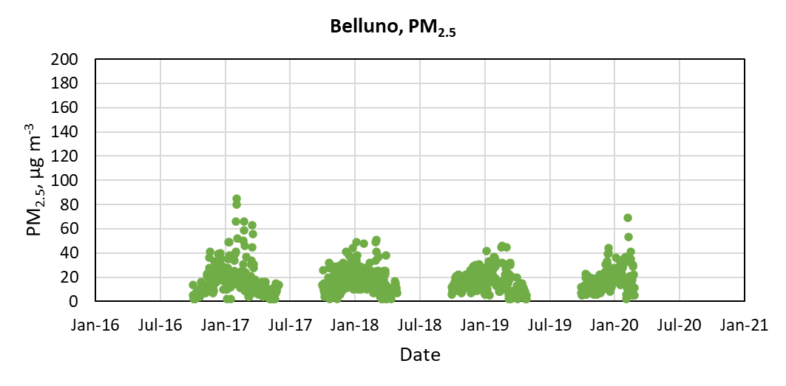
Figure S3. Daily concentrations of PM_{2.5} in the cities of Bologna, Biella and Belluno. Only days within the epidemiological season (October-March) have been considered.

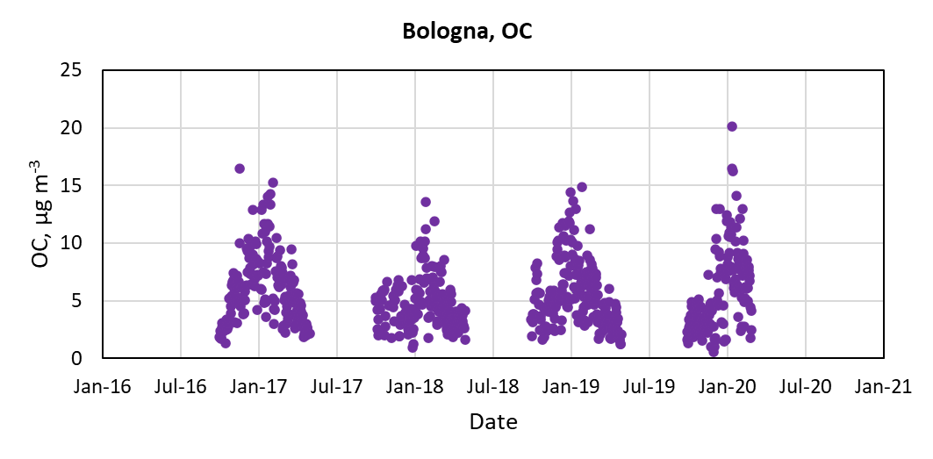
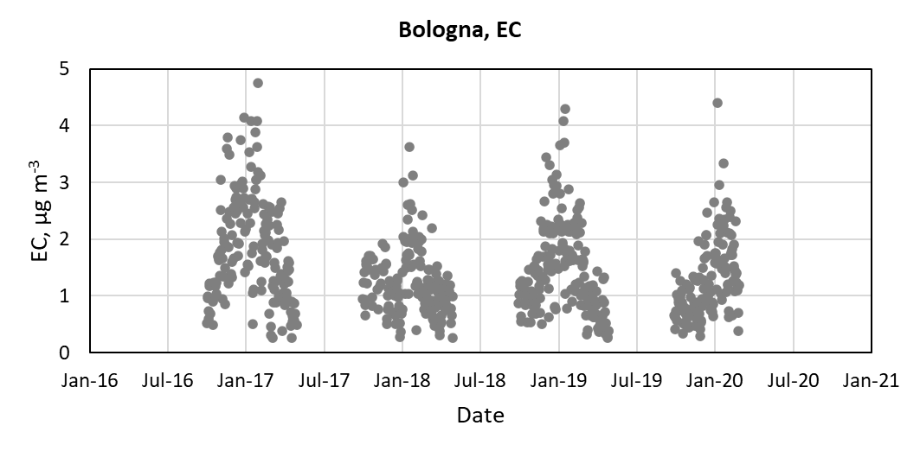
Figure S4. Daily concentrations of OC and EC in the city of Bologna. Only days within the epidemiological season (October-March) have been considered.

REFERENCES
1. Karr C, Kaufman J, Lumley T, et al. EFFECT OF AMBIENT AIR POLLUTION ON INFANT BRONCHIOLITIS. Epidemiology. 2004;15(4):S31.
2. Karr C, Lumley T, Shepherd K, et al. A case-crossover study of wintertime ambient air pollution and infant bronchiolitis. Environ Health Perspect. 2006;114(2):277-281. doi:10.1289/ehp.8313
3. Karr C, Lumley T, Schreuder A, et al. Effects of subchronic and chronic exposure to ambient air pollutants on infant bronchiolitis. Am J Epidemiol. 2007;165(5):553-560. doi:10.1093/aje/kwk032
4. Ségala C, Poizeau D, Mesbah M, Willems S, Maidenberg M. Winter air pollution and infant bronchiolitis in Paris. Environmental Research. 2008;106(1):96-100. doi:10.1016/j.envres.2007.05.003
5. Karr CJ, Demers PA, Koehoorn MW, Lencar CC, Tamburic L, Brauer M. Influence of ambient air pollutant sources on clinical encounters for infant bronchiolitis. Am J Respir Crit Care Med. 2009;180(10):995-1001. doi:10.1164/rccm.200901-0117OC
6. Karr CJ, Rudra CB, Miller KA, et al. Infant exposure to fine particulate matter and traffic and risk of hospitalization for RSV bronchiolitis in a region with lower ambient air pollution. Environ Res. 2009;109(3):321-327. doi:10.1016/j.envres.2008.11.006
7. Sheffield P, Roy A, Wong K, Trasande L. Fine particulate matter pollution linked to respiratory illness in infants and increased hospital costs. Health Aff (Millwood). 2011;30(5):871-878. doi:10.1377/hlthaff.2010.1279
8. Vandini S, Corvaglia L, Alessandroni R, et al. Respiratory syncytial virus infection in infants and correlation with meteorological factors and air pollutants. Ital J Pediatr. 2013;39(1):1. doi:10.1186/1824-7288-39-1
9. Darrow LA, Klein M, Flanders WD, Mulholland JA, Tolbert PE, Strickland MJ. Air pollution and acute respiratory infections among children 0-4 years of age: an 18-year time-series study. Am J Epidemiol. 2014;180(10):968-977. doi:10.1093/aje/kwu234
10. Evangelisti M, Cangiano G, Nenna R, et al. Air pollution and bronchiolitis from 2004 to 2014 in Rome. European Respiratory Journal. 2015;46(suppl 59). doi:10.1183/13993003.congress-2015.PA4505
11. de P Pablo-Romero M, Román R, Limón JMG, Praena-Crespo M. Effects of fine particles on children’s hospital admissions for respiratory health in Seville, Spain. J Air Waste Manag Assoc. 2015;65(4):436-444. doi:10.1080/10962247.2014.1001499
12. Mohammed NI, Everard ML, Ayres JG, Barker NJ, Litchfield IJ. A Preliminary Assessment of the Role of Ambient Nitric Oxide Exposure in Hospitalization with Respiratory Syncytial Virus Bronchiolitis. Int J Environ Res Public Health. 2016;13(6):578. doi:10.3390/ijerph13060578
13. Yitshak-Sade M, Yudovitch D, Novack V, Tal A, Kloog I, Goldbart A. Air Pollution and Hospitalization for Bronchiolitis among Young Children. Ann Am Thorac Soc. 2017;14(12):1796-1802. doi:10.1513/AnnalsATS.201703-191OC
14. Girguis MS, Strickland MJ, Hu X, et al. Chronic PM2.5 exposure and risk of infant bronchiolitis and otitis media clinical encounters. Int J Hyg Environ Health. 2017;220(6):1055-1063. doi:10.1016/j.ijheh.2017.06.007
15. Abdul Rahman SR, Ismail SNS, Sahani M et al. A case crossover analysis of primary air pollutants association on acute respiratory infection (ARI) among children in urban region of Klang valley, Malaysia. Ann Trop Med Public Heal. Published online 2017. doi:10(1):44-55. doi:10.4103/ATMPH.ATMPH_75_17
16. Nenna R, Evangelisti M, Frassanito A, et al. Respiratory syncytial virus bronchiolitis, weather conditions and air pollution in an Italian urban area: An observational study. Environ Res. 2017;158:188-193. doi:10.1016/j.envres.2017.06.014
17. Carugno M, Dentali F, Mathieu G, et al. PM10 exposure is associated with increased hospitalizations for respiratory syncytial virus bronchiolitis among infants in Lombardy, Italy. Environmental Research. 2018;166:452-457. doi:10.1016/j.envres.2018.06.016
18. Girguis MS, Strickland MJ, Hu X, et al. Exposure to acute air pollution and risk of bronchiolitis and otitis media for preterm and term infants. Journal of Exposure Science and Environmental Epidemiology. 2018;28(4). doi:https://doi-org.ezproxy.unibo.it/10.1038/s41370-017-0006-9
19. Horne BD, Joy EA, Hofmann MG, et al. Short-Term Elevation of Fine Particulate Matter Air Pollution and Acute Lower Respiratory Infection. Am J Respir Crit Care Med. 2018;198(6):759-766. doi:10.1164/rccm.201709-1883OC
20. Kennedy CM, Pennington AF, Darrow LA, et al. Associations of mobile source air pollution during the first year of life with childhood pneumonia, bronchiolitis, and otitis media. Environ Epidemiol. 2018;2(1):e007. doi:10.1097/EE9.0000000000000007
21. Martín Martín R, Sánchez Bayle M. [Impact of air pollution in paediatric consultations in Primary Health Care: Ecological study]. An Pediatr (Engl Ed). 2018;89(2):80-85. doi:10.1016/j.anpedi.2017.06.013
22. Terrazas C, Castro-Rodriguez JA, Camargo Jr CA, Borzutzky A. Solar radiation, air pollution, and bronchiolitis hospitalizations in Chile: An ecological study. Pediatric Pulmonology. 2019;54(9):1466-1473. doi:10.1002/ppul.24421
23. Matus C P, Oyarzún G M. [Impact of Particulate Matter (PM 2,5 ) and children’s hospitalizations for respiratory diseases. A case cross-over study]. Rev Chil Pediatr. 2019;90(2):166-174. doi:10.32641/rchped.v90i2.750
24. Cheng J, Su H, Xu Z. Intraday effects of outdoor air pollution on acute upper and lower respiratory infections in Australian children. Environ Pollut. 2021;268(Pt A):115698. doi:10.1016/j.envpol.2020.115698
25. Kim KN, Kim S, Lim YH, Song IG, Hong YC. Effects of short-term fine particulate matter exposure on acute respiratory infection in children. Int J Hyg Environ Health. 2020;229:113571. doi:10.1016/j.ijheh.2020.113571
26. Esteban ME, Bote-González M, Alejandre C, Balaguer M, Jordan I. [Influence of meteorological factors and air pollutants on severe bronchiolitis cases in the metropolitan area of Barcelona: A pilot study]. An Pediatr (Engl Ed). 2020;92(4):229-231. doi:10.1016/j.anpedi.2019.01.026
27. Ortega-García JA, Martínez-Hernández I, Boldo E, et al. [Urban air pollution and hospital admissions for asthma and acute respiratory disease in Murcia city (Spain)]. An Pediatr (Engl Ed). 2020;93(2):95-102. doi:10.1016/j.anpedi.2020.01.012
28. Davila Cordova JE, Tapia Aguirre V, Vasquez Apestegui V, et al. Association of PM2.5 concentration with health center outpatient visits for respiratory diseases of children under 5 years old in Lima, Peru. Environ Health. 2020;19(1):7. doi:10.1186/s12940-020-0564-5
29. Luong LTM, Dang TN, Thanh Huong NT, et al. Particulate air pollution in Ho Chi Minh city and risk of hospital admission for acute lower respiratory infection (ALRI) among young children. Environ Pollut. 2020;257:113424. doi:10.1016/j.envpol.2019.113424
30. Leung SY, Lau SYF, Kwok KL, Mohammad KN, Chan PKS, Chong KC. Short-term association among meteorological variation, outdoor air pollution and acute bronchiolitis in children in a subtropical setting. Thorax. 2021;76(4):360-369. doi:10.1136/thoraxjnl-2020-215488
31. Liang Z, Meng Q, Yang Q, Chen N, You C. Size-Specific Particulate Matter Associated With Acute Lower Respiratory Infection Outpatient Visits in Children: A Counterfactual Analysis in Guangzhou, China. Front Public Health. 2021;9:789542. doi:10.3389/fpubh.2021.789542
32. Wrotek A, Badyda A, Czechowski PO, Owczarek T, Dąbrowiecki P, Jackowska T. Air Pollutants’ Concentrations Are Associated with Increased Number of RSV Hospitalizations in Polish Children. J Clin Med. 2021;10(15):3224. doi:10.3390/jcm10153224
33. Milani GP, Cafora M, Favero C, et al. PM2 .5, PM10 and bronchiolitis severity: A cohort study. Pediatr Allergy Immunol. 2022;33(10):e13853. doi:10.1111/pai.13853
34. Chen PC, Mou CH, Chen CW, et al. Roles of Ambient Temperature and PM2.5 on Childhood Acute Bronchitis and Bronchiolitis from Viral Infection. Viruses. 2022;14(9):1932. doi:10.3390/v14091932
35. Gallo E, Bressan S, Baraldo S, et al. Increased risk of emergency department presentations for bronchiolitis in infants exposed to air pollution. Risk Anal. Published online August 21, 2022. doi:10.1111/risa.14007
36. Xiao D, Guo W, Xu D, Chen J, Liang Z, Zhang X. Three Exposure Metrics for Fine Particulate Matter Associated With Outpatient Visits for Acute Lower Respiratory Infection Among Children in Guangzhou, China. Front Public Health. 2022;10:876496. doi:10.3389/fpubh.2022.876496
37. Liang Z, You C, Zhang X, et al. Three exposure metrics of size-specific particulate matter associated with acute lower respiratory infection hospitalization in children: A multi-city time-series analysis in China. Sci Total Environ. 2022;816:151636. doi:10.1016/j.scitotenv.2021.151636
38. Dondi A, Manieri E, Betti L, et al. Exposure to outdoor air pollution and risk of hospitalization for bronchiolitis in an urban environment: A 9-year observational study. Pediatr Pulmonol. 2023;58(10):2786-2794. doi:10.1002/ppul.26583
39. Wang D, Wang Y, Liu Q, et al. Association of Air Pollution with the Number of Common Respiratory Visits in Children in a Heavily Polluted Central City, China. Toxics. 2023;11(10):815. doi:10.3390/toxics11100815
40. Zhang W, Ling J, Zhang R, et al. Short-term effects of air pollution on hospitalization for acute lower respiratory infections in children: a time-series analysis study from Lanzhou, China. BMC Public Health. 2023;23(1):1629. doi:10.1186/s12889-023-16533-7
41. Villamil-Osorio M, Moyano-Ariza LF, Camacho-Moreno G, Restrepo-Gualteros SM, Sossa-Briceño MP, Rodriguez-Martinez CE. Multilevel analysis identifying the factors associated with RSV detection in infants admitted for viral bronchiolitis in the era of the COVID-19 pandemic. Pediatr Pulmonol. 2023;58(10):2795-2803. doi:10.1002/ppul.26590
42. Lei J, Chen R, Liu C, et al. Fine and coarse particulate air pollution and hospital admissions for a wide range of respiratory diseases: a nationwide case-crossover study. Int J Epidemiol. 2023;52(3):715-726. doi:10.1093/ije/dyad056
43. Van Brusselen D, De Troeyer K, van Vliet MP, et al. Air pollution and bronchiolitis: a case-control study in Antwerp, Belgium. Eur J Pediatr. 2024;183(5):2431-2442. doi:10.1007/s00431-024-05493-8

