Supplementary
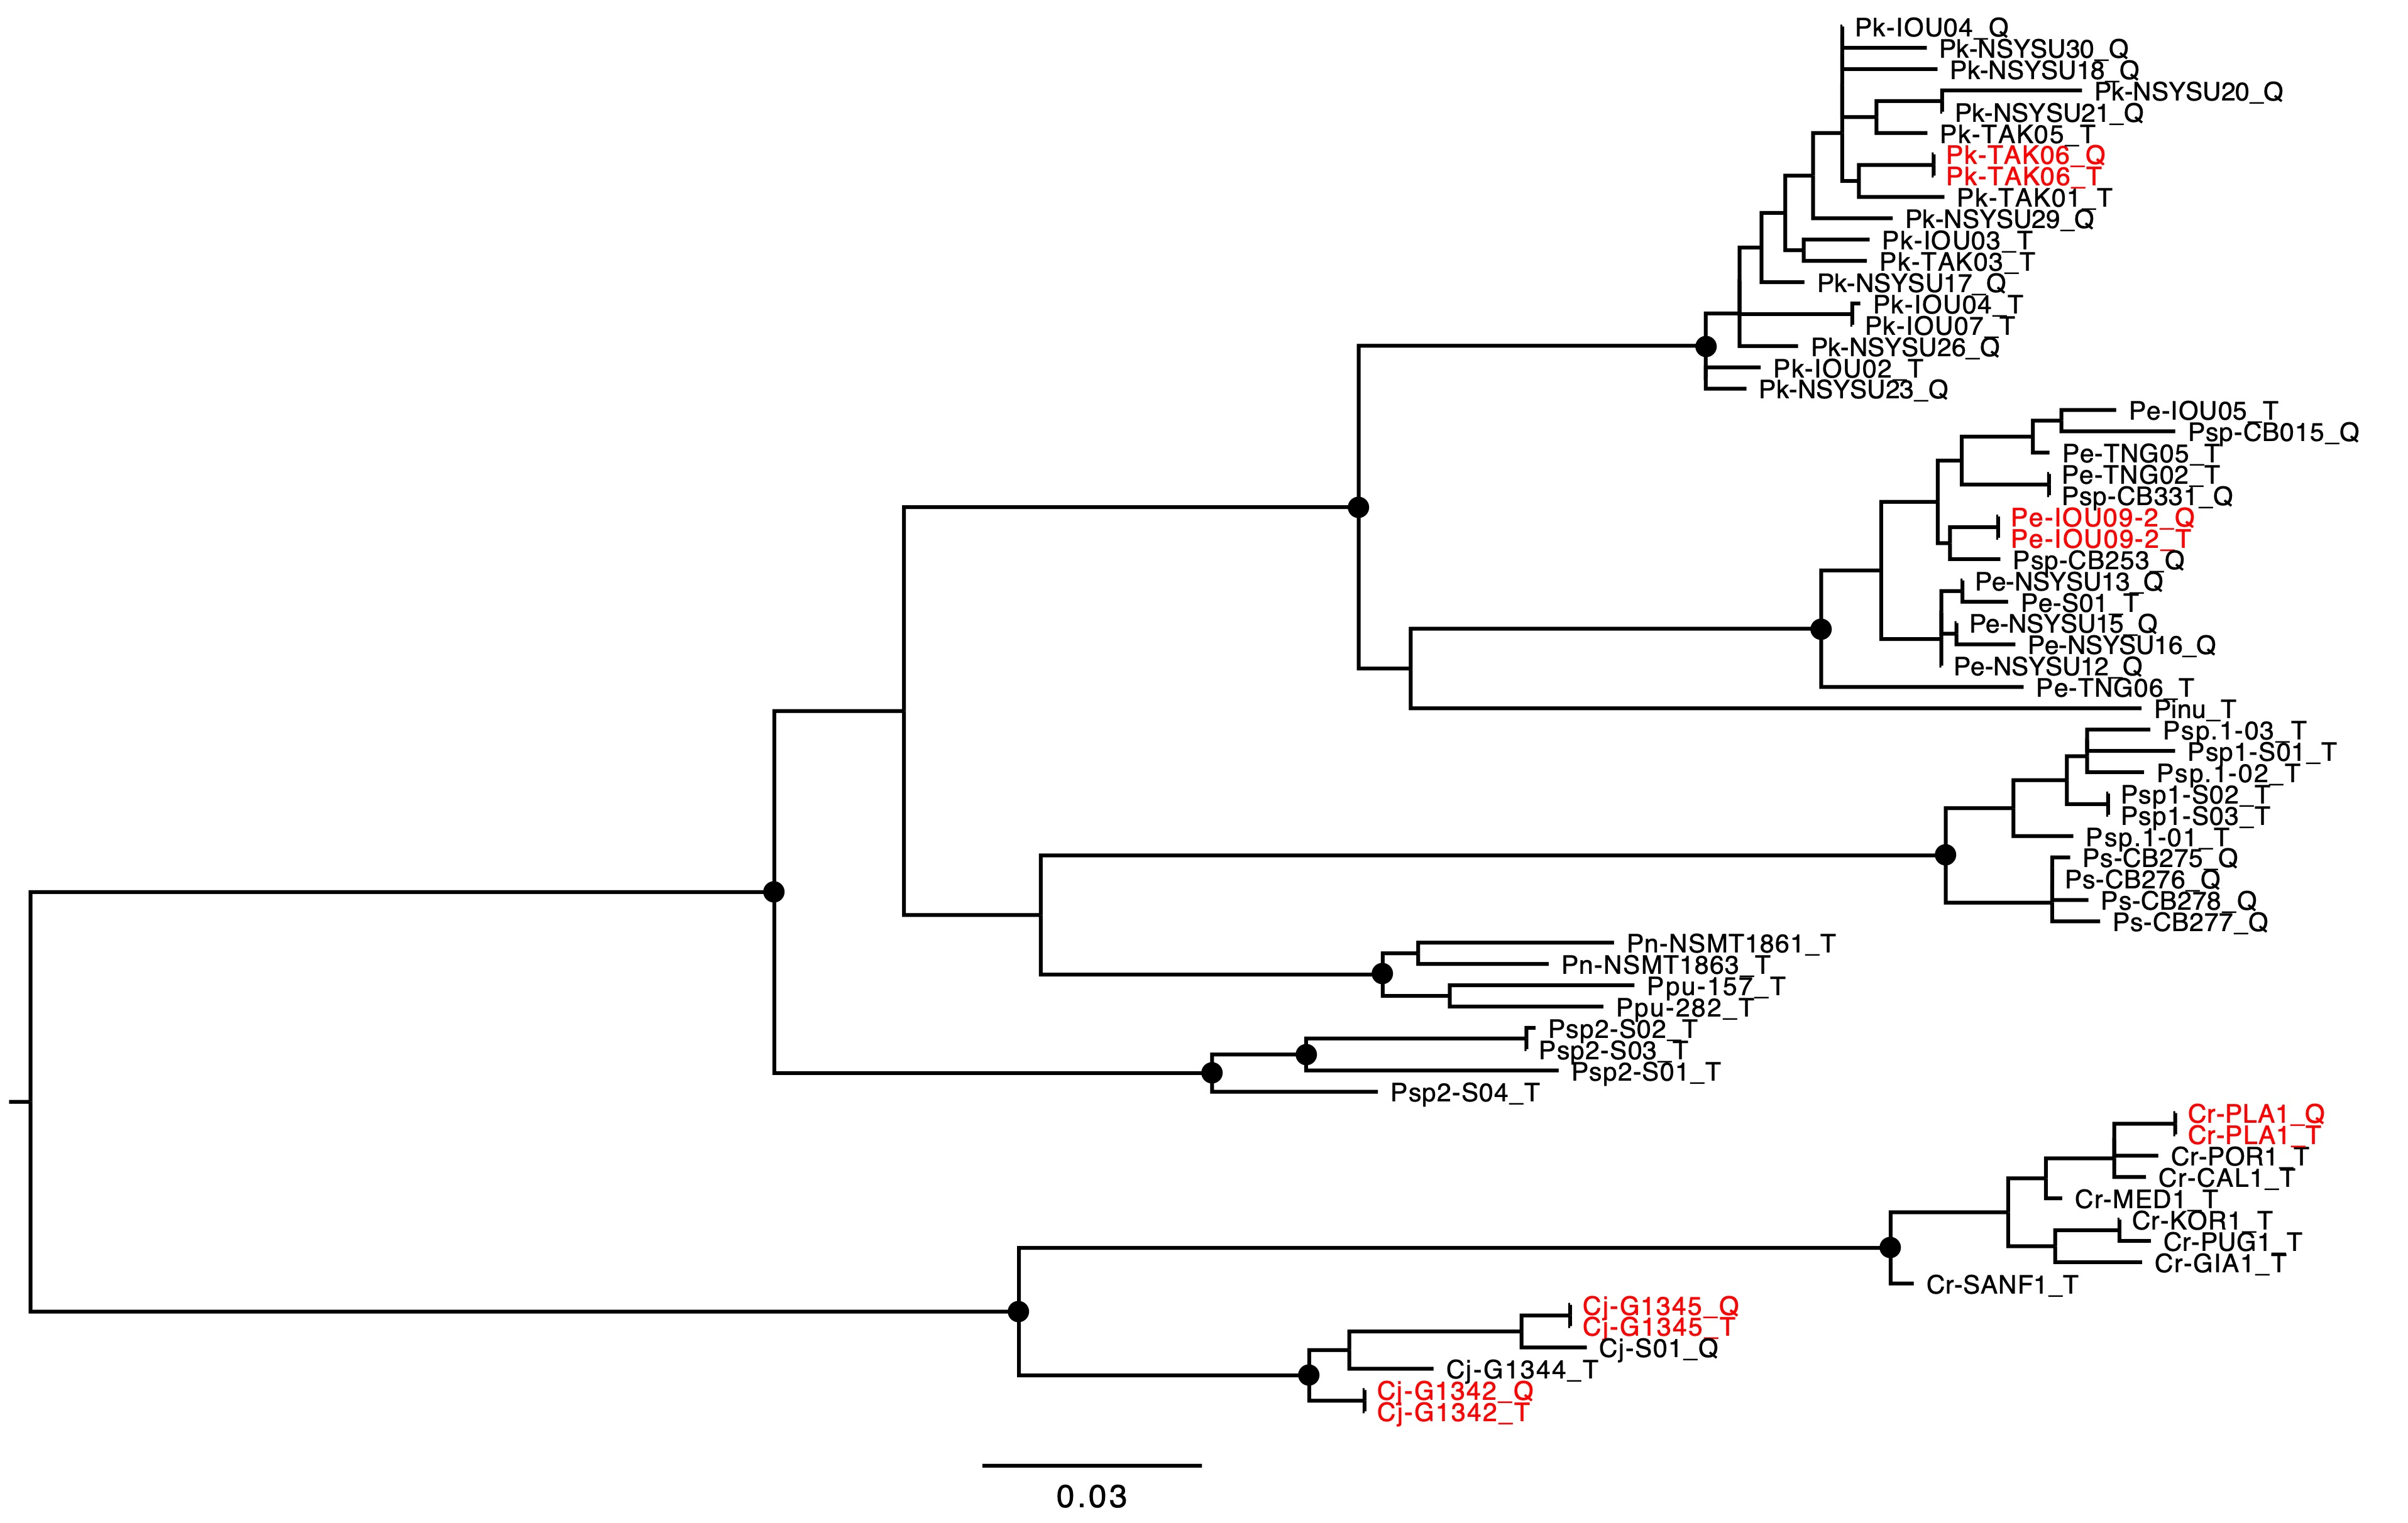
Fig. S1| Maximum likelihood phylogenetic tree of the genus Pleurocorallium (r-0.1) using MIGseq data including the samples, each amplified using two different enzymes. Circle symbols indicate internal nodes with SH-aLRT support (%) ≥ 80% and ultrafast bootstrap support (%) ≥ 95%. The adjacent red samples represent data obtained from the same individual using PCR with different enzymes.

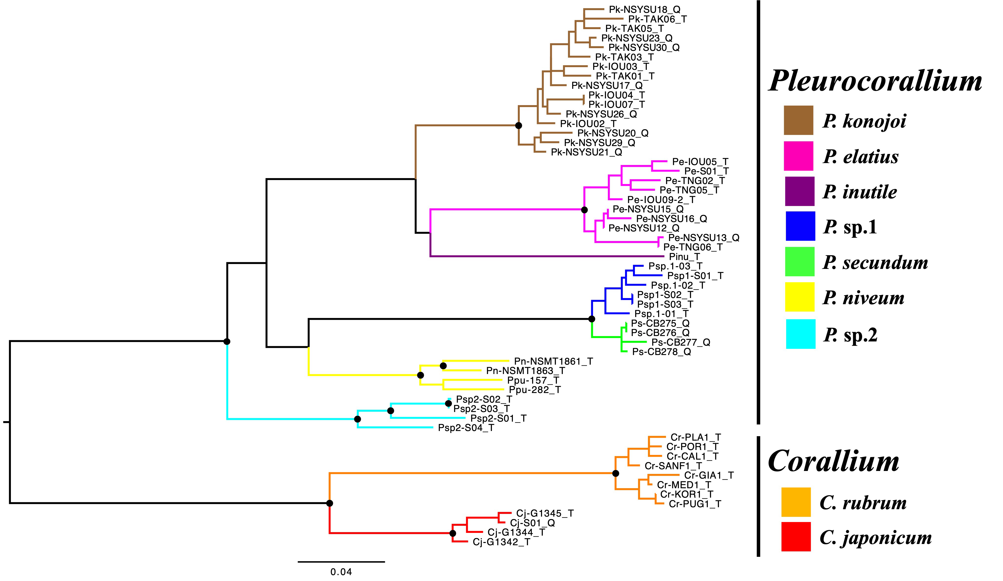
Fig. S2| Maximum likelihood phylogenetic tree of the genus Pleurocorallium (R-0.2) using MIGseq data. Circle symbols indicate internal nodes with SH-aLRT support (%) ≥ 80% and ultrafast bootstrap support (%) ≥ 95%.

Fig. S3| Scanning electron microscopy (SEM) images of sclerites of P. sp. 1 (P.sp.1-01) collected from four parts of the sampled colony (tentacle, tip, mound, and base) following the method described by Nonaka et al. (2025). The scale bar represents 0.1 mm.

Fig. S4| Scanning electron microscopy (SEM) images of sclerites of P. sp. 2 (P.sp.2-S01) collected from four parts of the sampled colony (tentacle, tip, mound, and base) following the method described by Nonaka et al. (2025). The scale bar represents 0.1 mm.

Table S1| Coralliidae samples and accession number for phylogenetic tree using mitochondrial DNA.
Taxon | sample name | Reference | MutS | LR | IGS
Corallium japonicum | japonicum_PAL_1 | Tu et al. 2015 | KF854892 | JX648084 | KF855045
Corallium rubrum | rubrum_MD_2 | Uda et al. 2011 | AB700136 | AB700136 | AB700136
Pleurocorallium borneense | borneense_NC_1 | Tu et al. 2015 | KF854846 | KF850234 | KF854972
Pleurocorallium borneense | borneense_NC_2 | Tu et al. 2015 | KF854859 | KF286563 | KF854974
Pleurocorallium borneense | borneense_NC_3 | Tu et al. 2015 | KF854856 | KF850236 | KF854973
Pleurocorallium borneense | borneense_NC_4 | Tu et al. 2015 | KF854848 | KF850235 | KF854971
Pleurocorallium carusrubrum | carusrubrum_TW | Tu et al. 2015 | KF854908 | KF483568 | KF855038
Pleurocorallium elatius | elatius_TW_1 | Tu et al. 2015 | KF854878 | KF850258 | KF855028
Pleurocorallium elatius | elatius_TW_2 | Tu et al. 2015 | KF854896 | KF850245 | KF855036
Pleurocorallium elatius | elatius_TW_3 | Tu et al. 2015 | KF854897 | KF850263 | KF855030
Pleurocorallium inutile | inutile_TW_1 | Tu et al. 2015 | KF854883 | KF850261 | KF854941
Pleurocorallium inutile | inutile_TW_2 | Tu et al. 2015 | KF854885 | KF850262 | KF854942
Pleurocorallium inutile | inutile_TW_3 | Tu et al. 2015 | KF854898 | KF286558 | KF854943
Pleurocorallium porcellanum | porcellanum_HW_1 | Tu et al. 2015 | KF854889 | JX648032 | KF855015
Pleurocorallium porcellanum | porcellanum_HW_2 | Tu et al. 2015 | KF854907 | JX648033 | KF855016
Pleurocorallium porcellanum | porcellanum_HW_3 | Tu et al. 2015 | KF854919 | KF850242 | KF855017
Pleurocorallium porcellanum | porcellanum_HW_4 | Tu et al. 2015 | KF854927 | JX648030 | KF854962
Pleurocorallium porcellanum | porcellanum_HW_5 | Tu et al. 2015 | KF854930 | JX648031 | KF854963
Pleurocorallium konojoi | konojoi_JP | Uda et al. 2011 | AB595190 | AB595190 | AB595190
Pleurocorallium konojoi | konojoi_TW_1 | Tu et al. 2015 | KF854877 | KF850257 | KF855034
Pleurocorallium konojoi | konojoi_TW_3 | Tu et al. 2015 | KF854876 | KF850256 | KF855033
Pleurocorallium konojoi | konojoi_TW_4 | Tu et al. 2015 | KF854880 | KF850259 | KF855029
Pleurocorallium konojoi | konojoi_TW_5 | Tu et al. 2015 | KF854881 | KF850260 | KF855035
Pleurocorallium konojoi | konojoi_TW_6 | Tu et al. 2015 | KF854902 | KF850264 | KF855031
Pleurocorallium konojoi | konojoi_TW_7 | Tu et al. 2015 | KF854906 | KF850266 | KF855032
Pleurocorallium gotoense | gotoense | Lendvay et al. 2025a | PV169451 | PV190011 | PV169458
Pleurocorallium uchidai | uchidai | Lendvay et al. 2025a | PV169453 | PV190013 | PV169460
Pleurocorallium sp.1 | sp.1_S01 | In this study | LC921273 | LC921273 | LC921273
Pleurocorallium sp.1 | sp.1_S02 | In this study | LC921274 | LC921274 | LC921274
Pleurocorallium sp.2 | sp.2_S01 | In this study | LC921275 | LC921275 | LC921275
Pleurocorallium sp.2 | sp.2_S03 | In this study | LC921276 | LC921276 | LC921276
Pleurocorallium niveum | niveum_HW_1 | Tu et al. 2015 | KF854840 | JX648073 | KF854954
Pleurocorallium niveum | niveum_HW_2 | Tu et al. 2015 | KF854844 | KF850233 | KF854955
Pleurocorallium niveum | niveum_HW_3 | Tu et al. 2015 | KF854893 | KF850239 | KF854952
Pleurocorallium niveum | niveum_HW_4 | Tu et al. 2015 | KF854936 | KF850244 | KF854970
Pleurocorallium niveum | niveum_HW_5 | Tu et al. 2015 | KF854934 | KF850243 | KF854968
Pleurocorallium niveum | niveum_HW_6 | Tu et al. 2015 | KF854915 | JX648071 | KF854966
Pleurocorallium niveum | niveum_HW_7 | Tu et al. 2015 | KF854935 | JX648069 | KF854969
Pleurocorallium niveum | niveum_HW_8 | Tu et al. 2015 | KF854910 | KF850241 | KF854958
Pleurocorallium niveum | niveum_09ESC05 | Lendvay et al. 2025a | PV169454 | PV190014 | PV169461
Pleurocorallium niveum | niveum_09ESC10 | Lendvay et al. 2025a | PV169455 | PV190015 | PV169462
Pleurocorallium niveum | niveum_10ESC284 | Lendvay et al. 2025a | PV169456 | PV190016 | PV169463
Pleurocorallium occultum | sp16_ES_1 | Tu et al. 2015 | KF854836 | KF273961 | KF854950
Pleurocorallium occultum | sp16_ES_2 | Tu et al. 2015 | KF854835 | KF765475 | KF854953
Pleurocorallium secundum | secundum_HW_1 | Tu et al. 2015 | KF854923 | JX648076 | KF854967
Pleurocorallium secundum | secundum_HW_2 | Tu et al. 2015 | KF854863 | JX648075 | KF854956
Pleurocorallium secundum | secundum_TW | Tu et al. 2015 | KF854890 | KF850238 | KF854951
Pleurocorallium sp10 | sp10_NC_1 | Tu et al. 2015 | KF854854 | KF850251 | KF855014
Pleurocorallium sp10 | sp10_NC_2 | Tu et al. 2015 | KF854851 | KF850247 | KF854947
Pleurocorallium sp11 | sp11_NC | Tu et al. 2015 | KF854873 | KF850254 | KF855012
Pleurocorallium sp12 | sp12_NC | Tu et al. 2015 | KF854875 | KF850255 | KF855013
Pleurocorallium bonsaiarborum | sp2_NC | Tu et al. 2015 | KF854911 | KF850267 | KF854957
Pleurocorallium norfolkicum | sp4_NC_1 | Tu et al. 2015 | KF854850 | KF850265 | KF854948
Pleurocorallium norfolkicum | sp4_NC_2 | Tu et al. 2015 | KF854853 | KF850250 | KF854949
Pleurocorallium norfolkicum | sp4_NC_3 | Tu et al. 2015 | KF854852 | KF850249 | KF854946
Pleurocorallium clavatum | sp9_NC | Tu et al. 2015 | KF854909 | KF850240 | KF855003
Pleurocorallium thrinax | thrinax_NC_1 | Tu et al. 2015 | KF854845 | KF850246 | KF854959
Pleurocorallium thrinax | thrinax_NC_2 | Tu et al. 2015 | KF854924 | KF850268 | KF854944
Pleurocorallium thrinax | thrinax_NC_3 | Tu et al. 2015 | KF854847 | KF850248 | KF854960
Pleurocorallium thrinax | thrinax_NC | Tu et al. 2015 | KF854857 | KF850252 | KF854961
Pleurocorallium sp. | Angel skin coral bead | Lendvay et al. 2025a | PV169450 | PV190010 | PV169457

